
M4X01160
Engineering Design

Task Two - Presentation of concept designs and final design proposal

Nathaniel Allcock – 1650013
Alexander Penny – 1706431
Joshua Lewis – 1703080
Salman Birch – 1800886
Emily-Kate Flewin – 1801668

Contents

Emily-Kate Flewin – Team leadership and systems integration 2
Josh Lewis - Power generation and storage 3
Alexander Penny - Mechanical drive and propulsion 4
Nathaniel Allcock – Control, Robustness, Reliability and Payload 5
Concept Designs 6
Final Design 7

Figure 4: Emily-Kate's Design 8
Figure 1: Nathaniel's Design 8
Figure 2: Josh's Design 8
Figure 3: Alexander's Design 8
Figure 5: Final Design CAD drawing without pipe 9
Figure 6: Final Design CAD drawing with pipe 9
Figure 7: Final Design 2D CAD drawing 9
Figure 8: Final Design 9

Emily-Kate Flewin – Team leadership and systems integration
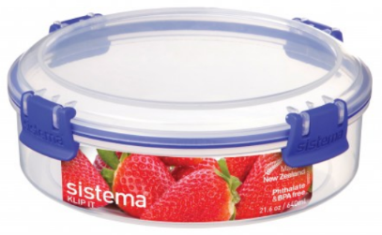
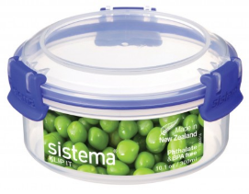
This is a report on our final design and the input we each had regarding our roles. This role is focusing on the integrating frame/chassis design. The chassis we have decided to choose is a Tupperware tub. The group has chosen to avoid making our own chassis as we are going to focus our efforts on functionality and adjustability. The idea behind using this chassis is that we aren't going to make one ourselves, we are going to buy a chassis that isn't heavy isn't going to break after testing. As well as this the chassis must be cheap, at best this chassis will cost a maximum of £5. We have looked at the following for our chassis.

(Sistema, 2019) (Sistema, 2019)
Using a Tupperware box can be justified because it will store the components in the box and provide protection for the components in the event of the freefall. As the lid can be removed and put back on easily, we can change our components very easily. Which means that time is saved when swapping out batteries or motors. Another reason pre-buying a chassis is a good idea is because it saves time building one, instead of spending time creating chassis that is stable, can hold our components and can with stand multiple tests we are just going to buy a chassis that we know won't break.
Durability is important. Our pipe crawler is going to freefall from a height therefore it must be durable. A Tupperware tub can withstand falling without breaking especially if it's falling from height, for example, from high cupboard onto a hard kitchen floor. Safety is another important part for the requirements of the chassis. Which is where the Tupperware box succeeds, as it is a microwave friendly therefore it will be able to withstand possible overheating from a motor or battery. One of the most important factors of the chassis is simplification and it doesn't get much simpler than a Tupperware box. Therefore, we save time and money on our design.
After a succession of meeting it was decided that we will use simpler methods of constructing our pipe crawler. Instead of wasting time creating a pipe crawler out of heavier, more expensive materials such as metals and using joining methods such as welding, we are going to use hot glue or drills and threaded hooks with washers for added security for the weight of the chains and hook.
Regarding team leadership and how that affects our final design, we had to re-assign roles as one of our team mates had not been present at team meetings or for lectures. This meant that one of the team members had to do extra work as they had to do another role and research into that role.
Cost and being cost effective was important for this role and effected the final design. This is because each role had a certain budget but since we have decided on using a cheap but strong chassis, we save money on this role. This can then be reassigned to another role and provide funding for spare components and or more expensive and reliable components.
We came to agree on our final design after we all drew ones ourselves (shown at the end of the report), then four of us had a team meeting to decide which one was the ideal design, would function, be the cheapest and be the quickest. This resulted in the final design at the end of this report.

Josh – Propulsion & Mechanical Drive
We met several times during the past few weeks to look at the task in hand and individually come up with our own concept design of the pipe crawler. Once everyone had presented their design, we chose the best features of the individual designs. My design used two motors powering two separate wheels either side of the pipe to ensure grip wasn’t an issue my main contribution to the final design was the positioning of the hook. I decided that it would be a good idea to place the hook for the chain on one side so that as the weight of the chain is lifted it will pull the opposite wheel into the pipe thus giving the pipe crawler in (picture 1) added traction.
The weight of the chain is at a total of 0.36kg once the whole chain has been completely raised from the ground meaning that theoretically speaking our pipe crawler will achieve its maximum grip once the chain leaves the floor. Thus, meaning we should have a steady advantage over any competition who haven’t explored this route. However, I think there could be some issues with the wheel closest to the chain as it may lose traction, but we will discover what happens once we reach the testing phase However, the added grip on the opposite wheel to propel the crawler up the slope We are still going to use the wheels that I had sourced in my previous research as I feel they still meet the product specification they are cheap light and readily available.
As for mounting the electrical motors to the Tupperware chassis I had thought of several methods such as using heavy-duty hook and loop Velcro because you could bring spare motors you would be able to easily swap the motor or check for faults however I feel that our best option would be to use a standard plumbers pipe clip as shown in (picture 1 ) as the motor which is available from https://www.kitronik.co.uk/pdf/MM28.pdf)(acessed 1/2/2019) as this has a 24mm outer diameter which is ideal for the 25mm stainless steel plumbers pipe clip (picture 2) available at (stainless-steel-top-pipe-clip) (acessed 1/2/2019) which can be easily bolted through the Tupperware this should have sufficient clamping force to stop the motor spinning while mounted. however, if we were getting problems regarding the motor spinning you could use a rubber inner tube to increase the friction between the motor and the mount increasing the friction stopping the motor from spinning.
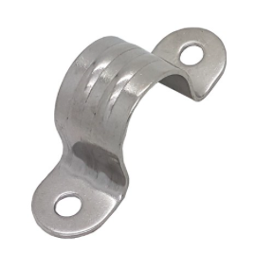
To mount the battery, we will use a standard 23a battery holder and use Velcro to secure it to our chassis as this will be more than enough to secure it. One of my initial thoughts was to secure the motors with the methods explained above and the use some expanding foam around the components to protect them in the event of it falling back down the pipe and breaking on impact However, it will add a little extra weight which could lose us time climbing up the pipe.
By using the methods above, I firmly believe we will make a cheap, reliable and robust pipe crawler which should theoretically be very competitive within the competition. We tried to keep everything simple we had considered 3D printing some of the parts like motor brackets ect, but no-one in the group has had previous experience using the printers and considering our time constraints we believe that this is the most reliable way to build our pipe crawler. (Products, 2019)
Alexander Penny - Mechanical drive and Power storage
A pair of 3v motors was decided upon after analysing the performance of the entries into a similar competition ran by the IMechE in 2015. Looking at the winning teams accent the acceleration was calculated to be 0.32m/s², this is considered our minimum performance demand. The pair of brushed motors will be used due to their low-end torque, having calculated the weight of the chain to be 0.36kg to meet our minimum performance criteria the system must produce 2.24x10⁻³Nm of peak torque. The motors should produce 3.90x10⁻³Nm and accelerate the pipe climbing device to the top in 2.72s, with the switch cutting power it could then freefall completing the cycle in under 3.5s (3.36s with ideal conditions & design). Each run is forecast to consume at least 2.6W, running the motors would require 0.43A per run.
The motors cost £0.79 which Is nominal for the critical role they play.
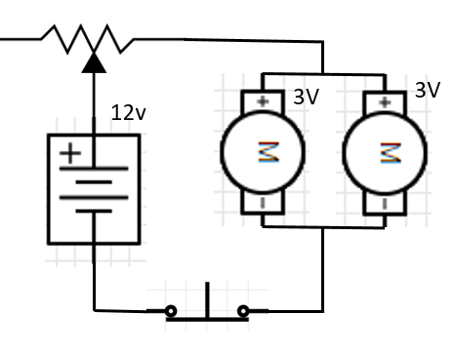
A potentiometer is going to be integrated within the device to allow the team to adjust the rpm of the motors though adjusting the voltage. Using the graph bellow supplied in the spec sheet the adjustment can be set to a specific rpm by measuring the current across a motor. During testing, we will vary the rpm and record the performance analysing the times to ensure the optimal calibration is in place. Alongside gathering data the process will be keenly monitored for any design flaws with the hope of improving upon them.

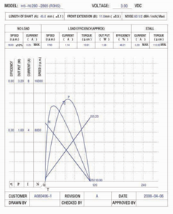

Using an Enhancement MOSFET would be a valuable addition in production models of the pipe climber as it would place limits on the adjustment to rpm which could be made ensuring it stays within its operating range. Since this is a prototype device built for competition purposes this additional cost and complication has been deemed unnecessary.

A 12v 23a battery had been selected as it will allow for the entire range of the batteries to be used and power the system from single cell. 2 batteries can be purchased for £1.49, these should provide sufficient power for all testing and competing the device will be undergoing. Since this device is not going to be used extensively recharging capabilities would be a waste of the limited budget as they will not improve the accent / decent times.

Nathaniel Allcock– Control, Robustness, Reliability and Payload (Final Design)

After participating in a number of team meetings discussing our final design for this project, some of the advantages and disadvantages of various concept ideas were explored and certain options were analysed exploring potential constraints and factors for the control, reliability, robustness and payload of the design.
Initially, one of our first designs for an external pipe climber was decided to be too complex for the task at hand and, based on the timeline for construction and availability of parts, was dismissed. This original concept idea would use two motors, connected to two opposite wheels with the use of rubber tracks around a gearing system, which would propel the climber up the pipe vertically, similar to how the tracks of a tank provide its motion over ground. We deemed that, although a clever idea, the weight of the machine itself, including all components and the weight of the chain it needed to carry, would be too heavy to function properly. Also, the extra complication of the gear system and additional labour involved to construct, would reduce the overall reliability of the design and also increase costs.
After following the design process and discussing the ideas for our different concepts, our final design is an evolution of what we deemed to be the ‘pros and cons’ from the ideas mentioned during the meetings. We have agreed to simplify our design and have now decided to produce a pipe climber consisting of two motors connected to two batteries, which will rotate two wheels opposite each other, using smooth rubber tyres for traction. We have also decided to use a plastic Tupperware tub as a chassis with a detachable lid. The use of a pre-made plastic chassis will save time in labour, allowing us to focus on other aspects of the design which require more focus e.g. ensuring the electrical wiring is correct and functions when needed. Also, as the pipe climber will be used indoors, it should not face any harsh external factors such as weathering or corrosion, therefore, the use of a Tupperware tub for a chassis was also deemed sufficient in terms of rigidity and strength, meaning that the pipe climber will be more durable and tough enough to perform the task at hand. Also, the use of a simpler design increases the reliability as there are less components which could break or malfunction. The chassis is also lightweight and, by having a removable lid, the components inside can be easily accessed should any repairs or modifications need to be made.
With regards to the attachment of the chain, which will need to be carried vertically up the pipe by the machine, we have decided to use a simple screw in metal picture hanging hook with the use of a nut and washer to help distribute the load. This will be placed on the outside bottom edge of the chassis, so the chain doesn’t interfere with the climbing action of the machine and doesn’t contact the pipe; any additional contact would hinder the performance of the machine. By placing the hook where we have, it should also act as a balance weight to increase friction between the tyres and the pipe by pitching the climber at an angle to the pipe, creating a moment in the same way as a cantilever.
For control, the final design will use a push button switch which, once pressed, will activate the motors powering the wheels to start the climb and will also stop the climber once it has reached the top of the pipe, by making contact with the flat surface. As previously mentioned, the cantilever effect built into our design will also ensure a greater contact patch between the push switch and the stop surface, stopping power to the motors and using the force of gravity to bring the pipe climber back down the pipe.
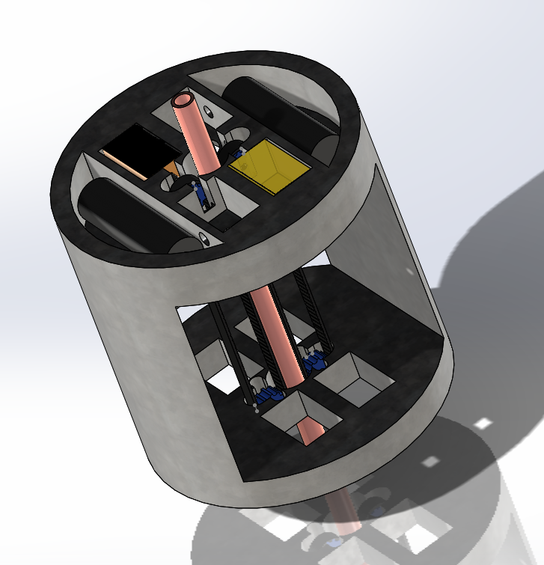
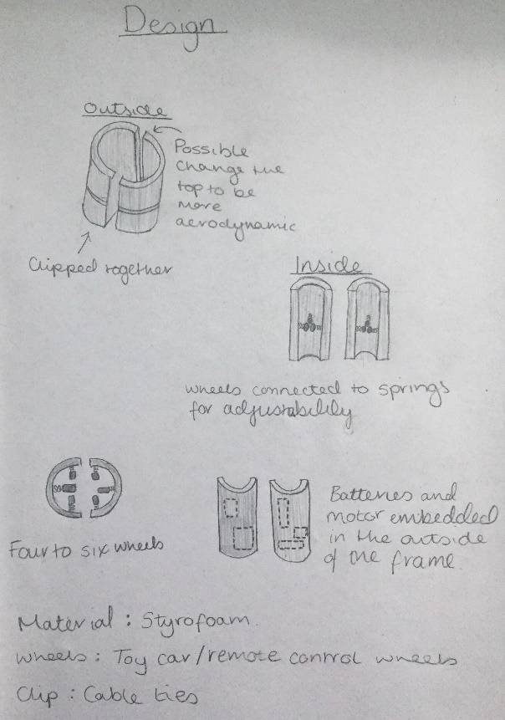
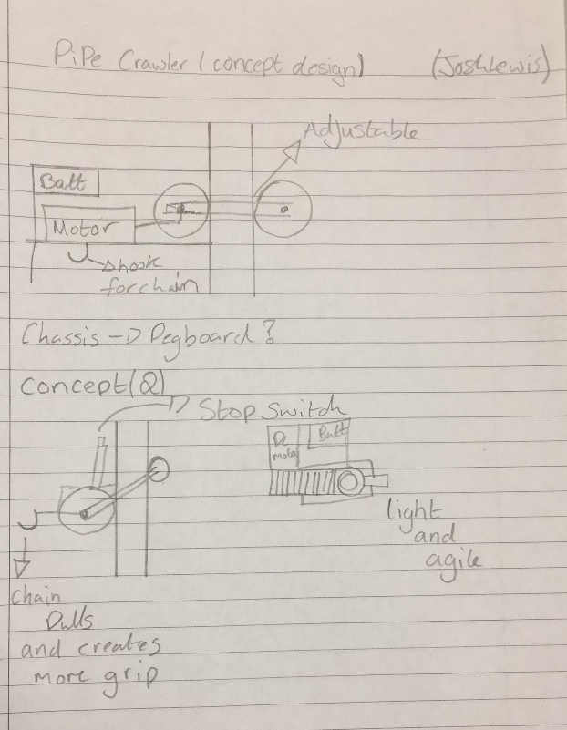
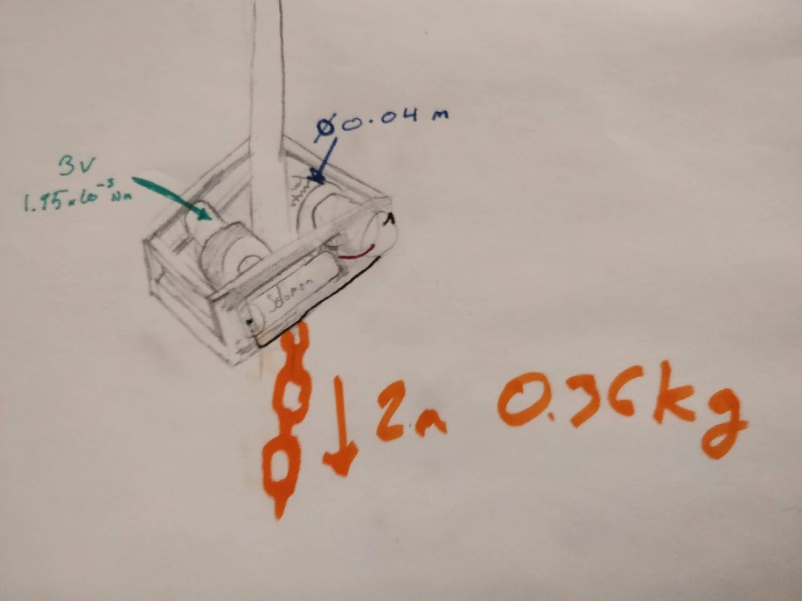
Concept Designs
Figure 4: Emily-Kate's Design
Figure 1: Nathaniel's Design
Figure 2: Josh's Design
Figure 3: Alexander's Design
Final Design
Figure 5: Final Design CAD drawing without pipe
Figure 6: Final Design CAD drawing with pipe
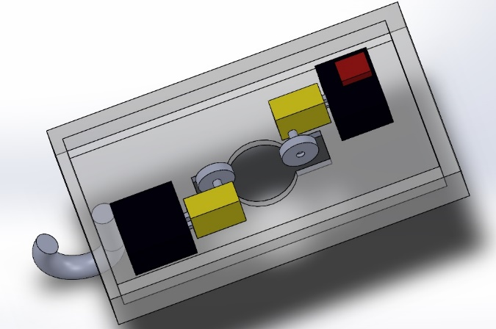
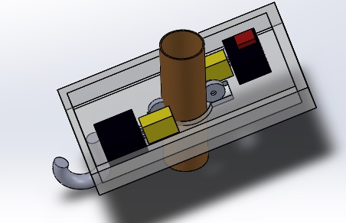
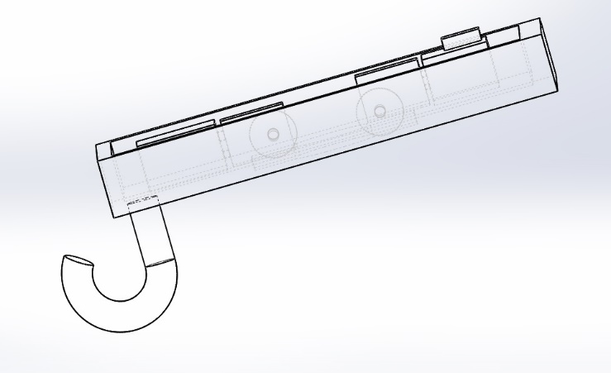
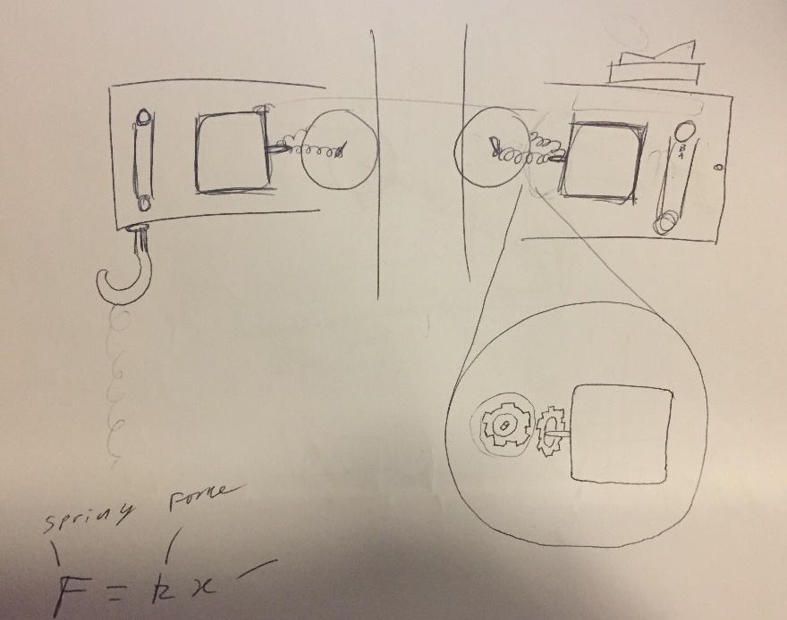
Figure 7: Final Design 2D CAD drawing
Figure 8: Final Design

References
Products, G., 2019. Stainless Steel Top Pipe Clip. [Online]
Available at: https://www.gsproducts.co.uk/stainless-steel-top-pipe-clip/
[Accessed 1st Feburary 2019].
Sistema, 2019. 300ml Round Klip-IT tub. [Online]
Available at: https://sistemaplastics.com/products/klip-it-round/300ml-round?fbclid=IwAR3bYHY0P4Atykd0Xd0oD0zViZWhT8CELNtH1n0FU_9t-Us5TmgPWADFI5Y
[Accessed 1 February 2019].
Sistema, 2019. 640ml Round Klip-IT tub. [Online]
[Accessed 1 February 2019].

