

Managing Project in the Organisation
Submitted by
Student Name: SHAHZAD KHAN
Student ID: 1604638

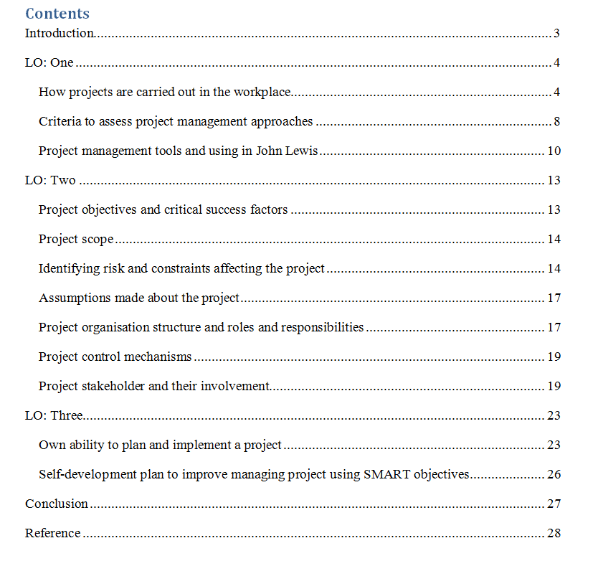

Introduction
The principle of the method is to grow knowledge from the experience of the past projects. In the past projects of John Lewis the organisation may face different barriers and the organisation may take different decisions to run the project. The structured and organised ways of working is essential when implementing the projects. Through implementing the PRINCE 2 project methodology, the organisation can easily make sure that the employees of the organisation are working according to the divisions of work. The communication is really essential within this project management process. This is because completion of tasks within the assigned time is really challenging in this theory. Therefore, precise working in essential. In a customer product and service based organisation like John Lewis maintaining this project model is crucial.

LO: One

How projects are carried out in the workplace
It is the duty of the management of the organisation to ensure successes of the taken projects. This is why project management is considered as the major requirement for the success of the project. The project management will contribute to manage and operate the project of the organisation (Lester, 2013). In the past projects of John Lewis the organisation may face different barriers and the organisation may take different decisions to run the project. The method will analyze the past projects and will take the required learning from the past projects. The method will apply the learning in the current project of John Lewis and will ensure different effectiveness for the project of the organisation. The communication is really essential within this project management process. This is because completion of tasks within the assigned time is really challenging in this theory. Therefore, precise working in essential. In a customer product and service based organisation like John Lewis maintaining this project model is crucial. Through maintaining the project model, the organisation can easily establish the projects along side ensuring customer satisfactions.
Principles of PRINCE2 Methodology
PRINCE2 is the method for project management. The organisation will be able to get the effective outcome in the organisational projects though considering the method (Haider and Shah, 2014). The method has seven principles. The principles of the method are highlighted and explained in the below discussion.
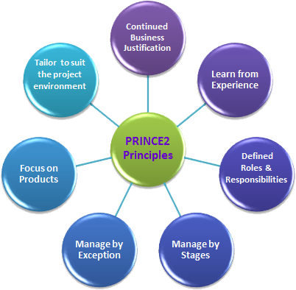
Figure 1: Principles of PRINCE2
Source: (Haider and Shah, 2014)
Continued Business Justification: The method will get the clear idea about the project of John Lewis. The principle of the method is to ensure that the method will allow the investors to get the investments return. This method will ensure continued justification of the business processes. In addition, the required resources of the project will be justified.
Learning from Experience: The principle of the method is to grow knowledge from the experience of the past projects. In the past projects of John Lewis the organisation may face different barriers and the organisation may take different decisions to run the project (Terho, 2009). The method will analyze the past projects and will take the required learning from the past projects. The method will apply the learning in the current project of John Lewis and will ensure different effectiveness for the project of the organisation.
Clear Roles and Responsibilities: In the projects of the organisation the employees will work as a team. Different employees will have different tasks, different roles to play and will have different responsibilities. According to the principles of the method, it is essential to provide the clear idea about the roles and responsibilities to the employees.
Manage in Stages: Projects managed by John Lewis will have different complex tasks and to get the success it is essential to complete these complex tasks in well manner. The principle of the method is to complete the complex tasks in different stages. This is why the task become easy to the employees and the employees will be able to complete the task successfully.
Manage by Exception: The project of John Lewis need to complete in time. The project of John Lewis need to have different resources and the project need to have the budget (Maltzman and Shirley, 2012). The method will focus on the expectations of the project and then will manage the project though filling the expectation in well manner. This is how the success of the project will be ensured.
Product Focus: The end outcome of the project is considered as the product of the project. The method will pay the attention of the product that the project of John Lewis becomes capable enough of making qualitative outcomes. This is how through focusing on the product the method becomes capable enough of making qualitative outcomes.
Tailor to Adjust to Specific Environment: The project management method will be tailored by keeping size, risk, environment, importance and capabilities in the mind.
Benefits of PRINCE2 for John Lewis
PRINCE 2 project management techniques are beneficial for (Petit & Hobbs, 2010). This method ensures structured and organised ways of working. The structured and organised ways of working is essential when implementing the projects. Through implementing the PRINCE 2 project methodology, the organisation can easily make sure that the employees of the organisation are working according to the divisions of work. The communication is really essential within this project management process. This is because completion of tasks within the assigned time is really challenging in this theory. Therefore, precise working in essential. In a customer product and service based organisation like John Lewis maintaining this project model is crucial. Through maintaining the project model, the organisation can easily establish the projects along side ensuring customer satisfactions.
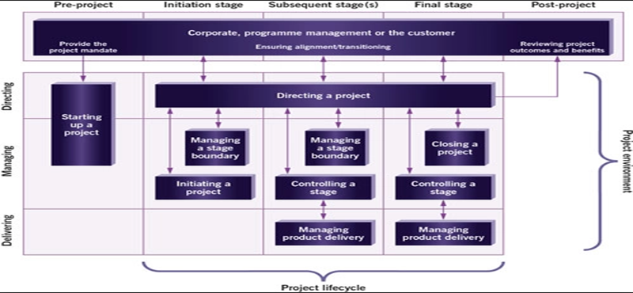
Figure 2: PRINCE2 Project Management Methodology
Source: (Petit & Hobbs, 2010)

Criteria to assess project management approaches
Criteria | Assess Project Management Approaches
Ease of Understanding | Understanding the project scenario and works are essential for the employees of the organisatio. The PRINCE 2 model let the employee easily understand the aspects of projects (Homburg, Workman, and Jensen, 2012). As a result, the employees can identify the works needed to be done and the skills they need to gain.  For Example: The simple approaches of PRINCE2 project management method allow the employees of John Lewis to adopt the method the employees can identify the works needed to be done and the skills they need to gain.
Fit with Requirements | To the run the project, to manage the project and to make successful the project there different requirements are available for the project. The requirements are necessary to fill in well manner to get the effectiveness from the project. This is why during the time of considering the project management method The PRINCE 2 model let the employee easily understand the aspects of projects. As a result, the employees can identify the works needed to be done and the skills they need to gain.
Fit with Organisational Culture | The behavior of the employees, the belief of the employees and the values of the employees are expressed though the culture of the organisation. Organisational culture is essential to get the control on the employees and to get control on the activities of the employees (Lyons and Wilker, 2012). This is why it is essential for John Lewis to choose the effective method for the project management that can fit with the culture of the organisation. PRINCE2 is the effective project management method that is able to fit with the culture of John Lewis.
Accessibility to Others | To get the effective outcome from the project it is necessary to make sure that different stakeholders are capable enough to access approaches. Different stakeholders are connected with the project of the organisation and the stakeholders provide their effective contribution to ensure the success of the project (Cheng, Hwang and Chen, 2005). The project is operated though considering a method. This is why it is the project it is necessary to make sure that different stakeholders are capable enough to access approaches. Different stakeholders are connected with the project of the organisation and the stakeholders.

Project management tools and using in John Lewis
Applications of project management tools are essential for any organisation. proper applications of the tools ensure proper implementation of the projects. As a result, the success possibilities of the organisation increase (Portny, 2017). Different project management tools are being used below for John Lewis.
Works Breakdown Structure: the management of the organisation needs to consider the works breakdown structure in project works. The duty of the tool is to divide different tasks in small tasks. This is why the complex situation will be avoided from the project and the organisation will get the effectiveness in operating and in completing the project.
John Lewis will be able to divide the complex tasks in the small tasks. This is how the organisation will get the effectiveness in completing the tasks. John Lewis will be able to implement the plan of the project in well manner. Except this to run the project it is essential for John Lewis to complete the tasks of risk management and the tasks of document management (Dennis, 2014).
John Lewis will face the difficulties if the project of the organisation will have the huge number of tasks. The work breakdown structure will not ensure the effectiveness for John Lewis in determining the major and minor tasks from the huge number of tasks.
Schedule: Scheduling is the activity of distributing tasks among the employees in an organised and structured order. Such ordering is essential within the projects of John Lewis in order to ensure completion of the tasks within time. The management of the organisation needs to assign the tasks according to the capabilities of the employees (Hobbs, 2012). Besides, proper timing is to be assigned to the employees to make sure completion of tasks perfectly and within schedule. This is considered as the limitation of the project management tool.
Gantt chart: Application of Gantt Chart within the projects are very common among the project managers. Gantt Chart presentation is the graphical presentation of the works of the project (Voss and Kock, 2013). As a result, proper understand about the works can be obtained by the employees. through applying the Gantt chart the project employees of John Lewis will understand their tasks and the assigned times for each task. As a result, the employees will put enough importance over their works.
In making the chart and in monitoring the Gantt chart it is essential for John Lewis to recruit an expert employee. In doing all these tasks the employees need to have the skills on the Gantt chart. The regular employee will not be able to do these tasks. This considered as the barrier of using the project management tool.
Stakeholder Analysis: Shareholders are the key part of the organisation. Therefore, the organisation needs to make sure that the shareholders are being served properly. In order to serve the shareholders, John Lewis needs to come up with shareholders analysis (Kimmich, 2012). Through shareholder analysis, the organisation can analyse the demands of the shareholders. Therefore, accordingly the organisations can serve them and can set project targets.
The tool faces the barrier in identifying the power and interest of all the stakeholders. In addition, the tool faces the barriers in filling the needs of the stakeholders in well manner. This is considered as the disadvantage of the project management tool.
Critical Path Analysis: Different complex tasks will be identified though considering the tool that can leave the negative impact on the project of the organisation (Eden and Fran, 2013). The tool will not be able to ensure the effectiveness for John Lewis without getting the appropriate and clear information. This is considered as the limitation of the project management tool.
Project Risk Management: The available risks for the project will be identified though considering the project management tool (Eden and Fran, 2013). The skilled employee is the main requirement for using the tool. The organisation will not be able to get the effective outcome though the regular employees. This is the limitation of the project management tool.

LO: Two
Introduction
The project management techniques are beneficial for organisations like John Lewis. These methods ensure structured and organised ways of working. The structured and organised ways of working is essential when implementing the projects. Through implementing the PRINCE 2 project methodology, the organisation can easily make sure that the employees of the organisation are working according to the divisions of work. The communication is really essential within this project management process. This is because completion of tasks within the assigned time is really challenging in this theory. Therefore, precise working in essential. In a customer product and service based organisation like John Lewis maintaining this project model is crucial.

Project objectives and critical success factors
Project Objectives:
- Introduce a new store to grow the business of John Lewis.
- Get new customers and increase the sales of John Lewis.
- Develop the brand image of John Lewis in well manner.
- Complete the project of John Lewis within ten months.
Success Factors from the Project: The expectations of John Lewis from the project of the organisation are highlighted below.
- The expectation of John Lewis is to get the new customers for the new store of the organisation and though the new store the organisation wants to increase the sale of John Lewis.
- John Lewis will be able to get the chance of capturing the market place though the new store of the organisation. The organisation wants to get the competitive advantage though the new store of the organisation.
- Assurance of quality products and services are the targets of John Lewis. This is how though ensuring the quality service the organisation wants to develop the brand image in well manner.

Project scope
Increasing the project scopes are essential for management of John Lewis. The managers of the organisation needs to make sure that proper projects are being identified for the organisation (Nag, 2015). Proper identification of the project will ensure profit increase for the organisation, besides ensuring development of areas of operations.

Identifying risk and constraints affecting the project
There different risks are available for the project of the organisation. This is why it is essential for John Lewis to identify the available risks for the project of the organisation and develop an effective plan to minimize the impacts of the risks on the project of the organisation (Kimmich, 2012).
Risk Breakdown Structure for the John Lewis Project:
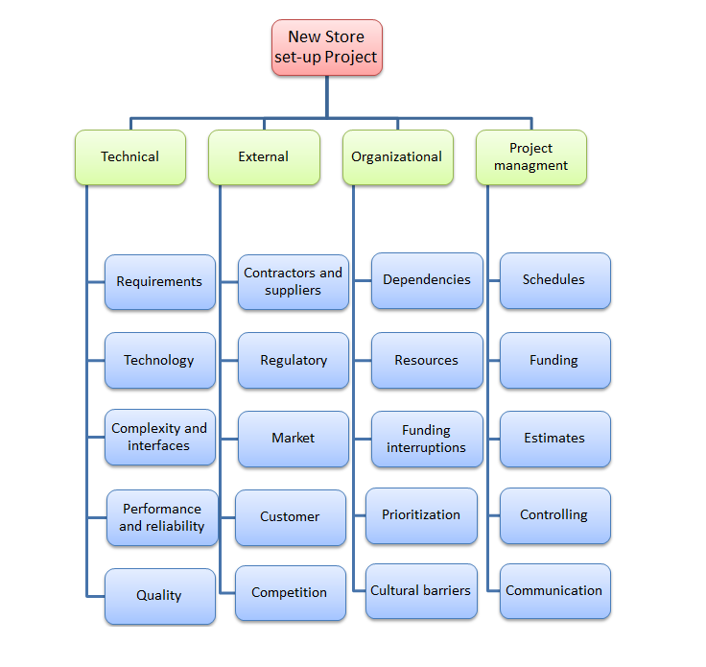
Identification of Risks for the Project of John Lewis: The available risks are identified below.
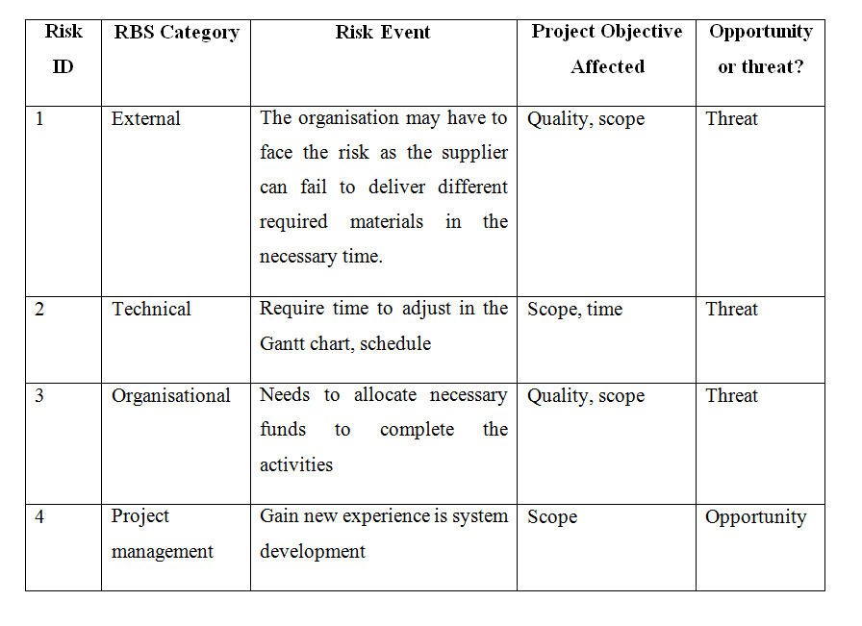
Risk Register:
Risk ID Number: | 1 | 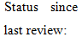 |  |  |  | Date of review: | 5-06-2019
Responsibility: | Project Manager
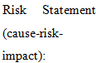 | If the suppliers fail to deliver the required materials in the required time then the project of the organisation has to get the negative impact.
Risk Rank |  |  | Time |  | Cost |  |  | Scope
High: (red)
Medium: (yellow)
Low: (green)
Risk ID Number: | 2 |  |  |  |  | Date of review: | 21-09-2019
Responsibility: | Project IT Consultant
 | The project of the organisation will have to get the negative impacts if the organisation fails to complete the tasks of the project in the scheduled time.
Risk Rank |  |  | Time |  | Cost |  |  | Scope
High: (red)
Medium: (yellow)
Low: (green)

Risk ID Number: | 3 |  |  |  |  | Date of review: | 29-09-2018
Responsibility: | Project Sponsor
 | The organisation will not be able to run the project in well manner if the organisation fails to get the required money from the sources of finance.
Risk Rank |  |  | Time |  | Cost |  |  | Scope
High: (red)
Medium: (yellow)
Low: (green)

Risk ID Number: | 4 |  |  | Satisfactory |  | Date of review: | 12-08-2018
Responsibility: | Project Manager
 | The organisation will be able to have the new experience though completing the project of the organisation and this will be useful in different new projects of the organisation.
Risk Rank |  |  | Time |  | Cost |  |  | Scope
High: (red)
Medium: (yellow)
Low: (green)

Assumptions made about the project
The known and the unknown assumptions of the projects are highlighted below.
Known Assumptions:
- The developed budget for completing the project will be cleared.
- The time plan will be developed for completing the tasks of the project.
- The available risks for operating the projects will be identified in well manner.
- Different requirements of the project will be cleared.
Unknown Assumptions:
- Accidents to employee might take place due to load of works or incautiousness.
- The organisation may need to consider different other source of finance and at the starting of the project the requirement cannot be identified.

Project organisation structure and roles and responsibilities
The project organisational structure is considered to define the role and responsibilities in well manner. The project organisational structure of John Lewis is highlighted below.
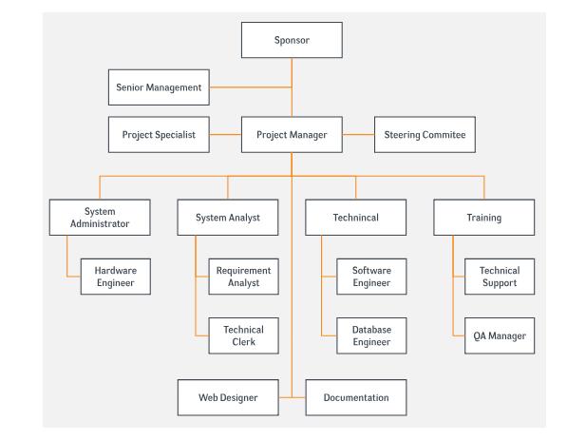
Figure 3: Project Organisation Structure
Source:
Project Sponsor: The duty of the project sponsors is to fill the financial requirement of the project of John Lewis in well manner (Petit & Hobbs, 2010).
Senior Management: The duty of the senior management is to identify different requirements of the projects and keep eyes on the project to get the knowledge about the progress of the project of John Lewis.
Project Specialist: The tasks of the project specialists is to ensure special project plans and to evaluate the project scopes.
Project Manager: The duty of the project manager is to run the project in an organized way and to implement different plan of the project in well manner (Nag, 2015).
Steering Committee: The duty of the committee is to perform to identify different organisational issues that may have the impact on the project of the organisation.
System Analysis: The duty is to identify different technical errors in well manner and also need to determine the requirements of the system of the project (Voss and Kock, 2013).
System Administration: Hardware engineering is the requirement of the project and the duty of the administration is to fill the requirement in well manner.
Technical: It is necessary for the organisation to do the proper management of the database to ensure the effectiveness from the project. And the technical employees have the duty of do doing the effective management of the database.
Training: It is necessary to develop the skills and the performance of the team members of the projects.

Project control mechanisms

The project management techniques are beneficial for organisations like John Lewis. These methods ensure structured and organised ways of working. The structured and organised ways of working is essential when implementing the projects. Through implementing the PRINCE 2 project methodology, the organisation can easily make sure that the employees of the organisation are working according to the divisions of work.

Project stakeholder and their involvement
In operating the project of the organisation it is essential for John Lewis to consider both the internal and the external stakeholders.
Internal Stakeholders: The internal stakeholders are
- Project manager
- Team members
- Sponsors
- Steering committee
- Senior management
- Project specialist
External Stakeholders: The external stakeholders are
- Suppliers
- Financial institutions
- Customers
- Competitors
- Shareholders
Work Breakdown Structure for John Lewis:
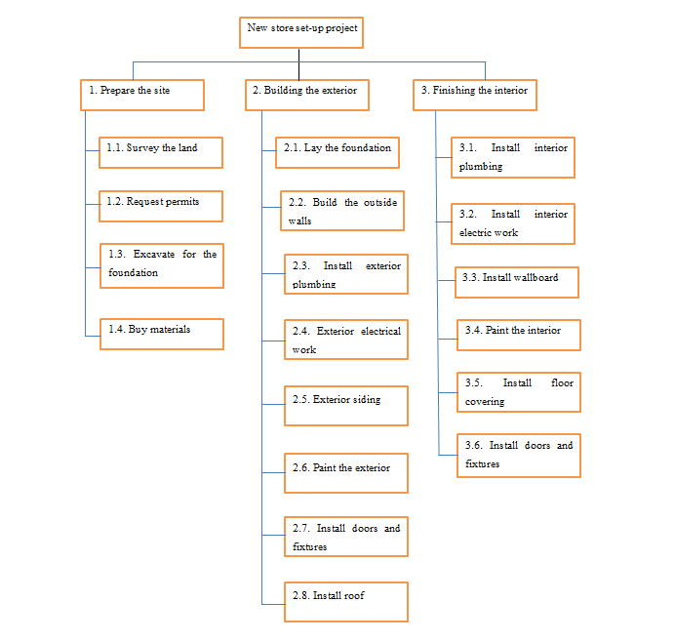
Figure 4: Work Breakdown Structure
Source: Developed by Author

Schedule of the Project:
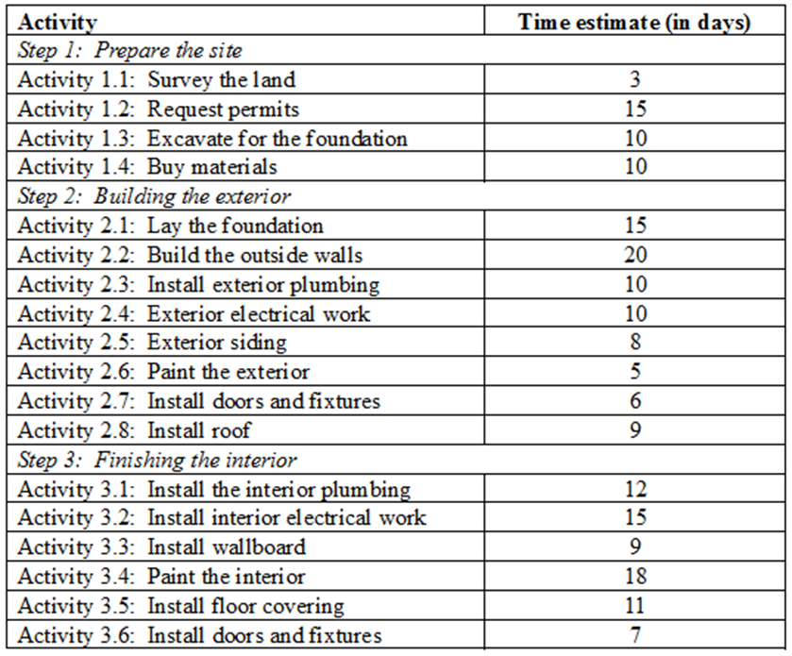
Gantt chart of the Project:
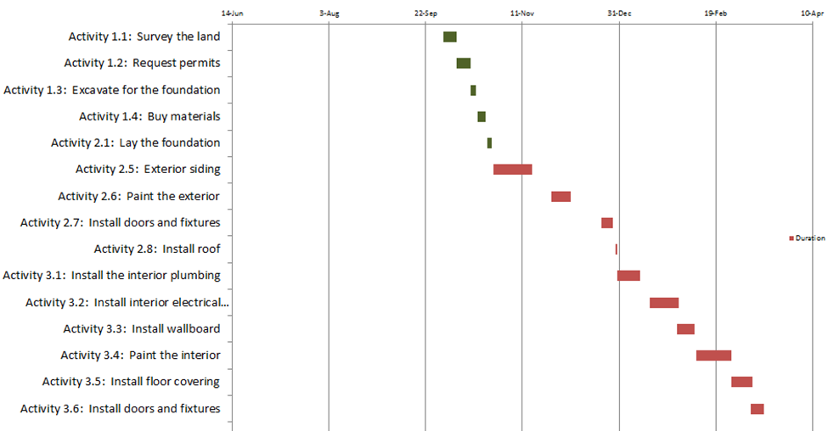
Figure 5: Gannt Chart
Source: Developed by Author
Budget of the Project:
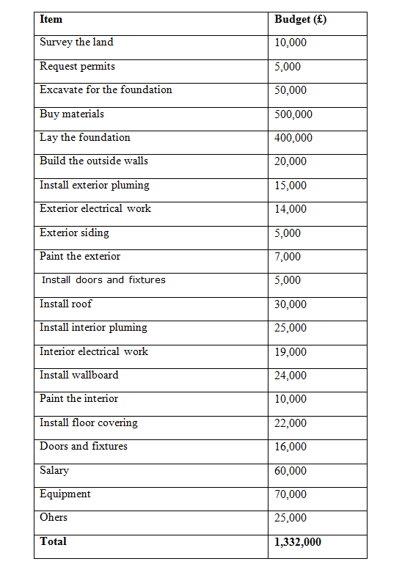

LO: Three

Own ability to plan and implement a project
As a project manager I need to have different skills to run the project in an organized way and I need to fix my lacking’s to ensure the effectiveness for the project. The feedback process is considered that I will be able to identify my strengths (Lyons and Wilker, 2012). In addition, I will be able to know about my weaknesses. It is necessary for me to do the effective use of my strengths and to fix my lacking’s in well manner. The strengths and weaknesses of mine are highlighted and discussed in the below discussion.
Own Strengths
Ability to take Responsibility: It is essential for the project manager to have the ability of taking responsibility. In operating and in running the project the project manager needs to take different responsibilities. As like, the project manager need to take the responsibility of developing the plan, the manager need to take the responsibility of implementing the plan and the manager need to take the responsibility of completing the tasks in time (Haider and Shah, 2014). Thus, I will be responsible and will be able to perform the assigned tasks.
Adoption Quality: adaption of the skills required is essential for the employees (Portny, 2017). Through adaption of the skills, project works can be served perfectly. This is why adoption quality is crucial for the project manager. According to the feedback, I am able to get adjust in different situation. The adoption skill of mine will help me to operate the project of the organisation in well manner.
High Commitment: High commitment is the major requirement for the success of the project. The project manager needs to be committed in different tasks. This is how the manager will be able to complete the tasks successfully and will be able to complete the tasks in the scheduled time. The feedback process expresses that I am committed to my works.
Strong Leadership: Development of the strong leadership quality is essential for project works. I have these skills. Therefore leading the employees or team members of the projects will be easier for me. (Haider and Shah, 2014). I will try to ensure participative leadership style where the employees can share their skills and opinions to complete the assigned tasks. Thus, the works will be completed perfectly I believe.
Ability to Decision Making: Great decision making skills are essential part of skills for the project employees. In projects, different scenario arise and thus decisions are to be made accordingly. I possess such skills and believe that I can handle situations through taking situation-demanded decisions. I hope that the skills of adaptability and proper decision making will help me to ensure quality works for the projects.
Own Weaknesses
Lack of Communication: Effective communication is very essential to provide the effective direction. Effective communication will help to control the activities of the employees and to ensure the progress of the project. The feedback process expresses that I do not have the communication skill. This is why the project of the organisation will face different barriers. I need to fix the lacking and ensure the effective communication channel in the project of the organisation.
Time Management Skill: The project manager needs to have the time management skill. It will help the project manager to complete different tasks in time. According to the feedback process, I have the lack of time management skill (Portny, 2017). This will leave the negative impact on the project of the organisation. This is why I need to work on my time management skill and need to develop the skill in well manner.
Lack of IT Skill: In the documentation process of the project, in developing the Gantt chart and in different other activities of the project the IT skill are the requirement for the project manager (Voss and Kock, 2013). According to the feedback process, I have the lack of IT skills. This is why I am facing barrier in completing different tasks of the project.

Self-development plan to improve managing project using SMART objectives
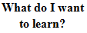 | 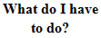 | 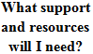 | 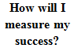 | 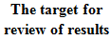
IT Skill | Need to take the trainings and learning’s. | Need to take the support of internet to have the development. | I will be able to complete different tasks in well manner. As like, I can develop the Gantt chart. | 3 Months (1st June 2019 to 30rd August 2019)
Communication Skill | Need to take the trainings and learning’s. | Need to do the effective communication with the other employees of the organisation. | I will be able to have the effective communication with the team members. | 5 Months (1st June 2019 to 30rd October 2019)
Time Management Skill | Need to take the trainings and learning’s. | Need to take the support of different time management strategies. | I will be able to complete the tasks in the scheduled time. | 6 Months (1st June 2019 to 30 November 2019)

Conclusion
Applications of project management tools are essential for any organisation. proper applications of the tools ensure proper implementation of the projects. As a result, the success possibilities of the organisation increase. These methods ensure structured and organised ways of working. The structured and organised ways of working is essential when implementing the projects. Through implementing the PRINCE 2 project methodology, the organisation can easily make sure that the employees of the organisation are working according to the divisions of work. The communication is really essential within this project management process. This is because completion of tasks within the assigned time is really challenging in this theory. Therefore, precise working in essential. In a customer product and service based organisation like John Lewis maintaining this project model is crucial. Through maintaining the project model, the organisation can easily establish the projects along side ensuring customer satisfactions.

Reference


