

Programme: BA Business Management
Module: Data Handling & Business Intelligence
Module code: LCBB5014_BIRM
Assignment Title: Component 2.

Module Lecturer: Dr Nassir Ibrahim
Student name: Szabolcs Isaszegi-Toth
Student ID number: 2218625

Table of Contents
Introduction 3
Aim 3
Objectives 3
Data Cleaning and Preparation 4
Descriptive Statistics and Summary 7
Average Rating and Fans 8
Director analysis (2+ war films) 8
Trend Analysis and Visualisation 10
Delivery Duration over time 10
Statistical Analysis using SPSS 11
Correlation analysis tested relationships between key variables in war subset 11
Insights and Recommendations 11
Key Insights and Findings 11
Limitations of the study 12
Reference 13

Introduction
The Letterbox Movie Classification Dataset shall be used for finding core insights in in the WAR genre, where themes of conflict, sacrifice and human resilience significantly influence viewer engagement and industry performance. Accurate analysis of WAR genre narratives directly impacts audience satisfaction and business outcomes, such as content curation, awards potential and production decisions. By delivering precise statistical summaries on war aspects, this report supports optimizing studio strategies, director selection, and meeting consumer demands for authentic storytelling. A model for movies in WAR genre success can be developed by examining the data in this paper. Important variables such as average ratings, description-based sub-themes (WW2, Vietnam battlefield, Vietnam veteran/backstory, fictional war), studios, directors, average ratings and fan base counts have been considered. The analysis employs Excel for cleaning, pivot tables and visualisation, with SPSS for correlation, group comparison and regression testing to reveal what truly drives high ratings and fan loyalty in war movies.

Aim
The aim of this report is to utilize war genre data to test patterns, evaluate performance, and identify underlying factors affecting critical and audience success. Through methodical investigation, the study generates insights to facilitate informed decision-making, resource maximization, and improved viewer satisfaction in the movie industry.

Objectives
- To clean and prepare the dataset by dealing with data inconsistencies for correct analysis.
- To employ descriptive statistical analysis to summarise fundamental information, ratings and fan counts across sub-themes.
- To analyse trends to determine patterns in popularity, like fan base size versus average rating, and assess WAR genre performance.
- To use statistical analysis for highlighting noteworthy correlations and variations between variables.

Data Cleaning and Preparation
Several inconsistencies were observed in the dataset selected for developing key insights on war movie success.
- Text and number error in Excel Data Sheet: Consistency in data type and format was established across several numerical columns. The Runtime and Average_rating column was transformed from text to a numeric type (Figure 2), with zero and two decimal places (Figure 1), and all associated fields were explicitly formatted as Number rather than General.
- Textual data inconsistency: The Film_title column was formatted as Text to prevent numerical misinterpretation of titles (Figure 3).
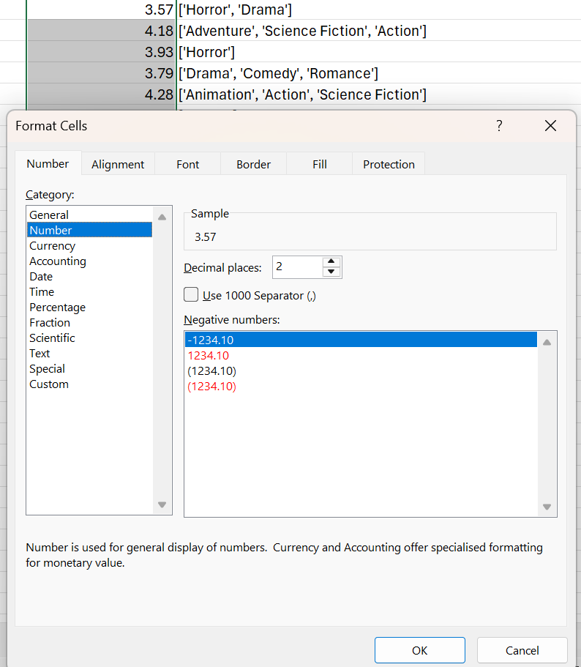
Figure 1: Average_rating column
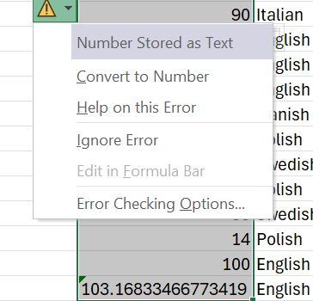
Figure 2: Text format in the dataset

Figure 3: Numerical format in the dataset

The first step in the cleaning procedure was to employ the Sort and Filter option to find the inconsistencies in every column. With the rapid separation of inconsistent records by providing a drop-down list, this method facilitated effective evaluation.
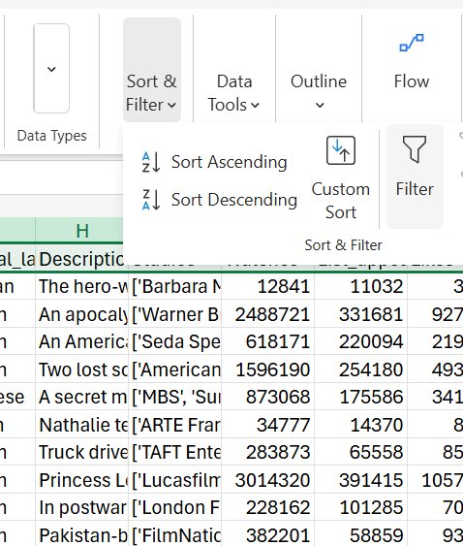
Figure 4: Sort and Filter
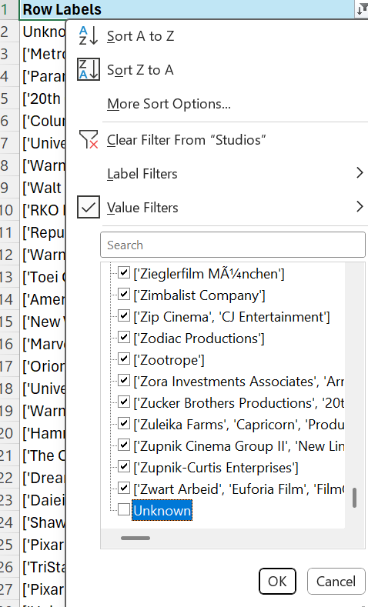
Figure 5: Rapid Identification of Inconsistencies
To maintain the data integrity, rows with Unknown names were deemed unusable and removed. The sorting technique allowed the verification of completeness for numerical fields with sporadic missing values, ensuring that no gaps were avoided. The WAR gene sub-sheet was created by filtering Genres for entries containing War, yielding 361 films copied to a dedicated sheet (Figure 6). Description text mining was applied using formulas searching for key terms (Vietnam, WW2, WWII, Pearl Harbor, Dunkirk, Stalingrad, 1945, 1917, World War), identifying 253 films (Figure 7). This dual-method approach ensured comprehensive coverage while highlighting genre classification limitations.
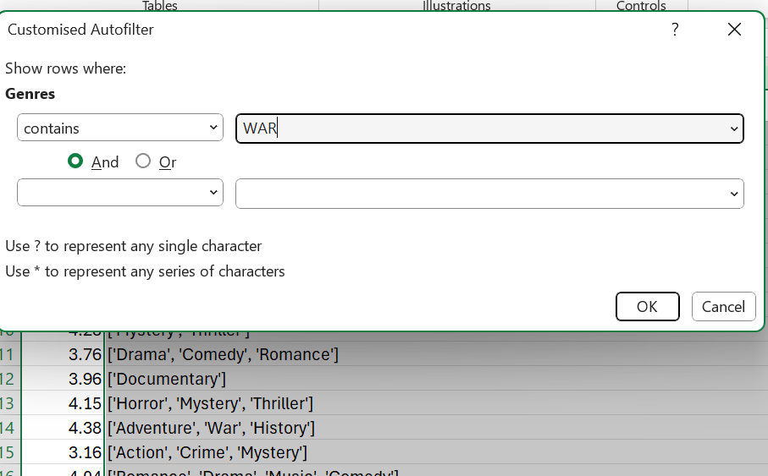
Figure 6: Creating sub-sheet

Figure 7: Text mining

Descriptive Statistics and Summary
The war genre subset of 361 films provides robust data for analysis. Key descriptive statistics were calculated for core variables measuring success and engagement.

Average Rating and Fans
 | Average Rating | Fans
Mean | 3.50 | 1213
Median | 3.45 | 21
Mode | 3.27 | 0
Standard Deviation | 0.46 | 5302
Range | 3.34 | 74000
Minimum | 1.29 | 0
Maximum | 4.63 | 74000
Count | 361 | 361
Table 1: Summarisation using descriptive statistics
The above table summarises the average rating, runtime, watches and fans for the 361 war genre films. The average of the average_rating is 3.50 with a standard deviation of 0.46, showing consistently high critical reception. The lowest rating is 1.29 (Foodfight! — clearly a misclassified animated film), and the highest is 4.63 (Come and See — Elem Klimov). Fans per movie average 1213, but the median is only 21 and the mode is 0 (79 films have zero fans). This shows the distribution is unbalanced — a few massive hits pull the average up, while the vast majority of war movies have almost no fan base at all. The standard deviation of fans is 5302 — very high, confirming the huge variation. War genre movies have decent average ratings (3.50) but very weak fan engagement — most war movies are forgotten (median only 21 fans).
Success is rare but massive when it happens (74,000 fans for Tarantino's one war movies).

Director analysis (2+ war films)
Director | Number of War Movies | War Movies Average of Average_rating | Average Fans/Movie
Stanley Kubrick | 5 | 4.24 | 7818
David Lean | 3 | 4.19 | 3830
Abel Gance | 2 | 4.14 | 267
Sidney Lumet | 2 | 4.14 | 167
Sergey Bondarchuk | 3 | 4.08 | 114

Table 2: Top war directors by average of average rating (2+ films or more)
Directors making only one war film but with massive existing fan bases achieved dramatically higher fans per film (Quentin Tarantino 74,000, Francis Ford Coppola 35,000 from 1 film), Chart 1.
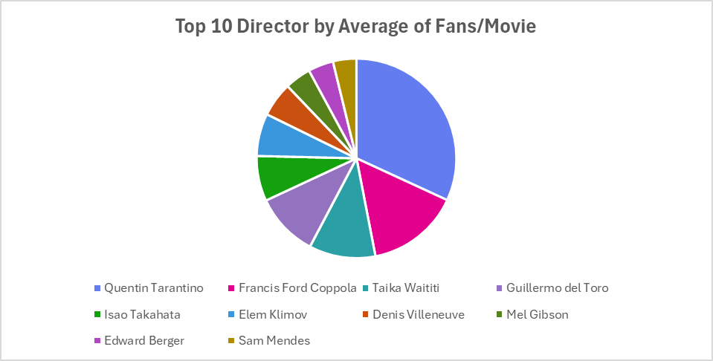
Chart 1.
Table 5: Vehicle Type Distribution

Trend Analysis and Visualisation

Delivery Duration over time
Pivot table analysis revealed distinct patterns in war film success. Directors with multiple war films show remarkable consistency — Stanley Kubrick maintains 4.24 average across 5 films. However, directors making their first war film generate exceptional fan engagement (Quentin Tarantino 74,000 fans from one film), indicating pre-existing audience loyalty transfers powerfully to the genre. The strongest trend is the "One-Shot War Director" effect: famous directors making their first war film generate 5-10 times more fans per film than multi-war specialists, (Chart 2)
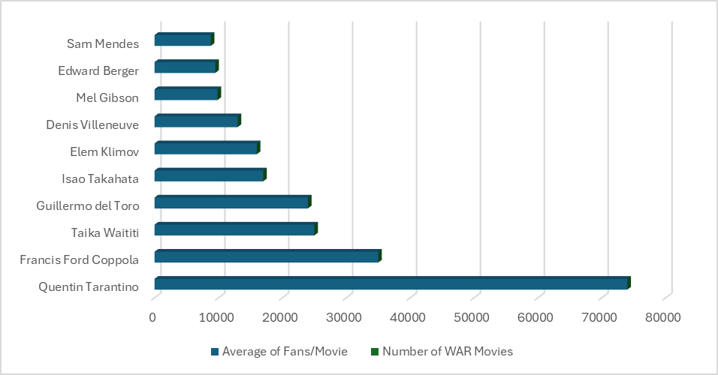
Chart 2: Average Fans per Movie
The chart shows directors with 1 war film achieve dramatically higher fan engagement than those with multiple films, confirming the One-Shot War Director effect.
Directors in overall top 20 fans who made war movie saw their WAR genre movies receive significantly more fans than genre average, confirming pre-existing director fan base as key success driver.

Statistical Analysis using SPSS

Correlation analysis tested relationships between key variables in war subset
Pearson correlations:
Average_rating and Fans: r = 0.341, p < .001
Average_rating and Runtime: r = 0.203, p < .001
Fans and Runtime: r = 0.150, p = .004

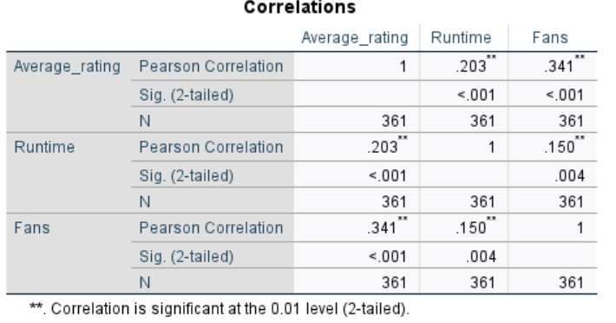
Figure 8.
#The moderate positive correlation between Average_rating and Fans (r = 0.341) confirms audience passion drives critical success. Runtime shows weaker but significant correlation with rating (r = 0.203), validating longer films better received.

Insights and Recommendations

Key Insights and Findings
- War films achieve moderate average ratings (3.50) with high variation in fan engagement — most have almost no fans (median 21, mode 0), while a few achieve massive cults.
- Most significant discovery is One-Shot War Director effect: directors making first war film generate exceptional fan engagement due to pre-existing loyalty.
- Specialised studios achieve highest ratings, major studios more films. Fan engagement strongest predictor of success (r = 0.341
- For producers:
- Hire directors with massive existing fan bases who have never made war movie
- Accept longer runtimes for critical acclaim
- Consider specialised studios for quality, major studios for volume
Discovery that directors with large overal#l top fan bases achieve superior war movie results provides key insight: war movie success lies in bringing existing audience.

Limitations of the study
While this study provides valuable insights, it is important to acknowledge its limitations. The dataset is likely biased toward English-language and Western-centric narratives, potentially overlooking significant works from other regions like Eastern Europe or Asia. The sole reliance on Letterboxd data means the findings represent a specific, perhaps more cine-literate, demographic and may not generalize to the entire movie-going public.

Future research would be greatly enhanced by incorporating additional data streams. Including box office figures and production budgets would allow for a Return on Investment (ROI) analysis, differentiating between critical darlings and commercial successes. Integrating data from platforms like IMDb or Rotten Tomatoes would provide a broader perspective on audience scores. Furthermore, a more sophisticated, multi-variable regression analysis could model the combined influence of director, runtime, studio, and sub-theme on a film's success, moving beyond pairwise correlations to a more holistic predictive model. Finally, a longitudinal study tracking how ratings and fan counts for war films change over decades could provide fascinating insights into shifting cultural perceptions and the establishment of classic status.

Reference
AOLCC. (2023). How to Make a Graph in Excel | AOLCC. [online] Academy of Learning. Available at: https://www.academyoflearning.com/blog/how-to-make-a-graph-in-excel-a-beginners-guide/ [Accessed 13 Aug. 2025].
Isaszegi, S. (2025) Data Sheet - C2 - Letterbox Movie Classification Dataset. [Accessed: 20 November 2025].
Olszak, C. (2020) Business Intelligence and Big Data: Drivers of Organizational Success. Boca
Rivery (2025) Big data statistics: How much data is there in the world?. Available at: https://rivery.io/blog/big-data-statistics-how-much-data-is-there-in-the-world/ (Accessed: 09 October 2025).

‌

‌

‌

‌

‌

‌

‌

‌

‌

