Student Name: Ffion Lavington
Student Number: 2204160
Programme of Study: BA Graphic Design
Chosen Three Words: Semiotics, Subscription, Design Evolution
Word Count: 2496
Lecturer: Donna Williams

The three words that I will cover throughout this essay regarding a book covers design are semiotics, subscription and design evolution. I’ve decided to choose the topic of book cover design, as I have always been an avid reader from a young age which turned into me starting to buy special editions of book series that I love. I also buy books when the cover art and additional design qualities are really nice and greatly designed. I will be covering the work of graphic designer and illustrator Micaela Alcaino who designs book covers, the book subscription special edition book box companies Fairyloot and Illumicrate and finally I will be discussing Penguin Books and how their designs have evolved over the years. This artist and these companies will help me further my opinion on the importance of an appealing book cover. An intriguing book cover design is important as “the cover is often a potential reader’s first point of contract with a book and can ultimately make or break a book’s success in the highly competitive publishing industry”, said Bickerton (2023).

The definition of the word semiotics is “the study of signs and symbols, what they mean, and how they are used”. Micaela Alcaino is a graphic designer and illustrator who specialises in making regular print and special editions of a best-selling series. As someone who collects special editions of my favourite books, I wanted to look into the designer who made the special editions of Jennifer L. Armentrout’s Blood and Ash book series.
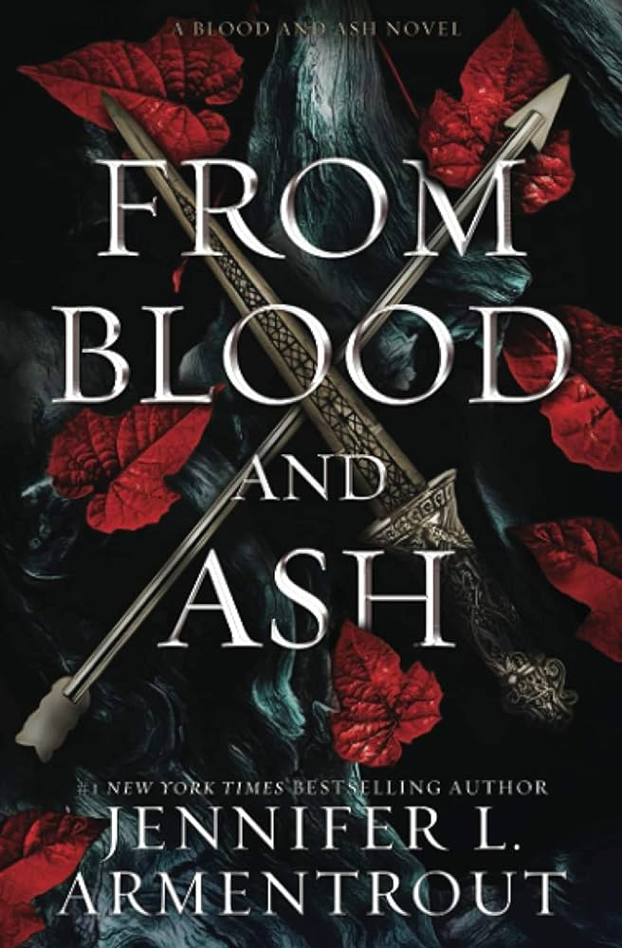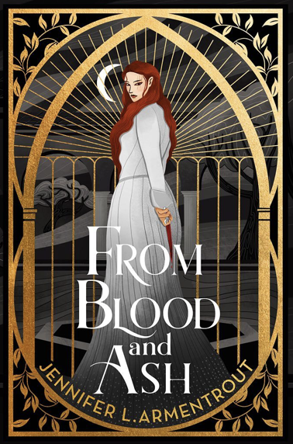
(Fig 1: Hang Le, From Blood and Ash Cover, 2020) (Fig 2: Micaela Alcaino, From Blood and Ash Cover, 2022)

The Blood and Ash series is a fantasy and romance series which went viral on the social media TikTok in early 2022 under the new hashtag BookTok and quickly became a bestseller. The original cover was created by designer Hang Le and she has continued to create the covers for the rest of the series and the prequels. The original cover depicts two different weapons, a dagger and an arrow. The dagger links to the main female character Poppy and the arrow represents that this is the only weapon that can be used to kill the dark creatures in the storyline. The original cover also depicts foliage, specifically red leaves. The red leaves represent the forest which surround the location in which the main female character lives and is known as the Blood Forrest. The original cover design successfully uses semiotics through imagery and colour to convey aspects of the storyline to a viewer and potential buyer. The dark colour scheme of the book cover also represents the dark themes throughout the book.

The special edition version of From Blood and Ash designed by graphic designer Micaela Alcaino is designed completely different to the standard publication. What makes Alcaino’s work different to Le’s is that it has character art on the front cover on the dust jacket as well as there being a foil embossed character design on the naked cover, this makes the book more visual appealing to the audience and too people who collect special editions. In personal correspondence with the Alcaino I asked what her opinion is on book cover design and its visual importance, she replied with “a great cover can harmoniously pair imagery and title, giving a sense of the essence of the book’s story as well as its genre. This not only includes a great cover design but also understanding the importance of spine design because nine out of ten times, a book will be displayed spine out in a bookstore. So, a good design should always extend to a well-designed spine”. The spine of the book has visuals of a sword and of royal style framing on the sides of the sword and at the top and bottom of the spine, these represent the medieval and royal themes shown throughout the book. This edition also stands out with its stencil sprayed edges of a sword on each of the books released. This book series is not light hearted in the storyline but quite dark with themes of loss and violence throughout with touches of romance, this is shown with the cover art being comprised of dark colours contrasting with the gold framing of the main female character and her distinctive red hair. The main character is also holding a dagger, which is known throughout the book as Poppy’s weapon of choice and the dagger is also worn by her throughout the book series. The colour of the clothing that the character represents Poppy being referred to as ‘The Maiden’ throughout the first act of the book as the colour white represents something pure. That then contrasts with the second books special edition where Poppy is then wearing a red dress. The font is also kept the same throughout the designs and the balance of imagery is kept the same as “it’s more important for a designer to know how to harmoniously pair typography and imagery well, as a good book cover knows how to tie both entities together effectively”, Alcaino (2023).

With the increase in popularity of the collection of special edition books, companies have been created where a reader can subscribe to a monthly book box. One of these companies is Fairyloot. The creator of fairyloot explains that “the goal has always been to share their love for fantasy with book lovers around the world and foster a passionate community of like-minded reader, which we hope you will be a part of too”. The definition of a subscription box is “a subscription box is a collection of niche and often customized items that are shipped regularly (usually once a month) to customers on a subscription payment model, in which customers subscribe and pay a certain period; month by month, 3-months, 6-months, and annual subscriptions are all common with subscription boxes” (Lehmann, 2020, p.368).
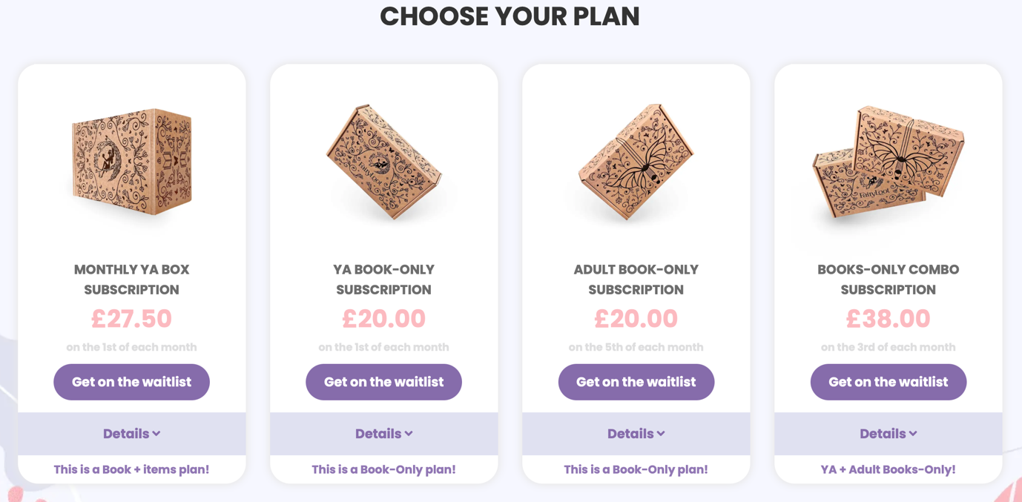
(Fig 3: Fairyloot Subscription Options, 2024)

Fairyloot started their business with there only being one option for people to choose, that one being the monthly YA book and goodies selection. However, with the company gaining more and more popularity that’s to the social media platform TikTok Fairyloot started offering multiple different options for their subscriptions, with them being YA book only, adult book only and the option of have both the YA and adult book without the extra book themed goodies. One of the additional incentives Fairyloot have given their subscribers is the chance to be able to get early accesses to special editions which are not included in the box, Fairyloot has also gained so much popularity in the last few years to the point that thy have had to make a waitlist for spots to open for their subscription plans. Additionally, in the email that artist Micaela Alcaino sent to me she specifies that “I constantly have people telling me that they buy my cover designs before they even know what the book is about. This trend is also reflected in the rise of the Special Editions and Book Boxes such as Fairyloot and Illumicrate”. The buyers of these subscription boxes only receive a box theme at the beginning of the month, to help give them an idea on what the box could include. So even when the buyer does not know what they are getting or how this cover is going to look like they still choose to continue with the payment knowing they are going to receive a beautifully designed book cover, as well as receive bookish themed accessories and goodies. As Micaela Alcaino said “in the last 10 years, we have seen technological advancements, such as the evolution from sprayed edges to digital edges, and the ability for printers to produce even more intricate foil designs. Special editions have become sought after “Limited Edition” collectibles for many book lovers”, the difference between a sprayed edge and a digital edge is that the sprayed commonly only consists of one or two colours sprayed on whereas the use of digitally designing the edge helps give the book an extra design aspect.
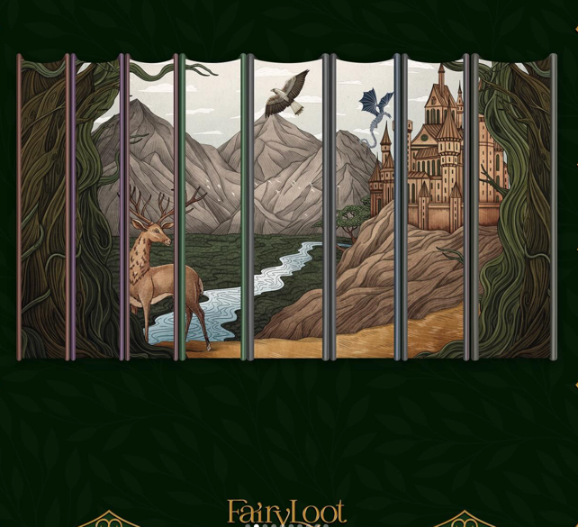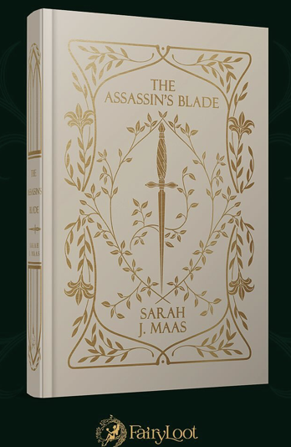
(Fig 4: Micaela Alcaino, Throne Of Glass Special Editions, 2024) (Fig 5: Micaela Alcaino, The Assassin’s Blade Special Edition, 2024)

In the images above you can see how recent technological advancements have led to books being more intricately designed. The edges of the book clearly paint the picture of a mountainous region with there being other elements that relate to the book series with them being the castle, the stag and the buzzard. The naked hardcover is also more detailed and more intricately designed which means it can also more accurately depict the themes of the story better, with the book name being The Assassin’s Blade and there being a short sword down the centre of the front cover with its.

As someone who has wanted to subscribe to one of these boxes and still being on the wait list, I started to look on the second hand and reselling app Vinted. When on the app I noticed how people had ridiculously increased the price of certain things. For example, the Twisted series by author Ana Huang originally retailed for £96 for all four books, however people bought this series with the purpose of reselling the series for a severely increased price. For example, someone on vinted is selling the series for £400 making it £100 per book. In the Fairyloot boxes, the one with the book and the goodies, the book retails as £22 and the extra goodies retail as £5.50. but on vinted, people are reselling mugs, bookmarks, decorations for double or triple the retail price for all five goodies included in the box.

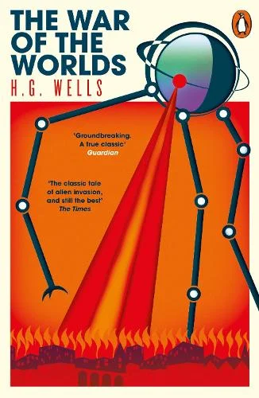

(Fig 6: Penguin Books, The War of The Worlds, 1898) (Fig 7: Penguin Books, The War of The Worlds, 2018)

The original print design for the original Penguin books were colour coordinated, with stripes on the sides of the cover framing it. These colours and their representations were “orange for general fiction, green for crime fiction, pink for travel and adventure, red for drama, blue for biographies, purple for essays, grey with elegant font for world affairs and yellow for everything else”, Kohlstedt (2019). When The War of The Worlds was originally printed Kohlstedt further discusses that “Penguin was able to fund new art in part because the Classics series featured many royalty-free works” said Kohlstedt (2019), the original cover art is clearly hand drawn which is common for the time period of when it was first printed. Penguin saw its first major design change in the early 1960s with it experimenting and adapting its unique cover designs to help compete with other publishing houses but because of them trying to keep up with consistency of trying to adapt their design style that they lost their unique brand identity, which affected their sales with their books not standing out against others on the bookshelves.

The new reprints and newly redesigned covers of The War of The Wolds were digitally mass printed compared to when they were printed using linotypes and monotype in the 1950s. the cover majorly visually differentiates against the original printed cover, with the never cover having a clear digitally created piece of artwork created by a graphic designer and illustrator. The cover also showcases a digitally evolved version of the Penguin logo, making the animal more pronounce and more easily recognisable. It is important to adapt a book cover the visual needs of the consumer as “a well-designed book cover serves as the visual representation of the content within. It is a powerful tool that captures the essence of the story, evokes emotions, and entices potential readers to explore what lies between the pages. The importance of a good book cover design cannot be overstated, as it has a profound impact on the success of a book”, Hampton (2023).


(Fig 8: Penguin Books, The War of The Worlds, 2018) (Fig 9: Penguin Books, The War of The Worlds, 2012)

An additional cover creation of The War of the Worlds is the clothbound versions which Penguin offer of their classic book selection. As Micaela Alcaino in email correspondence said, “more people are seeing beautiful cover designs as collectables for their bookshelves, especially in the BookTok and Bookstagram landscape”. Penguin also have an addition option for covers of their classics called “The Penguin English Library Edition” this is a good marketing strategy as “eye-catching book covers have the potential to go viral, generating buzz and attracting a large audience” Bickerton (2023). With the rising amounts of people and readers collecting books for their visual appearance, people are most likely wanting to buy one book of each style to complete their ‘collection’ increasing their sales, therefor increasing their popularity. With the additional options of have ‘pretty’ covers increase the possibility of the covers going ‘viral’ with the cover being one of the “key assets in an author’s marketing arsenal” said Bickerton (2019), but in Penguin’s case the cover being the key asset in the company’s unique branding. With the “rise of social media and visual culture is one of the key drivers behind the stronger emphasis on cover design, with platforms like Instagram, TikTok and Pinterest becoming influential channels for book promotion and discovery” Bickerton (2019) went on to further explain the importance of there being flexible covers for different platforms. With the rise of social media companies like Penguin have had to evolve their designs to fit in with more modern design standards and the evolution of technology to add additional design elements to their work. Even with Penguin adapting their designs they still make sure to use “unique elements to make the book stand out” and stick to “genre-specific design trends”, write Bickerton (2019) in the article “Why judging a book by its cover matters: the importance of professional book cover design for independent authors” which was published on the Whitefox website in 2019.

The first word looks how design elements link to people’s opinions and how imagery, colour and fonts can be used to get a message across to a potential buyer and to someone who is part of the reading community. The second word focusses on the behaviour of people and why they will be drawn to subscribing to these book boxes. The final word looks specifically at Penguin Books and how they have adapted their design to the newer age and to a newer audience as well as they still keep parts of their unique style to the covers. Each chosen word differentiates from each other but still are all linked to the design process of a book cover or are linked to books in some sort of way. At the end of the essay and through my writing you will be able to see how the three words link together in design theory. For possible study next year. One of my main ideas is to take one of my favourite books or book series and redesign the covers. Specifically, I will want to possibly redesign the naked cover, a dust jacket and to possibly design a sprayed edge for the book as well. This topic of potential study links to what I want to do as a career when I graduate university. A possible question for my third-year project could be ‘how does a book cover design influence a potential buyer?, ‘how important is it to have a visually appealing book cover?’ and ‘do we really judge a book by its cover?’.

Bibliography

Alcaino, M. (2024) Email to Ffion Lavington, 19th April.

Bickerton, H. (2023) Why judging a book by its cover matters: the importance of professional book cover design for independent authors. Available at: https://wearewhitefox.com/why-judging-a-book-by-its-cover-matters/#:~:text=The%20cover%20is%20often%20a,%2C%20tone%2C%20storyline%20and%20content (Accessed: 24 April 2024).

Book Collecting Haven (2015) Penguin Books in the Beginning. Available at: https://bookcollectingheaven.com/penguins-books-in-the-beginning/ (Accessed: 24 April 2024)

Fairyloot (2016) Our Story. Available at: https://fairyloot.com/our-story/ (Accessed: 24 April 2024)

Hampton, S. (2023) importance of a Good Book Cover Design: Grabbing Attention and Enhancing Sales. Available at: https://www.linkedin.com/pulse/importance-good-book-cover-design-grabbing-attention-sales-hampton/ (Accessed: 24 April 2024)

Illumicrate (2015) Our Story. Available at: https://www.illumicrate.com/our-story (Accessed: 24 April 2024)
King, A. (2013) History of the Book in the Twentieth Century Post 2: Technology, Ownership, Regulation, Distribution. Available at: https://blogs.gre.ac.uk/andrewking/2013/01/30/history-of-the-book-in-the-twentieth-century-post-2-technology-ownership-regulation/#:~:text=The%20two%20great%20revolutions%20in,only%20commercially%20established%20in%201897 (Accessed: 24 April, 2024)

Lehmann, M. (2020) A Box for ‘Bad Readers’? Bookish Gifts in Subscription Book Boxes. New York: Publishing Research Quarterly.

Kohlstedt, K. (2019) Classic Penguins: How Minimalist Book Covers Sold the Masses on Paperbacks. Available at: https://99percentinvisible.org/article/classic-penguins-how-minimalist-book-covers-sold-paperbacks-to-the-masses/ (Accessed: 24 April 2024)

List of Figure:

Figure 1: From Blood and Ash Cover, 2020. Available at: https://www.amazon.co.uk/Blood-Ash-Jennifer-L-Armentrout/dp/1952457009 (Accessed: 24 April 2024)

Figure 2: From Blood and Ash Special Edition Cover, 2022. Available at: https://www.instagram.com/micaelaalcainodesign/ (Accessed: 24 April 2024)

Figure 3: Fairyloot Website, 2024. Available at: https://fairyloot.com/subscription/#1667314971710-bdba08e6-a322 (Accessed: 24 April 2024)

Figure 4: Throne of Glass Special Editions, 2024. Available at: https://www.instagram.com/p/C4vRcUlNT5O/?img_index=2 (Accessed: 24 April 2024)

Figure 5: Throne of Glass Cover Art, 2024. Available at: https://www.instagram.com/p/C4vRcUlNT5O/?img_index=2 (Accessed: 24 April 2024)

Figure 6: The War of The Worlds, 1898. Available at: https://99percentinvisible.org/article/classic-penguins-how-minimalist-book-covers-sold-paperbacks-to-the-masses/ (Accessed: 24 April 2024)

Figure 7: The War of The Worlds, 2018. Available at: https://www.waterstones.com/book/the-war-of-the-worlds/h-g-wells/9780241387160 (Accessed: 24 April 2024)

Figure 8: The War of The Worlds, 2018. Available at: https://www.waterstones.com/book/the-war-of-the-worlds/h-g-wells/brian-aldiss/9780241382707 (Accessed: 24 April 2024)

Figure 9: The War of The Worlds,2012. Available at: https://www.waterstones.com/book/the-war-of-the-worlds/h-g-wells/9780141199047 (Accessed: 24 April 2024)

