

Student name: Nyarai O Kanderera
Student ID: 2243459

Module name: Independent Project.
Module code: BMHP6020
Supervisor’s name: Jolly Nwankwo

Acknowledgement: I confirm that I have not used any AI Tools in the research and creation of this assignment

I confirm that I have not presented any AI-generated Materials as my own.

I confirm I have copies of my draft notes and other resources that I used, which I may be asked to provide as evidence.

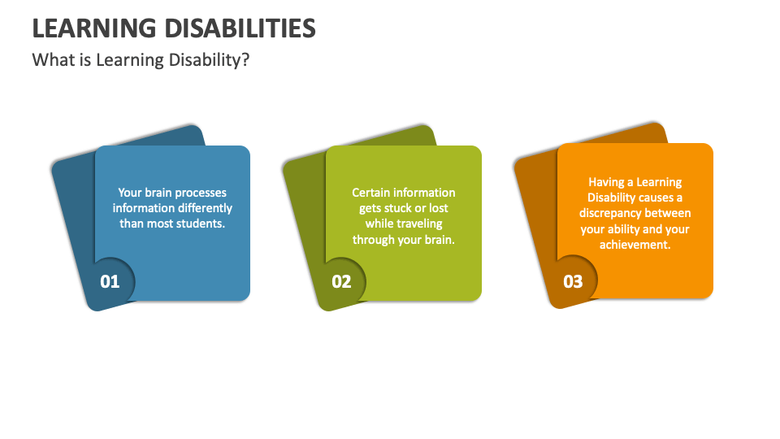  Collidu.com (2022) |  | Title: Exploring the impacts of adults living with learning disabilities and the challenges of accessing mental health services in the UK  Aim of the study: To explore the impacts experienced by Adults Living with Learning Disabilities (ALLD) and examine the challenges they face in accessing Mental Health Services (MHS) in the UK.  Objectives of the study  - To explore the lived experiences of adults with learning disabilities concerning their mental health needs.  - To identify major barriers that prevent equitable access to Mental Health Services for adults with learning disabilities in the UK.  - To analyse the roles of healthcare professionals, carers, and support networks in either facilitating or hindering access to MHS.  - To provide recommendations for enhancing access, service quality, and overall mental health outcomes for this group. |  | Poldma, T. et al (2014)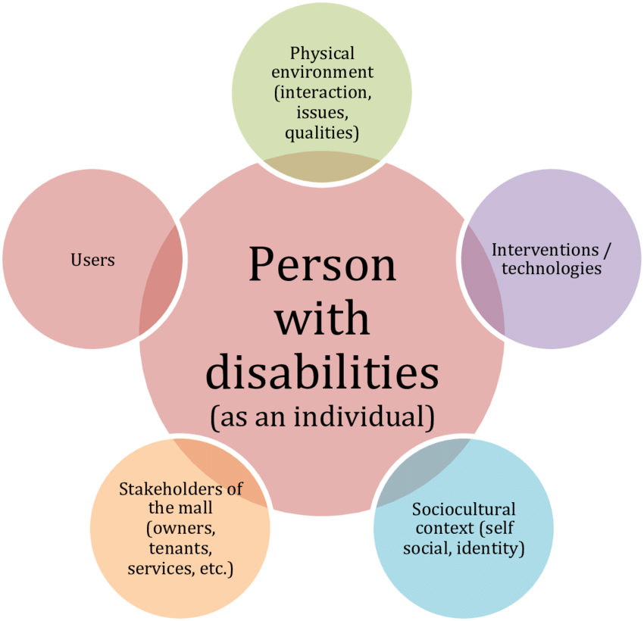
Methodology  This study will focus on secondary data sources that were utilised due to the ethical complexities associated with collecting primary data from individuals with learning disabilities, Goldsmith, L et al. (2015).  The study also draws on a comprehensive range of ten existing peer-reviewed literature. |  |  |  | Data Analysis method.  - Familiarisation with the Data  - Generating initial codes  - Searching for themes  - Defining and naming themes  - Reviewing themes  - Producing the report  Braun, V. et al (2016)  Thematic analysis  Theme 1: Systemic Barriers to Access  Theme 2: Diagnostic Overshadowing and Misidentification  Theme 3: Communication and Professional Knowledge Gaps  Theme 4: Impact of Service Reductions and Crisis Context (COVID-19)  Theme 5: Intersectional and Sociocultural Barriers  Ethical Considerations  This study relies on secondary data and does not involve direct contact with participants; the ethical integrity of the research process was ensured throughout Bedenik, T.et al (2023). UWTSD approved it.

Data Collection method.
Keywords: Learning disability, intellectual disability, mental health services, access, barriers, United Kingdom, health inequalities, reasonable adjustments, and diagnostic overshadowing.
Boolean operators (AND, OR).
Inclusion criteria:
- Studies focusing on adults (18+) with learning disabilities
- UK-based research or comparative international studies
- Publication within the last 20 years
- Studies addressing mental health or service access
Exclusion criteria:
- studies focusing solely on children or adolescents
- publications unrelated to healthcare access
- opinion pieces without empirical or policy-based evidence

References 5
Bedenik, T., Cahir, C. and Bennett, K. (2023) “Building public trust and confidence in secondary use of health data for healthcare improvement and research: a qualitative study pre-protocol,” HRB open research, 6, p. 47. Available at: https://doi.org/10.12688/hrbopenres.13711.2.
Braun, V. and Clarke, V. (2016) “(Mis)conceptualising themes, thematic analysis, and other problems with Fugard and Potts’ (2015) sample-size tool for thematic analysis,” International Journal of Social Research Methodology, 19(6), pp. 739–743. Available at: https://doi.org/10.1080/13645579.2016.1195588.
Collidu. “Learning Disabilities.” Collidu.com, 13 June 2022, www.collidu.com/presentation-learning-disabilities. Accessed 16 Feb. 2026.
Goldsmith, L. and Skirton, H. (2015) “Research involving people with a learning disability – methodological challenges and ethical considerations,” Journal of research in nursing, 20(6), pp. 435–446. Available at: https://doi.org/10.1177/1744987115591867.
Poldma, Tiiu & Labbe, Delphine & Kehayia, Eva & Swaine, Bonnie & Le Dorze, Guylaine & Lefebvre, Hélène & Lamontagne, Anouk & Archambault, Philippe & Ahmed, Sara & Fung, Joyce. (2014). Stakeholders and researchers: Dilemmas of Research as Practice and the Role of Design Thinking in the Case Study of a Rehabilitation Living Lab.

