

BA(Hons) Business Management

Student Name:Corina Cosma
Student Number:2114145
Course Name: International Financial Management
Lecturer Name: Andry Rakotovololona
Session: Octomber 2023

LCBB6002
International Financial Management
Component 1
Strategies for Managing Foreign Exchange Risks in Multinational Corporations: A comprehensive Analysis

Table of Contents
Introduction 3
Understanding Foreign Exchange Risk 4
Multinational Corporations’ Strategies for Managing Foreign Exchange Risks 6
Critical Analysis of the Strategies 8
Empirical Evidence and Case Studies 10
Conclusion 11
References 12

Introduction
Multinational firms operating in a globalised world must first focus on the research and application of international financial management, or IFM. Businesses are more vulnerable to the unpredictable nature of foreign exchange risks as they grow internationally. Given the frequent fluctuations in foreign exchange rates, which can have a big influence on a company's cash flows, profitability, and financial stability, these risks can seem daunting. Thus, for international firms to succeed and remain viable, it is critical that they comprehend and handle foreign exchange risks. The purpose of this report is to explore the complex field of international financial management, with a particular emphasis on the methods used by multinational companies to reduce the risk of currency fluctuations.
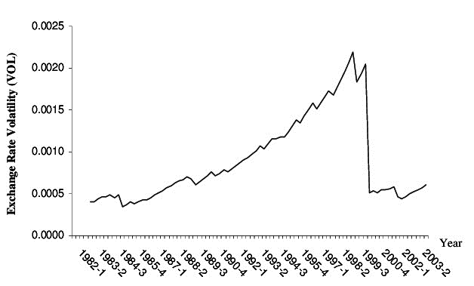
Figure 1: Chart showing global average Exchange Rate Volatility over the time (Ozturk, 2018)

Understanding Foreign Exchange Risk
For multinational firms involved in worldwide business and investment, currency risk, also known as foreign exchange risk, is a primary worry. It is the possible financial risk resulting from variations in the exchange rates of two different currencies. Developing successful risk management methods requires first having a thorough understanding of these hazards. Foreign exchange risk mostly comes in three forms:
Transaction Risk: The risk a business faces while doing financial transactions across borders is known as transaction risk. The exchange rate fluctuation prior to transaction settlement represents the risk. Transaction risk is basically caused by the lag between a transaction and its settlement. Options and forward contracts can be used to reduce transaction risk. For example, when a U.S.-based firm signs a contract to buy goods from a European supplier, the transaction risk becomes real if there is a change in the exchange rate between the USD and EUR between the times the contract is signed and when the payment is made. The cost of the goods in USD would go up if the USD strengthened compared to the EUR, but it would go down if the USD weakened (Hagelin and Pramborg, 2014).
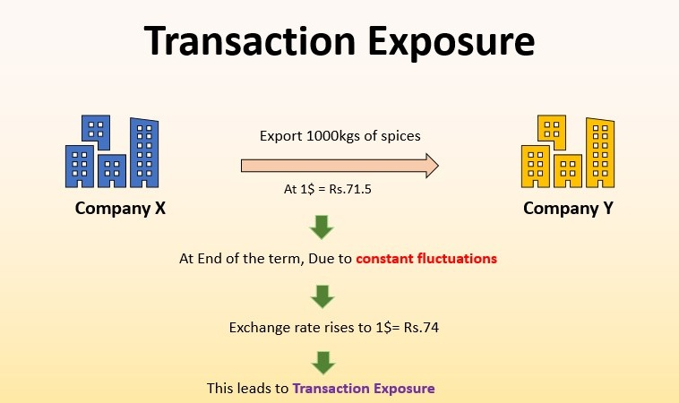
Figure 2: Visual representation of transaction risk (EDUCBA, 2020)
Economic Risk: Economic risk, which is also known as forecast risk, is the possibility that unavoidable exposure to exchange rate fluctuations will have an effect on the market value of a company. Typically, macroeconomic conditions, including political turmoil and government mandates, give rise to this category of risk. For instance, furniture importers will expose a domestically operating British furniture company to economic risk, particularly if the British pound unexpectedly strengthens (Hagelin and Pramborg, 2014).
Translation Risk: Multinational corporations that own or operate in foreign nations are impacted by this, which is sometimes referred to as accounting exposure. The books' translation from another currency into the native currency introduces a translation risk. The balance sheet may be significantly impacted by changes in the exchange rate between the currency in which a business reports and the currency in which its assets and liabilities are held. For example, when a company's Japanese subsidiary owns assets valued in Japanese yen (JPY), fluctuations in the JPY/USD exchange rate may have an impact on the parent company's overall financial standing upon consolidation of its financial statements (Hagelin and Pramborg, 2014).
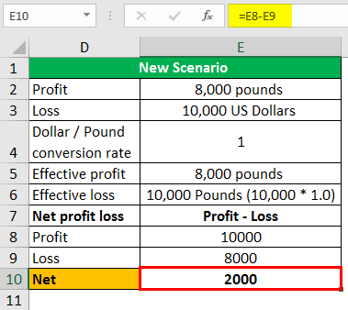 | 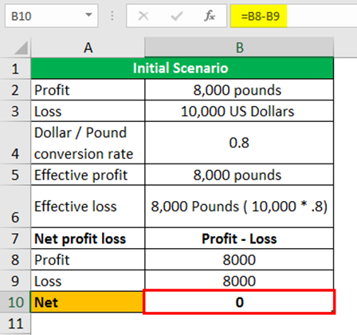

Figure 3: A side by side quantitative example of translation risk

Multinational Corporations’ Strategies for Managing Foreign Exchange Risks
To mitigate these risks and protect their bottom line, multinational corporations employ a range of strategies. These strategies can be broadly categorized into three main approaches:
Hedging Strategies:
- Forward Contracts: Forward contracts are a common tool used by multinational organisations as a transaction risk buffer. An agreement to exchange a certain amount of one currency for another at a predefined exchange rate at a later time is known as a forward contract. Because of the exchange rate certainty this offers, businesses are able to fix exchange rates for upcoming transactions (Branger and Mahayni, 2015).

Figure 4: Hedging and its related issues (Branger and Mahayni, 2015)
- Options: Options contracts give businesses the option, but not the duty, to swap money at a predetermined rate on or before a certain future date. This adaptability minimises possible losses while enabling businesses to profit from advantageous fluctuations in currency rates. (Ware and Winter, 2017)
- Currency Swaps: Principal and interest payments in one currency are swapped for equal amounts in another currency in a currency swap. These are employed to lower interest rate and transaction risk (Boenkost and Schmidt, 2016).

Operational Strategies:
- Diversification: As a natural hedge, diversifying a company's operations across several nations and currencies, can be beneficial. Exchange rate variations may not have as much of an overall influence when income and expenses are split across several currencies.
- Leading and Lagging Payments: Businesses can time their foreign currency payments and receipts strategically. One way to benefit from favourable exchange rate movements is to make leading payments, which involve making payments ahead of schedule, or trailing payments, which involve deferring payments.
Economic Strategies:
- Natural Hedging: Businesses can establish a natural hedge by aligning their revenue and expenses across different currencies. For example, exchange rate variations may have no impact on profitability if a business has expenses in the same currency and generates revenues in a foreign currency.
- Inflation Indexing: One smart approach to control economic risk is to modify contracts or prices in response to variations in inflation. One way to prevent the loss of actual returns is to price contracts taking predicted inflation rates into account. (Mercurio, 2015)
These tactics aren't without drawbacks. Not all solutions protect against foreign exchange risks, and they may cost. These strategies' efficacy depends on the economy, market, and company's operations. Thus, developing and implementing these techniques requires considerable analysis and continual evaluation.

Critical Analysis of the Strategies
Each strategy multinational firms use to control foreign exchange risks must be critically evaluated for pros, cons, and complications. Critical analysis lets the organisations evaluate these techniques in diverse contexts and market conditions.
Hedging Strategies:
Hedging tactics protect against foreign exchange market volatility. Through forward contracts and options, they reduce transaction risk and provide stability. These instruments stabilise profit margins by locking in currency rates. These solutions give security, but at a cost. Derivative contract fees can be costly, especially for smaller enterprises. While hedging techniques safeguard against bad exchange rate changes, they may hinder a company's capacity to capitalise on favourable currency variations. Balance between protection and profit maximisation is crucial (van Mieghem, 2021).
Operational Strategies:
Many organisations prefer operational strategies for managing foreign exchange risk because they are cost-effective. By distributing revenue and expenses across currencies, diversification reduces transaction risk. However, leading and extending payments optimise cash flows by timing transactions to take advantage of currency rates. However, larger multinational firms with many operations in many countries may find these tactics difficult to implement. Though operational solutions decrease transaction risk, they may not guard against excessive exchange rate volatility. Companies that rely entirely on operational strategy risk significant financial loss. (Allayannis, Ihrig and Weston, 2021)
Economic Strategies:
Economic solutions like natural hedging and inflation indexing manage foreign exchange risk more customised and long-term. They offer unique flexibility and customisation because they may be customised to an organization's needs. However, economic measures do not immediately defend against short-term exchange rate swings. Transaction risk may affect a company's short-term financial performance. Companies struggle to maintain a steady economic hedging due to market phenomena including inflation differentials, which can affect economic strategy effectiveness. Thus, while economic methods provide benefits, they should be part of a risk management strategy that balances short- and long-term goals. (Allayannis, Ihrig and Weston, 2021)

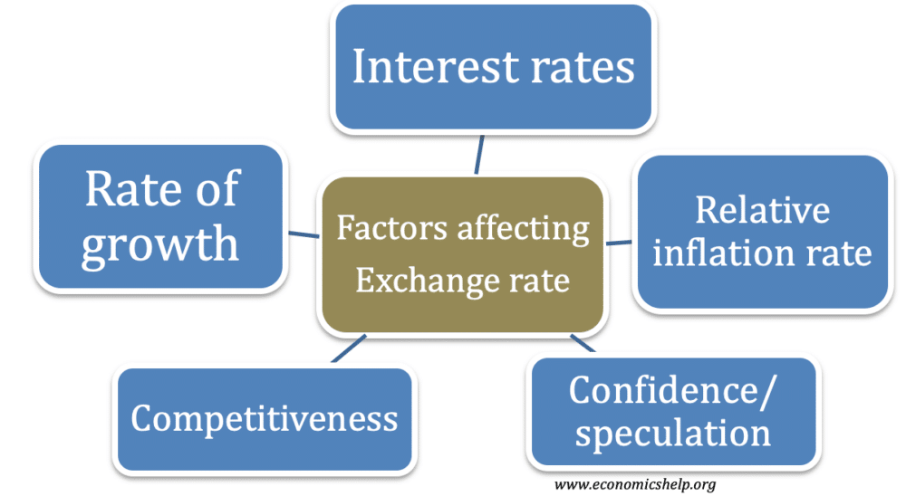
Figure 5: Ways of taking economic strategies (Allayannis, Ihrig and Weston, 2021)

Empirical Evidence and Case Studies
To gain a deeper understanding of how multinational corporations implement strategies for managing foreign exchange risks, some prominent empirical evidence and real-world case studies can be presented to better understand the scenario. These practical examples provide insights into the challenges and successes of different strategies.
Nike, Inc. - Hedging Strategy Success: Global sportswear giant Nike is renowned for its calculated approach to managing exchange risk. It uses a range of hedging techniques to reduce transaction risk. Nike once hedged its exposure to the Japanese yen via future contracts. By securing advantageous currency rates, the business was able to mitigate the effects of the yen's rise and preserve its profit margins (Marques, 2022).
Volkswagen AG - Translation Risk Mitigation: Volkswagen, a German carmaker with a significant global footprint, uses efficient techniques to control translation risk. Volkswagen uses financial instruments to lessen the effect of currency movements on its consolidated financial statements in a setting where exchange rates are subject to fluctuations. For stakeholders and investors, this method offers stability and transparency in financial reporting (Kalvet and Lember, 2020).
Porsche SE - Diversification and Operational Strategy:
German carmaker Porsche SE serves as an example of the advantages of diversification as an operating strategy. Porsche lessens its susceptibility to specific currency swings by maintaining a globally diverse manufacturing and sales network. This diversification can stabilise financial performance and distribute the risks related to fluctuations in exchange rates.

Conclusion
To sum up, this research provided a thorough analysis of the methods multinational companies use to control foreign exchange risks in the context of international financial management. The analysis of these tactics—which include operational, economic, and hedging approaches—has shown a complex environment with clear benefits and drawbacks. Global marketplaces are dynamic, necessitating a flexible and adaptive strategy that takes both short- and long-term goals into account. It is evident that the best approach to manage foreign exchange risks is frequently a combination of these tactics that are carefully adapted to the particular needs of a business. Adopting a complete risk management approach can equip multinational firms with enhanced competitiveness, financial stability protection, and success in the dynamic world of international commerce. This paper is an invaluable resource for making well-informed decisions in the intricate area of global financial management.

References
Allayannis, G., Ihrig, J. and Weston, J.P. (2021). Exchange-Rate Hedging: Financial versus Operational Strategies. American Economic Review, 91(2), pp.391–395. doi:https://doi.org/10.1257/aer.91.2.391.
Boenkost, W. and Schmidt, W.M. (2016). Cross Currency Swap Valuation. SSRN Electronic Journal. doi:https://doi.org/10.2139/ssrn.1375540.
Branger, N. and Mahayni, A.B. (2015). Tractable Hedging: An Implementation of Robust Hedging Strategies. SSRN Electronic Journal. doi:https://doi.org/10.2139/ssrn.493323.
Hagelin, N. and Pramborg, B. (2014). Hedging Foreign Exchange Exposure: Risk Reduction from Transaction and Translation Hedging. Journal of International Financial Management and Accounting, 15(1), pp.1–20. doi:https://doi.org/10.1111/j.1467-646x.2004.00099.x.
Kalvet, T. and Lember, V. (2020). Risk management in public procurement for innovation: the case of Nordic–Baltic Sea cities. Innovation: The European Journal of Social Science Research, 23(3), pp.241–262. doi:https://doi.org/10.1080/13511610.2011.553509.
Marques, N.M.R. (2022). Equity research - Nike, inc. run.unl.pt. [online] Available at: https://run.unl.pt/handle/10362/138955.
Mercurio , F. (2015). Pricing inflation-indexed derivatives. Quantitative Finance, 5(3), pp.289–302. doi:https://doi.org/10.1080/14697680500148851.
Ozturk, I. (2018). Exchange Rate Volatility and Trade: A Literature Survey. [online] papers.ssrn.com. Available at: https://papers.ssrn.com/sol3/papers.cfm?abstract_id=1127299 [Accessed 10 Dec. 2020].
van Mieghem, J.A. (2021). Risk Management and Operational Hedging: An Overview. The Handbook of Integrated Risk Management in Global Supply Chains, pp.13–49. doi:https://doi.org/10.1002/9781118115800.ch2.
Ware, R. and Winter, R. (2017). Forward markets, currency options and the hedging of foreign exchange risk. Journal of International Economics, 25(3-4), pp.291–302. doi:https://doi.org/10.1016/0022-1996(88)90056-6.

