Dolgarrog Dam Disaster Memorial
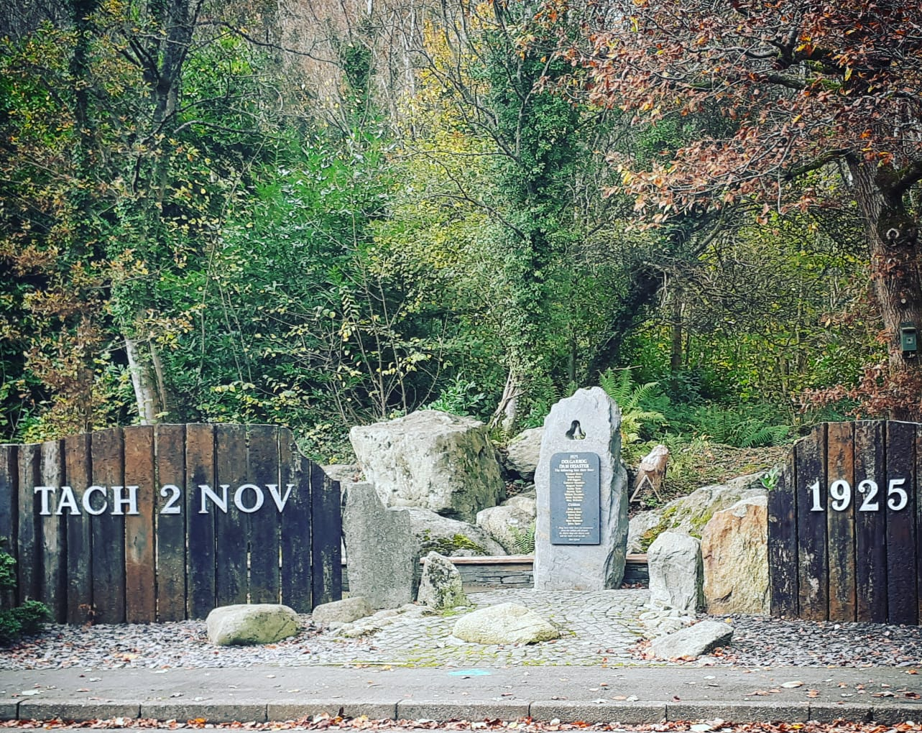

Fig. 1 Picture of memorial taken by Rebekah Carder 19/11/21

On 2 November 1925, Llyn Eigiau’s dam wall broke, spilling the gallons of water and debris into the lower Coedty dam, which subsequently also burst, creating a deluge racing into Conwy valley with enough force to hurl over many ice age boulders weighing hundreds of tons from their place and into the village of Dolgarrog below. No memorial was created at the time, but almost 80 years later, the local council decided to memorialise the event with a memorial walk, and in 2017, after receiving £10,000 from the Sharing Heritage Lottery Fund, they re-designed the entrance and consolidated the footpaths, as well as adding new explanatory plaques. The various factors contributing to the construction and use of this memorial can help us understand how this disaster and the people involved are remembered.
The memorial is primarily an environmental one, though like The Martyrs’ Forest in Israel, manmade monuments, markers, and plaques have been added, in this case, perhaps more to promote a narrative, rather than express scale of loss. Incorporating natural elements and, indeed the landscape is a feature found at many monuments and memorials, often associated with horrific deaths such as at the cemeteries of those soldiers who fought in the Great War – for example Heldenhaine where trees are planted in the place of graves - used to “mask death and destruction, transfiguring the horrors”. The blending of educational signs and carefully laid-out paths, meandering up the hillside to a viewpoint, suggests that this memorial, rather than being only commemorative, or a focal point for grieving descendants, is supposed to promote meditation on the past, look to the future and evoke an emotional response which may motivate change or greater empathy. It also implies consolation and evolution of the event and the dead in memory parallel to the growth and maturing of the forest which now enfolds the memorial, once a barren boulder field; that the grief of loved ones will pass, but the memory will endure, as the landscape changes but remains an integral part of life.
Indeed, it needs to express this sense of ‘moving on’ as that is exactly what many of the survivors and their descendants have done, either to the next life or merely other parts of the country. Although the walk is undoubtedly used by locals, this usage doesn’t really explain the initial £60,000 invested, and the later tens of thousands donated between various organisations. However, Dolgarrog as a destination for tourists visiting Snowdonia, and more recently Surf Snowdonia may go some way to justifying the gentrification of the memorial shortly after the construction of the tourist attraction. Memorial and burial site-seeing is not new, and many are drawn by both morbid curiosity, and a sense of obligation to remember victims of disasters. Though the aesthetic of the memorial suggests light and life, it is technically speaking, a dark tourism attraction, because it commemorates death, though some would debate to what degree it is ‘dark’. Its appeal is also increased due to it’s ‘uniqueness’ as the site of the worst dam disaster in Welsh history; emphasising this by re-opening and re-designing the memorial would help draw tourists to Dolgarrog, and thus benefit locals perhaps more than if it the previously wooden and plastic plaques were left to moulder, and explains why it seems to be a disproportionately accentuated memorial, especially compared to its war counterpart.
One cannot speak of the dam disaster memorial without reference to the war memorial park built just over 100 meters away. Arguably, as the memorial walk encompasses the entire site of the old village, and the Porth Lwyd Hotel was one of the only buildings to survive, the monuments overlap; the Royal Legion took over the building in 1927, and subsequently built said war memorial.
These two memorials share more than proximity they appear to be almost comically competing for the spotlight; both were re-designed by the same artist, Giovanni Jacovelli, within three years of each other, they are both blended environmental monuments and, unusually, all the victims of the disaster are named on the main memorial stone, in similar fashion to the soldiers who died, whereas many disaster memorials do not name all the victims. Perhaps this is not so unusual considering the death toll between both World Wars on the memorial, 23, is remarkably similar to the number lost in one night due to the disaster, 16.
The choice of what should be inscribed on the main stone at the entrance of the dam disaster memorial walk led to some contention when it was first unveiled. Under the names is a quote by singer Bob Dylan, “…Ring them bells from the sanctuaries ‘cross the valleys and streams for they’re deep and they’re wide and the world is on its side...”, a tribute to the story that the church bell rang out three times before the village was drowned. However, not everyone appreciated the homage, and felt that something in Welsh should’ve been featured instead, on hearing this Giovanni made a comment about the ‘Welsh language Taliban’ to which there was subsequent retaliation and a council meeting on how more Welsh could be included on the memorial. To date, there is no Welsh on the main stone, however, an abbreviation of Tachwedd is included on the wooden fronting, and Welsh translations of all the markers are found throughout the walk.
In examining the Dolgarrog dam disaster memorial, we can see reflected the trend in the past 30 year of increased memorialisation of events and people, and the conflict between what is most important to be remembered, as well as a reflection of the political and economic reasoning behind many memorials and monuments. We can also see an echo of local tensions priorities, communication or lack thereof, and bias through the issues arising from recent developments connected to this memorial; the memorial seems to have become more an attraction than a communal place of grieving.
Bibliography
Secondary Sources
Books
George Mosse, Fallen Soldiers, (Oxford: OUP, 1990)
Articles
Darko, Dimitrovski, Vladimir Senić, Dražen Marić, and Veljko Marinković, ‘Commemorative Events at Destination Memorials - a Dark (heritage) Tourism Context’, International Journal of Heritage Studies : IJHS, vol. 23.8 (2017), pp. 695–708
Piekarska, Maria, ‘“Instead of Tombstones - a Tree, a Garden, a Grove”: Early Israeli Forests as Environmental Memorials’, Colloquia Humanistica, vol. 9 (2020), pp. 101-115
Ulrike, Capdepon, Aline Sierp, and Jill Strauss, ‘Museums and Monuments: Memorials of Violent Pasts in Urban Spaces’, History and Memory, vol. 32.1 (2020), pp. 5–8
Online
https://www.theguardian.com/media/2020/nov/03/robert-fisk-obituary (Accessed 30/11/21)
https://www.bbc.co.uk/news/uk-wales-34652969 (Accessed 01/12/21)
https://historypoints.org/index.php?page=dolgarrog-dam-disaster-memorial (Accessed 01/12/21)
https://historypoints.org/index.php?page=dolgarrog-war-memorial (Accessed 01/12/21)
https://www.iwm.org.uk/memorials/item/memorial/6990 (Accessed 01/12/21)
https://www.warmemorialsonline.org.uk/memorial/178363 (Accessed 01/12/21)
https://dolgarrogcommunitycouncil.org/newsandevents.html (Accessed 01/12/21)
https://www.geograph.org.uk/photo/5611658 (Accessed 01/12/21)
https://www.atlasobscura.com/places/dolgarrog-dam-flood-disaster (Accessed 03/12/21)
https://www.google.com/maps/place/Dolgarrog,+Conwy+LL32+8AE/@53.1920278,-3.844498,267m/data=!3m1!1e3!4m5!3m4!1s0x48651a46949e99ef:0x4d597191d7058e9f!8m2!3d53.185394!4d-3.842482 (Accessed 04/12/21)
https://www.dailypost.co.uk/news/north-wales-news/welsh-language-taliban-slur-dam-13865016 (Accessed 04/12/21)
https://nation.cymru/news/welsh-language-taliban-comment-causes-outrage-following-memorial-unveiling/ (Accessed 04/12/21)

https://www.bbc.co.uk/news/uk-wales-34652969 (Accessed 01/12/21); https://www.geograph.org.uk/photo/5611658 (Accessed 01/12/21)
https://dolgarrogcommunitycouncil.org/newsandevents.html (Accessed 01/12/21)
Maria Piekarska, ‘“Instead of Tombstones - a Tree, a Garden, a Grove”: Early Israeli Forests as Environmental Memorials’, Colloquia Humanistica, vol. 9 (2020), pp. 105, 112
George Mosse, Fallen Soldiers, (Oxford: OUP, 1990), p. 112; Piekarska, ‘“Instead of Tombstones - a Tree, a Garden, a Grove”: Early Israeli Forests as Environmental Memorials’, p. 104
Piekarska, ‘“Instead of Tombstones - a Tree, a Garden, a Grove”: Early Israeli Forests as Environmental Memorials’, pp. 102-104; Dimitrovski Darko, Vladimir Senić, Dražen Marić, and Veljko Marinković, ‘Commemorative Events at Destination Memorials - a Dark (heritage) Tourism Context’, International Journal of Heritage Studies : IJHS, vol. 23.8 (2017), pp. 695–708
Piekarska, ‘“Instead of Tombstones - a Tree, a Garden, a Grove”: Early Israeli Forests as Environmental Memorials’, pp. 102-103
https://www.bbc.co.uk/news/uk-wales-34652969 (Accessed 01/12/21)
https://dolgarrogcommunitycouncil.org/newsandevents.html (Accessed 01/12/21)
Ibid.
Darko, Senić, Marić, and Marinković, ‘Commemorative Events at Destination Memorials - a Dark (heritage) Tourism Context’, p. 695–708
Ibid.
https://www.atlasobscura.com/places/dolgarrog-dam-flood-disaster (Accessed 03/12/21)
https://www.google.com/maps/place/Dolgarrog,+Conwy+LL32+8AE/@53.1920278,-3.844498,267m/data=!3m1!1e3!4m5!3m4!1s0x48651a46949e99ef:0x4d597191d7058e9f!8m2!3d53.185394!4d-3.842482 (Accessed 04/12/210)
https://historypoints.org/index.php?page=dolgarrog-dam-disaster-memorial (Accessed 01/12/21); https://historypoints.org/index.php?page=dolgarrog-war-memorial (Accessed 01/12/21); https://www.iwm.org.uk/memorials/item/memorial/6990 (Accessed 01/12/21)
See fig. 1 ; https://www.iwm.org.uk/memorials/item/memorial/6990 (Accessed 01/12/21) ; https://historypoints.org/index.php?page=dolgarrog-war-memorial (Accessed 01/12/21)
Ibid.
https://www.dailypost.co.uk/news/north-wales-news/welsh-language-taliban-slur-dam-13865016 (Accessed 04/12/21); https://nation.cymru/news/welsh-language-taliban-comment-causes-outrage-following-memorial-unveiling/ (Accessed 04/12/21)
See fig. 1; https://www.bbc.co.uk/news/uk-wales-34652969 (Accessed 01/12/21)
https://www.dailypost.co.uk/news/north-wales-news/welsh-language-taliban-slur-dam-13865016 (Accessed 04/12/21); https://nation.cymru/news/welsh-language-taliban-comment-causes-outrage-following-memorial-unveiling/ (Accessed 04/12/21)
See fig. 1
Capdepon, Ulrike, Aline Sierp, and Jill Strauss, ‘Museums and Monuments: Memorials of Violent Pasts in Urban Spaces’, History and Memory, vol. 32.1 (2020), pp. 5–6
https://dolgarrogcommunitycouncil.org/newsandevents.html (Accessed 01/12/21); Ulrike, Sierp, and Strauss, ‘Museums and Monuments: Memorials of Violent Pasts in Urban Spaces’, pp. 5–6

