

UNIVERSITY OF WALES TRINITY SAINT DAVID
IUBA4006 CONTEMPORARY CHALLENGES: MAKING A DIFFERENCE
MODULE CODE: IUBA4006
MODULE LEAD: DR EMMA ROBERTS
TOPIC: SIGNIFICANCE OF THE GLOBAL TEAM IN EFFECTIVE PROBLEM SOLVING
COMPANY: HSBC
SUMMER 2025

NAME | STUDENT ID | GIBBS REFLECTIVE CYCLE | VIDEO  PRESENTATION
FAATHIMAH AZZAHRAH BTE BACHO | 2423910 | Faathimah's Gibbs Reflective Cycle | Group 3 : HSBC
FARISH HAKIM BIN MAHADI  JERMADI MURAT | 2423912 | Farish's Gibbs Reflective Cycle | Group 3 : HSBC
NAMIRA IHSANIA SUDARMAWAN | 2423917 | Namira's Gibbs Reflective Cycle | Group 3 : HSBC
MARYAM KHAIRIYA IBRAHIM | 2423916 | Maryam's Gibbs Reflective Cycle | Group 3 : HSBC

TABLE OF CONTENT

1.0 INTRODUCTION 2
2.0 WICKED PROBLEMS IN A GLOBAL BANKING CONTEXT 2
THE CASE OF HSBC 2
2.1 HSBC’S SCANDALS AS WICKED PROBLEMS 2
2.2 WHY WICKED PROBLEMS ARE DIFFICULT IN GLOBAL BANKING 2
2.3 COLLABORATIVE GLOBAL TEAMS AS A SOLUTION 2
3.0 APPLYING DESIGN THINKING TO HSBC’S COMPLIANCE FAILURES 2
4.0 EMOTIONAL INTELLIGENCE AND CONFLICT MANAGEMENT IN GLOBAL TEAMS 2
5.0 INTERDISCIPLINARY THINKING FOR AML PROBLEM SOLVING 2
6.0 INTERNATIONAL CONTEXT AND PEST ANALYSIS 2
OF HSBC 2
6.1 POLITICAL FACTORS 2
6.2 ECONOMIC FACTORS 2
6.3 SOCIAL FACTORS 2
6.4 TECHNOLOGY 2
7.0 ETHICAL & TECHNOLOGICAL CONSIDERATIONS 2
IN HSBC’S CASE 2
8.0 CONCLUSION AND RECOMMENDATIONS 2
9.0 REFERENCES 2

1.0 INTRODUCTION


Figure 1.0 HSBC Company logo and name
In the modern, highly interconnected global economy, the performance of globally distributed teams - that bring together professionals with diverse cultural and geographic backgrounds - plays a critical role in solving complex cross-border problems (Kirkman and Mistry, 2017). They are empowered through local expertise, diversity of viewpoints, and real-time cooperation to tackle challenges which require international coordination, and a deep understanding of regional issues. However, effectiveness may be undermined by physical dispersion, inconsistent regulatory regimes, and incongruent incentive systems in the absence of strong leadership, communication practices and mechanisms.

One of the most recent and vivid examples of such dynamics is the inability of HSBC to regulate anti-money laundering (AML) in various jurisdictions on a repeated basis. The most publicized incident was in 2012, when HSBC was ordered to pay an unprecedented US$1.9 billion fine to U.S regulators because of systemic failures in its AML defenses, such as allowing over US $881 million of drug-cartel money and transactions with blacklisted countries to flow through its system unimpeded (Investopedia, 2013).

In more recent times, in 2021, the Financial Conduct Authority (FCA) in the United Kingdom fined HSBC 63.9 million over serious failings in oversight in transaction monitoring. The FCA concluded that during the period between 2010 and 2018, the institution did not assess the relevant risk scenarios, control parameters, and design effective flows of the data, which contributed to the longer-term exposure to financial-crime risks (FCA, 2021).

The issues continue in 2024-2025, HSBC Swiss private banking unit received regulatory fines and preliminary investigations by FINMA complemented by legal enforcement agencies in France and Switzerland. The inquiries are part of reactions to about US$300 million in suspicious transfers involving the politically exposed persons in Lebanon. Until remedial governance measures were taken, FINMA barred the admission of new clients of a similar profile (FT, 2025; Swissinfo, 2025; The National, 2025).

The repeated anti-money-laundering (AML) failures demonstrated in the following analysis of HSBC reveal them to be not isolated or in the past. Instead, these weaknesses represent an ongoing trend that has crossed several continents and been in existence over a decade, demonstrating structural and cultural weaknesses that run deep. This persistent recurrence is typical among wicked problems- deeply complicated issues that cannot be easily remedied and that change dynamically with time, as well as being based on structural and cultural complexities.

This report will explore HSBC AML challenges as a case study under the topic, The Significance of the Global Team in Effective Problem Solving. The research explains the way global teams can be involved with wicked problems, based on the concepts of Design Thinking, Emotional Intelligence, and Interdisciplinary Thinking, as well as taking into account wider PEST issues of factors, ethical aspects, and technology. Using the Reflective Cycle by Gibbs, it is observed that the report would facilitate self-reflective understanding by practitioners.

2.0 WICKED PROBLEMS IN A GLOBAL BANKING CONTEXT

THE CASE OF HSBC

The sphere of global financial institutions operates in a complex interdependent environment wherein action in one jurisdiction may have extensive effects long after the country borders. The issue of money laundering, non-compliance with regulations, cross-border misconduct, and other persistent problems in this sphere have been described as wicked problems (first expressed by Rittel and Webber, 1973). In comparison to the tame problems that are presented, clear the boundary conditions and expect a ready-made solution to be developed soon, the wicked problems are ill-defined, dynamic, and cannot be solved easily. They entail a wide range of stakeholders whose interest differ, the situation is prone to dynamic constraints and there is no single standard by which the problem should be solved. The banking industry is a good example; HSBC is one of the largest institutions in the world and has had a series of high-profile scandals that serve as an excellent illustration of the above discussed characteristics. The following discussion examines such occurrences, outlines the challenges they present, and emphasizes the need to have working groups that are cross-border and can handle such complexities successfully.

Rittel and Webber (1973) introduced these so-called wicked problems as social or organisational phenomena where neither a problem definition nor an exact resolution exists in their seminal article. Its hallmark characteristics are the failure to describe the problem as a whole, the lack of a denoument heuristic (a sign of when the problem is solved), the encouragement of judging as to whether the solution is good or bad, and the fact that each intervention carries irrevocable consequences. As it turns out in practice, wicked problems are extremely interdependent; fixing one aspect can inadvertently spawn new problems in other areas. In the global banking context, compliance breakdowns, regulatory violations, and system weaknesses are paradigmatic wicked issues since they are inherent in the structures, operations, and international regulations of organisations.

2.1 HSBC’S SCANDALS AS WICKED PROBLEMS

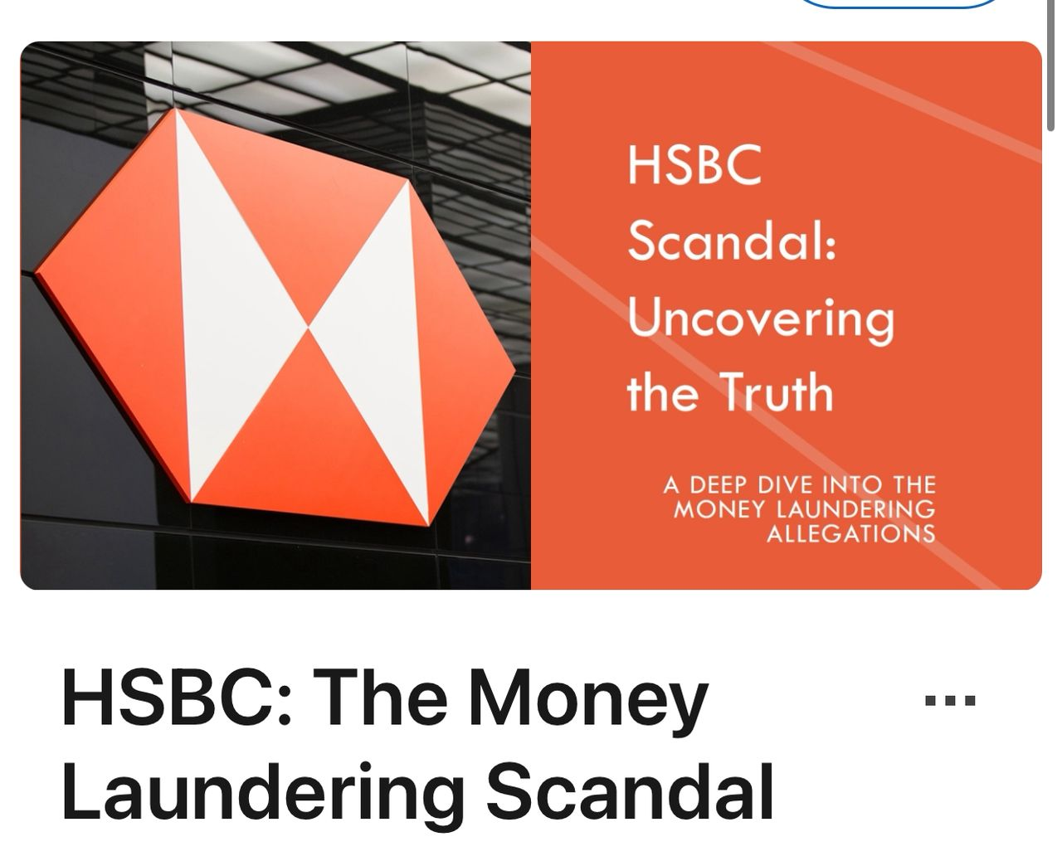
Figure 2.0 Shows the Money-Laundering Scandal of HSBC
The historical development of HSBC supports the nature of wicked problems in current banks. Institutional weaknesses of compliance monitoring are evidenced by 1.9 billion USD in 2012 which was purposefully to enable the drug cartel money laundering activities. Investigations also found that hundreds of millions of dollars in transaction originated from jurisdictions under sanctions were applied, including Iran and Sudan, which was not being tracked or reported (U.S. Department of Justice, 2012). Not only did this case lay bare certain organisational lapses in the system but also demonstrated vulnerabilities in the regulatory framework with the impossibility of the regulation of cross border financial flows in the backdrop of a decentralized banking system.

The second illustrative case is the one that, in 2021, the U.K. Financial Conduct Authority (FCA) fined HSBC 63.9 million pounds due to the inadequacy of its anti-money laundering (AML) monitoring controls. In its report, the FCA recorded major shortcomings in the transaction monitoring systems of the bank over a period of eight years, which did not alert suspicious activities ( Financial Conduct Authority [FCA], 2021). This case demonstrates the difficulty of maintaining a uniform degree of regulatory oversight across jurisdictions where operations are conducted and how the lack of technology and human carelessness can create the perpetration of wicked problems.

In 2024, Swiss officials opened an investigation regarding HSBC operations and transfers of Riad Salameh, the previous governor of the central bank of Lebanon worth over 300 million dollars (Swissinfo, 2025). This case is an issue concerning due diligence steps and the ability of the bank to identify complex, politically exposed transactions. All these together illustrate the qualities of wicked problems: they have many stakeholders, have no simple solutions, have intractable financial and reputational costs, and are inextricably linked to international regulatory systems.

2.2 WHY WICKED PROBLEMS ARE DIFFICULT IN GLOBAL BANKING

Figure 3.0 shows an Accountant working at the bank
Wicked problems are a challenging issue for global financial institutions, a fact that is strengthened by a number of interconnected obstacles. First of all, the proliferation of cross-border regulations generates a complex legal landscape that compounds the problem of implementing harmonized monitoring instruments. Financial entities operating across multiple jurisdictions must navigate divergent and, at times, contradictory statutory regimes, thereby complicating the design of uniform control frameworks (Claessens 2024). Even the small violations of regulations may result in enormous fines and reputational loss, as the case of HSBC demonstrated in the United States, the United Kingdom, and Switzerland.

Second, it is hard to trace the sources and destination of funds because of complicated chains of transactions. The international banking systems are usually characterized by multiple intermediaries, shell companies, and cross-border payments, complicating the task to track illicit flows, and detect suspicious activities (Mainelli, 2024). Such complexities in architecture further complicate the task of coming up with quality controls especially in institutions that have high volumes of transactions.

Third, knowledge in multinational banks is not shared and institutional actions are not coordinated due to cultural and operational silos. Regional operating units can have different objectives, and this can lead to patchwork in policy enforcement across offices (Zickgraf, 2024). The siloed structure can interfere with the exchange of necessary information in time, and this weakness is especially critical when addressing the multidimensional and dynamic nature of money laundering.

Lastly, the above challenges are worsened by resource constraints and technological constraints. Although more advanced monitoring systems are gaining popularity, they are implemented using highly qualified staff, they need continuous maintenance, and they need to be integrated into heterogeneous IT infrastructures. Without sustained investment, vulnerabilities emerge that enable compliance failures to persist undetected (Zickgraf 2024).

2.3 COLLABORATIVE GLOBAL TEAMS AS A SOLUTION


Figure 4.0 shows global collaboration
As a substitute to the systemic intricacy upon which wicked problems lie, traditional siloed responses are insufficient. Effective remediation also requires cross-functional teams, spanning geographic and organisational departmental boundaries, and expertise. These coalitions increase the scope of solving the issue due to the ability to combine different knowledge, establish common responsibility, and promote an integrated compliance and risk-management system (Sitra, 2021).

Empirical research shows that wicked problems require ongoing iteration, after-incident learning, and proactive cross-level communications. The collaborative arrangements increase recognition and mitigation of the high-risk transactions through the integration of the knowledge and experience of compliance officers, legal experts, IT experts, and regional managers, and at the same time develop adaptive strategies in response to the emerging regulatory environment, IT issues, and emerging financial risks. Research indicates that tackling wicked problems effectively often requires continuous iteration, learning from near-misses, and proactive communication across all organisational levels (Sitra, 2021). The culture of compliance failures at HSBC validates that these kinds of group work practices reduce institutional vulnerabilities and enhance the ability to predict and manage complex challenges.

3.0 APPLYING DESIGN THINKING TO HSBC’S COMPLIANCE FAILURES
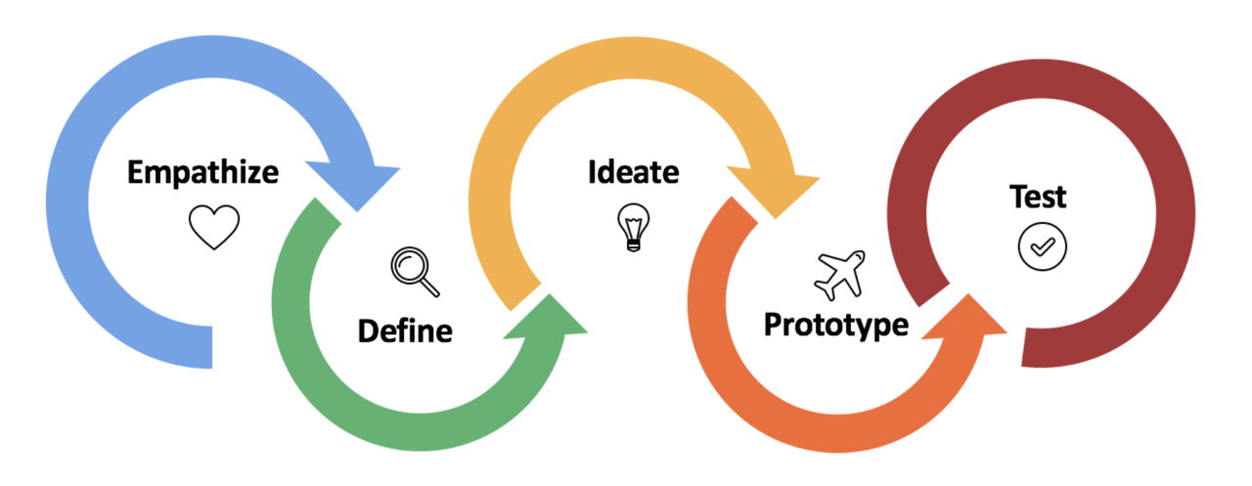
Figure 5.0 shows the 5 steps of design thinking
Given the complex and interdependent nature of HSBC’s compliance challenges, traditional risk management approaches often fall short. Design Thinking, a human-centered and iterative methodology, provides a structured approach for addressing these wicked problems by emphasising empathy, problem definition, creative solution generation, prototyping, and iterative testing (Brown, 2009). By applying Design Thinking to HSBC’s compliance failures in Mexico, Switzerland, and Hong Kong, the bank can develop more effective and adaptable anti-money laundering systems.

The first stage, empathy, involves building up a fine-grained picture of the experiences and challenges of stakeholders. In the case of HSBC, this is interaction with compliance officers, regional managers, operating personnel, and regulators. The 2012 laundering scandal in Mexico demonstrated weaknesses and structural pressures that hampered the ability to identify illicit transactions in a prompt manner (U.S. Department of Justice, 2012). The gaps in due diligence and monitoring were exposed in Swiss dealings (Swissinfo, 2025). The nature of cross-border transactions in Hong Kong and the fragmented nature of the compliance processes further compounded the capacity to identify suspicious activity in a timely fashion. Through keen observation of workflows, interviews, and studying previous occurrences, HSBC will be able to understand areas of operational pain and where the current processes are failing to work, hence making sure future interventions are based on operational realities.
During the define stage, results of an investigation are synthesized in order to identify root causes. Through HSBC high-risk areas, common issues such as outdated legacy systems, scattered surveillance procedures, inadequate training, and inconsistent red flag attention are common problems. Siloes in reporting and slow escalation in Mexico resulted in the failure to respond to alerts, and incomplete due diligence in Switzerland resulted in unreviewed high-risk transactions (U.S. Department of Justice, 2012; Swissinfo, 2025). By making the weaknesses of their systems descriptive, HSBC will be able to work on fundamental causes other than curing the symptoms of their systems and target the structural weaknesses.
Ideation involves the creation of an extensive list of possible solutions. The cross-functional global teams, which include compliance specialists, IT experts, data scientists, and regional managers, are used to explore novel solutions to the problem, including AI-based anomaly detection, predictive analytics used to identify high-risk clients, blocking transparency based on blockchain, and centralised dashboards allowing monitoring of the situation in real-time. This is a creative enterprise that values breadth and diversity of ideas, hence allowing localised and customised responses to local challenges and consistency in the global arena (Brown, 2009).

Complex technological systems, e.g. artificial intelligence (AI), are frequently developed through a process that requires prototyping (interventions are piloted in a controlled environment initially). In the example of HSBC, the company could use the simulation of the transactional environment, introduce AI-based surveillance systems in Mexico or Switzerland, estimate the efficiency of alerting systems, and have responses of the employees. The pilots enable the bank to identify the operational challenges and improve later versions, hence reducing the chances of a systemic breakdown. This recursive method, corresponding to the wicked problems nature, acknowledges that the original solutions are not usually definitive and must be modified towards the empirical data.

The last evaluation stage is testing, which achieves the goal of evaluating prototypes and successively improving performance. In the case of HSBC, tracking of alert accuracies, response time, and user feedback are critical; common measures include decreasing the number of suspicious transactions that go undetected and increasing the consumer reporting to regulators. Functional testing allows the potential of lessons learned in one area to be applied to inform practice in another, transferring knowledge and organisational learning. It is a loop of continuous quality development that keeps solutions viable in the dynamic regulatory and operational environments.

A main prerequisite in the successful application of Design Thinking to the compliance system of HSBC is the cross-functional and global teams. This structure helps to incorporate non-homogenous views, hence strengthening the problem-solving processes, reducing blind spots, and making anti-money-laundering (AML) solutions operationally viable and technologically reliable. In addition, the cross-functional nature of such teams creates an element of collective responsibility and minimizes the chances of non-compliance as a result of organizational silos. By integrating both collaboration and iterative learning processes into compliance operation, HSBC will be able to create a robust and flexible system that will help the company respond to the wicked problems that are continuously presented by such problems.

4.0 EMOTIONAL INTELLIGENCE AND CONFLICT MANAGEMENT IN GLOBAL TEAMS
In the increasingly interconnected world of global finance, the capacity to navigate intergroup tensions is central to organizational effectiveness. Emotional Intelligence (EI), as articulated by Daniel Goleman (1995), is a critical competency for navigating complexity in multicultural banking teams. At HSBC, a bank with vast global operations, tensions between compliance functions and profit-oriented executives are compounded by the uneven interpretation of sanctions and anti-money-laundering (AML) protocols across jurisdictions which underscore the urgent need for EI-driven conflict management strategies.

Goleman (1995) defined EI as comprising self-awareness, self-regulation, motivation, empathy, and social skills. These elements enable leaders to interpret emotional cues, modulate behavioural responses, align team motivation, understand diverse cultural perspectives, and communicate effectively. In multicultural banking teams, members often bring variant cultural norms about hierarchy, risk, compliance, and profit. Without EI, misunderstandings escalate into entrenched conflicts.

HSBC’s challenges illustrate the stakes at hand. In 2012–2013, the bank paid a combined U.S. fine of $1.9 billion for systemic failures in AML controls and sanctions compliance, including facilitating illicit transactions and violating sanctions (Ross, 2023). The scandal highlighted how corporate restructuring and cost-cutting undermined compliance oversight as profit imperatives overtook regulatory vigilance (Ross, 2023). More recently, HSBC faced compliance criticism in Continental Europe, where regulators flagged serious deficiencies in the bank’s compliance systems (O’Donoghue, 2025). These incidents reflect deep-rooted tensions: compliance teams are tasked with risk mitigation and regulatory adherence, while profit-driven executives may prioritize revenue generation, potentially leading to conflicts about acceptable business conduct across jurisdictions.

Emotional intelligence offers tools to bridge these divides. Firstly, culturally sensitive training can help teams develop self-awareness and empathy, two foundational EI dimensions—regarding how compliance and profit motives are valued differently across cultures. HSBC has made strides in cultivating inclusive practices: through its global employee networks, such as Embrace (ethnicity and race), Balance (gender), and others, the bank fosters environments where differences are respected and voices can be heard (HSBC, 2025). By extending such models to formal EI and compliance training where, for example, teams explore cultural interpretations of risk and authority that HSBC can enable individuals to better understand and communicate across departmental divides.

Secondly, regular virtual conflict-resolution workshops can enhance EI competencies. These workshops are designed to address real-world dilemmas, such as interpreting AML protocols when local laws conflict with global standards that can build social skills and empathy. Participants can practice active listening, articulate concerns without defensiveness, and collectively generate solutions that respect both compliance and profitability imperatives. EI research affirms that structured group interactions enhance emotional resilience and well-being, improving leadership effectiveness and relationships at work (Talogy, 2024).

Thirdly, encouraging active listening and empathy among managers reinforces emotionally intelligent leadership. Active listening attentively without judgment—validates differing perspectives and prevents escalation. HSBC’s inclusion strategy, which encourages employees to “listen actively, without judgement,” and “demonstrate zero-tolerance for prejudice,” provides a useful starting point (HSBC, 2025). Embedding such norms into performance and managerial development particularly in cross-functional teams that include compliance and revenue functions can foster mutual respect and reduce conflict.

Moreover, HSBC’s risk framework places compliance as an independent function separate from profit-generating operations, ensuring oversight and challenge in risk/return decisions (HSBC, 2025). However, the mere structural separation is insufficient without emotionally intelligent behaviours to operationalize cooperation. When compliance and revenue teams understand each other’s motivations and constraints, they can co-create solutions. For example, compliance adapting protocol communication to frontline realities, and executives embedding compliance dialogue into business planning.

5.0 INTERDISCIPLINARY THINKING FOR AML PROBLEM SOLVING

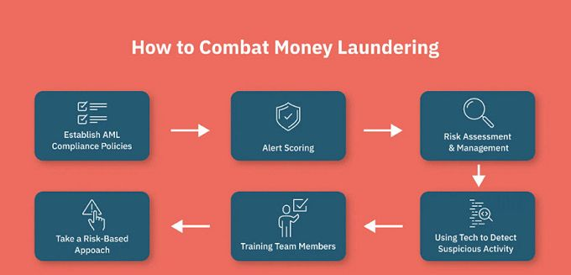
Figure 6.0 shows how to combat money laundering
Money laundering is a process of an activity where the “dirty” money from criminal and illegal activities becomes clean. Anti-Money Laundering (AML) is a measurement that refers to systems or programs to prevent institutions from being misused by criminals seeking to launder money through their business (Bank Negara Malaysia, 2022). Anti-Money Laundering (AML) compliance is a crucial aspect and has become more challenging for financial service institutions in this modern era. They have to face several challenges such as money laundering, terrorist financing and any other financial crimes (Davies, 2023). An Effective Anti-Money Laundering (AML) requiring interdisciplinary approach which means coordinating and collaborations leverages expertise from multiple departments within an organization including finance, data analytics, information technology (IT), legal and compliance and operations.

Anti-Money laundering (AML) needs interdisciplinary teams because money laundering is an activity that have intersect multiple domains financial systems, technology, data, legal frameworks and daily operations that requiring complexity demands and collaboration across departments. First, finance departments will be detecting financial irregularities, understanding the account hierarchy and providing insight into transaction behavior. Second, data analytics will be using machine learning to detect suspicious or odd figures. Third, information technology (IT) supports data integration and is secure for infrastructure-monitoring tools. Then, legal and compliance ensure that they follow the global and local regulatory requirements and conduct legitimate investigations. Finally, operations by strengthening know your customer (KYC) handling transaction reviews and ensuring the consistency of the Anti-Money Laundering (AML) process. By using interdisclipnary approach from various departments, it will be detecting, preventing and rs, it will be detecting,ncial activities.

Real world implementation through functional strategy are cross-departmental task forces where all departments do collaborations involving information technology (IT), finance, operations and any other departments than that to make it into teams for improving decision making. Next is an integrated data platform where centralized data is unified to unify customer data and transactional records across region. Following by ensuring all the data usage and all steps are complied with jurisdictional requirements. In addition, bringing in external regulator and consultants to enhanced transparency and trust where provide assurance to stakeholders that Anti-Money Laundering (AML) efforts are credible and independent also ensuring proactive compliance and identify process inefficiencies risk that the internal team might overlook. This initiative led to improved detection rates, reduced false, stronger regulatory relationships and operational resilience.

There are many benefits of interdisciplinary Anti-Money Laundering (AML) team's programs that enhanced effectiveness and operational efficiency, prevent money laundering, and improves compliance outcomes and internal collaboration. Firstly, broader risk perspectives where multi-disciplinary teams from various departments can view threat from various perspectives to uncover hidden vulnerabilities and assess risk more holistically. Second, faster and creative problem solving by diverse area of expertise encourages innovative approaches to detection methods, compliance strategies, and policy enhancements. Next is stronger adaptability, more agile in responding to new laundering techniques and evolving regulatory requirements, especially across jurisdictions. Lastly is improving operational efficiency by Coordinated workflows between departments reduce redundancy, accelerate investigations, and streamline decision-making processes.

6.0 INTERNATIONAL CONTEXT AND PEST ANALYSIS

OF HSBC

6.1 POLITICAL FACTORS
Politically, the HSBC is regulated by different authorities in different jurisdictions, including the United States, the United Kingdom and Switzerland. U.S. sanctions enforcement, especially after the imposition of a fine of 1.9 billion dollars in 2012 on laundering funds of drug-cartel (U.S. Department of Justice, 2012), have long been a topical issue, since even strict regime prohibiting any transactions with particular states or entities requires intense monitoring and reporting. In the United Kingdom, the Financial Conduct Authority (FCA) requires comprehensive anti-money laundering (AML) and financial crime controls; this requirement was the focus of the 2021 fines of the United Kingdom financial regulator against HSBC of 63.9 million (Financial Conduct Authority [FCA], 2021) due to gaps in transaction monitoring. Also, the Swiss Financial Market Supervisory Authority (FINMA) has specifically taken a keen interest in investigating how HSBC treated the high-risk politically exposed persons, a sign of how stringent the Swiss regulatory authorities are (Swissinfo, 2025). Such political realities necessitate HSBC to have strong flexible compliance structures that can be flexible enough to meet different international legal standards and coordinate operations in different regions to achieve uniformity in enforcement.

6.2 ECONOMIC FACTORS
A second level of stress in strategic and operational capability of HSBC lies in economic factors. The 2012 U.S. settlement in the multiple billions of dollars creates a cash flow burden in the short term and undermines investor confidence and market valuation at the same time. The result of high perception of risk exposure by the shareholders is its impact on capital allocation, cost of capital and long-term profitability because of the associated risk of continuous regulatory attention (Claessens, 2024). When resources are diverted to remediation efforts, modernization of technology and increased compliance personnel there is an increase in the operation costs of the bank. Potential and actual fines further affect lending ability, liquidity and limit strategic investment, which in turn echoes across the rest of economic performance measures. Such monetary consequences support the importance of proactive compliance effort and risk-aversion system in a competitive banking world.

6.3 SOCIAL FACTORS
Social variables that further influence the international environment of HSBC are reputation, customer trust, and media scrutiny. The failure of compliance has a concrete impact on the image, therefore, causing the loss of trust among the clients, counterparties, and regulators. The media coverage of the case of the U.S. fine in 2012 and other episodes has contributed to media coverage, as the systemic weaknesses get emphasized, and reputational damage grows (Sitra, 2021). The subsequent loss of trust can lead to a negative change in customer activity, deposits, and inability to attract new customers, which have a downstream economic and operational impact. Moreover, cultural and societal expectations regarding ethical banking activities compel HSBC to be responsible, transparent and adhere to international standard. To solve these social issues, it is required to not only be technically compliant but also to be actively communicating, corporate social responsibility activities and have a visible financial integrity commitment.

6.4 TECHNOLOGY
The technological determinants have a significant influence on the capacity of HSBC to reduce compliance risks and implement new operational practices. Legacy systems in the past have hindered the effectiveness of transactions monitoring hence poor detection of anti-money-laundering (AML) and reporting delays (Mainelli, 2024). In its turn, the new technologies, particularly artificial intelligence (AI) and blockchain, offer transformational opportunities to compliance operations. With AI-powered monitoring systems, anomalous transactions can be detected in real-time and patterns that could be related to money laundering can be identified, and the system can be updated to new threats. The Blockchain technology offers improved transparency and trackability of complex chains of transactions, which allows regulators and banks to check on the integrity of transactions effectively. The implementation of such technologies requires capital investment and cross-functional cooperation of IT experts, compliance officers, and operational managers to integrate successfully with the current processes in banking (Sitra, 2021).

This interaction of political, economic, social and technological forces makes the international environment a very complex environment in which HSBC is forced to perform. Political imperatives require compliance with a variety of regulatory regimes; economic impacts increase the costs of not complying; social trends require active reputation management; and technological changes introduce potential opportunities and challenges to compliance innovation. PEST analysis indicates that these dimensions are interdependent and thus requires comprehensive approaches that are balanced between regulatory compliance, efficiency and stakeholder confidence. Adopting AI-powered AML surveillance, e.g., not only counters technological issues but also alleviates political and economic risks of non-compliance and exposure to fines, and at the same time improves social trust by raising detection rates and accountability.

7.0 ETHICAL & TECHNOLOGICAL CONSIDERATIONS

IN HSBC’S CASE
Ethical Considerations
1. Prioritising Profit over Integrity
HSBC, between the 1990s and 2010, failed to implement adequate anti-money-laundering (AML) and sanctions controls. This caused it to process $881 million in drug proceeds and $660 million in transactions involving sanctioned countries such as Iran, Cuba, Sudan, Libya and Burma (HSBC, 2021). That kind of oversight shows a corporate culture that prioritised efficiency and profit over integrity.

2. Ignored Internal Warnings
Despite multiple alerts from Mexican law enforcement in 2008 to internal staff about cartel money-laundering activities, management failed to act (UKEssays, 2018; Wikipedia, 2025a). That is a red flag so big it needed its caution tape.

3. Governance Lapses
Governance failures were glaring. Under Lord Green’s leadership, AML controls were weak, and it was later acknowledged that between 2004 and 2010, the bank "should have been stronger and more effective" in catching unacceptable behaviour (Wikipedia, 2025b).

4. Reputational and Regulatory Fallout
In December 2012, HSBC agreed to pay a record $1.92 billion fine after regulators found large gaps in their AML mechanisms (Investopedia, 2013; Wikipedia, 2025a). More dominoes fell later in the UK: in December 2021, HSBC was fined £63.9 million for weak AML controls between 2010 and 2018 (Wikipedia, 2025c).

5. Lessons for the Financial Sector
This isn’t just HSBC’s problem, it’s a warning sign for the whole sector. Poor ethical standards or sidelining compliance not only invites legal trouble but also deeply undercuts trust and long-term sustainability (LearnSignal, 2023; IJRAR, 2019).

Technological Considerations
1. Legacy, Rule-Based Systems
HSBC historically relied on traditional, rule-based AML systems. These were rigid: overly broad parameters flagged too many false positives, wasting investigators’ time (Google Cloud, 2019).

2. Transaction Volumes and Scale
The bank screens over 1.2 billion transactions per month an immense volume that puts pressure on systems and staff (Google Cloud, 2019).

3. Rise of AI in AML
To tackle inefficiency, HSBC started integrating AI to improve customer service and process AML alerts more smartly though details on effectiveness remain thin (Google Cloud, 2019).

4. Emerging Tech Solutions
Research in the broader fintech space reveals cutting-edge approaches: deep learning frameworks for mobile transaction AML, network-based supervised learning to spot group-level laundering activity, and federated graph-learning models enabling cross-institution cooperation, all aiming to reduce false positives and cover blind spots (Arxiv, 2025).

8.0 CONCLUSION AND RECOMMENDATIONS

Analysis of HSBC compliance failures in the light of wicked problems, Design Thinking, and cross-nation contextual attributes shows that global coordination, technology advancement, and corporate culture are coveted instruments in the management of complex financial risks. The events of the HSBC case in Mexico, Switzerland, and Hong Kong reveal that a combination of poor transaction monitoring, siloed operations, and inconsistent application of anti-money laundering (AML) procedures can deliver grave financial, reputational, and regulatory consequences (U.S. Department of Justice, 2012; Swissinfo, 2025; Financial Conduct Authority [FCA], 2021). These events show that global banks are in a wicked problem space where they are interconnected, dynamic and not easily solvable (Rittel & Webber, 1973).

The present investigation confirms once again that geographically dispersed and cross-functional teams are needed to manage multi-faceted regulatory issues. The process of knowledge transfer can be facilitated through the formation of a team that consists of compliance professionals, data scientists, operational managers, and regional experts and pinpointing blind spots within the system and creating interventions that can be applied in various jurisdictions. The HSBC failures in the recent past show the risks of uncoordinated Ness and compartmentalized operation; any local policy break or mis-timed communication can result in a significant violation (Sitra, 2021). Design Thinking as applied to compliance efforts is an excellent demonstration of the value of systematic and iterative problem-solving, especially when empathy, prototyping, and testing are conducted in a global collaborative context (Brown, 2009).

To strengthen its future compliance risks resilience, HSBC needs to put in place a number of strategic interventions. The establishment of international interdisciplinary AML centers is the first one, which will be focused on centralizing the expertise, facilitating the real-time information exchange, and coordinating geographical oversight. These hubs will probably reduce fragmentation, guarantee uniformity in policy application and enhance the identification of complex cross-border transactions. The second measure will be to install AI-driven transaction-monitoring systems under human oversight. The incorporation of advanced analytics that detects abnormal patterns and speeds up the process of detecting suspicious activity and human judgment that provides contextual interpretation and enhances accountability is important. Third, HSBC should invest in the creation of a strong global compliance culture. Compliance as a core organizational principle is reinforced by holistic training, explicit leadership responsibility and rewards on ethical and regulatory principles, thereby reducing the risk of human error or local operating pressures (Mainelli, 2024; Sitra, 2021).

After examining the case of HSBC compliance issues, it becomes clear that the solution to wicked problems in international banking requires a holistic approach that unifies human knowledge, technological advancement, and organisational unity. The bank will be capable of mitigating regulatory, financial, and reputational risks by persisting in international cooperation, arranging AI-based monitoring systems, and strengthening an effective compliance culture. These actions do not only correct the current deficiencies that the prior failures revealed but also prepare the institution to proactively address and react to the emerging complexities and increased scrutiny that are the hallmarks of the international financial environment.

9.0 REFERENCES

- Investopedia. (2013, January 29). Investing News for Jan 29: HSBC’s money-laundering scandal, HBC, SCBFF, ING, CS, RBS. Investopedia. Retrieved August 16, 2025, from https://www.investopedia.com/stock-analysis/2013/investing-news-for-jan-29-hsbcs-money-laundering-scandal-hbc-scbff-ing-cs-rbs0129.aspx?utm_source=.com

- Swiss Financial Market Supervisory Authority (FINMA). (2024, June 18). FINMA proceedings: HSBC Private Bank (Suisse) SA violated money laundering regulations [Press release]. Retrieved August 16, 2025, from https://www.finma.ch/en/news/2024/06/20240618-mm-hsbc/?utm_source

- Claessens, S. (2024). Competitive implications of cross-border banking. World Bank Policy Research Working Paper No. 7124. https://openknowledge.worldbank.org/handle/10986/19135

- Financial Conduct Authority. (2021). FCA fines HSBC Bank plc £63.9 million for deficient transaction monitoring controls. https://www.fca.org.uk/news/press-releases/fca-fines-hsbc-bank-plc-deficient-transaction-monitoring-controls

- Mainelli, M. (2024). The wicked problem of good financial markets. Z/Yen Group. https://www.zyen.com/publications/journal-papers/the-wicked-problem-of-good-financial-markets

- Rittel, H. W. J., & Webber, M. M. (1973). Dilemmas in a general theory of planning. Policy Sciences, 4(2), 155–169.

- Sitra. (2021). Wicked problems require radical collaboration – five principles for developers. https://www.sitra.fi/en/articles/wicked-problems-require-radical-collaboration-five-principles-for-developers/

- Swissinfo. (2025). HSBC targeted in Swiss probe linked to ex-Lebanon central banker. https://www.swissinfo.ch/eng/hsbc-targeted-in-swiss-probe-linked-to-ex-lebanon-central-banker/89756571

- U.S. Department of Justice. (2012). HSBC Holdings PLC and HSBC Bank USA, N.A., admit anti-money laundering and sanctions violations. https://www.justice.gov/opa/pr/hsbc-holdings-plc-and-hsbc-bank-usa-na-admit-anti-money-laundering-and-sanctions-violations

- Neeley, T. (2015, October). Global teams that work. Harvard Business Review. https://hbr.org/2015/10/global-teams-that-work

- U.S. Department of Justice. (2012, December 11). HSBC Holdings Plc. and HSBC Bank USA, N.A. admit to anti-money laundering and sanctions violations, forfeit $1.256 billion in deferred prosecution agreement. https://www.justice.gov/opa/pr/hsbc-holdings-plc-and-hsbc-bank-usa-na-admit-anti-money-laundering-and-sanctions-violations

- U.S. Senate Permanent Subcommittee on Investigations. (2012, July 17). U.S. vulnerabilities to money laundering, drugs, and terrorist financing: HSBC case history [Senate hearing]. https://www.hsgac.senate.gov/subcommittees/investigations/hearings/u-s-vulnerabilities-to-money-laundering-drugs-and-terrorist-financing-hsbc-case-history

- Brown, T. (2009). Change by design: How design thinking creates new alternatives for business and society. Harper Business.

- U.S. Department of Justice. (2012). HSBC Holdings PLC and HSBC Bank USA, N.A., admit anti-money laundering and sanctions violations. https://www.justice.gov/opa/pr/hsbc-holdings-plc-and-hsbc-bank-usa-na-admit-anti-money-laundering-and-sanctions-violations

- Financial Conduct Authority. (2021). FCA fines HSBC Bank plc £63.9 million for deficient transaction monitoring controls. https://www.fca.org.uk/news/press-releases/fca-fines-hsbc-bank-plc-deficient-transaction-monitoring-controls

- Zickgraf, C. (2024). Bridging and breaking silos: Transformational governance for sustainability and migration. Proceedings of the National Academy of Sciences, 121(15), e2206184120. https://doi.org/10.1073/pnas.2206184120

- Investopedia. (2013, January 20). HSBC’s money laundering scandal. https://www.investopedia.com/stock-analysis/2013/investing-news-for-jan-29-hsbcs-money-laundering-scandal-hbc-scbff-ing-cs-rbs0129.aspx

- Kirkman, B. L., & Mistry, S. (2013). Global teams. In R. Griffin (Ed.), Oxford bibliographies in management. Oxford University Press. Abstract retrieved from https://www.oxfordbibliographies.com/abstract/document/obo-9780199846740/obo-9780199846740-0006.xml

- Swissinfo. (2025, July 30). HSBC Suisse investigated by Swiss and French courts. https://www.swissinfo.ch/eng/various/hsbc-suisse-under-investigation-by-the-swiss-and-french-courts/89758139

- The National. (2025, February 4). Lebanon files lawsuit against HSBC in Switzerland over Riad Salameh embezzlement case. https://www.thenationalnews.com/news/mena/2025/02/04/lebanon-files-lawsuit-against-hsbc-in-switzerland-over-riad-salameh-embezzlement-case/

- Financial Times. (2025). HSBC’s Swiss private bank under investigation by Swiss and French authorities [News report]. FT. https://www.fnlondon.com/articles/hsbcs-private-bank-under-investigation-by-swiss-and-french-authorities-2a9d7b3e

- Davies, N. (2023, May 22). The five biggest AML compliance challenges. NorthRow. https://www.northrow.com/blog/the-five-biggest-aml-compliance-challenges-facing-financial-institutions-in-2023-and-how-northrow-can-help

- Bank Negara Malaysia. (2022). What is Money Laundering? - Anti Money Laundering / Countering Financing of Terrorism (AML/CFT). Amlcft.bnm.gov.my. https://amlcft.bnm.gov.my/what-is-money-laundering

- Goleman, D. (1995). Emotional Intelligence : Why It Can Matter More Than IQ. Library of Unviolent Revolution.

- HSBC. (2025, February 15). Our culture | Our people | HSBC Holdings plc. HSBC. https://www.hsbc.com/who-we-are/our-people/inclusion-at-hsbc/our-culture?utm_source=.com

- HSBC HOLDING. (2023). Our partnership with Google to fight financial crime Risk review HSBC Holdings plc Annual Report and Accounts 2023 135.

- O’Donoghue, P. (2025, July 3). NEWS: HSBC France unit faces compliance audit – report - AML Intelligence. AML Intelligence. https://www.amlintelligence.com/2025/07/news-hsbc-france-unit-faces-compliance-audit-report/?utm_source=.com

- Ross, M. L. (2023). HSBC’s Money Laundering Scandal. Investopedia. https://www.investopedia.com/stock-analysis/2013/investing-news-for-jan-29-hsbcs-money-laundering-scandal-hbc-scbff-ing-cs-rbs0129.aspx?utm_source=chatgpt.com
- Talogy. (2024, July 17). Developing workplace emotional intelligence - Talogy. Talogy. https://talogy.com/en-ae/knowledge-hub/emotional-intelligence/?utm_source=.com

- Arxiv (2025). Advances in Anti-Money Laundering Using AI and Network Learning. [online] Available at: https://arxiv.org/abs/2503.10058 [Accessed 16 Aug. 2025].

- Google Cloud (2019). How HSBC fights money launderers with artificial intelligence. [online] Available at: https://cloud.google.com/blog/topics/financial-services/how-hsbc-fights-money-launderers-with-artificial-intelligence [Accessed 16 Aug. 2025].

- HSBC (2021). Restoring trust in HSBC. [online] Available at: https://www.hsbc.com/-/files/hsbc/our-approach/corporate-governance/pdfs/210217-restoring-trust.pdf [Accessed 16 Aug. 2025].

- IJRAR (2019). Ethical Analysis of the HSBC Money Laundering Scandal. International Journal of Research and Analytical Reviews. [online] Available at: https://ijrar.org/papers/IJRAR19D5361.pdf [Accessed 16 Aug. 2025].

- Investopedia (2013). Investing News for Jan 29: HSBC’s Money Laundering Scandal. [online] Available at: https://www.investopedia.com/stock-analysis/2013/investing-news-for-jan-29-hsbcs-money-laundering-scandal-hbc-scbff-ing-cs-rbs0129.aspx [Accessed 16 Aug. 2025].
- LearnSignal (2023). HSBC Money Laundering Scandal: Lessons for Accountants. [online] Available at: https://www.learnsignal.com/blog/hsbc-money-laundering/ [Accessed 16 Aug. 2025].

- UKEssays (2018). The Ethical Analysis and Evaluation of HSBC Money Laundering Scandal. [online] Available at: https://www.ukessays.com/essays/banking/the-ethical-analysis-and-evaluation-of-hsbc-money-laundering-scandal.php [Accessed 16 Aug. 2025].

- Wikipedia (2025a). HSBC. [online] Available at: https://en.wikipedia.org/wiki/HSBC [Accessed 16 Aug. 2025].

- Wikipedia (2025b). Stephen Green, Baron Green of Hurstpierpoint. [online] Available at: https://en.wikipedia.org/wiki/Stephen_Green%2C_Baron_Green_of_Hurstpierpoint [Accessed 16 Aug. 2025].

- Wikipedia (2025c). HSBC UK. [online] Available at: https://en.wikipedia.org/wiki/HSBC_UK [Accessed 16 Aug. 2025].

