How Censorship affects Video Games in the Industry.

Written by Toby Wheeler P147791
Creative Computer Games Design
11/12/2018

Abstract

This paper will cover how censorship affects Game Developers, Sony’s new Censorship Policy, and if Video Games should be censored. It has 3 case studies that cover the censorship and controversy involving 3 games. Mortal Kombat released in 1992, South Park: Stick of Truth released in 2014, and finally Senran Kagura Burst Re:Newal, a game that was scheduled for release in 2018, but due to Sony’s new Censorship policy was delayed to 2019.

List of Contents

P3. Image List
P4. Introduction
P5. Case Study 1- South Park: Stick of Truth.
P7. Case Study 2 - Japanese Games + Senran Kagura
P11. Case Study 3 - Mortal Kombat
P14. Should Video Games Be Censored
P17. How Censorship Affects Developers
P19. Conclusion
P20. Bibliography & References
Images

Figure 1: Screenshots from the Australian and European versions of the game
Figure 2: Image of Intimacy Mode gameplay from Senran Kagura Estival Versus
Figure 3: Censorship comparisons of Noraneko Heart HD Version in Study by user Galajo
Figure 4: Censorship Comparison of Mortal Kombat in a video from user VCDECIDE
Figure 5: Screenshot of Debate results from the Deate.Org website

Introduction

This document shall be covering censorship and cultural differences in Video Games, this includes symbolism, sexual content, violence and more. Game companies need to make sure they abide the laws of the countries they release their games in, this can cause various instances of censorship which can affect the game itself and also cause parts of the game to be removed. This write up will cover what effects censorship has on these games and the companies creating the games. It will cover 3 case studies that have all had varying degrees of censorship and how harsh that censorship has been. Additionally, the document will delve into if Games should be censored in the industry, even with the age rating system in place.

Case Study 1 - Stick of Truth

South park was censored in Australia and EU with major censorship. Instead of slight modifications, scenes would be completely covered as they are played out. The scenes would be images with text describing the scene. The developers clearly were not happy with these censorship rules as the text on the images were quite passive aggressive. The game was censored in Australia and Europe, these images vary from location to location. Below the images can be found. The game was put forward for review for age ratings and was told that in Europe and Australia, that some scenese needed to be cut from the game, co-creator Matt Stone of South Park commented on these changes and said “It does feel like a double standard, a little bit. We weren’t willing to change the content, but also it doesn’t ruin the game — it’s like 40 seconds’ worth of the whole game. As long as we could make a joke out of the fact that they made us cut this, that was fine” (Stone, in Dyce, 2013) this comment shows that the co-creator was against this censorship originally, but later accepted the censorship and removed the scenes because they were able to make the joke, the jokes used are black cards placed over the screen with passive agreed text against the censorship and also describing the scene that is censored. The Australian and European images are different from each other to add more comedic value to the respected culture, for Australia, the symbolic Koala is seen crying, with the text over it, whereas the European black card has the EU flag with a famous statue, face palming as it describes the scene with text.

South Park; Stick of Truth however, was not censored conventionally, and instead the publishers Ubisoft decided to censor the games, the company's spokesperson was only willing and/or able to state that the decision was “a market decision made by Ubisoft EMEA” (Moses, 2014) this means that both Europe and Australia did not explicitly censor the game, it was instead Ubisoft making the decision. However, the company believed they would get censored for the anal probe scenes, and the abortion scenes, so that could be the reason behind their censorship before the main age rating review in the respected countries. The North American version of the game is uncensored on all platforms, whereas in other countries its censored only on select platforms, for example, only the console versions of the game are censored in the EU, apart from Germany which has stricter censorship laws. “The German one is censored on console for anal probing etc, and censored on both console and PC for swastikas, Heil Hitler arm salutes” (Moses, 2014) Additionally, according to another article, the author states that the scenes added to the European version of the game, are the same cuts, that the Australian age rating executives made happen to allow an 18+ rating, this may have been to avoid the same issues when having the game Age rated by the USK in Germany. (Duncan, 2014)

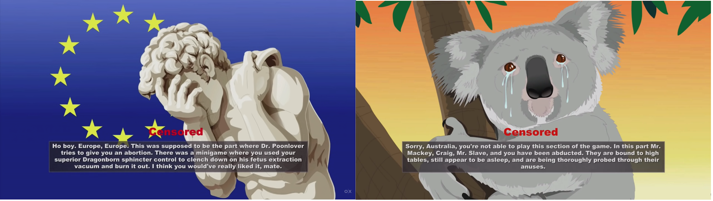
Fig 1. European and Australian Censorship Cards (Ubisoft, 2014)

Case Study 2 - Senran Kagura and Japanese Titles Censored on PS4

Sony have inducted a new policy on sexual content from Japanese games, this has affected a variety of games that were set to release on PS4. This new policy can hurt Japanese game developers because they are forced to tread lightly when developing their games. The company Marvelous have had to delay their newest game Senran Kagura Burst Re:Newal to remove the intimacy feature due to Sony censoring this portion of the game. The developers spoke out about the new policy and said “Recently, worldwide regulations regarding sexual depiction have been getting stronger, and in that respect, we have to make games in a way that they aren’t misunderstood. Certain things are harder than they’ve ever been before. Given that, I think the game is going to take some time… We want to make it happen, so right now we’re at a place where we’re thinking about how to do that” (Takaki, cited in Iggy, 2018) this shows that developers are struggling to create their games in the style they have done before, whilst following Sony’s new policy. The Intimacy mode of the game had to be completely removed from the game which meant that the localisation teams needed to re-code the game to have the Intimacy mode removed and un-accessible to consumers, however this mode has appeared in previous installments of the Senran Kagura series on PS4 without being censored by Sony, according to Xseed localisation producer Tom Lipschultz this is “brand new policy” from Sony, furthermore Tom added “that the age of the characters doesn't help”, he believes it's the "interactivity in general that's the issue" and changing the girls' age wouldn't make a difference.” (Lipschultz cited in, Taylor, 2018) As for Sony’s new policy, the company have come forward and given their reasoning for this sudden change in policy, the policy they have put in place is targeting sexual content in Japanese games and Sony of Japan’s president Atsushi Morita has addressed the new policy and explained why it is in place. He stated that “it’s simply a matter of matching global standards.” He also commented on Freedom of Expression, by saying that they need to “think about what might be unpleasant for children and shield them from those things while also thinking and assessing ways to find a balance.” (Morita cited in, Galajo 2018) Author Galajo, stated that he finds it ironic that Sony are saying these things about their policy, whilst ‘seemingly’ overlooking the sexual content in a western game named Witcher III, and further states that regardless of what Sony fans feel, they are dead set on sterilizing Japanese games, even if it hurts developers. (Galajo, 2018) This shows that people don’t just follow Sony and have conflicting opinions on Sony’s new policy.

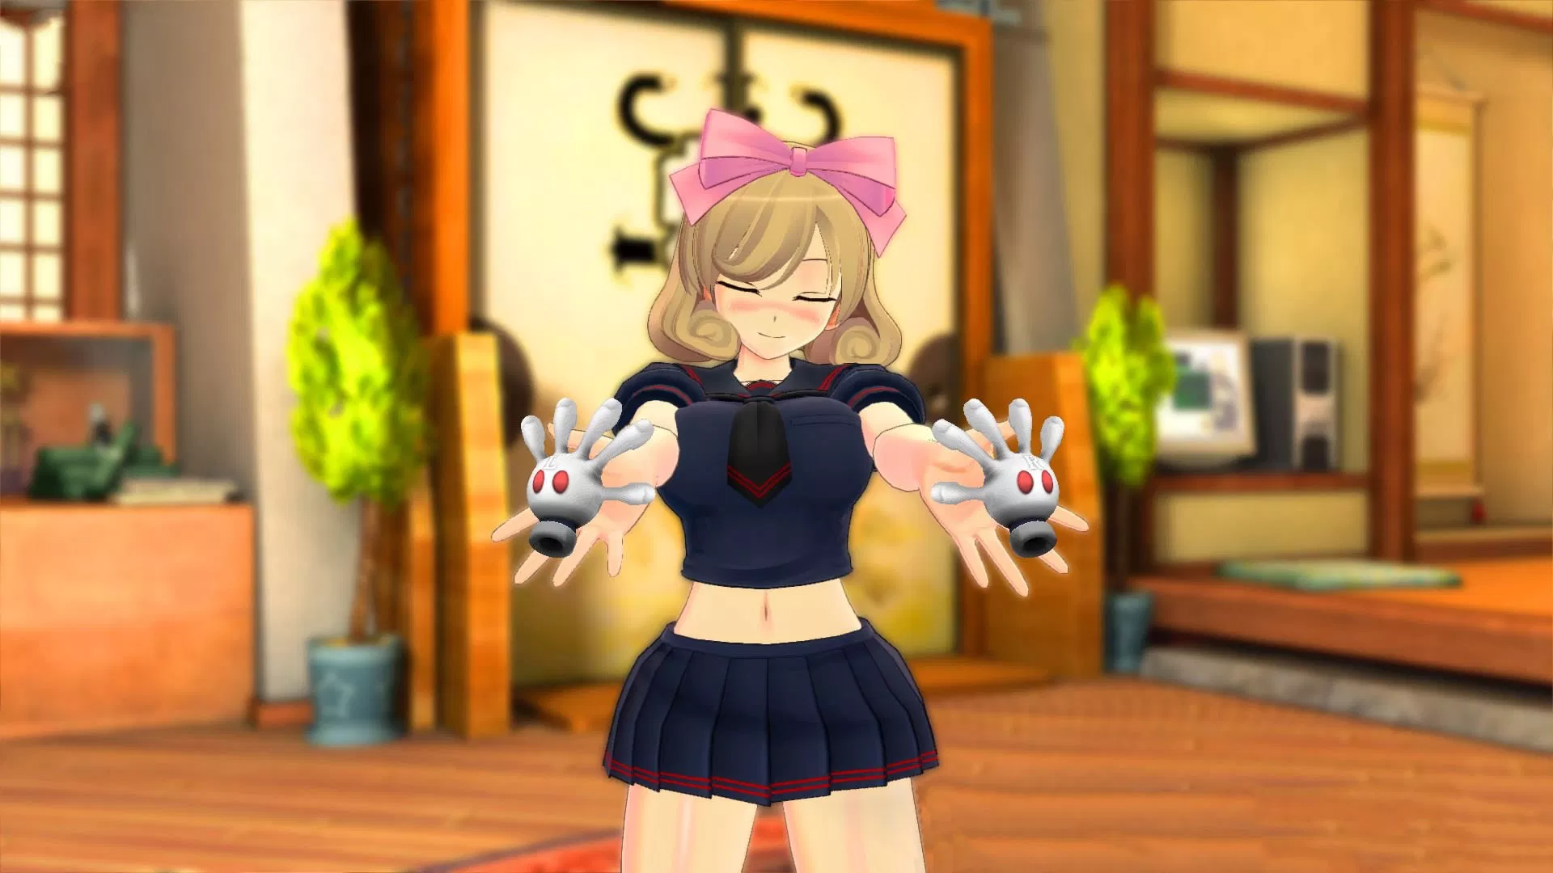
Fig 2. Senran Kagura Estival Versus, Intimacy Mode. (Marvelous Inc., 2018)

The above image shows the mode that was removed from the new game, as seen this feature allows the player to touch the girls with virtual hands using the controller, or in Senran Kagura Peach Beach Splash’s case, VR. This mode has been accepted in every installment, but with the release of Burst Re:Newal it has been cut.

Additionally, another game was censored heavily by Sony, this game has been released on three platforms, PS4, PC and Nintendo Switch, below is an image comparing the three platforms on the same scene of the visual novel. The game itself is Nora to Oujo to Noraneko Heart HD Version, released by Harukaze. As seen in the images, the PC and Switch versions are identical and uncensored, however Sony’s version of the game has huge streaks of Light to cover up the girl in the scene. This scene may be seen as nudity with the Sony censorship as the emphasis is on the breasts and lower half of the girl, the underwear being covered makes it look more mature than that of the other two platforms.
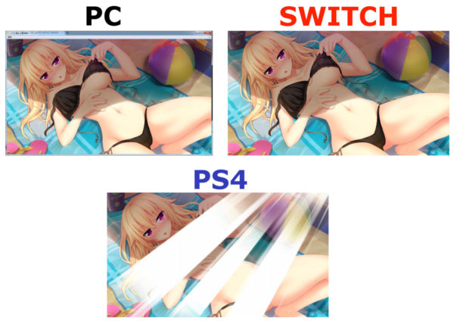
Fig 3. Censorship Comparison for Noraneko Heart HD Version (Censorship Comparison, 2018)

A final game coming out of Japan for localisation was not censored in the West, however it was instead banned from being released in the West, this decision by Sony was due to the new policy they have, the game had its contract pulled and was not allowed to be commercially released in the west. The publisher PQube spoke out about this matter and stated that they wanted to release all their Japanese content to their western fans, however Sony denied their game due to the game not complying with the age rating restrictions in the West, and thus all plans for a Western release on PS4 and PSVita have been withdrawn. (PQube cited in, Siliconera, 2018) This game has been banned in many countries due to the sexualisation of underage school girls, this is a more serious case than the censorship of Senran Kagura and Noraneko Heart, more so that it was taken to a last resort and banned. The Video Standards Council in the UK stated in a large statement that the game looks appealing to younger audiences because of how colorful it is, however the sexual themes in the game and ability to sexually stimulate the girls in game using a touch screen or controller is unacceptable for the UK audiences. (VSC UK Cited in, Hayes 2018)

Overall, Sony’s new policy is strongly affecting video games coming from Japan, with three games in the same year being affected, with censorship, removed features and an outright ban. There are many varying opinions against Sony’s new policy, with some consumers pulling out of their orders, others finding Sony to be hypocritical over some games sexual content, and of course some that agree with the policy. Japanese games have always faced controversy for their school girl themes and sexual content, and Sony’s policies are proving difficult for Japanese developers as their games are going through stricter censorship tests.

Case Study 3 - Mortal Kombat
The final case study that will be covered is a very old and very controversial game. The original Mortal Kombat. This game was released in 1992, and was censored on the SNES, Nintendo decided to censor the game by removing all of the blood and gore of the gaem, however the fighting elements remained in the game, the only thing removed was the blood, however Sega opted to release the game uncensored and put an age rating on the game. The age rating system back then was only for parents to be made aware, and stores had no laws revolving around the age ratings of the game, meaning anyone can purchase the games regardless of their age. (Herman, 1994). This age rating did little to the game market and Nintendo claimed that all of their games were G rated, however, Sega stated that other video game manufacturers should follow their example and use their age rating system, Nintendo quickly refused this stating that it was just to justify sales of violent games. (Herman, 1994). This was just one game back in 1992, and Nintendo chose themselves to remove the blood and gore of the game, this was one of the first instances of censorship, and paved the way for making people believe that games make people violent. Additionally, a game named Night Trap was completely denied access to the UK and Australia due to its violent images. On December 1st 1993, Mr Lieberman gathered the Washington press and claimed that video games were influencing violence on young minds, he did this by showcasing clips of violent games like Mortal Kombat and Night Trap and stated that he had plans to implement age rating bodies to Video Games, he stated "We're talking about video games that glorify violence and teach children to enjoy inflicting the most gruesome forms of cruelty imaginable." (Lieberman, cited in Crossley, 2014) Censorship, will always be a part of the video games industry because of games like Mortal Kombat, Night Trap, Rapelay and more recently, due to Sony’s ruling, Omega Labyrinth Z. The age rating system put in place helps monitor games and like movies, give them a law bound age rating, that allows sellers to deny the purchase of these games if they believe the consumer is under the age of the PEGI/ESRB Rating. However, like every other form of age rating system, it has flaws and can be walked around by having a parent, or adult purchase the items for the player. However, as stated above, children weren’t protected by this law back in 1993 when Mortal Kombat was on sale. Nintendo’s decision to censor Mortal Kombat hurt its sales, and allowed Sega to sell far more copies of Mortal Kombat, due to the lack of censorship. Founder of Digital Pictures Tom Zito stated that “Nintendo made a horrible blunder from a marketing standpoint in putting out a sanitized version of Mortal Kombat” (Zito, cited in Kent 2002). However, sales were not the only thing that Nintendo did wrong, they also upset a lot of their SNES customers, whilst Nintendo opted to censor MK1 to avoid backlash from parents and press, they instead received angry letters from customers, and also some angry letters from parents, warning Nintendo not to censor their games. (Kent, 2002). Even with censorship, parents were still unhappy with the decision, and so were fans. This shows that not everyone will ever be happy with a censorship decision, this happened in 1992, and is still happening, with fans angry at the censorship of Senran Kagura Burst Re:Newal in 2018. Censorship is a very sensitive topic in video games as they are a form of art, and some people are completely against censoring art, whereas others feel like games should be censored because they influence people to copy the acts in these games.
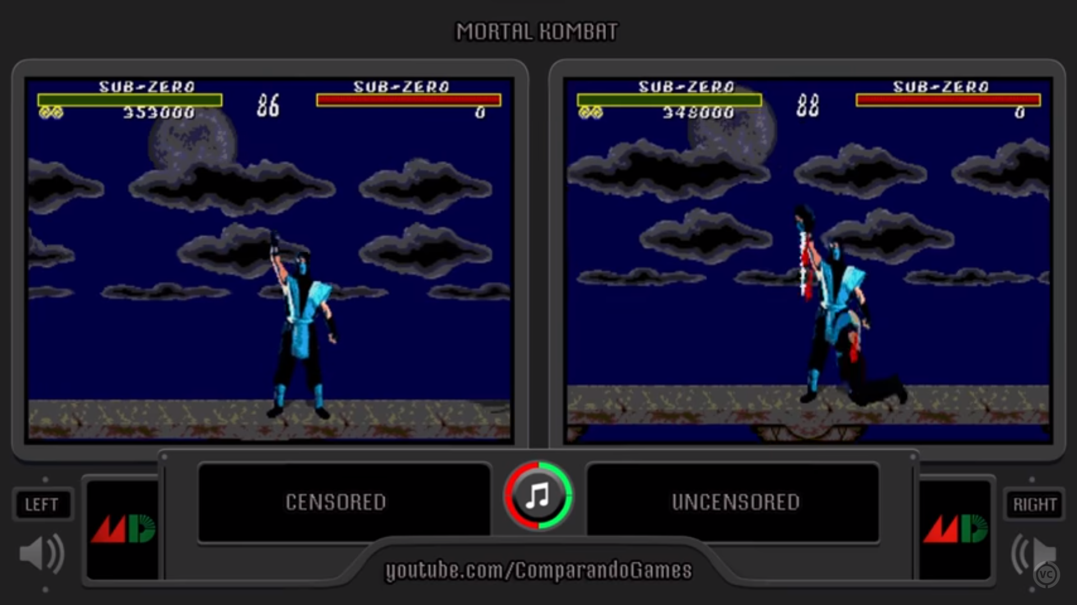
Fig 4. SNES & Sega Genesis Mortal Kombat Comparison (VCDECIDE, 2017)

This image comes from a youtube video, comparing the uncensored and censored version of Mortal Kombat, on the left Nintendo’s censored version, and on the right the original uncensored version. The fatality scene in the censored version, ends with the victim off screen, whereas the original uncensored version, had the player, rip the victims head off. This scene is a gruesome scene, especially for a game that had no law protecting it from reaching children’s eyes. Nintendo’s decision was seen as both a justifiable decision and a wrong decision. The lost sales and got a lot of hate, but at the same time they did prevent consumers on their platform from seeing these images when playing the game. With every decision made, a butterfly effect will always occur after, that butterfly effect resulted in the PEGI & ESRB age rating systems. One of the testimonies to the video game censorship congress meeting came from Robert Chase, of the National Education Association warned the meeting about censoring material in video games, however he was all for the Age rating system., and supported it fully, stating that parents would have “appropriate tools for making reasonable judgments.” (Chase, cited in Kent 2002)

Should Video Games be censored?

Like most media, Video Games are no stranger to controversy, censorship and backlash. Thus censorship is often out in place by developers, platform holders and age rating executives. One website online hosts debates and allows users to post their thoughts and opinions on a question put forward by the website. With each post the Yes and No bar will update to reflect the percentage of all responses to the debate. The question used to back up the claims of this dissertation was “Should Video Games be Censored?” this question resulted with a 16% of all responses favoring the Yes games should be censored, and the remaining 84% are against censorship in video games. This shows that the majority of consumers of video games do not agree with video games being censored in the industry, but unfortunately have no control over the censorship rules. One argument for censorship comes from user ‘wc’, stated that they believe that parents do not know what games are violent all the time, and this can cause children to become violent because of the games they have played. (wc, cited in Debate.Org) this view on games only covers violence and claims that these games are what cause violence in children, on the other hand user ‘CanadianTotoro’ believes that “Video games are art, and video game developers are artists. If they want to express their art through gore, they are 100% entitled to do so.” (‘CanadianTotoro, cited in Debate.Org) additionally, due to the various comments about Video Games causing Violence in children on the flip side of the coin, they added that video games do not cause violence, and that it has been proven that video games reduce violent tendencies in people.
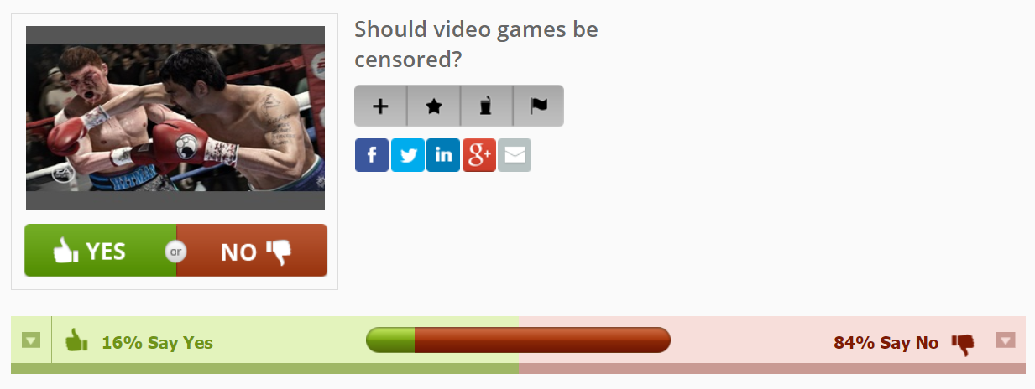
Fig 5. Results from Debate.org (Debate.org, 2018)

One of the most common claims against video games, is that it causes children to become violent and copy what they see in the video games. It is believed that children are influenced by video games and a lot of parents and government officials say that video games should be banned or censored heavily, this includes Sony’s new policy involving sexual content. A lot of studies have been carried out to test this theory, yet even with these studies, peoples opinions remain. An article from ScienceDaily took an experiment from the University of York, according to the article a series of experiments involving 3,000 participants, the team were able to demonstrate that Video Games, do not ‘prime’ the players to behave in different ways. One method they used, was exposing players to ragdoll physics, the physics that make the characters look and act more realistic, and had others play games without ragdoll physics,, following that the players were subjected to Word Association Games, the results were expecting more violent words, however this was not the case (University of York, 2018)

However, one study isn’t enough to prove anything, and many scientists, psychologists and more have carried out various studies, one author states “there was a sharp rise in research studies examining the link between child violence and video games though the results were rarely consistent.” (Vitelli, 2013). The lack of consistent research found across researchers, shows that there is no true hard evidence correlating to whether Video Games make children violent, or not. This lack of proof is what makes the age rating system remain in place, and censorships happen to avoid controversy and problems. If video games are allowed to show over the top gore, sexual scenes and other sensitive scenes without any form of age rating or censorship, then parents will be at risk of exposing their children to scenes they don’t want them to see, however, if a game has a PEGI rating of 18, then a parent decides if they can play the game or not, the responsibility falls on them for purchasing the game, or leaving payment details on the respected games console of the child. This can be used as an argument both for and against censorship in video games. It can be used for censorship because even though games have age ratings, there are still many ways to bypass this age rating, some stores if they are independent, may allow the children to purchase the games regardless of age, and children can also use the online stores of both game stores and the official console’s digital store. This means that some people would feel like another line of defence is needed before the games hit the shelves. On the flip side, other consumers feel like the age rating is enough, because the ESRB and/or the PEGI age ratings depending on location, will review the games and give age ratings they deem fair to put on the games, ready to retail sale. One author stated that “While the ratings system is technically voluntary, most stores won’t stock unrated games, and the major console manufacturers won’t license them” (Oztan, 2018) this shows that even retailers will refuse to sell these games if they aren’t rated, and the manufacturers won’t license them either, with this in mind, the parent’s are expected to make the decision for their children if they are asked for a game for Christmas or some other event, the parent is more than able to do research on the game and view the age rating before making the purchase for their child. Furthermore, any consumer over or at the age of the game then they’re able to purchase the game with no issues. It is also on the countries laws that add to the decision of censorships, for example Australia’s censorship laws are far more strict than that of Japan and America. And far more content gets cut from games in Australia. This is also seen in Germany, when they had a ban of Nazi symbolism in games. However, due to Games being seen as a form artistic and in some cases historic pieces of art, the nazi symbolism has been un-banned in games if they follow these artistic and historical accuracy guidelines.

How localization and Censorship affects Game Designers?

With every game release, there is always a raw unedited version of the game, this version is the developers intended vision of their game. This could mean the game includes gore, sexual references, drug use, sexual scenes and more, however, these scenes need to be edited if the developer wants to release a game worldwide, this is because each country and culture has its own set of rules about what can be portrayed in Video Games, furthermore if an unedited version of the 1998 game Pokemon Red and Green was released in the USA and UK, almost no one in the country would be able to read the text in the game as it would be Japanese, only a select few in the country who studied Japanese could, this forces companies like Game Freak, Naughty Dog etc to translate their games and localise them if they desire their game to be released worldwide. This affects the game designers because they need to research the censorship laws in each country they plan to release the game in, and also work to remove some features they put in the game if the country won’t allow those scenes or visuals in their country. “The localization process means some extra work for game designers.” (Gamedesigning.org, 2018) this quote can be proven by the game Senran Kagura Burst Re:Newal. Due to Sony censoring a feature of their game on the PS4 release the games release date was halted and delayed while the development team, worked to remove the censored feature on the PS4 versions of the game. Due to this game companies can lose pre orders or take big hits to their sales if people aren’t willing to play the censored game. “As some of you may have noticed during September we temporarily stopped taking pre-orders for SENRAN KAGURA Burst Re:Newal products on our online store. This action was in response to potential production delays which we can now confirm will take place.” (Marvelous Europe, 2018) this shows that the company Marvelous Games had to stop taking their pre-orders, this hurts the business as some comments in their announcement revealed that they pulled out of their order entirely because of the censor, this hurts the company's sales over a feature that a platform holder censored; “preorder cancelled. Thanks for saving me some. Money. Im highly disappointed” (Hong Kong, 2018), another user stated that Sony has made a lot of money from the series and that they are cancelling their pre-order because of this censorship (Joshua Neil Ortiz, 2018)

Video Game censorship will always face backlash from fans, and will also be accepted widely by other people, some who may have more authority than regular fas, like government officials, or people in charge of the press, affecting the news fans hear about games. The major argument for censorship is that children can be affected by what they see and play in media, and Video Games are one of the most accessible forms of media. One author talking about censorship stated that children will always be able to access mature content if it exists, additionally, when inappropriate content is censored it doesn’t always affect sales. (Garbus, 2017) This shows that censorship doesn’t strongly affect game developers all of the time, this can be seen in Fire Emblem; Fates, this game published by Nintendo and created by Intelligent Systems had an entire mini game cut from the game due to censorship and incorrect Japanese translation, this game received majo backlash for the removal of the feature, however Nintendo stated that it sold 300,000 copies stateside, far more than its predecessor Fire Emblem Awakening which sold 180,000 in its first month. (Nintendo cited in, Polygon, 2016) On the flip side, censorship is still capable of affecting sales, this can be seen in Mortal Kombat on the SNES vs the Sega Genesis, where Nintendo’s version was censored and sold less than the uncensored Sega Genesis version of the game.

Conclusion

In conclusion, censorship in any form of media will always will drawbacks. With the consequences of the first Video Game controversies and censorships resulting in an offication of the age rating system, and a congressional meeting about the case as it was seen as a serious problem at the time. Video games have long been seen as a bad thing in the community, especially from the press and parents of children, who speak out. However, there is also a lot of people who are against censorship in video games.This results in varying opinions across the media, with some people for censorship laws, who want to monitor what their children see. Various games have been affected by censorship and bannings, like Mortal Kombat, South Park and more recently Senran Kagura. Each instance of censorship affects developers sales and reputation, moreover, platform holders are responsible for the games they allow on their platforms. Censorship should not be issued out at every turn, as video games are a form of art, just like paintings, music and movies, they are given age ratings to let consumers know of the mature content in the games themselves. This does not mean however that censorship and bans should never happen, as each culture is different and have different views on what should be allowed to be shown commercially and what should not.

Bibliography

Books

Herman, L. (1994). Phoenix: The Fall and Rise of Home Videogames. 2nd ed. Union, NJ: Rolenta Press.

Kent, S. (2002). The ultimate history of video games. New York: Random House International.

Websites

Gamedesigning.org. (2018). Beginners Guide to Game Localization. [online] Available at: https://www.gamedesigning.org/gaming/localization/ [Accessed 11 Nov. 2018].

Garbus, A. (2017). Censorship in Video Games on the Rise. [online] ECHO. Available at: https://trinityecho.com/17471/features/censorship-in-video-games-on-the-rise/ [Accessed 11 Dec. 2018].

Polygon. (2016). Fire Emblem Fates has series' biggest stateside debut ever. [online] Available at: https://www.polygon.com/2016/2/24/11105150/fire-emblem-fates-launch-sales-record [Accessed 11 Dec. 2018].

Marvelous Europe. (2018). Important Product Update for SENRAN KAGURA Burst Re:Newal. [online] Available at: https://marvelousgames.com/blogs/news/important-product-update-for-senran-kagura-burst-re-newal [Accessed 12 Nov. 2018]

Dyce, A. (2013). ‘South Park’ Creator Addresses ‘Stick of Truth’ Censorship. [online] Game Rant. Available at: https://gamerant.com/south-park-stick-of-truth-censorship-comments/ [Accessed 28 Nov. 2018].

Moses, T. (2014). Why has the South Park: Stick of Truth game been censored in Europe?. [online] the Guardian. Available at: https://www.theguardian.com/technology/2014/mar/05/south-park-stick-of-truth-game-censored-europe [Accessed 30 Nov. 2018].

Iggy (2018). Senran Kagura Producer: Future Games Will Require More Time To Develop Due To Strict Regulations | NintendoSoup. [online] NintendoSoup. Available at: https://nintendosoup.com/senran-kagura-producer-future-games-will-require-more-time-to-develop-due-to-strict-regulations/ [Accessed 4 Dec. 2018].

Taylor, H. (2018). Sony delays PS4 release of Senran Kagura game over sexually explicit content. [online] GameIndustry.biz. Available at: https://www.gamesindustry.biz/amp/2018-10-15-sony-delays-ps4-release-of-senran-kagura-burst-re-newal-over-sexually-explicit-content-featuring-underage-girls [Accessed 5 Nov. 2018].

Galajo. (2018). Sony: PS4 Censorship Policies Are To Protect Kids & Match "Global Standards" | NintendoSoup. [online] Available at: https://nintendosoup.com/sony-ps4-censorship-policies-are-to-protect-kids-match-global-standards/?fbclid=IwAR1WYzZ8kAu1q4x3CmuKH4nyMwp2-9g0SnsXDaL_R3CZxvwa3IXKrn2VJEA [Accessed 4 Dec. 2018].

Siliconera. (2018). Omega Labyrinth Z For PS4 And PS Vita Cancelled In The West - Siliconera. [online] Available at: http://www.siliconera.com/2018/06/25/omega-labyrinth-z-for-ps4-and-ps-vita-cancelled-in-the-west/ [Accessed 5 Dec. 2018].

Hayes, M. (2018). Omega Labyrinth Z Cancelled in the U.S. for Sexualizing Young Characters. [online] WWG. Available at: https://comicbook.com/gaming/2018/06/25/omega-labyrinth-z-cancelled-north-america-europe-sexual-content/ [Accessed 5 Dec. 2018].

Duncan, A. (2014). South Park: The Stick of Truth will be censored in Europe. [online] destructoid. Available at: https://www.destructoid.com/south-park-the-stick-of-truth-will-be-censored-in-europe-271128.phtml [Accessed 6 Dec. 2018].

University of York. (2018). No evidence to support link between violent video games and behaviour. [online] Available at: https://www.york.ac.uk/news-and-events/news/2018/research/no-evidence-to-link-violence-and-video-games/ [Accessed 6 Dec. 2018].

Vitelli, R. (2013). Can Video Games Cause Violence?. [online] Psychology Today. Available at: https://www.psychologytoday.com/gb/blog/media-spotlight/201304/can-video-games-cause-violence [Accessed 6 Dec. 2018].

Crossley, R. (2014). Mortal Kombat's impact lives on. [online] BBC News. Available at: https://www.bbc.co.uk/news/technology-27620071 [Accessed 6 Dec. 2018].

Oztan, A. (2018). Can Parents Trust the ESRB Ratings?. [online] Tom's Hardware. Available at: https://www.tomshardware.co.uk/esrb-rating-history-and-usefulness,review-34389.html [Accessed 6 Dec. 2018].

Image References

Figure 1: Ubisoft (2014). EU and Australian Censorship. [image]. [Accessed 19 Nov. 2018].

Figure 2: Marvelous Inc. (2018). Intimacy Mode in Previous Installments. [image] Available at: https://www.thehindupatrika.com/senran-kagura-burst-renewal-western-release-delayed-after-sony-requests-intimacy-mode-is-removed/ [Accessed 4 Dec. 2018].

Figure 3: Censorship Comparison. (2018). [image] Available at: https://nintendosoup.com/wp-content/uploads/2018/10/NNCensor-600x428.jpg [Accessed 4 Dec. 2018].

Figure 4: VCDECIDE. (2017). Mortal Kombat 1 All Fatalities (Censored vs Uncesored) Side by Side Comparison. [Online Video, Image]. 4 August 2017. Available from: https://www.youtube.com/watch?v=JibV4da8KIo. [Accessed: 6 December 2018].

Figure 5: Debate.Org (2018). Debate.Org Results. [image] Available at: https://www.debate.org/opinions/should-video-games-be-censored [Accessed 5 Dec. 2018].

