NAME:  SURNAME: | MIRELA NICOLETA  PAVAL
STUDENT ID: | 2410788
MODULE TITLE: | (BMSW4009_CARD)  Effective Teamworking and Communication  (BMSW4009_CARD)
REPORT | EFFECTIVE COMUNICATION AND ADAPTABILITY IN TEAMWORK

REPORT

EFFECTIVE COMUNICATION
AND
ADAPTABILITY IN TEAMWORK

Table of Contents
Introduction 3
Definition of Teamwork 3
MY Natural Role in Teams 3
Findings 3
Application of Teamwork Models and Theories 3
Specific Examples from Personal Experience 6
Conclusion 7
Summary of Key Findings 7
Future Actions for Effective Teamwork 7
Reference 8

Introduction

Definition of Teamwork
Teamwork is the process of individuals working collaboratively towards a shared goal by utilising their strengths and complementing each other’s abilities (Kvellestad, Stana and Vatn 2021). Effective teamwork requires open communication, trust, mutual respect, and a clear division of roles and responsibilities. It plays a crucial role in both professional and academic settings, as it enhances problem-solving, efficiency, and innovation (Prada, Mareque and Pino-Juste, 2022). In a successful team, members actively contribute, listen to different perspectives, and adapt to challenges collectively. The ability to work well in a team fosters personal growth and improves organisational outcomes, making it an essential skill in today’s fast-paced and interconnected world.

My Natural Role in Teams
Using Belbin’s Team Roles theory, my natural role in a team aligns closely with the coordinator. I am skilled at organising tasks, clarifying objectives, and ensuring that each team member contributes effectively. I naturally take on leadership responsibilities, facilitating discussions and resolving conflicts to maintain group cohesion. Leaders need to find a balance between power and teamwork to be effective. To become more flexible as a manager who shares tasks and makes plans, I want to take on different jobs that require different skills. Working closely with others can help me get better at coming up with creative solutions to problems and looking at things from different points of view.

Findings

Application of Teamwork Models and Theories
Working closely with teams as they go through different stages of growth has helped me become a better leader. Tuckman’s approach of forming, storming, norming, and acting helps us understand how groups work. In the early stages of joining, members are excited and don’t know each other well. During the storming stage, when different points of view come up, and the team’s relationships are set, problems often arise (Robb, 2022). After these problems are solved, teams move on to the norming stage, where they become more cohesive and work together better. The goal is to lead the team through storming so that they can do useful work during the performance, which is marked by working together, depending on each other, and focusing on achieving common goals. Seeing this natural development happen in real life has given me the skills to help teams work well together. Recognising these stages has helped me manage conflicts better and remain patient during the initial stages of teamwork.
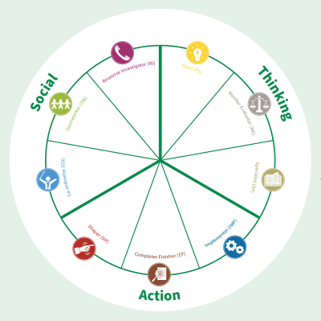
Figure 1: Belbin’s Team Roles theory
Source: Belbin (2025)
Belbin’s Team Roles theory has also influenced my self-awareness in group settings. As a Coordinator, I have recognised my ability to delegate effectively and ensure group cohesion. However, working with individuals who assume roles such as Implementers or Shapers has taught me the value of different contributions. Implementers bring structure, while Shaper drive progress, pushing the team forward. Understanding these roles has allowed me to appreciate diverse working styles and adapt my leadership approach accordingly.
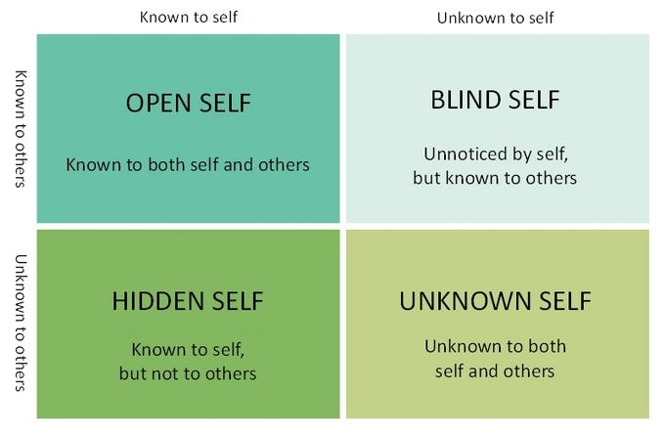
Figure 2: The Johari Window model
Source: Alberta (2020)
The Johari Window model has been useful in enhancing self-awareness and communication within a team (Silva et al. 2025). By receiving feedback from peers, I have identified blind spots in my teamwork approach, such as assuming leadership without always seeking consensus. Being more open to feedback has improved my ability to collaborate and build trust within a group.
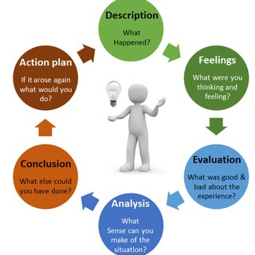
Figure 3: Gibbs Reflective Cycle
Source: Dutta (2023)

According to Bassot (2024), Gibbs's Reflective Cycle has provided a structured approach to evaluating teamwork experiences. Reflecting on both successful and challenging situations has allowed me to identify what worked well and what areas need improvement. Applying this reflective model has strengthened my ability to learn from past experiences and develop more effective teamwork strategies in future collaborations.

Specific Examples from Personal Experience
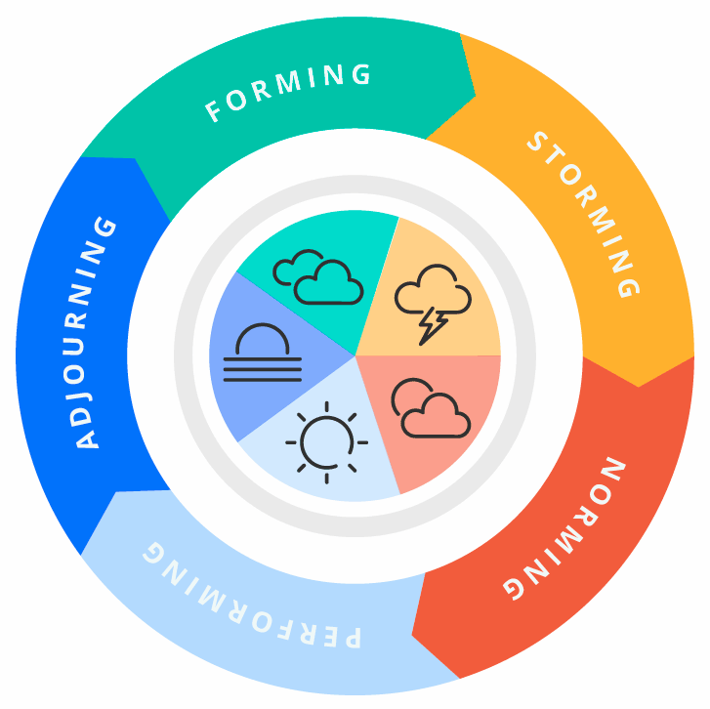
Figure 4: Tuckman’s Stages of Group Development
Source: Iqbal (2021)
One successful teamwork experience occurred during a group research project where we had to analyse market trends and present our findings. I naturally took on the role of Coordinator, ensuring that tasks were evenly distributed based on each member’s strengths. The project progressed through Tuckman’s stages, with initial hesitancy in forming, minor disagreements in storming, and eventual collaboration in norming (Patterson, 2022). By the time we reached the performing stage, our team worked seamlessly, meeting deadlines and delivering a well-structured presentation. Understanding our team roles allowed us to utilise each member’s strengths effectively, resulting in a successful outcome. A more challenging experience occurred during a different group assignment where miscommunication and lack of participation created obstacles.
At the storming stage, conflicts arose due to unclear expectations and differing working styles. Some members, including myself, assumed leadership roles, leading to power struggles and inefficiency. Applying the Johari Window model, I realised that my blind spot was assuming others shared my sense of urgency without openly discussing expectations. By getting opinions on how I lead, I was able to improve communication and better answer everyone’s issues. Using Gibb’s model to help me think about this event, I learned some useful lessons. I learned how important it is to set clear goals from the start of projects by having open conversations. Also, being flexible as a leader and letting everyone on the team contribute is better than giving orders. Going forward, I will use better ways to communicate and work to make sure that everyone feels like their unique contributions are valued. Putting group ideas into practice made them even more important. By using structured reflection to look back on problems I’ve faced in the past and make changes, I have strengthened my working skills in important areas like adaptability, collaboration, and leading effective group dynamics. This process has made me a better team player for future projects.

Conclusion

Summary of Key Findings
Thinking about the people I have collaborated with in the past has helped me understand how academic models apply to real-life group situations. Tuckman’s model of team growth helped me understand and get through the problems that I knew I would face during the “storming” phase of working together. Belbin’s Team Roles allowed me to recognise my strengths as a Coordinator while appreciating the contributions of other roles. The Johari Window improved my self-awareness, helping me communicate more openly, and Gibb’s Reflective Cycle provided a structured approach to learning from past experiences. These insights have enhanced my ability to work collaboratively, resolve conflicts, and contribute effectively to team success.

Future Actions for Effective Teamwork
To further develop my teamwork skills, I plan to focus on improving communication and adaptability. Setting clear expectations at the start of a project will help prevent misunderstandings, and I will encourage open discussions to address any concerns early. Additionally, I aim to be more flexible in my role, stepping out of my comfort zone to take on different responsibilities within a team. Seeking regular feedback will allow me to identify areas for improvement and strengthen my collaboration skills. Lastly, I will consciously apply teamwork models in future projects, using structured approaches to enhance group dynamics and productivity.

Reference
Alberta, J., 2020. Utilising Johari Window for Greater Self-Awareness - xPersona Labs - Medium. [online] Medium. Available at: <https://medium.com/xpersona-labs/utilizing-johari-window-for-a-greater-self-awareness-d41ebb35bcff> [Accessed 11 March 2025].
Bassot, B., 2024. The reflective journal. Bloomsbury Publishing.
Belbin, 2025. Belbin. [online] Belbin.com. Available at: <https://www.belbin.com/resources/articles-directory/team-role-communication-styles> [Accessed 11 March 2025].
Dutta, S., 2023. Figure 1. Gibbs’ reflective cycle (Adapted from Gibbs, 1988). [online] ResearchGate. Available at: <https://www.researchgate.net/figure/Gibbs-reflective-cycle-Adapted-from-Gibbs-1988_fig1_371536633>.
Iqbal, A., 2021. The 5 Stages of Team Development - Ali Iqbal - Medium. [online] Medium. Available at: <https://aliiqbalch.medium.com/the-5-stages-of-team-development-f6ba696ea26e> [Accessed 11 March 2025].
Kvellestad, R.V., Stana, I. and Vatn, G., 2021. Working Together: Cooperation or Collaboration?.
Patterson, D., 2022. 4.5. In-depth Look: Tuckman’s Model–Five Stages of Team Development. Strategic Project Management: Theory and Practice for Human Resource Professionals.
Prada, E.D., Mareque, M. and Pino-Juste, M., 2022. Teamwork skills in higher education: is university training contributing to their mastery?. Psicologia: Reflexao e critica, 35, p.5.
Robb, M.A., 2022. Stages of group development and group preparation. Group Art Therapy, pp.107-115.
Silva, D.B.D.S., Becerra, C.E.T., Feitosa, A.D., Albuquerque, A.P.G.D., Melo, F.J.C.D. and Medeiros, D.D.D., 2025. Evaluating the Leader’s Profile from the Team Members’ Perspective: A Case Study Applying Johari’s Window. Standards, 5(1), p.5.

