Assignment Title: Job interview
Programme: Cert HE Business Skills for the Workplace
Module: Employability and Career Development
Module code: LCLM4005
Student name: Gilda Banica
Student ID number: 2515680
Date: 19/07/2026
University: University of Wales Trinity Saint David

Job advertisment
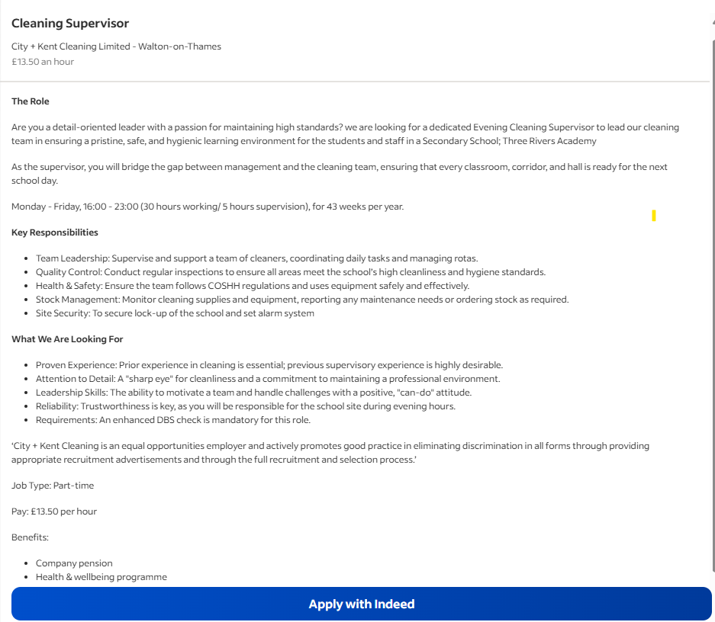

Gilda Banica

07344190000  gildabanica70000@gmail.com

Professional profile
Over eight years' experience of commercial and hospitality cleaning I am a dedicated cleaning supervisor and business owner, and currently the proud proprietor of Deep Cleaning Ltd, offering professional commercial and deep cleaning solutions. With an excellent understanding of rostering, setting up daily tasks, supervising teams, completing quality assurance checks, monitoring stock levels, and ensuring safe work practices that comply with the Control of Substances Hazardous to Health, I am currently undertaking a Certificate in Higher Education Business Skills at Arden University.
Core competencies
- Team leadership Cleaning
- Motivation Team-management
- Resource management to daily work tasks: Control of Substances Hazardous to Health regulations
- Site inspections and quality controls
- Rotas; Health and safety, stock ordering, cleaning equipment
- Time management and communication skills
- Attention to detail
- Customer service
- Reliable and trustworthy
- Problem-solving skills
Professional experience
Director / Cleaning Supervisor | Deep Cleaning Ltd | 2025 – Present
- Direct and supervise the daily running of the cleaning business which offers deep and commercial cleaning.
- Control and supervise cleaners, assign them their tasks and ensure quality and standard of work.
- Check cleaning results, ensure that COSHH and health & safety procedures are being followed.
- Monitor customers’ satisfaction, stock-keeping, rotation of cleaners and equipment usage.
Cleaning Supervisor | Holiday Inn | 2015 – 2020
- Managed and motivated a team of cleaners ensuring all planned activities was successfully delivered.
- Daily job programs and staff rota’s were planned to create coverage for the whole day/cleaning duties were prepared to prevent holes and missed areas being clean.
- Monitored regular quality standards in order to keep high standards of hygiene and cleanliness consistently.
- Ensured cleaning chemicals and equipment were used in a safe way to comply with the COSHH regulations and health and safety policies.
- Reported maintenance issues observed, supervised cleaning supplies and ordered replacements as necessary.
- Work collaboratively with management to uphold hotel standards, respond to issues and ensure a professional image of the establishment at all times.
- Provide training to new members of the cleaning team and provide ongoing support and mentoring.
Cleaner | Marriott Hotels | 2010 – 2013
- Maintained five star cleaning procedures and standards in all common areas, guest rooms, and corridors.
- Worked hard and maintained a fast pace in order to comply with all cleaning duties within required daily timeframe.
- Safely and correctly operated cleaning equipment and cleaning solutions.
- Promptly escalated health and safety concerns and any building defects.
- Supported and co-operated with colleagues and management to ensure total customer satisfaction.
- Remaining positive and approachable within a fast-paced environment.
Education
Certificate in Higher Education – Business Skills – University of Wales Trinity Saint David | Present
Additional information
- Ensured a 5-star cleaning standard across corridors, guest rooms and all public spaces.
- Followed rigorous daily cleaning programmes in an efficient and organised way.
- Worked safely and correctly with all cleaning tools and chemicals.
- Promptly notified manager or relevant team of maintenance faults and safety/health issues.
- Assisted manager and team to ensure that guest satisfaction was maintained at a high level.
- Maintained a good attitude and a professional demeanour at all times within a demanding workplace.

Cover letter
Gilda Banica
07344199802
gildabanica70@gmail.com

Dear Hiring Manager
Please accept my application for the Cleaning Supervisor – Evening Shifts vacancy at Three Rivers Academy with City + Kent Cleaning Limited.
My background and experience would allow me to be an excellent fit for this role. I am currently the owner of my own company, Deep Cleaning Ltd, and have over 8 years of cleaning experience in the hospitality and cleaning industries including 3 years as a cleaner for Marriott Hotels and 5 years as a Cleaning Supervisor at Holiday Inn. My company have enabled me to further develop my leadership, management, customer service, and problem-solving skills and I have accumulated a significant amount of experience when it comes to managing people, creating shift patterns, carrying out quality inspections and ensuring all duties are carried out to the highest of standards.
Within my previous role as a supervisor, I was responsible for assigning daily tasks to staff, creating staff rotas, training staff, supervising the team, monitoring cleaning standards, controlling stock and ensuring all cleaning equipment and products were used safely in line with the COSHH and health and safety regulations. I understand the importance of reliability, trust and a meticulous approach particularly when it comes to site security and ensuring all areas are clean and safe.
I am particularly interested in joining City + Kent Cleaning due to your commitment to maintaining the highest standards within the school environment and believe my hands-on experience, leadership and commitment to delivering quality results would benefit your team greatly from the start. I am happy to complete an Enhanced DBS check when required.
Alongside my practical experience, I am currently in the process of completing a Certificate in Higher Education in Business Skills at Arden University, further refining my management and organisation skills.
Thank you for your time in reviewing my application. I look forward to the opportunity to discuss my passion for the industry and experience and how it could be beneficial to your team.
Faithfully yours,
Banica Gilda

