INTERNET TECHNOLOGY AND SECURITY

Hyper-fort Bring Your Own Device

version 1.0

Author: Matthew James

No.: 1809299

Contents Table of Contents
1. Introduction 3
2. What is BYOD? 3
2.1 Why BYOD? 3
2.2 Using BYOD 4
2.2.1 General Data Protection Regulations 4
2.2.2 Confidentiality. Integrity. Availability C.I.A Triad 4
2.2.3 Advantages and Disadvantages of using BYOD 4
2.2.4 Monitoring personal device usage 5
3. Working with the Device 6
3.1. How will staff in the workplace access company data? 6
3.2 How will staff work when not within the workplace? 6
3.2.1 What is a Virtual Private Network? 6
3.2.2 How does a Virtual Private Network work? 7
3.3 Explaining the network 7
4. Keeping data safe yet accessible 9
4.1 Frequently asked questions 9
5. Conclusion 10
6. Bibliography 10
Appendix A: Bring Your Own Device Policy 12

Internet Technology and Security

Introduction
Hyper-fort is a consultancy company specializing in the energy sector which is currently under extreme pressure from its staff and clients to allow access to the company’s network and resources from a person device, this document highlights the Bring your own technology (BYOT)/Bring your own device (BYOD) and will go into depth on maintaining, supporting devices as well as the security feats such as client information and company intellectual property that the company may face when trying to implement BYOT/BYOD.

What is BYOD?
As defined by ‘Techopedia’” Bring your own device (BYOD) refers to employees who bring their own computing devices - such as smartphones, laptops and tablet PCs - to work with them and use them in addition to or instead of company-supplied devices” [1].
Since BYOD has been introduced in 2009, companies, businesses and schools around the world have taken an interesting in this technique as it is possible to reduce costs greatly and allows users to access information within the company’s network at the workplace or at home.
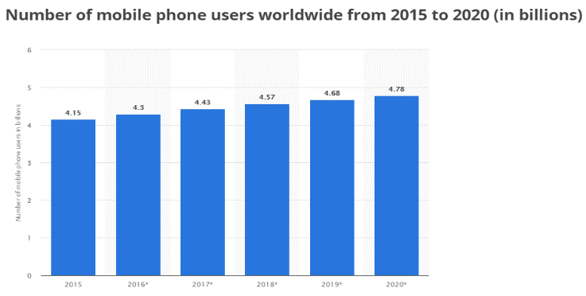
Figure 1- Mobile phone users from 2015 -2020(in billions) [2]

2.1 Why BYOD?
Bring Your Own Device is now a highly accepted part of businesses, the influx over the last decade of mobile and portable devices which is still growing to this day as shown in figure 1 [2].As a result of this trend “studies reveal that around 53 percent of employees are using their own technology for work purposes” [3] as found by Markeluk.com. Companies such as Apple, VMware and Citrix and some of the leading companies when introducing BYOD to the workplace. [4]

Companies that are using BYOD are saving money by introducing this business strategy as they do not need to procure devices then distribute to each user saving money in the short term and potentially in the long term if BYOD works out well.
As reported by DZone these are the key areas on which BYOD will save your company money:

- “Hardware
- Telecommunications
- Support and Training
- Improved employee retention
- Fewer company upgrades” [5]

Additionally, users that are forced to use company devices may receive it negatively, as they feel more comfortable to use their own devices to do their work, this would affect the mood of the user changing their productivity towards work, this may increase profits towards the business as better work may be produced compared to an unhappy worker.

Using BYOD
A company’s biggest concern is the protection of its data; Clients data and company data take priority as law in place such as the data protection act and GDPR along with other laws and policies which require a company to have a certain degree of security and protection of client data. Although, this data still needs to be accessible by the staff and 3rd parties involved. Confidentiality, integrity and availability also known as the C.I.A Triad.

2.2.1 General Data Protection Regulations
Recently a General Data Protection Regulations (GDPR) has come into place companies must meet those standards in order to trade within the EU “GDPR applies to any organisation operating within the EU, as well as any organisations outside of the EU which offer goods or services to customers or businesses in the EU.” [6] Failure to comply with the newly set GDPR laws can result in fines from 10 million euros up to 4% of that businesses annual global turnover as for some businesses can lead to billions being lost, the fines do depend on the severity of the breach which goes to a cap of 20 million or the 4%(whichever is more) [6].

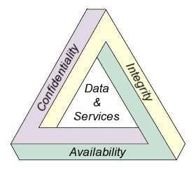
2.2.2 Confidentiality. Integrity. Availability C.I.A Triad
Figure 2- C.I.A Triad infographic [17]
The C.I.A triad is a model made to guide policies for information security within an organisation. C.I.A in this circumstance stands for Confidentiality which is a set of rules that limit the access of information., Integrity which is the assurance that the information being stored is trustworthy and accurate, lastly, availability which is a guarantee that information is available and reliable access to authorized users. [7]

2.2.3 Advantages and Disadvantages of using BYOD
With BYOD making its way around the years in the last 9-10 years is it very important to understand its strength and weaknesses that it has to offer.
Advantages | Disadvantages
Convenience – the convenience of the information as told by the C.I.A triad needs to be readily and available at all times within the workplace or at home. | Troubleshooting device – having a personal device the support from a structure company will be very little as they will have a wide variety of different devices connecting to the network and may be unable to discover the problem with a device causing delays to work.
Accessibility – Accessibility is one of the most crucial advantages as it is saying that all information will be readily available to be read and downloaded if required. | Distractions – It’s not unusual that users may become less productive as they have access to personal applications such as Facebook and Twitter which can lead them to doing no work.
Familiarity – the user will already be very familiar with their own device making it easier, cost and time effective. This can help the mood of the employee and produce better work. | Security - the security threats that a BYOD face is a long list unless taken seriously to prevent this. Security is not cheap and can cost a rather large sum of money.
Productivity – Productivity levels can be heavily increase as the user will most likely be happier using their own device than being forced to learn a company bespoke device. | Exit Procedures – the user may one day leave the company and have to delete all of their data in accordance to the policies this includes personal data and company data on the device.
Cost savings – the cost of procuring devices can add up, the tools and equipment costs for a business | Lost or stolen – lost or stolen devices are potentially a major security breech as unauthorized personnel can access the company network, additionally this will prevent the user from being able to do work as they will have no device.
This information was obtained by looking at multiple resources and combining them into a single table. [5] [8] [9]

2.2.4 Monitoring personal device usage
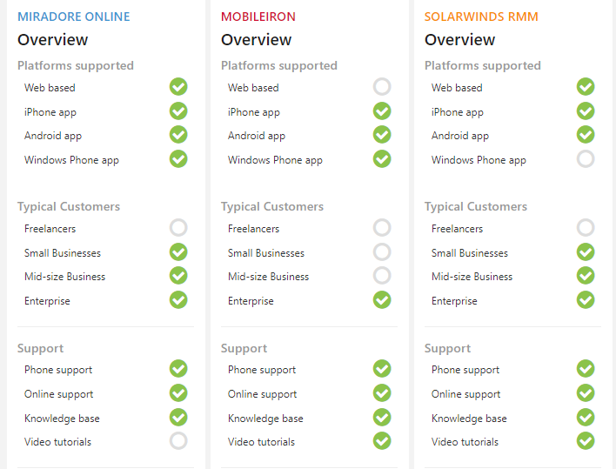
When implementing BYOD companies will have many different users with many different types of devices connecting to the network. There needs to be a way for users to connect securely and monitor their activity, as well as to not congest the network.
Figure 3 - Comparing monitoring software [18]

Researching which personal monitoring software I have found three software’s that would be suitable.
Miradore Online
MobileIron
SolarWinds RMM
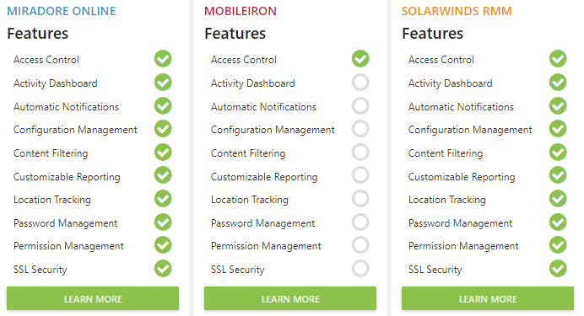
Figure 4- Features of Monitoring software [18]
Using an online comparing site to assist in the decision making. As needing to monitor all communications within the network, Miradore Online would be the best decision.

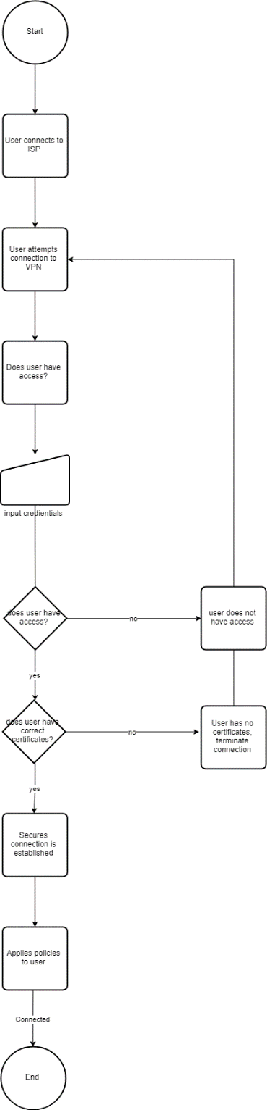
Miradore Online cover all platforms as shown in figure 2. Having all types of Operating system covered allows you to keep all types of incoming and outgoing data monitored. Using data controllers can assist in this as it limits the users on what they can see and interreact with. The features within Miradore Online far outweigh MobileIron as well as the supported devices make this the clear choice. [10]
Figure 5 - Simple VPN remote connection

Working with the Device

3.1. How will staff in the workplace access company data?

Company employees in the workspace will connect via ethernet connection or via wireless connection using the VPN or access points in the area. Ethernet connection may happen within the workplace which will give a direct connection to the data, this will remain the same within any and all companies.

3.2 How will staff work when not within the workplace?
Staff that have been given access to work without coming into the workplace will have to use a Virtual private network (VPN).
Using the VPN users can gain access via secure connection when not in the workplace preventing any attacks that may occur such as a man-in-the-middle-attack.

As illustrated by this flowchart, the connections will start by connecting to the Internet Service Provider, in this case it would be an access point within the office. Attempting to connect to this will prompt the user with login credentials and allow them access if correct. The system will then check if the laptop is a known device and is allowed access after a quick scan of certificates on the device. After this has been achieved the device will be given a secure encrypted connection to company information.

VPN tokens can be given out as an additional step to authenticate. Additionally, two factor authentication via the smartphone messenger or via an application provided by a third party.

3.2.1 What is a Virtual Private Network?
A Virtual Private network is a connection method that is used to add security and privacy when using public and private network such as Wi-Fi hotspots and Internet Service Providers (ISP). [11] Depending on the type of VPN your company has the type of encryption will change a variety of encryption methods can be used as listed below:
- IPSEC

- Layer2 tunnelling protocol

- Point-to-point tunnelling protocol

- Secure Socket Layer (SSL)

- Secure Shell (SSH)

Each of these methods give a different type of connection. [12]

3.2.2 How does a Virtual Private Network work?
A remote access VPN works by using a public network allowing them to access the internet on which VPN software can use this connection to connect to their organisations network. By using a VPN, all information is encrypted when being sent, this stops most attacks when accessing sensitive data. [13]

3.3 Explaining the network

A computer network is made of many different types of hardware like servers, computers and switches with software acting as operating system such Microsoft windows 10 and Ubuntu which is a distribution of Linux.
Each piece of hardware has its own purpose for being in the network, in this network the parts that are being used are:

Server – PT DHCP:

This server is a Dynamic host Configuration Protocol which is used to assign IP Addresses, default gateways and other network parameters automatically. This allows us to not have to go into each device and manually apply a static IP which will take a lot of time to do especially within a company with many devices let alone personal devices which can change each day. This must be configured correctly otherwise the network will not function.

Server – PT DNS

This Server is a Domain Name System, this server controls all of the domain names on the network by translating them into IP addresses. DNS makes it easier for the user to remember websites, without a DNS server the user would have to remember the IP address to each webpage they want to visit. This must be configured correctly in order to work with a Web Server to visit webpages.

Server – PT Mail Server
A Mail Servers job is to enable users within the network to send and receive emails from within the network and outside, this must be configured correctly otherwise users will not be able to communicate over email.

Server -PT Web Server
A webserver work with the DNS to server as that connection to the internet.
This server is a collection of files that form webpages. The server does this over HTTP as well as several other protocols. The server acts as the medium between the user and the internet ensuring a secure connection. In order to browse the internet this is needed.

Server -PT AAA
A Triple A server stands for Authentication, Authorization, and accounting. The purpose of this server is to interact with network access and gateway servers in order for remote connections. For any external system to connect to the network, this serve will be needed to give the assurance that the user is from the company. This is under the assumption that Hyper-fort will be configuring the server.

Switch
A switch is a device that allows multiple devices to connect and exchange data with each other by using packer switching to receive, process and forward data. This is a key part of the network as it allows the entire network to function over an ethernet connection. This is under the assumption that Hyper-fort will be configuring the switch and shutting down any ports that will pose threats.

Access Point
An access point is used so that smart devices and other wireless devices may connect to the network once entering a pre-shared password to the network. The password must be configured so that no unauthorised access can be given. This is under the assumption that Hyper-fort will be configuring the access points.

Server -PT VPN
A VPN server or VPN concentrator is used to provide a secure creation of VPN connections and delivery of messages between different VPN nodes.
The main features are to establish and configure VPN tunnels, authenticate users, assign tunnel/IP addresses to users, Encrypt and decrypt data and to ensure end to end delivery of data. This is under the assumption that Hyper-fort will be configuring the server.

Fire Wall
A Fire Wall is a security device that monitors all inbound and outbound network traffic and if configured correctly can be set to stop certain malicious traffic and only allow non-malicious traffic into the network. Fire walls are the first line of defence for a network. The network is established between a trusted network and an untrusted network to monitor the traffic between the two. In this network it is placed after the VPN concentrator to protect the inner network from the internet and potential malicious artefact. This is under the assumption that Hyper-fort will be configuring the Fire Wall.

Home Gateway
A home gate way or more commonly known as a router is a device that allows a local area network to connect to a wide area network via a modem. This is needed as to connect to the company’s network via VPN as VPN’s use a public or private network to connect to the user. This is under the assumption that Hyper-fort will be configuring the Gateway.

Computer
A computer is an end user device which can connect to the network via ethernet or Wireless. Computers connect via their Network Interface Card (NIC) as this is the part of the computer that makes the connection. Switches are needed for ethernet connection within the workplace for the computer to connect. This is under the assumption that Hyper-fort will be configuring the computers and their policies.

Laptop
A laptop is similar to a computer, they both have ethernet and wireless capabilities so that they can connect to most networks although, laptops are typically less powerful compared to its computer counterpart but offers portability. This device will most likely be used to connect via private or public networks when outside of the workplace, this is where the VPN server is needed so that this device can interact with the network. This is under the assumption that Hyper-fort will be configuring the laptops and their policies.

Tablet / Smart devices
Tablets and smart devices are portable wireless devices that have no ethernet connection available to them. Tablets and smart devices allow users to be on the move while connecting wirelessly to the network within the workplace using the wireless access points around the workplace or private and public networks using VPN to connect to the company network. This is under the assumption that Hyper-fort will be configuring the MDM software.

Physical security:

The network will be kept safe within a secure room with physical security, this security includes
- Radio Frequency identification (RFID) (not all present in diagram)
RFID readers will be placed at key points to allow access to rooms, each RFID reader will have different users that are able to access the room. Assuming that this is configured correctly this will prevent unauthorized users from tampering with the hardware within the server room. RFID cars distributed and configured by Hyper-fort.

- Biometrics (not present in the diagram)
Biometrics are being placed on certain doors and is being used as a verification method when any administrative actions are being made as someone could potentially steal an RFID Card and tamper with the systems. By adding this extra security, hyper-fort can replace the systems if tampered with back up hardware. The assumption is that Hyper-fort will be purchasing the software and setting it up.

- Cameras (not all shown on diagram)
Cameras will be set up in key positions to view and monitor the server room. This will work in unison with motion detectors placed within the server room. This is under the assumption that Hyper-fort will be configuring this.

Back up:
Back ups will be placed on and offsite in case of hardware failure as shown on the diagram, this will be handled by Hyper-fort and under the assumption that it will be placed within a secure environment similar to the internal network.

Resilient network:

Due to hardware failures and unforeseen user errors, servers and switch may fail to work for any given reason, by having a robust and resilient network, if taking out one of the switches or servers the network still works. This is under the assumption that Hyper-fort will be configuring the DHCP and any other server so that it will function as such.

Keeping data safe yet accessible

Frequently asked questions

- What type of data is retained by the mobile devices connecting to Hyper-fort network?

All data that has been downloaded will be retained by the user’s device, this includes, personal data, company data and client data. This will be kept secure using a Virtual private network while communicating these files and be encrypted via BitLocker once onto the user’s device as the hard drives themselves are encrypted.

- What is the potential for data leakage when the participating devices leaves the office environment?

The danger of potential data leakage is higher compared to when being in the workplace as the employee may not be in a secure area when viewing sensitive information. Devices will be using tinted windows to assist in stopping eyes from looking at the screen.
BitLocker can also prevent Universal Serial Bus (U.S.B) usage on the local device as they can stop data being transferred from the device to a U.S.B

- How to address the blending of personal and business usage when devices are in office.

Personal devices will be monitored during work hours via Miradore Online making sure that an employee is giving the hours that they are being paid for, no personal data will be read by the staff as Miradore Online can monitor the applications being used such as Google Chrome – Facebook. This information will be used to give disciplinary actions to users at the company’s discretion. Additionally, Firewalls can be configured to prevent connection taking place, so if connecting to Facebook becomes to much of an issue then firewalls can block the connection to the website.

- What strategy to deploy to deal with different brands of devices?

The software package selected to monitor personal devices has compatibility for most operating systems. These operating systems cover IOS such as iPhone, Windows devices such as the Nokia Lumia, Android such as the Samsung S-series as well as web based such as computers and laptops.

- What mitigating strategy will be deployed when the owner of a participating device leaves their employment, or the device is lost, stolen, or fails?

Encryption software BitLocker will be placed onto any device that wishes to connect to the network as a safety precaution of device loss. BitLocker can encrypt the hard drive of user’s devices using the AES encryption method and will un-encrypt them once a password has been entered. Additionally, BitLocker will not boot the system until this password has been entered to ensure that there can be no attempt at accessing command prompt or Power Shell as these applications have the power to override any application on the system. Once the device has been recovered, a technician within the company can unlock the device using the recovery password. Additionally, Location tracking is available for BitLocker but only for window devices. [14] [15] [16]

Conclusion

Hyper-fort can see huge benefits from implementing the Bring Your Own Device approach, as stated in the report in numerous areas the benefits from using this technology can assist users in many different areas such as convenience, productivity and familiarity. The policy although does have some negatives as data leakage will escalate a tremendous amount, users being able to access to company data, this includes Personally identifiable information (PII) which will lead to being fined as per the GDPR laws previously spoken. If Hyper-fort successfully implement Bring Your Own Device and configure the hardware and software the author believes that this will be overall beneficial for the organisation.

Bibliography

[1] | “Bring Your Own Device (BYOD),” Techopdia, ? ? ?. [Online]. Available: https://www.techopedia.com/definition/29070/bring-your-own-device-byod. [Accessed 1 1 2019].
[2] | “Number of mobile phone users worldwide from 2015 to 2020 (in billions),” Statista, [Online]. Available: https://www.statista.com/statistics/274774/forecast-of-mobile-phone-users-worldwide/. [Accessed 1 1 2019].
[3] | “Bring your own device (BYOD): the risks and how to protect against them,” markeluk, [Online]. Available: https://www.markeluk.com/articles/bring-your-own-device-the-risks-and-how-to-protect-against-them. [Accessed 1 1 2019].
[4] | Technavio, “Top 21 Companies in the BYOD Market,” Technavio, 19 3 2015. [Online]. Available: https://www.technavio.com/blog/top-21-companies-in-the-byod-market. [Accessed 6 1 2019].
[5] | I. Paretsky, “How Much Does BYOD Really Save Your Company?,” DZone, 5 1 18. [Online]. Available: https://dzone.com/articles/how-much-does-byod-really-save-your-company. [Accessed 5 1 2019].
[6] | “What is GDPR? Everything you need to know about the new general data protection regulations,” ZDNet, 23 4 2018. [Online]. Available: https://www.zdnet.com/article/gdpr-an-executive-guide-to-what-you-need-to-know/. [Accessed 1 1 2019].
[7] | M. Rouse, “confidentiality, integrity, and availability (CIA triad),” whatis.com, 11 2014. [Online]. Available: https://whatis.techtarget.com/definition/Confidentiality-integrity-and-availability-CIA. [Accessed 5 1 2019].
[8] | R. Raj', “Bring Your Own Device (BYOD) – Pros and Cons for Schools and Students,” MagicBox, 22 2 2018. [Online]. Available: https://www.getmagicbox.com/blog/bring-your-own-devices-byod-pros-cons-schools-students/. [Accessed 5 1 2019].
[9] | J. Blalock, “Are You Aware of these BYOD Advantages and Disadvantages?,” HummingBird Networks, 17 5 2018. [Online]. Available: https://info.hummingbirdnetworks.com/blog/are-you-aware-of-these-byod-advantages-and-disadvantages. [Accessed 5 1 2019 ].
[10] | Miradore, “The Easiest Mobile Device Management Software on the Market,” Miradore, 6 1 2019. [Online]. Available: https://www.miradore.com/. [Accessed 6 1 2019].
[11] | “What Is A VPN?,” WhatSsMyIP, [Online]. Available: https://www.whatismyip.com/what-is-a-vpn/. [Accessed 6 1 2019].
[12] | V. O. Click, “Types of VPN and types of VPN Protocols,” VPN One Click, [Online]. Available: https://www.vpnoneclick.com/types-of-vpn-and-types-of-vpn-protocols/. [Accessed 6 1 2019].
[13] | M. Rouse, “VPN (virtual private network),” Tech Target, 9 2018. [Online]. Available: https://searchnetworking.techtarget.com/definition/virtual-private-network. [Accessed 6 1 2019].
[14] | Microsoft, “Enabling Secure Boot, BitLocker, and Device Guard on Windows 10 IoT Core,” Microsoft, 28 8 2017. [Online]. Available: https://docs.microsoft.com/en-us/windows/iot-core/secure-your-device/SecureBootAndBitLocker. [Accessed 6 1 2019].
[15] | Microsoft, “BitLocker Countermeasures,” Microsoft, 9 6 2018. [Online]. Available: https://docs.microsoft.com/en-gb/windows/security/information-protection/bitlocker/bitlocker-countermeasures. [Accessed 6 1 2019].
[16] | Microsoft, “BitLocker recovery guide,” Microsoft, 17 8 2017. [Online]. Available: https://docs.microsoft.com/en-us/windows/security/information-protection/bitlocker/bitlocker-recovery-guide-plan. [Accessed 6 1 2019].
[17] | I. Sengupta, “CIA-Triad,” ResearchGate, [Online]. Available: https://www.researchgate.net/figure/CIA-Triad_fig1_267795761. [Accessed 5 1 2019].
[18] | “Miradore Online vs MobileIron vs SolarWinds RMM Comparison Chart,” GetApp, [Online]. Available: https://www.getapp.com/security-software/a/miradore-online/compare/mobileiron-vs-solarwinds-msp-rmm/. [Accessed 6 1 2019].

Appendix

7.1 Bring Your Own Device Policy

BRING YOUR OWN DEVICE
POLICY
This document covers Corporate and BYOD devices connecting to the Hyper-fort networks

version 1.0
Author: Matthew James
No.: 1809299

Purpose

Mobile devices such as smart phones, tablets and other wireless connecting devices are important tools for the organisation. These devices can provide users an easy way to complete business goals.
However mobile devices also represent a large risk to information security and data security. If appropriate security applications are not applied to these devices, they can be a conduit for unauthorized access to the company network and infrastructure. This can subsequently lead to data leakage and system infection

Scope
All mobile devices, whether they are owned by Hyper-fort or owned by employees that have access to the network, this will include all mobile devices such as tablets and smart devices.
Exemptions: if there is any need for this, a risk assessment will be conducted.

Policy
Acceptable use

Corporate devices will not be used at any time to:
  - Store any information that belongs to another business or company.
  - Harass others
  - To engage in any outside business activity

Devices and support
All devices that have not been provided by Hyper-fort will not be repaired by Hyper-fort. Please seek help from the manufacturer for any hardware, software or connectivity issues.

Reimbursement

The employee is liable for any and all fault costs with his/her device.

Device Security

      - Devices must be using the following operating systems or later:
      - Android 5, IOS 10, Microsoft windows 10
      - Devices must be protected by at least a six-digit pin
      - Device will lock after a period of time – 10 minutes of inactivity
      - After 5 fail password attempts the device will lock, to re-activate you must visit the Hyper-fort tech team
      - Any and all emails related to hyper-fort must be configured to go through secure encrypted channels
      - The email account must be protected by an eight-digit alpha-numeric password.
      - All devices will have their hard drives encrypted and any inserted media of any type will also be encrypted
      - Personal devices will have a secure email client on which you can only access via your Hyper-fort email account to assist in prevent data leakage to personal device.
      - All devices not procure by Hyper-fort will not directly interact with the internal corporate structure.
      - All devices will keep device location on at all time
      - Devices may be blocked if:
The device has been reported lost, stolen or broken.
Hyper-fort keeps the right to deny access to the network
The user terminates their employment with Hyper-fort

User requirement

      - Users will not share any pin/passwords secret and not allow any type of access to the information provided by Hyper-fort or partners
      - If user suspects that they have been compromised, the user must report this to the Hyper-fort tech team for a full analysis
      - Rooted or jailbroken devices are strictly forbidden from connecting to the network
      - Users must not download or use any pirated or illegal content on their device.
      - Applications must only be installed via the Hyper-fort tech team or approved sources. Installation of code from un-trusted sources is forbidden
      - Users are responsible for informing Hyper-fort tech team if they are leaving the organisation or no longer require the service. The user will be removed and wiped of any and all data.
      - If user suspects that unauthorized access has taken place via a mobile device, the user must report this to the Hyper-fort tech team.

Risk/Liability/disclaimer

      - Hyper-fort will take every precaution to prevent personal data leakage however it is the employee’s responsibility to take additional precautions such as backing up personal data such as documents and photos.
      - Hyper-fort is not responsible for any loss of, theft of, or damage to any device, data, or its part/accessories.
      - Hyper-fort reserves the right to take any disciplinary actions up to and including termination for non-compliance with this policy
      - Hyper-fort reserves the right to terminate the users connection to the network at any time.

