University of Wales Trinity Saint David
Wales Institute of Science and Art


Predictive Maintenance Strategies

Control technology ACMA6001

Lily Mather
2306724
25/09/2026

Word count:
3147
Contents
1 Introduction 2
2 Maintenance Strategies in Industrial Operations 3
3 Condition Monitoring and Fault Diagnosis 5
4 Case Study Model 6
5 Comparative Analysis 7
6 Discussion 12
7 Conclusion and Recommendations 14
8 References 15
9 Appendices 17

Figure 1 - Sensor drift classification learner SVM confusion matrices 7
Figure 2 - Shaft wear classification learner SVM confusion matrices 8
Figure 3 - Tooth fault classification learner SVM confusion matrices 8
Figure 4 - Sensor drift Neural network confusion matrices 9
Figure 5- Shaft wear neural network confusion matrices 9
Figure 6 - Tooth fault neural network confusion matrices 10
Figure 7 - Sensor drift five fold cv confusion matrix 10
Figure 8 - Shaft wear five fold cv confusion matrix 11
Figure 9 - Tooth fault five fold cv confusion matrix 11

Table 1 - Comparison of SVM and neural network classification performance 7
Table 2 - Shaft wear neural network tuning 17
Table 3 - Tooth fault neural network tuning 17
Table 4 - Sensor drift neural network tuning 18

Introduction
Maintenance decisions have a direct influence on the reliability and performance of industrial equipment. In process industries the consequences of an unexpected equipment failure can extend beyond the cost of repairing the failed component, potentially resulting in production losses, secondary equipment damage and increased safety risk. Reactive and time based preventive maintenance strategies attempt to manage these risks in different ways, but neither necessarily reflects the actual condition of the equipment at the point when a maintenance decision is made. Predictive maintenance (PdM) aims to address the limitations by using condition monitoring information to identify deterioration before it develops into functional failure (Adaramola et al., 2024).
Increasing use of machine learning and artificial intelligence has created new opportunities to automate the interpretation of condition monitoring data. However, achieving high classification accuracy alone does not necessarily demonstrate that a model is suitable for industrial deployment. False alarms, missed faults, model interpretability and the reliability of training data can all influence whether a predictive system improves maintenance decision making (Sharma, Mittal and Soni, 2022).
This report investigates these issues through a case study of crude charge pump P – 2201A and its associated drivetrain. A physics-based MATLAB/Simulink model is used to generate synthetic vibration data representing healthy operation and three degradation mechanisms, gear tooth damage, output shaft wear and vibration sensor drift. The use of synthetic data addresses the limited availability of labelled historical failure data, while also raising questions about how well performance achieved in simulation would transfer to real operating conditions. Rather than considering classification accuracy in isolation, the results are evaluated in terms of their implications for false alarms, missed faults, equipment availability, safety and product quality. This provides the basis for determining which approach offers the most appropriate balance of classification performance and practical deploy ability for the refinery scenario.

Maintenance Strategies in Industrial Operations
Maintenance strategy determines not only when equipment is repaired or serviced, but also how an organisation manages the costs and operational risks associated with equipment degradation. Maintenance can broadly be approached through reactive, preventive or predictive strategies. Although predictive maintenance is increasingly associated with modern industrial applications, this does not mean that it is automatically appropriate for all equipment. The consequences of failure, monitoring capability and cost of intervention should all influence the selected maintenance approach (Ighravwe, 2022).
Reactive maintenance involves allowing an asset to operate until functional failure occurs, after which repair or replacement is undertaken. Its main advantage is that the usable life of a component is not sacrificed through premature replacement, while little investment in routine condition monitoring may be required. For non critical, inexpensive or easily replaceable equipment, this can make run to failure a rational engineering decision rather than simply poor maintenance practice. However, its suitability decreases significantly as asset criticality increases. An unexpected failure of equipment within a continuous industrial process may interrupt production, require emergency maintenance and potentially cause secondary damage to connected equipment. The true cost of reactive maintenance can therefore be substantially greater than the cost of replacing the failed component itself (Benhanifia et al., 2025).
Preventive maintenance aims to reduce the likelihood of unexpected equipment failure by carrying out servicing, inspection or component replacement at predetermined time or usage intervals. Compared with a reactive approach, this allows maintenance activities to be planned more effectively and can reduce the risk of disruptive breakdowns identify scheduled maintenance as an important step away from run-to-failure strategies, particularly where equipment reliability is critical (Molęda et al., 2023). However, the approach also has limitations because maintenance intervals do not always reflect the true condition of an asset. Components may therefore be replaced while they still have useful service life remaining, increasing maintenance costs and resource use, while failures may still occur between scheduled intervals. This highlights a key weakness of preventive maintenance it reduces uncertainty through planned intervention, but does not remove it, because degradation is influenced by operating conditions, loading and equipment history rather than time alone (Yang et al., 2022).
Predictive maintenance takes a different approach by attempting to base maintenance decisions on evidence of the asset’s actual condition. Measurements such as vibration, temperature, pressure lubricant condition or electrical characteristics can be monitored for changes associated with developing degradation. Maintenance can then potentially be planned during the period between detectable deterioration and functional failure. This creates an important distinction from preventive maintenance. Intervention is driven by evidence of changing condition rather than solely by elapsed operating time. However , this transfers some of the uncertainty surrounding equipment failure into the monitoring and diagnostic system itself (Scaife, 2023). A maintenance decision is only as reliable as the measurements and interpretation on which it is based. Sensor degradation, inappropriate alarm thresholds and incorrect fault classification could therefore produce either a false alarm, leading to unnecessary intervention, or a missed detection, allowing a genuine fault to continue developing. Predictive maintenance should consequently not be viewed simply as a replacement for preventive or reactive maintenance, but as an additional maintenance strategy whose value depends on the characteristics and criticality of the asset being monitored (Achouch et al., 2022).

Condition Monitoring and Fault Diagnosis
Condition monitoring is used to assess whether equipment is operating as expected or whether there are signs that a fault may be developing. Instead of waiting for equipment to fail, changes in its behaviour can be monitored and used to support maintenance decisions. For rotating machinery, vibration monitoring is particularly useful because faults within components such as bearings, shafts and gears can alter the vibration response of the system before functional failure occurs. However, collecting condition data alone does not identify a fault, its usefulness depends on how accurately the signal can be interpreted and linked to equipment condition (Nithin et al., 2021).
Traditional fault diagnosis has often relied on experienced engineers analysing vibration signals and considering factors such as operating conditions, machine history and frequency content. This can provide useful insight into unusual or complex faults, but it depends heavily on specialist knowledge and can become time consuming when large numbers of assets require monitoring. Threshold and alarm-based systems provide a simpler automated approach by comparing measured values against predetermined limits. These systems are relatively easy to apply and understand, but fixed thresholds may not always account for normal changes in operating conditions. A limit set too low may generate unnecessary false alarms, while one set too high may allow an early stage fault to go undetected. Signal processing techniques can provide more detailed analysis by extracting useful characteristics from measured signals. Time domain values such as RMS, peak amplitude and kurtosis can be used to identify changes in vibration behaviour, while frequency domain analysis can highlight components linked to shaft speed, gear meshing or other repeating events. These features can then be used as inputs to statistical or machine learning models. However, the effectiveness of this approach depends partly on selecting features that are genuinely representative of the fault being investigated (Badihi et al., 2022).
Artificial intelligence and machine learning methods can automate more of the diagnostic process by learning patterns associated with healthy and faulty operation. Conventional machine learning models can classify faults using selected features, while neural networks can identify more complex patterns from larger or less processed datasets. This can improve the speed and consistency of analysis, but performance still depends heavily on the quality and representativeness of the training data. More complex models can also be harder to interpret and may become less reliable if operating conditions differ from those used during development (Surucu, Gadsden and Yawney, 2023).
Conventional and AI-based fault diagnosis should therefore not be seen simply as old and new methods. Traditional approaches can offer greater transparency, while data driven techniques provide more automation and may be better suited to complex datasets. The most suitable approach depends on the equipment being monitored, the quality of the available data and the consequences of an incorrect diagnosis.

Case Study Model
The case study uses a MATLAB/Simulink model of the drivetrain for crude charge Pump P-2201A. The system consists of an induction motor, Two speed gearbox and pump, with vibration and shaft speed measurements used to represent equipment condition. Three degradation mechanisms are included within the simulation: sensor drift, shaft wear and gear tooth damage. Synthetic data is used because there is insufficient historical failure data available to train the fault classification models using plant data alone. A total of 208 simulation runs are used, with each run containing vibration data and its corresponding fault condition. Before analysis, the first 10 seconds of the vibration signal are removed to exclude the start up period and focus on steady operation. The simulation parameters are then used to assign labels identifying whether sensor drift, shaft wear or tooth damage is present.
Two different approaches are used to classify the faults. For the conventional machine learning model, features are extracted from the vibration signal, including RMS, variance, peak amplitude, kurtosis, crest factor and several frequency based measures. These features are then used as input to the SVM classifier. The neural network approach instead uses the vibration spectrum directly. Each signal is resampled to 1024 points, converted into the frequency domain using an FFT and reduced to a one sided spectrum before normalisation. The neural network data is then divided into training, validation and test sets using a 70/15/15 split, with normalisation based on the training data. Separate binary networks are used to classify sensor drift, shaft wear and tooth damage. This provides a direct comparison between a feature-based method and a raw-spectrum neural network approach.

Comparative Analysis
The feature based support vector machine (SVM) and raw spectrum neural network were compared using the three simulated fault conditions: sensor drift, shaft wear and gear tooth damage. The SVM was developed in MATLAB classification learner using the 18 extracted vibration features, while separate neural networks were developed for each fault, with layer size, activation function and regularisation adjusted to investigate their effect on classification performance. Full neural network tuning results are provided in Appendix tables 2 -4.
SVM performance is reported using Classification learner validation accuracy, while the neural networks are assessed using a held out test set and five fold cross validation. The results shown in table 1 therefore indicate relative performance, although the evaluation methods are not completely identical.
Table 1 - Comparison of SVM and neural network classification performance
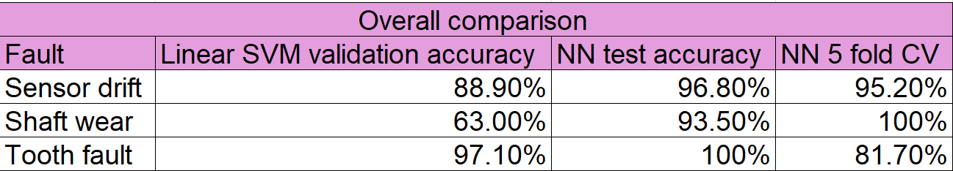
As shown in figures 1- 3, the linear SVM produced noticeably different performance between the three faults. Sensor drift achieved 88.9% validation accuracy with 23 of the 208 cases incorrectly classified. Shaft wear was the hardest fault to classify using SVM, achieving only 63.0% with 47 false positives and 30 false negatives. In comparison, tooth fault classification achieved 97.1% validation accuracy, with only six cases incorrectly classified.
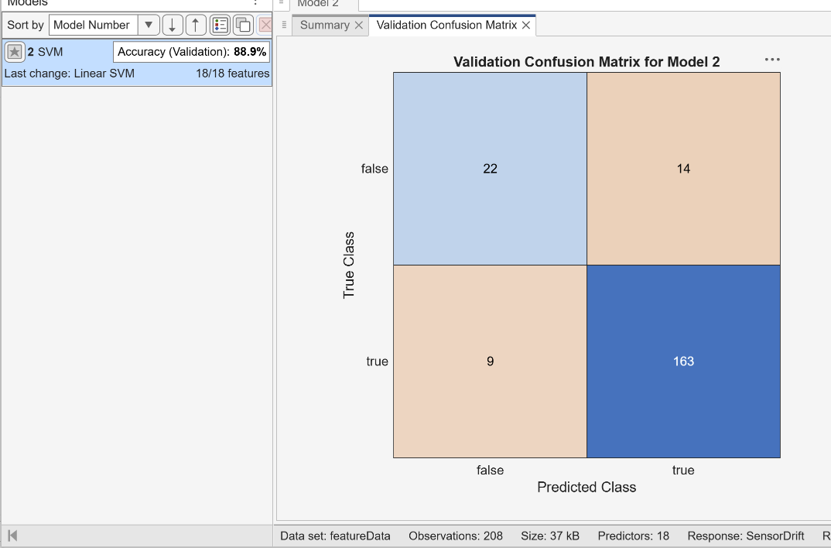
Figure 1 - Sensor drift classification learner SVM confusion matrices

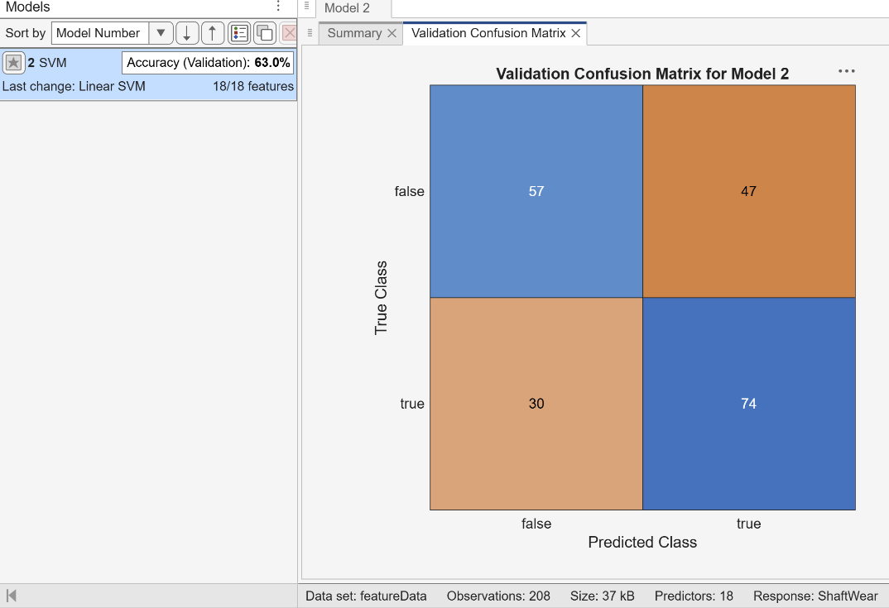
Figure 2 - Shaft wear classification learner SVM confusion matrices

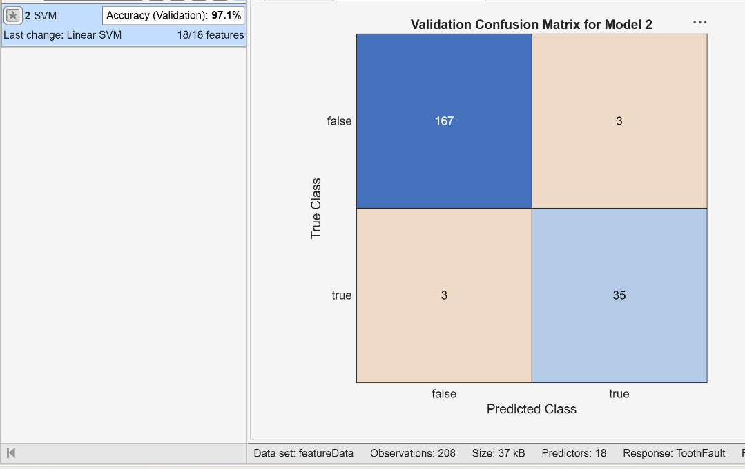
Figure 3 - Tooth fault classification learner SVM confusion matrices

The neural network approach generally produced higher held out test accuracy for all three faults. Sensor drift achieved 96.8% accuracy on the held out test set, with 26 true positives, four true negatives and only one missed fault. Shaft wear showed the greatest improvement compared with the SVM. After tuning the network parameters, test accuracy increased from 64.5% to 93.5% with only one false positive and one false negative. Gear tooth damage achieved 100% accuracy on the held out test set. These results as shown in figures 4 – 6.
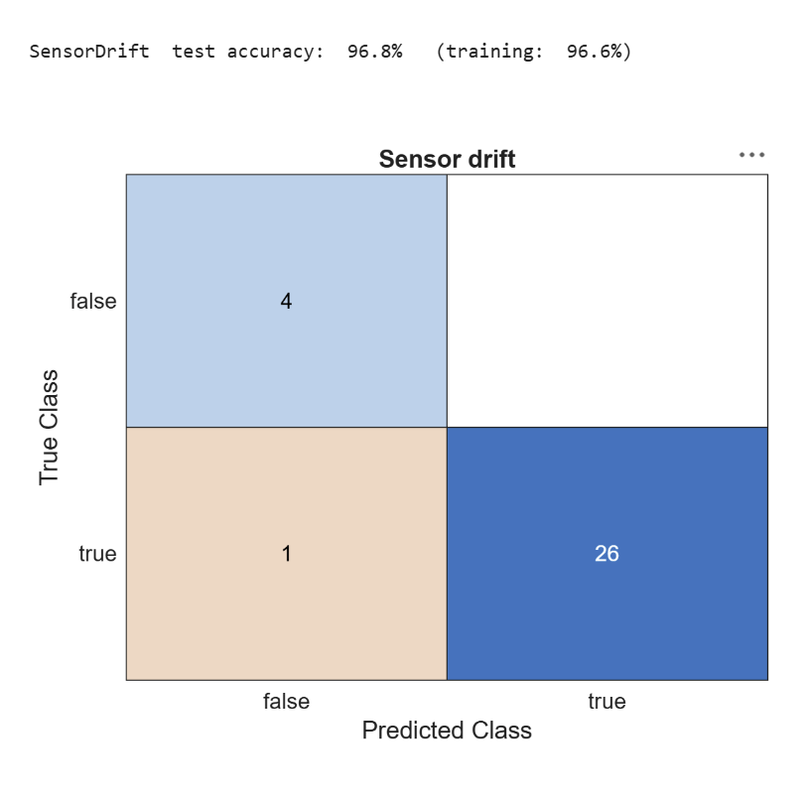
Figure 4 - Sensor drift Neural network confusion matrices

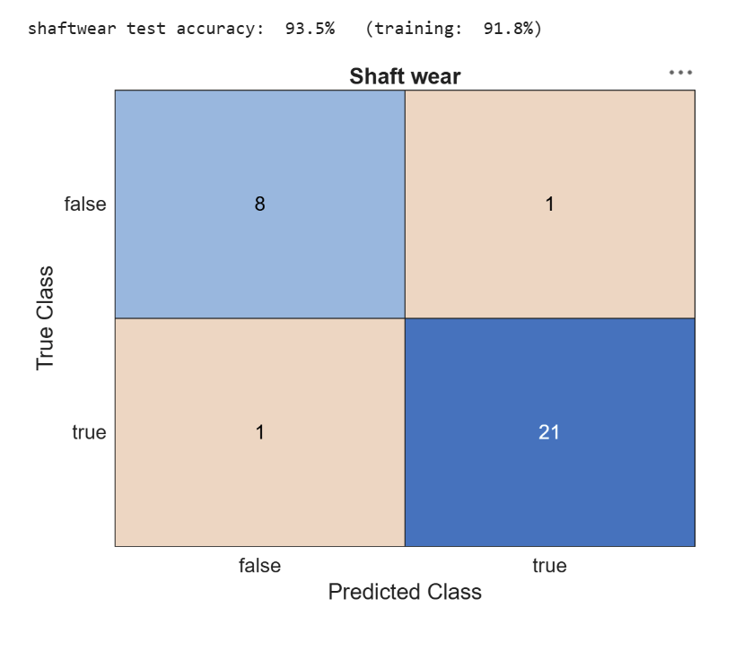
Figure 5- Shaft wear neural network confusion matrices
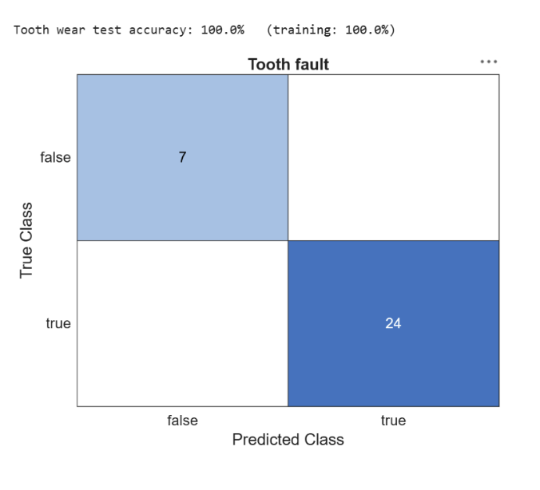
Figure 6 - Tooth fault neural network confusion matrices

Five fold cross validation was also used to examine whether the neural network performance remained consistent when different portions of the dataset were used for training and evaluation. Sensor drift achieved 95.2% while shaft wear achieved 100%. However the tooth fault network fell to 81.7%. Although this initially appeared to remain a reasonably high result, examination of the confusion matrix showed that the classifier predicted every observation as containing a tooth fault. This resulted in 170 true positives but also 38 false positives and no true negatives. The figures 7 -9 therefore demonstrates how accuracy alone can give a misleading indication of classifier performance when the classes are unevenly distributed.
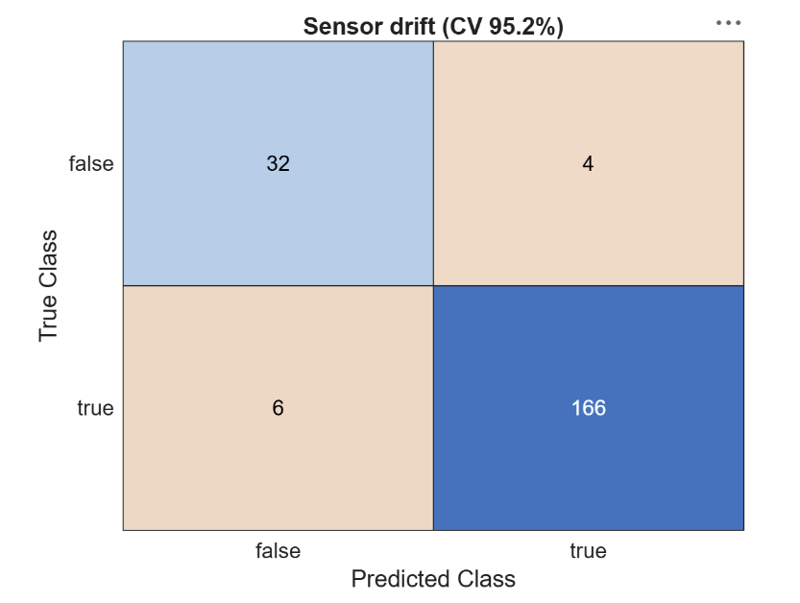
Figure 7 - Sensor drift five fold cv confusion matrix

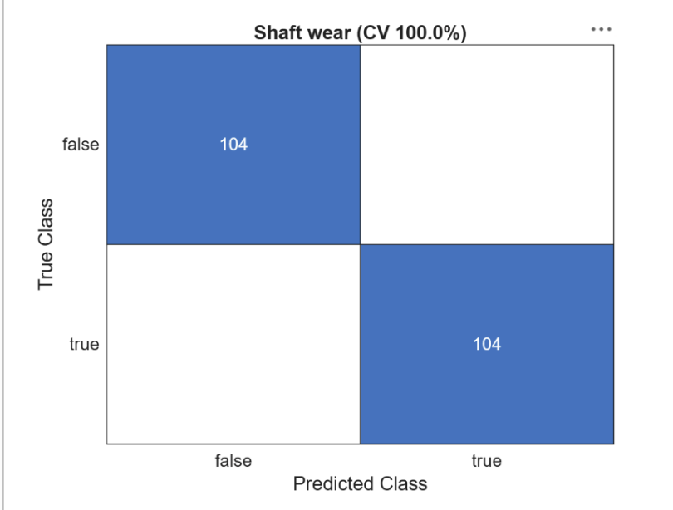
Figure 8 - Shaft wear five fold cv confusion matrix

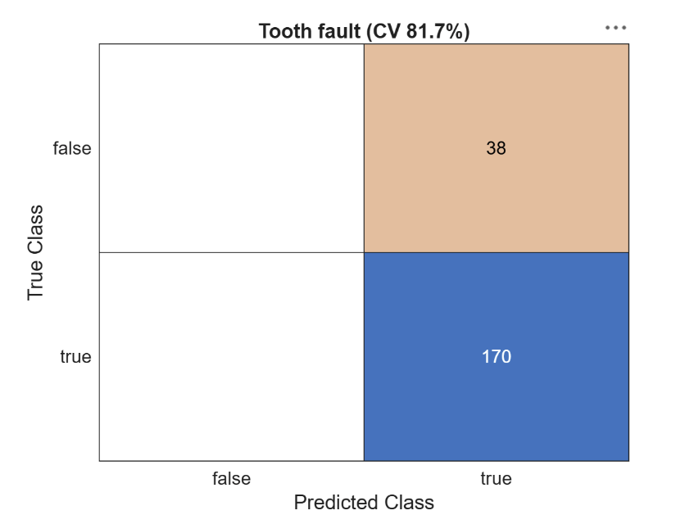
Figure 9 - Tooth fault five fold cv confusion matrix

It was noted that the tooth fault labels used opposite true/false conventions between the two datasets. The confusion matrices were therefore interpreted based on fault present and fault absent to allow a consistent comparison. This does not affect the calculated accuracy.
Overall the results show that the relative performance of the two approaches depends strongly on the fault being detected. The raw spectrum neural network showed a particularly large performance advantage for shaft wear, whereas the SVM performed strongly for tooth damage. The variation between validation accuracy, held out test accuracy, cross validation and confusion matrix behaviour also shows why model suitability cannot be determined from a single accuracy value alone.

Discussion
Shaft wear was the hardest fault to classify using the feature based approach, with the Linear SVM achieving 63.0% validation accuracy compared with 93.5% test accuracy for the neural network. One possible explanation is the way the vibration data were represented. The SVM relied on 18 predefined features, whereas the neural network used the vibration spectrum directly. Ayankoso et al. (2024) similarly distinguish between machine learning methods based on extracted features and deep learning approaches that can learn from less processed vibration data. This suggests that some information useful for identifying shaft wear may not have been sufficiently represented by the selected features. However, this cannot be confirmed from accuracy alone, and the sensitivity of the neural network to changes in its configuration means its final performance should not be assumed to be completely robust.
Despite its weaker shaft wear result, the feature based SVM offers an advantage in transparency. Its inputs include identifiable vibration measures such as RMS, kurtosis, crest factor and frequency based features, making it easier to investigate what information is contributing to a classification than with the raw spectrum neural network. This may be valuable in a safety critical application where engineers need to understand and validate the basis of a fault indication before acting on it. Arez, Navas and Gaspar (2026) similarly identify interpretability as an important consideration when applying AI within predictive maintenance.
Sensor drift was identified more consistently, with the SVM achieving 88.9% validation accuracy and the neural network 96.8% on the held out test set. During neural network preparation, the DC component of the spectrum was retained, meaning changes associated with signal offset remained available to the classifier. This is particularly relevant because sensor drift affects the reliability of the monitoring system itself rather than only representing a mechanical fault. Belgacem and Chihi (2025) identify drift and bias as sensor faults capable of reducing data integrity and system reliability. Detecting sensor drift is therefore important before vibration measurements are relied upon for maintenance decisions.
Gear tooth damage produced the strongest initial classification results, with 97.1% validation accuracy for the SVM and 100% test accuracy for the neural network. This is consistent with Goswami and Rai (2025), who demonstrated that broken gear teeth can be classified effectively from vibration data and reported stronger results from a CNN than feature based SVM models. However, the five fold cross validation result gave a different picture. Accuracy fell to 81.7%, with all 208 observations classified as containing a tooth fault. This produced 170 true positives and 38 false positives, but no true negatives. Ren et al. (2023) show that imbalanced fault diagnosis datasets can allow the majority class to dominate classification. The 81.7% result should therefore not be treated as evidence of strong performance, as it was largely achieved by repeatedly predicting the majority class.
This also shows why individual classification errors matter alongside overall accuracy. Although the tooth fault cross validation produced no false negatives, this was only because every case was treated as faulty and would therefore be unsuitable as a practical maintenance strategy. Lee, Hung and Le (2022) argue that false negative rate should be considered alongside accuracy when evaluating fault diagnosis systems. However, reducing missed faults at the expense of excessive false positives creates a different problem, as unnecessary fault indications can lead to additional inspection, maintenance and disruption. Seo and Yun (2024) also found that frequent false alarms can reduce operator confidence in condition monitoring systems. For P 2201A, an effective model would therefore need to balance the risk of missing a developing fault against the cost of unnecessary intervention.
The consequences of these errors are particularly important in the refinery context. A missed shaft or gear fault could allow degradation to progress towards unplanned pump failure, reducing plant availability and leaving less time to obtain replacement components. Severe mechanical failure could also increase safety risk if connected equipment or containment were affected. Conversely, repeated false alarms could lead to unnecessary inspection or shutdown, increasing maintenance costs and disrupt process operation. The classifier should therefore support maintenance planning rather than act as a standalone shutdown decision.
A further limitation is that all data were generated through simulation. Although this allowed faults to be controlled and labelled accurately, real operating conditions are more variable. Seo and Yun (2024) note that models developed using controlled fault data may not transfer directly to industrial equipment, while Arez, Navas and Gaspar (2026) highlight the limited real world validation of many AI based predictive maintenance studies. The results should therefore be treated as evidence of potential rather than proof of performance on P 2201A.
Overall, the neural network showed stronger classification performance for sensor drift and shaft wear, while the SVM offered greater transparency. The tooth fault cross validation also demonstrates that high accuracy alone does not guarantee a useful maintenance model. Practical deployment should therefore consider interpretability, false alarms, missed faults, sensor reliability and performance under real operating conditions rather than selecting a model on headline accuracy alone.

Conclusion and Recommendations
This study compared a feature based Linear SVM with a raw spectrum neural network for detecting sensor drift, shaft wear and gear tooth damage on P 2201A. The neural network showed stronger overall classification performance, particularly for shaft wear, while both approaches performed well for tooth damage. However, the tooth fault cross validation result showed that high accuracy alone does not guarantee a useful maintenance model. The 81.7% accuracy was achieved by predicting every case as faulty, highlighting the importance of considering class imbalance, false alarms and missed faults alongside overall accuracy. The SVM also offers greater transparency, which may be useful where fault predictions need to be understood and checked before maintenance decisions are made. For the refinery scenario, the neural network shows the most potential but should not be used as a standalone decision tool without further validation using real operating data and a better balanced dataset. A practical approach would combine neural network fault detection with feature based analysis and engineering review. This would provide the benefits of improved fault detection while reducing the risk of unnecessary maintenance, missed faults and poor decisions based on unreliable predictions.

References
Achouch, M., Dimitrova, M., Ziane, K., Karganroudi, S.S., Dhouib, R., Ibrahim, H. and Adda, M. (2022). On predictive maintenance in industry 4.0: Overview, models, and challenges. Applied Sciences, [online] 12(16), p.8081. doi:10.3390/app12168081.
Adaramola, B.A., Kayode, J.F., Monye, S.I. and Afolalu, S.A. (2024). Overview of maintenance management strategies in the industry. 2024 International Conference on Science, Engineering and Business for Driving Sustainable Development Goals (SEB4SDG), [online] 55, pp.1–11. doi:10.1109/seb4sdg60871.2024.10629938.
Arez, D., Navas, H.V.G. and Gaspar, P. (2026). The bridge between artificial intelligence and predictive maintenance in industry 4.0: A systematic review. Applied Sciences, 16(10), p.4882. doi:10.3390/app16104882.
Ayankoso, S., Dutta, A., He, Y., Gu, F., Ball, A. and Pal, S.K. (2024). Performance of vibration and current signals in the fault diagnosis of induction motors using deep learning and machine learning techniques. Structural Health Monitoring, 25(1), pp.196–212. doi:10.1177/14759217241289874.
Benhanifia, A., Cheikh, Z.B., Oliveira, P.M., Valente, A. and Lima, J. (2025). Systematic review of predictive maintenance practices in the manufacturing sector. Intelligent Systems with Applications, [online] 26, p.200501. doi:10.1016/j.iswa.2025.200501.
Goswami, P. and Rai, R.N. (2025). Broken tooth gear fault detection using vibration signals based on convolutional neural network. International Journal of System Assurance Engineering and Management, 17(8), pp.2401–2418. doi:10.1007/s13198-025-03093-9.
Hamed Badihi, Zhang, Y., Jiang, B., Pillay, P. and Subhash Rakheja (2022). A comprehensive review on Signal-based and model-based condition monitoring of wind turbines: Fault diagnosis and lifetime prognosis. Proceedings of the IEEE, 110(6), pp.754–806. doi:10.1109/jproc.2022.3171691.
Heni Belgacem and Inès Chihi (2025). Toward reliable and intelligent sensor systems: A comprehensive study of fault diagnosis and mitigation. IEEE Sensors Reviews, pp.1–27. doi:10.1109/sr.2025.3601092.
Ighravwe, D.E. (2022). Assessment of Sustainable Maintenance Strategy for Manufacturing Industry. Sustainability, 14(21), p.13850. doi:10.3390/su142113850.
Lee, C.-Y., Hung, C.-H. and Le, T.-A. (2022). Intelligent fault diagnosis for BLDC with incorporating accuracy and false negative rate in feature selection optimization. IEEE Access, [online] 10, pp.69939–69949. doi:10.1109/access.2022.3186753.
Molęda, M., Małysiak-Mrozek, B., Ding, W., Sunderam, V. and Mrozek, D. (2023). From corrective to predictive maintenance—A review of maintenance approaches for the power industry. Sensors, 23(13), p.5970.
Nithin, S.K., Hemanth, K., Shamanth, V., Shrinivas Mahale, R., Sharath, P.C. and Patil, A. (2021). Importance of condition monitoring in mechanical domain. Materials Today: Proceedings, 54, pp.234–239. doi:10.1016/j.matpr.2021.08.299.
Ren, Z., Lin, T., Feng, K., Zhu, Y., Liu, Z. and Yan, K. (2023). A systematic review on imbalanced learning methods in intelligent fault diagnosis. IEEE Transactions on Instrumentation and Measurement, 72, pp.1–35. doi:10.1109/tim.2023.3246470.
Scaife, A.D. (2023). Improve predictive maintenance through the application of artificial intelligence: A systematic review. Results in Engineering, [online] 21, p.101645. doi:10.1016/j.rineng.2023.101645.
Seo, M.-K. and Yun, W.-Y. (2024). Gearbox condition monitoring and diagnosis of unlabeled vibration signals using a supervised learning classifier. Machines, [online] 12(2), p.127. doi:10.3390/machines12020127.
Sharma, J., Mittal, M.L. and Soni, G. (2022). Condition-based maintenance using machine learning and role of interpretability: A review. International Journal of System Assurance Engineering and Management. doi:10.1007/s13198-022-01843-7.
Surucu, O., Gadsden, S.A. and Yawney, J. (2023). Condition monitoring using machine learning: A review of theory, applications, and recent advances. Expert Systems with Applications, [online] 221, p.119738. doi:10.1016/j.eswa.2023.119738.
Yang, L., Liu, Q., Xia, T., Ye, C. and Li, J. (2022). Preventive maintenance strategy optimization in manufacturing system considering energy efficiency and quality cost. Energies, 15(21), p.8237. doi:10.3390/en15218237.

Appendices
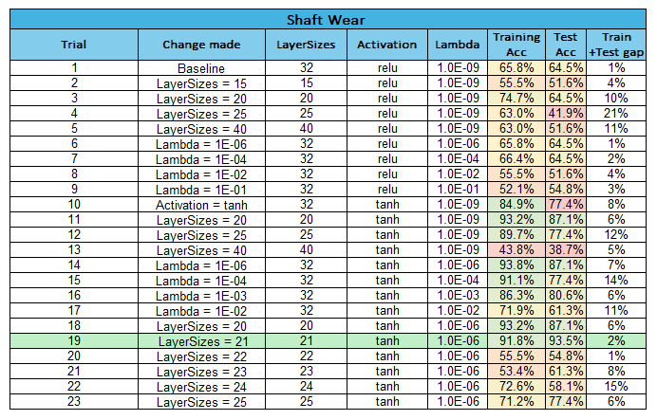
Table 2 - Shaft wear neural network tuning

Table 3 - Tooth fault neural network tuning
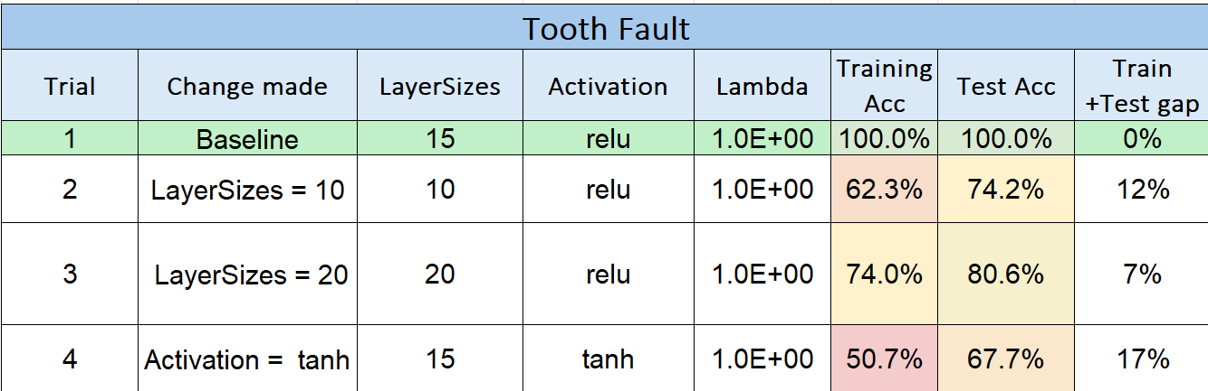

Table 4 - Sensor drift neural network tuning


