Financial Management for the Hotel Industry

Assignment 2: Report
Student: Gabriela Iuliana Giurgiu
Id Number: 2240417
Lecturer: Kathryn Roberts

Executive summary
Conducting the consultancy report regarding fiscal management for The City Hotel, it can be said that the company has been facing a fiscal crisis over the last few years. The revenue of the company has been evaluated which is an indicator of reduced performance in the market. The company has also reduced its expenses, which is further expected to do the same in the future as well. Lack of customer retention and digital marketing can be considered as the key reasons for the reduced profitability of the company which is also expected to continue. However, despite a fall in liquidity, increased solvency is expected from the company creating the possibility of concentrating on long-term debts. The consumers’ perception during post-COVID conditions and Brexit are considered mostly responsible for the condition of economic downturn of City Hall. Digital marketing investment, cash flow forecasting and more asset acquisition is recommended for the company for further improvements.

Table of Contents
1. Introduction 3
2. Trends and patterns of the hotel's financial performance over the past three years 3
2.1 Revenue 3
2.2 Expenses 4
2.3 Profitability 5
2.4 Liquidity 6
2.5 Solvency 8
3. Key reasons for the decline in profitability 9
4. Turnaround strategy to revitalise the hotel’s financial health and restore its reputation 10
4.1 Investing more in digital marketing. 10
4.2 Implementing Cash Flow Forecasting Strategies 10
4.3 Improving assets obtained from investors. 10
5. Conclusion 11
Reference list 12

1. Introduction
This proposed report is a consultancy portfolio to measure the financial performance of The City Hotel. The hotel has been experiencing a loss of revenue, overall customer occupancy rates and customer satisfaction rates. Customer devaluation in a hospitality industry operation can be caused by both external environmental conditions and the company’s accountability to deal with customer demands (Khatter, 2023). Thus, the consultancy report has been concocted to evaluate the future validity of the business regarding the current financial condition evaluation. A further recommendation has also been made regarding whether the financial operations of the company can be salvaged or not to ensure a better management strategy and turnaround practice for the company to be implemented.

2. Trends and patterns of the hotel's financial performance over the past three years

2.1 Revenue
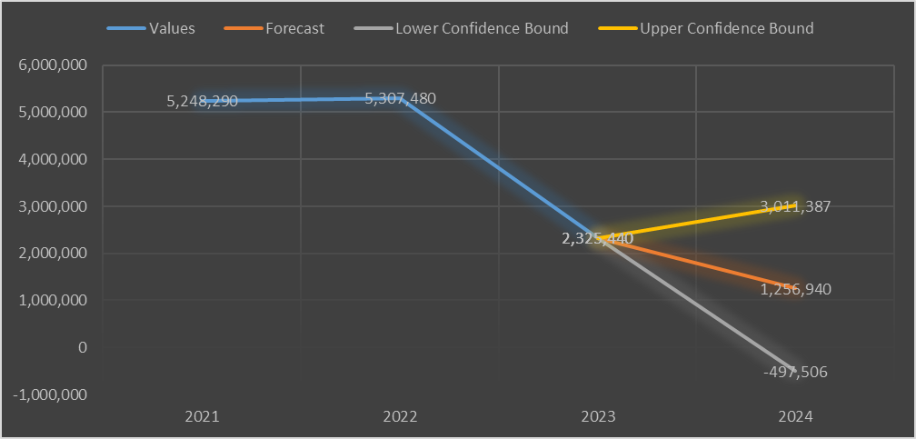
Figure 1: Current revenue generation of the company and future forecast
The general concept of the revenue model indicates that a higher degree of revenue generation indicates the increasing capability of an organisation to provide goods and services in the market. Thus, a higher form of revenue generation indicates better capability and sustainability in the company's operations (Remeňová et al., 2020). Evaluating the revenue generation of The City Hotel, between 2021 and 2022, the revenue generation of the company has only slightly increased from 5,248,290 to 5,307,480. However, in 2023, the revenue significantly reduced to 2,325,440. Following this trend of profitability, the revenue is mostly expected to reduce at the end of 2024. The lower bound of the profitability forecast is at -497,506 in 2024 which is the worst except that the company is expected to face a significant loss. The middle bound indicates a revenue generation of 1,256,940 which is still a significant loss from 2023. In the best-case scenario, the company is expected to generate revenue of 3,011,387 which is an increase in revenue from 2023, however cannot be considered as the highest revenue growth for the company. Thus, the trends indicate that The City Hotel is more likely to suffer in the case of revenue generation in the existing and future markets.

2.2 Expenses
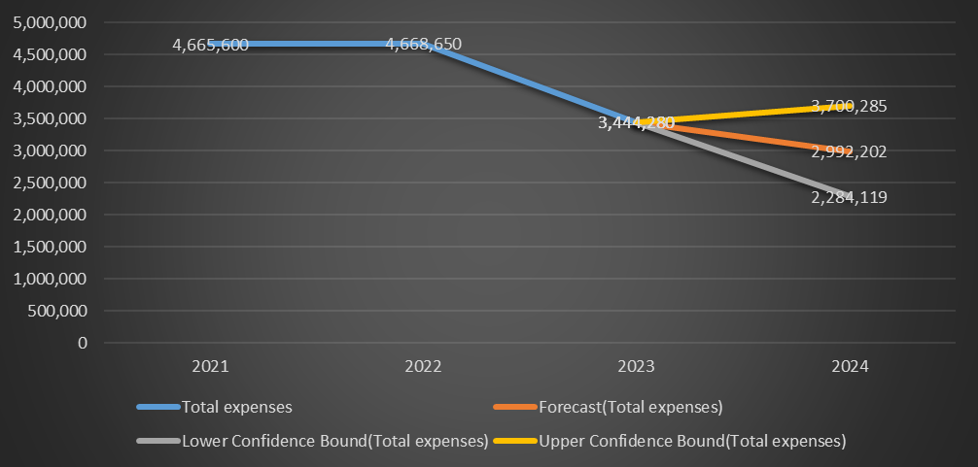
Figure 2: Current expenses of the company and future forecast
A higher form of expertise considered by a firm indicates the capability of a firm in managing all general and risk-based activities and maintaining a competitive advantage in the market. A high expense capacity of a company in the market indicates a higher capability of market dominance and operational convenience (Lee, 2023). Critical evaluation of the current expense trends of the company has demonstrated that the company has been reducing expenses between 2021 and 2023. The future forecasts regarding the expense trends suggest that the expenses are expected to mostly stay the same or reduce. The lowest bound of the forecasts suggests that the expenses may be reduced to 2,284,119 in 2024 from 4,665,660 as seen in 2021. The upper bound suggests that the expenses might increase to 3,700,285 in 2024 from 3,444,280, otherwise slightly increasing since 2023. However, the expenses are not expected to increase more than the 2022 value, indicating that the company might struggle with expenses in the future which might be due to lack of profitability and reduced revenue generation.

2.3 Profitability
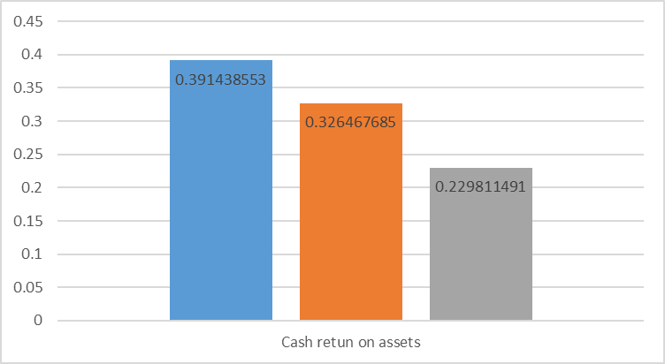
Figure 3: Current cash return of assets of the company
Profitability is one of the essential aspects of a company's financial health evaluation. A higher profitability generation of a company indicates a higher operational capability and growth of the firm in the market (Ngoc et al., 2023). Cash return on asset ratio is an essential aspect of evaluating profitability that evaluates the level of financial aspects from the investment of an asset. A higher return indicates a greater asset value and market capability of a company (Kusuma, 2021). In this case, the Cash return of asset values of the company indicates constantly reducing value. This means that the value of the assets of the company is constantly decreasing.

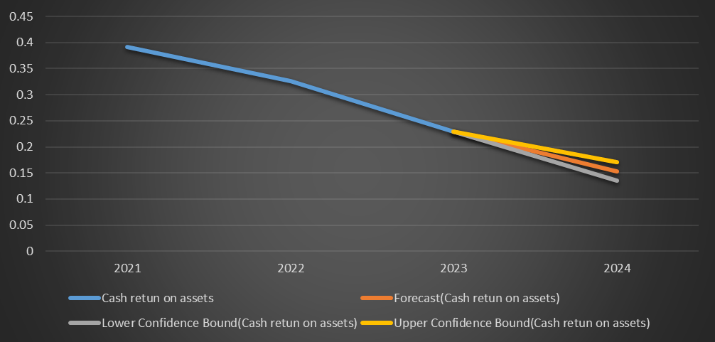
Figure 4: Future cash return predictions of the company
The forecasting trend of cash ROI also indicates a reducing value till 2024. The indication of reducing cash ROI value indicates that the value of the assets is going to be reduced shortly. The reduced cash return on assets means that in the future, the company might fail to invest the right amount of cash in the assets which might result in a further reduction of revenue growth for the company (Forbes, 2021). The evaluation of the profitability of the company through cash ROA trend analysis thus indicates that the company might fail to get a proper value of their assets and lose money further if the right value is not appointed in the assets.

2.4 Liquidity
The analysis of liquidity ratios is considered to evaluate how quickly companies can liquefy their assets and mitigate the short-term financial obligations of an organisation. The current ratio is one of the most essential liquidity ratios that are used to evaluate whether the company has good liquidity or not (Tumanggor, 2020). In this case, evaluating the ratio between the current assets and liabilities of the company, the asset values are constantly reducing, and the liabilities value is increasing, reducing the overall current ratio of the company till 2023. This indicates that the company is slightly reducing the value of assets and overall liquidity of the assets in the economic management operations.
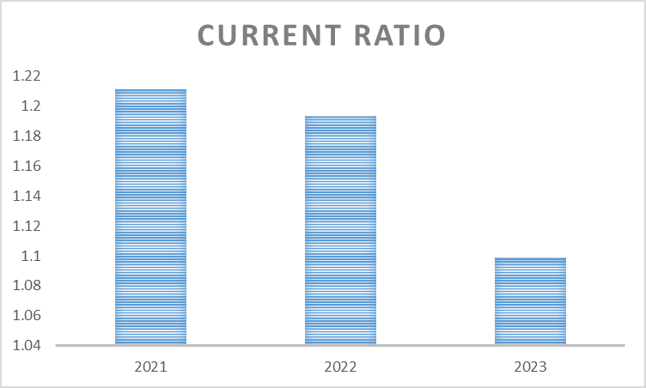
Figure 5: Current ratio of the company
Analysing the future trend of the liquidity of the company it can be said that, in the worst-case scenario, the current ratio may fall further from 1.09 in 2023 to 1.01 in 2024. In the best case, the ratio is expected to rise to 1.10. Thus, as per the trends, the liquidity of the company assets is either expected to reduce or stay mostly the same in the future. A decrease in the current ratio indicates that a firm facing a decline in the value of its current assets or short-term debts of the company is gradually increasing (Kontuš and Mihanović, 2020). For The City Hotel, the cause of the reduced current ratio can be either one of the above reasons or both as the decrease in the value of assets is confirmed in the previous section.
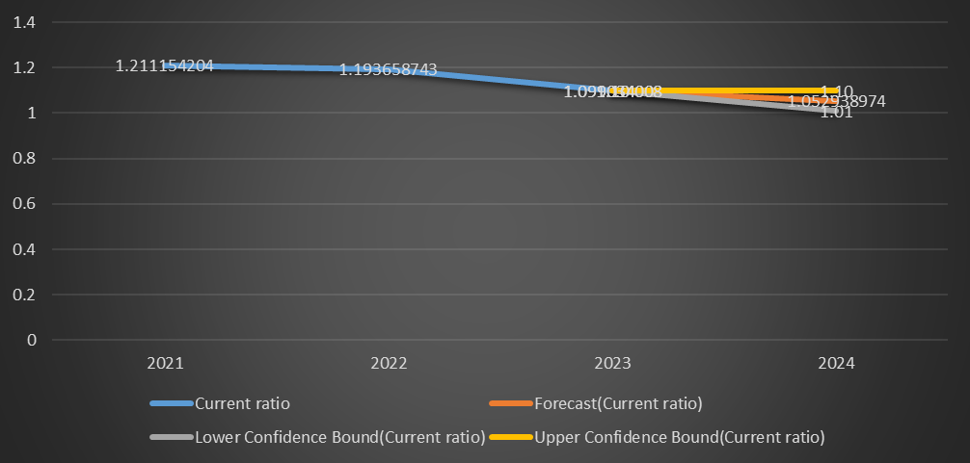
Figure 6: Future current ratio predictions of the company

2.5 Solvency
The solvency ratio is one of the key financial indicators of a company that evaluates the capability of a firm regarding its long-term debt mitigation. Thus, a higher solvency ratio is an indicator that the firm can meet long-term debts (CFI, 2023). In the case of The City Hotel, the Solvency ratio for all three years is less than 1, indicating that the company’s total debts exceed its total equity. On the other hand, between 2021 and 2023, the solvency ratio has gone up from 0.17 to 0.56. This trend is an indication that the company’s total equities are gradually increasing, in comparison to its total debts. This means that at this rate, the company might be able to generate a positive solvency rate in the future and become more capable of paying off all its long-term debts.
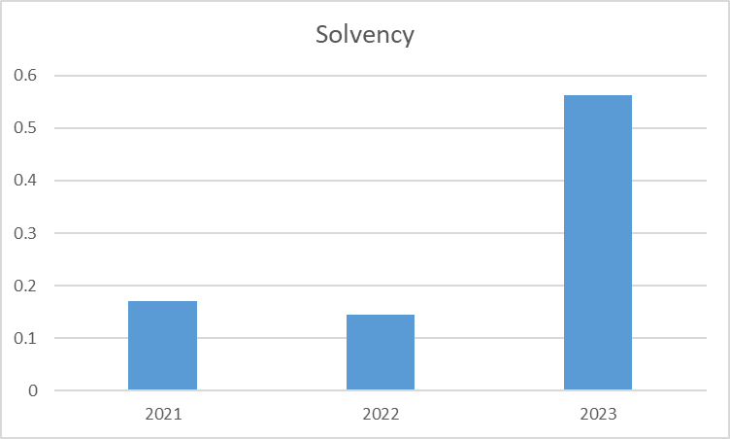
Figure 7: Current solvency ratio of the company

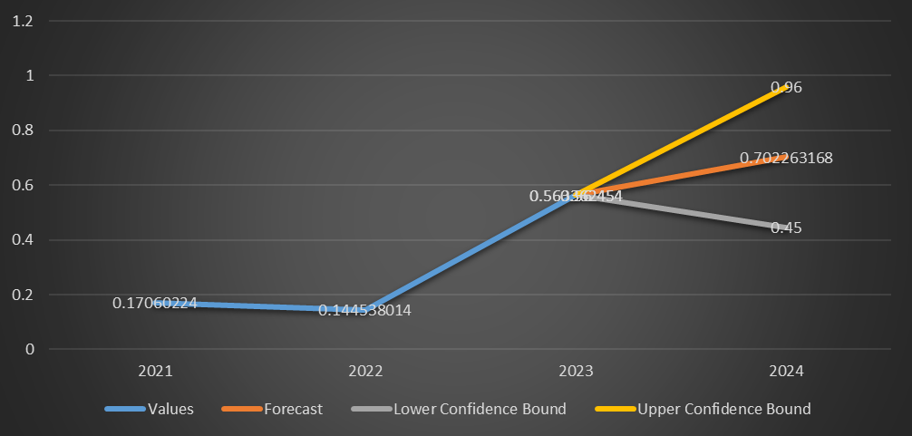
Figure 8: Future solvency ratio predictions of the company
On the other hand, evaluating the future direction trend of the solvency of the company, mixed predictions indicate either an increase or decrease in solvency. In the worst cashew scenario, the solvency of the company may be further reduced to 0.45. However, in the best case, the solvency ratio may rise to 0.96, almost equalising the total debt and equity of the organisation. An increase in equity and reduction in debt will ensure the increase of assets of the organisation and make the firm more financially stable in mitigating long-term debts (Arhinful and Radmehr, 2023). Thus, there is a higher possibility that the company can enjoy a better financial leverage in the future market.

3. Key reasons for the decline in profitability
The tourism industry has been increasingly flourishing up to the point of the pandemic. In 1950, the number of original tourists was seen at 25 million. By 2019, the number reached 1.5 billion (IMF.org, 2020). However, due to the pandemic, a sharp decline in both domestic and foreign tourism was observed, which also financially affected the companies, reducing their capabilities to operate in the market. The companies had to cut costs from their internal operations to survive which also considered reducing their expenses as seen in the above example. As an aftermath, the tourism companies cut 54% of the global tourism industry workforce creating further operational inconvenience for the company operations (IMF.org, 2020). As a result of all these aspects, a gradual profitability loss of the companies was also observed.
Concentrating on European Tourism operations, Brexit has impacted tourism operations, by reducing the workforce for the companies and restricting business operations. As the workers of both UK and other European reasons were called back, the UK needed to increase its extent of operations with other countries to develop as a business entity. This process has reduced the capability of the UK tourism companies in the market, while lowering the profitability of the tourism companies in the light of Brexit (Adedoyin et al., 2021). Thus, due to several different external environmental reasons, tourism companies are facing a gradual decline in financial profitability.

4. Turnaround strategy to revitalise the hotel’s financial health and restore its reputation

4.1 Investing more in digital marketing.
Investing more in digital marketing practices will help the organisation reach a larger number of customers in a shorter period (Dwivedi et al., 2021). Thus, a vast number of potential customers will know about the services of the company, which in turn will increase the volume of sales and customer retention. As the sales of the company is gradually improved, so will its profitability and thus, the firm will be able to recover from a financial downfall.

4.2 Implementing Cash Flow Forecasting Strategies
Cash flow forecasting strategies based on operating cash flow statements will help the company evaluate potential cash flow statements for the future (Noury et al., 2020). Thus, the company will be able to adjust its financial statement and manage cash accordingly to mitigate future cash flow needs and reduce related risks. The company can invest in AI technology for cash flow forecasting which will significantly reduce future operational risks of cash flow management.

4.3 Improving assets obtained from investors.
Approaching more investors with the right pitches can attract more investors to the company. Using the resources provided by the investors as additional assets can increase the amount of asset obtained by the company (Krukowski et al., 2022). As a result, the value of the current ratios might increase, creating the financial strength of the company in the existing market. The City Hotel must also concentrate on improving the number of investors in the management operations to create financial stability and security for the existing operations.

5. Conclusion
Concluding on the overall discussion of the report The City Hotel is suffering from a certain budgetary crisis, which may get worse in the future. The revenue of the company is on a trend of reduction, reducing the operational capability of the company and market share. The expenses and the profitability of the company are also gradually reducing, heading towards potential accountability of losses in the market. The liquidity trends suggest that the assets are losing value and might continue to do so in the future. However, the solvency of the company may rise improving the company's long-term debt mitigation capability. The post-pandemic situation and the Brexit conditions are expected to be the external environment reasons for such decline. A further look at digital marketing investment, cash flow forecasting and asset development from investors has been recommended to improve the financial conditions of the company.

Reference list
Adedoyin, F.F., Agboola, P.O., Ozturk, I., Bekun, F.V. and Agboola, M.O., 2021. Environmental consequences of economic complexities in the EU amidst a booming tourism industry: accounting for the role of Brexit and other crisis events. Journal of Cleaner Production, 305, p.127117.
Arhinful, R. and Radmehr, M., 2023. The Impact of Financial Leverage on the Financial Performance of the Firms Listed on the Tokyo Stock Exchange. SAGE Open, 13(4).
CFI, 2023. Solvency Ratio. Available at: https://corporatefinanceinstitute.com/resources/commercial-lending/solvency-ratio/ [Accessed on: 7th Oct 2024].
Dwivedi, Y.K., Ismagilova, E., Hughes, D.L. and Carlson, J., 2021. Setting the Future of Digital and Social Media Marketing research: Perspectives and Research Propositions. International Journal of Information Management, 59(1), pp.1–37.
Forbes, 2021. Understanding Return on Assets (ROA). Available at: https://www.forbes.com/advisor/investing/roa-return-on-assets/ [Accessed on: 7th Oct 2024].
IMF.org, 2020. Impact of the pandemic on tourism – IMF F&D. Available at: https://www.imf.org/en/Publications/fandd/issues/2020/12/impact-of-the-pandemic-on-tourism-behsudi [Accessed on: 7th Oct 2024].
Khatter, A., 2023. Challenges and Solutions for Environmental Sustainability in the Hospitality Sector. Sustainability, 15(15), pp.11491–11491.
Kontuš, E. and Mihanović, D., 2020. Management of liquidity and liquid assets in small and medium-sized enterprises. Economic Research-Ekonomska Istraživanja, 32(1), pp.3247–3265.
Krukowski, K.A., Pollack, J.M. and Rutherford, M.W., 2023. Winning the opportunity to pitch: Piquing startup investors’ interest by sending the right signals in executive summaries. Business Horizons, 66(1), pp.75-86.
Kusuma, M., 2021. Measurement of Return on Asset (ROA) based on Comprehensive Income and its Ability to Predict Investment Returns: An Empirical Evidence on Go Public Companies in Indonesia before and during the Covid-19 Pandemic. Ekuilibrium : Jurnal Ilmiah Bidang Ilmu Ekonomi, 16(1), p.94.
Lee, C.-C., 2023. Analyses of the operating performance of information service companies based on indicators of financial statements. Asia Pacific Management Review, 28(4).
Ngoc, T., Nguyen, X.H. and Pham, K., 2023. The Effect of Capital Structure on Firm Value: A Study of Companies Listed on the Vietnamese Stock Market. International Journal of Financial Studies, 11(3), pp.100–100.
Noury, B., Hammami, H., Ousama, A.A. and Zeitun, R., 2020. The prediction of future cash flows based on operating cash flows, earnings, and accruals in the French context. Journal of Behavioral and Experimental Finance, 28, p.100414.
Remeňová, K., Kintler, J. and Jankelová, N., 2020. The General Concept of the Revenue Model for Sustainability Growth. Sustainability, 12(16), p.6635.
Tumanggor, M., 2020. The Influence of Current Ratio, Quick Ratio and Net Profit Margin on Return on Assets at PT. Hero Supermarket Tbk. PINISI Discretion Review, 1(1), p.137.

