Task worksheet: Change the Organisation

Writing to explain
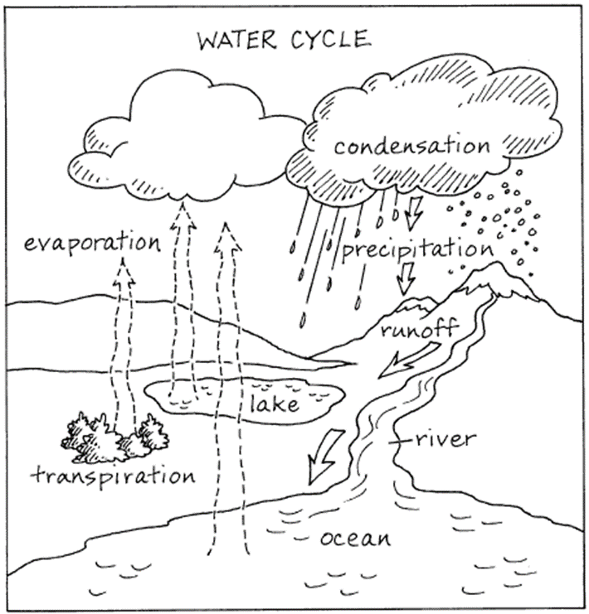
Heading statement

Sequence of how and reasons why

Summary

