Programme: BA Business Management
Module: Data Handling And Business Intelligence
Module Code: LCBB5000
Lecturer: Anupam Mazumdar
Student Name: Valentina Georgieva Pencheva
Student ID: 2023164
Level 5/ Term1/ Group 2
Assignment Title: Assessment 1

1,291 words

Table of Contents
Introduction 3
Main body 3
Strategic importance of BI 3
Critical analysis of key trends 4
Conclusion 7
References 8

Introduction
The report explores some of the most contemporary trends in data warehousing, business intelligence (BI) and data mining. These are key concepts with an increasing importance for business organisations; hence, the analysis attempts to critically evaluate the main trends. The article by Lim and Teoh (2020) is considered in more details, as it emphasises the role of BI and Big Data in gaining strategic advantage in three key fields of operations – business competitiveness, environmental and social excellence.

Main body

Strategic importance of BI
In general, the importance of BI is shown by its ability to collect, store and analyse significant quantities of data which could be used by business organisations for a variety of purposes (Lim and Teoh, 2020).
The role of Big Data analytics is quite evident in the context of BI. By definition, Big Data contributes to the collection of real-time heterogeneous data which are then used to support decision-making process and identify new areas of development and change (Riahi, 2018). Sophisticated computing, storage and analytical capacity are necessary to effectively apply Big Data analytics (Riahi, 2018). With the use of Big Data, business organisations become more responsive to changes in the external environment which in turn increases flexibility, efficiency of resource utilisation and overall competitiveness (Riahi, 2018).
These benefits of data-driven decision-making are numerous. For instance, BI tools are quite effective in monitoring consumer behaviour and adjusting the stock of inventory accordingly, so that expensive surpluses or shortages are avoided (Howard, 2022). Moreover, BI informs decision makers for relevant consumer trends which stimulate the development of new products and services with improved prospects for success in the marketplace (Countants, 2019). The evidence also shows the usefulness of BI in achieving optimisations in the operations of organisations. It is possible to minimise energy use, decrease errors and waste and other key advantages supporting the cost control and competitiveness of organisations, especially in the field of manufacturing (Slack and Brandon-Jones, 2019). Taken together, these benefits clearly show the increasing importance of BI ad data-driven decision-making for achieving operational and financial improvements; thereby, validating the views of Lim and Teoh (2020).
It is also important to note that BI strengthens the performance in other areas beyond the core financial goals. As argued by Carroll (2016), organisations have to consider various ethical and philanthropic activities as a part of the corporate social responsibility (CSR) process, as they contribute to improved brand development, reputation and sustainable performance over time. In this light, the earlier mentioned environmental and social improvements are of key strategic importance for organisations, as well (Lim and Teoh, 2020). The process of BI plays a key role in monitoring the behaviour of various stakeholder groups, such as customers, suppliers and others (Simmers, 2004). Thus, stakeholder management could be improved by delivering effective CSR policies and practices depending on the propositions from the incoming data. The earlier mentioned operational optimisations on the basis of Big Data analytics could be seen as a key way for minimising energy consumption, waste and other negative factors with adverse impact on the environment (Slack and Brand-Jones, 2019). In this way, the more precise and efficient organisational management is a key towards the achievement of environmental goals.
Similarly, the BI ability to monitor and reflect changes in respect to various stakeholder groups is seen as a way of identifying more relevant societal goals and achieving improvements in the CSR process.

Critical analysis of key trends
There are several key trends in the field of BI which could deliver additional opportunities and threats in the future. Understanding the specifics of these trends is a key towards an improvement in the field and a more sustainable strategic development as a whole.
The pandemic facilitated the implementation of new technologies in the fields of data warehousing (Aggarwal, 2021). The growth of cloud technologies and SaaS platforms has been quite strong recently and the trend is expected to continue in foreseeable future (Aggarwal, 2021). This adjustment; however, outs requirements to organisations to increase investments in the field and any delay may erode competitiveness given the dynamic nature of the change.
Another key trend refers to the emergence of mobile BI tools. They are able to deliver instantaneous real-time output; thereby, facilitating the data mining process (BARC, 2022). This is a key development, as BI is faster and more extensive – key features for improving decision-making and flexibility of reactions to different developments.
In addition, it is also important to note that the increases in the volume of available data poses elevated requirements for data warehousing and governance. Any breaches of sensitive customer- or business-related data could be quite costly for companies, as well as ruining reputation (Cole et al., 2015; SDI, 2019). In this relation, business organisations face increased requirements in the fields of cyber security, integrity and ethics, as the safe storage and appropriate use of sensitive data require the application of the best standards (SDI, 2019).
While all of the above-mentioned key trends can be addressed by financial investments and training, the role of organisational culture is much more complicated. The evidence in the field of BI demonstrates the importance of developing a data driven culture. In general, the role of organisational culture is to promote common values, attitudes and behavioural norms, so that all organisational members demonstrate a coherent approach and ability to effectively achieve common goals (Rollinson, 2019). Typically, organisational cultures tend to change quite slowly over a continuous period time; however, the dynamic changes in the field of BI require much faster adjustments by business organisations. This should be seen as a key challenge because of the risk for resistance to change and poor leadership which cannot promote change (Rollinson, 2019). Nevertheless, being able to develop a fully data-driven and open-to-change culture could be considered as a key success factor in the field of BI from a strategic point of view.
The evidence from a large-scale survey with almost 2,400 business professionals in the field of BI largely confirms the above-mentioned propositions (BARC, 2022). As shown below, the 2022 trends identify many areas of BI as more important in comparison to the 2018 data (BARC, 2022). The role of culture change, data governance and mobile-based self-service is quite relevant in the current context of business development (BARC, 2022).

Figure 1 – Key trends in BI
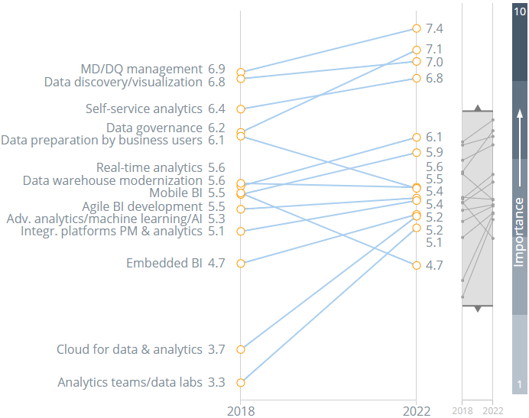

Source: BARC (2022)
Last, but not the least, BI trends also emphasise on the role of collaborating with external parties, as they may be important sources for change and innovation in general, including research and technological centres, business partners, consumers and others (Boddy, 2019). This is important in order to identify the most relevant ideas for change and future development. As shown below, creative individuals, groups and organisations, which are external for the respective company, may actively participate in the innovation process (Boddy, 2019). The specific domain of BI development is not an exception from the trend.

Figure 2 – Innovation process and its main determinants
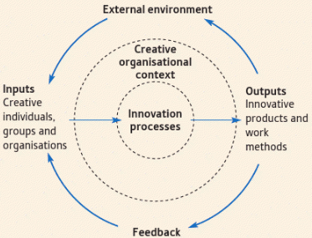
Source: Boddy (2019)
Moreover, the stakeholder management process becomes even more important for adopting effective BI practices. This trend is also validated by the BARC (2022) survey findings which show the significant increase in the role of analytics teams (see fig. 1).

Conclusion
In conclusion, the key trends in BI indicate its growing importance as a strategic tool for business organisations. The ideas by Lim and Teoh (2018) are validated given the increasing scope of application and value of BI. Nevertheless, the intended improvements are not given, as companies have to dedicate resources and training in order to fully benefit from the changes in the highly technological and dynamic field of BI. More importantly, the ability to change and be flexible also imposes requirements for cultural change which are seen as the main challenge for organisations.

References
Aggarwal, G. (2021) How the Pandemic Has Accelerated Cloud Adoption, [online] Available: https://www.forbes.com/sites/forbestechcouncil/2021/01/15/how-the-pandemic-has-accelerated-cloud-adoption/?sh=41d648bb6621 [Accessed: 8 May 2022]
BARC (2022) Top Business Intelligence Trends 2022: What 2,396 BI Professionals Really Think, [online] Available: https://bi-survey.com/top-business-intelligence-trends [Accessed: 8 May 2022]
Boddy, D. (2019) Management: using practice and theory to develop skill. 8th edition, Harlow, England: Pearson
Carroll, A. (2016) Carroll’s Pyramid of CSR: Taking another Look, International Journal of Corporate Social Responsibility, Vol. 1(3), pp. 1-8.
Cole, D., Nelson, J. and McDaniel, B. (2015) Benefits and Risks of Big Data, [online] Available: https://core.ac.uk/download/pdf/301367945.pdf [Accessed: 8 May 2022]
Countants (2019) How Business Intelligence can benefit your sales and marketing, [online] Available: https://medium.com/gobeyond-ai/how-business-intelligence-can-benefit-your-sales-and-marketing-b76e7a77a8ac [Accessed: 5 May 2022]
Howard, C. (2022) Why You Need Business Intelligence for Inventory, [online] Available: https://www.phocassoftware.com/business-intelligence-blog/why-you-need-business-intelligence-for-inventory [Accessed: 8 May 2022]
Lim, Y. and Teoh, A. (2020) Realizing the strategic impact of business intelligence utilization, Strategic Direction, Vol. 36(4), pp. 7-9.
Riahi, Y. (2018) Big Data and Big Data Analytics: Concepts, Types and Technologies, International Journal of Research and Engineering, Vol. 5, pp. 524-528.
Rollinson, D. (2019) Organisational Behaviour and Analysis: An Integrated Approach. 7th edition, London: Pearson
SDI (2019) How does cyber security support business intelligence, [online] Available: https://sdi.ai/blog/how-does-cyber-security-support-business-intelligence/ [Accessed: 7 May 2022]
Simmers, C. (2004) A Stakeholder Model of Business Intelligence, Proceedings of the 37th Hawaii International Conference on System Sciences – 2004, [online] Available: http://citeseerx.ist.psu.edu/viewdoc/download?doi=10.1.1.98.4981&rep=rep1&type=pdf [Accessed: 7 May 2022]
Slack, N. and Brandon-Jones, A. (2019) Operations Management. 9th edition, Pearson

