
Student Name: Farhan Rafique Student ID: 2611430

Assessment 1 – Reading Task Template
PART 1: Upload your photo of your A3 in-class notes here:
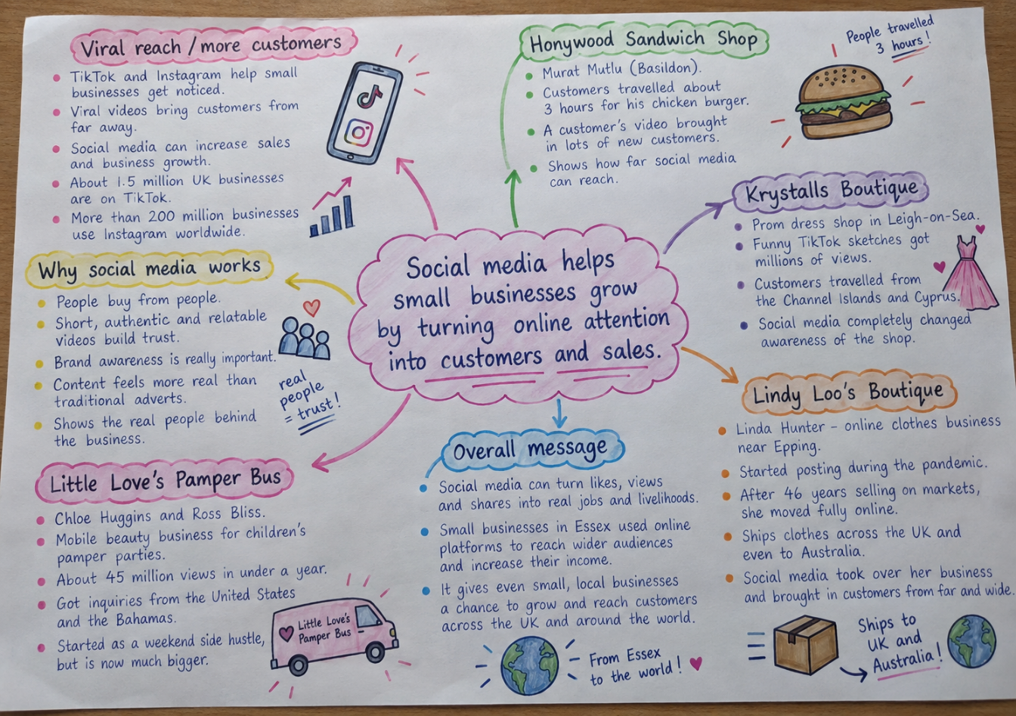

PART 2:

- What is the main idea of the whole text?
The point is that social media might assist small companies to transform online popularity into actual customers, extended reach and revenue, and even alter the business model.

- What is one key point that supports the main idea, and which specific example from the text shows this?
The first thing is that with social media, it is possible to attract customers who would otherwise be miles away due to a local business. Indicatively, customers have been traveling approximately three hours to Honywood Sandwich Shop just to have its chicken burger after the online content assisted the shop to receive publicity.

- What is a different key point that supports the main idea, and which specific example from the text shows this?
Another important aspect is that social media has the potential to alter the way a business sells and grows. After beginning to post during the pandemic, Linda Hunter has transitioned the Boutique of Lindy Loo to be entirely online and now delivers not only to the rest of the UK but even to Australia.

- Which part of the text do you think is most important, and why?
I believe that the part that describes that people react to genuine and relatable content is the most significant as it describes why the various businesses were successful in the internet. It links the examples with the fact that customers tend to believe more in content that will make them feel personal and not like a traditional advert.

Reflection:
- What did you find difficult in this task (including in-class components), and why was it difficult?
The most difficult thing was to divide the main idea and two various important points since the majority of the business illustrations were linked to the same topic social media development. I needed to determine which points were general and which were just illustrations of the points.

- What helped you with this difficulty, and how did it help you?
The second time I read the text and clustered the similar examples on the mind map came to my aid. This helped view the overall message initially and then pick two distinct key points and evidence of each.

