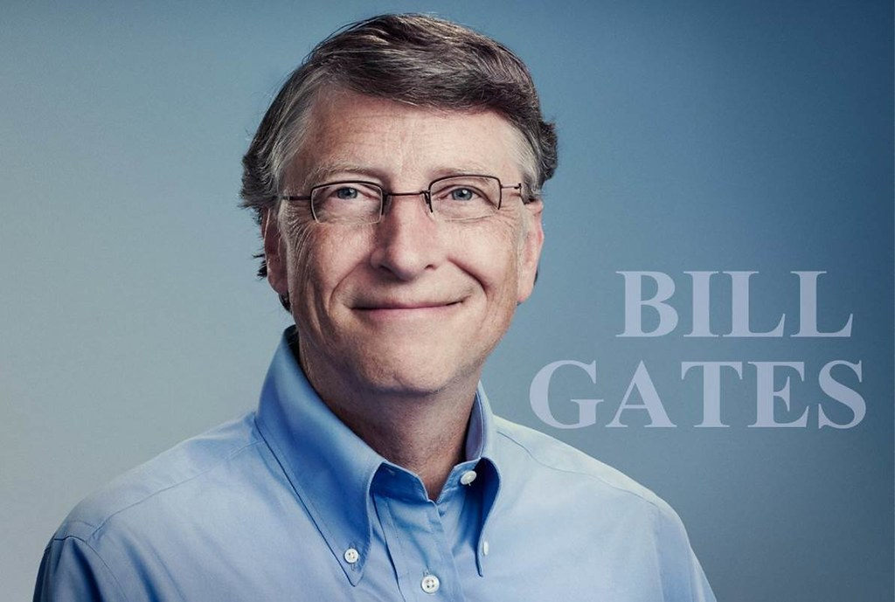  What makes a great leader?  Module Number: BMSW6101 | Submission Date:  3rd December 2021  Charlene Morgan  Student Number: 1906685

Contents Page

Introduction | 2
Background of Leader | 3
The Leaders traits and styles | 4
Influence of the Leader | 6
Reflection | 8
Leading on change | 9
Conclusion | 10
References | 11

Introduction

This essay will discuss various leadership styles, traits and behaviours whilst using a case study on a specific business leader. Touching on the background of that leader it shall include a critical discussion and the type of leadership strategy that is linked with various styles and traits. This information will be analysed through different resources such as books, articles and factual internet websites.
It will give insight on a personal reflection of one’s own leadership style, show examples of how this has been achieved and enhance the achievement in an organisation. Past working roles will incorporate real life situations and how to overcome hurdles in a well thought out methodical way, and finish with any changes that may have been learnt along the way.
Lastly a conclusion will collectively bring all this knowledge as one, with a clear understanding of what true effective leadership is and how looking towards the future can gain more understanding of believing in a better workforce resulting in a more advanced outcome.

Background of leader
Leadership is a term most known as a type of influence which can maximise the best efforts of others who want to achieve a main goal focus. However, there are many different styles of leadership, but the overall emphasis remains the same.
Being the youngest Billionaire at the age of 31 takes some extraordinary leadership, motivation, hard work, risky decisions throw that in with a pinch of determination and drive and the outcome is none other than Bill Gates. The man who founded Microsoft.
Born, William Henry Gates III grew up in Seattle, Washington, in 1955. He was surrounded and part of an upper middle-class family, who strove for brilliance. Gates was a bright young individual and in 1973 he graduated from Lakeside school. Here he produced an impressive SAT test score of 1590 out of 1600, which continued him to enrol in Harvard University embarking on a law degree that very same year. However, this was never Gates true passion and within two years he dropped out, to pursue his focus on computers and programming. (Biography.com Editors 2021).
Childhood friends Bill Gates and Paul Allen started up Micro-Soft (as it was known then) both men gave up University for Gates and a computer programmer job for Allen to concentrate on this new adventure. In 1979 this company had already turned into a multi-national corporation. The company went on to permit its MS-DOS working framework to IBM for its first personal computer, which debuted in 1981. Unfortunately, Allen had to depart the firm in 1983 due to an illness called Hodgkin’s lymphoma. This allowed Gates to continue with the business and in 1985 release a new system named Windows. The business went from strength to strength and by the late 80s Microsoft was now considered the largest personal software computer company based on sales. The Mid 90s was no exception Windows 95 was now introduced, with more features than ever before, 7 million copies were rolled out and purchased in the first 5 weeks. In only a short space of time, people were presented with Microsoft’s web browser better known as Internet Explorer. (History.com Editors 2015).
The dream for Gates was quoted “ A computer for every desk and every home” this dream became reality and gave people around the world a new way of using technology.
In 1994 Gates and his wife embarked on opening the largest foundation in the word and named it Bill and Melinda Gates Foundation, ultimately this passion for Microsoft shifted into becoming a philanthropist, in later years and in 2014 Gates stepped down from being a chairman of Microsoft to fully engage in becoming an advisor and to support CEO Satya Nadella which led him to deal with global change, health and development and education. In 2020 Gates very much still cares about the world and determinately carries on giving talks, visits and bringing knowledge to generations. (Biography Timeline 2020).

The leaders Traits and style
Sagor, R. and Rickey, D. (2012) reveal that in becoming a successful transformational leader there are 3 key elements to the following model which demonstrates that every circle overlaps each other this is because it is considered that the development and nurture is respectively valued whilst remaining as an important role to play.

Three Key Leadership Functions
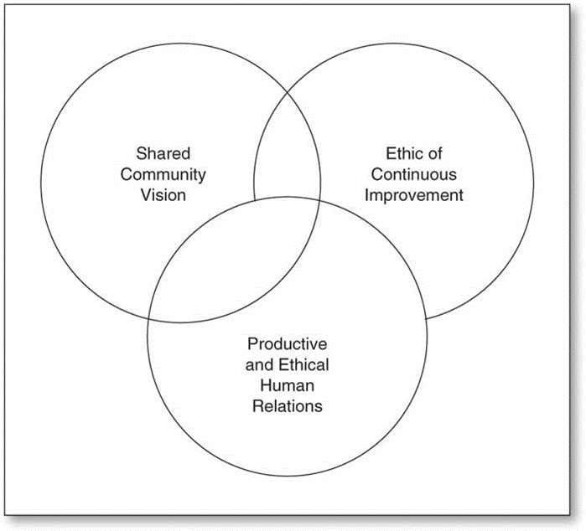

In the 1930s Kurt Lewin devised a framework where it described three different leadership styles Autocratic, this covers a more commanding approach, and not really letting the team help or contribute in anyway, this can get demoralising for the team but effectively in can be a great way to deal with any kind of emergency or crisis. Next is democratic which is the complete opposite, leaders want to incorporate the teams input and supports creativity, ultimately the end decision is made by the leader, because sometimes a quick decision still needs to be made. Lastly is Laissez-faire, this allows a much more open-minded approach to the team, as they can have full range of letting ideas flow and eventually having the answer to that all requested task, the only downside to this however can be time management. (MindToolsVideos 2020).

A leadership style can refer to a characteristic behaviour when reverting to a group of people. It will demonstrate a way of direction to get others to work fittingly. By motivating the team, it will show how plans are observed this will give good insight of how a leader behaves whilst leading. Whilst starting off as an Autocratic leader, Gates had to be in control of his hard work he tirelessly put in to drive his company and fellow employees, this in turn had huge respect for the man Gates had become and not one individual came away from a meeting with him to not feel inspired or creative in some way. The only downfall towards all this control was a stubborn behaviour which created barriers with the company not having a positive atmosphere. (The Global Hues 2020).
Qualifications was never really needed for Gates, he had a natural flair for computers, this transpired into being a great interesting leader. A transformational leader suggests that over time Gates came in with a strong vison and an enthusiasm for work, this rubbed off onto employees who would start follow him. (FOW 2021).
Zitelmann (2020) writes that Gates wasn’t the best leader to begin with, some say his approach to employees was demanding and intense, often sending emails late at night with impolite and not very motivated speech, he often used cursing whilst getting his point across. This is referenced yet again in a video by Biography Timeline (2021) where it states he gained a reputation for being tough yet focused.
Whilst there is common knowledge of Gates not being the best role model in his youth, his successful journey is somewhat an impressive read. The leadership styles, traits, skills and qualities define the man Gates is today. One leadership quality that stands out more than any other, is Gates work ethic and how diligently the work encompasses one person in a greater way.
Bill Gates follows Autocratic Leadership since he is competent and well-informed enough to decide what he is talking about. The Transformational Leadership style he holds influences employee’s emotions through motivation and support. Furthermore, he possesses Visionary Leadership style. (Sittar 2021) The visionary upholds the way we live today Microsoft has changed that over the decades, such a change demonstrates a very much focused determined way of thinking and managing.
No doubt that Gates has this need to keep on learning, his resilience is second to none, he has always stayed one step ahead of the ever-changing technology, but with knowledge and encouragement with his team it no doubt has gained him success and the title of one great leader, even today the world is still seeing significant changes. (Financhill 2021).

In today’s society where all things are ever changing, society has a need for understanding what the best approach for styles of Leadership today and for future practice. (Tracy 2017) shares some insightful knowledge in just which leadership styles are the key to being a successful leader with equally the same outcome for the team. A structural style can help plan and have a knowhow of what exactly is the task ahead. It can reward or punish team members based on performance level. However, the leader must have complete responsibility for undertaking any outcome because it lets the leader to make decisions a lot faster without others procrastinating, there really is no movement and ideas can be very restricted. Participative Style has a more hands on feel approach it will cover a way of making the team more involved, having a duty of care and understanding any concerns or interest. The benefits of this involvement will make the team feel more valuable to the organisation and will boost team morale. A one-sided method is Servant Style, this style must make sure everyone is instructed and have clear direction for they begin. If this is an issue, then the leader must step in to help with extra learning and training. I can be somewhat of a repetitive style, so it would be a great style to begin with knowing that a rapport and sense of respect can be gained. The Freedom style is very much like the Laissez – faire and can be a great help whilst allowing originality and abilities to flow more easily. Finally transformational leadership remains one of today’s exceptional styles it gives an individual time to explore ideas. Being able to tap into ones mind it reveals great communication skills and it becomes apparent that visionary gets only the best results. By adopting any one of these five leadership styles will give insight of how the team will gravitate or pull in the other direction when in practice.

Influence of the leader
Influence is fundamentally creating a change in which things may get done through the work of other people, Leadership involves getting individuals of an entire workforce to turn up and ultimately focus by having a lightbulb moment. Motivation is the key, to be influenced by others but there needs to be a part of oneself to feel that influence too. (Naidu 2016).
According to World of Work Project (2021) Social psychologists John French and Bertram Raven theory (1959) devised the six forms of power in leadership that can be used to influence others. This covers Legitimate, Reward, Coercive, Informational, Referent and Informational. Part of using legitimate power can be quite capricious at times if a leader does happen to lose the title role the power also goes with it. A team can be influenced by a hierarchy of power and abide to being told what to do because of the rules of workplace. The reward power presents an opportunity to give incentives, if members comply with direction, a personal ‘thankyou’ or a pay rise maybe the key to keep the team driven and have longevity within the organisation. The third of French and Raven’s Forms of Power is coercive which is team members can experience a fear of a leader who may abuse their power and use it to punish in many ways for example, withholding pay rises and promotions. Informational power concentrates on not overpowering with information when things need to be completed. In the everchanging world of data informational power is formidable so if it does get misplaced then the power will be gone with it. A more appealing power is the referent kind as every leader wants to be liked and respected. It’s derived from a person’s perceived value, worth or desirability. Lastly is expert power it includes leaders in having the competence and expertise in helping them to be a loyal individual and to be influential to others. (Heffernan, 2021)

Citeman (2008) state looking at the different powers only one stands out as a negative, coercive does not provide any influence however the rest do give a considerable amount of effectiveness and more positive outcome. Both referent and expert power are the most effective when giving a chance to employees and satisfaction. These powers all work well together so it can achieve what influence best determines the right leader.
Bill Gates is a well prominent influential leader amongst the elite, starting off in technology, and now a worldwide known philanthropist many may see why people may look up to a figure of such calibre. However, Rodrigues (2021) enlightens the readers by making it clear that greed only overcomes philanthropy, Gates made himself very clear that whilst the foundation of Melinda and Bill Gates want to do nothing but have good intentions for the Covid 19 injection, it came across slightly one-sided displaying actions of not wanting to share the formulas with other countries and to only profit from keeping in line with exclusive deals rather than promote fair access.
Whether it be education, global health, or climate change (Hess 2017) explains the 1.7 billion investment Bill and Melinda have brought to the public education system in America have been second to none. This has funded inequality over students of colour and low income. Climate change was an investment which promises underfunded technologies to gather information and teach people in aiding ideas to transform the pressures of our damaging planet. It is also well known that the foundation reaches out to global heath causes, again another investment was offered, in turn the charity has raised billions to see the end of malaria, tuberculosis and aids.
The influential mindset that Gates possesses is to make a huge impact on the world, this has been done through the vast fortune which has been netted and how it was made through new technology, Gates bestows a large amount of earnings to world health. Always being the forward thinker, technological innovation has helped to provide these noble charities, which gives a new lease of life to individuals who are in dire need. (Bloomberg 2020).
Since leaving Microsoft Gates has continued to stay true to being a transformational leader, Taylor (2020) discloses that Gates is a forward thinker and how the software programme was going to help everyone around the world, every PC would be a must have in every home and office. Staying focused and determined was another fantastic way of showing passion for the work and kept in tune with perseverance , it influenced many people to become goal orientated and work just as hard.

Reflection

Taking into consideration my working and personal life, I have always been a leader in some manner, I believe I can come across in quite an authoritative way and found that some colleagues have either gravitated towards this trait or pulled in the other direction, very much like Gates I was a driven young woman who worked hard and wanted to achieve my goals. I excelled when targets were met, or sales were driven.
When the opportunity arose for me to take a Leadership stye questionnaire, I knew instinctively what I would be an authoritarian Leader, in fact I knew very little about myself, the leadership style I turned out to be, was none other than a democratic leader receiving a high range score of 26 points and following that up with 16 points authoritarian I was surprised to learn this, however when learning more about the democratic view I came to understand that it very much focuses on others opinions, taking a step back and making slower decisions, letting others take part and encourage them to take responsibility and allowing this to be a regular part of leadership will allow a better two way communication to be built upon. I far more can relate to this as life experiences, different cultures, maturity and skills has led me to understand that leadership is not a one tunnel vision. The autocratic side of me very much still plays a part in my personality, I still like to make quick decisions, and executing quantity over quality, direction is key and with a clear insight of planning and precision others feel more at ease and don’t feel the pressure as easily. But while all these can be helpful at times the downside could jeopardise staff morale and discourage staff input. (Cherry 2020). In the low range of only 13 points did I have a Laissez – faire leadership style this I could agree with I have never been one to step back from responsibility and allow others to take over the reins solely. Having a hands-off approach can lead to low performance and mistakes can be made. I want to give others the chance to be heard and guide them into becoming successful individuals.
Channelling McGregor’s X and Y theory, studies show how motivation can affect management leadership style, I gravitate towards both these concepts but lean more to theory Y, this is because it is all to do with being optimistic and encouraging, these attributes can bring out the best in people, allowing workers to freely use their creative ideas will self-motivate and enjoy their job far more. Work needs to be more than just about money, it needs to be about having value, self-worth and confidence to drive people into the right careers and pathways.

Leading on change

Reflecting on past work experiences, I have been a secretary, an assistant manager of bars and nightclubs, eventually volunteering as a Samaritan before joining university. These roles have included various skills and traits to solidify my career direction. Over the years I have learnt to deal with situations differently, understand everyone has a voice, guiding fellow colleagues, ensuring that team involvement makes a world of difference in the workplace, and more apparent making sure that communication is vital, as without clear instruction of leadership things can get lost in translation, and problems will occur.
The leadership I encountered whilst working in nightclubs was a very authoritative one. I was very determined and came across many hurdles along the way. An example of this was always spotting a problem at work and finding ways to resolve the concern. I would always try and deal with the problem there and then, maybe not listening intently but just getting a quick picture of the problem acting on it and brushing the rest under the carpet. In time I understood that things can’t always be a quick fix, and I remember asking my manager if I could hold monthly team meetings, where I would get a chance to speak to staff about, new and upcoming promotions, prices, new products, air any concerns, explain how well we may be doing as a business, have a refresh on staff training, and made sure we kept things light by playing various games to keep up team morale and the bond a tight one. I believed it worked and no longer did we see each other as rivals but more of a team which had a passion to work hard for the company. When the day came for me to become a Samaritan I trained vigorously and really had to home in on my listening skills, people want to be truly listened and feel like someone is paying attention to every detail. Fellow co-workers leaned against each other for support, training was paramount, and no one left a shift without being asked the question “Are you ok”. It was a privilege to volunteer and to be someone’s safety net, I gained resilience, patience, enhanced my listening skills, and supported the callers to make their own decisions and take their own responsibility, but also being aware to signpost somebody due to a safeguarding issue.
I have come along way, in learning more about myself and how leadership can be something that creates a greater confidence. Ultimately what you see through your eyes is what others are keen to expand upon and make things great for the organisation. (American Business Times 2021) express that when building a character base there are certain attributes that will help the leader become that much more dedicated to the role, this can include enabling innovation, create a positive organisational culture, trusting different relationships and keeping engaged. In the future I want to have an impact on change, to ensure I can do these things I want to be more aware of myself, these will include learning how to deal with difficult conversations, invest in time to coach others, challenge others to be more creative, and to lead by example because effectively I can be a good teacher to others which will in turn make me a great leader. Adair (2019, p. 8), explains it takes time to be a leader, and that you must be open to feedback whether it be good or bad. You must build your self-confidence and be accessible to grow in integrity.
Conclusion

In conclusion Gates may seem somewhat a failure to begin with, a Harvard dropout, a start-up business which collapsed and went nowhere, but lessons are learnt from any let-down that may occur. If Gates never followed his dreams, he may never have become the successful billionaire, leader and philanthropist he is today (Banshee 2020).
While some may think that leadership is all about power, someone who commands control , respect and dominates their workforce can fully understand this is not always the case. A great leader will always let go and show that great success cannot evolve by oneself but with a workforce to back it up. (Costantino 2015).
As leaders cannot fix all the problems in which the workplace has to bear, attention needs to be raised in other areas such as motivation, growth and listening to the leader’s fellow colleagues. (Wallace 2019).

“As we look ahead into the next century, Leaders will be those who empower others”
- Bill Gates

Summarising my own reflection of leadership, it has become apparent that to become a thriving leader who can motivate others, I will be able to take away knowledge from Lewins method and apply them to my skill set which I have already learnt regarding the leadership style questionnaire. I am delighted to recognise that the leadership styles I have covered in my reflection are still being applied today. It gives me great confidence, knowing that there are many options to choose from and how best to utilize them whilst observing the kind of organisation I go in to. I shall now focus on developing my leadership skills further by leading with impact and showing a great first impression, bringing the team together by using the democratic approach, bring out others motivation but also focus on my own inspiration so others can lead by example. If I can give others a speaking voice, in turn they will have understood I have listened and acted upon their ideas, thoughts and expectations.

"The pessimist complains about the wind. The optimist expects it to change. The leader adjusts the sails.”
-John Maxwell

References
Adair, J. (2019) Develop Your Leadership Skills London kogan Page.

American Business Times (2021) What is Leadership and Why is it so Important? Available at: https://abt.news/what-is-leadership-and-why-is-it-so-important/ (Accessed 19th November 2021).

Banshee (2020) How Bill Gates Failed Before He Became Successful Available at: https://failfection.com/how-bill-gates-failed-before-he-became-successful/ (Accessed 24 October 2021).

Bin Sattar S. (2021) Leadership Qualities, Skills, and Style of Bill Gates Available at: https://www.thestrategywatch.com/leadership-qualities-skills-style-of-bill-gates/ (Accessed 9 November 2021).

Biography Timeline, (2021) Who is BILL GATES? | Biography Timeline Available at: https://www.youtube.com/watch?v=gFdnE2fYdbg&t=168s (Accessed 19 October 2021).

Biography.com Editors, (2021) Bill Gates Biography Available at: https://www.biography.com/business-figure/bill-gates (Accessed: 12 October 2021).

Bloomberg (2020) Bill Gates Wants to Save the World Available at: https://www.youtube.com/watch?v=Gnh4GBzgPHM (Accessed 19 November 2021).

Bradley Taylor “Bill Gates Leadership Style: Millionaire SUCCESS ADVICE Series” You Tube. 14 Apr. 2020. Web. 1 Dec. 2021.

Brain Tracey “5 Different Types of Leadership Styles” You Tube. 11 May. 2017. Web. 1 Dec. 2021.

Cherry K. (2020) Autocratic Leadership Available at: https://www.verywellmind.com/what-is-autocratic-leadership-2795314 (Accessed on 16 November 2021).

Citeman (2008) Which bases of power are most effective? Available at: https://www.citeman.com/3712-which-bases-of-power-are-most-effective.html (Accessed 1 December 2021).

Costantino T. (2015) The 3 Ways Leadership Is the Opposite of What Most People Think Available at: https://www.entrepreneur.com/article/243308 (Accessed 19 November 2021).

FOW (2021) 9 Bill Gates Leadership Style Traits, Skills and Qualities Available at: https://futureofworking.com/9-bill-gates-leadership-style-traits-skills-and-qualities/ (Accessed 19 October 2021).

Heffernan, B. (2021) ‘Week 3: Power of Leadership’ BMSW6101: Available at: https://moodle.uwtsd.ac.uk/course/view.php?id=7834 (Accessed: 1 December 2021).

Hess A. (2017) 3 ways Bill Gates is spending billions to change the world Available at: https://www.cnbc.com/2017/12/20/3-ways-bill-gates-is-spending-billions-to-change-the-world.html (Accessed 16 November 2021).
History.com Editors (2015) Microsoft founded Available at: https://www.history.com/this-day-in-history/microsoft-founded (Accessed 23 October 2021).

MindToolsVideos “Leadership Styles” YouTube. 6 Mar. 2020. Web. 1 Dec. 2021.

Naidu, Y. (2016) Power Play : Game Changing Influence Strategies for Leaders, John Wiley & Sons, Incorporated, Milton, QLD. ProQuest Ebook Central.

Qualtrics (2020) 10 powerful quotes on leadership to inspire your organization Available at: https://www.qualtrics.com/blog/10-powerful-leadership-quotes/ (Accessed 1 December 2021).

Rodrigues S. (2021) Bill Gates is not a philanthropist but a money-making opportunist Available at: https://goachronicle.com/bill-gates-is-not-a-philanthropist-but-a-money-making-opportunist/ (Accessed on 16 November 2021).

Sagor, R. and Rickey, D. 2012. Three Key Leadership Functions. In: 2012. The Relentless Pursuit of Excellence: Lessons from a Transformational Leader, Thousand Oaks, CA: Corwin Press. pp. 14 Available at: http://www.doi.org.ezproxy.uwtsd.ac.uk/10.4135/9781483350547.n3 (Accessed 24 October 2021).

The Global Hues (2020) Leadership Styles And What Lessons To Learn From Bill Gates? Available at: https://theglobalhues.com/bill-gates-leadership-style/ (Accessed 19 November 2021).

Wallace N. (2019) “Tomorrow’s Leaders Will be Those That Empower Others” Available at: https://real-leaders.com/bill-gates-tomorrows-leaders-will-be-those-that-empower-others/ (Accessed 19 November 2021).

World of Work project (2021) French and Raven’s Forms of Power: A Simple Summary Available at: https://worldofwork.io/2019/08/french-and-ravens-forms-of-power/ (Accessed 1 December 2021).

Zitelmann R. (2020) Bill Gates was an angry, difficult boss in early Microsoft days—here’s why employees still liked him Available at: https://www.cnbc.com/2020/02/24/bill-gates-was-difficult-boss-in-early-microsoft-days-but-employees-still-liked-him.html (Accessed 12 October 2021).

