

Student name: MUSA BAMWINE
Student ID: 2425291

Module name: INTRODICTION TO PHYSIOLOGY
Module code: (BMHP5023 LON)
Lecturer name: DR SOBAN SADIQ

Assessment: ASSESMENT 1 (DIABETES)

TABLE OF CONTENT

Introduction describing what diabetes is and what the risk factors ….3
How blood sugar levels are maintained at a safe and effective level for the body’s needs......4
How oxygen and glucose are used to produce energy through cell metabolism..
2)……………… How recording and tracking blood sugar levels helps individuals with Type 2 diabetes to safely manage their condition
3) …… Evidence-based recommendations on how lifestyle changes could help improve their condition.
4) ……… Conclusion
5) ……….. Reference list

1) INTRODUCTION
Diabetes is usually a long-term medical condition where the sugar levels (glucose in the body) turn out or become excessive to the body thus instead of being good it becomes harmful or disastrous for the body causing problems for the individual in this case even causing many adverse illnesses ,mostly as a result of the body failing to manufacture insulin enough to be able to move glucose from the blood to the cells manufacturing energy for the body (Odya, 2018)
Diabetes can also be defined as a chronic condition in which blood glucose levels rise abnormally, becoming harmful rather than providing energy. This usually occurs when the pancreas fails to produce sufficient insulin or when the body’s cells become resistant to insulin, preventing glucose from entering cells to generate energy (Odya, 2018). Excess body fat, particularly around the abdomen, can worsen insulin resistance, causing glucose to remain in the bloodstream rather than being utilised for energy. Studies show that a large proportion of people with type 2 diabetes are overweight or obese (Odya, 2018).
Genetic factors also significantly influence diabetes risk. Individuals with a family history, such as a parent or sibling with diabetes, have a higher likelihood of developing the condition, suggesting that inherited traits affect insulin production and cellular response (Odya, 2018). Age is another risk factor; the risk of type 2 diabetes rises after 35–45 years, as metabolic processes become less efficient over time (Odya, 2018).
Additional contributing factors include unhealthy diets high in processed foods and sugar, sedentary lifestyles, high blood pressure, and a history of gestational diabetes (Odya, 2018). These can be categorised as modifiable factors—such as diet, weight, and physical activity—and non-modifiable factors, including age and genetics. Understanding these risks enables individuals to take preventive steps, including maintaining a healthy weight, following a balanced diet, exercising regularly, and monitoring blood glucose, which collectively reduce the likelihood of developing diabetes or help manage it effectively (Odya, 2018).

2)BLOOD SUGAR (GLUCOSE) LEVELS ARE TIGHTLY REGULATED
To ensure the body has a constant energy supply without reaching harmful extremes. This balance is maintained through a negative feedback system involving the pancreas and two key hormones: insulin and glucagon.
After eating, carbohydrates are digested into glucose, which enters the bloodstream and raises blood sugar levels. In response, beta cells in the pancreas release insulin. Insulin acts like a key, allowing glucose to move from the blood into body cells, particularly muscle and liver cells. In the liver, excess glucose is converted into glycogen for storage. This process lowers blood sugar back toward a normal range, preventing damage to tissues and organs.
Between meals or during physical activity, blood glucose levels may fall. When this happens, alpha cells in the pancreas release glucagon. Glucagon has the opposite effect of insulin: it signals the liver to break down stored glycogen into glucose and release it into the bloodstream. It can also stimulate the production of new glucose from non-carbohydrate sources. This raises blood sugar levels to ensure the brain and other vital organs receive enough energy.
This system operates continuously, adjusting hormone release based on current blood glucose levels. The use of negative feedback ensures that any deviation from the normal range is corrected efficiently. If this regulation fails, conditions such as diabetes can occur, where blood sugar remains too high or becomes dangerously low.
Overall, the coordinated actions of insulin and glucagon maintain blood glucose at a safe, stable level, supporting the body’s constant demand for energy.
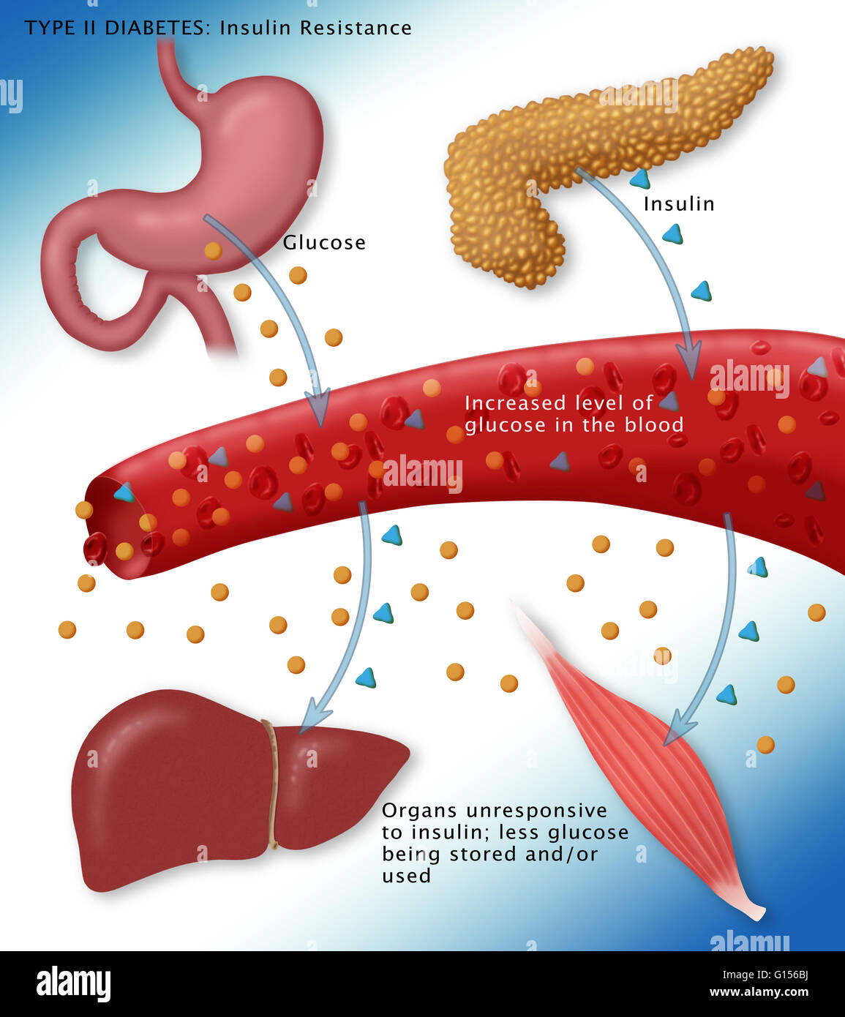

3)CELL METABOLISM USES OXYGEN AND GLUCOSE
A process called cellular respiration to produce usable energy in the form of ATP. This process occurs mainly in the mitochondria and involves a series of linked reactions that gradually release energy stored in glucose molecules
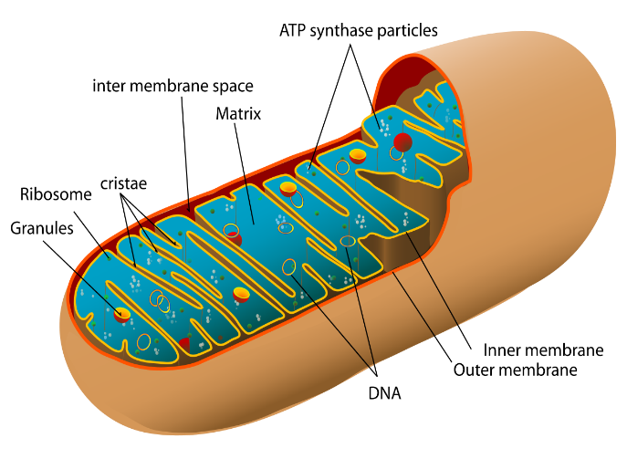
First, glucose (C₆H₁₂O₆) enters the cell and is broken down in the cytoplasm during glycolysis. In this stage, one glucose molecule is split into two smaller molecules called pyruvate. A small amount of ATP is produced, but most of the energy remains stored in intermediate molecules. This step does not require oxygen, yet it prepares glucose for further energy extraction.
Next, the pyruvate molecules move into the mitochondria, where oxygen becomes essential. Inside the mitochondrial matrix, the Krebs cycle (citric acid cycle) breaks down pyruvate completely. Carbon dioxide is released as a waste product, and high-energy electron carriers (NADH and FADH₂) are generated. These carriers store energy that will be used in the final stage.
The most significant energy production occurs in the electron transport chain, located in the inner mitochondrial membrane. Here, oxygen plays a critical role as the final electron acceptor. Electrons pass through a chain of proteins, releasing energy that pumps protons across the membrane and creates a gradient. This gradient drives ATP synthase to produce large amounts of ATP. When oxygen accepts the electrons and combines with hydrogen ions, water is formed as a byproduct.
Overall, oxygen and glucose work together to fuel cellular activities. Glucose provides the chemical energy, while oxygen enables efficient energy release. The complete process converts glucose and oxygen into carbon dioxide, water, and about 30–32 ATP molecules, supplying cells with the energy needed for movement, growth, and repair

Recording and Tracking Blood Sugar Levels
Recording and tracking blood sugar levels is a vital tool that helps people with Type 2 diabetes manage their condition safely and effectively. By regularly monitoring blood glucose, individuals can understand how factors such as food, physical activity, medication, and stress impact their sugar levels (Odya, 2018). Using a blood glucose monitor allows people to check their levels multiple times a day, providing real-time feedback on their body’s response to daily activities.
Keeping a detailed record of these readings helps identify patterns, such as periods when blood sugar spikes after meals or drops during exercise. This information enables individuals and healthcare professionals to make informed adjustments to diet, physical activity, and medication, keeping blood glucose within a healthy range. Regular tracking also supports early detection of abnormal readings, reducing the risk of serious complications, including organ damage, cardiovascular issues, and nerve problems caused by prolonged high blood sugar (Odya, 2018).
Furthermore, self-monitoring encourages accountability and greater awareness of the effects of lifestyle choices. Individuals who track their blood glucose are better equipped to plan meals, time exercise, and manage stress, which collectively improve long-term diabetes control. In summary, recording and tracking blood sugar levels empowers people with Type 2 diabetes to take active control of their health, optimise treatment, and maintain safer, more stable glucose levels over time (Odya, 2018).

4)RECORDING AND TRACKING BLOOD SUGAR LEVELS
Also plays a vital role in helping individuals with Type 2 diabetes manage their condition safely and effectively. By regularly measuring glucose levels using a glucose meter or continuous monitoring device, individuals gain immediate insight into how their body responds to food, physical activity, medication, and stress.
One key benefit of tracking is improved awareness. When a person records their blood sugar throughout the day, patterns begin to emerge. For example, they may notice that certain meals cause sharp increases, while exercise helps lower levels. This understanding allows individuals to make informed lifestyle adjustments, such as choosing healthier foods or increasing physical activity.
Tracking also helps prevent dangerous complications. Blood sugar that is too high (hyperglycaemia) or too low (hypoglycaemia) can lead to serious health risks if not addressed promptly. By monitoring levels, individuals can take quick action—such as adjusting medication, eating carbohydrates, or seeking medical advice—to return glucose to a safe range.
In addition, recorded data supports better communication with healthcare professionals. Doctors and nurses can review blood sugar logs to evaluate how well treatment plans are working and make necessary changes. This leads to more personalised and effective care.
Furthermore, consistent tracking encourages responsibility and self-management. It empowers individuals to take control of their condition rather than relying solely on occasional medical visits.
Overall, recording and monitoring blood sugar levels provides essential feedback, reduces health risks, and supports informed decision-making. This ongoing procesis a cornerstone of safely managing Type 2 diabetes and maintaining long-term health.

5) LIFESTYLE CHANGES TO IMPROVE TYPE 2 DIABETES
Lifestyle changes are a key part of managing Type 2 diabetes, and strong scientific evidence shows they can significantly improve blood sugar control and overall health. One of the most effective strategies is adopting a balanced, nutrient-rich diet. Research shows that diets high in whole grains, vegetables, lean proteins, and healthy fats can stabilise blood glucose levels. Reducing intake of refined sugars and processed foods helps prevent sharp spikes in blood sugar, making it easier for the body to use insulin effectively.
Regular physical activity is another essential recommendation. Studies indicate that at least 150 minutes of moderate exercise per week, such as brisk walking or cycling, improves insulin sensitivity. This means the body’s cells respond better to insulin, allowing glucose to enter cells more easily and lowering blood sugar levels. Exercise also supports weight management, which is closely linked to improved diabetes outcomes.
Weight loss, even in small amounts (5–10% of body weight), has been shown to significantly reduce blood glucose levels and, in some cases, may even lead to remission of Type 2 diabetes. Maintaining a healthy weight reduces strain on the body and improves how insulin functions.
In addition, consistent monitoring of blood sugar, combined with these lifestyle changes, helps individuals understand how their habits affect their condition. Adequate sleep and stress management are also important, as poor sleep and high stress levels can raise blood glucose.
Overall, evidence-based lifestyle changes—including healthy eating, regular exercise, and weight control—empower individuals to manage Type 2 diabetes effectively, reduce complications, and improve long-term quality of life.

6) CONCLUSION ,
Diabetes is a chronic condition where the body cannot effectively control blood glucose, often due to insulin resistance or insufficient insulin. Key risk factors include obesity, inactivity, poor diet, age, and genetics. Blood sugar levels are regulated by insulin and glucagon, which maintain balance through a negative feedback system. At the cellular level, glucose combines with oxygen in respiration to produce ATP, supplying energy for vital processes. For individuals with Type 2 diabetes, monitoring blood glucose is essential, as it helps identify patterns and prevent harmful highs or lows. This supports better treatment decisions and safer self-management. Evidence shows that lifestyle changes, such as a balanced diet, regular exercise, and weight control, can significantly improve insulin sensitivity and reduce blood sugar levels. Overall, understanding these processes enables individuals to manage diabetes effectively and reduce the risk of long-term complications.
7) REFERENCE ,
1)Glasby, Jon., 2nd ed., Bristol :, Policy Press, 2012., Total pages 1 online resource (226 p.)

2)Hansen, J.T. (2019) Netter’s anatomy flash cards . 5th edition. Amsterdam :, Elsevier.

3) M. Nair & I. Peate (eds) (2011) Fundamentals of anatomy and physiology for student nurses . Chichester, West Sussex, England ; Ames, Iowa :; Chichester, West Sussex, England ; Ames, Iowa :, Wiley-Blackwell.
4) Lean, M.E.J. (2017) Barasi’s human nutrition : a health perspective . Third edition. Boca Raton :, CRC Press Taylor & Francis Group.
5) M. Lomer & A. Stuart (eds) (2014) Advanced nutrition and dietetics in gastroenterology . Electronic version. Chichester, England :, Wiley Blackwell.

