
School of Engineering
Final Report
Koa Brook
2203480
Motorcycle Engineering BEng
16/03/2024
Group Design Project
ACHA5014

Contents
1. Introduction 3
2. Project Organization 4
Team roles within Belbin’s model 4
3. Project Work 5
Initial testing 5
Cylinder head modifications 5
Testing and analysis 6
Intake 6
Exhaust 7
4. Progress and achievments 8
5. Project Review 9
6. References 10

Introduction
The project that will be discussed in this report aims to convert a stock road legal motorcycle for motorsport use. The motorcycle in question is a pre-1990 GSX 1100F, the bike was previously on the road however it seems to have been stored incorrectly for some time and therefore in no condition to be on the road. The motorcycle will be used for drag racing with either the national sprint association or the straight liners events. The bikes performance should be tested prior to modification and checked against stock figures to determine the engines performance condition and if any repairs and rebuilding is necessary. The motorcycle is then to be stripped and any parts that are not to be modified are to be stored until rebuilding. Some components will require restoration, and some will need to be replaced. Frame and engine modifications will be carried out to improve performance and its handling behaviour. The final modifications will be made to the fairings and wheels to improve aerodynamics and traction. The final product will be used for a student led UWTSD drag race team. Drag race specific systems may be added later on in the season or before the racing season however due to the complexity of the systems and possible time constraints may not be a feature that is implemented. The two main systems include an air shifter and a nitrous system.

Project Organization
The roles of each team member are crucial to the project as the division of roles can dictate the progression and the time taken to complete the project. The project work and development will be considered as well as team roles relating to Belbin’s model. Belbin’s model looks into different team roles that help the group to function efficiently and effectively. If certain roles are not filled, then the project organization will be at risk which could delay the project. Due to the limited size of the team this is a possible issue.
Figure 1, Belbin’s team roles
(Aritzeta, Swailes and Senior, 2007)

Team roles within Belbin’s model
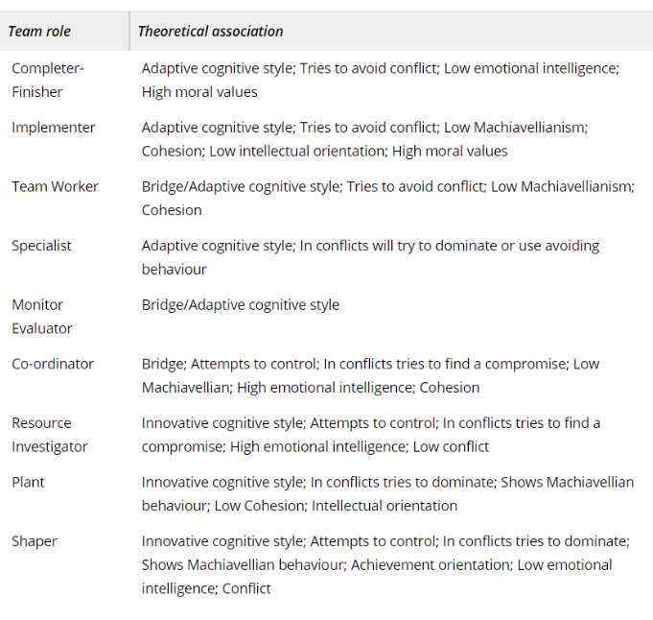
the team is extremely diverse in terms of personality and role traits, these mostly fit in within Belbin’s team roles (figure 1). Timothy Vale takes an organizational role within the team overviewing the project and each of its developments. This helps the team to work efficiently as he also organises the job list which allows each member to stay on track of what work is required to be carried out at each milestone in the project. If a member is struggling with a task, then the team would be able to see this and help so each milestone in the team. Timothy also looks into potential sponsorships for when the team begins racing, which allows the team to focus on the work at hand as he organises and focuses on the future of the project. Therefore, within Belbin’s model he can be linked to three of the roles, shaper, monitor/evaluator, and co-Ordinator. Koa Brook focuses on the mechanical improvements being made to the motorcycle; this is a very unorganised section due to the nature of the work. Due to the wait for machining, multiple tasks have to be balanced and completed at similar times so that the whole project remains on schedule. This can make this section very unorganised during vital stages of the project as numerous mechanical tasks need completing for each milestone. This puts him as a completer/finisher as well as an implementer when relating to Belbin’s model. Catriona Burn takes part in some mechanical work, and organises the team’s social media, but focuses on the design side of the project as their main responsibility. This will be one of the finishing features to the bike that completes the project and allows all the parts to be assembled. This links to the completer/finisher, and specialist roles within Belbin’s model. Megan Gwilym also helped with initial mechanical work, and then focused on the electrical systems being implemented towards the end of the project. This section requires research to understand and complete. The recourse investigator and team worker roles are displayed within their project work.

Project Work
The work completed throughout the project will be explained in detail within this section. The teams’ milestones will be explained with what they represent in terms of the project’s progression. The process of each task will be explained including any specialist equipment used to complete the tasks. All calculations and tests will be included. All errors and issues will be cover as well as how they were resolved.

Initial testing
Figure 1
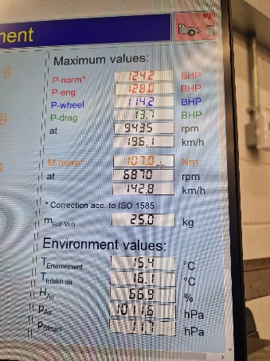
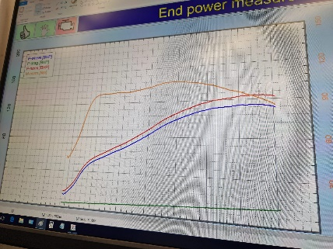
as this motorcycle is to be used for dragging racing the main focus of the project is the power and torque of the motorcycle. Before any modifications were made initial dynamometer testing were done for a baseline power and torque reading. The first dynamometer test had to stopped shortly after starting this was due to a severe oil leak and the clutch not functioning. The clutch cover was removed, and the plates inspected, the plates were deemed fit for use. So, the clutch slave cylinder was checked after removal the dirt was cleaned and the clutch oil seal on the engine was damaged and leaking. This was replaced which corrected the oil leak, however the clutch itself was not functional. After dismantling the clutch system, it was determined that the slave cylinder was corroded causing gaps in the seal, not allowing it to pressurise. The master cylinder was also damaged. The slave cylinder was cleaned and rebuilt with a new seal. A replacement master cylinder was found and fitted. The carburettors were then balanced, and the motorcycle tested. The results at the wheel were max power 85.16 kW @ 9,435 RPM, and max torque 107 Nm @ 6,870 RPM (figures 1&2). The factory results at the wheel are “97.5 kW @ 10,000 RPM” and “112Nm @ 7,000 RPM” (Correia, no date). This lost power should be mostly regained when all necessary components are replaced, and then increased further with other modifications. After these tests the team stripped the entire motorcycle for further work to take place.
Figure 2

Cylinder head modifications
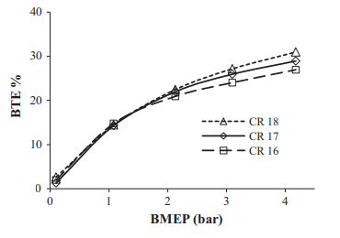
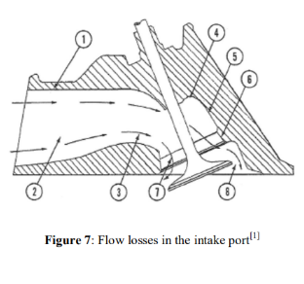
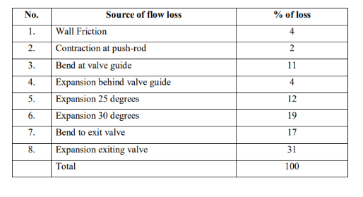
To increase power the main focus is to modify and test the cylinder head. Increasing the compression ration of the engine would increase power as the air fuel mixture would experience a higher pressure at combustion. Figure three shows the relationship between efficiency and pressure at different compression ratios. As can be seen as they increased compression ratio the efficiency increased. As efficiency is the ratio of useful power to input power it can be predicted that the increased compression ratio would increase power. Before making any modifications to the cylinder head the clearance between the valves and pistons had to be checked. This was done by removing the cylinder head from the engine and placing a 10mm thick layer of plasticene over each piston, the attaching the cylinder head and valve train back to the engine. The engine was then turned 720° to allow for impressions to be made for each cylinder. Using a digital calliper the depths of the valve impressions were measured (4.6mm exhaust, and 4mm intake). The possible achievable compression ratios were the calculated based on the maximum height removable from the cylinder head based upon valve clearance. Figure 4 shows potential compression ratio in the first column and the depth of material that would require to be skimmed off the cylinder head to achieve these compression ratios. Due to the distance between the top surface and the first cooling fin 1.3mm was deemed to be a suitable amount of material to remove. This would achieve a compression ratio of 11.9, without restricting the cylinder air cooling system. Power can also be increased by increasing the airflow through the ports and valves of the cylinder head. Figure 5 shows the factors that reduce the flow of air through the cylinder head ports, the paper is based of a similar 4 cylinder 16 valve engine. The valve port will be sanded down to reduce air friction with the valve wall and to smoothen any bends and sharp edges to allow for increased flow and reduce air turbulence within the port. The intake port will be made slightly rough to allow atomization to occur in the ports which allows the fuel to be well distributed throughout the air fuel mixture. The valve side of the ports will be counter bored to have a width of 24mm intake and 22mm exhaust (roughly 87% of their valve head diameters). This will allow an ideal flow when entering the cylinder reducing the flow lost due to expansion when exiting the valve. The counterbore will be sanded and blended in with the rest of the port. All valve seats will be cut to have three angles (30°,45°,60°), this will reduce turbulence when the air travels around the valve seat into the cylinder as there is a more subtle change in angle. The intake valves will also have a 30° back cut to increase flow around and over the valves, the exhaust valves will be a larger radius round the valve margin to allow for increased flow around the valve for exiting gasses.
Figure 4
Figure 3 (V. Hariram , R. Vagesh Shangar. ,2015)
Figure 5 (MOHD TAUFIK BIN ABD KADIR, 2008)

Testing and analysis
The modified cylinder head and a stock cylinder head will be tested on the flow bench to measure the flow of air through the valves and ports of both the intake and exhaust. These results will be compared with results and data collect by Mark Fall (November, 2011, GSXR 1100 Flow) and to a stock cylinder head. This comparison will allow us to know whether any improvements have being made, and the comparison to a more race orientated engine (GSXR 1100) will allow the team to understand the magnitude of the changes.

Intake
Figure 6
figure 6 shows the flow through the intake of all 3 cylinder heads, as can be seen the modified GSXF 1100 head has the same amount of airflow as the GSXR. The modified head has 20 CFM more flow than the stock cylinder head this is 17% increase. This increased flow will allow more air to enter the combustion chamber which will allow for more energy to be released on ignition if the amount of fuel entering the cylinder is also increased. This will allow for increased power and torque which will increase the motorcycles acceleration which is one of the most important factors in sprint racing. Figure 7 shows the flow over the effective valve area (EVA) as can be seen the modified cylinder head has the highest values, even though the GSXR has nearly the same flow it also has larger valves reducing the flow per EVA. This value neglects the effect of the valves allowing us to see the effect of the port surface and shape. Theoretically of the valve size is increased the flow should increase. However, if the valve size was to be increased then the ports shape would have to be altered which in itself could change the rate of flow. To allow the port to breath more considerations are being made for larger 38mm carburettors. To fit these the outer section of the port will need to be made wider and blended in with the rest of the port by tapering it inwards. This taper would accelerate the air flowing through the port and would increase the flow through the valves.
Figure 7

Exhaust
Figure 8
figure 8 shows the flow through the exhaust ports and valves for all three cylinder heads. The flow through the modified cylinder head and the stock remains similar until 6mm valve lift, this is as at the point of testing the valves hadn’t been modified, the radius on the valves will allow this to change and the flow should be more similar to the GSXR cylinder head. After the 6mm lift the modified cylinder head has a larger flow, this shows the effect of the changes made to the ports. Larger valves would be beneficial to the exhaust as the porting has little to no effect at low to mid-range valve lift. An increased flow through the exhaust allows for more burnt fuel/exhaust gasses to pass through, this reduces the amount of residue exhaust gasses in the cylinder on the intake stroke allowing for more air and fuel in the cylinder.

Progress and achievments
Initially the project was delayed due to the mechanical issues with the initial benchmark dynamometer testing, however was still on schedule. The results from the test itself was a benchmark achivement as it gave results that could be compared to tests when the project is finished. Stripping down the motorcycle took longer than predicted, initally predicted to take a week maximum it took two weeks as the corrosion and damage to sertain components was underestimated. Some of the damaged compenets needed repair and others replacement. The repair of these parts delayed the project further, due to the welding required. The swingarm was not suitable for repair, however as the damage was towards the rear we used the fromt mounting of the swingarm and the body and rear section of an extended honda black bird swingarm to manufacture a useable lengthened swingarm. This would help gain some time as some compenants for the finall drive such as wheel, rear sprocket, rear spindle and spacrs were already avalible. This reduced time waiting for components and allowed the team to focus on other aspects of the motorcycle. the cylinder head been skimmed was a large achivment for the team as it meant that the overall project was nearly finished and the majority of the work left was the assembly of the motorcycle. howeveer this was delayde by numerouse weeks and the motorcycle could not be assembled until this task was complete.

Project Review
The overall project can be seen as a failure as it was not fully finished. This is mainly related to time management, there was a large number of delays. The more substantial delays being the initial testing of the motorcycle which pushed back all future work, and the delayed skimming of the cylinder head which was most damaging as it was delayed 3 weeks longer than the normal wait and as this was the last task before assembly condemned the project to failure. If completed sooner a fully assembled motorcycle could have been produced and tested on the dynamometer. The goal of producing an extended swingarm took longer than initially thought this was due to complications with removing the swingarm as well as what method to use to manufacture one. The lager more difficult tasks of the project were completed; however, the final stage of the project hadn’t been implemented by the deadline. Overall, it is estimated that the project was four weeks behind schedule. If at the start of the project time management had more focus and considerations in terms of possible delays and booking times for machining.

References
- Aritzeta, A., Swailes, S. and Senior, B. (2007b) 'Belbin’s Team Role Model: development, validity and applications for team building*,' Journal of Management Studies, 44(1), pp. 96–118. https://doi.org/10.1111/j.1467-6486.2007.00666.x.
- Correia, A. (no date) Motorcycle specifications. https://www.motorcyclespecs.co.za/model/suzu/suzuki_gsx1100f%2088.htm.
- V. Hariram , R. Vagesh Shangar. (2015) Influence of compression ratio on combustion and performance characteristics of direct injection compression ignition engine (figure 2) Influence of compression ratio on combustion and performance characteristics of direct injection compression ignition engine (sciencedirectassets.com)
- MOHD TAUFIK BIN ABD KADIR, (2008) INTAKE PORT FLOW STUDY ON VARIOUS CYLINDER HEAD USING FLOWBENCH, chapter 2. Microsoft Word - INTAKE PORT FLOW STUDY ON VARIOUS CYLINDER HEAD USING FLOWBENCH.doc (ump.edu.my)
- Mark Fall, (November, 2011) GSXR 1100 Flow

