

The development of Y Fforwm

Method Statement

- Introduction

This report has been prepared for the development of Y Fforwm in the SA1 Waterfront. The purpose of this report is to define the proposed methodology and phasing of Y Fforwm.

This report will look at the construction programme required for the development and the considerations made to ensure the site has been properly allocated sufficient resources. It will assign a suitable site set-up to ensure the proposed work is carried out in a safe and manageable way and has minimal disturbances on the surrounding environment. This report will also define the health and safety requirements to safeguard the wellbeing of the general public as well as the appropriate measures that could be required for mitigation of the site set-up.

This report is based on realistic expectations, as construction is uncertain during this stage and is be subject to change.

2.0 Scope of Works

The construction of ‘Y Fforwm’ is proposed to start during May 2020 and will continue for 205 days. The development is located in the SA1 Waterfront, adjacent to the UWTSD iQ Building and is a multi-storey facility comprising a GIFA of 3552m2.

The relevant legislation has been identified to ensure work carried out is within guidance for the health, safety and welfare of workers on site. The following legislation has been acknowledged for the management of hazards on site:

Health and Safety at Work Act 1974 - For all construction work, adherence to the Health and Safety regulations must be made. This Act sets out the general duties that employers have for themselves, employees and members of the public. Employers have the responsibility to encourage and promote high standards of health and safety to protect everyone within the workplace.

Supply of Machinery Regulations 2008 - As there is machinery to be used on-site the SMR2008. This act gives the requirement for manufacturers to make machinery safe for use.

Construction Design Management Regulations 2015 - Work on-site will need to comply with CDM2015. The Construction Phase Plan will include the risks involved and how they are managed from the start to completion. It would also include the cooperation or coordination of workers so they can communicate effectively through the project.

Management of Health and Safety at Work Regulations 1999 - To ensure appropriate management of H&S on-site, adherence to MHSWR1999 will be required. This requires suitable risk assessments and arrangements to be made as well as ensuring each personnel on-site will be trained and competent.

Site Waste Management Plans - To avoid problems arising, waste needs to be managed in a timely and effective way and there is a need for a responsible person to collect and dispose of specific waste produce on site.

- Programme of Works

Please see attached for the programme of works. It illustrates the Gannt Chart with the critical path.
Reports for the time, resources and cost have been produced from the programme of works. Each of which will advise the client on the current on-going activities.

Programme Control:

The proposed project is set to commence May 6th 2020 and is scheduled to finish 16/02/21. The report attached in figure 1 has identified milestones where each phase of the construction work is set to finish. The milestones identified have been based on the estimated time of work and the amount of personnel on site. Once the project has begun, the reports will allow an up-to-date overview of the total completion per phase, whilst providing the client milestone marks for the progress of their facility.

The total project length is estimated to take 205 days. All relevant durations of phases can be seen on the attached programme.
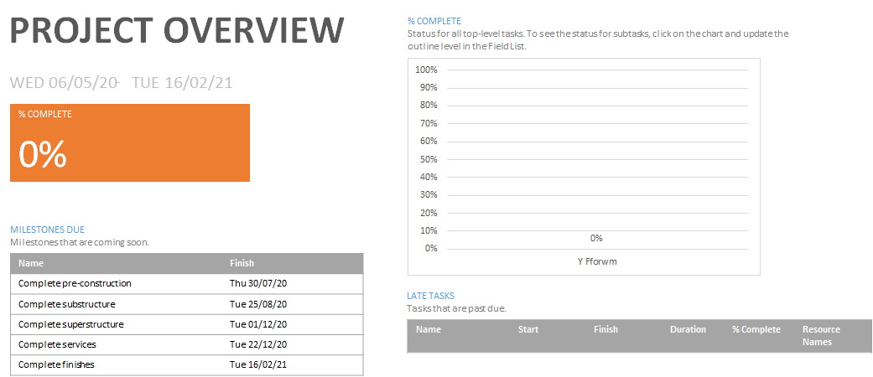

A progress report for the cost has also been allocated. However, the report only reflects the cost which has been calculated for the project workers. No cost has been included for the materials.
The total expected amount is depicted in figure 2. The individual cost of each worker can be seen on the attached programme. The purpose in producing the cost overview, is to monitor the cost in relation to the progress made, to ensure budgeting is maintained.

A cost overview of each phase, with cost estimations of specific tasks can be seen on the attached programme.

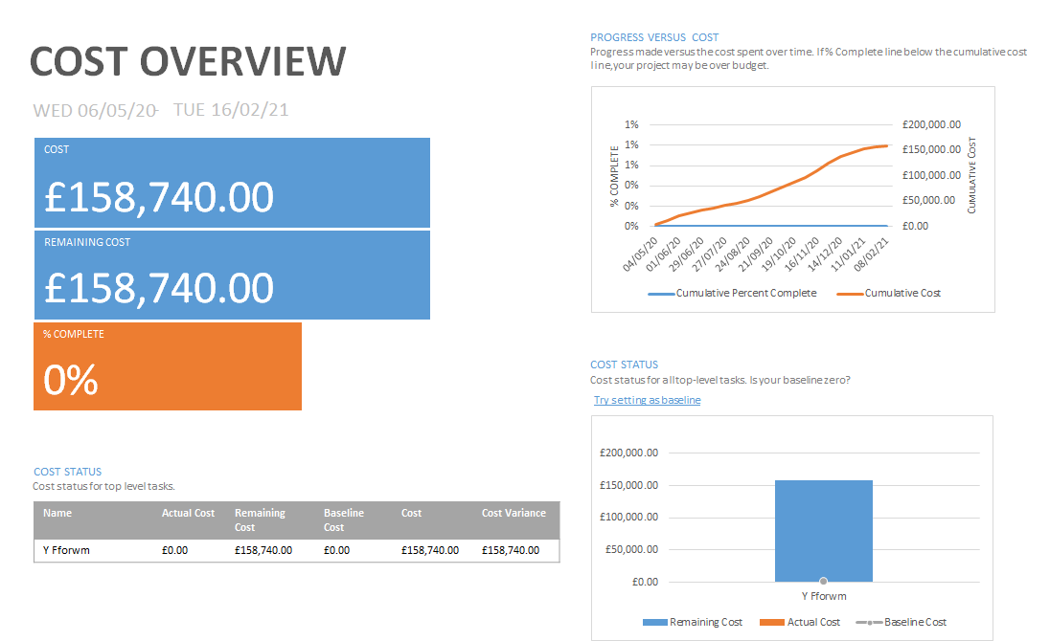

Resources

A progress report has also been created for the resources overview. See the attached programme for the total amount of people expected to be on site and their working hours. Each resource has been specified based on their phase of working. So there is a sufficient amount of workers allocated to the project for the pre-construction, substructure, superstructure and external works of the project.

It is likely to be more resourced demanding during the superstructure phase. This is based on the erection of the frame and necessary tasks required for completion. Figure 3 has the estimated hours required during the project.
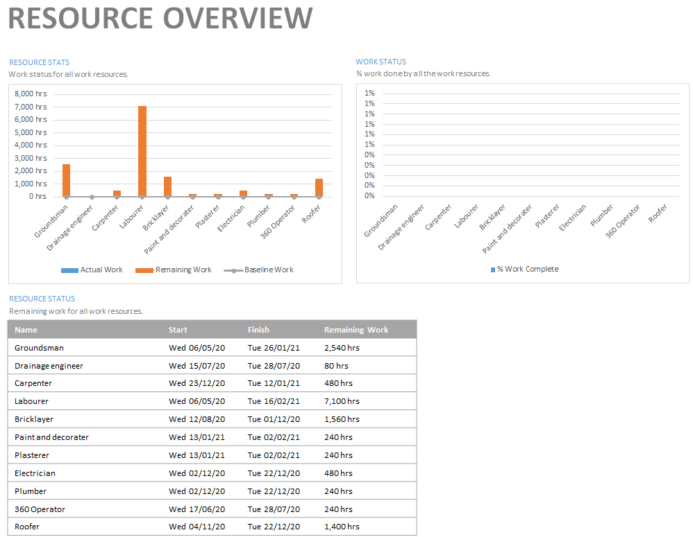

- Construction Methodology

4.1 Pre-construction

4.1.1 Safe site access

The main entrance to the site will be accessed from Kings Road, following from Fabian Way (A483).
It was assumed that there are no restrictions surrounding access to the development. To ensure minimal disruption will be made to the neighbouring buildings, a temporary road has been constructed. This road will travel through the car-park and access the development to the rear. Doing so, will minimise any potential traffic build-up that could arise from the transportation of materials and plant on site. It will also provide the neighbouring buildings and the University, un-disrupted road access.

As you can see from figure 1, the access points have been labelled 1. The projected traffic circulation plan is also noted. Along with pedestrian access to the University which is near the development boundaries.

4.1.2 Site boundaries

The site boundaries can also be seen in figure 4, with the perimeter of the development being outlined in red. The site will be suitably fenced off with 2m high perimeter fencing and signed, to ensure the protection of people from any dangers that could occur on-site. This will also minimise any potential vandalism or theft from occurring.

4.1.3 Site security layout

The site security layout can be seen in figure 4. There will be appropriate surveillance surrounding the development. Security will include a site guard in order to keep track of visitors, adequate lighting for site and boundary fencing. There will also be provisions in place to ensure safety when the site is closed. This will be:

- Possible night security.
- Ensuring site is locked down.
- Materials and equipment are taken down, protected or stored.
- Plant is locked or boxed in, provided it remains on site.
- Hazardous substances are locked away.

4.1.4 Site Signage

Upon initial establishment of the site, there will be relevant signage issued on the boundary fencing that will notify the public and local authorities that construction is underway. The relevant signage that will be posted, is as follows:

- Notice board
- Health and Safety Legislation Poster
- Strict Speed Limit
- Insurance Certificates
- Fire and Emergency Plan
- Traffic Management Plan

4.1.5 Site Set-Up and Construction Logistics

Notification will be made to the Health and Safety Executives prior to construction (HSG150). The site is subject to change at any point and the following remediation’s should be released as soon as possible. After checking site conditions are safe for commencement of the development and the suitable provisions have been issued. As per the regulations, adequate provisions for workers are required. Relevant facilities for the development will be issued:

Facility | Need | Location
Offices | Site offices. | Along the entrance to site. Nearby for emergency’s and supervision.
Sanitary/Washing | Toilets and hand washing facilities. | Facilities located near canteen and personal belongings. In case of emergencies.
Canteen/Storage | Preparation of food, storage of personal items and PPE storage. | Canteen/Storage will be located next to the sanitary/washing facilities. Ease of accessibility.
Storage Units | Material and equipment. | Located on-site, out of the line of construction work but nearby for accessibility.
Off-loading area | Transporting materials on and off site. | Located on-site but not in way of construction. Ease of dropping off materials on entering site, then following roundabout exiting the site.
Recycling and waste storage | Designated for on-site waste and recycling. Ensure compliance with regulations. | Located on-site but out of construction works way. Any waste produced, to be separated accordingly.
Scaffolding | Scaffolding required for construction of the development. | Perimeter of the structure.
Location of cranes | Cranes required for construction of the development. | Perimeter of the structure. Subject to change based on size of plants arm-stretch.

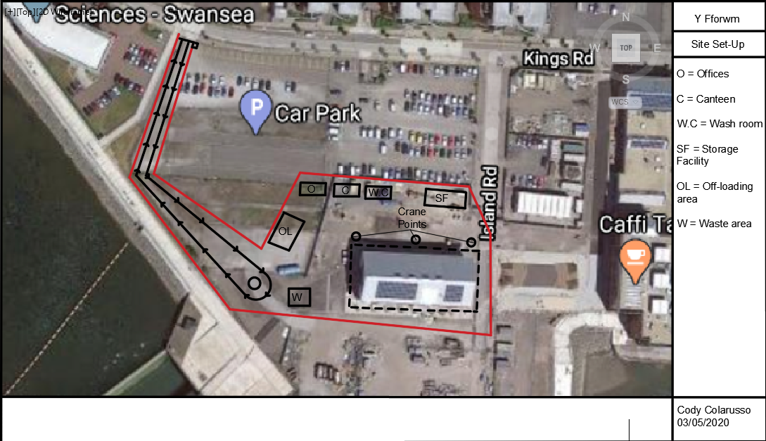

Figure 4

- Productivity and Incentivisation

In order to explain the different methods of addressing performance issues through productivity and Incentivisation within a project, performance within the project must be defined. Performance within a construction contract is defined by the “iron triangle”, which is comprised by three key elements: time, cost and quality (Lock, 2007). Defined by CIRIA (2001):

Time – The period of time required to complete the construction project, whilst ensuring the clients requirements have been fulfilled.
Cost – The total sum required for completing the project to the client’s requirements, compared to the initial sum agreed.
Quality – The quality of the completed work that fulfills the client’s requirements.

Therefore, enhancing performance of the construction project will be through enhancing either the time of completion, where the project can be delivered faster, the cost of the project, where the completed project is cheaper, or the quality of the project, where the initial project requirements are exceeded. Subsequently, poor performance is measured by lack of compliance of the three requirements. As suggested by Lo et al., (2006) poor performance in construction projects is not unusual and that difficulties in payment, management or relevant problems, are usually the cause of time or cost overruns. This is continued by Hughes et al (2012), who suggest that poor performance can also stem from conflicts of interest among stakeholders, where a lack of motivation to work ceremoniously is found.

In order to help negate lack of motivation, prevent overruns, or if there are difficulties or concerns that have been highlighted by the client, an incentive contract can be employed to entice stakeholders into completing the works (CIRIA 2001). Appropriate risk sharing and allocation is determined by Wamuziri (2000) as factors depending on the level of project uncertainty, degree of risk aversion and the ability of the contractor to control costs. Consideration for risk can be the determining factor when addressing performance issues through incentivisation. However, Incentivisation would usually come in the form of either a financial or non-financial agreement, where a financial incentive can be referred to as “pay for performance” (Monitor, 2014) and a non-financial incentive could be through non-monetary gain.

Tavistock (200) define a financial incentive as either direct or indirect monetary gain for encouragement of increased performance. They continue by explaining financial incentives also contain hard and soft issues. Hard is perceived as the time and money gain from the project and soft can be repeated business with the client, which is beneficial for both parties, as the client understands the competence of the contractor.

Non-financial incentives hold great importance when supporting partnerships between members of a supply chain, as it can provide recognition to one of the parties or positive feedback to a particular member, that is of interest to the party. This can result in a motivated supply chain and consequently result in productivity increasing within the project. There are a variety of non-financial incentives, but to keep it brief, the two main types can be:

Recognition – As previously noted, it could be providing feedback to a particular interest of importance to one of the available parties.
Opportunity – Alike recognition in a sense where a particular interest has been acknowledged, but this could be an opportunity for a party, which would not have been there prior to the contract.

However, although the types incentivisation remain the same, the terms in which incentivisation can be produced, are different. Broome (2002) explains these are:

Pre-planned, where the client imposes an incentive scheme.
Responsive, where the contractor offers an incentive scheme.
Reactive, where negotiation of an incentive plan is made.

In this project, the contractor is proposing an incentive scheme, which is responsive. This allows the contractor to propose incentives that are conceivable within their eyes to the client. Provided the client has communicated their objectives well and the contractor has understood them correctly.
- Delay and disruption

The specified construction contract will typically have a completion date, whereby the works essential for the project will be required to be completed prior to this date. Although, in most cases, there are particular events that occur and halt the course of the project. These is usually in the form of delay and disruption, which often result in disputes or claims (LexisNexis 2020). When delays occur within a construction project, it is up to both parties involved to resolve it. A delay event can be classified by (PA 2020):

- Whether it will impact the delivery date.
- Whether it will result in unplanned expenses to the contractor/client.
- Whether it was produced from the actions of two or more parties in the construction.

Delays will then typically fall within two general forms, the difference in both is of high importance, as it essentially governs which party holds liability for the delay. The forms are:

Excusable – Is an unforeseen circumstance or event, that is out of the contractors control. This could be acts of god, fires, floods, epidemics, severe weather etc (Majid 2006).
Non-excusable – Is a foreseeable circumstance or event within the contractors control. This could be the contractor not performing to their ability expected within the contract and in turn, not provide the agreed requirements (Majid 2006).

Excusable delays can be categorised further into compensable or non-compensable:

- Compensable are delays caused by the client or their associated party, which results in an extension of time or financial damages being paid to the contractor.
- Non-compensable are delays that are out of the control of both parties; adverse weather, strikes, fires etc. However, the contractor is till able to claim time extensions.

Extensions of time in JCT are used to alleviate liability of the contractor from any damages of delay (SCL 2017). These can be seen as relevant events under the JCT contract and like NEC, defines protocol such as weather conditions, force majeure, instructions issued by client (Chappell 2012).

Compensation event in NEC is a clause within an NEC contract that are either; extensions of time, variations, loss or expense. These are defined similarly to JCT, as the contractor is not at fault. NEC also defines neutral fault, which is risk allocated between the parties (Evans 2020).

When defining whether a delay is excusable and compensable, is must be shown to be critical, in the sense where it holds critical value within the project (Keane 2008); affected critical path in programme of works which results in a delay of completion.

While delay and disruption are correlated to some extent (SCL 2017), there is differentiation between them both. Disruption can be described as an interruption to the programme of works and is most likely the cause of delay. Disruption essentially refers to a loss of productivity and this has direct outcome of financial loss (Keane 2008). This is because disruption does not allow the contractor the ability to claim an extension of time but can be compensated for any costs/loss occurred.

In order to identify a successful delay or disruption claim, the causation, liability and damages must be established (Keane 2008). There are various Delay Analysis Techniques that can be used to investigate the causation (Braimah 2013). This can be through: Impacted as-planned, collapsed as-built, as-planned vs as-built and time impact analysis (Keane 2008).

As the there has been a 2 week delay for the shipping of materials which has been stopped through travel restrictions, it is an excusable delay for the contractor. There is nothing the contractor could of done to prevent it and as such, has the option of creating a delay claim. This could be either an extension of time, compensation event or financial reimbursement for losses earn through the delay, which is unlikely.

References

2020. [ebook] Available at: <https://drahmedelyamany.weebly.com/uploads/7/0/1/0/7010103/site-layout_dremad.pdf> [Accessed 4 May 2020].

Hse.gov.uk. 2020. [online] Available at: <https://www.hse.gov.uk/pubns/priced/hsg150.pdf> [Accessed 4 May 2020].

App.croneri.co.uk. 2020. Site Set-Up: In-Depth | Croner-I. [online] Available at: <https://app.croneri.co.uk/topics/site-set/indepth> [Accessed 4 May 2020].

2020. [ebook] Available at: <https://moodle.uwtsd.ac.uk/pluginfile.php/360379/mod_resource/content/0/hsg144.pdf> [Accessed 4 May 2020].

Legislation.gov.uk. 2020. Health And Safety At Work Etc. Act 1974. [online] Available at: <http://www.legislation.gov.uk/ukpga/1974/37/contents> [Accessed 4 May 2020].

Rbkc.gov.uk. 2020. Health And Safety At Work Act | Royal Borough Of Kensington And Chelsea. [online] Available at: <https://www.rbkc.gov.uk/business-and-enterprise/regulation/health-and-safety/safety-work/health-and-safety-work-act> [Accessed 4 May 2020].

Quittance Legal Services. 2020. Supply Of Machinery (Safety) Regulations 2008 Explained | Quittance.Co.Uk®. [online] Available at: <https://www.quittance.co.uk/personal-injury/advice/work-accident/supply-of-machinery-safety-regulations-2008-explained> [Accessed 4 May 2020].

Hse.gov.uk. 2020. [online] Available at: <https://www.hse.gov.uk/pubns/hsc13.pdf> [Accessed 4 May 2020].

Hse.gov.uk. 2020. Construction - Waste Management & Storage Health & Safety. [online] Available at: <https://www.hse.gov.uk/construction/safetytopics/storage.htm#waste> [Accessed 4 May 2020].

Hse.gov.uk. 2020. Construction - Construction Design And Management Regulations 2015. [online] Available at: <https://www.hse.gov.uk/construction/cdm/2015/index.htm> [Accessed 4 May 2020].

T, Y, Lo, I,W,H, Fung, K, C, F, Tung,
“Construction delays in Hong Kong civil
engineering projects.” Journal of
Construction Engineering and Management,
132(6), pp. 636-649.
T, Y, Lo, I,W,H, Fung, K, C, F, Tung,
“Construction delays in Hong Kong civil
engineering projects.” Journal of
Construction Engineering and Management,
132(6), pp. 636-649.
Tommy Y Lo. 2006. “Construction delays in Hong Kong Civil Engineering Projects” Journal of Construction Engineering and Management.

2020. [ebook] Available at: <https://moodle.uwtsd.ac.uk/pluginfile.php/340867/mod_resource/content/0/Bryde%20and%20Joby%202007.PDF> [Accessed 4 May 2020].

2020. [ebook] Available at: <https://moodle.uwtsd.ac.uk/pluginfile.php/340863/mod_resource/content/0/Is_incentivisation%5B1%5D.pdf> [Accessed 4 May 2020].

2020. [ebook] Available at: <https://constructingexcellence.org.uk/wp-content/uploads/2015/03/D6Disc-inc.pdf> [Accessed 4 May 2020].

Broome, J., 2009. Procurement Routes For Partnering. London: Thomas Telford Ltd.

Scl.org.uk. 2020. [online] Available at: <https://www.scl.org.uk/sites/default/files/SCL_Delay_Protocol_2nd_Edition.pdf> [Accessed 4 May 2020].

2009. Delay Analysis In Construction Contracts. Chicester: Wiley.

Steven C Evans Ltd. 2020. NEC3 Compensation Events – A Practical Guide. [online] Available at: <http://www.stevencevans.com/nec3-compensation-events-a-practical-guide/> [Accessed 4 May 2020].

Braimah, N., 2013. Construction Delay Analysis Techniques—A Review of Application Issues and Improvement Needs. Buildings, 3(3), pp.506-531.

Chappell, D., n.d. The JCT Standard Building Contract 2011.

Ibnu Abbas Majid., 2006. Causes And Effects Of Delays In Aceh Construction Industry. Skudai: Universiti Teknologi Malaysia.

Lepage, M., 2020. Types Of Schedule Delays In Construction Projects. [online] Plan Academy. Available at: <https://www.planacademy.com/types-of-schedule-delays-in-construction/> [Accessed 4 May 2020].

Lexisnexis.com. 2020. [online] Available at: <https://www.lexisnexis.com/uk/lexispsl/construction/document/391375/56C2-3Y81-F186-J08P-00000-00/Delay-and-disruption-in-construction-projects> [Accessed 4 May 2020].

