Student Name: Evaristo Freite De Melo. 
Student Number: 2129710.
Module: Problem Solving and Decision Making.
Module Code: BMSW 4004.
Lecture Name: Mohammed Islam.
Title: Problem Solving and Decision making.

Contents

- Introduction
- The TM Lewin timeline
- T M Lewin PESTEL Analysis
- T M Lewin SWOT Analysis
- T M Lewin Fishbone Diagram
- T M Lewin PMI Analysis
- Measure the effectiveness
- References

Introdution
The Covid-19 Pandemic has had a significant impact on the retail industry, as evidenced most obviously by the entire closure of all non-essential stores between March and June 2020 and the ongoing one-month lockdown. With the COVID-19 pandemic still wreaking havoc on the high street, T.M. Lewin said on Tuesday that company would close all its physical locations and solely operate online, creating 600 redundancies.
66 stores will close as a result of the agreement, and the internet firm will be sold in a pre-pack administration to Torque Brands, an acquisition arm of Stonebridge Private Equity. Since the 1898-founded menswear retailer's future was uncertain due to Britain's coronavirus lockdown, which closed all non-essential stores from late March to June, Stonebridge Capital Partners, a private equity group, acquired it from Bain Capital in May.
T.M. Lewin was unable to maintain leasing agreements in its previous configuration, making it an unviable going concern. “Our customers have been unable to shop in store for more than three months owing to social distancing requirements, which still apply to all of our locations.

The TM Lewin timeline
Thomas Mayes Lewin founded the renewed British company TM Lewin, establishing his first store in London in 1898. An online business that first specialised in producing shirts eventually expanded into men's suits, outerwear, knitwear, jackets, chinos, ties, and accessories.
In nearly 120 years, the corporation had a few different owners, but its current form proved unsustainable. When constrained by the lockdown, it was unable to keep the interest on the debt from the 2015 transaction (Bain Capital and management purchased the equity portion owned by Caird Capital).
The team had maintained a largely cash flow-neutral position. But the main reason for that is that the hefty interest fees (up to 10%) were added to the loan. It was a sizable amount compared to revenue that would need to be recapitalized, and loan repayment was due the next year.
(Fig 1)
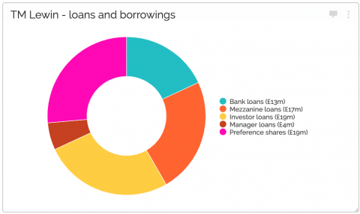

Source: Financial statements for 2019 from TM Lewin (TML Topco Limited).
That effectively amounts to £72 million in debt for a company with a £125 million annual revenue and an operational loss. Do you think that's a sound business? To be fair, the company had positive EBITDA, but due to significant depreciation and amortisation charges, there wasn't enough money left over to pay the interest or even come close to building up enough money to pay the debt off sooner rather than later. The auditors were sure the company could continue as a going concern despite the lacklustre financial condition of the business; therefore, they must have had a positive outlook on their recapitalization plans as the company consistently had a clean audit opinion.
The interest cover ratio for TM Lewin is displayed in the graph below. Even though there are numerous things to consider, analysts want to see a coverage ratio of three, with an interest cover ratio of at least two generally being considered the minimum acceptable ratio. Given that the ratio is much below one, TM Lewin is unable to fulfil its present interest payment obligations. In 2019, the interest expense of £7 million was much greater than EBITDA of £4 million, resulting in an interest cover ratio of one, as shown below.
(Fig 2)
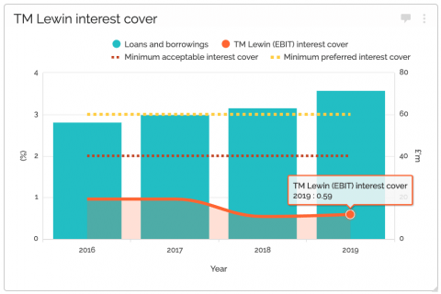
Financial statements for (TML Topco Limited), owned by TM Lewin (2016–2019)
The graph above also demonstrates how debt levels rose as interest rates rose. This amounted to £72 million in 2019.
Brexit was the main risk in 2019 at that time. Now that the country is under lockdown, office workers don't need to buy new suits, shirts, or ties because they aren't going to work, which worries TM Lewin more than anything.
The corporation laid off 650 of its 700 UK employees and apparently took all the steps I've previously mentioned (see Primark story). However, when you're in debt and there isn't a plausible chance that life will return to normal soon for office workers, losing a sizeable portion of income from three months of lockdown isn't an easy thing to swallow.
Stonebridge Capital (via Torque Brands) purchased the TM Lewin brand in May of this year, and just last week it announced, via a pre-pack administration, the closing of all 66 UK locations and the layoff of 600 employees. Rishi Sunak probably didn't have this in mind when he devised the furlough plan back in March.
The future for the clothes company appears to be rather promising, despite consumer tastes and preferences changing as a result of the expected ongoing transition to home employment.

T M Lewin PESTEL Analysis

PESTEL analysis is a vital and popular tool that aids in illuminating the overall picture of a Businesses external environment, particularly as it relates to international markets. An organization's operating environment's political, economic, social, technical, environmental, and legal factors are collectively referred to as PESTEL. (Fig 3)

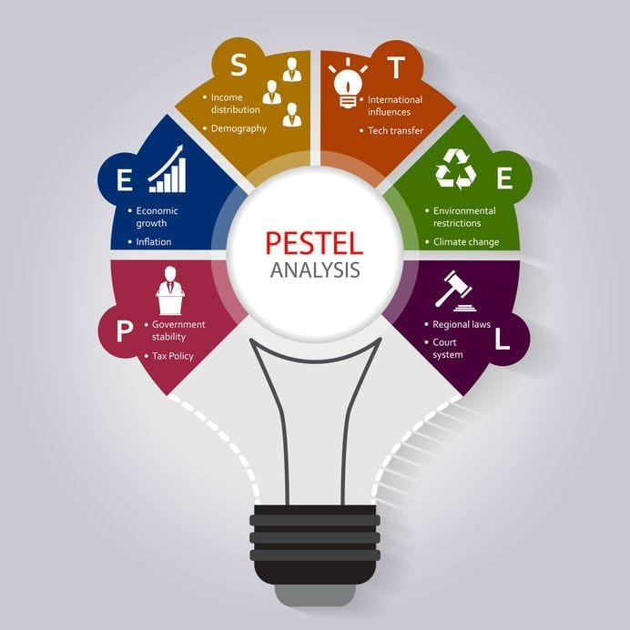

Political:
- Pandemic, lockdown, political change, tax laws, trade policy.
Economic:
- Interest rates, inflation, unemployment.
Social: up
- local customs, age ranges of the population, work/life customs, religious considerations, and others.
Technological:
- Impacted by innovation, use modern machinery, online sale social media
Environmental: Issues such as scarcity, sustainability, climate, and ecology.

Legal:
- Government Regulations, Employment and Law Tax policies.

T M Lewin SWOT Analysis

I also used the SWOT model to analyse the case of the organization T M Lewin.
But first I want to give the definition of SWOT analysis.
A SWOT analysis examines both internal and external elements that may have an impact on your organisation. Your internal elements are your strengths and weaknesses. External factors are the threats and opportunities. (Fig 4)


Strengths: Online selling and social media.
- Online selling

- Costs associated with processing orders are reduced since website orders can be automatically entered into your orders database.
- Achieving a worldwide audience, so expanding the potential for sales.
- Opening 24 hours a day, seven days a week, to compete with bigger enterprises.
- Receiving payments from online transactions more promptly.
- Use the information gleaned from monitoring consumer transactions to enhance your products.
- Displaying your products to current customers through your web store.

- Social media
- Social media helps you increase customer engagement and brand loyalty by enabling you to communicate with your customers fast, directly, and easily.
- Social media helps you increase brand awareness as you'll be able to keep clients updated. In addition to being utilised as a promotional tool, social media platforms are also employed as a customer care channel where customers may speak directly with the company to receive a quicker and more individualised answer.

Weaknesses: Cost of living crisis and Inflation.

1.Cost of living crisis.
- As a result of the increase of prices, consumer's buying behaviours have been affected. Nearly two-thirds of business owners explained that demands have decreased due to consumers having less disposable income meaning consumers are no longer spending money on luxuries.
2.Inflation
(Fig 5)
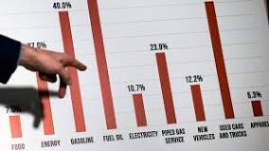
Opportunities: Online selling and change supplies
1.Online selling
- Introducing a method for clients to buy your products securely and promptly is a terrific opportunity as, in 2022, online shopping is the most popular way for most
people to buy clothing with 63% of shopping being done online.
2.Change supplies
- A change in suppliers might open new possibilities for a business, such as the introduction of a range of new products.

Threat: Inflation, Government Restriction and supply chain.
- Supply chain management has an impact on manufacturing businesses in several ways, including the accessibility of the inputs required for production processes, the price and profitability of manufactured goods, corporate infrastructure, and how businesses interact with their suppliers and clients.
- Inflation: If prices are rising as a result of inflation, a company might not be able to pass those costs through to customers (PED) Expenditures can decrease due to inflation, which can also interfere with corporate planning. As interest rates rise in response to rising inflation, economic development is slowed, and a recession may result.
- Government restriction nearly of the 43% of enterprises that have temporarily closed attributed their closures to COVID-19. Most respondents who had temporarily shut down cited declining demand and employee health issues as the causes, with supply chain interruptions playing a less significant role.

T M Lewin Fishbone Diagram
- I organised my ideas into relevant groups using the Fishbone diagram as a tool to brainstorm potential sources of an issue. An effective visual representation of cause and consequence is a fishbone diagram. Compared to some of the other resources for brainstorming a problem's causes, it takes a more organised approach. The team can use the diagram to investigate the categories and come up with alternative explanations by using it to find potential causes of an issue that they may not have otherwise thought of. Include team members who have first-hand experience with the systems and processes related to the issue or incident under investigation, and because we can examine both internal and external issues with the company using the Fishbone diagram, it is one of the most crucial reasons to utilise it. It was because of this criterion that I chose to examine the case of retailer T.M. Lewin. ( Fig 6 )

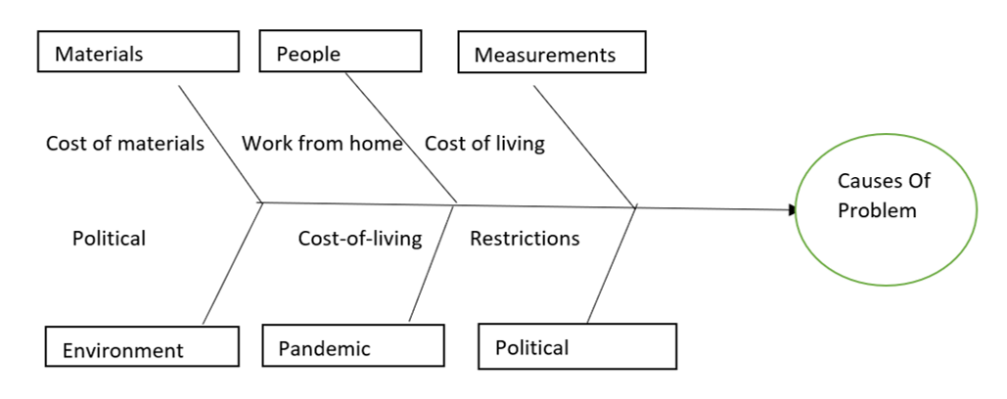

T M Lewin PMI

(Fig 7)
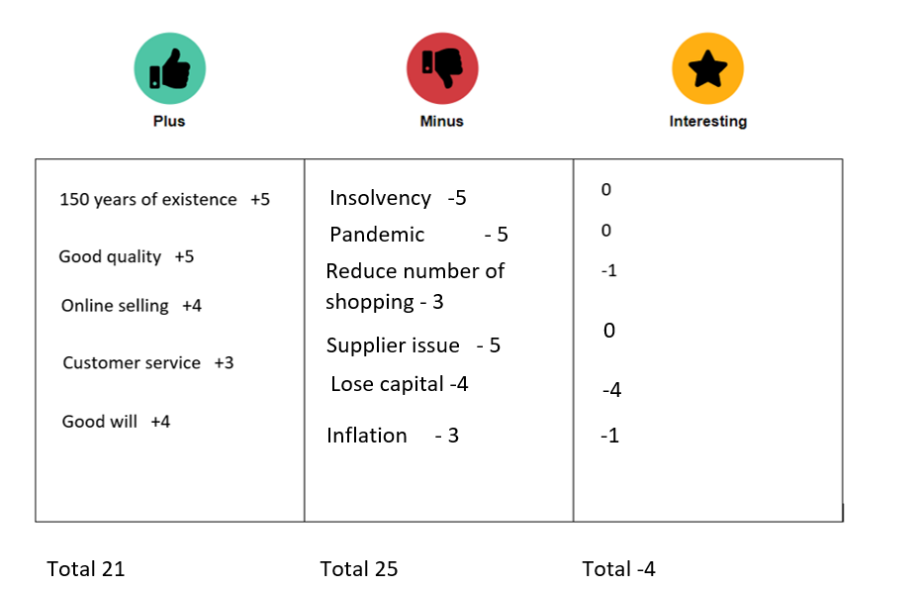

Measure the effectiveness:

The challenges
T.M. Lewin requires a digital marketing system that can retain a variety of customer and prospect data and has the capability to extensively segment the database as needed because of its combination of storefronts and worldwide internet audiences. T.M. Lewin also wants to continue expanding its social presence and recognises the significance of community marketing and social media. Its website already had a well-liked community part where users could read blogs, watch videos, get sizing and fashion tips, and learn how to iron shirts. T.M. Lewin need an email service provider that comprehends the benefits of multichannel marketing and can easily integrate its online, offline, and global presences.

The Solution
With the help of Silverpop Engage, the T.M. A Lewin team can centralise all of its customer and contact information, enabling its marketing teams to segment the data according to their needs with the use of the tool's data consultation functionality. The new members of the marketing team can complete the Silverpop online training quickly and easily so that they can access reports and data.
Being able to direct communications complemented T.M. Lewin's efforts to combine his efforts on social media and email to encourage engagement and expand the size of his data bank. The TM Lewin team must create a website called Engage where users can enter their data and choose to receive future communications. In addition, the business will include Share-to-Social links in its emails to encourage participants to spread word of the competition.
Following the draw's success, the marketing division ought to hold another competition, this time a test that would assist collect more brand assets. The marketing team needs to use Engage Landing Pages to develop a new contest with a multiple-choice quiz this time.

The next step is to use Engage to send a series of "teaser" emails outlining the quiz concept and instructing recipients on where to look for the competition's solutions. Over a two-week period, he sent three emails promoting the T.M. Lewin, and another email informing his contacts to seek for the new catalogues since one of the questionnaire answers was concealed inside of them.
The team should develop concepts that enhance the T.M.Lewin brand's quality and heritage in order to encourage greater brand engagement. The trial winner, for instance, can only use their rewards at T M Lewin shops. Following this theme, the third prize was 156 points on each T.M. Lewin buttonhole, or a gift certificate worth £156. On Valentine's Day, Mother's Day, Christmas, New Year's, and any other occasions that present themselves, these exercises should be repeated. The competition's prize draw was a big success and contributed to the expansion of the T.M. Lewin database. More than 4500 subscribers shared the campaign as a result of the promotion's combination of shareable content and social-sharing buttons, which is an excellent indicator of how engaged T.M. Lewin's database is with the brand and how email can promote social buzz and practical outcomes.

The results

The organisation saw great success with this quiz campaign, which generated more than 20,000 responses, far beyond all expectations. The marketing team was able to significantly expand its email list and increase store revenue that was directly linked to the campaign. In addition, T.M.Lewin saw a boost in Facebook "likes" by 45 percent, a 4 percent increase in Twitter activity, an increase in the standard Facebook interaction rate from 3% to a whopping 37% when the quiz was active.

Reerences

A. Scheinkman, J. (2020) Covid-19: Impact on retail consumer behavior, Accenture. Available at: https://www.accenture.com/us-en/insights/retail/coronavirus-consumer-behavior-research (Accessed: November 23, 2022).
A. Scheinkman, J. (2020) The impact of covid-19 on small business outcomes and ... - PNAS, https://doi.org/10.1073/pnas.2006991117. Available at: https://www.pnas.org/doi/10.1073/pnas.2006991117 (Accessed: November 22, 2022).
Barlow, A. (2020) How changing consumer preferences are impacting restaurants, https://www.accountingweb.co.uk/community/blogs/alastairbarlow/tm-lewin-loses-its-shirt-with-600-jobs-lost. Available at: https://aaronallen.com/blog/changing-consumer-preferences (Accessed: November 21, 2022).
Employment, S.B.and T. (2022) Starting a business, Business Queensland. corporateName=The State of Queensland; Available at: https://www.business.qld.gov.au/starting-business (Accessed: November 21, 2022).
Lewin, J. (2022) Put your pestel to the mettle, Cayenne Consulting. Available at: https://www.caycon.com/blog/put-your-pestel-to-the-mettle (Accessed: November 21, 2022).
Lohrey, J. (2017) Steps for the decision implementation plan, Your Business. Available at: https://yourbusiness.azcentral.com/steps-decision-implementation-plan-28720.html (Accessed: November 25, 2022).
Nichols, A. (2022) Online shopping: SWOT analysis of online stores, Firmbee. Available at: https://firmbee.com/swot-analysis-of-online-stores (Accessed: November 23, 2022).
Pettyjohn, K. (2019) 7 benefits of using social media for your business, Folio. Available at: https://www.foliowebsites.com/blog/7-benefits-of-using-social-media-for-your-business (Accessed: November 23, 2022).

