University of Wales Trinity Saint David
London
Student Name: Bogdan Draghici
Student ID: 2027588
Module Title: Managing Projects in an Organisation
Module Code: BMSW5104_LON
Lecturer: Dr. Alfred Mensah
Date 31/08/2023

Executive Summary

Ugly Pickles' Canteen and Wellbeing Initiative aims to reduce waste, promote healthy living, and inclusivity. By establishing an on-site canteen, the project will minimize staff movement during lunch breaks, addressing local congestion. The canteen will use Ugly Pickles' preserved products, educating staff about their nutritional value. The initiative will also recruit individuals with disabilities, enabling them to lead fulfilling lives. The scope of the project is to develop a canteen and wellbeing initiative with in the premises of Ugly Pickles, as the community interest company tend to focus more on the maintenance of healthy diet and also leads to diminish the level food waste. The project adheres to the Project Life Cycle model, integrating costing, risk assessment, and communication strategies. With a detailed WBS and Gantt chart, this project management plan ensures efficient implementation, meeting the company's objectives for a better workplace and community impact.

Table of Contents

Introduction: 4
1. Project Objective and Outline 4
1.1. Stakeholder Analysis: 5
1.2. Tasks and Resources: 6
1.3. Project Schedule/ Gantt Chart: 7
2.1. Gantt Chart: 8
2. Communication Strategies Project Implementation: 8
3. Costing and Resources Consideration: 9
4. Risk Management: 9
Conclusion: 10
References: 12
Appendices 14

Introduction:
Ugly Pickles is referred as the Community Interest Company (CIC) which is dedicated to reducing food waste by collecting unwanted vegetables from supermarkets and farms and preserving them through pickling and cooking processes (Monterey Bay Food Tours, n.d.). They are committed to educating their staff and customers about the nutritional value of their products and promoting their integration as an essential part of a healthy diet. Additionally, the company is passionate about inclusivity and employs local people with various physical and learning disabilities, enabling them to lead fulfilling lives (PlantX US, n.d.).
The basic purpose of this proposed project is to establish a canteen on the premises of Ugly Pickles in order to foster the sense of community, providing the space for the staff to have a lunch and relax as well as to promote a healthy diet in order to improve overall employees’ wellbeing. Developing a canteen aligns with Ugly Pickles' relevant business objectives for the current financial year (Pitchbook, n.d). By having a canteen on-site, the company can reduce the movement of staff during lunch breaks, addressing congestion issues in the local area and promoting a more efficient use of time. Additionally, the canteen provides a dedicated space for staff to have lunch and relax, fostering a sense of community and belonging within the organisation. Offering nutritious meals prepared with Ugly Pickles' preserved products promotes a healthy lifestyle, which contributes to the company's Corporate Social Responsibility (CSR) efforts and can lead to reduced staff absenteeism due to improved overall well-being (Foodwise, n.d.).

Project Objective and Outline
The scope of the project is to develop a canteen and wellbeing initiative with in the premises of Ugly Pickles, as the community interest company tend to focus more on the maintenance of healthy diet and also leads to diminish the level food waste. The canteen will provide a space for all staff to have lunch and relax, fostering a sense of community and improving staff wellbeing. The canteen will offer free lunch to all staff, prepared using Ugly Pickles' products, reinforcing the company's commitment to a healthy diet. The lunch break will be synchronised for all staff, and production will halt during this time.
The project involves setting up a canteen on the company's premises, divided into different sections:
- Quiet Area: Where individuals can enjoy their lunch alone, listening to music on headphones or reading.
- Common Area: A space for staff to congregate, featuring amenities such as ping-pong tables to encourage social interaction.
- Outside Area: A small garden with benches to provide a peaceful and relaxing outdoor space for staff.
The canteen will exclusively utilise Ugly Pickles' preserved products, emphasising their nutritional value and integration into a healthy diet. To further promote inclusivity and social impact, the company will employ local individuals with disabilities, offering them opportunities to lead fulfilling lives. The project will involve tasks such as canteen infrastructure setup, staff training on nutrition and disability inclusivity, and ongoing canteen operation. By implementing this project, Ugly Pickles aims to enhance employee wellbeing, minimise food waste, and contribute positively to incorporating the local community by incorporating new project in the company. Before implementing any project it is essential to deeply analyse the impact of project on the stakeholders and proper structure of the work.

Stakeholder Analysis:
Stakeholders play a crucial role in the success of the project. This process holds a great importance in the project management plan as helps to identify and understand the individuals or groups that have an interest in or will be affected by the project (De Oliveira and Rabechini, 2019). In the context of the canteen and wellbeing initiative at Ugly Pickles, the stakeholder analysis includes the following key stakeholders:
- Ugly Pickles Staff: The primary stakeholders are the employees of Ugly Pickles. They will directly benefit from the canteen facility, as it will provide a convenient and comfortable space to have lunch and relax during their breaks. Moreover, the wellbeing initiative will promote a healthy lifestyle, contributing to their overall physical and mental health (Adams, 2019).
- Senior Management Team: The senior management team has a vested interest in the successful implementation of the project. They are responsible for project approval, funding, and providing overall direction. They also want to achieve the business objectives of reducing staff movement during lunch breaks and reducing staff absenteeism.
- Local Community: As the project aims to employ local individuals with disabilities, the local community becomes a significant stakeholder. Their support and acceptance are vital for the success of the initiative, and they may also benefit from the reduced congestion in the area due to fewer staff moving off-site for lunch.
- Suppliers: Suppliers of food ingredients and equipment used in the canteen are essential stakeholders. Their timely and reliable delivery of resources will directly impact the canteen's operation and efficiency.
- Customers: While not directly involved in the project, customers who visit the canteen are relevant stakeholders. Their feedback and satisfaction with the canteen's services and products can influence the success and sustainability of the initiative.
Stakeholder analysis can be adapted for any project, regardless of the specific company involved, using Mendelow's Power-Interest Matrix and insights from Freeman (1984). This approach involves identifying project stakeholders, categorizing them into four groups based on their power and interest levels, and tailoring engagement strategies accordingly. It also integrates Freeman's concept of stakeholder salience, considering not just power and interest but also legitimacy. By recognizing stakeholders' rightful claims on the project, this approach helps guide engagement strategies effectively. The strategies vary based on where stakeholders fall within the matrix. Continuous monitoring and adaptation are essential to account for shifting stakeholder dynamics. This flexible adaptation offers a robust foundation for understanding and managing diverse stakeholder relationships in various project scenarios, ultimately contributing to project success and positive outcomes.

Tasks and Resources:
There are certain steps that are included in the project life cycle: All the tasks needed to achieve the project’s goal go under these main steps:
- Project Initiation
- Infrastructure Setup
- Staff Training and Education
- Canteen Operation
- Resource Allocation and Budgeting
- Project Communication and Reporting
- Quality Control and Assurance
- Risk Management
- Project Evaluation and Closure
There are multiple different tasks associated in each of the step. Task division is done through work breakdown structure (WBS). WBS is the most significant strategic management tool that helps to categorise and distribute work to the relevant department. It provides the structure with the help of which tasks are divided into subtasks so that different teams can easily handle them (Saputra and Latief, 2020). Moreover it helps the project teams to conveniently recognise how much resources are required and how much cost will be generated.
It has been seen that WBS is referred as a hierarchical decomposition of the complete scope of the work that needs to be performed by the project team in order to achieve the project targets and to create the required deliverables (Al-Kasasbeh et al., 2021).Each of these WBS elements represents a specific task or activity required to achieve the project's objectives. By breaking down the project into smaller, manageable components, the team can effectively plan, execute, and monitor progress throughout the canteen and wellbeing initiative project.
You can see a detailed Work Breakdown Structure for this project in Appendix 1

Project Schedule/ Gantt Chart:
A Gantt chart is regarded as one of the most effective project management tool that helps to effective manage time and schedule (Tereso et al., 2019). It has been developed to oversee and regulate the project schedule. It displays the project's start and end dates, the duration of various activities, interdependencies between tasks, and significant project milestones (Nafianto et al., 2019). The Gantt chart facilitates monitoring and controlling the project by maintaining a record of the planned schedule and tracking the actual progress of tasks. It provides a comprehensive overview of the project's timeline, ensuring that tasks are on track and any deviations can be identified and managed effectively (Nafianto et al., 2019).The chart shows the sequence of tasks, their start and end dates, and the duration of each task. The project may have multiple tasks running concurrently, and some tasks may be dependent on others. Regular monitoring and updates to the Gantt chart will be necessary to ensure the project stays on track and any adjustments can be made as needed. Below is a detailed Gantt chart for Ugly Pickles' Canteen and Wellbeing Initiative:

2.1. Gantt Chart:
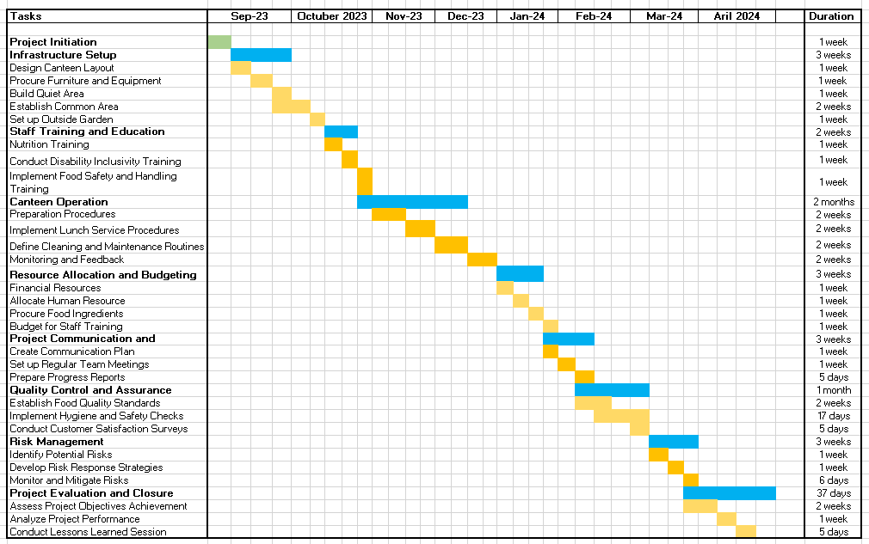 Gantt chart: Time schedule(Source:Author)

Communication Strategies Project Implementation:
Effective communication strategies are essential for the successful implementation of Ugly Pickles' Canteen and Wellbeing Initiative. Here are some relevant communication strategies:
- Stakeholder Engagement: Regularly communicate with all stakeholders, including Ugly Pickles staff, senior management, the local community, suppliers, and customers. Keep them informed about project progress, milestones, and any changes or updates.
- Transparent Communication: Transparent communication is adopted about the project's goals, objectives, and potential impacts. Transparent communication builds trust and fosters a sense of ownership among stakeholders, increasing their commitment to the project's success. Clear internal communication plan have been made to keep the project team and all Ugly Pickles staff informed about project developments, timelines, and key activities. This helps maintain alignment and ensures everyone is working towards the same goals. Effective external communication strategies are developed to inform the local community, suppliers, and customers about the canteen and wellbeing initiative.
- Two-way Communication: Feedback and open communication channels are developed to actively listen to stakeholders' concerns, suggestions, and feedback, and incorporate their input into decision-making processes when appropriate. Regular updates through various communication channels such as emails, newsletters, meetings, and social media platforms will be provided. Timely updates keep stakeholders engaged and demonstrate progress towards project objectives.
- Training and Education: Conduct training sessions for staff to educate them about the nutritional value of the products and the benefits of the wellbeing initiative. Educating staff helps create a shared vision and enthusiasm for the project.
By adopting these communication strategies, Ugly Pickles can ensure that all stakeholders are well-informed, engaged, and committed to the successful implementation of the canteen and wellbeing initiative. Effective communication will help overcome challenges, maintain support, and enhance the overall project experience.

Costing and Resources Consideration:
The project manager should consider not only financial resources but also human resources, time, and other intangible resources. Although the company may allocate some budget for the project, it is essential to assess the availability and capacity of the staff to take on additional responsibilities related to the canteen. Costing is crucial before implementing a project for several reasons:
- Budget Allocation: Costing allows for the accurate estimation of financial resources required to execute the project. It helps in securing appropriate funding and ensures that the project remains financially viable throughout its lifecycle (Armenia et al., 2019).
- Finances will be obtained through: Finance can be acquired by applying for grants, crowdfunding, or own funds.
- Resource Planning: Costing enables effective allocation of resources, including manpower, materials, and equipment. This ensures that the right resources are available when needed, preventing delays and resource shortages (Venkataraman and Pinto, 2023).

Risk Management:
Risk assessment is referred as another project management technique that is used to effectively implement the project of Canteen and the development if the three main areas in the Ugly Pickle Company. It is a critical process in project management that involves identifying, analysing, and evaluating potential risks that may affect the project's objectives, timeline, or budget. Effective risk assessment enhances project resilience by reducing the likelihood of negative outcomes and improving the project's overall management (Alzoubi, 2022). It fosters better decision-making, resource allocation, and proactive problem-solving, thereby increasing the project's chances of successful completion within the defined scope, time, and budget constraints. Effective risk assessment enhances project resilience by reducing the likelihood of negative outcomes and improving the project's overall management (Wang et al., 2020). It fosters better decision-making, resource allocation, and proactive problem-solving, thereby increasing the project's chances of successful completion within the defined scope, time, and budget constraints. The goal of risk assessment is to proactively address uncertainties and develop strategies to minimise their impact on the project's success. Here are the key steps involved in risk assessment:
- Identify Risks: Project teams brainstorm and compile a comprehensive list of potential risks. These risks can be categorised as internal (within the project) or external (outside influences).
- Analyse Risks: Each identified risk is assessed based on its likelihood of occurrence and potential impact on the project. Risks with higher probability and significant consequences are prioritised for further analysis.
- Evaluate Risks: The project team quantifies and ranks risks, considering factors like probability, severity, and detectability. This evaluation helps prioritize risk responses and allocate resources accordingly.
- Develop and Implement Risk Response Strategies: For high-priority risks, specific response strategies are formulated. These strategies can include risk mitigation, risk avoidance, risk transfer, or risk acceptance, depending on the nature of the risk.
- Monitor and Control Risks: Throughout the project's lifecycle, risks are continuously monitored to ensure that response strategies remain effective. If new risks emerge or existing risks evolve, the project team adapts the responses accordingly.

Conclusion:
The proposed canteen and wellbeing initiative align well with Ugly Pickles' mission of reducing waste and promoting a healthy lifestyle. By creating a space for staff to gather, relax, and enjoy nutritious meals, the company fosters a sense of community and employee wellbeing. The project management plan presented above outlines the essential components to ensure successful implementation. Continuous monitoring and adaptation are crucial for the sustained success of this initiative. With adequate resources and stakeholder engagement, Ugly Pickles can achieve its goal of setting up a canteen that serves both the community and the environment.

References:
Adams, J.M. (2019) ‘The value of worker well-being.’ Public Health Reports, 134(6), pp.583-586.
Al-Kasasbeh, M., Abudayyeh, O. and Liu, H. (2021) ‘An integrated decision support system for building asset management based on BIM and Work Breakdown Structure.’ Journal of Building Engineering, 34, p.101959.
Alzoubi, H.M. (2022) ‘BIM as a tool to optimize and manage project risk management. International Journal of Mechanical Engineering, 7(1).
Armenia, S., Dangelico, R.M., Nonino, F. and Pompei, A. (2019) ‘Sustainable project management: A conceptualization-oriented review and a framework proposal for future studies.’ Sustainability, 11(9), p.2664.
De Oliveira, G.F. and Rabechini Jr, R. (2019) ‘Stakeholder management influence on trust in a project: A quantitative study.’ International journal of project management, 37(1), pp.131- 144.
Foodwise. (n.d.) Ugly Pickle Co. Makes Food Waste Fun and Delicious. [online] Available at: https://foodwise.org/articles/ugly-pickle-co-makes-food-waste-fun-and-delicious/ [Accessed 2 Aug. 2023].
Freeman, R.E. and McVea, J. (2001) ‘A stakeholder approach to strategic management’, SSRN Electronic Journal [Preprint]. doi:10.2139/ssrn.263511
Monterey Bay Food Tours. (n.d.) Ugly Pickle Co. Dilly Carrots. [online] Available at: https://mbftmarketplace.com/products/ugly-pickle-co-dilly-carrots [Accessed 2 Aug. 2023].
Nafianto, C., Puspitasari, W. and Saputra, M. (2019) ‘August. Development of Flexible Production Scheduling by Applying Gantt Charts in Manufacturing Module Open Source ERP (Case Study CV. XYZ).’ In 2019 International Conference on Sustainable Engineering and Creative Computing (ICSECC) (pp. 182-185). IEEE.
Pitchbook. (n.d.) Profile Previews: Company, Investor and Advisor Profiles | PitchBook. [online] Available at: https://pitchbook.com/profiles.
PlantX US. (n.d.) Ugly Pickle Co. [online] Available at: https://plantx.com/collections/ugly-pickle- co [Accessed 2 Aug. 2023].
Saputra, P.D. and Latief, Y. (2020) ‘April. Analysis of safety cost structure in infrastructure project of precast of precast concrete bridge based on Work Breakdown Structure (WBS).’ In IOP Conference Series: Materials Science and Engineering (Vol. 830, No. 2, p. 022074). IOP Publishing.
Tereso, A., Ribeiro, P., Fernandes, G., Loureiro, I. and Ferreira, M. (2019) ‘Project management practices in private organizations.’ Project Management Journal, 50(1), pp.6-22.
Venkataraman, R.R. and Pinto, J.K. (2023) Cost and value management in projects. John Wiley & Sons.
Wang, F., Ge, X., Yang, P., Li, K., Mi, Z., Siano, P. and Duić, N. (2020) ‘Day-ahead optimal bidding and scheduling strategies for DER aggregator considering responsive uncertainty under real-time pricing.’ Energy, 213, p.118765.
.

Appendices
Appendix 1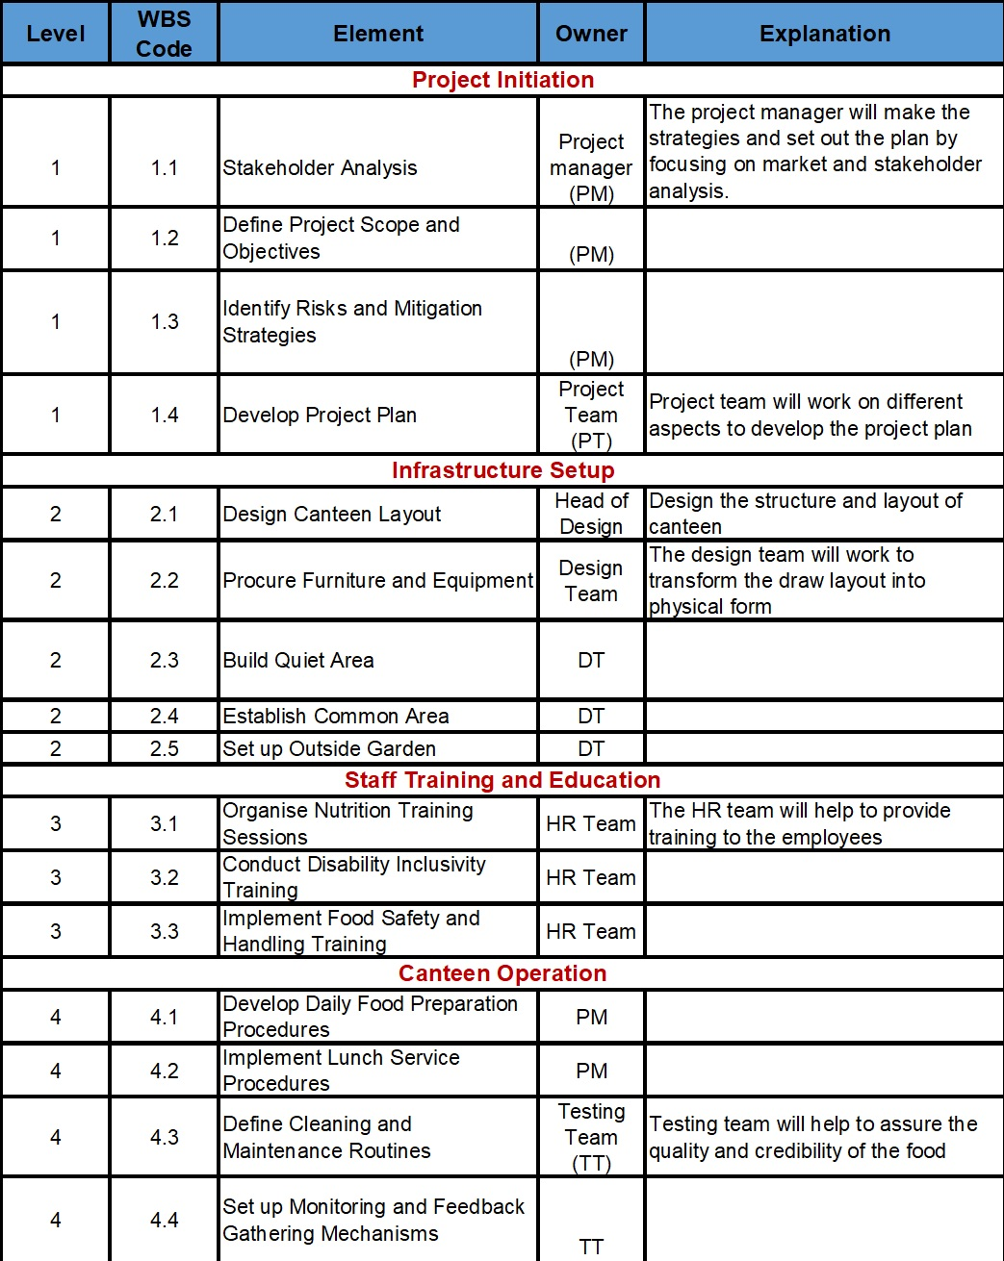

Appendix 1 (cont)
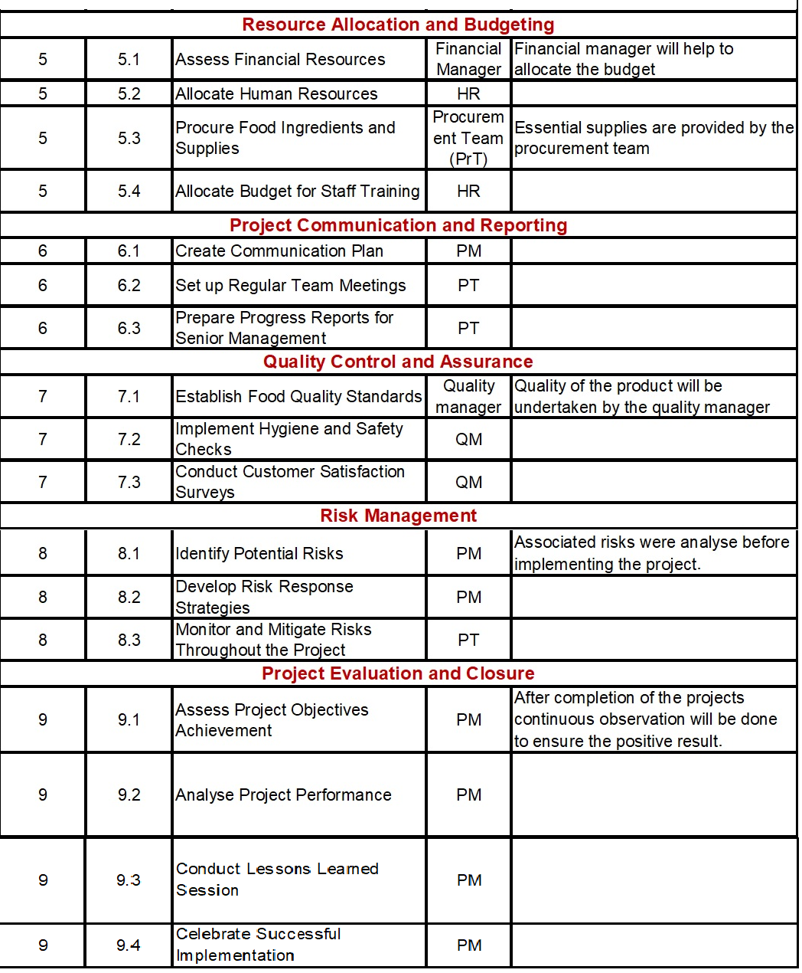

Appendix 2
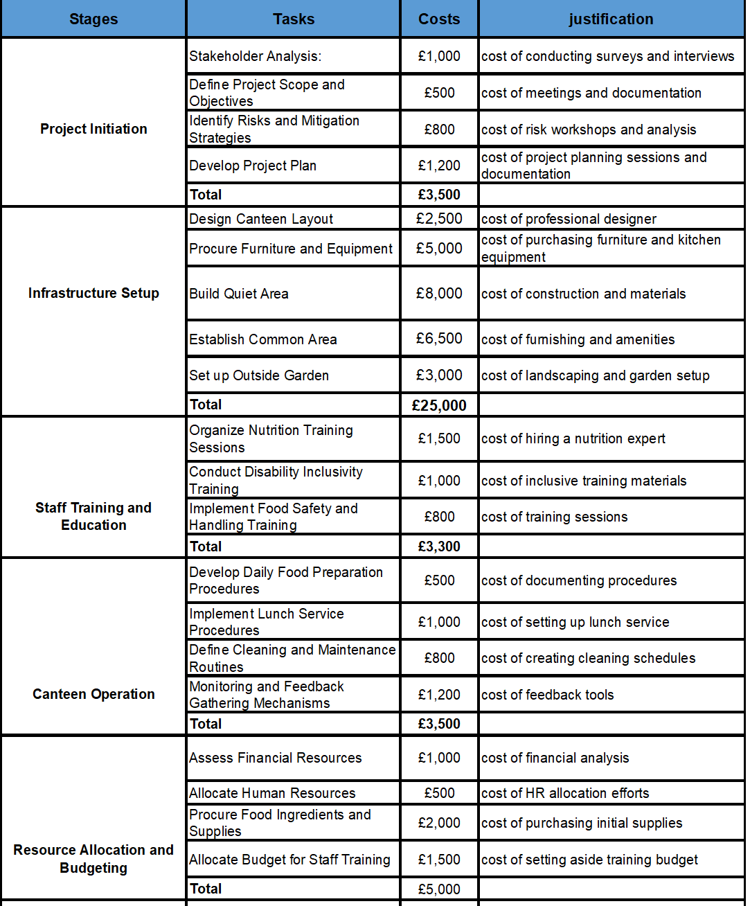

Appendix 2 (cont)
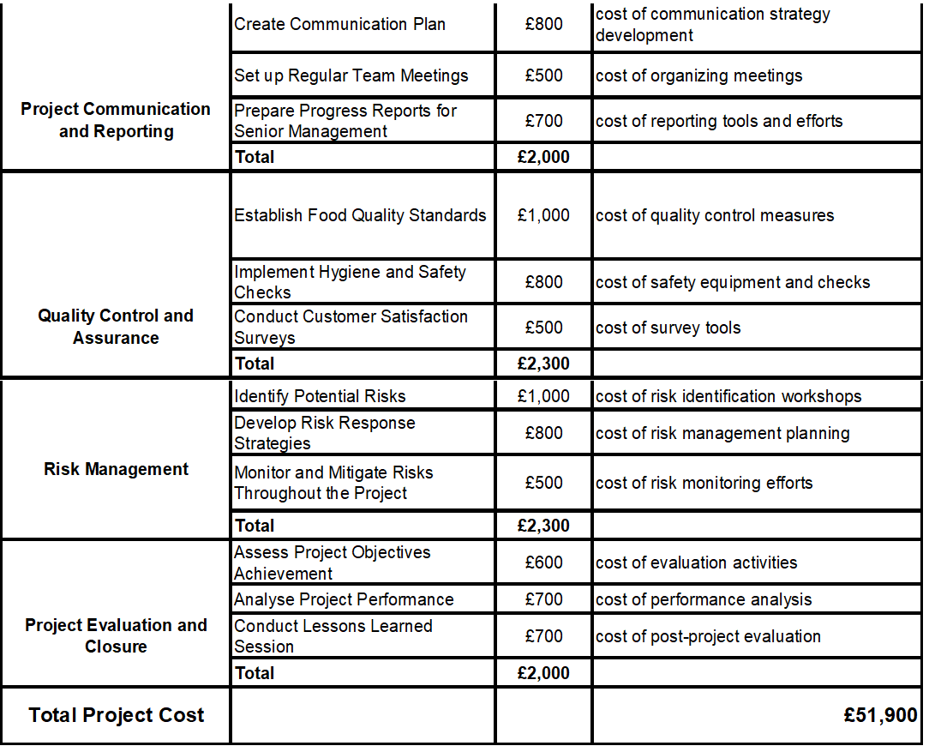

Appendix 3


