MODULE TITLE: HOSPITALITY AND GUEST SERVICE MANAGEMENT M4X01915

ASSIGNMENT TITLE: THE QUALITY MANAGEMENT AND SERVICE PROVIDED IN THE HOTEL

STUDENT NAME: IOSIF DANIEL STAN

STUDENT ID NUMBER: 1815377

LECTURER NAME: DR.OLU ADEGBITE

1

Content

1. Presentation.......................................................................................... Page 3

2. Item and Services at JW Marriott Bucharest Grand Hotel ………...Page 3

3. Methodologies............................................................................................ Page 5

4. USP (Unique Selling Point) .................................................................Page 6

5. The officials Guest Service............................................................. Page 7

6. Quality Guest Service ......................................................................... Page 7

7. Organization setting.......................................................................... Page 8

8. Organization course of action and quality administration........................ Page 9

9. Conclusion........................................................................................... Page 10

10.Termination......................................................................................... Page 11



1. Presentation
The lodge is the reception form organized in homes or our bodies of homes, which gives travellers rooms, studios or homes efficiently organized, provides unique offerings and has receptions and public catering areas inner. The accommodation commercial enterprise business enterprise goals to create the conditions and comfort for comfy haven and the rest of the customers.
The lodge enterprise has evolved in parallel with the improvement of accommodations capacities and their involvement within the activity tourism, enriching itself with new abilities and varieties of services. In the start, the lifestyles of the hotel have become associated with making trips for different purposes than the traveller ones, often growing the tourist drift attracting and developing the lodge enterprise. Thus, approx. 70% of the existence of inns areas are placed in regions of visitor interest.

2. Item and Services at JW Marriott Bucharest Grand Hotel
The development of Marriott International is the story of an American dream that has become a reality in time. It is the story of a own family commercial enterprise that started out with the outlet of a brewery of simplest 9 locations, which then reached the extent of a corporation nicely worth several billion dollars, succeeding in recent times to be one of the global leaders within the discipline of resort and meals offerings.
The Romanian experience of the corporation is also a successful one.
The hotel is considered one of the most beautiful European properties in Marriott Hotels, Resorts and Suites - MHRS.
Due to its membership in an international chain, the hotel aims to provide quality services, has adopted quality-based strategies, especially from the point of view of the product offered to customers.
Whether we are talking about exclusive services and facilities for the business environment or the most refined leisure or shopping experiences, "A City within the City" is the promise of comfort and accessibility of services and products to the highest quality standards.
A building with personality, a landmark of Bucharest, a whole universe under the same roof.
The ideal world is one where compromise is not present in people's lives as a substitute for quality. We want our actions and manifestations to be a source of joy and inspiration for all those who interact with us, without compromise, always having the highest standards.
Aware of the impact that the quality of products and services has on the experience experienced by our customers, collaborators and partners, we strive, daily, to deliver excellence through all our actions and manifestations.
"Everything under one roof" is more than a promise, it is the foundation of a unique experience, The Grand brand. Thus, in the imposing and at the same time fascinating building of Calea 13 Septembrie, the services, the brands and the products create the perfect context for living the most refined experiences.

Whether it's a shopping session among the luxury brands on The Grand Avenue, just after enjoying your favourite coffee in the Pavilion Lounge or Vienna Cafe, the impeccable hotel services guaranteed by JW Marriott Bucharest Grand Hotel standards, The Grand's versatile offices, moments of relaxation or intense activity from the World Class, the enthusiasm we find at the Grand Casino or the delicious moments that can be spent in the restaurants Cucina, JW Steakhouse or the lively Champions Pub, the time spent at The Grand is highly appreciated by anyone who visits us. Costumer do not acquire sustenance in addition refreshments, purchase appetizing surveys. (Campbell-Smith, 1967).

Welcome to an opulence Hotel in Bucharest
JW MARRIOTT Bucharest Grand Hotel
- Inaugurated within November 2000
- Representing 2050 ownership of the Marriott concern;
- It became the first unit in Europe operating under the J. W. Marriott brand, a classification superior to the classic 5-star, characterized by the so-called "affordable luxury";
- Is the largest such complex in Romania.
A true symbol of excellence in the hospitality industry, the 5-star JW Marriott Bucharest Grand Hotel is a place where it is a high standard of services defines a unique and memorable experience. Completely renovated and redecorated in 2019, the hotel offers guests the guarantee of quality and diversity.

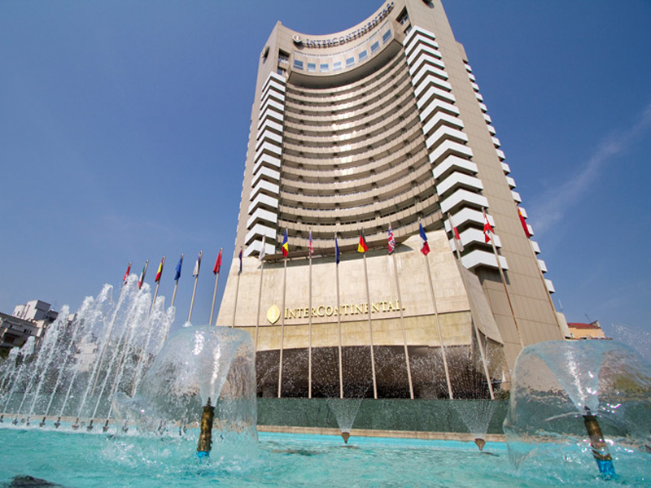

3. Methodologies

The management of the hotel has kept from the beginning that the services offered are of the highest quality, starting from the cleanliness, and continuing with the equipping of the location, and the staff who deal with them.
The interiors are made according to the model of the Schonburn and Hofburg Viennese castles, thus combining the Viennese architectural styles with the typical elements of the Marriott chain (a true "city in a city").
Future reorientation of the geographical position, as it does not have green spaces for relaxation, and many clients prefer to spend their free time in such places.
We strongly believe that the responsible and respectful spirit of all the actions taken, carried out under conditions of complete safety and efficiency, in constant contact with social and environmental changes, ensures the best conditions for a manifestation and a sustainable development, as Jana and Chandra (2016) have pointed out, buyers' satisfaction remains the most exceptional effort problem.



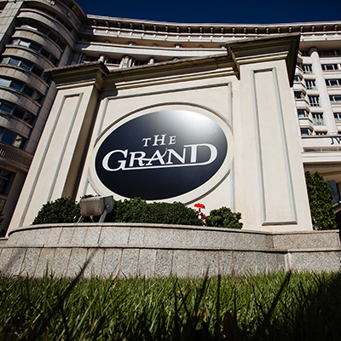
4. USP (Unique Selling Point)

- THE GRAND OFFICES

Over 11,000 square meters of premium office space, in the most attractive multifunctional complex in Bucharest, The Grand.
The Grand Offices is the place where business experience blends in with functionality, an exceptional Class A office area, the ideal combination of comfort, flexibility and style.

- THE GRAND AVENUE
Milan, Paris, London, Vienna or Bucharest? We invite you to enjoy a unique shopping experience, on the only "luxury brand boulevard" in the capital, where the strongest names on the international market have settled, over time. The reason for choosing this place is simple: The Grand Avenue is the only place in Bucharest and Romania, which meets all the standards imposed by the international luxury brands.
- THE GRAND PARKING
One of the most spacious private car parks in the central area of ​​Bucharest awaits you with approximately 400 places, arranged either underground or underground, in two different areas as well as with a fast charging station for electric and hybrid cars.

5. The officials Guest Service

Here you will benefit from the highest standards of services, intended for both business and travel purposes, through the 402 Deluxe rooms, six restaurants, multiple conference rooms, a Spa centre, a health club, a gallery and a casino.
The 20 years of presence and excellence on the Romanian market are a testimony and at the same time a milestone for the future, an additional guarantee that is added to the standards to what have enshrined one of the most appreciated names in the hospitality industry, JW Marriott.
“Customers don't buy sustenance's and beverages, buy culinary surveys.” (Campbell-Smith, 1967).

6. Quality Guest Service
Here are a number of the number one highlights of price control:
Substantial first-class: Staff accessibility and correspondence with the purchaser;
Earnestness: The personnel has the important aptitudes; The administration is finished with the important health and ability
Speed: The carrier is completed inside the terms preferred and trendy through the customer.
Politeness: The personnel shows kindness and appreciate, in personal touch with the customer.
Security and Safety: When the company is furnished, complete safety and the absence of danger and doubt are confident.
Accessibility: The service may be used without boundaries and troubles at the proper time.
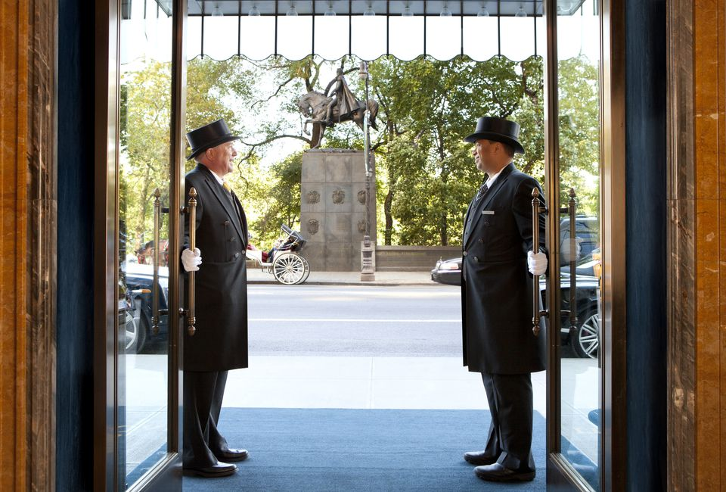
Correspondence: The client is well informed, in a language that is easy to understand for him/her

7. Organization setting
As exhibited by means of the way of Dana V. Tesone, tourist affiliation includes the ones affiliations and exchanges that meddle most of the customer and the employees, from the minute the tourist enters the unit until it leaves.
In JW Marriott hotels, correspondences among clients and a personnel exchange right into a real, superb lot or transient affiliations, subordinate upon the patron's stay within the resort. "In the generosity commercial agency, we're set up to test the requirements of our traffic and proactively act to meet the ones essentials." (Tesone, 2017).
KEY FACTS - THE GRAND OFFICES

- 11,000 sqm of office space spread over 10 floors
- Available surfaces from 24 sqm to 1,200 sqm
- Room heights between 2.70 m and 3.80 m
- Flexible floor features for various compartmentalization styles
- Superior sound insulation
- Humidity detectors to prevent condensation
- Power connection, IT - all through pipes on the floor
- Heated and cooled ceiling - the most efficient and comfortable air conditioning
- Optional installations for individual kitchens and / or bathrooms
- All areas are equipped with sprinklers according to Romanian and American standards
- 4 high quality OTIS elevators for the exclusive use of office space tenants
- Full range of business services, in-house: meeting and conference rooms for rent, catering hotel, luxury commercial gallery, restaurants, bank, pharmacy, cleaning services, beauty services, hotel.
- Approximately 400 guarded parking spaces inside and outside the building
- Reception and secretarial service

8. Organization course of action and quality administration

The great is directly associated with the delight of the guests who have acquired tourist services and products. The great components inside the hospitality enterprise that may be used to expand and enforce a quality service system are the subsequent:

• Considering that the visitor is served
• Determining the preference of the visitors
• Develop methods to offer what the traveller wishes
• Staff training and empowerment
• Implementation of the revised systems
• Evaluation and change of provider shipping structures
According to Felix in order to make the decision of these change before the visitor pack, the administrators must perceive their clients and must finally evaluate their discernments about the associations. (Felix, 2015)
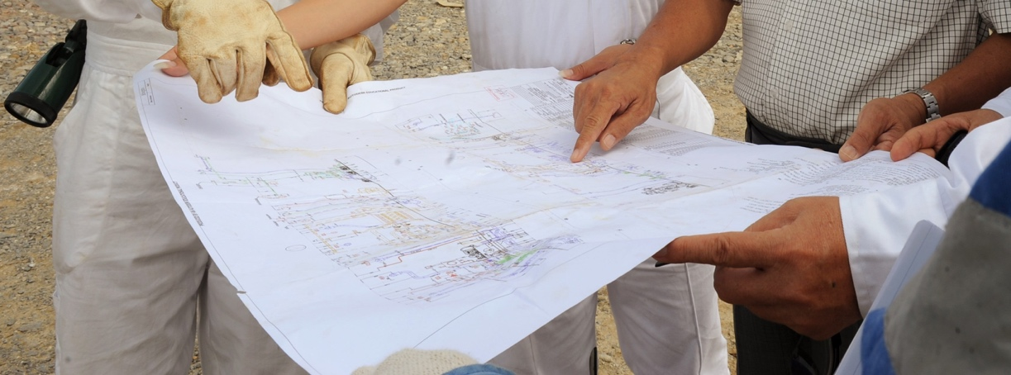

9. Termination

In conclusion, the Hotel and eating place managers ought to offer first rate offerings for each themselves and the personnel. Recommendations for advanced offerings to customers so one can gather a fulfilment and worthwhile effects encompass: the point of interest on pleasant offerings and customer delight; preserving present visitors nicely beyond their expectancies, non-stop top notch development; employment, ordinary schooling and obligation of issuer-oriented workforce; look for best practices via benchmarking; exercising satisfactory accreditation thru one-of-a-kind schemes.
The hotel organization will offer, as can be visible inside the figure above, a series of primary services, which define the resort hobby: patron reception, accommodations, leisure, meals, records, plus a diffusion of offerings. : forex, maintaining valuables, washing and ironing the purchaser's underwear, cleansing garments and footwear, baggage transport, parking vehicles, equipping rooms with extra stock, so on., which form complementary resort sports, with the role of improving the consolation of the unit lodging.



10. References

•Campbell-Smith, G. (1967). Showcasing of the Meal Experience; a Fundamental Approach. London: University of Surrey (Department of Hotel and Catering Management Research Unit), pp.11-209.

•Doyle, A. (2019). The most effective method to Answer Job Interview Questions About Customer Service. [online] The Balance Careers. Accessible at: https://www.thebalancecareers.com/inquiries questions-about-client administration 2063349 (Accessed November 21, 2019)

•Felix, E. (2015). Advertising Challenges of Satisfying Consumers Changing Expectations and Preferences in a Competitive Market. Global Journal of Marketing Studies, 7(5), p.41.

•J. Willard Marriot (January 20, 1964) The Marriott Management Philosophy. "A living convention of qualities and convictions."

•Jana, An., and Chandra, B. (2016). Intervening Role of Customer Satisfaction in the Mid-Market Hotels: An Empirical Analysis. Indian Journal of Science and Technology, p9

•Kotler, P. (2002). At the point when to utilize CRM and When to overlook it! Paper exhibited at the Academy of Marketing Science, Sanibel Harbor Resort and Spa, 30 May

•Marriott (2017). Marriott International, accessible @: marriott-international_5880c2a6b6d87fa1738b5c6c.html (Accessed November 21, 2019).

•Sipe, L.J. what's more, Testa, M.R., 2018. From Satisfied to Memorable: An Empirical Study of Service and Experience Dimensions on Guest Outcomes in the Hospitality Industry. Diary of Hospitality Marketing and Management, 27(2), pp.178-195.

•Tesone, D. (2017). Standards OF MANAGEMENT FOR THE HOSPITALITY INDUSTRY. [S.l.]: ROUTLEDGE, pp.4 to 20.

