Organization Structure, Culture and Performance

Student: Ioan Bogdan Hodor
Student ID:1917709
Professor: Gregory Cowan

Introduction
An organization does exist in a vacuum but in an environment where both the internal and external environment affects its operations. Internally, employees play a major role in determining the success of the firm. For any successful business, managers and other executives must take into consideration the behavior of employees. In doing so, the company is able to understand what the customers want. Understanding the internal aspect of the firm helps the organization strategies on aspects such as leadership styles, management style, define the business structure, and develop a culture that suits the organization and employees (Babatunde & Adebisi, 2012). According to Čepel et al. (2019), the internal business environment does include not only the employee but also management, suppliers, and other individual attached to the firm, such as investors. Besides, the author identified factors such as mission and objectives, value system, corporate culture, organization structure, and quality human resource, which determines the internal environment of a business. The ability to regulate these internal determinants will guarantee the company maximum output and increased revenue. Among the most perceived internal determinants of a company, organizational culture and structure come in handy. The two shapes the company’s image and determines its long-term success. According to Cherunilam (2016), it is important for a firm to consider factors such as culture and structure as they are the primary determinant of the organization’s progress. In this regard, the following paper will discuss in detail the aspect of culture and structure and how they influence the firm. Precisely, the paper will use a case of Debenhams Company to establish how organization structure and culture contribute to organizational performance and employee productivity (Debenhams, 2020).
A Brief Overview of Debenhams
Debenhams is one of the global leading multinational, multichannel department store with its headquarters in the United Kingdom. The majority of the company’s stores are in the UK and Denmark but it has established stores in other countries across the globe. Debenhams was founded as a single company in the 18th century in London, but over the decades, the company has grown to over 200 locations in 18 countries. In the U.K alone, Debenhams has 130 established stores in major malls and on retail parks. Outside the U.K, the company has established over 50 stores in the world’s leading markets, including South East Asia, Eastern Europe, and the Middle East. Business-wise, Debenhams deals exclusively with designer clothes from the world’s major brands such as Jasper Conran, Hannah Gibbins, Preens and Mathew Williams, and Patrick Giant. The company has grown very fast due to the strong company culture and well-established business structure(Debenhams, 2020).
Organization Culture
Ahmed & Shafiq (2014) postulates that organizational culture is a term that is used to describe the behaviors of employees and how the environment in a firm explains how employees behave in a certain way. Precisely organization culture defines values, beliefs, policies, and procedures in an organization that employees should hold up to in an organization. An organization is defined by its culture, and managers are mandated to developing share values and beliefs that all employees are expected to adhere to all times. For instance, an organization can set a specific dress code that its employee must follow. Failure to follow such codes will lead to serious repercussions. A well-defined organization culture helps a firm solve their disputes in the best way possible. The development of culture in a firm can be described by the culture model.
Martinez et al. (2015) highlight that culture in a firm is a continuous process, which cannot be adopted in a single day. Therefore, as long as the manager has the urge to developed culture, it will take time for it to be adopted. The culture model is also based on the adaptation of a business culture over a period of time. As Schein (2004) puts, the organization's culture model has three levels as shown in the diagram below;
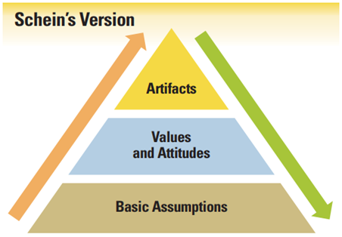
These are the elements that define Debenhams organizational culture. In Debenhams, artifacts define attributes of culture that cannot be hidden from the external parties to the firm. They include aspects such as the attitude of employees, the company’s mission and vision statement, dress code, and office presentation. Debenhams believes that their image is determined by the outsider based on their artifacts elements. The second attribute that defines Debenhams as an organization, according to Schein’s model of culture, is the values and attributes. Values define what the company stands for in terms of product development and provision of service. Debenhams is known for its quality provision and exceeding customer expectations. The employees have been trained to always portray a positive attitude toward employees because they believe customer satisfaction should come first. The last level of culture mode describes the basic assumptions. Basic assumptions are intangible entities and include entities such as personal space, gender equality, and distribution of power and responsibilities of employees.
In most cases, basic assumptions are always overlooked, but Debenhams defines these elements as they are the basis for competitive advantage. For instance, management at Debenhams defines the roles of each employee to avoid conflict. The also, ensure gender equality between in the workplace because they believe in giving equal opportunities to all. In general, culture is important because it gives a firm direction and makes employees have a sense of belonging (Shahzad et al., 2012). While establishing a company’s image customer looks at some aspect of culture, such as service delivery and interaction with customers. Therefore, Debenhams takes the initiative to ensure that the company has a well-established organization culture (Debenhams, 2020).
Organization Stricture
According to Egeberg, Gornitzka & Trondal (2016), organization culture is a system within the firm that sets out how activities should be carried in an organization. They determine how various activities should be done to achieve organizational goals. They set out the roles and responsibilities of employees in the firm. Yanase & Limpaphayom (2017) postulates that an organizational structure defines the information flow in a firm as well as how employees relate in a firm. For instance, a centralized organization structure establishes that information should flow from top-down, but in a decentralized structure, the power and information are distributed equally on various levels of the firm. It is important to establish an organizational structure because with a structure that reflects the firm’s values, and the firm remains focused and efficient. Kanten, Kanten & Gurlek, 2015) identifies that a successful organization structure helps to identify employees, their roles, responsibilities, and rules that govern the firm toward achieving its goals.
Organizational structure can either be centralized or decentralized. A centralized organization structure is a form of the hierarchical structure where decision making is left for the top-level managers. The power is distributed unevenly to the lower-level managers and employees. In a centralized organization structure, specific procedures must be followed when relaying information and solving disputes. On the other hand, the decentralized structure is a form of the structure where each leader in a department or a given region manages their own operation independently. The power is distributed equally, and no one has power over the other. Decentralization allows efficiency and timely decision making and managers do not have to wait for fort top-level management to decide for them (Egeberg Gornitzka & Trondal, 2016). Debenhams has adopted a decentralized structure where each chain manages its store independently, and their decisions are not tied to the main head office. Besides, there are four main types of structures that categorize a firm, including functional divisional, flat, and mixed organizational structure. Functional organization structure is a type of structure where the firm group its employees based on their specialization under one leadership. Under this structure, a firm is divided into departments such as finance, marketing, operations, and human resources. Divisional organization structure is the one in which the firm is structured based on the products suited for specific customers. Each product structure the firm based on the customers they serve. A mixed organizational structure combines both functional and divisional structures. A flat structure is a structure where there are no levels of management, and employees are left to govern themselves. Employees communicate freely with the managers (Kanten, Kanten & Gurlek, 2015). Debenhams adopt a functional organization structure as shown in the diagram below;
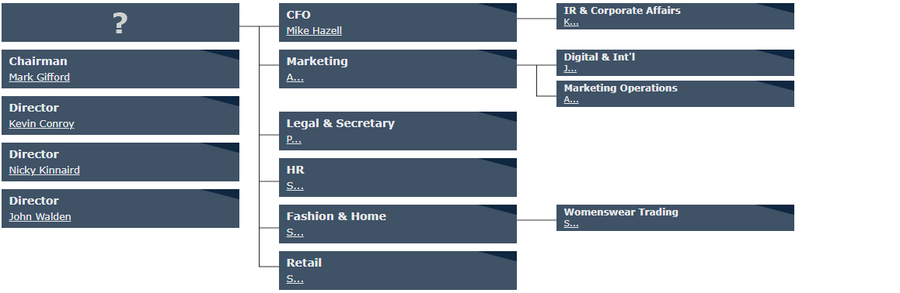
Overall, the store has a decentralized system of management, where each store is managed independently. The organization has then divided its stores into departments based on their functions within the firm. Such departments include HR, Marketing, Retail, and CFO departments. Each of these departments is managed independently. This has enabled the firm to improve the decision-making process as each department manager is responsible for the success of their department and the achievement of the organization's goal. Another benefit of adopting a functional structure is that the structure allows developing structure in their respective areas. Also, it allows Debenhams to develop more skilled employees in their departments. The success of the firm over the years has been pinned to this type of structure because it allows interaction and employee engagement.
Relationship between culture, structure, and organization performance
Organizational culture and structure determine the success of a company because they help improve the performance of employees. Any organization adopts an organizational culture based on the environment in which it operates, its objectives, management style, and the belief system of employees (Hogan, & Coote, 2014). Debenhams adopts a well-structured and highly collaborative structure. This is a kind of structure with strict controls, and employees need to follow well-stipulated roles and responsibilities. The adherence to this kind of structure allows the management to communicate the roles, responsibilities, and standards that employees need to follow. Also, an employee knows what is expected of them from the management and how the management evaluates their performance. A structure within Debenhams creates a strong bond between management and employee, which helps them to avoid misunderstanding and focus on the core operations of the firm.
The culture at Debenhams affects the performance of the firm in many ways. First, culture creates a bond between employees and make them part of the organization. When employees feel that they are part of the company, they become the best performers. Second, Debenhams is believed to be the global leader in the provision of quality products from the most renowned brands. In order to remain at the top, their employees needed to maintain a high standard of customer services and satisfaction. According to Biswas (2015), a strong culture is seen as the driving force for improving performance. It enables employees to become committed and self-confidence toward their tasks. It also enhances commitment to ethical behavior, among which is a major step toward attaining an organizational goal.
On the other hand, organization structure adopted by Debenhams helps them to improve their performance. Precisely, organizational function structure is considered the anatomy of the firm, stipulating ways in which organization functions. For instance, each structure allows the evaluation of each department, which assists in determining areas that perform lowly for an upgrade. At the same time, functional structure increases competition between departments, which translates to high performance. The structure identified adopted by Debenhams sets the boundaries which allow understanding their roles and responsibilities perfectly.
Conclusion
In conclusion, the structure and culture of a firm determine the performance of its employees. A strong company’s culture gives increases the competitive advantage of the firm because customers tend to consider aspects such as customer services and firms believe in satisfying human wants. The structure, on the other hand, is considered the anatomy of the firm, stipulating ways in which an organization functions. For instance, each structure allows the evaluation of each department, which assists in determining areas that perform lowly for an upgrade. Therefore, it is important for an organization to establish a structure and culture that suits their needs.

References
Ahmed, M., & Shafiq, S. (2014). The impact of organizational culture on organizational performance: a case study on telecom sector. Global journal of management and business research
Babatunde, B. O., & Adebisi, A. O. (2012). Strategic Environmental Scanning and Organization Performance in a Competitive Business Environment. Economic Insights-Trends & Challenges, 64(1).
Biswas, W. (2015). Impact of Organization Culture on Job Satisfaction and Corporate Performance. Journal of Research in Humanities and Social Science, 3(8), 14-16.
Čepel, M., Stasiukynas, A., Kotaskova, A., & Dvorský, J. (2018). Business environment quality index in the SME segment. Journal of Competitiveness.
Cherunilam, F. (2016). Business environment. Himalaya Publishing House.
Debenhams. (2020). About Debenhams | Debenhams. Debenhams. Retrieved 27 August 2020, from https://ir.debenhams.com/about-debenhams-0#:~:text=Debenhams%20is%20a%20leading%20international,brands%2C%20international%20brands%20and%20concessions.
Debenhams. (2020). Corporate Governance| Debenhams. Debenhams. Retrieved 27 August 2020, from https://ir.debenhams.com/about-debenhams-0#:~:text=Debenhams%20is%20a%20leading%20international,brands%2C%20international%20brands%20and%20concessions.

Egeberg, M., Gornitzka, Å., & Trondal, J. (2016). Organization theory. In Handbook on theories of governance. Edward Elgar Publishing.
Hogan, S. J., & Coote, L. V. (2014). Organizational culture, innovation, and performance: A test of Schein's model. Journal of business research, 67(8), 1609-1621.
Kanten, P., Kanten, S., & Gurlek, M. (2015). The effects of organizational structures and learning organization on job embeddedness and individual adaptive performance. Procedia Economics and Finance, 23(2015), 1358-1366.
Martinez, E. A., Beaulieu, N., Gibbons, R., Pronovost, P., & Wang, T. (2015). Organizational culture and performance. American Economic Review, 105(5), 331-35.
Shafritz, J. M., Ott, J. S., & Jang, Y. S. (2015). Classics of organization theory. Cengage Learning.
Yanase, N., & Limpaphayom, P. (2017). Organization structure and corporate demand for reinsurance: The case of the Japanese Keiretsu. Journal of Risk and Insurance, 84(2), 599-629.

