Module code: LCMB7034
Lecturer: Baber Syed
Student name: Mihail Croitoru
Student number:2124152
Brand: Toyota
Programme: Master of Business Administration


International Business Concepts

Table of Contents
- Introduction ..................................................................................................................... 2
- Benefits and Challenges of International Operations .................................... 2
2.1 Toyota as a Multinational and Transnational Corporation ......................... 2-3
2.2 Overview of Toyota’s Global Value Chain ..................................................... 3-4
2.3 Entry Modes in International Markets ........................................................... 4
2.4 Benefits of International Operations ............................................................. 4-5
2.5 Challenges of International Operations ......................................................... 5-6
2.6 Summary .................................................................................................................. 6
- OLI Factors Influencing Toyota’s Market Entry Strategy ................................. 6
3.1 Ownership Advantages ......................................................................................... 7-9
3.2 Location Advantages ............................................................................................ 9-13
3.3 Internalisation Advantages ................................................................................ 13-14
3.4 Application of the OLI Framework in India .................................................... 14-15
3.5 Critical Evaluation ................................................................................................ 15-16
3.6 Summary ................................................................................................................ 16-17
- Cultural Differences and Impact on Market Entry Strategy ....................... 17
4.1 Comparative Cultural Analysis: Japan vs. India ............................................ 17
4.2 Impact on Market Entry and Management .................................................... 18
4.3 Human Resource and Marketing Adaptation ................................................ 18
4.4 Cultural Challenges .............................................................................................. 18
4.5 Cultural Factors and Market Success ............................................................. 18-19
4.6 Theoretical Reflection .......................................................................................... 19
4.7 Summary ................................................................................................................ 19
- SOP Adjustments and Recommendations ......................................................... 19-20
5.1 Localization of Products and Supply Chain Processes ................................. 20-21
5.2 Cultural Integration and Human Resource Adaptation ............................... 21-22
5.3 Sustainability and Digital Transformation Alignment ................................. 22-23
5.4 Integrated Strategic Implications ....................................................................... 24
5.5 Implementation Considerations ......................................................................... 24-25
5.6 Summary ................................................................................................................ 25
- Conclusion .................................................................................................................. 25
References ....................................................................................................................... 26
List of Figures
Figure 1: Toyota Global Marketing Concept ............................................................. 8
Figure 2: Toyota Global Production and Financial Overview .............................. 9
Figure 3: India’s Automotive Market Growth ........................................................ 10
Figure 4: Toyota Marketing Adaptation in India .................................................. 11
Figure 5: India’s Economic and Investment Trends .............................................. 11
Figure 6: India’s FDI Inflows in Automotive Manufacturing ............................... 12
List of Tables
Table 1: OLI Framework Application in Toyota India .......................................... 14-15
Table 2: Comparative Cultural Analysis – Japan vs. India .................................. 17
Table 3: Strategic Goals and SOP Adjustments Summary ................................. 24

1. Introduction
Toyota Motor Corporation is a Japanese multinational automotive manufacturer headquartered in Aichi, Japan. Established in 1937, Toyota has evolved into one of the world’s largest automobile producers, operating in more than 170 countries and regions (Toyota, 2024). The company’s mission “Producing happiness for all” reflects its commitment to sustainable mobility and global innovation. Toyota’s international operations span across Asia, Europe, North America, and emerging economies such as India, Brazil, and South Africa, demonstrating its strong transnational orientation.
This report critically examines Toyota’s international business strategies and operations, focusing on the benefits and challenges of its global expansion. It further applies the Ownership–Location–Internalisation (OLI) framework to assess Toyota’s entry strategy in emerging markets, particularly India. The analysis also explores the cultural factors influencing Toyota’s international success and concludes with recommendations for revising its Standard Operating Procedures (SOPs) to enhance competitiveness and cultural integration in diverse markets.

2. Benefits and Challenges of International Operations
2.1 Toyota as a Multinational and Transnational Corporation
Toyota exemplifies both a Multinational Corporation (MNC) and a Transnational Corporation (TNC) due to its ability to combine global integration with local responsiveness. The company manages a network of more than 350,000 employees worldwide and operates over 50 manufacturing plants outside Japan (Toyota Annual Report, 2024). Toyota’s presence in over 170 markets demonstrates its extensive international reach and decentralized operational model, enabling it to adapt to the socio-economic and cultural conditions of each host country.
As a TNC, Toyota integrates core global functions such as research and development (R&D), engineering, and quality assurance from its headquarters in Japan, while delegating production and marketing decisions to regional subsidiaries. For example, Toyota Kirloskar Motor Pvt. Ltd. in India, a joint venture with the Kirloskar Group, exercises autonomy in tailoring products and marketing strategies for the Indian market (Toyota India, 2024). This balance between global consistency and local flexibility defines Toyota’s transnational strategy.

2.2 Overview of Toyota’s Global Value Chain
Toyota’s international competitiveness is anchored in its global value chain, which integrates R&D, sourcing, production, sales, and financing activities to deliver consistent quality and efficiency worldwide.
Research and Development (R&D):
Toyota maintains an extensive R&D network spanning Japan, North America, and Europe, with emerging R&D hubs in Asia. The company invests heavily in hybrid and electric vehicle technologies—approximately ¥1.3 trillion (US$8.5 billion) in 2023 (Toyota Sustainability Report, 2024). These investments have yielded technological innovations such as the Hybrid Synergy Drive and the Toyota New Global Architecture (TNGA) platform, which standardizes vehicle components across models to achieve economies of scale.
Sourcing and Supply Chain:
Toyota’s sourcing strategy emphasizes partnerships with local suppliers while maintaining stringent quality standards. Its keiretsu system—long-term collaborative relationships with suppliers such as Denso Corporation and Aisin Seiki—allows Toyota to ensure quality and reliability across borders (Liker, 2021). In emerging markets like India, local sourcing exceeds 90% of production components, aligning with the country’s Make in India initiative.
Manufacturing:
Toyota’s manufacturing system is guided by the Toyota Production System (TPS), which emphasizes Just-in-Time (JIT) production, Kaizen (continuous improvement), and waste elimination. Plants are strategically located to minimize logistics costs and import tariffs—such as in India, Thailand, and Brazil. Toyota’s plant in Bidadi, India, produces models like the Innova Hycross and Fortuner, catering to local preferences and affordability levels.
Sales and Marketing:
Toyota tailors its marketing strategies to reflect local consumer behaviour. In India, marketing focuses on reliability, fuel efficiency, and after-sales service, while in developed markets, campaigns emphasize innovation and sustainability. Toyota’s customer-centric approach has earned it one of the most trusted reputations globally (Interbrand, 2024).
Financing and Services:
Through Toyota Financial Services (TFS), the company provides leasing, insurance, and financing solutions in over 40 countries. In India, TFS plays a vital role in expanding vehicle ownership by offering low-interest loans and flexible repayment options for first-time buyers.

2.3 Entry Modes in International Markets
Toyota employs multiple market entry modes depending on host-country conditions such as government policy, market potential, and resource availability.
- Joint Ventures (JVs):
Toyota often uses joint ventures to overcome regulatory restrictions and share risks in emerging markets. For example, Toyota entered India in 1997 through a JV with the Kirloskar Group (89:11 shareholding), which enabled access to local knowledge, distribution networks, and compliance with India’s FDI regulations (Toyota India, 2024).
- Wholly Owned Subsidiaries:
In developed markets such as the United States, the United Kingdom, and France, Toyota operates wholly owned subsidiaries, giving it full control over production and quality management. This model ensures consistency in brand image and technology transfer.
- Strategic Alliances:
Toyota forms alliances to leverage complementary strengths. Its alliance with Suzuki Motor Corporation in 2019 aimed to share technology and expand hybrid vehicle offerings in India and Africa (Reuters, 2024). Partnerships with Panasonic and BYD in electric vehicle (EV) battery production enhance Toyota’s technological competitiveness.
- Acquisitions and Mergers:
Toyota has strategically acquired or invested in companies like Daihatsu and Hino Motors to strengthen its product range and access niche segments such as compact cars and commercial vehicles.
- Exporting and Licensing:
In smaller or restricted markets, Toyota exports vehicles from regional hubs or licenses assembly operations to local manufacturers. For instance, vehicles assembled in Thailand are exported throughout Southeast Asia.

2.4 Benefits of International Operations
a. Economies of Scale:
Operating globally allows Toyota to spread fixed costs across large production volumes. Platforms like the TNGA enable the use of common parts and manufacturing processes across different models, reducing per-unit costs. Economies of scale also enhance R&D efficiency by allowing shared technological innovation across markets.
b. Market Diversification and Risk Reduction:
Global diversification reduces dependence on any single economy. When sales in Japan or North America decline, growth in emerging markets such as India, Brazil, and Indonesia helps stabilize overall performance (UNCTAD, 2023). This diversification shields Toyota from currency volatility and regional demand fluctuations.
c. Access to Emerging Market Growth:
Emerging economies contribute a growing share of Toyota’s revenue. In India, for instance, vehicle sales grew by over 35% in 2024 (Economic Times, 2024). These markets offer expanding middle classes, rising disposable incomes, and increasing demand for affordable mobility solutions.
d. Knowledge Transfer and Innovation Synergies:
Toyota’s international presence facilitates cross-market learning. Its experience with small cars in Asia has informed the development of fuel-efficient hybrid models for Europe. Conversely, advanced safety and emission technologies developed in Japan are transferred to emerging markets, enhancing product quality globally.
e. Brand Strength and Global Recognition:
Toyota ranks among the top global automotive brands (Interbrand, 2024). Its consistent commitment to quality, innovation, and sustainability strengthens customer loyalty, enabling premium pricing and long-term market leadership.
f. Employment and Socioeconomic Contributions:
Toyota’s localized operations create employment and develop industrial ecosystems in host countries. In India alone, Toyota Kirloskar Motor employs over 9,000 people and supports more than 60,000 indirect jobs through suppliers and dealers.

2.5 Challenges of International Operations
Despite its success, Toyota faces significant operational and strategic challenges in its global expansion.
a. Regulatory and Trade Barriers:
Automotive regulations vary widely across markets, encompassing safety standards, emissions requirements, and localization policies. In India, high import duties (up to 60% on fully built cars) and shifting emission norms challenge Toyota’s profitability (Business Standard, 2024). Compliance costs also increase as countries tighten environmental regulations under climate agreements.
b. Cultural and Managerial Differences:
Toyota’s Japanese management style emphasizes consensus-building (nemawashi) and hierarchical decision-making, which can clash with local expectations for quicker and more flexible responses. In India, where employees expect direct leadership and clear hierarchies, Toyota has had to modify its communication and management practices to maintain efficiency and morale (Hofstede Insights, 2024).
c. Supply Chain Vulnerabilities:
Toyota’s global Just-in-Time supply system increases efficiency but exposes the company to disruptions. The 2021 semiconductor shortage and geopolitical tensions in East Asia disrupted production across multiple regions (Bloomberg, 2023). Balancing efficiency with resilience is now a key strategic challenge.
d. Technological Transformation and EV Transition:
Global demand is shifting rapidly toward electric vehicles. While Toyota pioneered hybrid technology, it has been slower than competitors like Tesla and BYD in fully electrifying its fleet. Adapting its value chain and production infrastructure to EV manufacturing poses a major strategic and financial challenge (Financial Times, 2024).
e. Economic and Currency Volatility:
Fluctuating exchange rates, inflation, and interest rates in emerging markets such as Brazil and India can erode profit margins. The depreciation of the Indian rupee and Brazilian real against the yen increases the cost of imported components and reduces overall competitiveness.
f. Sustainability and Environmental Pressures:
As global environmental awareness rises, Toyota faces pressure to reduce carbon emissions and improve energy efficiency. Critics argue that its hybrid strategy delays full electrification. Additionally, in emerging markets, balancing affordability with sustainability adds complexity to product and pricing decisions.

2.6 Summary
Toyota’s global expansion boosts efficiency and competitiveness but requires constant adaptation; the next section applies the OLI framework to India.
3. OLI Factors Influencing Toyota’s Market Entry Strategy
The Ownership–Location–Internalisation (OLI) paradigm, first proposed by John Dunning (1980, 1988), explains the conditions under which firms expand internationally through foreign direct investment (FDI) rather than alternative entry modes such as licensing or exporting.
The model posits that companies evolve into multinational enterprises (MNEs) when they possess distinctive ownership assets, exploit location-specific advantages in host countries, and internalise operations to safeguard efficiency and intellectual property.
Applying this framework to Toyota Motor Corporation sheds light on the rationale behind its global expansion and its strategic decision to invest in India, one of its most significant emerging markets.

3.1 Ownership Advantages
Ownership advantages comprise the resources and competencies that differentiate a firm from its competitors and enable it to compete effectively abroad.
Toyota’s ownership advantages are largely derived from its technological leadership, brand equity, production excellence, and financial capability.
Technological and R&D Leadership
Toyota’s consistent investment in research and development has established it as a pioneer in automotive innovation. In fiscal year 2023, the company allocated over ¥1.3 trillion (US$8.5 billion) to R&D activities (Toyota Annual Report, 2024).
This commitment has produced landmark innovations such as:
- The Hybrid Synergy Drive (HSD) system, introduced in the Prius in 1997, positioning Toyota as a leader in hybrid mobility.
- The Fuel Cell Electric Vehicle (FCEV) technology used in the Mirai, advancing hydrogen-based transportation.
- The Toyota New Global Architecture (TNGA) platform, which standardises components across models to reduce costs and enhance production flexibility.
These technological strengths form a core intangible asset, giving Toyota an edge in markets such as India where consumers value fuel efficiency, reliability, and cost-effectiveness.
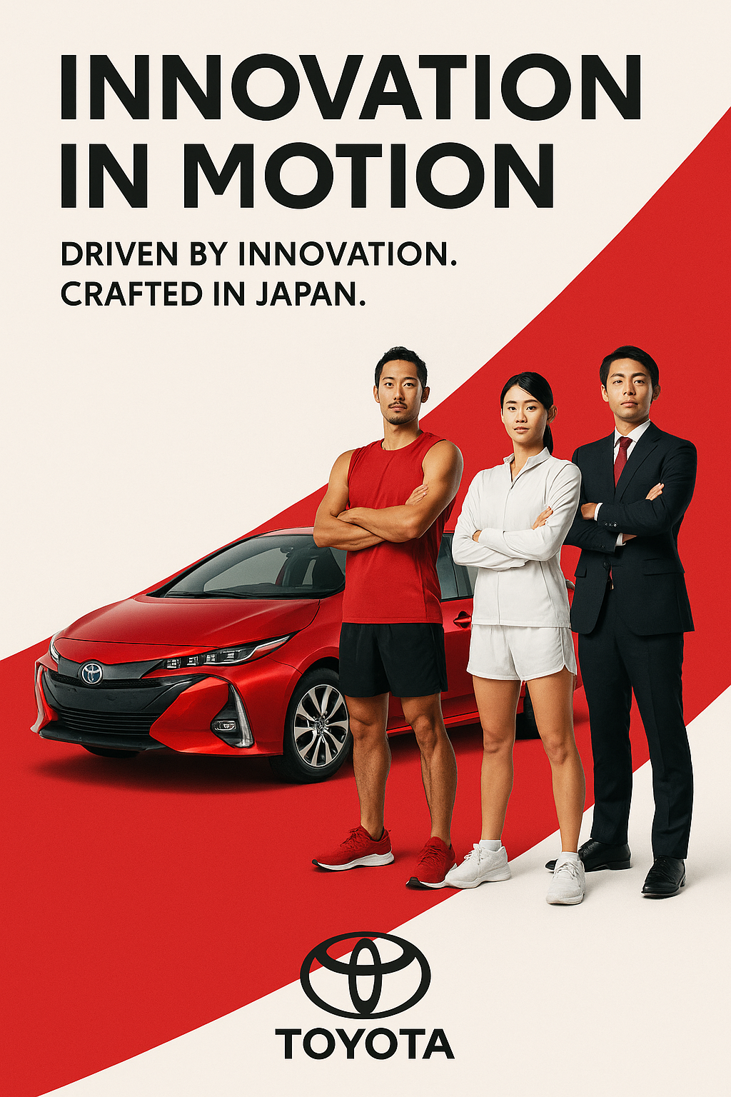
Source: Author-created illustrative marketing concept (2025).
Brand Strength and Global Reputation
Toyota consistently ranks among the world’s top automotive brands, with a valuation exceeding US$52 billion in 2024 (Interbrand, 2024).
The brand is synonymous with durability, quality, and environmental responsibility, making it a trusted choice in both developed and emerging economies.
In India, models like the Innova Crysta and Fortuner have built strong consumer loyalty, particularly among middle- and upper-income households.
This reputation reduces the risks associated with market entry by enhancing consumer acceptance and dealer confidence.
Operational Excellence through TPS
Another critical proprietary strength is the Toyota Production System (TPS) — an integrated manufacturing philosophy grounded in Just-in-Time production, Kaizen (continuous improvement), and Jidoka (automation with human oversight).
TPS minimises waste and ensures consistent quality worldwide.
Its diffusion to Toyota Kirloskar Motor in India has helped build local production competence while maintaining the global brand’s hallmark efficiency.
Financial Capacity and Global Network
Toyota’s substantial financial assets — exceeding US$500 billion (Toyota Financial Report, 2024) — enable large-scale investment and resilience during economic volatility.
Its access to affordable capital supports greenfield investments and long-term projects in infrastructure-intensive markets like India.
This financial stability enhances the firm’s ability to sustain competitive advantage over rivals with fewer global resources.
In short, Toyota’s combination of technological prowess, operational discipline, and global financial strength represents a powerful set of ownership advantages that underpin its international success.
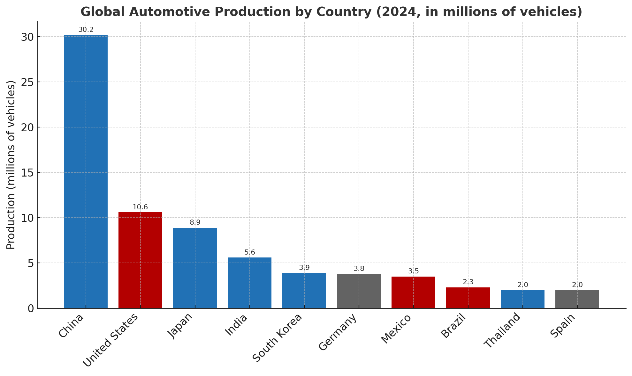Source: OICA, World Bank

3.2 Location Advantages
Location advantages refer to the economic, political, and structural attributes that make a particular country attractive for investment.
Toyota’s selection of India as a key production and sales base reflects the country’s favourable market dynamics, supportive policy environment, and strategic geographic position.
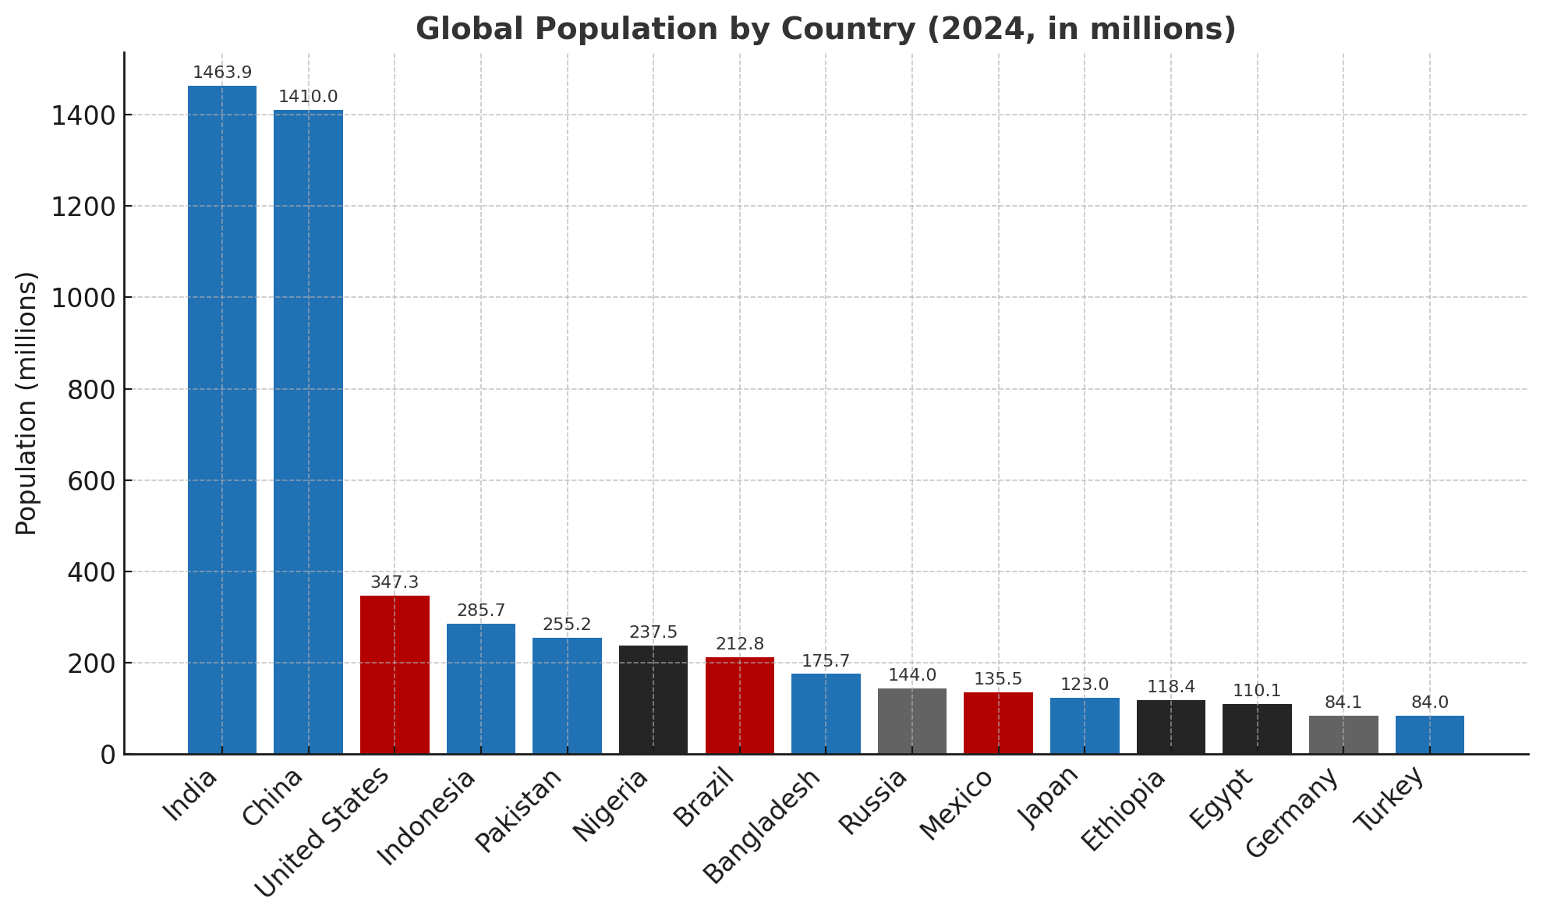
Source: World Bank, United Nations Population Division

Market Size and Consumer Growth
With a population of over 1.4 billion, India is one of the world’s largest and fastest-growing automobile markets (Statista, 2024).
Rapid urbanisation, a rising middle class, and expanding infrastructure have spurred demand for both passenger and commercial vehicles.
Toyota recognised India’s potential as a hub for affordable, efficient cars, leading to region-specific models such as the Glanza and Urban Cruiser, co-developed with Suzuki to meet local price expectations.
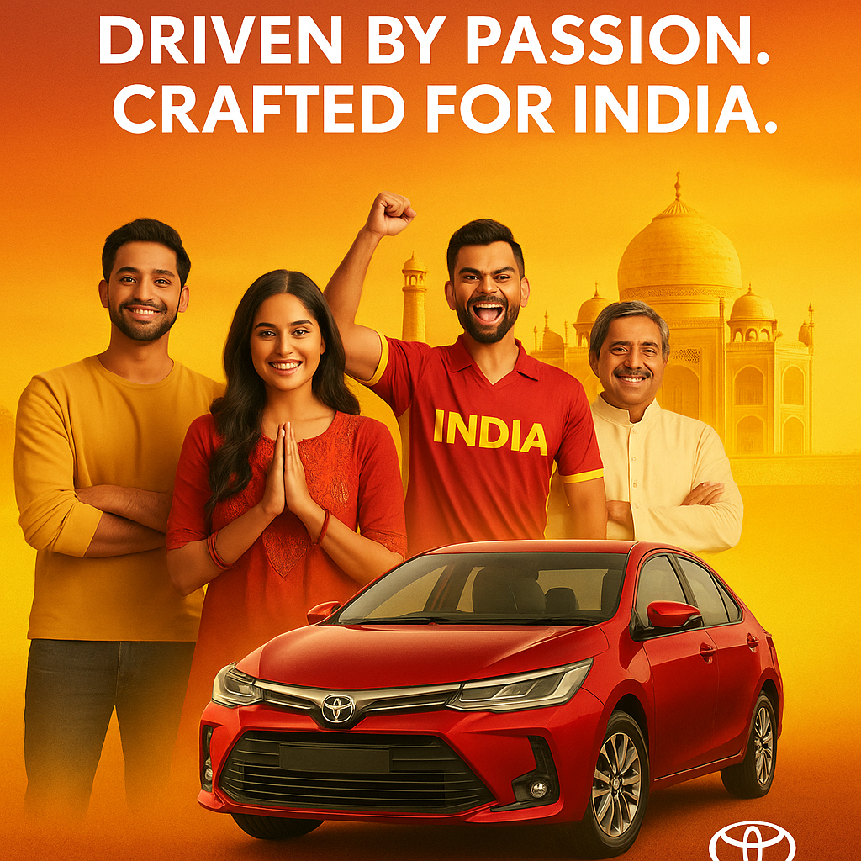
Source: Author-created illustrative marketing concept (2025).
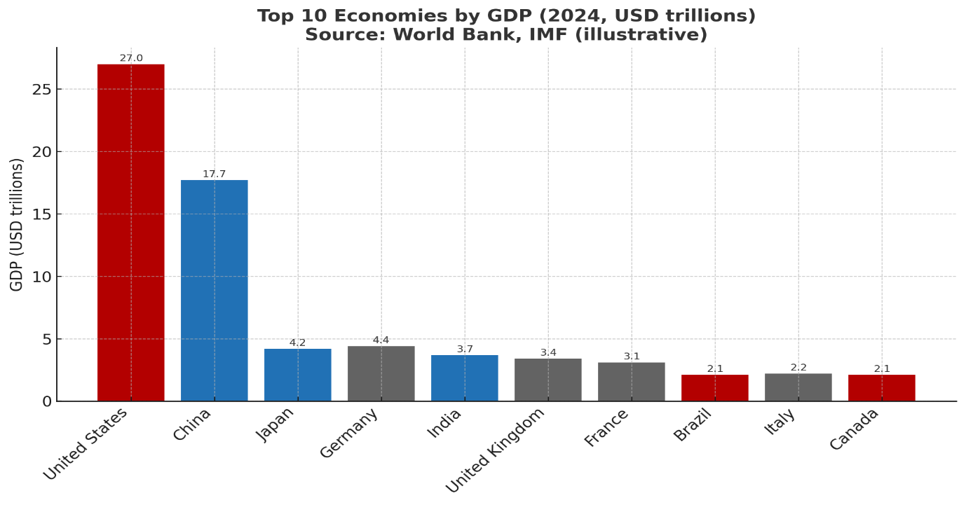
Source: World Bank, IMF

Cost and Labour Efficiency
India’s lower production and labour costs provide Toyota with significant savings compared to operations in developed markets.
The availability of skilled engineers and technicians complements Toyota’s emphasis on lean manufacturing and quality assurance (PwC, 2024).
This cost advantage allows Toyota to balance affordability with high product standards — essential for price-sensitive markets.
Government Policy and Institutional Support
The Indian government actively encourages FDI through policies such as Make in India and the Automotive Mission Plan 2026.
Toyota benefits from tax incentives, R&D subsidies, and local sourcing requirements that promote domestic manufacturing.
India’s 100% FDI allowance in the auto sector (DPIIT, 2024) further simplifies Toyota’s ability to retain control while expanding investment.
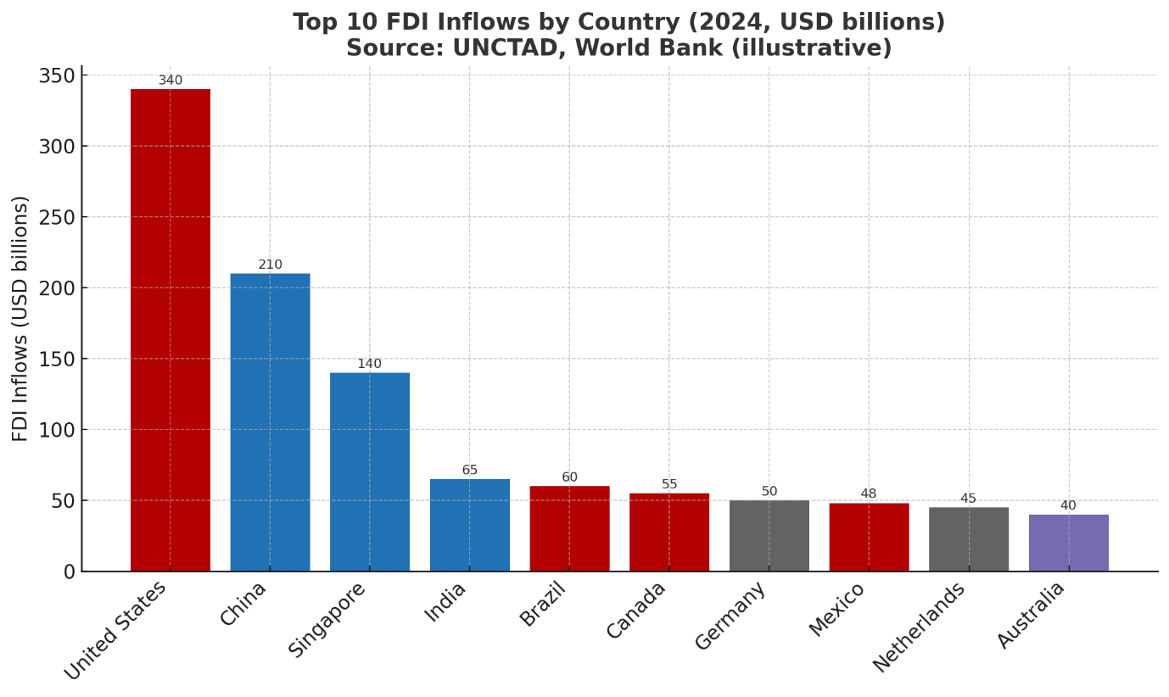
Source: UNCTAD, World Bank
Geographical and Strategic Access
India’s central location within Asia provides Toyota with logistical advantages for exports to South Asia, the Middle East, and Africa.
The company’s plant in Bidadi, Karnataka serves both domestic demand and regional export markets, reinforcing Toyota’s global supply chain integration.
Infrastructure and Supplier Development
Rapid improvements in transport and industrial infrastructure have enhanced India’s appeal as a production base.
Toyota collaborates with local suppliers through the Toyota Supplier Network, which delivers training in Total Quality Management (TQM) and Kaizen principles to maintain global standards while nurturing local capability.
Together, these factors make India a location of strategic value that complements Toyota’s long-term ambitions for sustainable and inclusive growth.

3.3 Internalisation Advantages
Internalisation advantages clarify why Toyota favours direct control through subsidiaries and joint ventures instead of licensing its technologies to external manufacturers. This strategic approach ensures uniform quality, technological integrity, and brand consistency across all global markets—core pillars of the Toyota philosophy.
Quality and Brand Integrity
Toyota’s reputation rests on precision engineering, reliability, and customer trust. Direct ownership of production facilities allows the company to apply its Toyota Way principles—continuous improvement (Kaizen) and respect for people—without dilution. If Toyota were to outsource manufacturing, variations in standards or procedural discipline could compromise product quality and damage its global reputation.
By internalising its operations, Toyota preserves the authenticity of its brand promise, delivering uniform value regardless of location. The company’s factories in India, for instance, follow identical quality protocols as those in Japan, guaranteeing consistent consumer experiences and reinforcing long-term brand equity.
Protection of Proprietary Technology
Toyota’s strength in hybrid and hydrogen fuel-cell vehicles arises from decades of sustained research investment. The firm holds thousands of global patents and continues to lead in next-generation mobility technologies. However, emerging economies such as India still face challenges in intellectual property protection and enforcement.
Through internalisation, Toyota avoids excessive exposure of its proprietary knowledge and manufacturing secrets to potential imitation. Direct management of operations enables controlled technology transfer, allowing local partners and engineers to learn gradually without jeopardising Toyota’s competitive edge. This approach balances innovation diffusion with technological security.
Integrated Supply Chain Efficiency
Internalisation gives Toyota full control over its Just-in-Time (JIT) and lean manufacturing systems. The company’s global production network depends on efficient supplier coordination, minimal inventory, and rapid response to market demand.
In India, the integration of Toyota Kirloskar Motor with regional supplier networks has reduced lead times and improved logistics efficiency. Close supplier relationships foster real-time information sharing and continuous improvement cycles, reinforcing Toyota’s productivity while lowering costs. This tightly coordinated ecosystem would be difficult to maintain under a licensing or outsourcing model.
Knowledge Sharing and Organisational Learning
Owning local subsidiaries allows Toyota to transfer knowledge, culture, and management philosophy throughout its global structure. Internalisation enables cultural transmission of Toyota’s hallmark principles—teamwork, discipline, and innovation.
Institutions such as the Global Production Center (GPC) and Toyota Institute India exemplify this approach, offering leadership and technical training that replicate Japanese best practices. This fosters a unified corporate identity, where global consistency coexists with local adaptation.
Long-Term Strategic Commitment
Toyota’s sustained investment in hybrid technology production in India reflects its long-term commitment to the market. Internalised control ensures that profits are reinvested into research, training, and local community development, rather than distributed to external licensors.
This ownership model strengthens Toyota’s capacity to nurture local talent, develop region-specific innovations, and maintain flexibility in strategic decision-making. Ultimately, internalisation ensures Toyota’s ability to align global strategy with local realities while maintaining operational excellence.
In summary, internalisation secures Toyota’s control over its brand, technology, and production systems. It provides a mechanism for embedding global standards in diverse contexts—safeguarding competitiveness and ensuring long-term growth.

3.4 Application of the OLI Framework in India
Toyota’s market entry into India in 1997 through a joint venture with the Kirloskar Group illustrates the balanced application of Dunning’s Ownership–Location–Internalisation (OLI) framework.
The joint venture structure allowed Toyota to preserve authority over its technology and production quality, while Kirloskar contributed local insight, distribution experience, and institutional legitimacy.
OLI Dimension | Implementation in Toyota India
Ownership | Advanced hybrid and lean manufacturing technologies, robust brand equity, and strong financial base.
Location | Expanding consumer market, competitive labour costs, supportive FDI policies, and improving infrastructure.
Internalisation | Joint venture enabled technology protection, quality assurance, and progressive localisation.
Over time, this collaboration evolved from simple assembly operations to a regional hub for R&D and exports. Toyota expanded its facilities in Bidadi, enhanced supplier localisation, and began exporting vehicles and components to neighbouring countries.
The 2019 strategic alliance with Suzuki Motor Corporation further advanced Toyota’s localisation goals. Combining Suzuki’s proficiency in small, affordable cars with Toyota’s technological leadership enabled both firms to penetrate India’s vast mass-market segment. This hybrid approach demonstrates how Toyota effectively integrates its OLI advantages to achieve both global control and local responsiveness.
Summary
Applying the OLI model clarifies the underlying coherence of Toyota’s globalisation strategy.
- Ownership advantages
- Location advantages
- Internalisation advantages

3.5 Critical Evaluation
Although the OLI framework successfully interprets Toyota’s expansion into India, it also exhibits several conceptual limitations. Developed in the late twentieth century, Dunning’s model focuses primarily on firm-specific assets and market determinants, while giving limited consideration to institutional, cultural, and environmental dynamics that heavily influence multinational operations in emerging economies.
Institutional and Cultural Constraints
In practice, Toyota’s performance in India has been shaped not only by economic incentives but also by bureaucratic processes, labour legislation, and cultural norms. Complex regulatory procedures, frequent tax reforms, and strict compliance requirements have occasionally restricted operational efficiency. Furthermore, contrasts between Japan’s collective, consensus-driven management style and India’s hierarchical work culture have influenced leadership communication and decision-making.
These contextual realities demonstrate that MNEs operate within multifaceted institutional systems—an area where OLI’s analytical scope is narrow.
Hybrid and Dynamic Strategies
Toyota’s global operations do not conform to a single mode of entry. The company employs a hybrid internationalisation strategy, combining joint ventures, alliances, and wholly owned subsidiaries depending on local conditions. This fluidity contradicts the OLI framework’s static assumption that ownership, location, and internalisation advantages operate in fixed relationships.
In India, Toyota’s evolution—from joint venture to partial localisation and eventual strategic alliance with Suzuki—illustrates a dynamic balancing act between control and collaboration. The OLI model explains the logic of investment but not the strategic flexibility required for sustained success in complex, evolving markets.
Emerging Global Trends
The twenty-first century business environment introduces new variables—digitalisation, sustainability, and global value-chain integration—that the traditional OLI paradigm does not fully incorporate. The automotive sector’s transition toward electric mobility, artificial intelligence, and carbon neutrality demands that ownership and location advantages include technological ecosystems, data networks, and environmental compliance.
Toyota’s investment in smart manufacturing, Internet-of-Things (IoT) applications, and hydrogen innovation represents precisely this shift toward digital competitiveness and sustainability—factors beyond OLI’s original framework.
Theoretical Evolution
Scholars such as Rugman (2010) and Narula (2023) have extended OLI into Internalisation Theory 2.0 and the OLID (Ownership–Location–Internalisation–Digital) paradigm. These models acknowledge new drivers of competitiveness: digital infrastructure, institutional partnerships, and networked innovation.
Toyota’s digitalised supply chains, data-driven manufacturing processes, and sustainability programs align closely with these modern interpretations. Hence, Toyota’s Indian operations illustrate a transition from traditional FDI rationale to a holistic, technology-integrated internationalisation model.
In conclusion, while Dunning’s OLI remains an invaluable foundation for analysing Toyota’s entry into India, it should be supplemented by frameworks that address contemporary realities—digitalisation, sustainability, and institutional interdependence. Toyota’s experience demonstrates the evolution from static theory to dynamic strategic adaptation, where flexibility, learning, and cross-sector collaboration define multinational success.

3.6 Summary
Toyota’s internationalisation represents a textbook application—and progressive reinterpretation—of the OLI paradigm.
- Ownership advantages such as innovation capability, TPS efficiency, and global brand recognition anchor its success.
- Location advantages in India—market growth, low-cost production, and policy support—drive investment.
- Internalisation advantages preserve technological control, quality standards, and cultural cohesion.

4. Cultural Differences and Impact on Market Entry Strategy
Understanding cultural contrasts is essential for multinational enterprises seeking effective localisation. For Toyota, cultural intelligence has been a central competency, allowing it to align its Japanese organisational ethos with Indian societal norms. National culture affects everything from leadership style and communication to consumer decision-making.
4.1 Comparative Cultural Analysis: Japan vs. India
Applying Hofstede’s Cultural Dimensions Framework (1980; 2010) reveals both alignment and divergence between the two nations:
Dimension | Japan | India | Implications for Toyota
Power Distance | 54 | 77 | Indian teams expect hierarchy; Toyota must combine clear authority with participative methods.
Individualism / Collectivism | 46 | 48 | Both value teamwork and loyalty, supporting Toyota’s group-oriented culture.
Masculinity | 95 | 56 | Toyota must integrate its performance-driven ethos with India’s relationship-based approach.
Uncertainty Avoidance | 92 | 40 | Japan prefers structure; India tolerates flexibility—Toyota must adapt to ambiguity.
Long-Term Orientation | 88 | 51 | Shared focus on perseverance supports long-term strategic collaboration.
Indulgence / Restraint | 42 | 26 | Both favour restraint and discipline, reinforcing Toyota’s professional ethos.
This analysis highlights a shared collectivist foundation but differences in hierarchy, decision-making, and tolerance for uncertainty. Toyota’s capacity to harmonise these values underpins its operational success.

4.2 Impact on Market Entry and Management
Cultural sensitivity shaped Toyota’s joint venture choice with the Kirloskar Group. Beyond regulatory and financial logic, the partnership offered:
- Relational capital in navigating India’s trust-based business environment.
- Cultural intermediation bridging Japanese and Indian managerial expectations.
- Institutional legitimacy through collaboration with an established local conglomerate.
Management adaptations followed: Toyota integrated hybrid leadership models—retaining consensus-building while empowering Indian managers for faster execution. Cross-cultural workshops further aligned employees around Toyota’s principles.

4.3 Human Resource and Marketing Adaptation
Toyota restructured its HR systems to fit Indian preferences for meritocracy and career progression. Performance-linked rewards, flexible work arrangements, and leadership programs through the Toyota Institute India improved engagement and retention.
Marketing strategies also reflected cultural sensitivity: campaigns such as “Building Relationships that Last” emphasised family, trust, and social harmony, aligning perfectly with Indian collectivist values. Locally designed models—Etios, Glanza, Urban Cruiser—illustrate how product customisation reinforces cultural relevance.

4.4 Cultural Challenges
Despite progress, challenges persist. Communication differences,Japan’s indirect style versus India’s expressive approach,can hinder collaboration. Toyota mitigates this through bilingual training and intercultural dialogue.
Japan’s slow consensus culture occasionally clashes with India’s demand for agility, prompting Toyota to delegate more authority to local leaders.
Divergent work ethics,collective discipline versus individual recognition,are balanced through performance incentives and flexible scheduling.
Toyota also pursues gender inclusion via its Diversity and Inclusion Policy (2023), promoting women in leadership roles within a traditionally male-dominated industry.

4.5 Cultural Factors and Market Success
Toyota’s cross-cultural adaptability has yielded tangible advantages:
- Stable partnerships with suppliers and dealers founded on mutual trust.
- Low employee turnover and high morale through culturally aligned HR systems.
- Strong consumer loyalty supported by socially responsible community initiatives.
Nevertheless, penetrating India’s mass-market segment remains challenging due to its extreme price sensitivity. Achieving equilibrium between Japanese quality and Indian affordability continues to test Toyota’s flexibility and innovation.

4.6 Theoretical Reflection
Hofstede’s framework helps explain Toyota’s adaptation but simplifies complex cultural realities. In practice, Toyota’s success stems from glocalisation—the fusion of global systems with local practices—consistent with Bartlett and Ghoshal’s (1989) transnational strategy.
Toyota’s operations in India embody learning duality: global innovations are customised locally, while local insights influence global processes. Thus, culture becomes a strategic resource—not merely a constraint—for innovation and resilience.

4.7 Summary
Toyota’s experience in India demonstrates mastery of balancing alignment and adaptation:
- The firm’s collectivist, process-oriented ethos resonates with India’s social values.
- Differences in hierarchy, communication, and uncertainty tolerance demand continuous managerial adjustment.
- Through localised HR systems, culturally attuned marketing, and community engagement, Toyota merges Japanese precision with Indian relational warmth.
5. SOP Adjustments and Recommendations
As Toyota continues expanding its footprint in emerging economies,particularly India,it must continuously refine its Standard Operating Procedures (SOPs) to maintain competitiveness, efficiency, and cultural alignment. While Toyota’s global systems have proven highly successful for quality assurance, innovation, and operational excellence, the company must increasingly localise its practices to address host-country dynamics such as regulatory complexity, market diversity, and cultural variation.
Drawing from the previous OLI and cultural analysis, this section proposes three strategic SOP adaptations for Toyota’s Indian operations:
- Localization of Product and Supply Chain Processes
- Cultural Integration and Human Resource Adaptation
- Sustainability and Digital Transformation Alignment
These recommendations remain consistent with The Toyota Way and its five guiding principles—Challenge, Kaizen, Genchi Genbutsu (go and see), Respect for People, and Teamwork (Toyota Global, 2024). Together, they position Toyota to combine its global strengths with local insight, ensuring both resilience and long-term value creation.

5.1 Recommendation 1: Localization of Products and Supply Chain Processes
Rationale
Toyota’s portfolio in India has historically concentrated on premium and mid-segment vehicles such as the Fortuner, Innova, and Hycross. However, India’s automotive market is overwhelmingly price-sensitive, dominated by compact, fuel-efficient cars. To capture this mass-market potential, Toyota must enhance localization across product design, component sourcing, manufacturing, and customer service.
Proposed SOP Adjustments
a. Localized Product Development SOP
- Establish a dedicated India Market Product Development Division within Toyota Kirloskar Motor to design and engineer vehicles specifically for India’s road conditions, climate, and consumer preferences.
- Integrate structured Voice of Customer (VOC) systems within R&D to ensure models reflect local expectations—emphasising affordability, fuel efficiency, and reliability.
- Benchmark against Maruti Suzuki and Hyundai, both leaders in the small-car segment, to align Toyota’s offerings with mass-market expectations.
b. Supplier Localization SOP
- Increase local sourcing to 95–98%, supporting India’s Make in India initiative while reducing import dependency and logistics costs.
- Introduce a Supplier Development Program modelled after Toyota’s U.S.-based Toyota Supplier Support Center (TSSC), providing Kaizen and lean training to Indian suppliers.
- Deploy digital supplier monitoring systems to enhance transparency, ensure quality consistency, and enable real-time feedback loops between suppliers and manufacturing units.
c. After-Sales and Service SOP
- Expand Toyota’s dealership and maintenance network into Tier 2 and Tier 3 cities to reach underserved customers.
- Introduce affordable service packages and flexible maintenance plans for new buyers, improving loyalty among cost-conscious consumers.
- Offer language and cultural sensitivity training for front-line employees to strengthen customer engagement and trust.
Justification
Localization enhances Toyota’s ability to exploit both location advantages (cost efficiency and market access) and internalisation advantages (control over quality and processes) under the OLI framework. By tailoring its supply chain and product offerings to Indian conditions, Toyota reduces transaction costs, strengthens competitiveness, and deepens its local presence.
Expected Outcomes
- Greater penetration in India’s rapidly expanding small-car segment.
- Improved supplier performance and reduced production costs.
- Enhanced customer trust and stronger brand equity through local responsiveness.

5.2 Recommendation 2: Cultural Integration and Human Resource Adaptation
Rationale
Cultural differences between Japan and India significantly shape leadership, communication, and employee motivation. For sustained operational excellence, Toyota must institutionalise intercultural understanding and inclusive management systems across its Indian operations.
Proposed SOP Adjustments
a. Cross-Cultural Management SOP
- Implement a Cross-Cultural Competency Framework as part of Toyota India’s HR policies.
- Require intercultural training for both Japanese expatriates and Indian managers to strengthen communication, negotiation, and conflict resolution skills.
- Appoint cultural liaisons or mentors to facilitate collaboration across national teams.
- Encourage reverse mentoring, where Indian employees coach Japanese managers on local norms and expectations.
b. Leadership and Decision-Making SOP
- Adapt Toyota’s traditional Ringi (consensus-based decision-making) to India’s hierarchical culture by introducing hybrid structures—maintaining collective consultation but enabling faster top-down execution.
- Launch an Empowered Local Leadership Programme to develop Indian managers who embody Toyota’s global philosophy while exercising contextual autonomy.
- Establish leadership metrics that assess cultural intelligence, collaboration, and employee engagement as key performance indicators (KPIs).
c. Employee Engagement and Performance SOP
- Transition from seniority-driven to performance-based rewards to align with India’s career-oriented workforce.
- Strengthen Diversity and Inclusion (D&I) programs, especially to promote women and underrepresented groups, consistent with Sustainable Development Goal 5 (Gender Equality).
- Organize Toyota Cultural Exchange Weeks, offering Indian employees immersive virtual experiences of Toyota’s Japanese operations to foster cross-border learning and respect.
Justification
This recommendation builds on Hofstede’s cultural dimensions, notably addressing high power distance, differing uncertainty tolerance, and communication styles. By aligning HR policies with local expectations, Toyota can reduce friction, enhance motivation, and preserve its corporate culture.
Expected Outcomes
- Improved collaboration and mutual understanding across national teams.
- Higher staff retention and satisfaction rates.
- Better alignment between Toyota’s global culture and India’s socio-organisational environment.

5.3 Recommendation 3: Sustainability and Digital Transformation Alignment
Rationale
The future of mobility lies in sustainability and technological innovation. India’s automotive industry is being reshaped by government initiatives such as FAME II (Faster Adoption and Manufacturing of Hybrid and Electric Vehicles), which aim to promote clean energy and reduce emissions. To remain competitive, Toyota must embed sustainability and digitalisation directly into its SOPs.
Proposed SOP Adjustments
a. Green Manufacturing SOP
- Integrate renewable energy sources—solar panels, biomass, and wind—into Toyota’s Indian facilities.
- Employ ISO 14001 environmental management systems to track and reduce carbon footprints across production lines.
- Collaborate with government and industry partners to establish eco-industrial clusters that minimise waste and improve logistics efficiency.
b. Electric and Hybrid Vehicle SOP
- Localise battery assembly and EV component manufacturing through joint ventures with firms like Panasonic Energy or Tata Power.
- Set up a Toyota India EV Academy to develop expertise in battery systems, hydrogen technology, and EV maintenance.
- Work with Suzuki Motor Corporation to co-develop affordable compact EVs below ₹10 lakh to reach the mass market.
c. Digital Transformation SOP
- Deploy digital dashboards and Internet of Things (IoT) systems for predictive maintenance and real-time performance tracking.
- Expand Toyota India’s online sales and financing platforms, integrating AI-driven customer relationship management (CRM) for personalization.
- Use digital analytics to enhance customer experience and operational decision-making.
d. Circular Economy SOP
- Establish vehicle recycling and reuse frameworks aligned with India’s Extended Producer Responsibility (EPR) regulations.
- Launch buy-back and refurbishment programs to extend vehicle lifecycles and reinforce environmental accountability.
Justification
These initiatives align Toyota’s Indian operations with its Environmental Challenge 2050 goals and India’s decarbonisation agenda. They also advance the firm’s ownership advantages in innovation and strengthen location advantages through policy alignment and market reputation.
Expected Outcomes
- Significant reduction in carbon emissions and enhanced regulatory compliance.
- Improved competitiveness in the rapidly growing EV sector.
- Reinforced public image as a sustainability and innovation leader.

5.4 Integrated Strategic Implications
Together, these SOP reforms reinforce Toyota’s transnational strategy—balancing global efficiency with local responsiveness (Bartlett & Ghoshal, 1989). They represent the practical application of Kaizen—continuous improvement—within Toyota’s international operations.
Strategic Goal | SOP Adjustment | Expected Impact
Market Expansion | Localized product and supply chain operations | Enhanced affordability and competitiveness
Cultural Integration | HR and management adaptation | Strengthened teamwork and communication
Innovation and Sustainability | Green and digital transformation SOPs | Long-term growth and environmental leadership
Collectively, these measures redefine Toyota’s role from a traditional automaker into a sustainable mobility provider capable of serving both developed and emerging markets with equal agility.

5.5 Implementation Considerations
a. Phased Rollout
Toyota should adopt a three-phase implementation plan to ensure strategic coherence and risk management:
- Short Term (1–2 years): Launch supplier development and cross-cultural training programs.
- Medium Term (3–5 years): Expand local R&D, establish hybrid/EV production lines, and introduce digital supply chain systems.
- Long Term (5–10 years): Achieve full sustainability integration, digital maturity, and circular economy compliance.
b. Monitoring and Evaluation
- Use KPIs such as localisation rate, employee engagement scores, carbon emissions per unit, and digital adoption index.
- Conduct biannual audits by Toyota’s global compliance team to assess progress and identify areas for improvement.
c. Risk Mitigation
- Address regulatory risks through proactive engagement with Indian policymakers and industry associations.
- Safeguard intellectual property via secure technology transfer agreements.
- Manage organisational resistance by investing in change management, communication, and training programs.

5.6 Summary
Toyota’s ability to thrive in India’s complex market depends on effectively localising its global systems while maintaining the core philosophy of The Toyota Way.
- Localization enhances affordability and customer relevance.
- Cultural integration builds trust, cohesion, and productivity across diverse teams.
- Sustainability and digitalisation secure Toyota’s future competitiveness and environmental leadership.

6. Conclusion
Toyota Motor Corporation’s internationalisation journey exemplifies the complexity and adaptability required of modern multinational enterprises. Through its transnational strategy, Toyota has effectively leveraged its ownership advantages,technological excellence, the Toyota Production System, and a globally respected brand,to build a powerful presence in over 170 markets. Its expansion into India, one of the world’s fastest-growing economies, demonstrates a practical application of Dunning’s OLI framework, balancing global efficiency with local responsiveness.
India’s strong location advantages,including market potential, cost competitiveness, and policy support,have underpinned Toyota’s investment decisions. Meanwhile, internalisation has enabled the firm to safeguard technological integrity, maintain quality standards, and transmit its organisational culture across borders. Yet, long-term success in emerging markets also depends on cultural intelligence. Managing differences between Japan’s consensus-driven, precision-oriented work ethic and India’s hierarchical, relationship-based environment requires flexibility and inclusive leadership.
To secure sustained growth, Toyota must continue refining its Standard Operating Procedures by deepening localisation, fostering cross-cultural integration, and advancing sustainability-driven innovation. By aligning its Kaizen philosophy with evolving global and local expectations, Toyota is well-positioned to remain a leader in shaping the future of sustainable mobility worldwide.

References
- Bartlett, C.A. and Ghoshal, S. (1989) Managing Across Borders: The Transnational Solution. Boston: Harvard Business School Press.
- Dunning, J.H. (1988) ‘The eclectic paradigm of international production: A restatement and some possible extensions’, Journal of International Business Studies, 19(1), pp. 1–31.
- Dunning, J.H. (1993) Multinational Enterprises and the Global Economy. Wokingham: Addison-Wesley.
- Hofstede, G. (2010) Cultures and Organizations: Software of the Mind. 3rd edn. New York: McGraw-Hill.
- Narula, R. (2023) ‘The evolving OLI paradigm and the rise of digital multinationals’, International Business Review, 32(3), 102072.
- Toyota Motor Corporation (2024) Annual Report 2024. Toyota Global Newsroom. Available at: https://global.toyota/en/
- Toyota Motor Corporation (2024) Sustainability Data Book 2024. Toyota Global. Available at: https://global.toyota/en/sustainability/
- Toyota Kirloskar Motor (2024) Company Overview. Toyota India. Available at: https://www.toyotabharat.com/
- Interbrand (2024) Best Global Brands 2024. Available at: https://interbrand.com/best-global-brands/
- PwC (2024) India Automotive Market Outlook 2024. PricewaterhouseCoopers.
- UNCTAD (2023) World Investment Report 2023: Investing in Sustainable Energy for All. United Nations Conference on Trade and Development.
- The Economic Times (2024) ‘Toyota India posts 35% growth in domestic car sales’. Available at: https://economictimes.indiatimes.com/
- Reuters (2024) ‘Toyota and Suzuki expand hybrid collaboration for India and Africa’. Available at: https://www.reuters.com
- Bloomberg (2023) ‘Toyota faces production challenges amid global chip shortage’. Available at: https://www.bloomberg.com
- Financial Times (2024) ‘Toyota accelerates EV strategy after investor pressure’. Available at: https://www.ft.com
- Business Standard (2024) ‘High import duties impact auto manufacturers in India’. Available at: https://www.business-standard.com/

