Module name: Dissertation Proposal
Module ID: LCBB6000

Assignment 1 - Research Proposal

Topic:

Exploring the strategies for enhancement of employee motivation in the UK retail sector: A case study of Burberry Plc

Student Name: Florentina Fistoleanu
Student ID: 2115309

Table of Contents
1. Introduction 3
1.1 Background 3
1.2 Rationale 3
1.3 Aim 4
1.4 Objectives 4
1.5 Questions 4
2. Literature Review 5
2.1 Concept of employee motivation 5
2.2 Factors influencing employee motivation 5
2.3 Existing strategies to enhance employee motivation 6
2.4 Theoretical framework of employee motivation 6
3. Methodology 8
3.1 Research Philosophy 8
3.2 Research Approach 8
3.3 Research Design 8
3.4 Data collection method 8
3.5 Sampling method 9
3.6 Data analysis method 9
3.7 Ethical considerations 9
Timeline 9
References 11

1. Introduction

1.1 Background
The retail sector of the UK has been a great contributor to its GDP with an output of £112.8bn in 2023 and a creation of more than 2.7m jobs in 2022 (Ward, 2024). The retail sector generates a huge portion of the UK’s total revenue and operates in a competitive market. Along with opportunities, the sector is prone to a wide range of challenges like high rates of employee turnover, low morale, and fluctuations in productivity levels. Employee motivation has become a critical aspect influencing the satisfaction levels of employees with their jobs, productivity levels, and the performance of the organisations (Ali and Anwar, 2021). Several practices and theories have studied employee motivation factors and applied them to understand and enhance their motivation levels. Some of the most used and renowned theories include Herzberg’s Two Factor theory, Self-determination theory, and Maslow’s needs hierarchy. This proposal intends to explore evidenced strategies which can assist in the enhancement of employee productivity and motivation within the retail sector. It studies the implementation of appropriate strategies used by organisations with examples and evidence while delivering insights into essential practices that similar retail businesses can adopt to enhance their employees’ motivation for competitive benefits.
Problem statement: Although the retail sector like fashion has been flourishing, it is facing emerging challenges such as low employee morale, productivity fluctuations, and higher employee turnover rates (Fuller et al., 2022). Burberry Plc operates amongst the market leaders in this sector determining the extent of impacts of these issues such as influence on competitiveness and operational efficiency. If these issues are unaddressed, they can consequently cause decreased rates of employee satisfaction, decreased performance of the company, and increased costs. Studies have shown the need for exploring more definitive need for the exploration of effective employee motivation improvement strategies since current practices do not sufficiently address such challenges (Pilkington, 2021). Hence, this study’s aim to investigate evidence-based practices will be helpful in achieving higher productivity and motivation levels for employees at Burberry with insights benefiting similar retail organisations.

1.2 Rationale
Employee motivation has a direct association with the levels of productivity in employees which is a critical aspect of the sustainability and competitiveness of a business (Hitka et al., 2021). Within a challenging industry like the UK retail sector, the long working hours, significant pressures for customer services and sales, and repetitive tasks, the maintenance of higher motivation levels becomes challenging. However, good motivation levels are critical for the achievement of higher productivity and enhanced workforce and organisational performance. This research can be justified based on the current need to address those challenges while shedding light on practical solutions purposefully and effectively helping retailers enhance the satisfaction and performance of employees. Developing a deeper understanding of employee motivation can be significantly helpful in decreasing turnover rates, increasing profitability, and improving customer service. The focus of this research is on the UK retail sector, it offers information specific to the context which can be studied and applied by various retail HR professionals and managers so that a highly productive and motivated workforce is fostered.

1.3 Aim
This research’s aim is to investigate some strategies used by the UK’s retail sector to enhance employee motivation using Burberry Plc as a case study.

1.4 Objectives
1. To analyse the UK retail sector’s current state of employee motivation.
2. To determine the main factors influencing employees' motivation in this sector.
3. To recommend strategies to enhance employee motivation in the retail sector.

1.5 Questions
1. What motivates employees in the retail sector of the UK?
2. What are the main factors affecting motivation of employees in this sector?
3. How effective are the existing strategies in improving employee motivation?

2. Literature Review
Employee motivation is determined as a critical factor impacting productivity, job satisfaction, and overall performance of the company, especially in the UK retail industry (Loor-Zambrano et al., 2022). This literature review focuses on the exploration of key themes like the concept of employee motivation, factors influencing employees' motivation within this sector, and strategies used for improving motivation aided by a theoretical framework. The examination of such elements will enable the review to deliver detailed knowledge about the current gaps and information available on employee motivation in the retail sector emphasising Burberry Plc.

2.1 Concept of employee motivation
As per Desmet and Fokkinga (2020), employee motivation is all the internal and external factors stimulating workers to take appropriate actions leading to the achievement of their personal or professional goals. This is a multilayered concept involving intrinsic motivators like personal fulfilment and growth and extrinsic motivators like recognition and financial rewards. The concept of employee motivation is a critical element for driving the performance of individuals or groups. According to Ali and Anwar (2021), employee motivation is one of the most extensively studied subjects which led to the development of numerous theories and models as frameworks that determined the drivers of motivation. Studying these concepts and understanding the complexities helps businesses in developing and implementing appropriate and effective strategies to improve workforce performance and engagement. Contemporary studies have also depicted the importance of psychological employee empowerment and its positive correlation with outcomes like employees’ commitment to the organisation and job satisfaction (Alhozi et al., 2021).

2.2 Factors influencing employee motivation
As per Kearney et al. (2023), numerous factors influence the motivation of employees in the UK retail sector which includes their satisfaction with the jobs, the environment for the employees to work in, opportunities for career development, recognition of their work and efforts, and leadership styles used in the organisation. Various intrinsic and extrinsic rewards deeply affect employee motivation as it is a complex concept with multiple understandings (Malek et al., 2020). Job satisfaction is critical to the successful retention of employees in a workplace which is influenced by numerous factors like the nature of the role one is asked to fulfil, job compensations, and the balance between their work and personal life. An appropriate working environment fostering motivation would include good organisational culture, physical conditions, and effective workplace relationships making them feel belongingness and valued (Medhn Desta and Mulie, 2024). For instance, workplaces promoting positive organisation culture are likely to see an increase in employee engagement and lower rates of turnover. Hence, positive and supportive workplaces are likely to improve employee motivation and morale while toxic environments result in higher turnover possibilities and stress levels among employees. As per Virgiawan et al. (2021), leadership styles have become essential for effective employee motivation like the transformational leadership style which is known for positively influencing empowerment, encouragement, and productivity among employees with the right amount and approach to motivation. Transformational leadership approaches are particularly essential in developing a trusting and innovative environment (Khan et al., 2020). Career development in this context has also been proven to be essential in increasing motivation among employees seeking opportunities and growth in the industry and various job roles. Opportunities offered to individuals for professional growth can have an enormous influence on their commitment to their employers’ organisations. Through effective career pathways and advancements, organisations do not just motivate their employees but also develop a loyal and highly skilled workforce (Alhozi et al., 2021).

2.3 Existing strategies to enhance employee motivation
According to Kang and Lee (2021), several strategies like offering competitive benefits and salaries have been proven to be effective in enhancing the job satisfaction of employees alongside career advancement opportunities and recognition programs. In the UK retail sector, the effectiveness of such strategies can vary based on their implementation and context. UK retail organisations like Marks & Spencer and John Lewis are examples of how thorough and effective strategies for employee motivation have enhanced commitment and motivation among employees with the help of a partnership model at John Lewis and development programs and schemes for recognition at Marks & Spencer (Clark et al., 2020). Such financial incentives have been identified to be helpful in the maintenance of a highly motivated workforce by meeting their basic needs and delivering financial security. As per Wilshaw et al. (2021), developing positive work environments and recognition programs have been identified as effective mediums of employee retention and motivation across businesses like Boohoo and John and Lewis where rewards, bonuses, verbal praise, training and development programs, supportive environments like Waitrose’s and so on as pieces of evidence for effective strategies to achieve employee motivation.

2.4 Theoretical framework of employee motivation
“Herzberg’s Two-Factor Theory”
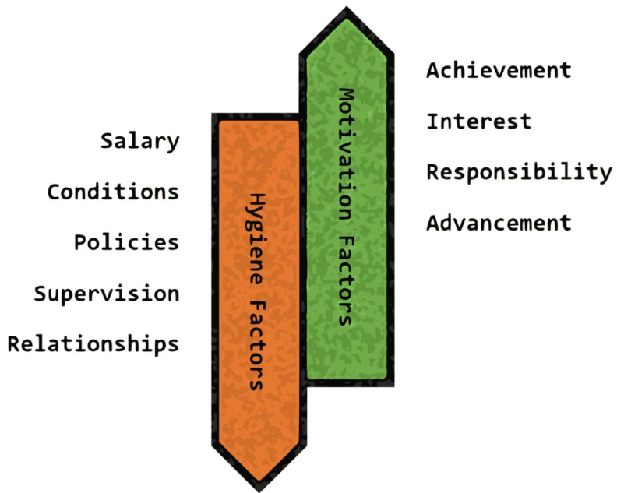
Figure 1: “Herzberg’s Two-Factor Theory”
Source: (Alsaqqaf, 2023)
According to Alsaqqaf (2023), “Herzberg’s Two-Factor Theory” is a well-known theory of motivation that distinguishes between the hygiene factors essential for the prevention of employee dissatisfaction and the motivators which are factors promoting satisfaction. Within the retail sector, hygiene factors can involve working conditions, company policies, and salary. The motivating factors would be related to the fulfilment of individual needs for recognition, personal growth and development opportunities, and responsibility. The implementation of both hygiene and motivating factors would be significantly essential in the maintenance of higher levels of employee motivation that consequently improves their productivity and commitment.

3. Methodology

3.1 Research Philosophy
This research will be planned and executed following the pragmatism philosophy as it puts a strong emphasis on practically applying the findings and effectively utilising multiple methods to draw information that addresses the research questions. Pragmatism is the suitable method for this research as it assists in the integration of qualitative and quantitative data in order to achieve a detailed knowledge of the discussed research problem (Ormerod, 2024). This perspective will be especially essential for studying employee motivation at Burberry Plc as it can assist the study in yielding actionable information to be adopted and implemented by retail organisations.

3.2 Research Approach
To ensure informative and comprehensive research, a mixed-methods approach is proposed as it combines data types, tools, and techniques of both qualitative and quantitative forms of research. A more cohesive analysis of the research topic will be possible with the triangulation of the information gained from varying sources (Dawadi et al., 2021). This research is specifically focused on utilising both data types since qualitative data will be important to increase the depth of information on the experiences and perceptions of employees, business leaders, managers, and so on in the retail sector. On the other hand, quantitative will ensure that measurable and accurate findings are collected and analysed based on the motivation and productivity levels of employees within the UK retail industry.

3.3 Research Design
Using a descriptive research design, the study will combine surveys and secondary data collected through databases which will be interpreted and discussed to understand employee motivation strategies in the UK retail sector. This multi-method design ensures that both the objectives and the research questions are being considered and addressed carefully with the help of detailed and measurable data (Froehlich et al., 2020).

3.4 Data collection method
Data for this research presented as findings will be collected using online mode of primary surveys with close-ended questions using the Likert-scale questionnaires. Online surveys will be performed with the retail employees so that a good number of samples can be used to gather information on the factors influencing productivity and motivation levels (Dawadi et al., 2021). The secondary qualitative data collection from the online search strategy will provide further evidence for strategies utilised throughout time for motivating employees, identifying challenges that occurred, and outcomes of those strategies.

3.5 Sampling method
With the help of stratified random sampling, the research proposes to represent the entire population of employees in the UK retail sector from various segments like small, medium, and large retailers (Creamer, 2021). Through this approach, a diverse range of perspectives and experiences will be captured in the survey findings. 15 participants are to be sampled for this survey. This will be followed by the selection of online data sources, a maximum of 7, for the secondary data collection and analysis.

3.6 Data analysis method
Quantitative survey data will utilise statistical methods for analysis with descriptive statistics so that relationships and patterns between various factors influencing the productivity and motivation of employees are understood. Qualitative data from secondary sources will be included in the thematic analysis process for informed presentation and interpretation of the findings through appropriate themes.

3.7 Ethical considerations
In alignment with the “The University of Wales Trinity Saint David (UWTSD)” ethical guidelines, this research maintains its adherence to all the principles and ethical conduction considerations. In line with its compliance with the Data Protection Act 2018 and the GDPR guidelines, the research will also maintain anonymity and confidentiality and address any forms of discomfort related to the research. The participants will also remain informed about their right to withdraw if they need to while adhering to all the ethical guidelines set for such research studies.

Timeline
Activities | Start Date | End Date | Duration (days)
Topic selection | 21/7/2024 | 22/7/2024 | 2
Setting aim objectives | 23/7/2024 | 25/7/2024 | 3
Literature review | 26/7/2024 | 31/7/2024 | 6
Survey design | 1/8/2024 | 5/8/2024 | 5
Data collection (Survey) | 6/8/2024 | 10/8/2024 | 5
Data collection (secondary) | 11/8/2024 | 14/8/2024 | 4
Data analysis and discussion | 15/8/2024 | 20/8/2024 | 6
Conclusion and recommendations | 21/8/2024 | 22/8/2024 | 2
Table 1: Research timeline
Source: (Self-created)
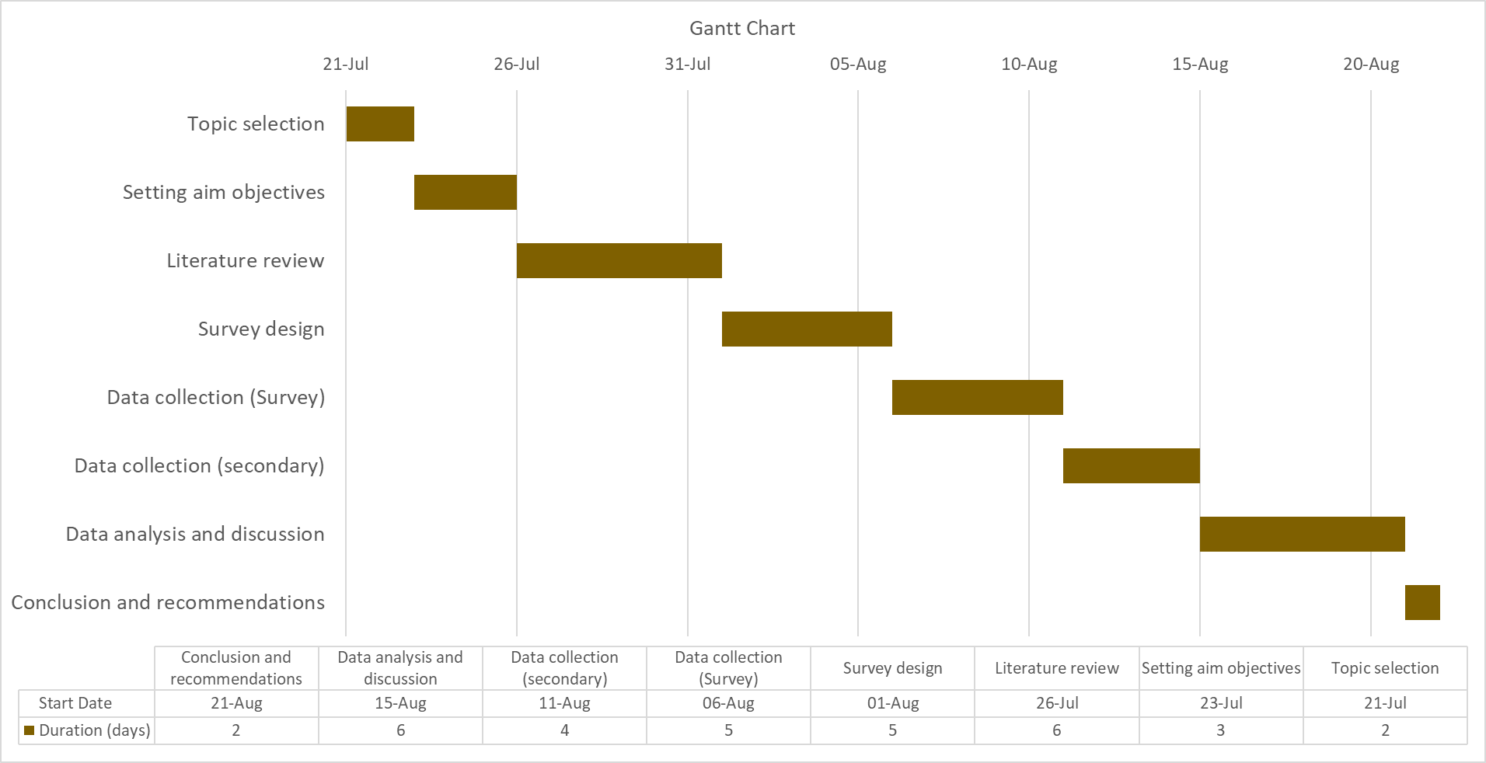
Figure 4: Gantt Chart
Source: (Self-created)

References
Alhozi, N., Hawamdeh, N.A. and Al-Edenat, M., (2021). The impact of employee empowerment on job engagement: Evidence from Jordan. International Business Research, 14(2), pp.90-101.
Ali, B.J. and Anwar, G., (2021). An empirical study of employees’ motivation and its influence job satisfaction. Ali, BJ, & Anwar, G. (2021). An Empirical Study of Employees’ Motivation and its Influence Job Satisfaction. International Journal of Engineering, Business and Management, 5(2), pp.21-30.
Alsaqqaf, A., (2023). Does Motivation Affect Employees' Productivity.
Clark, H., Royal, P., West, H., Clothier, S., Smith, S., Chui, B., Howells, K., Hodgson, C., Porter, L., Albon, D. and Bagnall, P., (2020). Healthy families: the present and future role of the supermarket.
Creamer, E.G., (2021). Advancing grounded theory with mixed methods. Routledge.
Dawadi, S., Shrestha, S. and Giri, R.A., (2021). Mixed-methods research: A discussion on its types, challenges, and criticisms. Journal of Practical Studies in Education, 2(2), pp.25-36.
Desmet, P. and Fokkinga, S., (2020). Beyond Maslow’s pyramid: Introducing a typology of thirteen fundamental needs for human-centered design. Multimodal technologies and interaction, 4(3), p.38.
Froehlich, D.E., Van Waes, S. and Schäfer, H., (2020). Linking quantitative and qualitative network approaches: A review of mixed methods social network analysis in education research. Review of research in education, 44(1), pp.244-268.
Fuller, D., Logan, B., Suarez, P. and Valkova, A., (2022). How retailers can attract and retain frontline talent amid the Great Attrition. McKinsey & Company, August, 17.
Hitka, M., Schmidtová, J., Lorincová, S., Štarchoň, P., Weberová, D. and Kampf, R., (2021). Sustainability of human resource management processes through employee motivation and job satisfaction. Acta Polytechnica Hungarica, 18(2), pp.7-26.
Kang, E. and Lee, H., (2021). Employee compensation strategy as sustainable competitive advantage for HR education practitioners. Sustainability, 13(3), p.1049.
Kearney, T., Coughlan, J. and Kennedy, A., (2023). The influence of the physical work environment on retail employees. Journal of Services Marketing, 37(6), pp.719-731.
Khan, S.N., Abdullah, S.M., Busari, A.H., Mubushar, M. and Khan, I.U., (2020). Reversing the lens: The role of followership dimensions in shaping transformational leadership behaviour; mediating role of trust in leadership. Leadership & Organization Development Journal, 41(1), pp.1-18.
Loor-Zambrano, H.Y., Santos-Roldán, L. and Palacios-Florencio, B., 2022. Relationship CSR and employee commitment: Mediating effects of internal motivation and trust. European research on management and business economics, 28(2), p.100185.
Malek, S.L., Sarin, S. and Haon, C., (2020). Extrinsic rewards, intrinsic motivation, and new product development performance. Journal of product innovation management, 37(6), pp.528-551.
Medhn Desta, A.G. and Mulie, H., (2024). The effect of empowering leadership practices on employee’s performance with the mediating role of work engagement: the case of ethio-telecom. Cogent Business & Management, 11(1), p.2307066.
Ormerod, R., (2024). Pragmatism as practice theory: The experience of systems and OR scholars. Systems Research and Behavioural Science, 41(1), pp.52-81.
Pilkington, M., (2021). Retail recovery: how creative retailers are winning in their post-apocalyptic world. Bloomsbury Publishing.
Virgiawan, A.R., Riyanto, S. and Endri, E., (2021). Organizational culture as a mediator motivation and transformational leadership on employee performance. Academic Journal of Interdisciplinary Studies, 10(3), pp.67-79.
Ward, M. (2024). Retail sector in the UK. [online] Parliament.uk. Available at: https://researchbriefings.files.parliament.uk/documents/SN06186/SN06186.pdf.
Wilshaw, R., Fowler, P. and Wallace, B., (2021). Working in Marks and Spencer's Food and Footwear Supply Chains.

