Module: Problem Solving and Decision Making
Module Code: BMSW 4004

Contents
1. Introduction 3
2. The Workplace Problem 4
3. Analysing Information 4
3.1 Root Cause Analysis (RCA) 4
4. Applying Situational Analysis Models 6
5. Range Of Alternative Solutions 7
6. Evaluation Of Alternative Solutions 7
7. Implementing The Solution 8
8. Communication Plan With Stakeholders 9
8.1 Power and Interest Matrix 9
8.2 Communication Plan 9
9. Monitoring And Review Techniques 10
10. Conclusion 11
References 12
APPENDIX 13

- Introduction
Identifying and solving real-life problems is an important leadership skill which helps to get success in professional life. In this report, Hotel Marriott will be chosen for identifying workplace problems. It is one the largest multinational companies that has a huge market share and business operations. Applying managerial understanding and knowledge, solutions to those problems will be provided.

- The Workplace Problem
The most significant workplace problem identified in Hotel Marriott from the analysis of employee feedback and other published sources is low employee motivation and engagement levels in the organisation. This problem is very serious for the achievement of the organisational goals and objectives (Glassdoor, 2023). Because it can have a huge impact on the company's operations and overall performance. When there is low employee motivation and engagement level, the quantity and quality of work are affected. In other words, Hotel Marriott is facing lower productivity, low employee satisfaction, and high employee turnover. The company's performance in terms of revenue generation has not improved expectedly. If the workplace problem is resolved, the performance will be improved. The problem may arise due to various reasons such as dissatisfied employees, limited career growth and opportunities in the workplace, poor workplace culture, low compensation and rewards, and poor compensation (Bratton and Gold, 2017).
- Analysing Information

3.1 Root Cause Analysis (RCA)
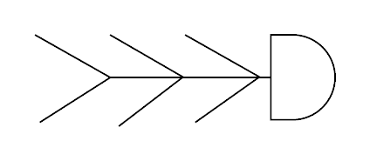
Figure 1 Fish bone diagram
Source: (Jayswal et al., 2011)
It is important to reach the root cause of a problem to solve it. Root Cause Analysis (RCA) is an effective tool for analysing the workplace problem of Hotel Marriott. Here the fishbone diagram is attached for a clearer explanation. Each bone of the fish can be taken as a possible reason for the problem. Therefore, this model is highly effective in terms of relating the problem to its causes and thus resolving the problem becomes easier for companies. First, data needs to be collected for the analysis of the workplace problem. Then these data should be analysed and the possible causes will be identified for further analysis and get to the root cause for providing an appropriate solution to the problem (Jayswal et al., 2011). The workplace problem of Hotel Marriott is low employee motivation and engagement. The possible causes for this workplace problem are explained below:
- Poor Leadership and Management Practice: Leadership is an art that guides the employees to the right direction for achieving the organisational goals and objectives. If the leadership is not suitable for the organisational settings, employees of that organisation might not feel motivated and inspired to perform their jobs (Rose, 2018). The leadership style of Hotel Marriott is participative which is a democratic type of leadership. Employees are given opportunities to participate in the decision making process (Jayswal et al., 2011). Particularly, the organisation is more focused on the functional level of the organisation for decision making. This leadership style is very effective in increasing the motivation of the employee. In fact, it encourages the employees to be more participative and engaged with the workplace (Bratton and Gold, 2017). Hence, this is not the appropriate cause for the workplace problem of Hotel Marriott.
- Inadequate Recognition and Rewards: It is another probable reason for low employee motivation and engagement. A significant portion of employees who left Hotel Marriott have reported that they are not adequately rewarded for their contributions to the company (Glassdoor, 2023). Without providing adequate rewards and recognition, they are likely to be demotivated and lower the engagement with the workplace (Rose, 2018). Hence, this can be an important cause of the workplace problem.
- Inadequate Compensation: Compensation is an influential external motivating factor. Most of the time employees lose their motivation and lower their engagement with the workplace if they are not provided adequate compensation. Even sometimes, they move to other organisations for getting better compensation (Bratton and Gold, 2017). The case of Hotel Marriott is related to inadequate compensation. The company may not provide adequate compensation based on the employee's expectations and market competitiveness. A significant number of employees' perception of the organisation is not satisfied regarding the compensation structure of the company (Jayswal et al., 2011). It can be a major cause for the workplace problem which is low employee motivation and engagement.
- Poor Workplace Culture: Hotel Marriott's workplace culture might have influenced the employees' motivation and engagement. Because employees' performance is greatly influenced by the workplace culture (Valentine et al., 2020). If there is a positive workplace culture where employees find support and appreciation, the performance of that workplace gets better, employees become motivated and engaged (Rose, 2018). So the workplace culture of the company is another cause for workplace culture.
Considering all of these causes, the most significant cause of the workplace problem can be determined as inadequate compensation and lack of reward and recognition for the employees.
- Applying Situational Analysis Models
For situational analysis, the SWOT framework is appropriate. This framework will evaluate the influential factors that might be contributing to the workplace problem.
Strengths:
- A Well-Established Company: Hotel Marriott is a well-established multinational company in the UK. It has so many chain of businesses around the world which are the biggest strength of the company.
- Market Share: Hotel Marriott's current market share is almost 23℅ in the tourism industry. It is one of the biggest strengths of the company (Hotel Marriott, 2023).
- Provide a wide range of product Portfolios: The company offers a wide range of products for each segment of the market.
Weaknesses:
- High Employee Turnover: Compared to other companies, Hotel Marriott has high employee turnover because of its workplace issues (Glassdoor, 2023).
- Negative Publicity: Recent incident about the failure of data protection has caused a huge loss to its reputation.
Opportunities:
- To be Market Leader: Hotel Marriott has the opportunity to increase its business operations in the UK and become a market leader.
- Business Expansion: The company has the opportunity to expand its business operations in other areas and other parts of the world.
Threats:
- Economic Instability: Economic instability created by the impact of the covid-19 pandemic has caused huge drop to the company’s revenue (Hotel Marriott, 2023). Such external factors can affect the company's operations.
- Intense Competition: The tourism industry of the UK is highly competitive (Ons.gov.uk, 2023). If Hotel Marriott does not implement appropriate business strategies, there is a high possibility that it will lose its market position.
- Range Of Alternative Solutions
Considering the Root Cause Analysis and the situational analysis, three alternative solutions are provided below for solving the workplace problem:
Solution 1: Hotel Marriott can enhance benefits and compensation for increasing the motivation and engagement of the employees.
Solution 2: The company can improve and implement the recognition program.
Solution 3: It can offer training and development programs for the employees.
- Evaluation Of Alternative Solutions
PMI is an acronym that stands for Plus, Minus, and Implications. PMI analysis for the three alternative solutions is provided below:
PMI for Solution 1: Enhancing Employee Benefits and Compensation
Plus: This solution will drive employee motivation and increase employee engagement because compensation and benefits are external motivation factors. It can also increase the retention rate and the company will be able to increase the employee's productivity and performance (Bratton and Gold, 2017).
Minus: The company's expenditure will be increased and it will be difficult to continue this solution implementation in the long term.
Implications: The solution may make the workplace competitive. A talented workforce will be attracted to the company. Employees will feel financially secure staying in the workplace (Rose, 2018).
PMI for Solution 2: Improve and Implement Recognition Program
Plus: The recognition program will improve motivation and encourage the employees to participate in more challenging work in the organisation. The company will be able to retain its valuable staff and improve performance (Bratton and Gold, 2017).
Minus: The use of software to recognise employees can be expensive. Moreover, continuing the recognition program effectively is a challenging task for the management.
Implications: The company can use software in which employees will be recognised for their contributions and everyone within the organisation can see it.
PMI for Solution 3: Offer Training and Development Program
Plus: Employees will be highly skilled and experienced. They can be motivated and engaged in the workplace (Valentine et al., 2020). A sense of loyalty and responsibility can also be developed from training and development.
Minus: This solution might not be effective for all employees. Moreover, it is time-consuming and expensive.
Implications: There should be a cost-benefit analysis for each training program. The program should be designed to meet the expectations and needs of Hotel Marriott and its employees.
- Implementing The Solution
Based on the alternative solution analysis, the management should implement solution 1 which is enhancing employee benefits and compensation. Applying the ADKAR model for change management will need the following activities:
- Awareness: At first, the employees need to be aware of the new compensation and benefits policies. The management should communicate with the employees about the increase and create awareness within the organisation (Angtyan, 2019).
- Desire: The management has to convince the employees to have the desire to accept the new compensation and benefits. It can be done by communicating with them about the benefits of the change (Rose, 2018).
- Knowledge: The management must ensure that all employees have the proper knowledge about the new compensation and benefits package (Angtyan, 2019).
- Ability: The employees need to be enrolled in the new compensation and benefits package with ease and proper support from the HR department.
- Reinforcement: Finally, by taking feedback and tracking the usage of the new policy from the employees, the company can reinforce the change in its compensation and benefits. This feedback can also be used for further improvement in the process.
- Communication Plan With Stakeholders
Key stakeholders of the company are listed below:
1. Customers
2. Employees
3. Suppliers
4. Shareholders
5. The regulatory bodies

8.1 Power and Interest Matrix
- Customers: They have high power as they drive the revenue of the company (projectmanagement.com, 2023). They also have a high interest because Hotel Marriott’s products and services are purchased by them.
- Employees: They have high power because they are responsible for the company’s operations. Also they have high interest as their job security depends on the company’s success.
- Suppliers: They have both medium power and interest.
- Shareholders: They have high interest and power on Hotel Marriott as they are the owners.
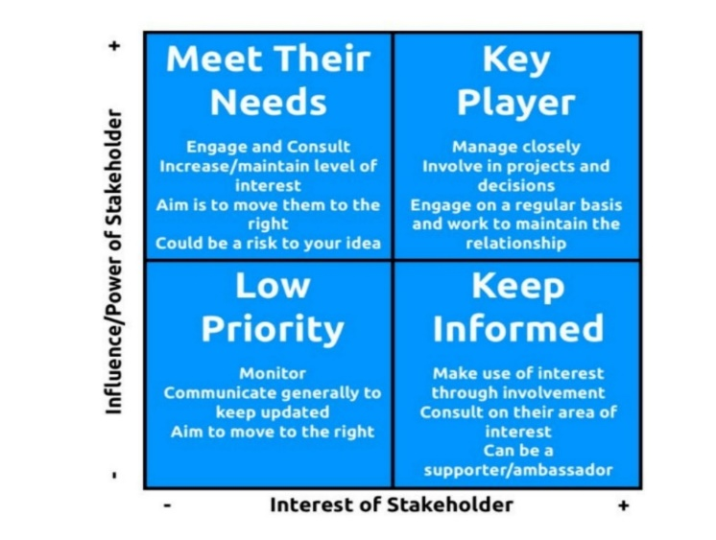
- The regulatory bodies: They have high power and interest because they impose fine and penalties as well as ensure compliance of rules and regulations.
Figure 2 Power and Interest Matrix
Source: (projectmanagement.com, 2023)

8.2 Communication Plan
Stakeholders Communication Plan
Stakeholder | Power/Interest | Key Interest and Issue | Communication vehicle | Frequency | Comment
Customers | Interest | Product and service quality | Website, social media platforms | Continuously | They should be assured of the product and service quality
Employees | Power and interest | Better compensation and benefits | Email | Monthly | Contribute to the success
Suppliers | Interest | Availability of products and services | Website, email | Monthly | They must ensure a strong supply chain
Shareholders | Power and Interest | Profitability | Annual Report | Annually | Support the growth of the company
The regulatory bodies | Power | Compliance of the law | Annual Report | Annually | Support the change implementation
- Monitoring And Review Techniques
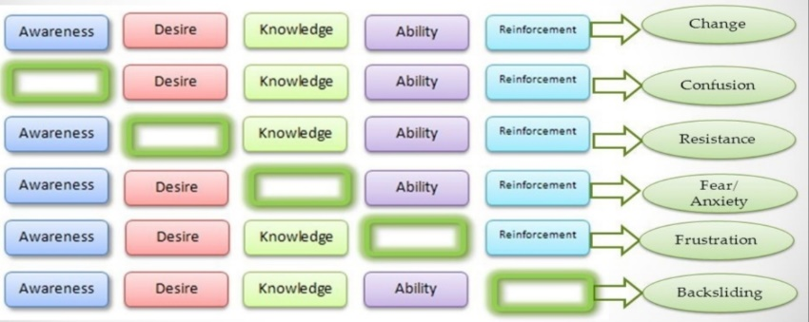
The management has to monitor the change and review the process whether it is successfully removing confusion, resistance, fear, frustration, and backsliding. For that, survey feedback is useful. Employees will get the opportunity to provide their feedback and the company will work on the feedback to make the change implementation successful (Angtyan, 2019).
Figure 3 ADKAR Gap Model
Source: (Angtyan, 2019)
- Conclusion
Hotel Marriott is facing low employee motivation and engagement. The root cause of this problem is inadequate compensation and benefits. So the management must focus on the company’s compensation and benefits policies. It must ensure that the company has competitive compensation and benefits. Therefore, employee motivation and engagement will be improved.

References
Angtyan, H. (2019) ADKAR model in change management. International Review of Management and Business Research, 8(2), pp. 179–182.
Bratton, J. and Gold, J. (2017) Human Resource Management: Theory and Practice. London: Palgrave.
Glassdoor (2023) JW Marriott "turnover rate" reviews, Glassdoor. Available at: https://www.glassdoor.com/Reviews/JW-Marriott-turnover-rate-Reviews-EI_IE2362538.0,11_KH12,25.htm (Accessed: April 29, 2023).
Hotel Marriott (2023) About Marriott International: Corporate Information, About Marriott International | Corporate Information. Available at: https://www.marriott.com/marriott/aboutmarriott.mi (Accessed: April 29, 2023).
Jayswal, A., Li, X., Zanwar, A., Lou, H.H. and Huang, Y., 2011. A sustainability root cause analysis methodology and its application. Computers & chemical engineering, 35(12), pp.2786-2798.
Ons.gov.uk (2023) Tourism Industry, Tourism industry - Office for National Statistics. Available at: https://www.ons.gov.uk/businessindustryandtrade/tourismindustry (Accessed: April 29, 2023).
projectmanagement.com (2023) Stakeholder analysis using the power interest grid. Available at: https://www.projectmanagement.com/wikis/368897/Stakeholder-Analysis--using-the-Power-Interest-Grid (Accessed: April 29, 2023).
Rose, M. (2018) Reward management. London: KoganPage.
Valentine, S.R., Meglich, P., Mathis, R.L. and Jackson, J.H. (2020) Human Resource Management. Boston, MA: Cengage.

APPENDIX


