University of Wales Trinity Saint David

Engineering Academic Discipline

Engineering Skills Technical Report
Pablo Model Rodrigues
2503092
BEng Automotive
07/12/2025
Engineering Skills (ACHA4022A)
Word Count: 2020

Contents
1.Introduction 1
2.0 – Health & Safety with Risk Assessment 2
2.1 – Introduction to Workshop Health & Safety 2
2.2 – Description of the Workshop Activity 2
2.3 Relevant Health & Safety Legislation 2
2.4 Risk Assessment 3
2.4.1 Introduction to the Risk Assessment 3
2.4.2 Risk Assessment – Machine Workshop (Lathe & Milling Machine) 3
2.4.3 - Risk Assessment (Engine & Suspension Workshop) 4
3.0 - Security Risk Matrix 6
3.1 - Security Risk Matrix – Introduction 6
3.2 - Identification of Security Threats 6
Digital Threat 1 - Attacks via Wireless Interfaces 6
Digital Threat 2 - Message Injection into the CAN Bus 6
Physical Threat 3 - Relay Attacks on Keyless Entry Systems 6
Physical Threat 4 - Misuse of the OBD-II Port 6
3.3 - Risk Matrix for Identified Security Threats 7
3.4 - Engineering Response to the Highest Risk 7
4.0 - Engineers Role in Society 8
4.1 - Introduction 8
4.2 - Codes of Conduct in Engineering 8
4.3 - Engineers’ Responsibilities for Sustainability in Automotive Engineering 8
5.0 - Problem Solving 9
5.1 - Introduction to Engineering Problem Solving 9
5.2 - Problem-Solving Methods Used by Engineering Teams 9
5.3 - Flow Diagram Integration 10
5.4 - Problem-Solving Flow Diagram 10
6.0 - Team Structure 11
6.1 - Personal Reflection — Real Team Experience 11

6.2 - Team Structure Used During the Activity 11
6.3 - Table of positive and negative points 12
6.4 - Alternative Team Structure (Hierarchical team ) 12
7.0 - Conclusion 14
8.0 Reference list 15

1.Introduction
This report provides an overview of the engineering topics studied throughout the term. These included health and safety in the workshop, risks in automotive systems, professional ethics, problem solving methods, and teamwork. Each chapter has a specific area: safety standards and risks in lathes, a risk matrix for digital and physical threats in cars, the ethical role of engineers, and problem-solving methods in engineering when working in a team. The report concludes with a summary of the topics learned.

2.0 Health & Safety with Risk Assessment

2.1 Introduction to Workshop Health & Safety
Occupational health and safety are essential in engineering workshops due to the hazards of machinery. This chapter reviews the necessary safety measures during a practical session and a risk assessment to ensure a safe environment.

2.2 Description of the Workshop Activity
The workshop portion involved learning how to operate two machines: a D-model lathe and a milling machine. The first class began with a demonstration where the instructor showed how to turn on the lathe, adjust the speed, fix the cutting tools, clamp the material, and use the emergency stop pedal. After the demonstration, the students were able to practice these procedures in the following class.
The first assessment task was the production of a stepped steel bar. Students had to turn the material into three diameters (30 mm, 41 mm, and 36 mm) and a length of 105 mm and check the final dimensions using micrometers and calipers. The tolerances were ±0.2 ±0.5 mm, and the final measurements were compared to the provided technical drawing.
The second part involved the production of a stepped profile plate using the milling machine. As with the lathe, the instructor gave a demonstration before the students carried out the machining process. The steel material was marked with squares and a digital height gauge before being placed in the vise. The students then milled the horizontal and vertical steps, drilled the pieces to the specified dimensions, and removed excess material using both the milling machine and a hand saw. The measurements were checked again to ensure the piece was within tolerances.
Both machining activities demonstrated precision, machine setup, and knowledge of the risks. The classes were important for applying the correct procedures and following supervision when operating rotating equipment.

2.3 Relevant Health & Safety Legislation
Safety in engineering workshops in the United Kingdom is ensured by laws controlling the risks associated with lathes and milling machines. The Health and Safety at Work Act 1974 requires employers to maintain safe conditions through training, supervision, and appropriate equipment. The Protection and Equipment at Work Regulation 1998 (PUWER 1998) ensures that machines are fitted with guards, as accidents occur when these guards are absent. The Management Regulation 1999 requires risk assessments, and reports show that incidents happen when safe methods are ignored. PPE requirements are covered by the PPE at Work Regulation, ensuring the provision of items such as safety glasses and safety boots. In summary, legislation and literature highlight that safety in workshops depends on adequate controls, machine guarding, supervision, and the use of PPE.

2.4 Risk Assessment

2.4.1 Introduction to the Risk Assessment
Working on lathes and milling machines involves risks that must be identified and controlled. An assessment is necessary to check the risk and hazards to ensure that appropriate control measures are in place. This ensures safe practices in accordance with UK health and safety standards.

2.4.2 Risk Assessment – Machine Workshop (Lathe & Milling Machine)

Hazard | Risk | Who is at risk | Likelihood | Severity | Control Measures / PPE
Rotating spindle (lathe) | Entanglement of hair, clothing, gloves | Students | Medium | High | Tie hair, remove jewellery, no gloves, keep distance, supervision
Flying metal chips | Eye injury | Students / staff | Medium | Medium | Safety goggles, guards correctly positioned
Hot chips | Burns | Students | Low | Medium | Allow cooling, use tongs or pliers
Swarf on floor | Slips/trips | Everyone | Medium | Medium | Clean floor, use brushes, no hands in swarf
Milling cutter rotation | Impact/cutting injury | Students | Medium | High | Secure workpiece in vice, use correct feeds, keep clear of cutter
The workshop identified key risks associated with rotating equipment, sharp cutting tools, and metal debris.
The most common hazards included entanglement, impact injuries, and burns.

2.4.3 Risk Assessment (Engine & Suspension Workshop)
A risk assessment was conducted for the practical sessions of engine assembly and suspension measurement, as the activities involved manual work, sharp parts, and hand tools, requiring supervision and the use of PPE.
Hazard | Risk | Who is at risk | Likelihood | Severity | Control Measures / PPE
Engine tipping on the stand | The engine may become unstable and fall, causing crush injuries | Students / staff | Medium | High | Ensure stand is locked, check centre of gravity, avoid leaning on stand, supervision
Dropping heavy engine components | Feet or hands may be injured by falling parts such as the flywheel, crankshaft, or head | Students | Medium | Medium/High | Safety boots, correct lifting method, use two people for heavy parts
Sharp edges on engine block and components | Cuts to fingers when handling pistons, block edges, timing covers, gaskets or metal burrs | Students | Medium | Medium | Wear cut-resistant gloves when not near rotating tools, careful handling
Injury from tools | Hand impact injuries, skin pinching, bruising | Students | Medium | Low/Medium | Use tools correctly, avoid over-extension, maintain firm grip
Suspension arm pinch point | Fingers may be crushed when moving or rotating the suspension hub/arms during measurement | Students | Medium | High | Keep hands clear of pivot points, communicate with partner, maintain stable support
Falling measuring equipment (DTI gauges, rulers) | Foot injuries and damage to equipment | Students / staff | Low | Low | Handle equipment carefully, do not place near edges of table
Spring/damper movement | Sudden movement of damper during setup may cause impact injuries | Students | Low/Medium | Medium | Compress damper slowly, maintain controlled movement, supervision

3.0 Security Risk Matrix

3.1 Security Risk Matrix – Introduction
Vehicles rely on electronic systems and wireless communication, which improves comfort and safety, but also creates cybersecurity risks. Standards such as ISO/SAE 21434 and UNECE R155 show that manufacturers must treat these digital threats in the same way they manage other security risks, using risk assessment and control measures.

3.2 Identification of Security Threats
Vehicles rely on multiple electronic control units, which increases their exposure to cybersecurity risks. Studies show that connected cars can be exploited through digital and physical vulnerabilities, making cybersecurity an engineering concern (Petit & Shladover, 2015).

Digital Threat 1 - Attacks via Wireless Interfaces
Modern vehicles utilize Wi-Fi, Bluetooth, and cellular networks, which can expose them to remote attacks. Studies have shown that attackers can control braking, steering, or engine control systems through insecure communication channels (Checkoway et al., 2011).

Digital Threat 2 - Message Injection into the CAN Bus
The CAN network interconnects the sensors and control units of a vehicle, but if attackers access the system through interfaces such as telematics or diagnostic ports, they can send false messages and disrupt vehicle functions. As cars become more connected, the attack surface of the CAN network increases, making it more vulnerable to cyberattacks (Plappert et al., 2021).

Physical Threat 3 - Relay Attacks on Keyless Entry Systems
Keyless systems improve convenience but enable relay attacks, where criminals extend the remote-control signal to unlock and start the vehicle. Industry reports show that this method remains one of the most common types of vehicle theft, largely due to the use of passive entry systems and the easy availability of inexpensive relay devices (GlobalData, 2024).

Physical Threat 4 - Misuse of the OBD-II Port
The OBD-II port provides direct access to vehicle diagnostics and control, making it a common target for criminals who use tools to disable immobilizers or clone keys. Because it was designed for maintenance and not security, it remains a high-risk entry point. Recent studies show that, without proper monitoring and protection, diagnostic interfaces in connected vehicles can create serious vulnerabilities (Yang et al., 2022).

3.3 Risk Matrix for Identified Security Threats
Threat | Probability | Impact | Overall Risk
Digital Threat 1 – Wireless Remote Intrusion | High | High | Severe
Digital Threat 2 – CAN-Bus Message Injection | Medium | High | High
Physical Threat 3 – Keyless Entry Relay Theft | High | Medium | High
Physical Threat 4 – OBD-II Port Misuse | Medium | Medium | Moderate

Explanation:
Wireless attacks are becoming more common because modern vehicles utilize features such as keyless entry, Bluetooth, and telematics. Injection into the CAN network is less likely, as it requires access to the vehicle, but the impact can be severe. Theft of the key fob code is one of the most frequent methods in real-world vehicle crimes. Misuse of the OBD-II port also requires physical access but still represents a security risk.

3.4 - Engineering Response to the Highest Risk
Among the threats identified, message injection into the CAN network is the most serious because it interferes with several vehicle systems. Research shows that vulnerabilities remain even with the addition of extra protections (Jo & Choi, 2022).
To mitigate this, vehicles need smarter networks, traffic filters, and monitoring to detect suspicious activity. Implementing message authentication, along with software updates and security testing, helps strengthen protection.
Overall, the best approach combines technical improvements with good maintenance practices. While these measures cannot eliminate the risk entirely, they significantly reduce the chances of an attack and improve vehicle security.

4.0 Engineers Role in Society

4.1 Introduction
Engineers play an important role in society. To support professional standards, engineering institutions have created codes of conduct that define the ethical, environmental, and social responsibilities that engineers must follow.

4.2 Codes of Conduct in Engineering
Two main organizations guide ethics in engineering in the United Kingdom: The Engineering Council and IMechE. The Engineering Council (Engineering Council, 2020) defines principles such as integrity, public safety, environmental responsibility, and professional development. The IMechE (IMechE, n.d.) code reinforces safe practices and the need to consider environmental impacts in all engineering work these codes provide a basis for ethical decision making in engineering.

4.3 Engineers Responsibilities for Sustainability in Automotive Engineering
Both organizations state that engineers must act responsibly regarding sustainability, especially in the automotive sector. The Engineering Council highlights the need to minimize environmental damage and use resources efficiently during the design, testing, and operation of vehicles (Engineering Council, 2020). IMechE encourages engineers to focus on low-emission and energy-efficient technologies (IMechE, n.d.).
In practice, these responsibilities influence areas such as emissions reduction, the choice of less impactful materials, and the efficiency of fuel and electric motors. By following these codes of conduct, engineers help create clean and safe mobility systems.

5.0 Problem Solving

5.1 Introduction to Engineering Problem Solving
Engineers frequently deal with technical problems during product planning, and problem solving is essential to keeping projects safe and on schedule. Using structured models helps identify root causes, compare solutions, and take steps to prevent recurrence. These approaches contribute to better decision making and help maintain engineering standards throughout the entire process.

5.2 Problem Solving Methods Used by Engineering Teams
Engineering teams use structured tools to address problems that arise during product development. One commonly used method is the toolbox approach, in which engineers choose the most appropriate tool depending on the type of problem they face (Hisey, 2021). This avoids guesswork and encourages data driven decisions and organized analysis.
Another method used in the industry is 8D problem solving, which guides teams through steps such as finding the problem, identifying the cause, applying corrective actions, and preventing the problem from recurring. Research shows that 8D is especially effective for complex failures, as it strengthens teamwork and ensures that the investigation is properly documented (8D Problem Solving Process, no date). Using structured approaches like these helps engineering teams solve problems faster, reduce delays, and maintain safe and high-quality products.

5.3 Flow Diagram Integration
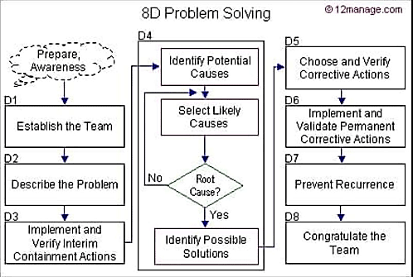
Figure 1 - Example of 8D problem solving flowchart, the eight stages used by engineering teams to identify, analyse and resolve problems. Adapted from HRM Practice (n.d.).

5.4 Problem-Solving Flow Diagram
The 8D flowchart shows how the engineering team progresses through each stage. It begins with team formation and finding the problem, then making temporary changes to control the situation. Next, the engineers investigate possible causes, identify the root problem, and develop safe solutions.
In the final part, the team verifies if the actions worked and ensures that the problem has been solved. This flow helps engineers stay organized and consistent in problem solving throughout project development.

6.0 Team Structure

6.1 Personal Reflection — Real Team Experience
During the engine disassembly session, our class was divided into two groups (group 1 with 3 students and group 2 with 2 students, each working on a Ford 1.6 engine. My subgroup, however, had two people, so we would have more work. I had experience in mechanics, while my colleague did not, so I helped him by telling him what he should do. I explained the disassembly steps, showed how to use the tools, and helped with measurements such as crankshaft bearings, piston skirts, and cylinder wear. This helped us do our work, and I also shared some things I already knew.
Despite being only two of us, our teamwork was effective. We communicated well and divided the parts to disassemble, which helped with organization. I did some of the more difficult parts, and my colleague helped me with the rest and also recorded the measurements. Experience helped me, and I didn't get lost without knowing what to do and could guide my colleague, and we finished the work correctly as required by instructor.

6.2 Team Structure Used During the Activity
In the engine disassembly class, 5 students were in this work group, which was divided into 2 subgroups of 2 and 3 students. We did a split teamwork project (I don't remember another experience with more people before), where each subgroup worked on the same type of engine, but performed the tasks independently.
This type of model worked well in some aspects, because each group worked independently at its own pace. Both teams had a tool cart available, and this prevented people from waiting too long. I don't think it was a negative point to have only two people in the group, because there isn't much space for many people to work on the engine, and perhaps that could be a hindrance in my opinion.
Even with a smaller group, we still managed to finish the task before the larger group, as we already had experience in the area.

6.3 Table of positive and negative points

Feature |  | Positive points | Negative points
Divided into subgroups |  | Fewer students around the engine. | The group needs to work harder.
Dividing tasks |  | Each student could pick a piece to take apart. | If the group doesn't have the same experience, the person with the most experience should delegate the other tasks.
Apprenticeship |  | You have the chance to accomplish more tasks and learn by doing. | Those with less experience depended on their colleagues.

Figure 2 - Table of positive and negative points, where you can see some characteristics with the pros and cons of this type of model.

6.4 Alternative Team Structure (Hierarchical team)
In a hierarchical team structure, the leader sits at the top and distributes tasks to team members. Bang and Midelfart (2021) argue that this model creates order, workflow, and simplifies communication because orders come from the leader, who may be necessary when tasks require coordination.
However, this also shows that hierarchy can reduce flexibility and limit team members participation in decision making. Even so, in engineering workshops, this structure often works well because it helps maintain organization and avoids confusion during work.
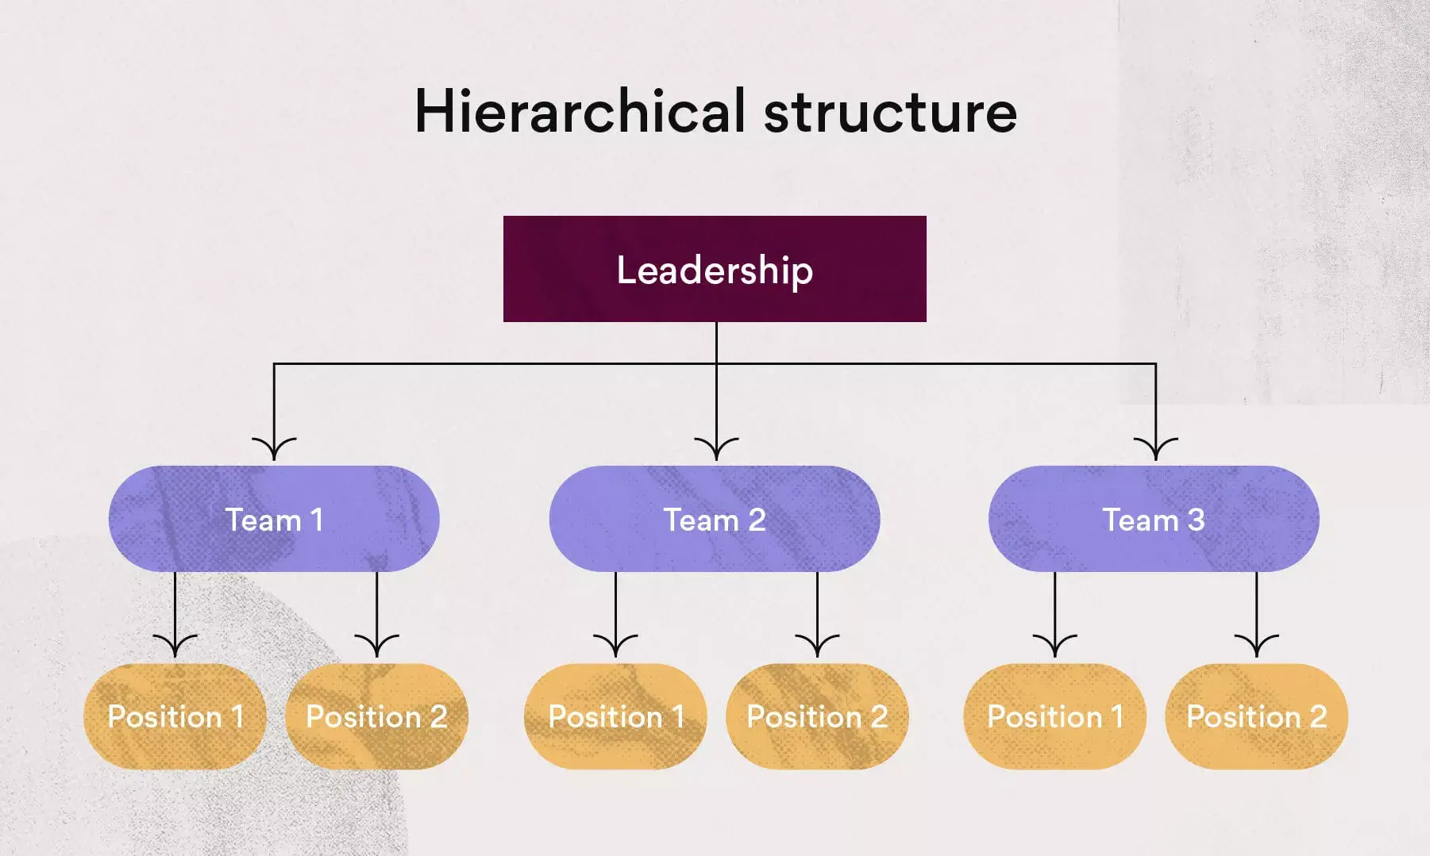
Figure 3 - Example of a hierarchical team structure. Adapted from Asana (2025).

7.0 Conclusion
This report presented several areas in engineering practice, including health and safety, safety risks, professional conduct, problem solving, and teamwork. Workshop classes, such as machining, suspension measurement, and engine disassembly and measurement, show how safety standards and risk assessment are essential for accident prevention.
The chapter on digital and physical safety risks showed the challenges that modern vehicles bring to engineering. The codes of conduct of the Engineering Council and IMechE show how engineers should work responsibly and ethically, towards sustainability and public safety.
Problem solving methods and reflection on teamwork also showed a contribution to better results in engineering projects. In summary, the report reinforced that technical knowledge must be combined with responsibility and professional standards in the engineering industry.

8.0 Reference list
- Anon., A. (1976) ‘THE BANTAM 2000 CENTRE LATHE WILL HAVE WIDE APPEAL FOR TRAINING PURPOSES AND INDUSTRY GENERALLY’, Steel Times, 204(7), pp. 605–605.
- Asana (n.d.) Team structure. Available at: https://asana.com/resources/team-structure (Accessed: 04 December 2025).
- Bang, H. and Nesset Midelfart, T. (2021) Effective management teams and organizational behavior: a research-based model for team development. 1st ed. New York; Routledge, Taylor & Francis Group.
- Engineering Council (2020) Annual Review 2020. London: The Engineering Council. Available at: https://www.engc.org.uk/media/lhyh0bek/annual-review-2020.pdf (Accessed: 1 December 2025).
- Hisey, L. (2021) ‘The Toolbox Approach’, ASQ Six Sigma Forum Magazine, 20(2), pp. 30–30.
- HRM Practice (n.d.) 8D methodology. Available at: https://hrmpractice.com/8d-methodology/ (Accessed: 03 December 2025).
- IMechE (n.d.) Code of Conduct explained. Institution of Mechanical Engineers. Available at: https://www.imeche.org/about-us/imeche-governance/governance-and-finance-reviews/code-of-conduct-explained (Accessed: 01 December 2025).
- ‘Labels firm fined over absence of machine guarding’ (2013) The Safety & Health Practitioner, 31(2), p. 16.
- ‘Safe method was identified but ignored’ (2012) The Safety & Health Practitioner, 30(3), p. 11.
- Sector Innovation Report: Vehicle Access, Anti-Theft, and Security: Part 3: Sector Forecast (2024) Just Auto - News & Sector Market Reports. London: GlobalData plc, pp. 12–20.
- ‘8D PROBLEM SOLVING PROCESS’ (no date) International Journal of Modern Trends in Engineering & Research [Preprint]. Available at: https://doi.org/10.21884/ijmter.2016.3056.gntz1.
- Petit, J. and Shladover, S.E. (2015) ‘Potential Cyberattacks on Automated Vehicles’, IEEE Transactions on Intelligent Transportation Systems, 16(2), pp. 546–556. Available at: https://doi.org/10.1109/TITS.2014.2342271.
- Plappert, C. et al. (2021) ‘Attack Surface Assessment for Cybersecurity Engineering in the Automotive Domain’, in Proceedings - Euromicro Workshop on Parallel and Distributed Processing. IEEE, pp. 266–275. Available at: https://doi.org/10.1109/PDP52278.2021.00050.
- Tombs, S. (2001) ‘Enforcing Safety Law in Britain: Beyond Robens?’, Risk Management (Leicestershire, England), 3(2), pp. 29–41. Available at: https://doi.org/10.1057/palgrave.rm.8240084 .
- Yang, C. et al. (2022) ‘Intelligent Connected Vehicles Cybersecurity Vulnerability Rating Methodology Based on Multiple Factors’, in Proceedings of the 4th International Conference on Advanced Information Science and System. New York, NY, USA: ACM, pp. 1–6. Available at: https://doi.org/10.1145/3573834.3574528

