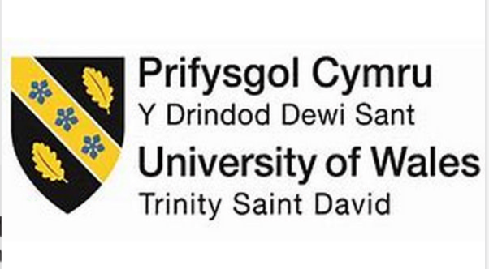

Student: Meliha Drenk

Student ID: 1922136

Lecturer:

Dr Laila Surani

Community Care and Development

(BMHP6022_LON)

Assessment 2 - Report

Table of contents

Introduction…………………………………………………………………………………2
Demographic characteristics of Birmingham city………………………….……………2
Overview of the Muslim community in Birmingham……………………......…………..3
Problem in the community…………………………………………………………….…..4
Causes using social media and communications to promote initiatives for reducing poverty among the community………………………………………….………….……..5
Policies and legislations to reduce poverty in the borough………….…………………6
Applying Maslow’s theory to reduce poverty……………………...…….……………….7
Approach to improve health and social care in the community………..………………8
Recommendations………………………………………………………………………….9
Conclusion………………………………………………………..…………..……………10
References…………………………………………………………………..……………..11
Approaches and initiatives for addressing health and social needs of a Muslim community in Birmingham

Introduction

This report will be exploring different approaches and initiatives for addressing health and social care needs of the Muslim community in Birmingham. More specifically, will promote and explore borough’s initiatives to reduce poverty in the Muslim community.
Community is a term that defined as a group of people that live in the same area which have a specific characteristic in common. (NHS, 2023).
Communities are fluid groups and can vary wildly with respect to ethnicity, race, class, age, and culture. An individual may belong to several different communities at any one time with a range of different binding characteristics.
Moreover, community development is the process where people come together to take actions on what is important to them. (SCDC, 2023)
And lastly, as a summary the aim of this report will be to address the issues of poverty surrounding the Muslim community in Birmingham and to raise awareness about the negative consequences and impact which they experience.

Demographic characteristics of Birmingham city

Birmingham is a city and metropolitan borough in West Midlands in England.
It is the most populous local government district in the United Kingdom with a population of 1.145 million. The results from the latest census showed that Birmingham had the highest population growth with 6.7% compared to the previous census from 2011. (ONS, 2022).
Currently, the diverse population of Birmingham keeps expanding as the area is extremely cultural. There is a wide range of communities within the city, and it is also often referred to as the culture centre- which specifically focuses on the Muslim community.
According to a data from the Office for National Statistics based on ethnicity, white British are the highest amount of people with almost half a million, followed by Asian or British Pakistani at almost 200 thousand in Birmingham. Other big ethnic communities are Asian or British Indians – 66,519, followed by Asian British Bangladeshi – 48,232, and Black British Caribbean – 44,673. (ONS, 2023).

The most popular religion in the borough is Christianity with more than 400 000 people, followed by Islam with 341,811. People describing themselves with No religion are more than 270 000, followed by Sikh and Hindu. (ONS, 2023).

Comparison statistics for the employment rate and gender in the borough shows that the percentage of economically active full-time adults decrease during the last 10 years.
In contrast, the proportion of people aged 16 years and over working 15 hours or less per week increase (from 10.0% in 2011 to 11.2% in 2021).
Based on gender: the number of young women aged 20 and over is higher compared with England, and the same applies to the males. (ONS, 2023).

Overview of the Muslim community in Birmingham

Muslims are the second biggest ethnicity group in Birmingham - 341,811. which represents approximately 30% of the city's total population. (ONS, 2023).
The community itself consists of relatively young population with a median age of 28 years, compared to the city's overall median age of 35 years.
The Muslim population in Birmingham is diverse, with people from various ethnic and cultural backgrounds.
According to the Census, the largest ethnic group within the Muslim community in Birmingham was Pakistani (60%), followed by Bangladeshi (13%), other Asian and Black African. (see Figure 1).

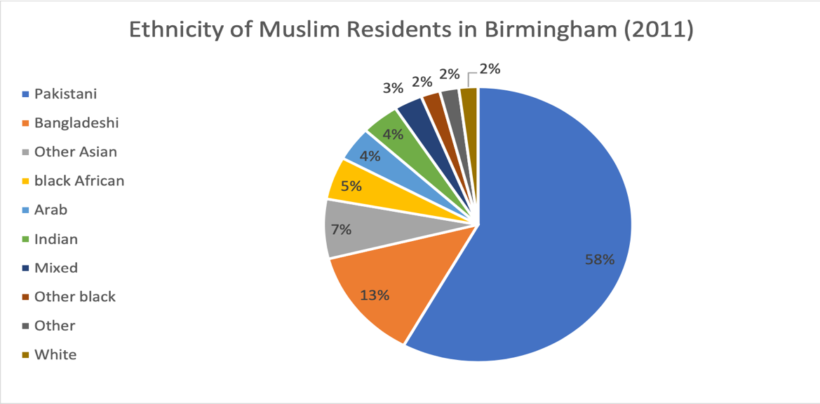

Figure 1

Photo credit: Office for National Statistics, 2011)

Data from the local council confirms that Muslim community in Birmingham has way higher unemployment rates compared with other communities, with many working in low-paying jobs. Focusing on education, Muslims have a higher rate of uneducated people who lack knowledge and qualification. (Birmingham city council, 2023.)

Problem in the Muslim community
The biggest issue affecting Muslim community in Birmingham is poverty.
Some of the reasons for this are that Muslim have high rate and uneducated and unemployed people. (Alen, 2017)

Poverty can have significant negative impacts on an individual's health and well-
being. Examples of health problems that are caused by poverty are:
- Malnutrition: Poverty can lead to insufficient access to healthy and nutritious foods, resulting in malnutrition, which can cause weak immune systems, and other health problems.
- Mental health problems: Poverty can also have negative impacts on mental health, leading to increased rates of depression, anxiety, and other mental health disorders.
- Chronic illnesses: Poverty can also increase the risk of chronic illnesses such as diabetes, heart disease, because of poor nutrition.
People living in poverty have limited access to healthcare due to financial issues or lack of health insurance, which can result in delayed diagnosis and treatment of their health problems. (Birmingham City Council, 2020). This results in an increase in the mortality levels and lowers the life expectancy within Birmingham.

Causes using social media and communications to promote initiatives for reducing poverty among the community

Social media and communications are a useful tool and play a significant role in promoting poverty reduction by raising awareness, facilitating communication, and providing access to resources. They are used to communicate health-related information to the community and as a tool for fundraising. Many organisations and mosques use platforms like JustGiving and GoFundMe to raise money for different community projects and initiatives to reduce poverty.
Platforms such as Facebook, YouTube and Instagram can be used to raise awareness about poverty-related issues. Different organisations and individuals can use these platforms to share stories, statistics, and information about poverty and its impact on individuals and communities. This will help to educate people about poverty and its causes and encourage them to take action to address it.
Mobile Apps: Many Muslim community organisations have launched their mobile apps to provide access to prayer times, daily Quranic verses, Islamic calendars, and other resources.
Live Streaming: With the closure of mosques during the pandemic, many imams started live streaming their lectures and religious events on social media platforms. This has allowed the community to continue to engage with religious leaders and stay connected with their faith.
Social media also can facilitate communication between individuals and organisations working to reduce poverty. For example, they can be used to connect people with similar interests and goals, to share information about events, campaigns, and initiatives related to poverty reduction. This can help to build networks and partnerships to address poverty effectively.
Online platforms also can be used to share information about job opportunities, training programs, and financial assistance programs. This can help to connect people with the resources they need to improve their economic situation and reduce their risk of poverty.
The council is working with organisations to raise awareness and provide services such as food banks, debt advice and homelessness support. Some of the biggest organisations are:
The Birmingham Poverty Truth Commission is a group of people with direct experience of poverty who work together with civic and business leaders to tackle poverty in the city. The Commission aims to influence policy and decision-making by sharing the stories of people living in poverty. (Birmingham city council, 2022)

Hazrat Sultan Bahu Trust is a charity organisation which educates Muslims and provides necessary resources such as food banks and clothing distribution and educational programs. (Charity commission for England and Wales, n.d.)

Muslim Hands is international aid agency with a presence in Birmingham that delivered aid, food banks and clothes. (Muslim Hands, 2023)

Islamic Relief is another international agency that provide healthcare, education, and pleasant activity scheduling for the community in need. (Islamic Relief, 2023)

Policies and legislations to reduce poverty in the borough
The main policies and legislation that address poverty are:
- The Welfare Reform Act 2012: introduced and welcomed a range of changes to the UK's welfare system, including the introduction of Universal Credit. It is a means-tested benefit that replaces several other benefits, and its purpose is to motivate people for employment. (Department for work and pension, 2023).
- Child Poverty Act 2010: sets out targets for reducing child poverty in the UK. The Act requires the government to make a strategy for tackling child poverty and to report on progress towards the targets. Local authorities, including Birmingham City Council, are also required to produce their own strategies for tackling child poverty. (Kenedi, 2014).
- Equality Act 2010 protects individual from discriminations based on race, religion, gender, social status because poverty can be a reason for discrimination. (Equality and human rights commission, 2020).

Applying Maslow’s theory to reduce poverty

The theory that is most suitable to reduce poverty is Maslow’s hierarchy of needs.
Maslow's theory of needs suggests that human beings have a set of needs that must be met in a specific order. The needs are arranged in a pyramid, with the most basic needs at the bottom and the most complex needs at the top.
According to Maslow, individuals have five basic needs that must be met in order to attain self-actualization: physiological needs, safety needs, love and belongingness needs, esteem needs, and self-actualisation needs.
The basic needs include physiological needs such as food, water, and shelter, followed by safety needs such as security and stability.
The next level is the need for love and belonging, followed by esteem needs such as self-esteem and respect from others.
The highest level is self-actualisation, which refers to the need for personal growth and fulfilment. (Mindtools, 2022).
To reduce poverty, Maslow's theory can be applied by addressing the basic needs of individuals. This can be done by providing access to food, water, and shelter, which are the most fundamental physiological needs. Government and organisations can provide food banks, soup kitchens, and shelters for the homeless to ensure that people have access to these basic needs.
In terms of safety needs providing secure jobs and affordable healthcare can help individuals to feel secure and stable, which is essential for their well-being.
The need for love and belonging can be addressed by creating a sense of community and social support. This can be done by opportunities for social interaction, such as community centres, sports clubs, and other social events.
Lastly, the need for esteem can be addressed by education and training opportunities. This will help individuals develop skills and knowledge, which will increase their self-esteem and respect from others. With free education and training programs individuals can improve their skills and increase their employability.
Finally, the need for self-actualisation can be addressed by providing opportunities for personal growth and development. This can be done by giving access to cultural and artistic events, as well as opportunities for personal development such as counselling and therapy.

Approach to improve health and social care in the community
One distinct approach is to focus on health promotion and disease prevention through culturally appropriate education and programs. These programs can be designed to address specific health concerns that are prevalent in the Muslim community, such as diabetes, heart disease, mental health, and cancer. To effectively communicate this information to the community, it is important to utilize multiple methods. Working in a partnership with local mosques and community centres to provide health education sessions and screenings. This approach can be effective because it allows the information to be disseminated by trusted faith leaders and provides a familiar and comfortable setting for community members to access health information.
Birmingham city council is using social media platforms to introduce intervention to improve the health of the Muslim community. Some of these interventions are:
- Pathways to Recovery
- Islamic Faith Settings Toolkit
- Birmingham Joint Health and Wellbeing Strategy 2022-2030
(Birmingham City Council, 2023)
The council in collaboration with Public Health England has developed strategy to support mosques in their work to improve health and wellbeing of people they serve locally, and to prevent illness. The purpose of this guide is to provide faith leaders and communities with public health evidence and recommendations. The guide includes a self-assessment checklist for mosques to reflect on current initiatives, recognise achievement, and develop plans for future projects.
Recommendations

There isn’t a single solution to tackle all poverty in Muslim communities because poverty is a complex issue that requires a multifaceted approach. As a way to deal with these issues there are a variety of solutions which can help fight against the challenges such as:
Promote education:
Education is a powerful tool that can help break the cycle of poverty.
It is not only a fundamental human right, but it also provides individuals with the skills and knowledge, increase individual’s earning potential, and give resources they need to improve their lives and escape poverty.
Muslim communities can focus on providing education and training programs that help people acquire the skills they need to find better jobs and improve their economic status. Providing trainings and apprenticeships can also provide individuals with valuable skills and lead to well-paying jobs. Additionally, promoting financial literacy and entrepreneurship can help individuals start their own businesses and become financially independent.
Job opportunities: Governments can work to create job opportunities in Muslim communities. This can be done by providing incentive schemes for businesses to set up in the area, or by investing in infrastructure projects that will create new working places.
Community development: Building strong communities can help reduce poverty. Muslim communities can focus on creating safe and supportive environments that foster social and economic development.
Advocacy: Muslim communities can advocate for policies and programs that address poverty at the local, national, and even international levels. This can include government and different international organisations to prioritise poverty reduction.

Conclusion
In conclusion, poverty is a complex issue that affects millions of people around the world, including Muslim communities. It is not just about lack of income, but it is also a lack of access to necessities such as food, shelter, education, and healthcare.
Reducing poverty requires a multifaceted approach that includes government policies, community development, education, job creation etc.
By working together and implementing effective strategies, we can help reduce poverty in Muslim communities and improve the lives of millions of people.
We all have a role to play in this effort, and we must continue to prioritize poverty reduction as a global community.

References

Alen, C. (2017) Birmingham's Muslims: A City of Challenges And Opportunities. Available at: https://www.huffingtonpost.co.uk/dr-chris-allen/birmingham-muslims_b_12567710.html (Accessed: 24 March 2023).

Birmingham City Council (2020) Muslim community health profile. Available at: https://www.birmingham.gov.uk/download/downloads/id/24450/muslim_community_health_profile_report.pdf (Accessed: 10 April 2023).

Birmingham City Council (2022) Birmingham Poverty Truth Commission. Available at: https://www.birmingham.gov.uk/info/50266/other_public_health_projects/2410/birmingham_poverty_truth_commission (Accessed: 26 March 2023).

Birmingham City Council (2023) Community health profiles. Available at: https://www.birmingham.gov.uk/info/50265/supporting_healthier_communities/2463/community_health_profiles/6 (Accessed: 15 April 2023).

Birmingham Health and Wellbeing Board (2022) Birmingham joint health and wellbeing strategy creating a bolder, healthier city 2022-2030. Available at: https://www.birmingham.gov.uk/download/downloads/id/23756/creating_a_bolder_healthier_city_2022_to_2030.pdf (Accessed: 17 April 2023).
Charity commission for England and Wales (n.d.) HAZRAT SULTAN BAHU TRUST (UK) Available at: https://register-of-charities.charitycommission.gov.uk/charity-search/-/charity-details/292697/full-print (Accessed: 26 March 2023).

Department for work and pension (2023) Welfare Reform Act 2012 regulations. Available at: https://www.gov.uk/government/publications/welfare-reform-act-2012-regulations/welfare-reform-act-2012-regulations (Accessed: 26 March 2023).

Equality and human rights commission (2020) Your rights under the Equality Act 2010. Available at: https://www.equalityhumanrights.com/en/advice-and-guidance/your-rights-under-equality-act-2010 (Accessed: 25 March 2023).

Islamic relief (2023) The impact of poor health. Available at: https://www.islamic-relief.org.uk/giving/areas-of-work/health/ (Accessed: 26 March 2023).
Kenedi, S. (2014) Child Poverty Act 2010: a short guide. Available at: https://commonslibrary.parliament.uk/research-briefings/sn05585/ (Accessed: 25 March 2023).

Mind tools (2022) Maslow's Hierarchy of Needs. Available at: https://www.mindtools.com/a4denhh/maslows-hierarchy-of-needs (Accessed: 20 April 2023).
Muslim Hands (2023) United for the needy: overview. Available at: https://muslimhands.org.uk/about-us (Accessed: 26 March 2023).

National Health Service (2023) NHS Data model and Dictionary. Available at: https://www.datadictionary.nhs.uk/nhs_business_definitions/community.html (Accessed: 20 March 2023).

Office for National Statistics (2022) How the population changed in Birmingham: Census 2021. Available at: https://www.ons.gov.uk/visualisations/censuspopulationchange/E08000025/ (Accessed: 17 April 2023).

Office for National Statistics (2023) How life has changed in Birmingham: Census 2021. Available at: https://www.ons.gov.uk/visualisations/censusareachanges/E08000025/ (Accessed: 25 March 2023).

Scottish Community Development Centre (2023) What is community development? Available at: https://www.scdc.org.uk/who/what-is-community-development (Accessed: 23 March 2023).

