
40%
APPENDIX GA36b

LEVEL 5 ASSESSMENT SPECIFICATION

Student name: | Finn Rees | Student ID number: | REE14818461
Programme: | HND LEVEL 5
Module: | MECHANICAL PRINCIPLES
Module code: | M5X00926 | Contribution to Overall Module Assessment (%): | 25%
Lecturer: | EMILY NYATHI | Internal Verifier: | EDWARD HORNAGOLD
Assignment Title: | COMPLEX LOADING, I | Word count (or equivalent): | (NOMINAL 3000)
Submission deadline: | 24/01/2020 | Return date of provisional marks & written feedback: | 04/02/2020
Submission method: | All written assessments, where practical and possible, must be submitted via Turnitin unless otherwise instructed by the Lecturer. (Please DO NOT put this assessment specification into Turnitin or it will match many similarities with other students’ submissions.)  Alternative submission method (if applicable):  Late submission of the assessment will result in a late penalty mark. Penalties for late submission: Up to one-week late, maximum mark of 40%. Over one week late, 0%. Only the Extenuating Circumstances Panel may approve a change to submission dates.
Academic honesty / referencing: | Academic honesty is required. In the main body of your submission you must give credit to authors on whose research and ideas your work is based. Append to your submission a reference list that indicates the books, articles, etc. that you have used, cited or quoted in order to complete this assessment.

Student FEEDBACK FORM

This section details the extent to which you demonstrate the assessment criteria, which in turn determines your mark. The marks available for each category of skill are shown. Lecturers will use the space provided to comment on the achievement of the task(s), including those areas in which you have performed well and areas that would benefit from development/improvement.

Generic Assessment Criteria | Marks available | Marks  awarded
1. Engagement with Literature Skills
.
You have engaged with a limited range of information. Carrying out background research in Task 2 could have given you more marks |  | 10
 | 25 | 10
2. Knowledge and Understanding Skills

In Task1 you did not show any calculations for your beams of choice. You could have shown calculations for the second moment of inertia of your beams in different orientations in Task 2. |  | 12
 | 30 | 12
3. Cognitive and Intellectual Skills

You have made an attempt on analysing your data using tables and graphs. You need to work on improving on your presentation and making sound conclusions. Analysing your FEA results in detail could have scored you more marks here |  | 10
 | 25 | 10
4. Practical Application Skills

You have shown basic understanding of application of the theory of beam deflection. |  | 6
 | 15 | 6
5. Transferable Skills for Life and Professional Practice

Work on improving your presentation skills. | 5 | 2

Assessment Mark (Assessment marks are subject to ratification at the Exam Board. These comments and marks are to give feedback on module work and are for guidance only until they are confirmed. ) | Late Submission Penalties (tick if appropriate) |  | 40%
 | Up to 1 week late (40% Max) |  | 40%
 | Over 1 week late (0%) |  | 40%

Contents

Task 1 2
Summary 2
Introduction 2
Background theory / research and Design Methodology 2
Analysis 5
Conclusion 6
Task 2 7
Introduction 7
Equipment Used 7
Procedure and Results 7
Data analysis and Calculations 8
Conclusions 10
Bibliography 11

Task 1

Summary

This report will cover the design of a cantilever I beam. This will be done through finite element analysis (FEA).

Introduction

This report will cover the design of a cantilever I beam. This will be done through finite element analysis (FEA). FEA is used to calculate the stress and strain in structures that cannot easily be calculated manually. The material should be low cost and must be able to lift 350Kg to a height of 6 meters.

Background theory / research and Design Methodology

3 arbitrary sizes of I beam where designed using Autodesk Inventor. All I beams had a length of 1 meter as length was not a specified characteristic of the I beam. A shorter length was chosen as if you “Decrease the length L of the cantilever” (Ho, 2018) then there will be less flexion in the beam and a smaller beam will be able to hold more load. Moving the load “closer to the support” (Ho, 2018) will also increase the load the beam will be able to hold; however the beam must be able to hold 350kg at the end of the beam to be functional so this was not done. “Increasing the section size” (Ho, 2018) would also increase the amount of weight that the beam will be able to hold however the beam must also be cost effective (this was taken into consideration when designing the beams). All beams were assumed to be high carbon steel as “it has been seen that the increase of carbon content results in an increase in strength” (Adnan Calik, 2009). High Carbon steel costs “$500/ton” (Susrut, 2019) whereas stainless steel costs “$2000/ton” (Susrut, 2019). So high Carbon steel costs about a quarter the price of stainless steel.
I beam 1 dimensions below. The Dimensions below are in cm. There is also a table of the physical properties of the 3d rendered beam as well as a photo of the beam with a constraint on one end and a point load at the other end of the beam.
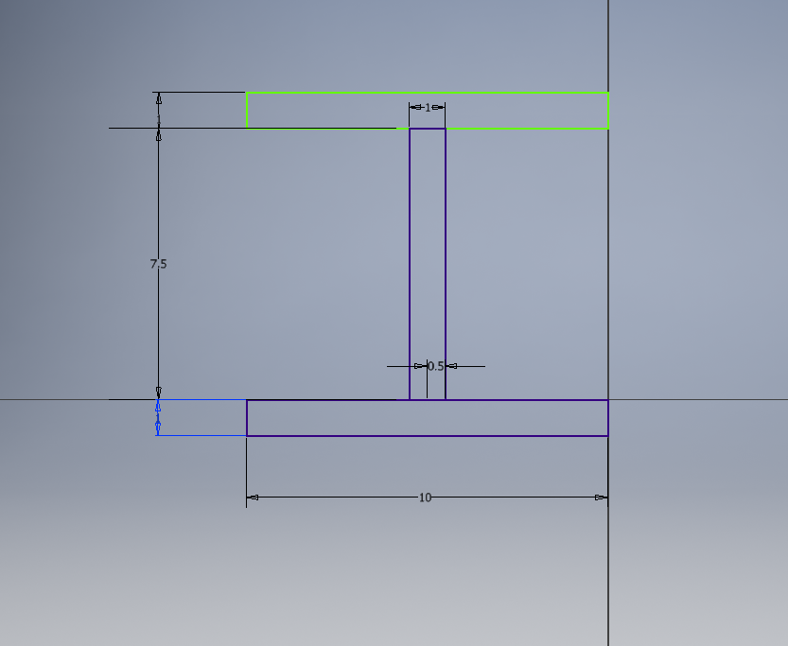
Material | Steel, Carbon
Density | 7.85 g/cm^3
Mass | 21.5875 kg
Area | 5755 cm^2
Volume | 2750 cm^3
Center of Gravity | x=3.75 cm  y=50 cm  z=-5 cm
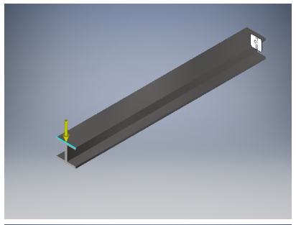
I beam 2 dimensions below. The Dimensions below are in cm. There is also a table of the physical properties of the 3d rendered beam as well as a photo of the beam with a constraint on one end and a point load at the other end of the beam.
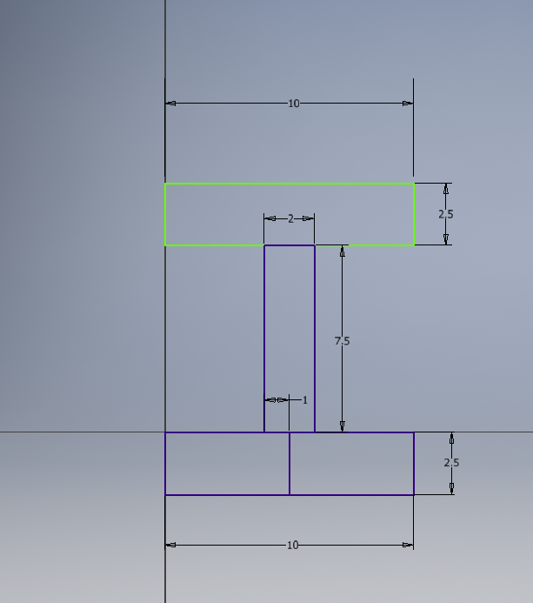
Material | Steel, Carbon
Density | 7.85 g/cm^3
Mass | 51.025 kg
Area | 6230 cm^2
Volume | 6500 cm^3
Center of Gravity | x=3.75 cm  y=50 cm  z=-5 cm
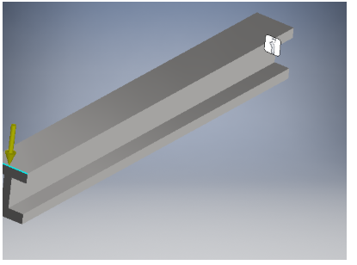

I beam 3 dimensions below. The Dimensions below are in cm. There is also a table of the physical properties of the 3d rendered beam as well as a photo of the beam with a constraint on one end and a point load at the other end of the beam.
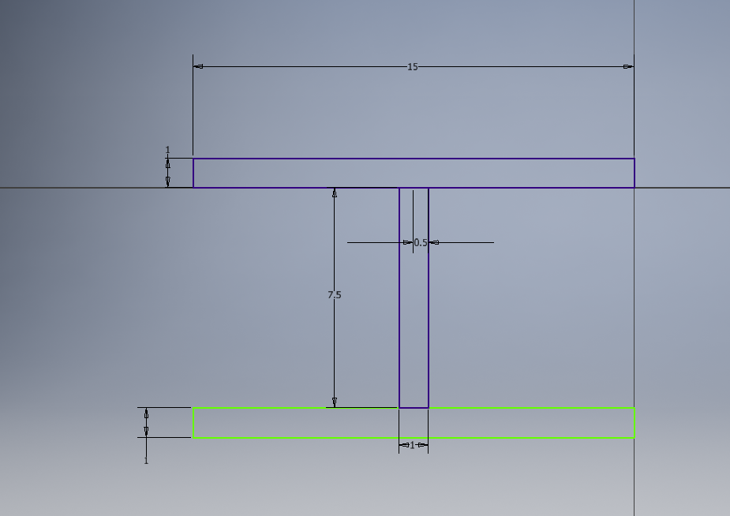
Material | Steel, Carbon
Density | 7.85 g/cm^3
Mass | 29.4375 kg
Area | 7775 cm^2
Volume | 3750 cm^3
Center of Gravity | x=7.5 cm  y=50 cm  z=3.75 cm
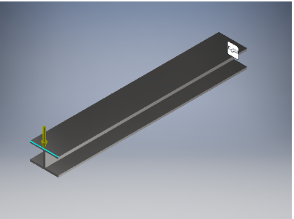

Analysis
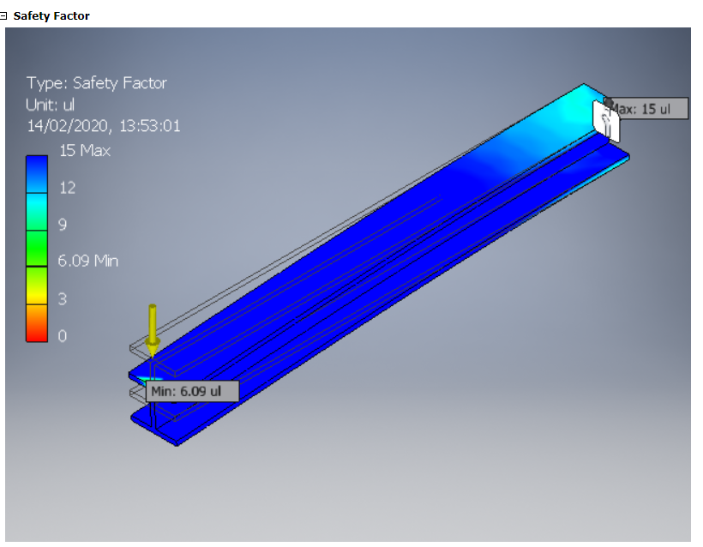
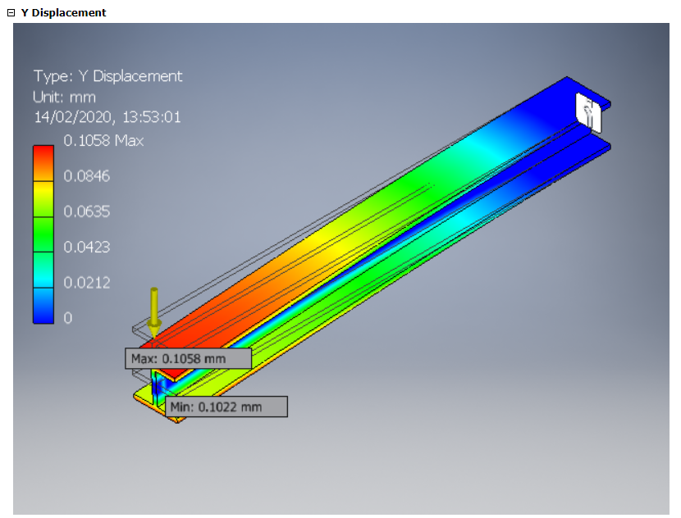
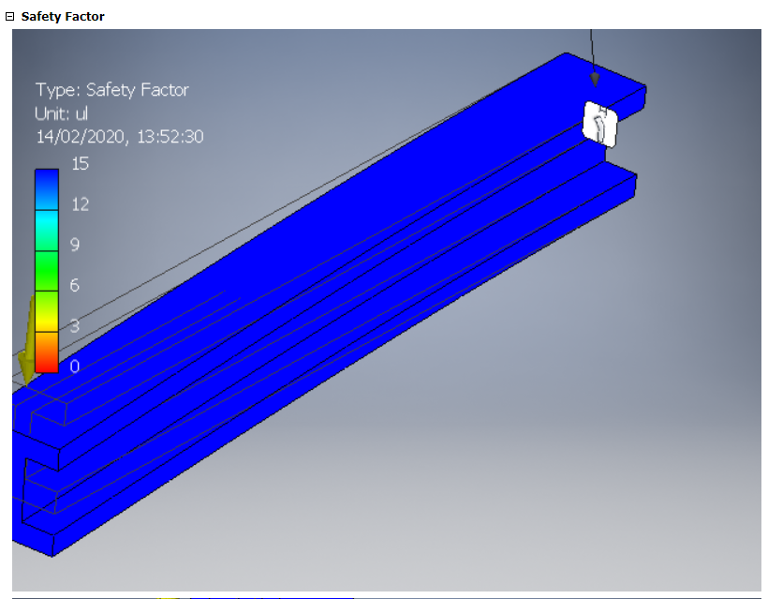
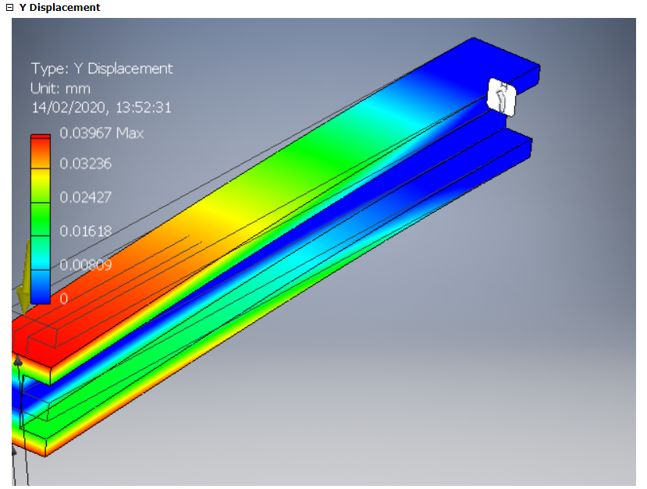
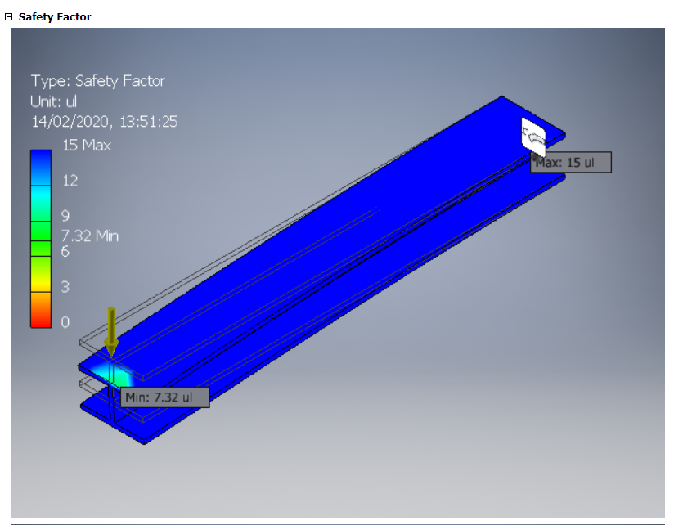
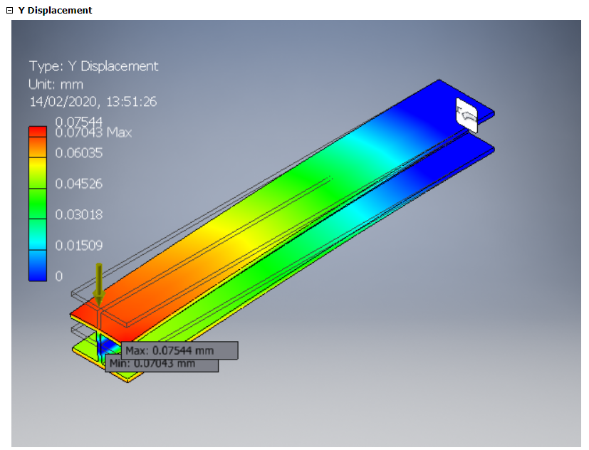

Conclusion

In conclusion I beam 2 had the least displacement at 0.03mm and a safety factor of 15. It was also the heaviest bar at 51.025kg. The other beams however had a safety factor of 6.09 for beam 1 and 7.32 for beam 3. The safety factor seems to correlate with the overall mass of the beams with a mass decrease there is a safety factor decrease. The design must however be cost effective and as 6.09 is a good safety factor I beam one will be chosen.

Task 2

Introduction

This section will cover how to build more efficiently. Using less material will firstly cost less to buy the raw material but it will also be more lightweight. An experiment will be carried out regarding beam deflection. Macaulay’s method will be used to determine the beam deflection and this will be compared against the results found in the experiment. Suggestions will be made on how the beam in the experiment withstand more load. All length measurements in this work will be written in millimetres (mm)

Equipment Used

In the experiment a S355 steel bar with the dimensions of 30mm thickness, 12 mm depth and 1,765mm length. Two 90mm height supports were also used in the experiment. Five 10 Newton (N) weight where used. A 300mm steel rule was also used during the experiment.

Procedure and Results

The experiment began by placing the S355 steel bar on the 90mm supports. The supports were placed at either end of the bar 1,765mm from each other. The Bar was positioned with the 30mm bar thickness dimension on the X axis (horizontal) plane and the 12mm bar depth dimension was placed in the Y axis (vertical) plane.
Measurements were taken at the supports to see how far the bottom of the bar was from the ground. It was found that the bar was 90mm from the ground at the supports. The distance from the centre bottom of the bar to the ground was then taken. This dimension was found to be 83mm.
Setup was complete. The first 10N weight was then placed in the centre of the bar and the distance from the centre bottom of the bar to the ground was then taken. This dimension was found to be 82mm. Next another 10N weight was placed on top of the first weight (equating to 20N load) and the distance was again measured. It was found to be 80.5mm. After that another 10N weight was placed on top of the second weight (equating to 30N load) and the distance was again measured. It was found to be 79.5mm. Another 10N weight was placed on top of the third weight (equating to 40N load) and the distance was again measured. It was found to be 78mm. Finally the last 10N weight was placed on top of the fourth (equating to 50N load) and the distance was again measured. It was found to be 76.5mm.
Once the first part of the experiment was complete the second phase could begin. The bar was unloaded of all weights and was flipped so that the 12mm bar depth was now in the X axis (horizontal) plane and the 30mm bar thickness was placed in the Y axis (vertical) plane.
Again measurements were taken at the supports and it was found to be 90mm. A measurement was also taken at the centre bottom of the bar to the ground and was found to be 88.5mm.
The first 10N weight was then placed in the centre of the bar and the distance from the centre bottom of the bar to the ground was then taken. This dimension was found to be 88.2mm. Next another 10N weight was placed on top of the first weight (equating to 20N load) and the distance was again measured. It was found to be 88mm. After that another 10N weight was placed on top of the second weight (equating to 30N load) and the distance was again measured. It was found to be 87.8mm. Another 10N weight was placed on top of the third weight (equating to 40N load) and the distance was again measured. It was found to be 87.5mm. Finally, the last 10N weight was placed on top of the fourth (equating to 50N load) and the distance was again measured. It was found to be 87.2mm.

Data analysis and Calculations

Below are tables and graphs that were produced from deflection experiments 1 and 2 to make the trends more visible.

Deflection Experiment 1
Weight (N) | Deflection (mm)
0 | 0
10 | 1
20 | 2.5
30 | 3.5
40 | 5
50 | 6.5

Deflection Experiment 2
Weight (N) | Deflection (mm)
0 | 0
10 | 0.3
20 | 0.5
30 | 0.7
40 | 1
50 | 1.3

Macaulay’s method.
$$EI \frac{d^{2}y}{dx^{2}} = 5x-10 \left(x-0.83\right)$$

Integration.
$$EI\frac{dy}{dx}=\frac{5x^{2}}{2}-10\frac{\left(x-0.83\right)}{2}+C1$$

Integration.
$$EIy=\frac{5x^{3}}{6}-10\frac{{\left(x-0.83\right)}^{3}}{6}+C1x+C2$$
Sub:
X=1.765
Y=0
C2=0

$$EI(0)=\frac{5{\left(1.765\right)}^{3}}{6}-10\frac{{\left(1.765-0.83\right)}^{3}}{6}+C1(1.765)+C2(0)$$

$$C1=4.985$$
Sub C1 = 4.985 into the equation.

$$EIy=\frac{{5(1.765)}^{3}}{6}-10\frac{{\left(1.765-0.83\right)}^{3}}{6}+4.985+C2$$

$$C2=\frac{10}{\frac{{5(1.765)}^{3}}{6}}-\frac{4.985}{\frac{{(1.765-0.83)}^{3}}{6}}$$

$$C2=-34.409$$

Conclusions

In conclusion the more weight that is added to the beam the more it will sag. The bar thickness in the y axis influences the sag more than the width in the x axis. The thicker the bar in the y axis the bar will significantly sag less. The thicker the bar in the x axis the bar will sag slightly less. This is shown by the graphs as the same bar was used and the sag was (6.5/1.3=5) 5 times greater with 50 Newtons on the bar when the bar was placed with the thick portion in the X plane and the thin portion in the Y plane. The sag increases in an almost linear fashion in both cases. Both experiments graphs are extremely similar shapes showing that sag can increase at in predictable (close to linear) increments when the force exerted on the beam is increased linearly. The graphs have been shown below side by side to show that the increase in beam deflection increases in a similar fashion despite the scale of sag being different between the two experiments. The slight difference in increase in deflection between the two experiments could be due to human error as a steel rule was used to measure the sag of the beam, however more research needs to be conducted to know if this is true.

These results would suggest that beam deflection can be predicted, however further research needs to be conducted to conclude this theory as fact.

Bibliography
Adnan Calik, A. D. (2009, 07 17). Effect of Carbon Content on the Mechanical Properties of Medium Carbon Steels. Retrieved from PDF: http://www.znaturforsch.com/s65a/s65a0468.pdf
Ho, Y. S. (2018, 08 07). What are the various ways to decrease deflection at the cantilever beam. Retrieved from Quora: https://www.quora.com/What-are-the-various-ways-to-decrease-deflection-at-the-cantilever-beam
Koutromanos, I. (2020, 02 07). Finite Element Analysis. Retrieved from Linear Finite Element Analysis: file:///C:/Users/ree14818461/Downloads/Fundamentals%20of%20Finite%20Element%20Analysis_%20Linear%20Finite%20Element%20Analysis%20(%20PDFDrive.com%20).pdf
Susrut. (2019, 2 6). What is the Cost of Stainless Steel vs Carbon Steel. Retrieved from Cost Finder: http://cost-finder.com/what-is-the-cost-of-stainless-steel-vs-carbon-steel/

