Homework sheet
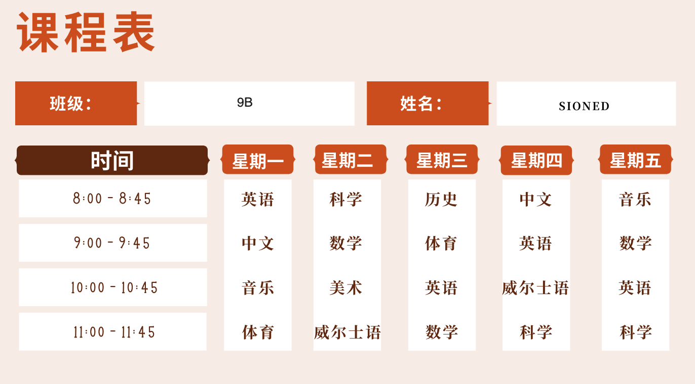
- Read the timetable below and circle True or False for these sentences.

1. Sioned 星期一八点上英语课。 True False
2. Sioned星期二上中文课。 True False
3. Sioned星期三十点上体育课。 True False
4. Sioned星期四十一点上科学课。 True False
5. Sioned星期五七点上音乐课。 True False
- Listen to the audio and fill in the information
tāmen zài nǎr gōng zuò
他们在哪儿工作？

wēiěrshì yīnggélán sūgélán zhōngguó
A. 威尔士 B. 英格兰 C. 苏格兰 D. 中国

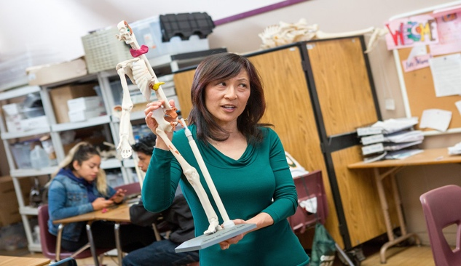
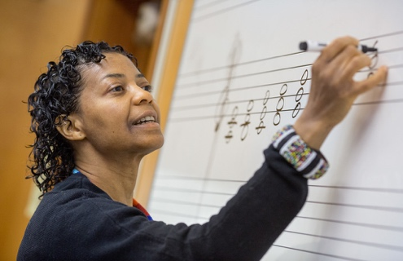
This Photo by Unknown Author is licensed under CC BY-NC
This Photo by Unknown Author is licensed under CC BY-NC

This Photo by Unknown Author is licensed under CC BY-SA-NC

Name: Name:
Location: Location:


This Photo by Unknown Author is licensed under CC BY-SA-NC
This Photo by Unknown Author is licensed under CC BY

Name: Name:
Location: Location:

3. Type a paragraph to introduce yourself and your family. Then recording yourself reading it afterwards. (Please feel free to look up the words you are not sure about, e.g.: jobs and adjectives that are not included in our lesson. I will give you some feedback on that afterwards.)
you can talk about:
- your name
- your nationality
- your age
- your job and location
- the subject you teach
- people in your family (What are they like? What are their jobs?)
- your pet

4. Cultural study
https://youtu.be/vI9atXXt6Lg

