

Student Name: Vedant Rakesh Patel

Student ID: 2437457

Module Name: International Business Concepts

Module Code: LCMB7034

Lecturer’s Name: Akshay Narayanan (London)

Work Count: 5482

Term 2

Table of Content
INTRODUCTION 10
1. Overview of the Company - BMW 10
1. Country A – BMW Operations in Russia 11
2. Country A – BMW Operations in Canada 12
2. The Macroenvironment (PESTLE) Analysis of BMW 13
2.1 Political Factors 15
2.1.1 Russia 15
2.1.2 Canada 16
2.2 Economic Factors 17
2.2.1 Russia 18
2.2.2 Canada 19
2.3 Social Factors 20
2.3.1 Russia 20
2.3.2 Canada 21
2.3.3 Social Environment Analysis 22
2.3.3.1 Changing Social Trends in Russia 22
2.3.4 Cultural Environment Analysis 23
2.3.4.1 Hofstede model 23
2.3.4.2 Advantages and disadvantages of Hofstede Model 24
2.3.4.3 Hofstede Model Analysis 25
2.3.4.4 Cultural Factors in Russia 26
2.3.4.5 Cultural Factors in Canada 27
2.3.4.6 Similarities and Differences of cultures between the Two Markets 28
2.4 Technological Factors 29
2.4.1 Russia 29
2.4.2 Canada 30
2.5 Legal Factors 31
2.5.1 Russia 31
2.5.2 Canada 32
2.6 Environmental Factors 33
2.6.1 Russia 34
2.6.2 Canda 35
2.7 Similarities and Differences in PESTLE Factors – Russia vs Canada (BMW) 36
3. Comparison of BMW’s STP Strategies in Country A and Country B 37
3.1 Segmentation Strategies 37
3.1.1 VALS-2 Personality Types Under Psychographic Segmentation 38
3.1.2 Segmentation Strategies for BMW in Russia and Canada 39
3.2 Targeting Strategies 41
3.2.1 Russia 42
3.2.2 Canada 43
3.3 Positioning Strategies 44
3.4 Comparative Summary: Similarities and Differences in STP 45
4. Comparison of Marketing Mix Strategies in Country A and Country B 47
4.1 Product Strategy 47
4.1.1 Russia 47
4.1.2 Canada 48
4.1.3 Product Variety, Depth & Width 48
4.1.3.1 Russia 49
4.1.3.2 Canada 49
4.1.3.3 Main Differences Between Russia and Canada 50
4.1.4 Product Design 51
4.1.4.1 Russia 51
4.1.4.2 Canada 51
4.1.5 Branding Strategies 52
4.1.5.1 Branding Strategies in Russia and Canada 52
4.1.5.2 Branding Strategy in Russia 52
4.1.5.3 Branding Strategy in Canada 53
4.2 Price Strategy 54
4.2.1 Russia 54
4.2.2 Canada 55
4.3 Place (Distribution) Strategy Definition 56
4.3.1 Russia 56
4.3.2 Canada 57
4.3.3 Direct vs Indirect Channels & Intensive Distribution – BMW in Russia and Canada 58
4.3.4 Which Market Entry Method? 59
4.3.4.1 Advantages and Disadvantages of This Entry Method (Canada) 60
4.4 Promotion Strategy 61
4.4.1 Russia 61
4.4.2 Canada 62
4.4.3 Promotion Evaluation Table 63
4.5 People Strategy 64
4.5.1 Russia 64
4.5.2 Canada 65
4.6 Process Strategy 66
4.6.1 Russia 66
4.6.2 Canada 67
4.7 Physical Evidence Strategy 69
4.7.1 Russia 69
4.7.2 Canada 71
4.8 Similarities and Differences in the 7Ps – BMW in Russia vs Canada 71
4.9 Evaluation of Marketing Strategies 73
4.9.1 Russia 73
4.9.2 Canada 73
4.10 Profit and Sales 74
4.10.1 Russia 74
4.10.2 Canada 75
4.11 Social Media Engagement 76
4.11.1 Russia 76
4.11.2 Canada 76
4.12 Customer Reviews 76
4.12.1 Russia 76
4.12.2 Canada 77
5. Ethics of Canada 78
6. Recommendations 80
6.1 Recommendations – Russia (Country A) 80
6.2 Recommendations – Canada (Country B) 81
7. Conclusion 81
References 83
List if Figures
Figure 1: BMW Logo 10
Figure 2: PESTLE Analysis 13
Figure 3: PESTLE Analysis Definition 13
Figure 4: Comparative Summary of Favourable and Unfavourable Factors – Russia vs Canada 14
Figure 5: Political Factors 15
Figure 6: Russian Auto Industry Crisis 16
Figure 7: Canada EV Industry Challenges 17
Figure 8: Economic Factors 17
Figure 9: Russia’s Economic Growth 18
Figure 10: Canada’s GDP vs Population Growth 19
Figure 11: Social Factors 20
Figure 12: Russia Auto Market Upheaval 21
Figure 13: Canadian Millennial Auto Consumers 22
Figure 14: Hofstede model definition 23
Figure 15: Hofstede model 23
Figure 16: Hofstede Model Analysis 25
Figure 17: Russia Auto Brand Shift 26
Figure 18: Canada Automotive Manufacturing Landscape 27
Figure 19: Technological Factors 29
Figure 20: BMW Russia Production Technology 29
Figure 21: BMW Cana Technology 30
Figure 22: Legal Factors 31
Figure 23: Russia Auto Regulatory Constraints 32
Figure 24: Canada Vehicle Compliance Framework 33
Figure 25: Environmental Factors 33
Figure 26: BMW Avtotor Russia Plant 34
Figure 27: BMW Canda Sustainability and Renewables 35
Figure 28: VALS-2 Personality Types 38
Figure 29: BMW Russia High end buyers 43
Figure 30: BMW Canada Luxury Marketing 43
Figure 31: Definition of Perceptual Map 44
Figure 32: Perceptual map 44
Figure 33: Product Strategy Definition 47
Figure 34: BMW luxury sedans 47
Figure 35: BMW Canada 48
Figure 36: Product Variety, Depth & Width Definition 49
Figure 37: BMW X Series 49
Figure 38: BMW Canada wide range 50
Figure 39: Product Design Definition 51
Figure 40: Russia Parallel Import Market 52
Figure 41: BMW Canada Media Strategy 53
Figure 42: Price Strategy Definition 54
Figure 43: BMW Russia Price Strategy 55
Figure 44: BMW Canada Price Strategy 55
Figure 45: Place (Distribution) Strategy Definition 56
Figure 46: BMW Russia Distribution Diagram 57
Figure 47: BMW Canada Distribution Diagram 57
Figure 48: Wholly owned subsidiaries 59
Figure 49: Promotion Strategy Definition 61
Figure 50: Russia BMW social media 62
Figure 51: Canada BMW social media 63
Figure 52: People Strategy Definition 64
Figure 53: BMW Russia People Strategy 65
Figure 54: Promotion Strategy Definition 66
Figure 55: Customer Complaint Process – Russia 67
Figure 56: Customer Complaint Process – Canada 68
Figure 57: Physical Evidence Strategy Definition 69
Figure 58: BMW Russia Former Dealership 70
Figure 59: BMW Canada EV models 71
Figure 60: Russia Sales BMW 74
Figure 61: BMW Canada Financial Performance 75
Figure 62: BMW Russia Customer Reviews 77
Figure 63: BMW Canada Customer Reviews 78
Figure 64: Ethical vs Unethical Marketing Definitions 78

List of Tables
Table 1: Similarities and Differences of cultures between the Two Markets 28
Table 2: Similarities and Differences in PESTLE Factors – Russia vs Canada (BMW) 37
Table 3: Segmentation Strategies for BMW in Russia and Canada 41
Table 4: Differentiation and undifferentiation strategies 42
Table 5: Comparative Summary: Similarities and Differences in STP 46
Table 6: Main Differences Between Russia and Canada 51
Table 7: Direct vs Indirect Channels & Intensive Distribution – BMW in Russia and Canada 59
Table 8: Promotion Evaluation 64
Table 9: Similarities and Differences in the 7Ps – BMW in Russia vs Canada 73
Table 10: Examples of Ethical and Unethical Marketing Practices Using STP and 7Ps 80

INTRODUCTION
This report examines the international marketing strategies implemented by the automobile company BMW through the analysis of its operations in two different and contrasting markets: Russia and Canada. As a global leader in the premium automotive manufacturing industry, BMW faces a range of macroenvironmental conditions, cultural factors, and regulations that drive its international performance. The report considers the external environments of the company by using the PESTLE, social and cultural analysis and use the STP framework and the 7Ps marketing mix to compare the strategic response of the BMW company in both countries. By diving into differences in market behaviour, geopolitical influences and consumer expectations, this report identifies key challenges and opportunities as well as data-driven recommendations to improve BMW's global marketing effectiveness.

1. Overview of the Company - BMW
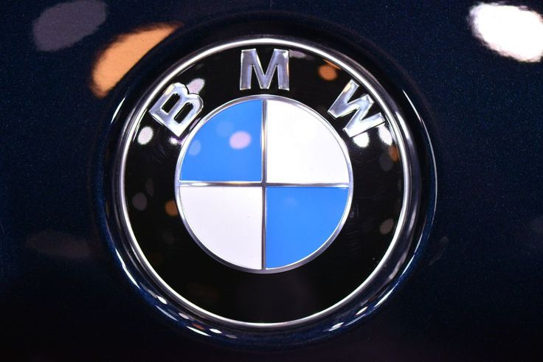
Figure 1: BMW Logo
(Source: BMW Group, 2025)
BMW Group (Bayrechsche Motoren Werke AG) is one of the biggest German multinational vehicle producers and is reputable because of its innovative revolution, engineering, and strong sustainability dedication (BMW Group, 2025). The Group was founded in 1916 and manages over 140 countries and has a portfolio of brands, including BMW, MINI, and Rolls-Royce (Li, 2025). The efficiency continued technological improvement, and the international regulatory standards are the pillars of the operational set up of the Group. It has been varying levels of success with strategic expansion in various parts of the world - more specifically in Europe, North America, and Asia. However, the geopolitical tensions have been bringing significant challenges in particular regions such as Russia, however other regions such as Canada continue to represent significant growth drivers (Quinn, 2025).
BMW Vision
Most commonly refers to the Vision Neue Klasse, a concept car family showcasing the company's future direction towards electric, digital, and sustainable mobility

(Source: BMW Group, 2025)
This report is an analysis of BMW in Canada and in Russia: the background of the company, its operation and its market presence. It provides a comparison of PESTLE environments, STP, and 7ps; it analyses the performance (sales, share, dealer networks, EV uptake) and ethical concerns (sanctions compliance). It ends with recommendations supported by data regarding the international marketing strategy including pricing, communication, positioning, digital branding, sustainability.

1. Country A – BMW Operations in Russia
BMW entered the Russian market under a manufacturing cooperation with Avtotor in Kaliningrad and started production in August 1999 with the 5 Series and 7 Series. Subsequent expansion of production output included the 3 Series of later generations of 5 and 7 Series, and the X models. In 2014, BMW Group Russia developed a strong distribution system with 63 dealerships in 39 cities. However, when dealing with economic uncertainty, BMW had to delay their 2015 intentions of a wholly owned manufacturing plant in Russia and instead continue their partnership with Avtotor.
Operations relied mainly on semi-knockdown assembly kits that were sent to Avtotor for local distribution (Boston, 2022). Subsequent to the invasion of Ukraine by Russia in 2022, BMW suspended all its exports and domestic production, citing disrupted supply chain and geopolitical hostilities as reasons for the suspension (BMW Group, 2023). This action was a step back from core manufacturing and distribution operations once and for all.
In 2024, BMW faced reputational and regulatory challenges after selling over one hundred luxury cars to Russian buyers through the agency of sales, therefore violating EU sanctions (Lahiri, 2024). Such incidents shed light on the ongoing grey-market operations using transit jurisdictions and were related to revenue loss in addition to a reduced corporate presence today that has mainly been relegated to financial services (BMW Group, 2023).

2. Country A – BMW Operations in Canada
The first entry of BMW in the Canadian market was the side opening of its first dealership in Ottawa in 1969. Formalization of the corporate presence came in 1986 with the formation of BMW Canada Inc. as a wholly owned subsidiary of the parent company, BMW AG. The company is based in Richmond Hill, Ontario, and later grew its lineup to include MINI and BMW Motorrad, enabling nationwide control of the brand and generating long-themed sales expansion.
BMW Group Canada operates one of the brand’s most stable markets, supported by a LEED-certified facility opened in 2010 and employing over 250 staff across sales, marketing, and financial services (BMW Group Canada, 2025). The company manages an extensive national network of BMW, MINI, and Motorrad dealerships.
By Q3 2025, BMW Canada recorded vehicle sales growth of 5.9%, driven by strong demand for M models and electric vehicles such as the i4 and iX (BMW Group Canada, 2025). Despite facing US tariff pressures on X-series imports, BMW’s adaptability and innovation underpin its sustained performance (Kennedy, 2025; Adil and Hussain, 2024).

2. The Macroenvironment (PESTLE) Analysis of BMW
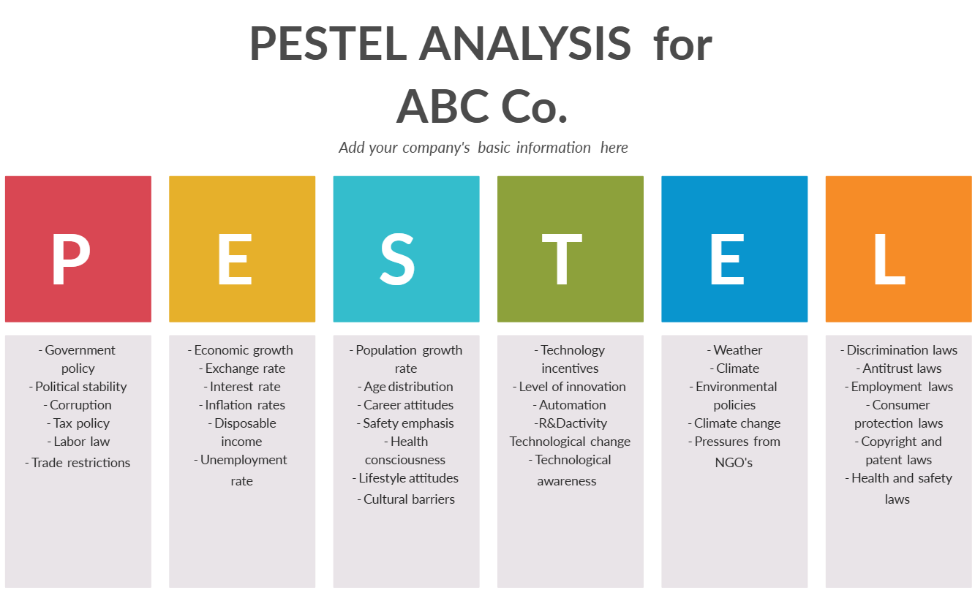
Figure 2: PESTLE Analysis
(Source: Dubetcky, O., 2024)
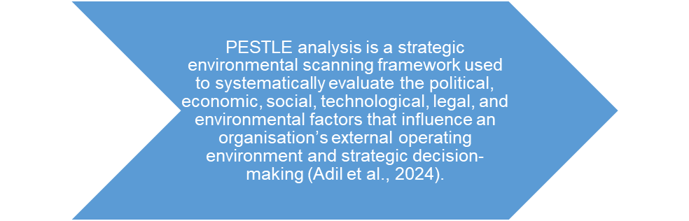
Figure 3: PESTLE Analysis Definition
(Created by learner)
Comparative Summary of Favourable and Unfavourable Factors – Russia vs Canada
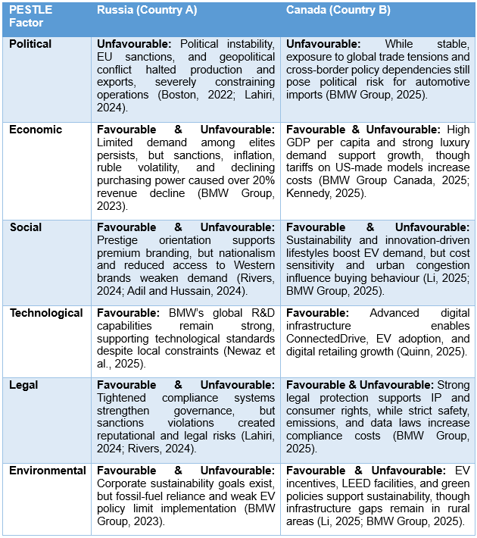
Figure 4: Comparative Summary of Favourable and Unfavourable Factors – Russia vs Canada
(Created by learner)

2.1 Political Factors
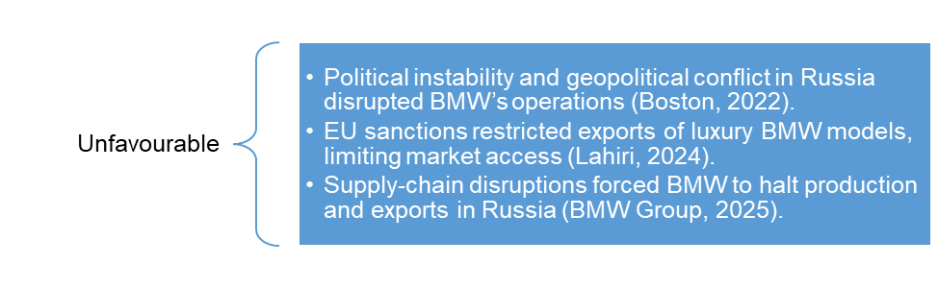
Figure 5: Political Factors
(Created by learner)

2.1.1 Russia
BMW's international activities are heavily influenced by the prevailing situation of political stability, governmental policy parameters and international diplomatic relations in each target market. In the Russian context, political uncertainty and international sanctions have created major obstacles to the continuity of business operations. After the Russian incursion into Ukraine in 2022, BMW halted both production and export activities directed towards Russia, thus terminating its longstanding collaboration with Avtotor in Kaliningrad (Boston, 2022). The European Union fines limited the export of cars whose engines had capacities over 1,900‛cubiccentimeters which directly hampered the ability of BMW to sell its high-end models (Lahiri, 2024). Such regulatory limitations, together with the disruptions in supply-chains, have significantly cost BMW its presence and earnings in the Russian market.
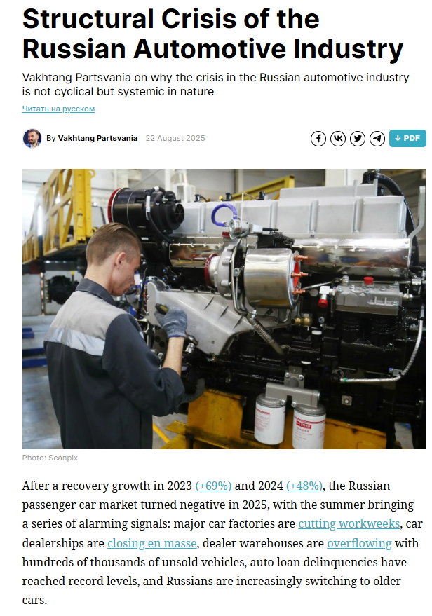
Figure 6: Russian Auto Industry Crisis
(Source: Partsvania, V., 2025)

2.1.2 Canada
In Canada, BMW benefits from a steady political environment, with business-friendly policy, enabling foreign investment and helping to promote sustainable practices. The Canadian involvement in the international trade accords such as the United States-Mexico-Canada Agreement (USMCA) has facilitated the streamlined importation of BMW vehicles manufactured in the United States (Kennedy, 2025). The Canadian government also offers tax break on the purchase of electric vehicles (EVs) therefore helping in the green transition plan by BMW (Li, 2025). As a result, Russia and Canada have different the risks of political instability and regulatory risk due to the favorable environment to grow BMW in the long term, respectively (BMW Group, 2025).
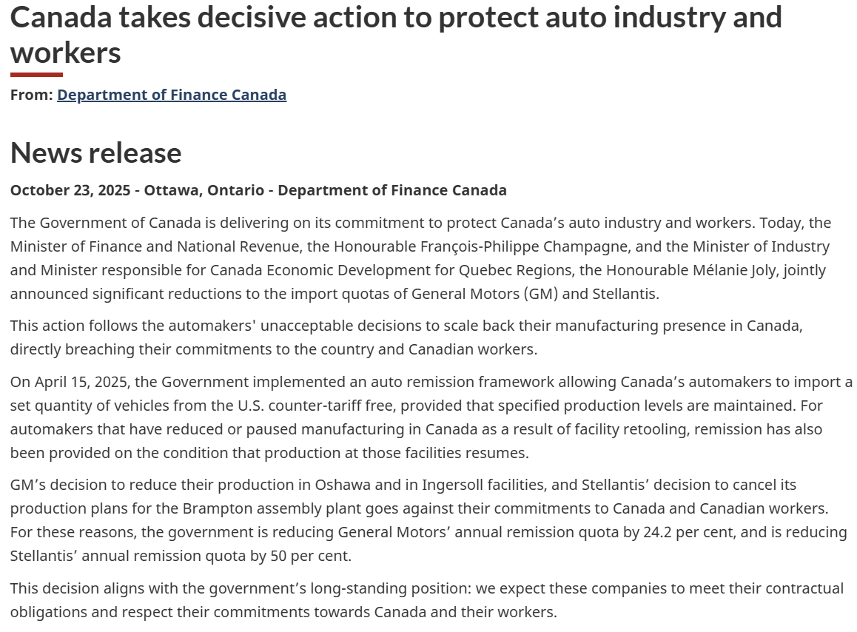
Figure 7: Canada EV Industry Challenges
(Source: Zeifmans LLP, 2025)

2.2 Economic Factors
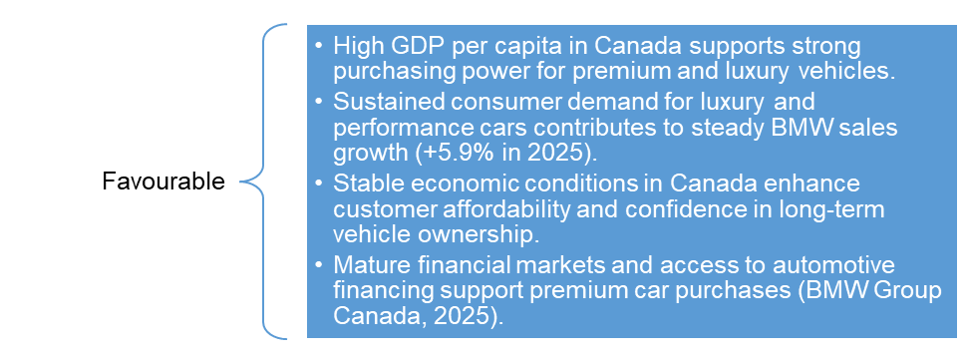
Figure 8: Economic Factors
(Created by learner)

2.2.1 Russia
Economic conditions have a great impact on BMW's pricing strategy as well as production strategy and consumer demand. In the Russian market, the national economy has been severely affected by sanctions, currency depreciation, and rising inflationary pressure since 2022. As a result, increased volatility of the ruble and limited access to Western banking infrastructures have reduced the consumer's purchasing power when it comes to imported luxury vehicles (BMW Group, 2023). As a result, the revenues made by BMW in Russia have reduced over 20-percent between 2023 and 2024 (BMW Group, 2023). The above circumstances have forced BMW to consider the low volume, all service, operational paradigm in Russia, hence maintaining minimal financial service operations, including those undertaken by BMW Bank.
Russia’s Economic Growth
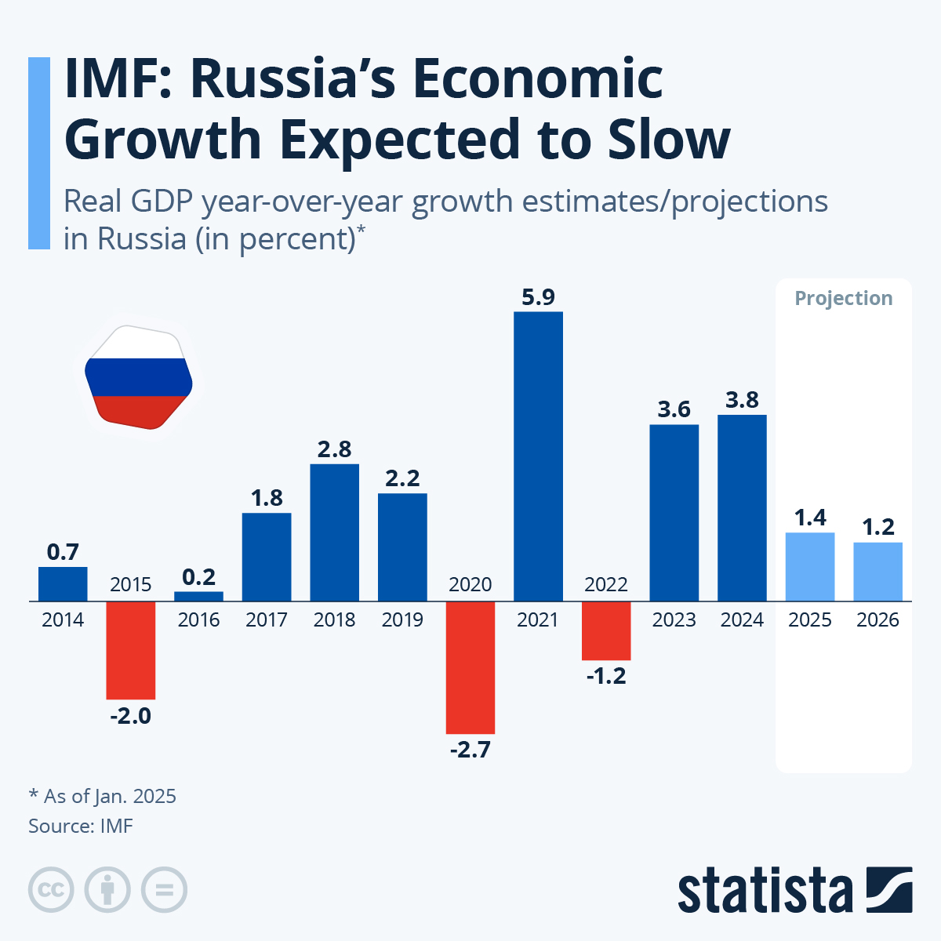
Figure 9: Russia’s Economic Growth
(Source: Fleck, A., 2025)
The chart illustrates Russia's varied increased GDP growth, with strong GDP growth in 2021 (5.9%), followed by slumps as a result of sanctions and geopolitical conflicts, including a decrease of b-1.2% in 2022. Growth levels off somewhat in 2023-2024 but is expected to slow down considerably to 1.4% in 2025 and 1.2% in 2026.

2.2.2 Canada
On the contrary, the economy of Canada is quite strong as evidenced by high GDP per capita and growing consumer spending on luxury items. Canadian automotive market is driven by the consistent growth in the disposable incomes, minimal inflationary forces, and an already growing need in sustainable means of mobility (BMW Group Canada, 2025). Despite the increase in the tariff rates of various models of imported BMW cars in the U.S., such as the X3 and X5, operating costs have increased, but the premium segment has still exhibited strong performance (Kennedy, 2025). The stable 5.9% rise in the sales of BMW vehicles by Q3 2025 is a mark of the resilience of the brand and its correlation with the overall economic situation in the country (BMW Group Canada, 2025).
Canada’s GDP vs Population Growth
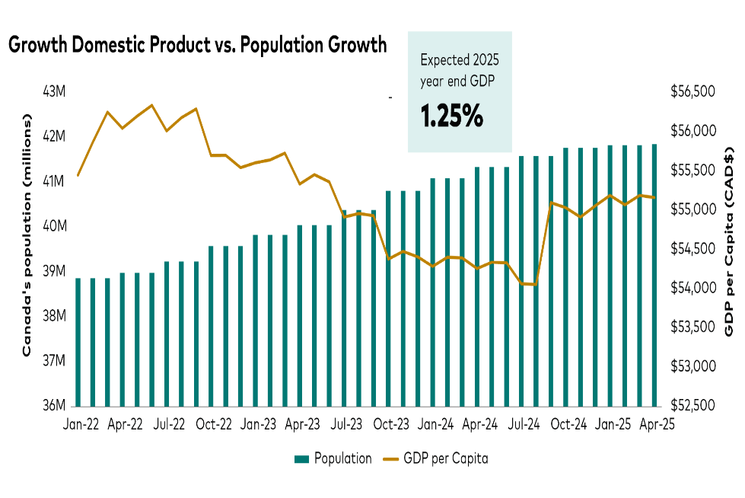
Figure 10: Canada’s GDP vs Population Growth
(Source: Dewan, A., 2025)
The population growth of Canada is continuous between 2022 and 2025, whereas the GDP per capita is not high but relatively good, ranging between CAD $54,000 and 55,500. The trend shows that it is resilient despite the economic pressure. The forecasted GDP growth in the year 2025 will be 1.25 as it shows that there is a stable economic performance that will be based on increase in population and stable consumer purchasing power.

2.3 Social Factors
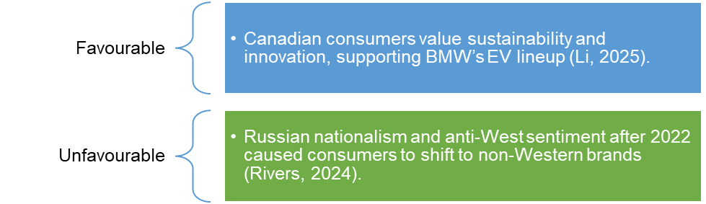
Figure 11: Social Factors
(Created by learner)

2.3.1 Russia
Social dynamics such as lifestyle choices, demographics and cultural critiques towards sustainability define BMW's consumer base. In Russia, the brand's clientele mainly comprises wealthy urban consumers who consider BMW as a symbol of prestige and social status (Adil and Hussain, 2024). However, the ongoing geopolitical crisis has shifted the mood of consumers, with some consumers linking Western brands to political resentment or economic elitism (Rivers, 2024). Moreover, hard access to Western imports has contributed to the growth of Chinese alternatives in Russia's luxury auto market.
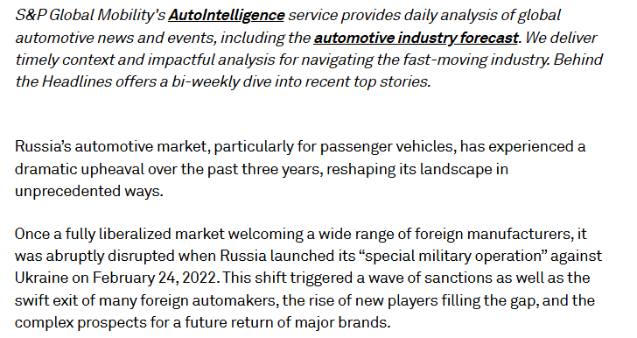
Figure 12: Russia Auto Market Upheaval
(Source: Urquhart, T. 2025)

2.3.2 Canada
The social values in Canada are closely related to innovativeness, environmental friendliness, and inclusivity. There is a social trend of eco-friendly lifestyles that is increasingly turning to hybrid and electric models like the BMW i4 and iX among the Canadian consumers (Li, 2025). The increasing number of young professionals and immigrants also increased the target audience as they are attracted to technological functions developed by the brand and its international image (BMW Group, 2025). Additional community work and sports and sustainability related sponsorships by BMW also increase its accessibility and brand loyalty in Canada (BMW Group, 2025).
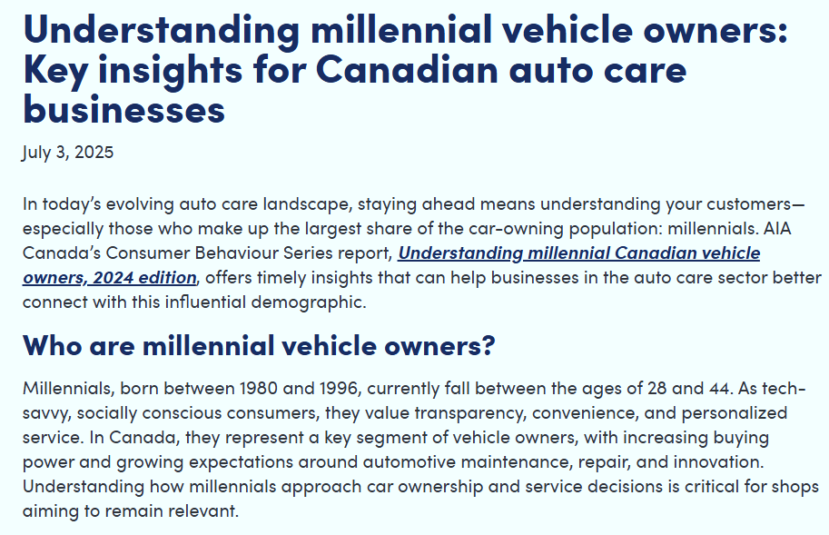
Figure 13: Canadian Millennial Auto Consumers
(Source: Automotive Industries Association of Canada, 2025)

2.3.3 Social Environment Analysis

2.3.3.1 Changing Social Trends in Russia
Russia's social environment has changed because of political and economic instability and luxury consumption has decreased an overall demand for premium vehicles is weakened (BMW Group, 2023). Sanctions and shrinking incomes have driven the hand of constraint, while nationalistic inclinations have driven domestic and non-Western brands (Rivers, 2024). Although rich consumers still favour the use of high-performance cars, affordability pressure and limited access to imports has limited the market growth (Boston, 2022).

2.3.3.2 Changing Social Trends in Canada
The Canadian society is highly promoting sustainability, diversity, and digital-based lifestyles, majoring in the demand of BMW electric and hybrid models (Li, 2025). Younger customers are more focused on the sustainability and ethical brands, which points to the sustainability concept of BMW (BMW Group Canada, 2025). Inclusive marketing and interest in smaller, energy-saving vehicles with high-quality digital services is also affected by Canada as a multicultural society and flexible urban lifestyle (Adil and Hussain, 2024).

2.3.4 Cultural Environment Analysis

2.3.4.1 Hofstede model
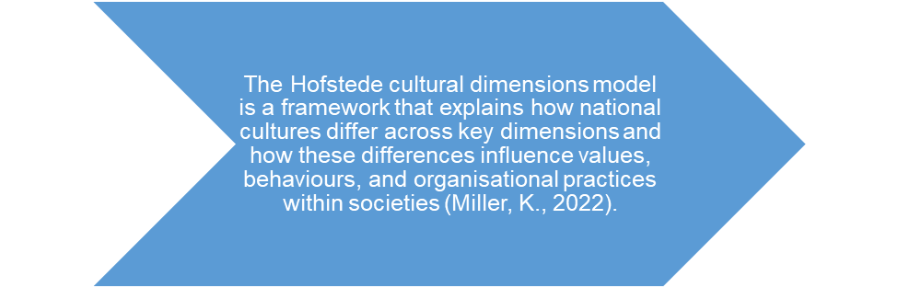
Figure 14: Hofstede model definition
(Created by learner)
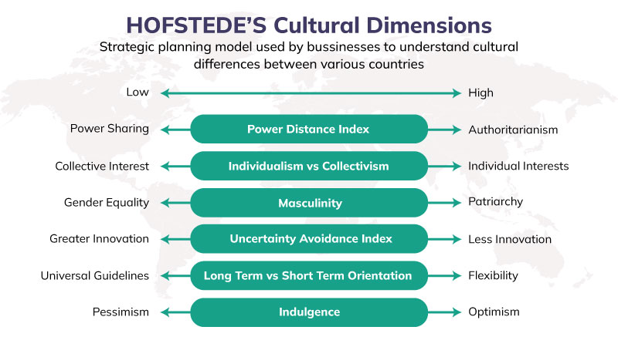
Figure 15: Hofstede model
(Source: Miller, K., 2022)

2.3.4.2 Advantages and disadvantages of Hofstede Model
Advantages of the Hofstede Model
- Offers a clear and systematic way of comparing the national cultures along their measurable dimensions, to facilitate international management and marketing decisions (Hofstede, 2011).
- Helps multinational organizations anticipate cultural differences that might have a bearing on leadership, communication and workplace behaviour (Adil et al., 2024).
- Widely employed and supported by empirical evidence, therefore, a practical reference in cross-cultural research and in global business studies (Hofstede et al., 2010).
Disadvantages of the Hofstede Model
- The method is rooted on national averages a methodology that can simplify cultural differences and hide regional or individual differences within nations (McSweeney, 2002).
- Its empirical basis is based on information initially collected on one multinational company and as such limits its representativeness and reduces its current topicality (McSweeney, 2002).
- It can have a weak representation of cultural changes over time or effects of globalization and digitalization on modern communities (Adil et al., 2024).

2.3.4.3 Hofstede Model Analysis
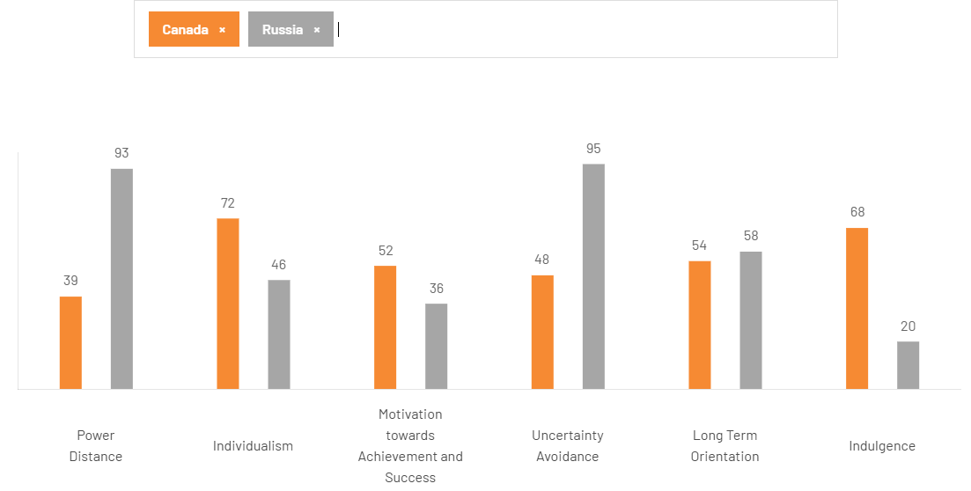
Figure 16: Hofstede Model Analysis
(Created by learner)
The Hofstede cultural dimension scores paint a definite contrast between Canada and Russia, and these scores influence BMW's management and what they do in the market. If we look at how power distance is displayed in Canada or Russia overall, Canada's low power distance (39) signals egalitarian values, promoting such leadership styles as participative and empowering employees, whereas Russia's very high power distance (93) signals hierarchical structures and centralised decision making (Hofstede et al., 2010). The individualism score of Canada is relatively high 72 and this basis the orientation towards autonomy, innovation, and personal achievement, whilst the collectivist orientation of Russia has a score of 46 and prefigures loyalty, authority, and group dependence.
Russia's very high level of uncertainty avoidance (95) indicates a level of uncertainty, risk aversion, and reliance on formal rules that is totally opposite to that found in Canada (48) and thus it supports flexibility and adaptability. Canada with 68 is a stronger indulgence whereas Russia with 20 is a lower score reflecting the culture preferences of restraint and social control. Differences in the long-term orientation are another indication of Canada's balanced pragmatism compared to Russia's more future-oriented persistence (Hofstede, 2011).

2.3.4.4 Cultural Factors in Russia
Russian culture is typified by high power distance and high uncertainty avoidance that support hierarchical leadership, formal authority and risk aversive decision making (Hofstede, 2011). Collectivist tendencies embrace loyalty and obedience whereas low dimension of indulgence underscores modest lives and soft discretionary expenditure. These cultural qualities shape consumer behaviour and organisational activities therefore requiring organised governance and strong regulatory adherence of organisations like BMW (Hofstede et al., 2010).
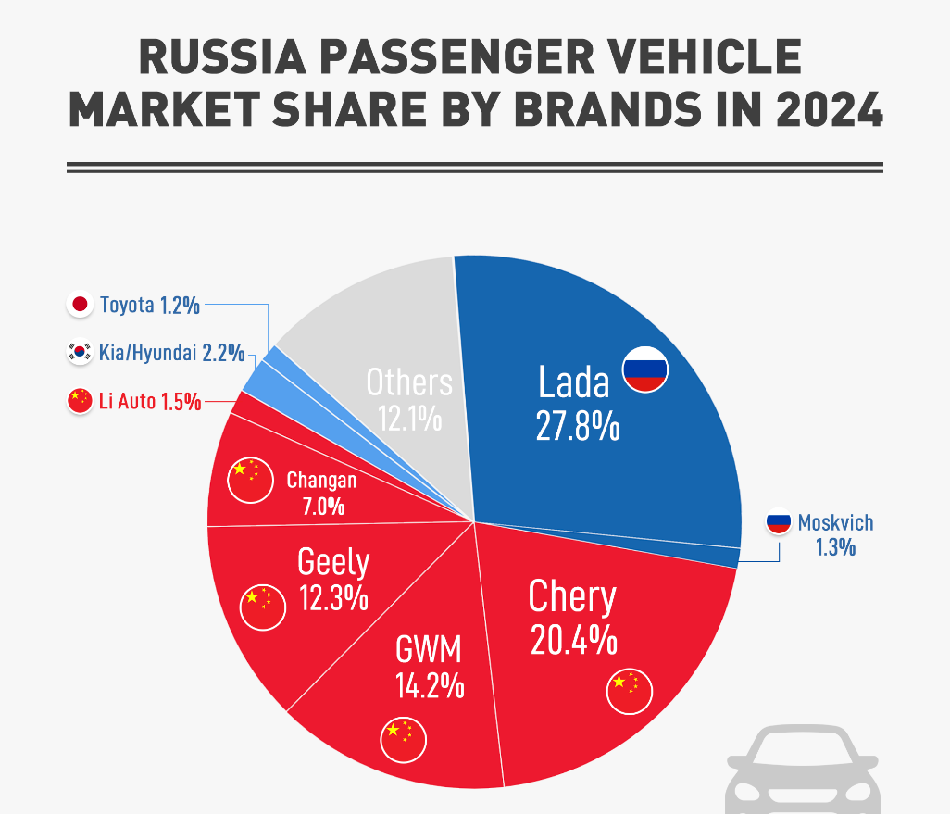
Figure 17: Russia Auto Brand Shift
(Source:

2.3.4.5 Cultural Factors in Canada
Canada's culture has proved to have a low power distance and high individualism; there is equality, autonomy and participative leadership constructs (Hofstede, 2011). Moderate scores in uncertainty avoidance allow for flexibility and innovation, while a high indulgence dimension encourages consumer preferences for lifestyle-oriented consumerism. Multiculturalism and inclusivity influence ethical branding and sustainable consumption further, which is aligned with BMW's customer-centric and innovation-driven approach in the Canadian market (Adil et al., 2024).
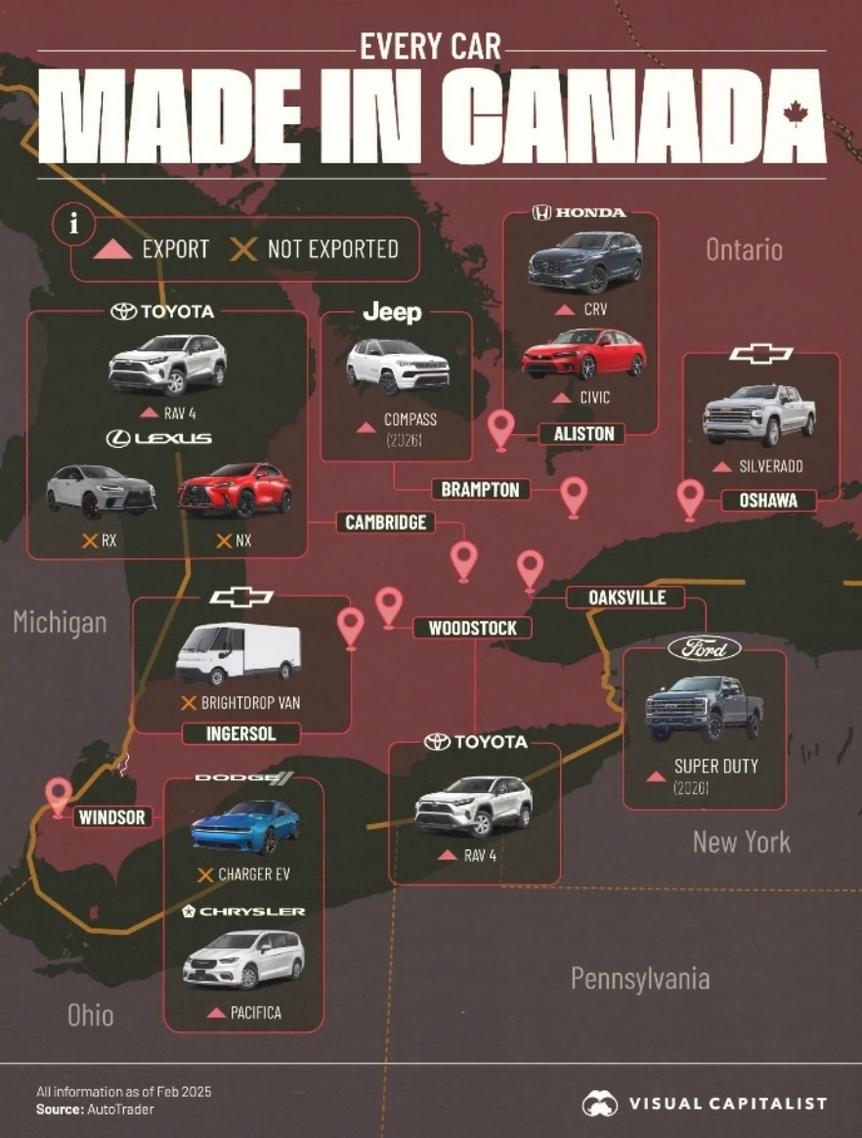
Figure 18: Canada Automotive Manufacturing Landscape
(Source: Voronoi, 2025)

2.3.4.6 Similarities and Differences of cultures between the Two Markets
Aspect | Similarities (Russia & Canada) | Differences between Russia and Canada
Cultural Framework | Both cultures can be systematically analysed using Hofstede’s cultural dimensions to inform international management and marketing decisions (Hofstede, 2011). | Russia scores very high on power distance, while Canada demonstrates low power distance, favouring egalitarian relationships (Hofstede et al., 2010).
Decision-Making Style | In both markets, organisations value clarity in roles and expectations to ensure operational effectiveness (Adil and Hussain, 2024). | Russia favours centralised, top-down decision-making, whereas Canada supports participative and decentralised approaches (Hofstede, 2011).
Risk & Uncertainty | Both societies recognise the importance of rules and stability in organisational operations (Hofstede et al., 2010). | Russia exhibits very high uncertainty avoidance, while Canada shows moderate tolerance for risk and flexibility (Hofstede, 2011).
Individual vs Collective Values | Social norms and group belonging influence workplace behaviour in both countries (Adil and Hussain, 2024). | Canada is highly individualistic, encouraging personal initiative, while Russia is more collectivist, emphasising loyalty and authority (Hofstede et al., 2010).
Lifestyle Orientation | Consumers in both markets associate premium brands with status and quality (BMW Group, 2025). | Canada’s high indulgence supports lifestyle-driven consumption, whereas Russia’s low indulgence reflects restrained social norms (Hofstede, 2011).
Table 1: Similarities and Differences of cultures between the Two Markets
(Created by learner)

2.4 Technological Factors
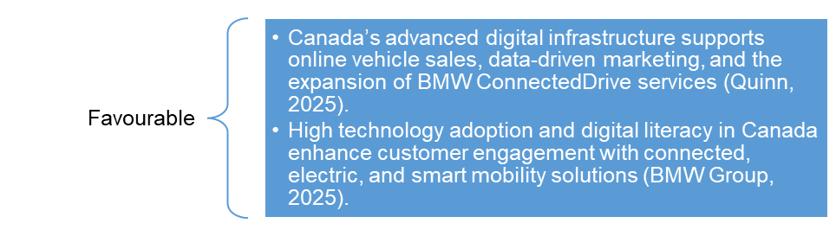
Figure 19: Technological Factors
(Created by learner)

2.4.1 Russia
The use of technology is a critical triggering factor in the innovation and competitiveness of BMW. At the international level, BMW invests heavily in electric mobility, autonomous driving and connected vehicle systems through their research and development (Newaz et al., 2025). In the Russian background, transfer of technology has been significantly restricted due to trade barriers and erosion of partnership with the suppliers in the West. This isolation, in turn, has hindered the local innovation, making it difficult to sustain the high level of production at the plant of Avtotor (BMW Group, 2023).
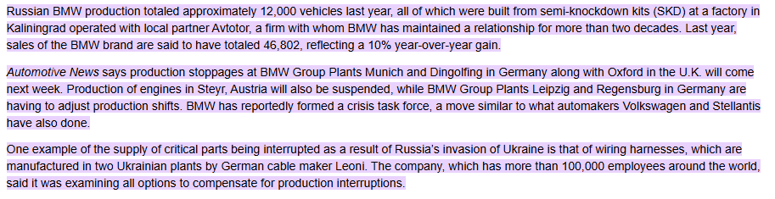
Figure 20: BMW Russia Production Technology
(Source: Taylor, J., 2025)

2.4.2 Canada
Contrastingly, Canada enjoys BMW's state-of-the-art technology advances and digitalisation, with a high focus on sustainability. The launch of the all-electric iX3 50xDrive and i4M50 is part of BMW's strategic integration of green technologies in Canada (BMW Group Canada, 2025). The advanced digital infrastructure in the Canadian market also facilitates the introduction of BMW's ConnectedDrive services and digital retailing channels (Quinn, 2025). The brand's collaboration with other local technology companies has improved the user experience with smart service apps, thus underscoring the company's adaptability to the new digital ecosystem.
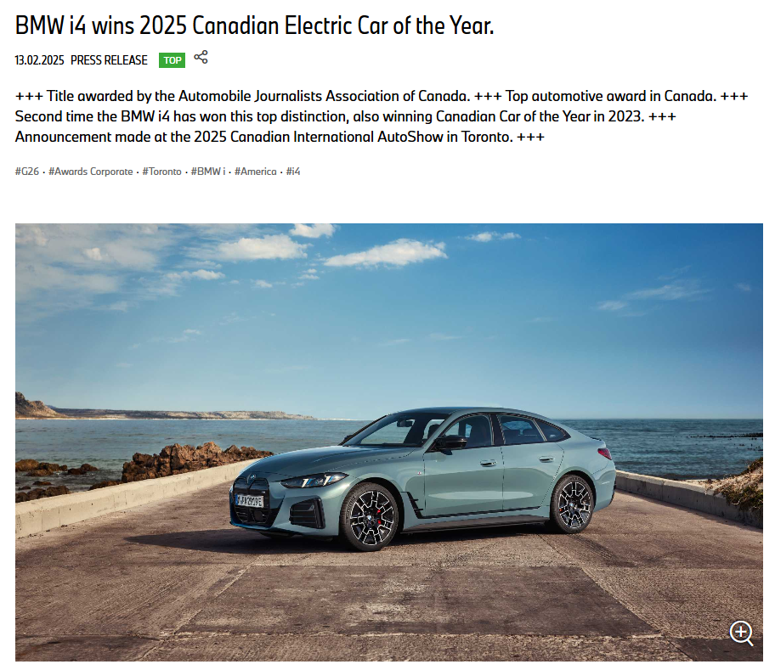
Figure 21: BMW Cana Technology
(Source: Taylor, J., 2025)

2.5 Legal Factors
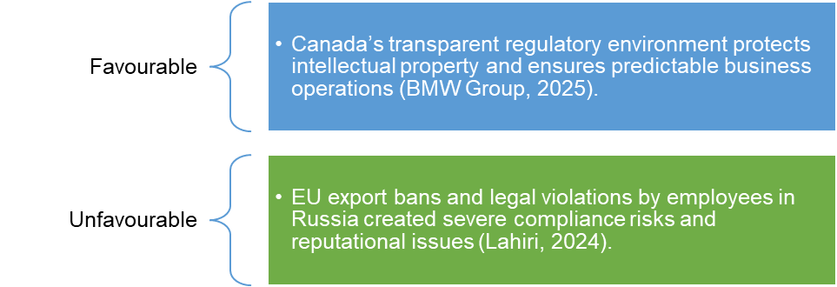
Figure 22: Legal Factors
(Created by learner)

2.5.1 Russia
The strategic activities of BMW are strongly impacted by legal and regulatory environments. In the Russian environment, the firm has been facing a wave of legal issues that are related to trade restrictions and sanctions. The discovery that BMW salespeople had sold over one hundred luxury models to Russian customers in breach of EU sanctions evoked major compliance issues and impacted negatively on the reputational positioning of the firm (Lahiri, 2024). In response to this, BMW has had to strengthen its internal governance frameworks and improve compliance policies to avoid future violations (Rivers, 2024).
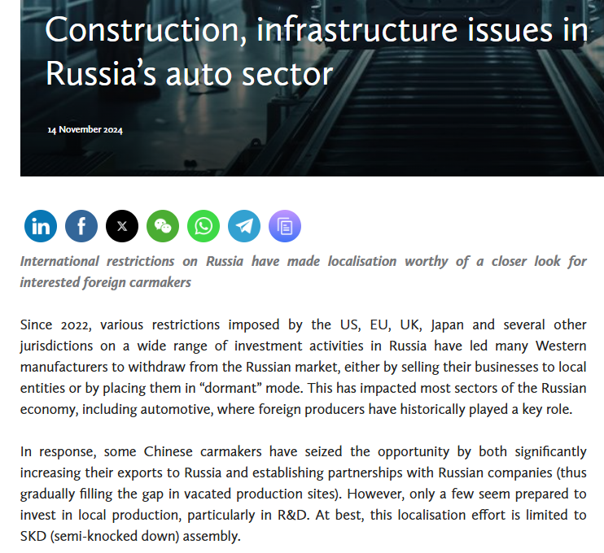
Figure 23: Russia Auto Regulatory Constraints
(Source: Daneliya et al., 2024)

2.5.2 Canada
In Canada, BMW works in a well-defined legal environment that supports the protection of intellectual property, fair trade and consumer rights. Compliance with safety and emissions regulations means that all imported vehicles must meet Transport Canada's standards (BMW Group, 2025). Moreover, Canadian data protection and privacy laws greatly affect BMW's digital operations, especially the use of customer information for online sales and vehicle connectivity services. The company is thorough in its adherence to Canada's Personal Information Protection and Electronic Documents Act (PIPEDA) for ethical management of data (BMW Group, 2025).
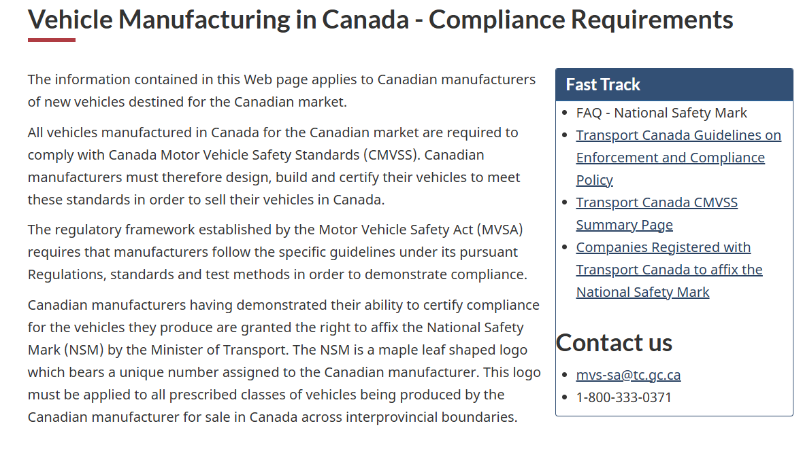
Figure 24: Canada Vehicle Compliance Framework
(Source: Canada, Department of Finance, 2025)

2.6 Environmental Factors
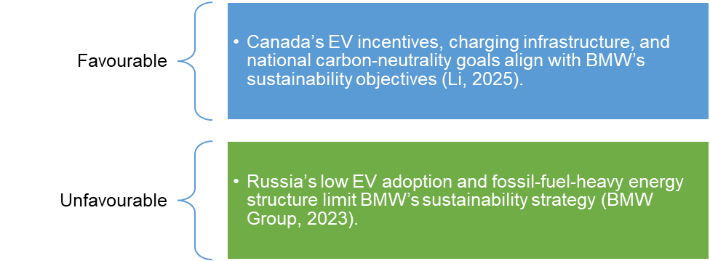
Figure 25: Environmental Factors
(Created by lelarner)

2.6.1 Russia
Another aspect that BMW has incorporated into the corporate strategy is environmental considerations. The environmental activities of the company are limited in Russia by low working power as well as non-existence of favourable environmental policy structures. The overdependence on fossil fuels and a slow uptake of renewable energy sources are crucial challenges to supporting electric mobility in the country (BMW Group, 2023).
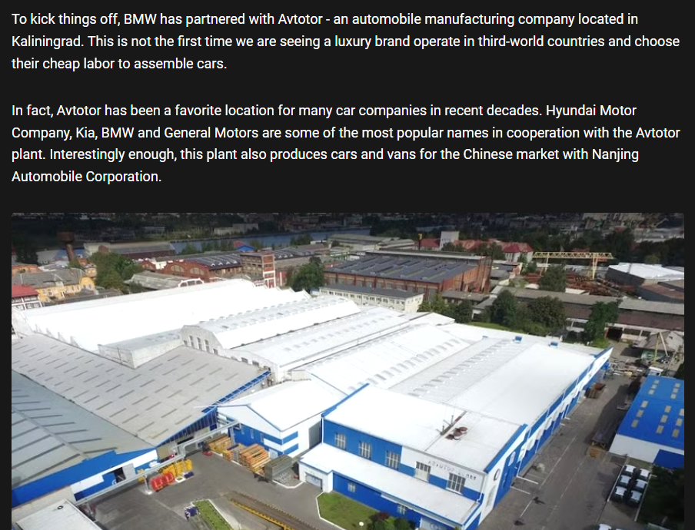
Figure 26: BMW Avtotor Russia Plant
(Source: Lame, G., 2022)

2.6.2 Canda
In contrast, environmental policies in Canada are in a good match with BMW's sustainability agenda. Governmental incentives to encourage the ownership of electric vehicles, investments in the charging infrastructure, and the national commitment towards becoming carbon neutral have helped in the growth of the electric fleet of BMWs (Li, 2025). The headquarters at Richmond Hill will act under the environmental standards of LEED which will in turn accelerate energy efficiency and environmentally friendly ways of operation (BMW Group, 2025). The use of recyclable materials and the reduction of emissions by the brand create an appeal to green oriented tastes of the Canadian consumers thus making BMW a pioneer in the sustainable luxury mobility (Adil et al., 2024).
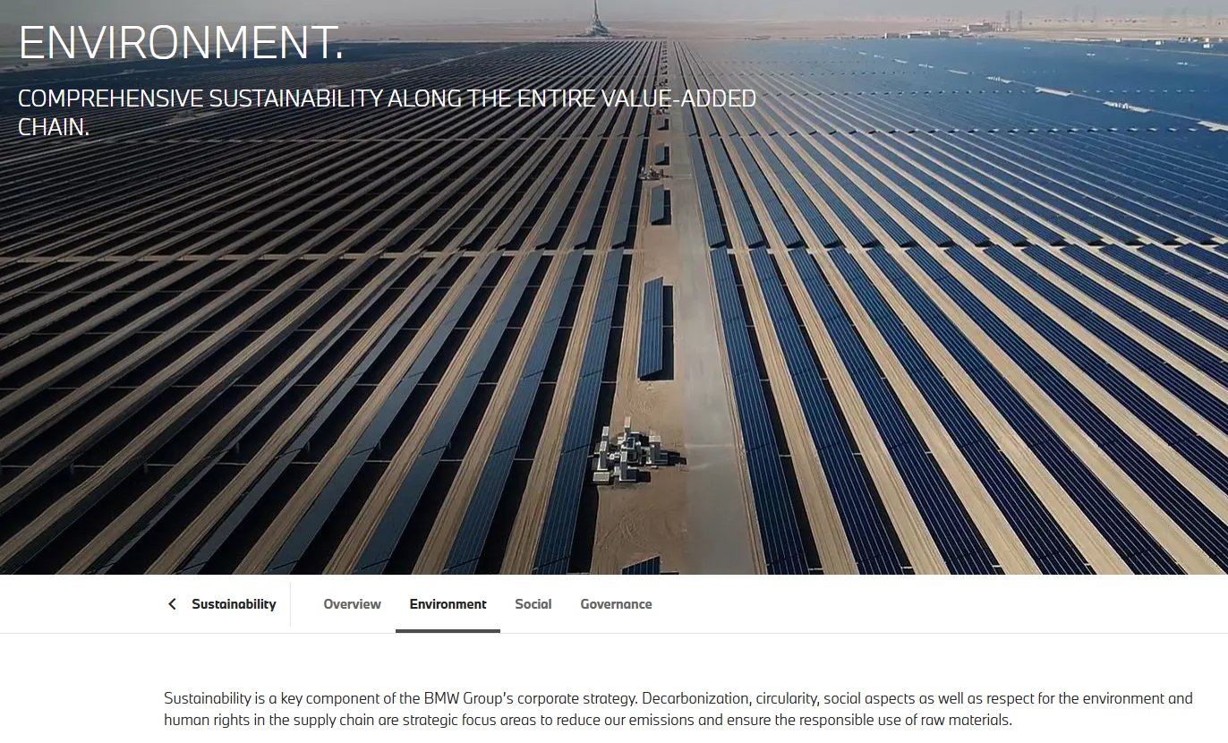
Figure 27: BMW Canda Sustainability and Renewables
(Source: BMW Group, 2025)

2.7 Similarities and Differences in PESTLE Factors – Russia vs Canada (BMW)
PESTLE Factor | Similarities (Both Countries) | Differences (Russia – Country A) | Differences (Canada – Country B)
Political | Both markets influence BMW through government policies and regulations. | High political instability, sanctions after 2022 invasion, halted production, restricted exports, weak policy support. | Stable democracy, pro-business policies, EV incentives, smooth trade via USMCA.
Economic | Luxury car demand influenced by income levels and macroeconomic stability. | Sanctions, inflation, ruble devaluation, reduced purchasing power, revenue dropped 20% (2023–2024). | Strong GDP, high disposable income, growth in luxury/EV demand, 5.9% sales increase in 2025.
Social | Consumers in both countries value premium and technologically advanced vehicles. | Prestige-driven, elite consumers, rising nationalism, preference shift to Chinese brands. | Sustainability-focused, diverse population, preference for EVs, strong brand loyalty.
Technological | BMW promotes innovation, EVs, and digital services in both markets. | Restricted technology transfer, limited R&D, sanctions block Western partnerships. | Advanced digital infrastructure, strong EV ecosystem, ConnectedDrive widely supported.
Legal | Both require compliance with national regulatory systems. | Heavy sanctions, legal breaches by employees, reputational damage, strict export restrictions. | Strong consumer protection laws, emissions and safety compliance, PIPEDA governing data privacy.
Environmental | BMW globally aims for sustainability and reduced emissions. | Limited environmental policies, fossil-fuel dependence, weak EV adoption. | Strong EV incentives, charging infrastructure, LEED-certified HQ, carbon-neutrality goals.
Table 2: Similarities and Differences in PESTLE Factors – Russia vs Canada (BMW)
(Created by learner)

3. Comparison of BMW’s STP Strategies in Country A and Country B

3.1 Segmentation Strategies
In Russia, BMW has historically segmented the market based on income level, lifestyle characteristics and geographic location, meaning that they are targeting urban elites in metropolitan centres (Moscow and St. Petersburg) (BMW Group, 2023). This segmentation strategy targets those consumers who emphasize aspects of-social prestige and better vehicle performance. In Canada, the segmentation method combines psychographic and behavioral factors, which include environmental awareness, technological affinity, and diversity of the lifestyle (BMW Group, 2025). Consequently, BMW can actually draw on younger and environmentally-conscious customers who are looking for top-notch and sustainable mobility solutions (Li, 2025).

3.1.1 VALS-2 Personality Types Under Psychographic Segmentation
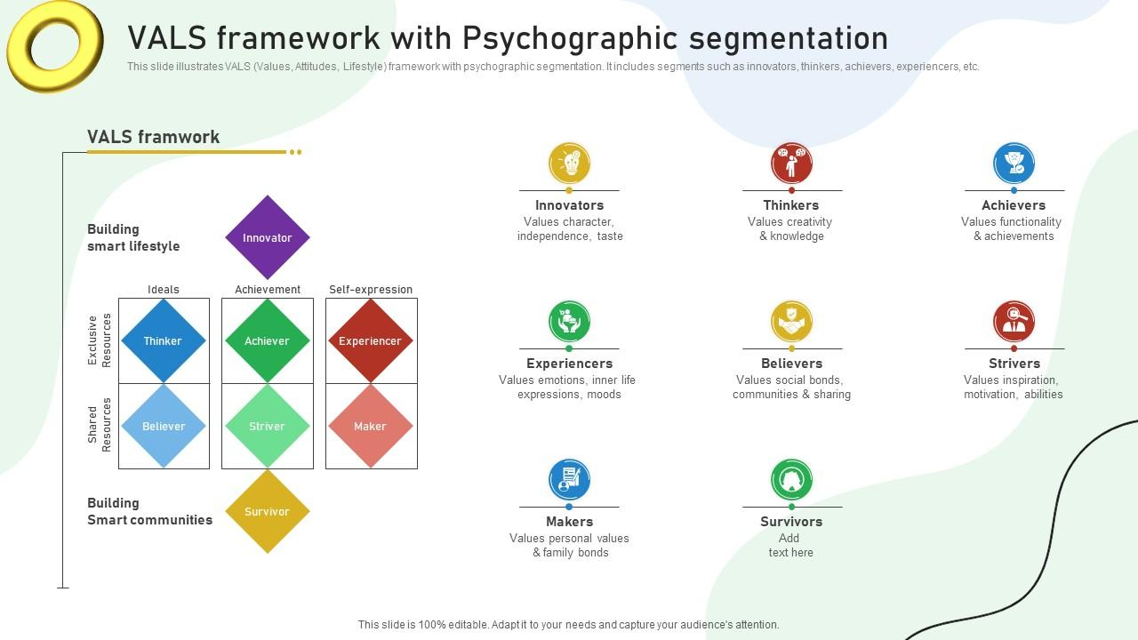
Figure 28: VALS-2 Personality Types
(Source: Kotler et al., 2023
VALS- 2 categorizes the consumers based on psychological characteristics and lifestyle drives. This grouping is essential to BMW, where the luxury and the electric vehicle markets depend on personality-based demand (Kotler et al., 2023).

In Russia
Achievers - who show main motivations as status, prestige, and financial success - show preference for vehicles such as the BMW 7 Series (Adil et al.,ily 2024).
Strivers - who have hopes of upward mobility- face economic restrictions, and sanctions make their buying power even lower.

In Canada
Innovators- Tech-oriented, green-concerned consumers that exhibit a strong interest in the BMWi4 and iX (Li, 2025).
Experiencers - Young adults who give high importance to the excitement, design, and performance and thus associate with the BMW M models.

3.1.2 Segmentation Strategies for BMW in Russia and Canada
Segmentation Type | Russia (Country A) | Canada (Country B)
Demographic Segmentation | Targets affluent consumers aged 30–60, business executives, and wealthy families seeking status-oriented luxury vehicles. Focus on high-income males in major cities such as Moscow and St. Petersburg (Adil & Hussain, 2024). | Targets diverse consumers aged 28–60, including professionals, dual-income families, and eco-conscious younger buyers. Broader appeal to both genders due to inclusive advertising and EV incentives (BMW Group Canada, 2025).
Geographic Segmentation | Focus on urban centres with strong economic activity, such as Moscow, St. Petersburg, Yekaterinburg, and regions with established dealership networks (BMW Group, 2023). Limited operations post-2022. | Nationwide presence with 51 auto dealerships, especially in Ontario, British Columbia, and Quebec. High EV adoption in urban areas such as Toronto and Vancouver supports demand for i4/iX models (BMW Group Canada, 2025).
Psychographic Segmentation | Appeals to status-driven, prestige-oriented consumers who associate BMW with power, luxury, and social recognition (Rivers, 2024). Risk-averse buyers prefer durable, traditional-engine models due to uncertainty. | Appeals to environmentally conscious, innovation-oriented consumers who value sustainability, digital features, and premium comfort. Strong alignment with lifestyle trends such as eco-mobility and work–life balance (Li, 2025).
Behavioural Segmentation | Focus on consumers seeking performance, reliability, and premium driving experience. High loyalty among elites, but sanctions reduce repeat purchases. After-sales service now the main retention tool (BMW Group, 2023). | Focus on buyers motivated by sustainability, technology, and safety. High interest in EVs and hybrid models. Loyalty driven through BMW ConnectedDrive, financing plans, and strong after-sales support (Quinn, 2025).
Benefit Segmentation | Consumers value prestige, engine power, and premium craftsmanship. Cars serve as symbols of authority and financial success (Adil & Hussain, 2024). | Consumers value environmental performance, advanced technology, connectivity, and energy efficiency. BMW’s EVs provide environmental and economic benefits (BMW Group Canada, 2025).
Usage Rate | Smaller but concentrated user base among high-income groups; usage tied to social events, business travel, and status display. | Wider user base across multiple income segments; frequent use for commuting, family travel, and long-distance mobility due to Canada’s vast geography.
Loyalty Level | Historically high loyalty among wealthy buyers, but geopolitical instability reduces long-term brand commitment. | Strong loyalty due to consistent customer experience, nationwide dealer support, and long-term EV strategy.
Table 3: Segmentation Strategies for BMW in Russia and Canada
(Created by learner)

3.2 Targeting Strategies
Strategic Aspect | Russia (Country A) | Canada (Country B)
Differentiation Strategy | Prior to 2022, BMW differentiated through premium positioning, large-engine models, and status-oriented branding aligned with elite consumer segments (BMW Group, 2023). However, sanctions and supply disruptions severely limited product variety and brand-led differentiation (Boston, 2022). | BMW strongly differentiates in Canada through high-performance M models, electric vehicles (i4, iX), advanced ConnectedDrive technology, and sustainability-led branding, appealing to environmentally conscious and lifestyle-oriented consumers (BMW Group Canada, 2025; Li, 2025).
Undifferentiation / Standardisation | Post-2022, BMW’s presence is minimal and largely undifferentiated, relying on residual financial services rather than tailored product or marketing strategies due to regulatory and operational constraints (BMW Group, 2023). | While differentiation dominates, BMW maintains some undifferentiated global standards in product quality, safety, and brand identity across Canada to ensure consistency and operational efficiency (BMW Group, 2025).
Strategic Outcome | Differentiation is largely unsustainable in Russia due to sanctions, reduced demand, and reputational risks, forcing BMW into strategic withdrawal (Lahiri, 2024). | Differentiation enhances competitiveness and growth in Canada, supporting sales expansion, EV leadership, and long-term brand strength in a stable market (Adil and Hussain, 2024).
Table 4: Differentiation and undifferentiation strategies

3.2.1 Russia
In the Russian market, BMW's addressing strategy mainly focused on high income customers, business elite and corporate clients with a desire for luxury, prestige and high performance vehicles (Rivers, 2024). The company concentrated on premium and large-engined models in line with consumer patterns looking towards prestige. Nonetheless, the economic contraction, the imposition of sanctions and the resultant reduction in affordability have significantly limited the target market, curtailing BMW's ability to maintain a wide or diversified customer base (BMW Group, 2023).

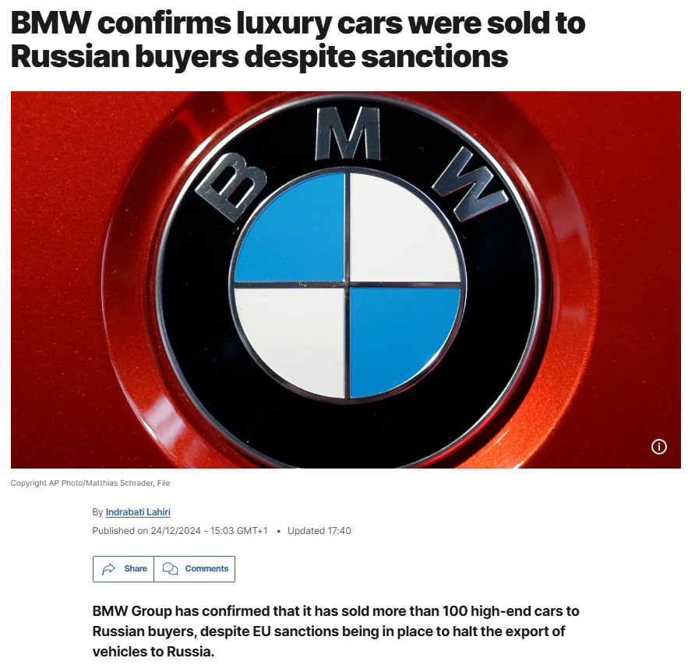
Figure 29: BMW Russia High end buyers
(Source: Lahiri, I., 2024)

3.2.2 Canada
BMW in Canada is developing a wider and more adaptable targeting mix of affluent customers with slightly more eco-friendly middle-class prospects (BMW Group Canada, 2025). BMW tries to hit different lifestyle and sustainability preferences by positioning its properties through its Power of Choice strategy, which focuses on internal combustion, hybrid, and fully electric cars. This broad based targeting approach supports sales expansion and strengthens BMW market standing in a secure, innovation based environment (Li, 2025).
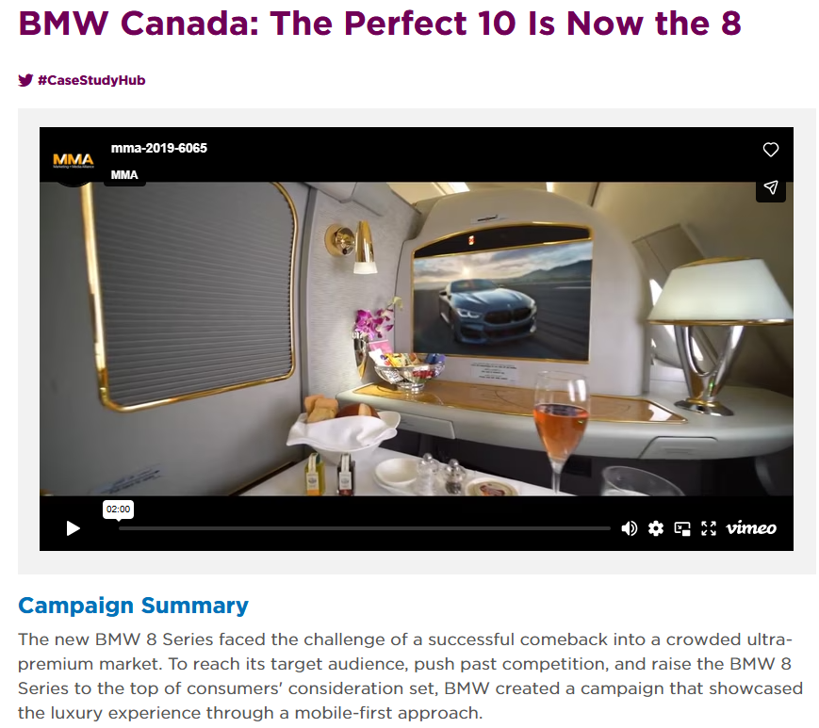
Figure 30: BMW Canada Luxury Marketing
(Source: MMA Global, 2025)

3.3 Positioning Strategies
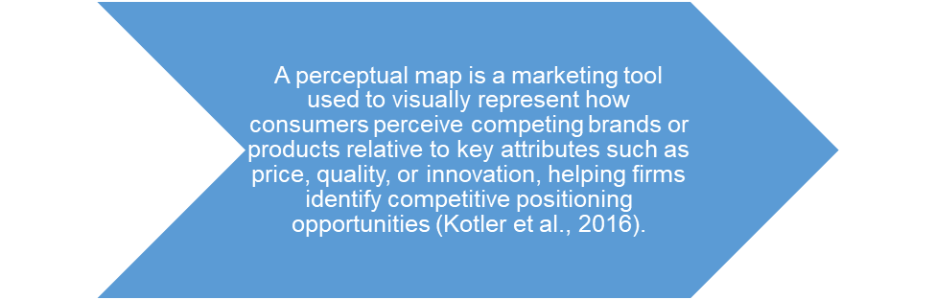
Figure 31: Definition of Perceptual Map
Created by learner)
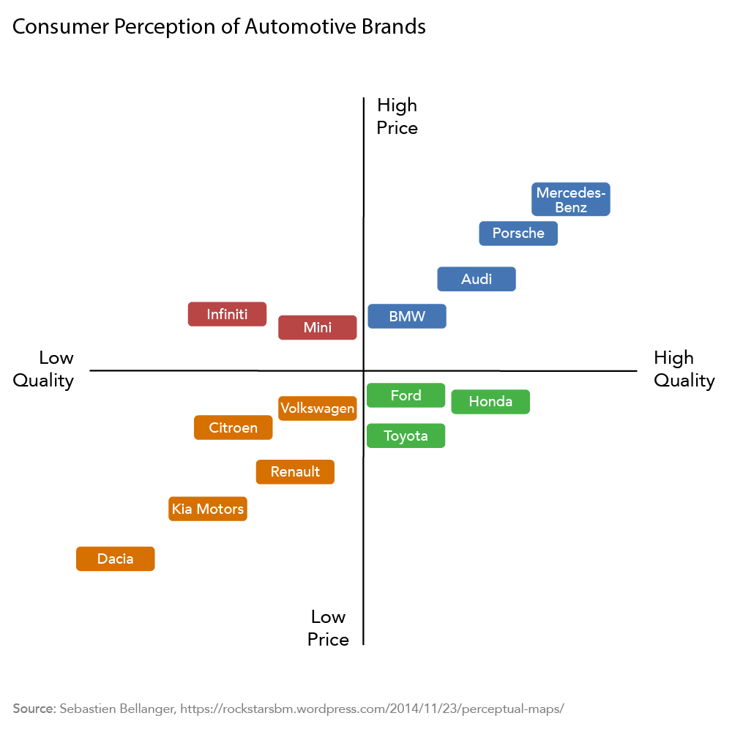
Figure 32: Perceptual map
(Created by learner)
The perceptual map illustrates the consumer's perception of the major automotive brands in terms of price and quality. Premium German brands such as Mercedes-Benz, Porsche, Audi and BMW are in the high-price, high-quality quadrant and reflect good engineering reputation and luxury positioning. Brands like Ford, Honda and Toyota are perceived as high quality but low price and attractive to value-conscious buyers. Meanwhile, the likes of Citroen, Renault, Kia and Dacia are in the low-price, low-quality landscape, meaning budget positioning with low premium appeal. Mini and Infiniti are perceived as a higher priced but lower in quality.
Traditionally in Russia, BMW positioning focused on prestige, engineering excellence, and performance, which is similar to the dreams of social recognition held by consumers (Adil and Hussain, 2024). But sanctions and political tensions have undermined this image, which is why the brand is concerned with ensuring trust by means of limited-service operations (BMW Group, 2023). Canadian BMW is innovating, sustainable, and customer-oriented and has local marketing efforts that underscore environmental leadership and online connectivity (BMW Group Canada, 2025).

3.4 Comparative Summary: Similarities and Differences in STP
STP Element | Similarities between Russia & Canada | Key Differences between Russia (A) and Canada (B)
Segmentation | In both markets, BMW segments customers using demographic (income, age) and psychographic factors aligned with premium brand expectations (BMW Group, 2025). | Russia focuses on income, status, and urban elites with prestige-driven lifestyles, while Canada emphasises psychographic and behavioural variables such as sustainability, technology affinity, and lifestyle diversity (BMW Group, 2023; Li, 2025).
Targeting | BMW targets consumers seeking premium quality, advanced engineering, and strong brand reputation in both countries (Adil and Hussain, 2024). | Russia targets a narrow segment of high-income individuals and corporate elites, whereas Canada adopts a broader target including affluent buyers and environmentally conscious middle-class consumers through the “Power of Choice” strategy (Rivers, 2024; BMW Group Canada, 2025).
Positioning | In both markets, BMW is positioned as a premium German automotive brand associated with quality and performance (BMW Group, 2025). | In Russia, positioning historically stressed prestige and power but has weakened due to sanctions; in Canada, BMW is positioned around innovation, sustainability, EV leadership, and digital experience (BMW Group, 2023; Li, 2025).
Strategic Outcome | BMW aims to maintain global brand consistency while adapting to local conditions (Adil and Hussain, 2024). | Russia faces strategic contraction and limited positioning flexibility, while Canada demonstrates growth-oriented STP alignment supporting long-term competitiveness and market expansion (Lahiri, 2024; BMW Group Canada, 2025).
Table 5: Comparative Summary: Similarities and Differences in STP
(Created by learner)

4. Comparison of Marketing Mix Strategies in Country A and Country B

4.1 Product Strategy
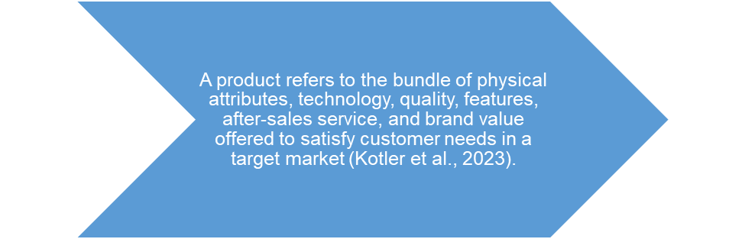
Figure 33: Product Strategy Definition
(Created by learner)

4.1.1 Russia
BMW, as a brand, was historically concentrated in luxury sedans (3, 5, 7 Series) and performance-based SUVs (X3, X5) to satisfy ' Elton John tastes' of rich clients, who demanded prestige, comfort and status. However, because of sanctions and the official withdrawal of BMW from the Russian market in 2022, the availability of the products has drastically decreased as the availability has shifted to grey imports and unofficial means (Boston, 2022; Lahiri, 2024). This has resulted in inconsistent availability of the product and low access to alternative EV vehicle models.
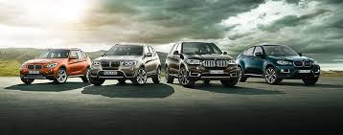
Figure 34: BMW luxury sedans
(Source: BMW Group, 2025)

4.1.2 Canada
BMW offers a full, officially distributed body of products, including sedans, SUVs, electric vehicles (including i4, i5 and iX), and performance M models, in Canada. The Canadian branch of BMW fits its product range to the preferences of the North American market, focusing on all-wheel-drive models, larger SUVs, and winter-safe qualities, which is enabled by the strong network of dealerships and official after-sales services (BMW Group Canada, 2025).
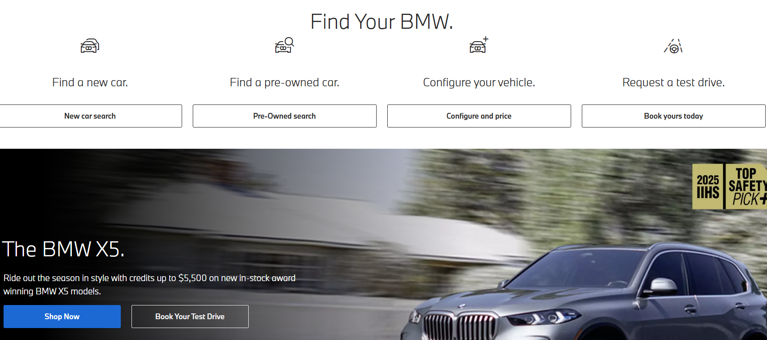
Figure 35: BMW Canada
(Source: BMW Group, 2025)

4.1.3 Product Variety, Depth & Width
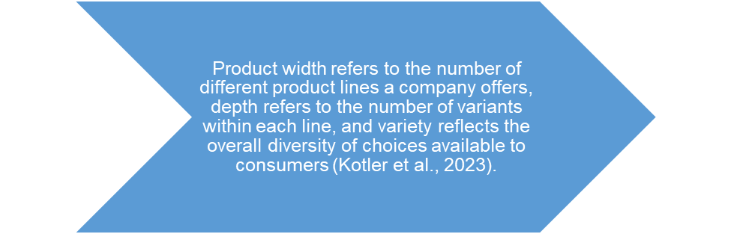
Figure 36: Product Variety, Depth & Width Definition
(Created by learner)

4.1.3.1 Russia
Prior to sanctions, BMW had a fairly wide and deep range of the sedan and SUVs - particularly the X Series. Nonetheless, the penetration rate of electric vehicles remained low, due to limited infrastructure for electric vehicle charging and low initial adoption rates. Following 2022, both breadth and depth shrank significantly, as only a few models find their way to the domestic market through parallel imports, thus depriving customers of contemporary variants and new technologies (BMW Group, 2023).

Figure 37: BMW X Series
(Source: BMW Group, 2025)

4.1.3.2 Canada
Prior to sanctions, BMW had a fairly wide and deep range of the sedan and SUVs - particularly the X Series. Nonetheless, the penetration rate of electric vehicles remained low, due to limited infrastructure for electric vehicle charging and low initial adoption rates. Following 2022, both breadth and depth shrank significantly, as only a few models find their way to the domestic market through parallel imports, thus depriving customers of contemporary variants and new technologies (BMW Group, 2023).
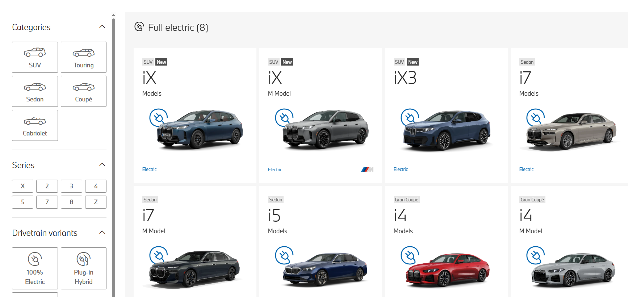
Figure 38: BMW Canada wide range
(Source: BMW Group, 2025)

4.1.3.3 Main Differences Between Russia and Canada
Aspect | Canada | Russia
Availability | Full official access through authorised dealerships | Reliance on grey-market imports
Product Width | Complete BMW product portfolio available | Restricted product range post-exit
Product Depth | Wide SUV and EV variants across segments | Limited depth; minimal EV availability
Technology Access | Latest models and updates available | Delayed or discontinued models
Market Stability | Stable, regulated, and organised market | Unpredictable supply conditions

Table 6: Main Differences Between Russia and Canada
(Created by learner)

4.1.4 Product Design
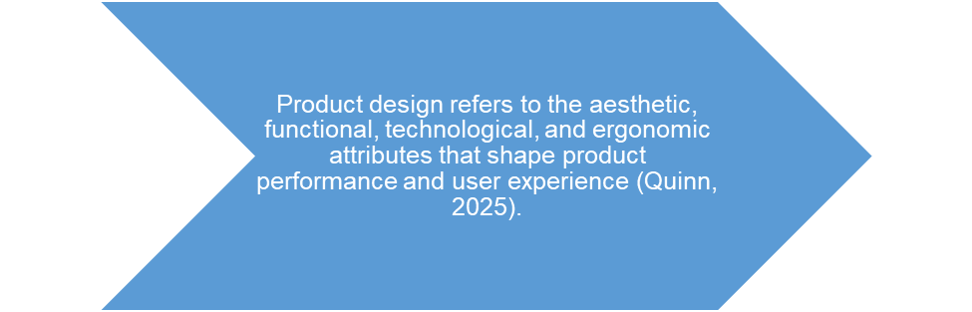
Figure 39: Product Design Definition
(Created by learner)

4.1.4.1 Russia
BMW's design strategy in Russia has traditionally focused on aspects of comfort, luxury appeal and performance tailor-made for urban premium buyers. Models with strong suspension tuning and sporty looks were in the majority. However, with the sanctions imposed, customers are restricted to some novel design innovations among them, BMW's latest aerodynamic EV forms, efficient EV platform and digital cockpit technologies (Lahiri 2024).

4.1.4.2 Canada
BMW product design in Canada is very much aero efficient, electrically mobile, and winter ready, including xDrive, heated parts, and wide-ranging adaptive LED lights. This philosophy is in line with the Canadian requirements of sustainability, safety, and technology. The digitalisation efforts of BMW, such as the BMW OS, the driver-assistance systems and its effective electric vehicle (EV) architecture are extensively adopted internationally (BMW Group 2025).

4.1.5 Branding Strategies

4.1.5.1 Branding Strategies in Russia and Canada
BMW uses a global premium branding strategy, which is based upon innovation, engineering excellence, performance and luxury. Nevertheless, each market requires local adaptations in the way it communicates, is positioned, and is made to emphasize its products.

4.1.5.2 Branding Strategy in Russia
Before BMW officially pulled out of the market, the branding strategy was aligned to luxury, status, and exclusivity thus attracting high-end consumer segments who understood the marque as a symbol of status and prestige (Adil et al., 2024). Formal branding efforts have been discontinued since 2022, also due to sanctions and milder the brand in question, necessitating a sense of scarcity and exclusivity. Informal resale markets still persist with brand image even though the official support or commercial channels are missing (Rivers, 2024).
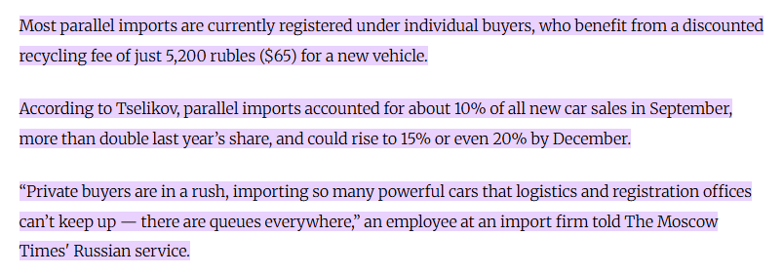
Figure 40: Russia Parallel Import Market
(Source: The Moscow Times, 2025)

4.1.5.3 Branding Strategy in Canada
In Canada, the BMW brand follows its international premium position and at the same time personalized communications around key themes of performance, innovation, electrification and driving experience. It puts safety, winter performance, and leadership in electric vehicles in the forefront, achieved by significant marketing efforts, live events, and digital interaction on social media platforms. BMW Canada's strong dealer network further adds to brand consistency and develops customer loyalty (BMW Group Canada, 2025).
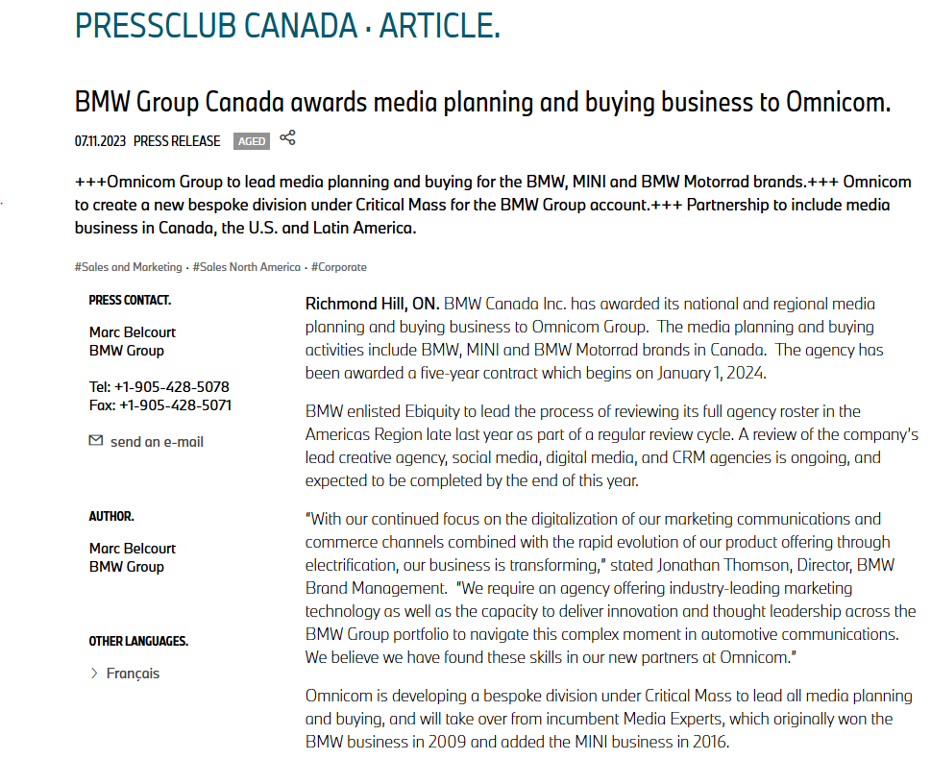
Figure 41: BMW Canada Media Strategy
(Source: BMW Group, 2025)

4.2 Price Strategy
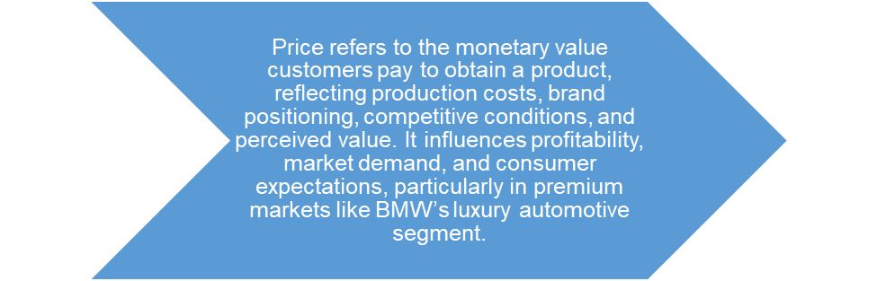
Figure 42: Price Strategy Definition
(Created by learner)

4.2.1 Russia
International sanctions and lack of presence of BMW in the formal domestic market have significantly destabilized the pricing of the model in Russia. Models which are still in the market are priced very high as the vehicles are mostly bought via grey import, which causes unreliable supply and high transaction costs (BMW Group, 2023; Boston, 2022). The scarcity of novel electric cars and premium models also contributes to a rise in prices. This means that Russian consumers are paying premium prices that are strictly enabled by scarcity instead of BMW normal strategic pricing practices.
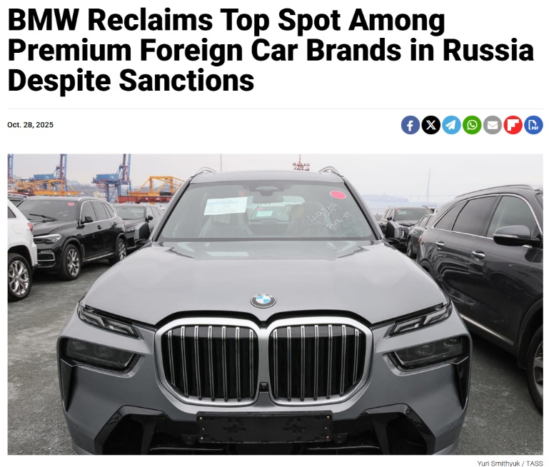
Figure 43: BMW Russia Price Strategy
(Source: The Moscow Times, 2025)

4.2.2 Canada
In Canada, BMW pursues a structured premium price strategy that is consistent with the brand position and product technological characteristics, and market standards of the luxury market Prices are affected by official distribution mechanisms, stability of supply chains, and bull run for SUVs and electric vehicles that come with transparent dealership pricing frameworks as well as financing options (BMW Group Canada, 2025). Seasonal promotional activities, loyalty incentives and certified pre-owned programs give customers additional value while maintaining BMW's premium brand image. Robust market confidence along with continued sales performance further attest to the stability of pricing.
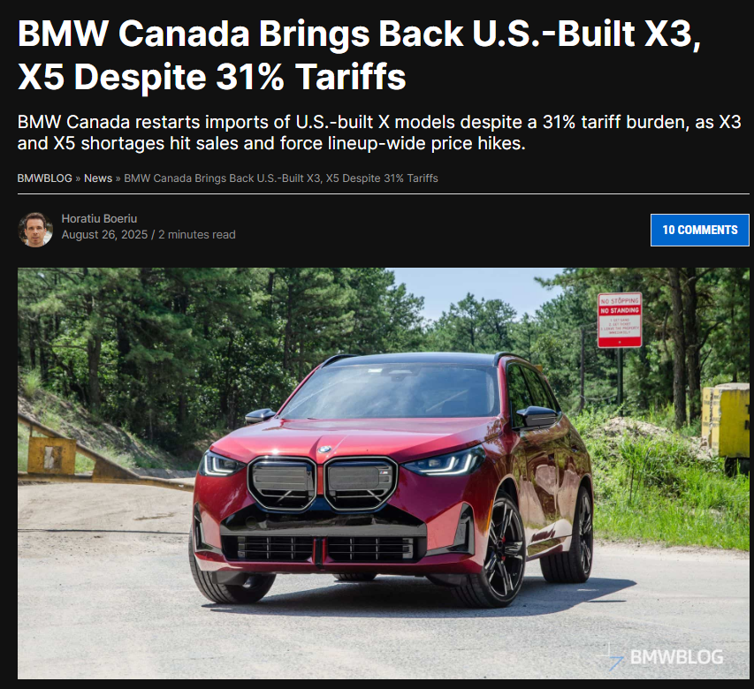
Figure 44: BMW Canada Price Strategy

4.3 Place (Distribution) Strategy Definition
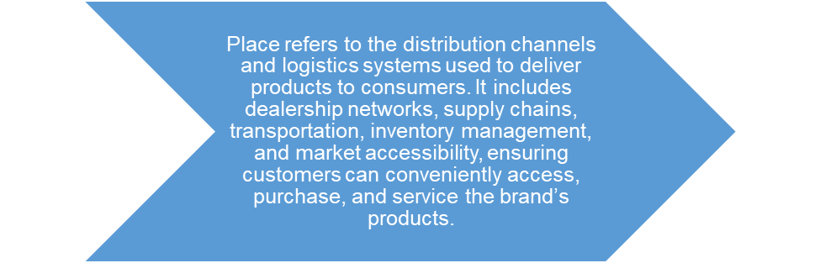
Figure 45: Place (Distribution) Strategy Definition
(Created by learner)

4.3.1 Russia
The distortion of the BMW strategy of the place in Russia after quitting the market in 2022 has caused a considerable change in the system of distribution. BMW no longer supplies new vehicles, parts, or services to official dealerships, forcing consumers to go to grey importers and non-official workshops (BMW Group, 2023; Boston, 2022). As a result, distribution is discontinuous and ineffective currently, with limited access to the electric-vehicle network and genuine spare parts. This has undermined the market of BMW and the overall accessibility by the customers in most of the key cities in Russia.
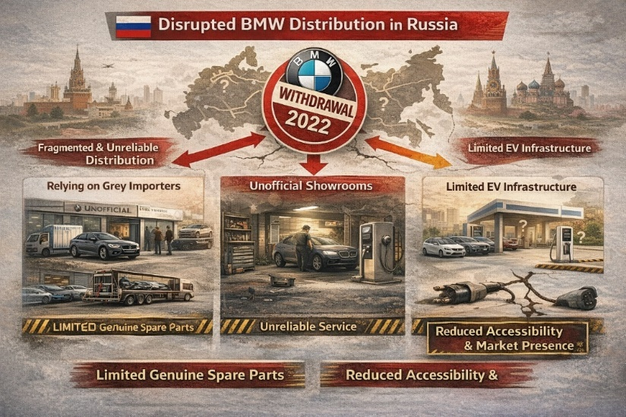
Figure 46: BMW Russia Distribution Diagram
(Created by learner)

4.3.2 Canada
Within the Canadian market, BMW has developed a complete and systematically organised distribution network with officially authorised dealerships, service centres and logistics centres located throughout the primary provinces (BMW Group Canada, 2025). The place strategy ensures reliable consumer access to new vehicles launched, certified electric vehicle (EV) models, certified pre-owned vehicles, and full-service after sales offerings. Efficient oversight of the supply chain, optimised transport routes and a well-developed infrastructure are the basis for the availability of products. The very organised retail environment inside Canada helps with BMW's ability to maintain a standardised customer experience and provides good nationwide coverage.
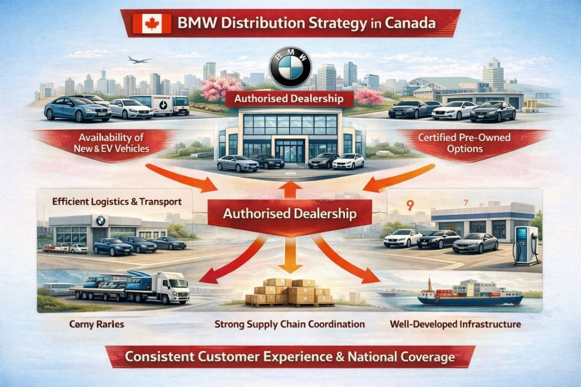
Figure 47: BMW Canada Distribution Diagram
(Created by learner)

4.3.3 Direct vs Indirect Channels & Intensive Distribution – BMW in Russia and Canada
Distribution Aspect | Russia | Canada
Direct Distribution Channels | BMW no longer operates official dealerships or direct sales channels due to its 2022 market withdrawal, resulting in the end of authorised distribution, servicing, and new vehicle imports (BMW Group, 2023; Boston, 2022). | BMW uses a strong network of authorised dealerships and service centres nationwide. Direct channels ensure reliable access to new vehicles, EV models, parts, and after-sales support (BMW Group Canada, 2025).
Indirect Distribution Channels | Indirect channels dominate through grey importers who source BMW vehicles unofficially. These imports lack manufacturer oversight, leading to inconsistent supply, variable pricing, and uncertain servicing quality (Lahiri, 2024; Rivers, 2024). | Indirect channels include certified pre-owned partners, leasing firms, and third-party automotive retailers. These operate within an organised regulatory environment and still maintain BMW-approved standards when authorised (Newaz et al., 2025).
Intensive Distribution Strategy | BMW cannot use an intensive distribution strategy because official operations have ceased. Market coverage is limited, fragmented, and dependent on unofficial sellers concentrated in major cities (BMW Group, 2023). | BMW applies a form of intensive distribution within the premium segment, ensuring widespread availability across major provinces with well-distributed dealerships, EV infrastructure, and service centres to maximise market reach (BMW Group Canada, 2025).
Table 7: Direct vs Indirect Channels & Intensive Distribution – BMW in Russia and Canada
(Created by learner)

4.3.4 Which Market Entry Method?
BMW has mainly resorted to wholly owned subsidiaries and authorised dealership network to venture into the Canadian market (BMW Group Canada, 2025). In Canada, the company has total domination in the company via BMW Group Canada, which is based in Richmond Hill, Ontario.
Why This Method?
Wholly owned operations allows BMW to maintain high levels of control of brand standards, customer experience, pricing strategies, the electric vehicle portfolio, sustainability goals, and supply chain effectiveness. The economic context in Canada, with its stability, clearness of regulations and high demand for high-end car makes direct ownership the most efficient way to enter a market, compared to licensing agreements or joint ventures.
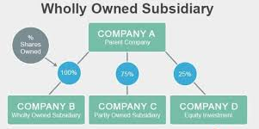
Figure 48: Wholly owned subsidiaries
(Created by learner)

4.3.4.1 Advantages and Disadvantages of This Entry Method (Canada)
Advantages
- BMW ensures there exists a high level of control in terms of product quality, marketing, pricing and service delivery, which would be critical in maintaining its high-level standards in the world.
- The operating policies are used in all dealerships to ensure consistent customer experience.
- Direct management of the implementation of electric vehicles (EV) will help BMW to strategically grow its model line-up i4, i5, and iX in consideration of EV adoption incentives in Canada.
- The fact that BMW did not need to be affected by third parties during its communication, brand identity, and presence in the market enhances its positioning.
Disadvantages
- The high operational costs of investments in logistics locations, dealership infrastructure, employee training and technological systems put a heavy financial burden.
- The financial risk is compounded, since BMW is fully responsible for market volatility, the modifications in the regulation and the economic downturns.
- The ability to cut costs or quickly scale down operations is limited compared with franchising or partnership business models.
- The potential for expansion is reduced as both wholly owned models require a large investment of capital as well as long-term planning.

4.4 Promotion Strategy
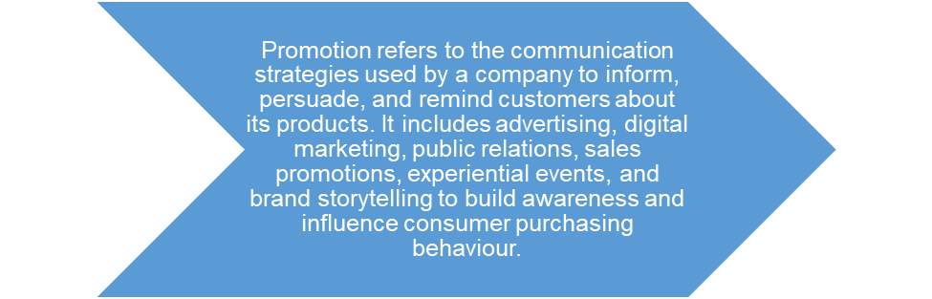
Figure 49: Promotion Strategy Definition
(Created by learner)

4.4.1 Russia
The advertisement campaigns of BMW have decreased significantly in Russia after the company had to stop its official work in 2022. The brand has stopped any approved advertising, online work, or promotional activities due to the imposed sanctions and stopped export operations (BMW Group, 2023; Boston, 2022). The visibility is now largely limited to social-media reports, advertising by grey-market dealers and the residual brand prestige. Without formal communication methods, the power of BMW in promotion situations is reduced, and its message no longer highlights innovation, electric vehicle creation, or the benefits of high-end services.
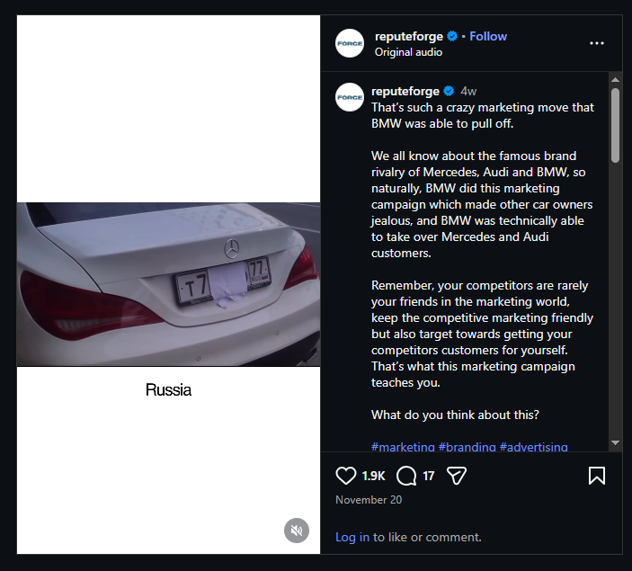
Figure 50: Russia BMW social media
(Source: Instagram)

4.4.2 Canada
In Canada, BMW has strong promotional strategies through digital advertising, social media storytelling, dealership events and campaigns focusing on performance, luxury and electrification (BMW Group Canada, 2025). These promotional efforts bring forward such new EV car lineups as i4, iX, winter adaptation of new technologies and premium driving experiences. BMW further orchestrates experiential test drive events, loyalty programs and seasonal offers to buttress brand engagement. Consistent communication forms the basis of customer loyalty and reinforces BMW's top market status at a national level.
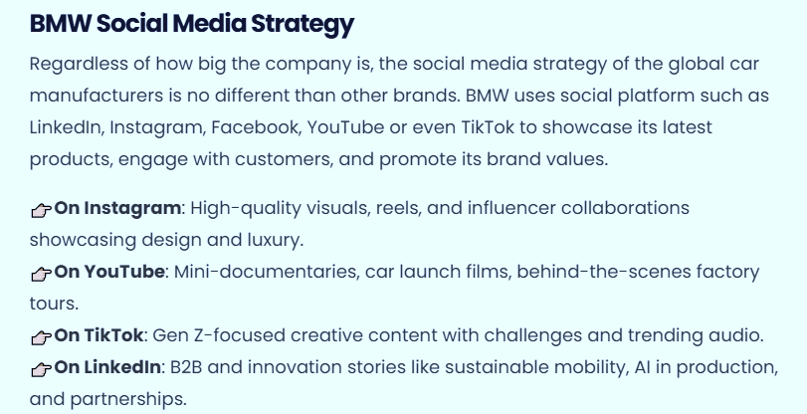
Figure 51: Canada BMW social media
(Source: Digital Agency Network, 2025)

4.4.3 Promotion Evaluation Table
Promotion Method | Russia (Country A) | Canada (Country B) | Effectiveness
Digital Marketing | Limited post-2022 | Highly active on Instagram, YouTube, TikTok | Very effective in Canada
Events & Sponsorships | Minimal due to sanctions | Motorsport events, sustainability forums | High in Canada
EV Campaigns | Not applicable | Strong push for i4, iX | Very strong
Celebrity Endorsements | Declined due to political sensitivity | Used selectively | Moderate
Table 8: Promotion Evaluation
(Created by learnrer)

4.5 People Strategy
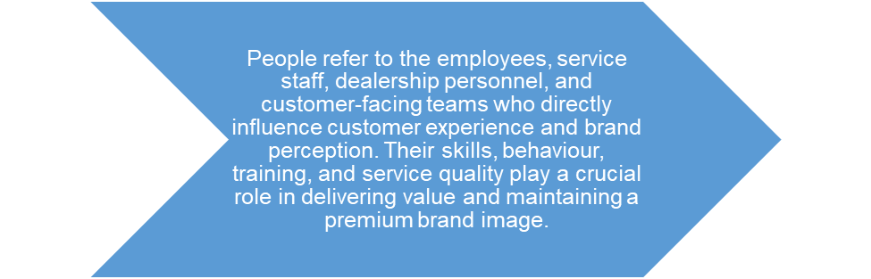
Figure 52: People Strategy Definition
(Created by learner)

4.5.1 Russia
The number of employees in Russia is very few, with BMW typically providing residual financial services after it withdraws operations (BMW Group, 2023). People element of BMW diluted in Russia as the company ceased its presence and ceased to fund official dealerships in 2022 (BMW Group, 2023; Boston, 2022). BMW employees trained in the program lost access to corporate systems, technical updates, and formal training around the service. Consequently, customers are inclined to turn to independent mechanics/ grey-market service providers of different skill levels. Lack of qualified staff has decreased service reliability, technical stability, and the ability of BMW to sustain its high-quality service levels.
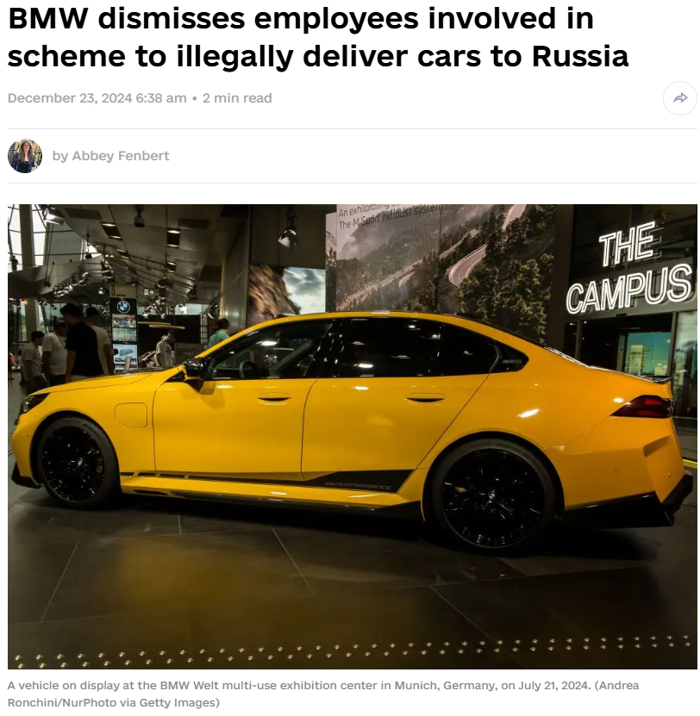
Figure 53: BMW Russia People Strategy
(Source: The Kyiv Independent, 2024)

4.5.2 Canada
In Canada, BMW has a strong and well-trained workforce through BMW Group Canada supported by structured recruitment, ongoing technical training and also certified service programs (BMW Group Canada, 2025). Dealership staff get constant updates on the technology of EVs, customer service standards and maintenance protocols. With this professional workforce, it boosts customer satisfaction, maintains a good quality of service delivery and boosts the premium positioning of BMW. Skilled personnel in different roles such as sales, after-sales, and technical play a role in consistent nation-wide brand experience and customer loyalty.

4.6 Process Strategy
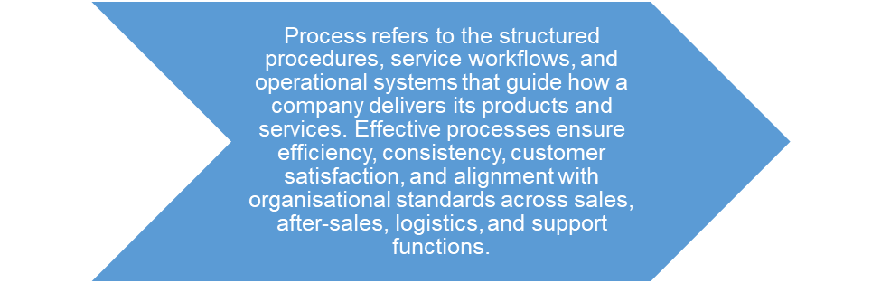
Figure 54: Promotion Strategy Definition
(Created by learner)

4.6.1 Russia
The situation in Russia was much worse as BMW disrupted its service and sales processes when the company ceased its official activities and ceased to ship vehicles and parts (BMW Group, 2023; Boston, 2022). In the absence of the authorized dealerships, formalities workflow like warranty claims, digital diagnostics and certified maintenance will not work. The consumers have to use unofficial ways of doing things, inconsistent because the process is not official, and hardly precise technical-wise (Lahiri, 2024; Rivers, 2024). Consequently, the process of premium service in BMW is disjointed, lessening reliability and destabilizing operational authority.
Customer Complaint Process – Russia
In Russia, BMW formalized customer complaint process is no longer functioning due to the company's withdrawal from the market, Official dealerships cannot register and therefore escalate complaints to BMW systems, and customers are left in the hands of grey market sellers or independent workshops. Complaint handling is inconsistent with no assured resolution, lack of access to actual parts, no official support for warranty, technical issues and recovering services.
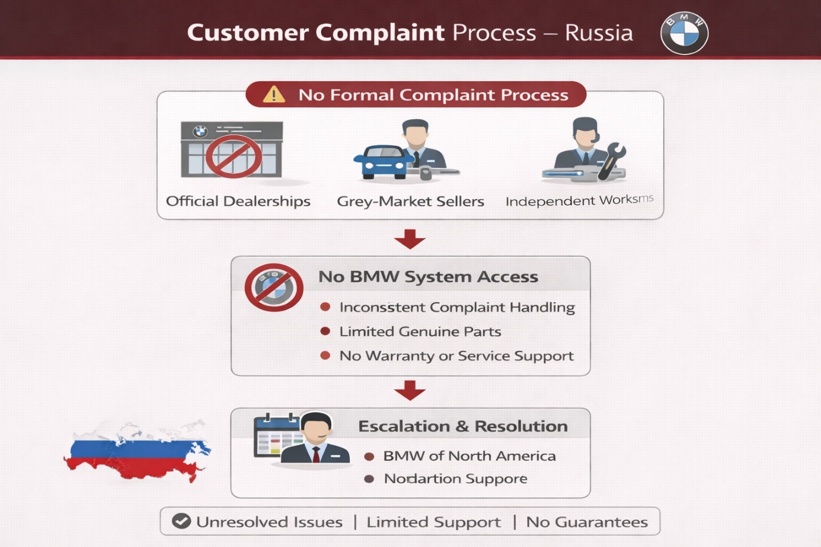
Figure 55: Customer Complaint Process – Russia
(Created by learner)

4.6.2 Canada
BMW has well organised and standardised operations and authorised dealerships, high-tech diagnostics and digital service platforms in Canada (BMW Group Canada, 2025; Quinn, 2025). The EV-related procedures, sales, and maintenance comply with rigid BMW global policies, providing unified customer experience and operation efficiency. Good coordination within the supply chain is improving the reliability of the service (Newaz et al., 2025). Constant training and making changes to the corporate system enables employees to perform the processes correctly, which contributes to the premium positioning of BMW in the Canadian marketplace.
Customer Complaint Process – Canada
In Canada, BMW has a structured, transparent complaint process that is administered through authorized dealerships and BMW Group Canada. Customer issues are recorded in digital CRM systems, diagnosed quickly and escalated if they need to be. The process incorporates service follow-ups, warranty support and satisfaction checks. Trained Staff Ensure Professional Communication Timely Solutions Consistent Service Recovery Reinforce BMW's Premium Customer Experience Across The Country
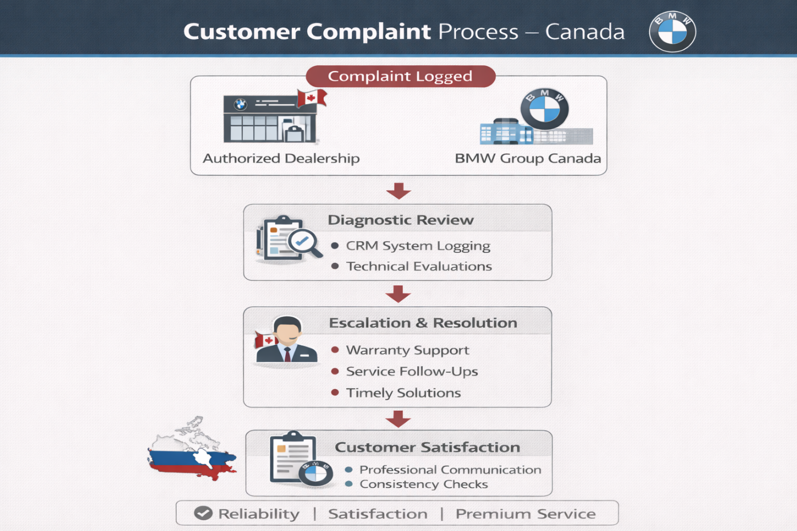
Figure 56: Customer Complaint Process – Canada
(Created by learner)

4.7 Physical Evidence Strategy
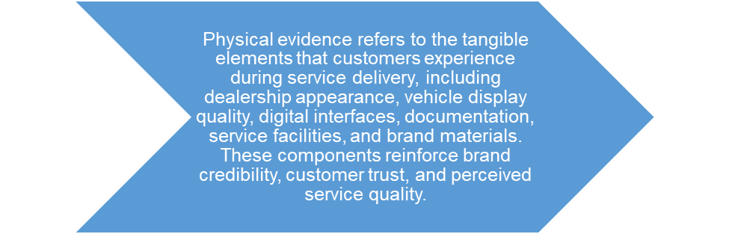
Figure 57: Physical Evidence Strategy Definition
(Created by learner)

4.7.1 Russia
The presence of BMW physical evidence in Russia deteriorated enormously once it ceased operational activities because authorized dealerships do not get new branding, show cars, or certified parts (BMW Group, 2023; Boston, 2022). The old showrooms are autonomous with unstable standards, no-go visual identity, and inaccessible to original parts (Lahiri, 2024). Lack of formal service settings and customer touch point branding undermines the BMW brand premium image and subtleties of its global brand quality expectations.
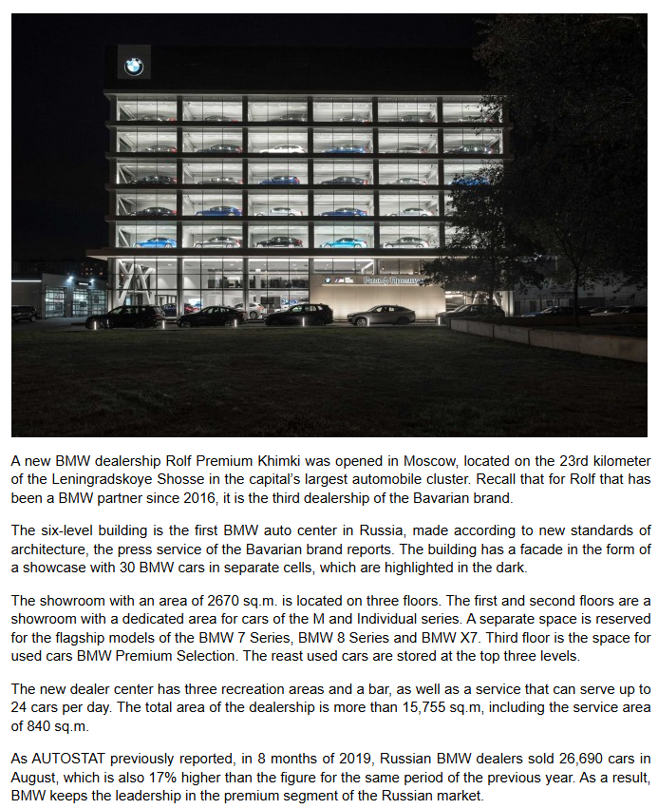
Figure 58: BMW Russia Former Dealership
(Source: AUTOSTAT, 2019)

4.7.2 Canada
In Canada, BMW has strong physical evidence in the form of modern showrooms, certified service centres, branded signage, and professionally designed customer areas designed to corporate standards (BMW Group Canada, 2025; BMW Group, 2025). Dealerships feature new models, EV technology, and digital interfaces to improve customer interaction experience. Consistent design of the facility and access to authentic parts contributes to trust and high-brand awareness. High quality physical touchpoints support BMW's commitment to luxury, innovation and service excellence across Canada.
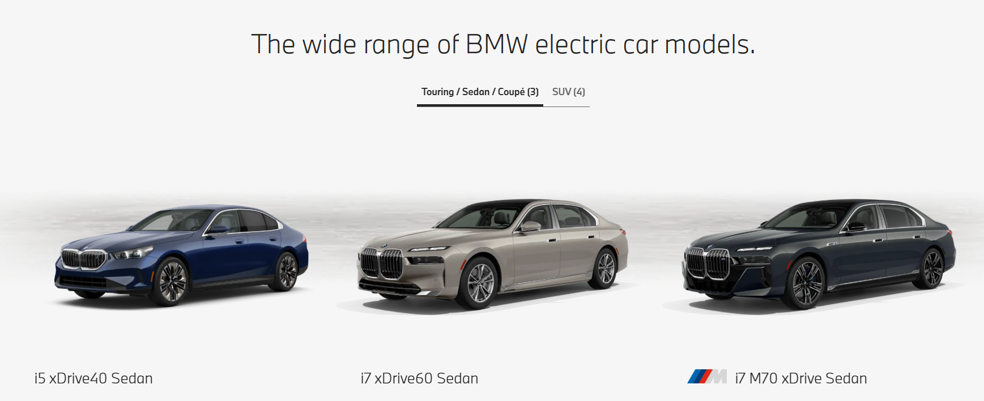
Figure 59: BMW Canada EV models
(Source: BMW Group, 2025)

4.8 Similarities and Differences in the 7Ps – BMW in Russia vs Canada
7Ps | Similarities (Both Countries) | Differences – Russia (Country A) | Differences – Canada (Country B)
Product | Premium cars, strong engineering quality, emphasis on brand excellence. | Focus on high-performance petrol models like 5, 7 Series and X models; EV presence extremely limited due to sanctions and weak infrastructure. | Wide portfolio including EVs (i4, iX, iX3), hybrids and M models; strong sustainability focus.
Price | Premium pricing due to luxury positioning. | Prices inflated by sanctions, currency devaluation and limited supply; affordability reduced. | Value-based premium pricing with flexible leasing, EV incentives and competitive financing.
Place (Distribution) | Uses dealership networks for sales and service. | Distribution collapsed after sanctions; production halted; only service operations remain. | Extensive national network (51 auto dealers); strong digital retailing and logistics support.
Promotion | Brand messaging highlights quality, technology and luxury. | Promotion reduced due to sanctions; minimal marketing activity; no major campaigns. | Active digital marketing, sustainability messaging, community events and EV-focused campaigns.
People | Skilled staff trained to deliver premium customer experience. | Workforce reduced; limited staff due to halted operations; service-only roles. | Strong employee training, multicultural focus, EV expertise and high customer interaction.
Process | Standardised BMW global processes for sales and service. | Processes disrupted by supply-chain restrictions; no production; only aftersales support. | Streamlined digital processes, online sales, ConnectedDrive, efficient EV service systems.
Physical Evidence | Premium showrooms, branded service centres, strong visual identity. | Many physical facilities underutilised; reduced brand visibility post-2022. | Modern showrooms, LEED-certified HQ, EV-charging infrastructure and premium customer spaces.
Table 9: Similarities and Differences in the 7Ps – BMW in Russia vs Canada
(Created by learner)

4.9 Evaluation of Marketing Strategies

4.9.1 Russia
The marketing plan used by BMW in Russia has experienced significant attenuation, which can be explained by the fact that not only formal operations ended but also authorized advertising, sales and service activities (BMW Group, 2023; Boston, 2022). Without corporate promotion campaigns or dealership coordination, the marque cannot perform premium positioning or practice electric-vehicle-focused marketing. The grey-market distribution channels rely on nonhomogeneous messages not reflecting the global standard of BMW. This has consequently reduced the ability of the company to influence consumer perception, reinforce innovation or provide integrated brand communication.

4.9.2 Canada
In Canada, we can say that BMW's marketing strategy is marked by a very well-designed structure based on focusing on luxury, electrification and experiential involvement. The company's campaigns are used to bring front and center the innovation, safety, electric vehicle (EV) models, and winter-ready performance to meet the regulatory and consumer expression (BMW Group Canada, 2025). Consistent branding, digital advertising, dealership events and loyalty programs all help build strong customer relationships. Consequently, BMW's marketing strategy fits well with Canada's stable luxury market and growing EV demand, thus reinforcing growth of the brand and maintaining competitive edge.

4.10 Profit and Sales

4.10.1 Russia
After the suspension of production and exports due to geopolitical sanctions (BMW Group, 2023; Boston, 2022), BMW has significantly decreased profit and sales in the Russian market. Not in the formal channels, the company was no longer enjoying the financial benefits of authorized sales, and instead, relied on unofficial channels, which had minimal financial value. Though the grey market might fetch high prices, it does not have a quantifiable effect on the financial performance of the firm. Therefore, the apparent shrink in legit sales highlights the strategic financial implications of the BMW quitting the Russian marketplace.
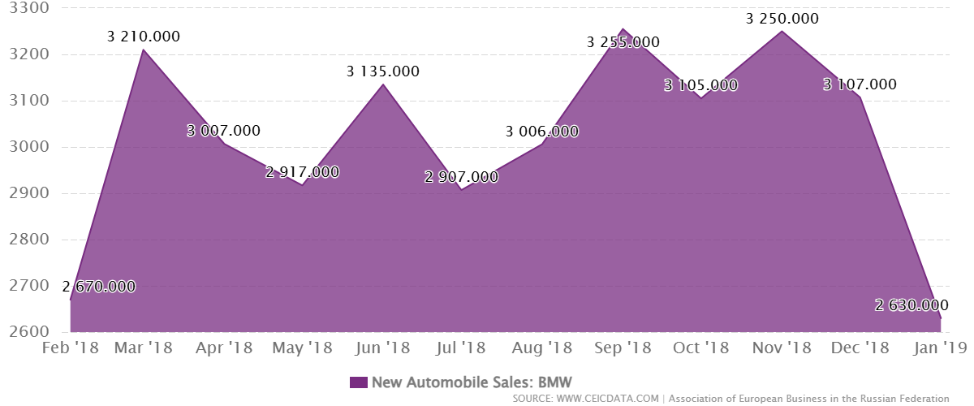
Figure 60: Russia Sales BMW

4.10.2 Canada
And Canada is still a robust and lucrative market for BMW. Sales performance continues to expand, boosted by SUVs, EV adoption and good dealership operations. BMW Group Canada reported consistent year-on-year growth in 2025 with model line-ups such as the X Series and i Series being a major contributor to this growth (BMW Group Canada, 2025). Stable economic conditions, brand loyalty and structured distribution support maintained profitability and competitive strength.
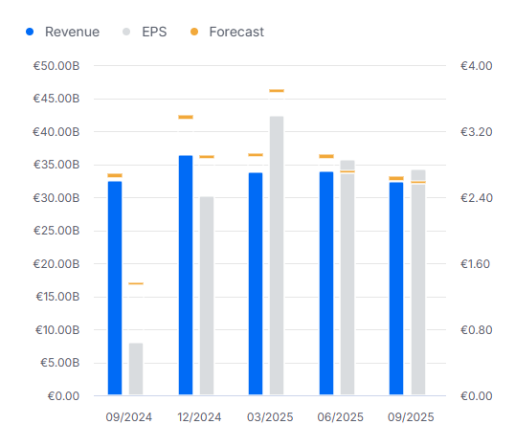
Figure 61: BMW Canada Financial Performance
(Source: Investing.com, 2025)

4.11 Social Media Engagement

4.11.1 Russia
The social media activity of BMW in Russia has turned out to be insignificant and sporadic after the official activity was suspended. The company does not control local digital platforms and do not run the campaigns that are oriented to Russian consumers (BMW Group, 2023). Reports made unofficially, groups of owners and grey-market discussions all exist online and have no corporate messages. Consequently, the quality of engagement and brand narration has been compromised in comparison to international BMW markets.

4.11.2 Canada
In Canada, BMW has excellent digital presence on Instagram, Facebook, YouTube and dealership affiliated channels. Content that emphasizes performance, innovation, EV technologies, and storytelling with a focus on lifestyle (BMW Group Canada, 2025). High engagement given by promotional videos, model launches, winter driving features, and user interaction. The united social media approach increases brand visibility, provides consumer education, about EVs and enhances the premium brand experience.

4.12 Customer Reviews

4.12.1 Russia
Russian customer reviews have gotten more negative or uneven, which has been explained by the lack of official service centres, complication of finding authentic parts, and warranty lack of warranty (Lahiri, 2024; Rivers, 2024). Many customers complain of frustration through grey-market activities, exaggerated price, and untrustworthy after-sale services. The overwhelming reviews that have been made about BMW are mostly related to the high quality of its vehicles though these positive reviews have often been overshadowed by dissatisfaction on ease of access to its services once the company shuts down.
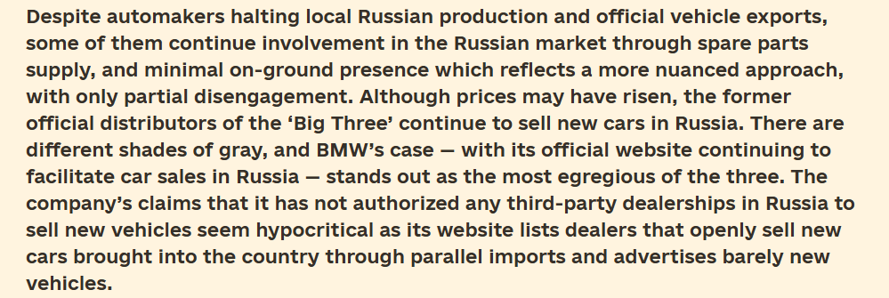
Figure 62: BMW Russia Customer Reviews
(Source: B4Ukraine, 2025)

4.12.2 Canada
In Canada, customer reviews are generally positive with high standards of professionalism by dealerships, reliable after-sales service and superior product offerings. Customers often praise the performance of BMW's electric vehicles, their suitability in winter, their technological capabilities and responsiveness to service (BMW Group Canada, 2025). Occasional critiquing on premium priced or maintenance costs; however the overall satisfaction remains strong and is quiet and kept up by constant corporate supports and service infrastructure nationally.
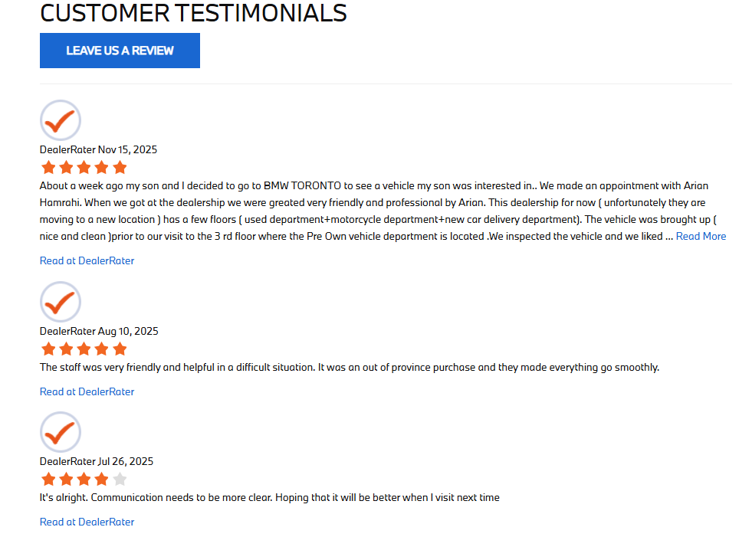
Figure 63: BMW Canada Customer Reviews
(Source: BMW Group, 2025)

5. Ethics of Canada
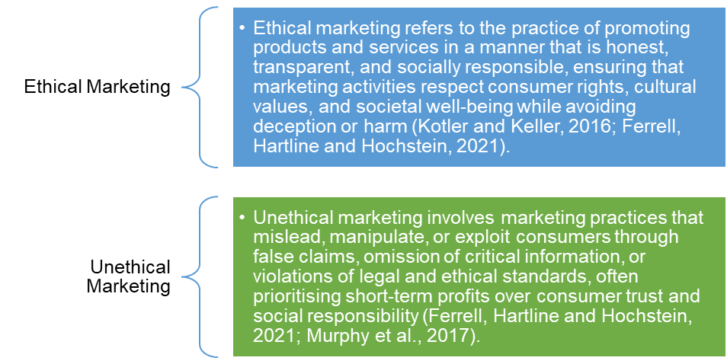
Figure 64: Ethical vs Unethical Marketing Definitions
(Created by learner)
There is well-organized and clear regulatory environment in Canada, the environment in which BMW can introduce strong ethical practices in its operations. Another ethical value maintained by BMW in Canada refers to the concept of responsible sourcing, sustainability, and consumer transparency, which is addressed in the global sense of corporate ethics (BMW Group, 2025). Canadian car dealerships follow strict pricing fairness, honest advertising and proper materialization of specifications of various vehicles, which further ethical marketing principles in the up-market automotive industry. The fact that Li (2025) identifies BMW as a company interested in the development of EVs also suits the expectations of the Canadian environment by facilitating the decrease in emissions and technological advancements.
Employee ethics are equally important, with focused focus on fair labour practices, encouraging skill development, and ensuring equal employment opportunities in its employee workforce, BMW Group Canada (BMW Group, 2025; BMW Group Locations, 2025). Ethical governance is also supported by compliance programmes, internal audits and safety protocols that ensure the vehicles meet strict regulatory requirements from Canada.
BMW will also strive to ensure the transparency of its complaint management, warranties, and service accuracy because of the solid consumer protection policies implemented in Canada. The well-organized process of customer complaints provided to BMW Canada promotes responsibility and adequate response, which evidences ethical responsibility toward customers.
Contrasted to markets where political instability is prevalent - Russia, where BMW abandoned its activity due to ethical and legal requirements (BMW Group, 2023) - Canada enables a more stable policy that promotes regular coherence between corporate ethics and sociopolitical expectations at national level. As a result, BMW's ethical strategy in Canada is indicative of a responsible corporate behaviour, sustainable innovation, and customer orientated integrity, thus strengthening stakeholder trust and reinforcing the premium nature of its brand identity.
Marketing Type | Example (Using STP / 7Ps) | Explanation with In-text Citations
Ethical Marketing | BMW Canada – Targeting & Product (STP + Product) | BMW ethically targets environmentally conscious and middle-income consumers in Canada through its “Power of Choice” strategy, offering EVs (i4, iX), hybrids, and ICE vehicles without misleading sustainability claims. This transparent targeting aligns product features with genuine consumer needs and environmental policies (BMW Group Canada, 2025; Li, 2025).
Ethical Marketing | BMW Canada – Promotion (7Ps) | BMW Canada promotes sustainability, inclusivity, and EV benefits using factual performance and emissions data, supporting informed consumer decision-making and long-term trust (Adil and Hussain, 2024).
Unethical Marketing | BMW Russia – Distribution & Promotion (7Ps) | Despite official withdrawal, BMW vehicles were sold to Russian buyers via third-party and grey-market channels, indirectly targeting sanctioned markets and undermining ethical distribution standards (Lahiri, 2024; Rivers, 2024).
Unethical Marketing | BMW Russia – Targeting (STP) | Continued indirect targeting of affluent Russian buyers through intermediaries contradicted stated exit strategies and EU sanctions, raising concerns about transparency and regulatory compliance (BMW Group, 2023; Lahiri, 2024).
Table 10: Examples of Ethical and Unethical Marketing Practices Using STP and 7Ps
(Crated by learner)

6. Recommendations

6.1 Recommendations – Russia (Country A)
- Extensive, tight shipment of 3rd-party control and supply chain visibility would be necessary to prevent grey-market markets and avoidance of sanctions (Lahiri, 2024; Rivers, 2024).
- Communication by the brand must be reduced to the allowed after-sales and financial services, and the transmission of false market signals is prevented (BMW Group, 2023).
- The ethical environment of marketing is also advised to be strengthened through enhanced employee and partner compliance training that will hold them accountable under the law (Adil & Hussain, 2024).
- To restore the stakeholder trust and protect the brand image, the compliance audits and the corrective measures should be publicly disclosed (BMW Group, 2023).
- Any promotional messages that are aspirational or promotion based based on prestige that may indirectly trigger approved demand should be put on hold (Boston, 2022).

6.2 Recommendations – Canada (Country B)
- Transparent promotion of electric vehicle (EV) performance, charging infrastructure and lifecycle emission should be retained to reduce the risks of greenwashing (Li, 2025).
- Inclusive targeting strategies have to be broadened to represent the Canadian multicultural demographics and gender diversity within marketing communications (Adil & Hussain, 2024).
- Ethical data usage and consumer privacy standards should be increased in digital platforms such as BMW ConnectedDrive (Quinn, 2025).
- Pricing and incentives communications should be well paired with governmental EV subsidies to help inform consumer decision-making (BMW Group Canada, 2025).
- Sustainability terminology in storytelling must be supported through metrics and third party certification that can be verified to support ethical brand positioning (BMW Group, 2025).

7. Conclusion
The report logically contrasted the international strategies of BMW through the combination of the vision of the firm (BMW Group, 2025), localized PESTLE analyses, and updated model applications, a Hofstede model used is mentioned as well as VALS2 segmentation. The analytic tables were recognized as learner-generated where product comparisons depicted the difference in depth, breadth, and branding which were supported by visual illustrations. Distribution evaluations included direct, indirect and intensive, as well as a detailed market-entry method; sales promotion, advertising and sponsorship activities strengthened the Promotion component. Process analysis included the customer complaint systems of each country and Physical Evidence was increased to refer to the website references, marketing strategy evaluations, profit and sales data, social media engagement data and reviews as well as the examination of similarities and differences. The comparative insights were reinforced substantially with the ethical considerations and strategies. In general, this report clarifies the way BMW develops its strategies in divergent environments, thus highlighting the importance of localisation, adherence to regulatory structures, and customer experience improvement as the core mechanisms that maintain its global competitiveness.

References
Adil, I. and Hussain, M.M. (2024) Report on Management Challenges of Managing the Workplace: Case Study BMW. Northeastern University (Shenyang, China) and MediClinic International Hospital & Fertility Research Center. doi:10.13140/RG.2.2.20596.97927
Automotive Industries Association of Canada (2025) Understanding millennial vehicle owners: key insights for Canadian auto care businesses. AIA Canada. Available at: https://www.aiacanada.com/news/understanding-millennial-vehicle-owners-key-insights-for-canadian-auto-care-businesses/
AUTOSTAT (2019) ‘BMW dealership for 30 cars was opened in Moscow’, AUTOSTAT, 4 October. doi: https://eng.autostat.ru/news/17565/
B4Ukraine (2025) ‘BMW, Mercedes, Audi: Have the German ‘Big Three’ left Russia?’, B4Ukraine, available at: http://b4ukraine.org/whats-new/bmw-mercedes-audi
BMW Group (2023) Company profile and statement on operations in Russia. Leave Russia. Available at: https://leave-russia.org/bmw-group
BMW Group (2025) BMW Group Report 2024. Available at: https://www.bmwgroup.com/content/dam/grpw/websites/bmwgroup_com/ir/downloads/en/2025/bericht/BMW-Group-Report-2024-en.pdf
BMW Group (2025) BMW Special Sales Sustainability Hub: Environment overview. BMW Canada. Available at: https://www.bmw.ca/en/topics/offers-and-services/bmw-special-sales/sustainability/bmw-special-sales-sustainability-hub-environment-overview.html
BMW Group (2025) History of BMW Group. Available at: https://www.bmwgroup.com/en/company/history.html
BMW Group (2025) Locations — BMW Group Canada Careers. Available at: https://www.bmwgroup.jobs/ca/en/location.html
BMW Group (2025) The Company BMW Group. Available at: https://www.bmwgroup.com/en/company.html
BMW Group Canada (2025) ‘BMW Group Canada reports Q3 2025 sales results’, PressClub Canada (Press release, 1 Oct.). Available at: https://www.press.bmwgroup.com/canada/article/detail/T0453117EN/bmw-group-canada-reports-q3-2025-sales-results?language=en
Boeriu, H. (2025) ‘BMW Canada brings back U.S.-built X3, X5 despite 31% tariffs’, BMWBLOG, 26 August. doi: https://www.bmwblog.com/2025/08/26/bmw-canada-resumes-us-built-x-model-imports-tariffs/
Boston, W. (2022) ‘BMW halts production in Russia and stops exports to the country’, The Wall Street Journal, 1 March. Available at: https://www.wsj.com/livecoverage/russia-ukraine-latest-news-2022-03-01/card/bmw-halts-production-in-russia-and-stops-exports-to-the-country-T36AO5SxgtXwEfXJBsZ8
Canada, Department of Finance (2025) Canada takes decisive action to protect auto industry and workers. Government of Canada. Available at: https://www.canada.ca/en/department-finance/news/2025/10/canada-takes-decisive-action-to-protect-auto-industry-and-workers.html
CEIC Data (2019) Russia motor vehicle sales: new: BMW, 2006–2019 | Monthly | Unit | Association of European Business in the Russian Federation, CEIC Data. doi: https://www.ceicdata.com/en/russia/new-automobile-sales-passenger-cars-and-lcv/motor-vehicle-sales-new-bmw
Daneliya, G. and Bogdanov, D. (2024) Construction, infrastructure issues in Russia’s auto sector. Law.asia. Available at: https://law.asia/construction-infrastructure-issues-russia-auto-sector/
Dewan, A. (2025) Vanguard’s mid-year outlook for the economy. Fund Library. Available at: https://fundlibrary.com/Articles/Detail/vanguards-mid-year-outlook-for-the-economy/1986
Digital Agency Network (2025) ‘6 key points about the digital marketing strategy of BMW’, Digital Agency Network. doi: https://digitalagencynetwork.com/6-key-points-about-the-digital-marketing-strategy-of-bmw/
Dubetcky, O. (2024) Re-imagine the business strategy: PEST/EL analysis. Medium. Available at: https://medium.com/
Fleck, A. (2025) IMF: Russia’s economic growth expected to slow. Statista. Available at: https://www.statista.com/chart/34186/real-gdp-year-over-year-growth-estimates-projections-in-russia/
Investing.com (2025) BMW ST (BMWG) earnings dates & reports, Investing.com. doi: https://ca.investing.com/equities/bay-mot-werke-earnings
Lahiri, I. (2024) ‘BMW confirms luxury cars were sold to Russian buyers despite sanctions’, Euronews, 24 December. Available at: https://www.euronews.com/business/2024/12/24/bmw-confirms-luxury-cars-were-sold-to-russian-buyers-despite-sanctions
Lahiri, I. (2024) ‘BMW confirms luxury cars were sold to Russian buyers despite sanctions’, Euronews, 24 December. doi: https://www.euronews.com/business/2024/12/24/bmw-confirms-luxury-cars-were-sold-to-russian-buyers-despite-sanctions
Lame, G. (2022) The real reason why BMW stopped making cars in Russia and halted exports. HotCars. Available at: https://www.hotcars.com/the-real-reason-why-bmw-stopped-making-cars-in-russia-and-halted-exports/
Li, S. (2025) ‘BMW Electric Vehicles Transition and Future Market’, Proceedings of the 2025 3rd International Conference on Digital Economy and Management Science (CDEMS 2025), pp. 723–733. doi:10.2991/978-94-6463-770-0_81
Miller, K. (2022) Hofstede’s cultural dimensions: implications and how to apply. CrowJack. Available at: https://crowjack.com/blog/strategy/hofstedes-cultural-dimensions
MMA Global (2025) BMW Canada: The Perfect 10 Is Now the 8, CaseStudyHub, MMA Global. doi: https://www.mmaglobal.com/case-study-hub/case_studies/view/56553
Newaz, A.A.H., Hossain, E. and Uddin, N. (2025) BMW-Supply Chain Management System. University of Bridgeport and Humphreys College. DOI: https://doi.org/10.5281/zenodo.14890184
Partsvania, V. (2025) Structural crisis of the Russian automotive industry: why the crisis is not cyclical but systemic in nature. Riddle Russia. Available at: https://ridl.io/structural-crisis-of-the-russian-automotive-industry/
Quinn, N. (2025) BMW’s Operations Management (10 Critical Decisions) & Productivity. Panmore Institute. Available at: https://panmore.com/bmw-operations-management-10-critical-decisions-productivity-case-study
Rivers, S. (2024) ‘BMW Staff Smuggled Over 100 Cars To Russia, Despite Sanctions’, Carscoops, 23 December. Available at: https://www.carscoops.com/2024/12/bmw-staff-smuggled-over-100-cars-to-russia-despite-sanctions/
Rivers, S. (2024) ‘BMW Staff Smuggled Over 100 Cars To Russia, Despite Sanctions’, Carscoops, 23 December. Available at: https://www.carscoops.com/2024/12/bmw-staff-smuggled-over-100-cars-to-russia-despite-sanctions/
Taylor, J. (2025) BMW i4 wins 2025 Canadian Electric Car of the Year. BMW Group Canada Press Release. Available at: https://www.press.bmwgroup.com/canada/article/detail/T0448047EN/bmw-i4-wins-2025-canadian-electric-car-of-the-year?language=en
The Kyiv Independent (2024) ‘BMW dismisses employees involved in scheme to illegally deliver cars to Russia’, The Kyiv Independent, 23 December. doi: https://kyivindependent.com/bmw-dismisses-employees-involved-in-scheme-to-illegally-deliver-cars-to-russia/
The Moscow Times (2025) ‘BMW Reclaims Top Spot Among Premium Foreign Car Brands in Russia Despite Sanctions’, The Moscow Times, 28 October. doi: https://www.themoscowtimes.com/2025/10/28/bmw-reclaims-top-spot-among-premium-foreign-car-brands-in-russia-despite-sanctions-a90963
The Moscow Times (2025) ‘BMW reclaims top spot among premium foreign car brands in Russia despite sanctions’, The Moscow Times, 28 October. doi: https://www.themoscowtimes.com/2025/10/28/bmw-reclaims-top-spot-among-premium-foreign-car-brands-in-russia-despite-sanctions-a90963
Tock, A. (2022) BMW halts exports to Russia, conflict responsible for production interruptions. BimmerLife. Available at: https://bimmerlife.com/2022/03/02/bmw-halts-exports-to-russia-conflict-responsible-for-production-interruptions/
Urquhart, T. (2025) Russia’s automotive market: a complex dilemma for foreign OEMs. S&P Global Automotive Insights. Available at: https://www.spglobal.com/automotive-insights/en/blogs/2025/06/russia-automotive-market-challenges-foreign-automakers
Voronoi (2025) Mapped: Every car built in Canada. Voronoi. Available at: https://www.voronoiapp.com/automotive/Mapped-Every-Car-Built-in-Canada---4516
Zeifmans LLP (2025) Beyond the EV hype: the hard truth about Canada’s auto sector crisis. Zeifmans. Available at: https://www.zeifmans.ca/beyond-the-ev-hype-the-hard-truth-about-canadas-auto-sector-crisis/

