NAME: FAIJANALI IRFAN SAIYED
STUDENT ID: 2525946
MODULE: MARKETING MANAGEMENT
MODULE CODE: LCMB7024
LECTURER: LAILA MAAZOUZ DIAN MAYASARI

Table of Contents

Task 1: Macro-Environmental Analysis 3
A. Technological Actor 3
1. Vertical Integration Cost Moat (2021-2025) 3
2. Software vs. Hardware Dominance 4
3. Battery Innovation Shifts: 4680 vs. LFP 4
B. Economic Actor 5
1. Global Price War & Inflation (2024–2026) 5
2. Subsidy Expiration & Policy Retrenchment 6
Competitive Position Impact (2025) 7
Analysis 7
Task 2: Strategic Framework Application 7
1. Porter’s Generic Strategies: Differentiation vs. Cost Leadership 8
2. Ansoff’s Growth Matrix: Strategic Paths to Sustained Growth 8
3. Critical Evaluation: The “Lead-Follower” Reversal 10
Conclusion 11
Reference 12

Task 1: Macro-Environmental Analysis
This part critically examines two macro-marketing players, one of them being Technological and Economic, and it assesses how the forces have transformed the competitive advantage of the pioneer and the fast follower in the global EV industry between the year 2021 and 2026.

A. Technological Actor
The macro-variable that is structurally most transformative to the EV industry is still technological forces. Three interconnected changes taking place between 2021 and 2025 have changed cost structures and competitive positioning materially, namely, vertical integration, software-hardware strategic orientation, and battery chemistry innovation.

1. Vertical Integration Cost Moat (2021-2025)
Industry Development
The vertical integration became a determining competitive advantage between 2021 and 2025. The consumption of the semiconductor, battery, and motor production allowed BYD to develop the so-called “Blade Battery” (based on LFP) which along with the control over its production, costs about 15% less compared to most of the Western rivals (Mokhale, S.I., 2025). The BYD model is less dependent on the suppliers and will limit the impact of supplier variability in the supply chain (especially during the semiconductor shortages in 2021-2023).
Tesla has a history of vertical integration, including Gigafactories and battery development (especially using 4680 cells) (Ozsevim, 2024). Nonetheless, its supply chain is globally located and slightly dependent on the external partnerships of raw materials and components.
Opportunity/Threat Analysis
Tesla (Pioneer) | BYD (Follower)
Opportunity: Early Gigafactory strategy created scale efficiencies and learning-curve advantages.  Threat: BYD’s deeper upstream integration in battery and semiconductor manufacturing narrows Tesla’s cost advantage (Yan, 2022). | Opportunity: Vertical integration acts as a structural cost moat, particularly during price wars.  Threat: High capital intensity increases financial exposure if demand weakens.

Critical Insight
The first-mover advantage has been re-established by the technological transformation of integrated manufacturing. The initial innovation leadership of Tesla gave differentiation-based superiority. The vertically integrated business model of BYD transforms the technological capability into cost leadership on a large scale. Cost leadership would be more decisive as a strategic metric in the face of a maturing industry where growth would be steadily determined by affordable pricing.

2. Software vs. Hardware Dominance
Industry Development
Tesla continues to be a software architecture, over-the-air (OTA) and Full Self-Driving (FSD) industry leader. Its use of AI makes vehicles software platforms and not strictly mechanical products (Wansley, 2024). BYD has focused on uninterrupted hardware innovation, introducing models with high specifications like Dolphin and Seagull at much lower prices, which are aimed at the masses.
Opportunity and Threat Analysis
Tesla | BYD
Opportunity: The program of software monetisation (FSD subscriptions) generates a stream of recurring earnings outside sales of cars (Bello, 2025).  Threat: Oversight of autonomous assertions and safety has a chance of tarnishing a good name and legal penalties. | Opportunity Hardware-based rapid iteration can respond to consumer price sensitivity faster.  Threat: Software minor quality can damage the potential of long-term lock-in of the ecosystem.

Critical Insight
The technological macro-environment points to the bifurcation of strategic logics: Tesla is fighting in the paradigm of an ecosystem, software-based, and BYD is fighting in the paradigm of high volume, cost-efficient hardware. With the mounting pressure of economic considerations, there is an increase in dedicating consumer preference to cost over sophisticated autonomous functionality. The technological macro-force consequently enhances the scalability of BYD at the expense of Tesla which is dependent on a premium position.

3. Battery Innovation Shifts: 4680 vs. LFP
Industry Development
The invention of batteries is the centre of technological struggle. The 4680 cylindrical cells of Tesla are designed to maximise the energy content and the production efficiency. The LFP in BYD Blade Battery focuses on safety, durability and reduced cost of production though more energy density is obtained with high-nickel chemistries (Gorsch et al., 2025).
Opportunity/Threat Analysis
Tesla | BYD
Opportunity: Higher energy density enhances range performance, reinforcing premium differentiation.  Threat: Manufacturing complexity and slower-than-expected scaling of 4680 production increase cost uncertainty. | Opportunity: LFP chemistry reduces reliance on expensive nickel and cobalt, stabilising costs (Evro et al., 2024).  Threat: Lower energy density may constrain high-performance segments.

Critical Insight
The technological evolution has shifted towards performance maximisation converting to price maximisation and supply stability. In new and price-irrelevant markets, marginal gains in range are not as significant as safety and cost efficiency. This macro-technological change is structurally in favour of the choice of chemistry at BYD. The technology strategy Tesla has is still technologically oriented innovation, yet the convergence that is taking place in the industry due to the LFP chemistry reduces the differentiation and increases the competitive scale advantage of BYD.

B. Economic Actor
The macro-environmental economic factors of 2024-2026 have significantly contributed to the competitive results as compared to the effect of technology itself. Profitability and market share have materially changed out of inflation, an increase in interest rates, withdrawals of subsidies, and increasing competition in prices.

1. Global Price War & Inflation (2024–2026)
Industry Development
The intensifying competition led to high-stakes price cuts in the international market. Tesla launched several price reductions in the period of 2023-2025 to boost demand. At the same time, the effects on purchasing power were also inflationary due to a decline in the consumer purchasing power, especially of more expensive EV models that are financed via credit (Slowik et al., 2023).
Opportunity/Threat Analysis
Tesla | BYD
Threat: Greater exposure to premium segments increases sensitivity to financing costs.  Margin compression reduced automotive gross margins significantly from peak levels.  Opportunity: Price cuts defend volume but at the expense of profitability. | Opportunity: Lower cost base enables sustained competitive pricing with less margin erosion.  Threat: Overcapacity risks if price competition intensifies further.

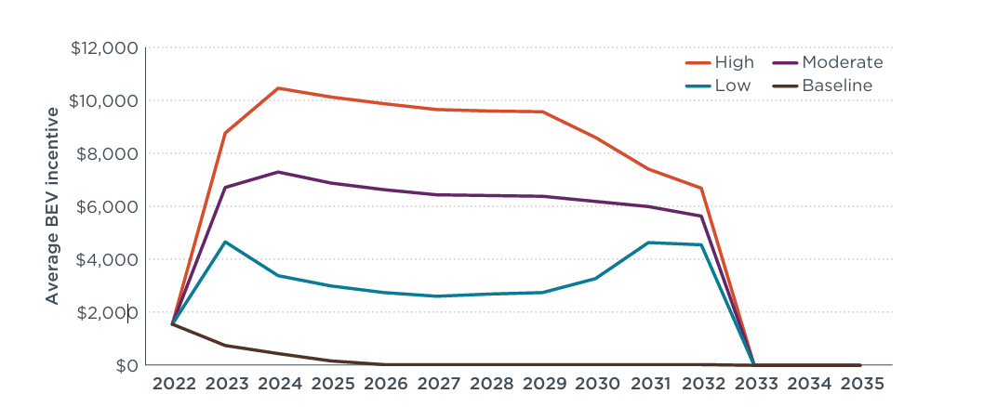
Figure 1: IRA incentive values applied to battery electric vehicle prices in the IRA Low, Moderate, and High scenarios
(Source: Slowik et al., 2023)
Critical Insight
The macro-environment economic environment has shifted the race of EVs to margin pain narrowing as opposed to the previously experienced expansion competitions. The differentiation model of Tesla is based on high pricing. Therefore, the tightening of the macroeconomic system has a disproportionate impact on its financial arrangement. The cost leadership model employed by BYD is more flexible in the case of inflationary and high-interest rates. Economic volatility then shrinks Tesla's strategy and increases the scalability of BYD.

2. Subsidy Expiration & Policy Retrenchment
Industry Development
The loss of the US federal tax credit on EVs of $7,500 at the end of 2025 had a big influence on the demand elasticity. In Germany, sales of Tesla cars fell by 48% due to subsidy cuts (Ricks and Kay, 2025). These changes demonstrate that EV implementation is tied to fiscal boost strategies.
Opportunity/Threat Analysis
Tesla | BYD
Threat: Lack of sales stability after reconstruction of subsidies means that the company depends on the incentive-generated demand.  The higher price bracket brand positioning puts elasticity sensitivity on its toes. | Opportunity: There are still relatively affordable, non-subsidized lower-priced models.  Threat: Policy like unpredictability may be similar in an international expansion.

Critical Understanding
The unsubsidized depicts the vulnerability of the EV demand structures. The first advantage of the pioneers is normally conjoined with the favourable regulatory climate, however, when the subsidies are shrinking intrinsic affordability begins to emerge.. The structural cost advantage means BYD does not need fiscal help to stay competitive, and Tesla has to be vulnerable when aligning with the premium (Yan, 2022). This macroeconomic change significantly alters the competitive equilibrium for cost-effective producers.

C. Competitive Position Impact (2025)
The joint technological and economic powers led to a drastic change in the leadership scenario throughout the world. In 2025, BYD shipped about 2.26 million Battery Electric Vehicles (BEVs) compared to 1.64 million of Tesla (Hidayat, 2026). This achievement is the milestone of the loss of first-mover advantage. The shrinking of the Tesla market share is the outcome of the contraction of the margin as well as the sensitivity of the demand to economic contraction. The rise of BYD reinforces the idea that the follower strategies based on cost leadership and vertical integration could be more successful compared to those based on innovation and pioneering in the stage of the mature market (Clear Waters Capital, 2025). The control of BYD in the mass-market areas increases both mass penetrations globally especially within the emerging markets.

D. Analysis
The macro environment of 2021-2026 reflects the transition in the structural shift taking place in the EV industry. Firstly, the technological forces supported innovation leadership, which strengthened the pioneering power of Tesla. Nonetheless, convergence in technology, especially in battery chemistry and manufacturing efficiency and a constrained economy have increased cost economy as the principal basis of competition. Price wars, inflation, subsidy withdrawal and other economic impacts have posed different problems to premium-focused strategies in a disproportionate manner. This makes BYD a more suitable model in the existing macro-environmental arrangement due to its vertical, cost-efficient organisational model (An, 2021) .
Commoditisation of technology and economic pressure interaction have hence re-tuned competitive balance. The pioneer continues to lead in terms of symbolic innovation, but the follower reflects better adjustability to the dynamic macro-marketing environment, and is able to apply cost discipline to quantifiable market share (Chen et al., 2024). This is dynamic, and points towards a key strategic lesson in the technology-based industries: first-mover advantage is time-bound and may be eliminated once macro-environmental conditions change away around the rapidity of innovation in favour of economic rationalisation.

Task 2: Strategic Framework Application
On the basis of the macro-environmental analysis completed in Task 1, this section assesses the strategic reactions of both Tesla and BYD to continue growth during economic rationalisation and technological convergence. Through the use of Porter's Generic Strategies and Ansoff Growth Matrix, it critically analyzes how each of the firms' processes of moving away from the innovation-led leadership style towards a marginally strained competitive environment.

1. Porter’s Generic Strategies: Differentiation vs. Cost Leadership
The difference in competitive advantage between the pioneer and the follower can be explained best through the prism of Difference and Cost Leadership developed by Porter.
Tesla: Focused Differentiation and the “Aspirational” Premium
The position of Tesla is still based on Differentiation, where the brand equity as a tech company is employed instead of an ordinary automaker. This can be seen based on its software architecture dominance in the industry and Full Self-Driving (FSD) features, which make the car a high-margin software platform. The diversification of Tesla was advanced between 2021 and 2025 through its network of Superchargers, which allowed Tesla to establish a proprietary ecosystem worthy of premium prices (Liu, Boothman and Graham, 2025).
This is not the case in 2026 when this strategy enters a differentiation trap. According to industry reports, in the already mature markets such as Europe, Tesla is getting more and more exposed due to the lapse of subsidies in its premium positioning. Tesla's reply has been a contradiction of itself, dipping into price-cutting to maintain volume, which analysts claim jeopardises its luxury brand. These pressures notwithstanding, Tesla continues to enjoy gross profit margins in the industry, with a profit share in the global EV market of over 90% in early 2025 that shows that differentiation still has huge monetary worth (Richter, 2026).
BYD Structural Cost Leadership through Vertical Integration
On the contrary, BYD is the international role model of the Cost Leadership. Having produced its own battery, semiconductor and motors about 75% in-house, BYD has cut out the “supplier markup” that afflicts Western competitors. This vertical integration enabled BYD to be able to introduce price reductions of up to 15% possible in 14 models within the 2024-2025 cycle at a gross margin of around 20% (Li, Yan and Goh, 2024).
The cost moat that BYD has is not only the consequence of low labour, but the economies of scale. Focusing on the affordable market share (10-20k dollars) with the Seagull, BYD has received the mass-market sales volume powered by the higher Tesla price of products (Average Sales Prices). To the follower, its leadership in costs is the key to its goals of reaching 2025: becoming the first to sell more than 2.26 million BEVs annually of the model (2.26 million compared to 1.64 million Tesla) (L, 2026).

2. Ansoff’s Growth Matrix: Strategic Paths to Sustained Growth
In order to sustain the momentum in the presence of macro-environmental actors that were identified in Task 1, the two companies have implemented different growth strategies.
Market penetration and product development (Tesla)
The new strategy is a focused effort of Market Penetration and Product Development of Tesla. Tesla repriced its two most popular models, Model 3 and Model Y, in the US in October 2025 to boost its demand following the lapse of federal tax credits (Stanley, 2021). At the same time, Tesla is reducing its line-up, stopping the sale of the Model S and X in certain markets in 2026, to zero in on the high-volume Cybertruck and the new Cybercab. This would be a leap of product development towards AI and autonomous transport, to establish a new market of robot taxis to avoid the existing price wars in the passenger car industry (As in Figure 2).
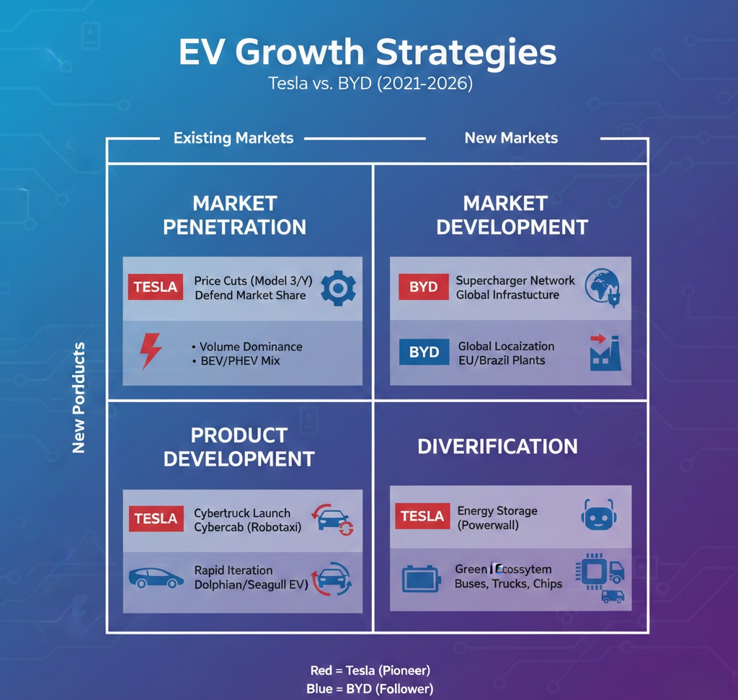
Figure 2: Ansoff Growth Matrix: Tesla vs. BYD
(Source: Self-created)
Market Development and Diversification (BYD)
BYD has worked towards an aggressive Market Development policy. In 2025, it reached its highest export of 1.05 million units (Nasdaq.com, 2025). Last year, BYD overtook Tesla in the sales rankings as the U.S. company and brands in charge of it suffered a second year of diminished sales. When BYD registered an electric car sale to 2.26 million vehicles worldwide, a 28% increase, Tesla became the focus of this consonance with sales of 1.64 million vehicles falling by nearly 10%, the electric heartbreak of EV tax incentives and the divisive politics of Musk picked Tesla firmly, eroding its sales (Richter, 2026).
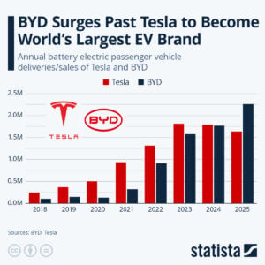
Figure 3: BYD Surges Past Tesla to Become World's Leading EV Brand
(Source: Richter, 2026)
In addition, BYD employs more Diversification as compared to Tesla. Whereas Tesla is diversified in the energy storage (Megapacks), BYD has its Full-Scenario Green Energy Ecosystem, which extends to electric buses, trucks, as well as the monorail. This diversification helps BYD to be immune to any changes in the performance of one segment of consumers, but Tesla depends on a few passenger cars, exposing it to demand shock.

3. Critical Evaluation: The “Lead-Follower” Reversal
The analysis of strategy shows that there has now been an elementary reversal, the pioneer has now become a “defender” and the follower has become an “aggressor”.
- The Strength of the Follower: BYD has been able to effective a hybrid strategy via a “hub-and-spoke” interaction, involving conventional dealerships alongside immediate sales in international markets to expand circumventing Tesla, however, which solely utilises a direct-to-customer approach (Ayad and Bultena, 2024).
- The Pioneer Burden: Tesla has a growing stagnant product portfolio and has political scandals that have decreased its growth with over 40% issues of registration in high focus European markets early in 2026.

Analysis of Competitive Position
Tesla, the technology icon and driving force behind profits, still has to concede the volume war to BYD who integrates better operational efficiency and market flexibility. The Tesla strategic reaction switching to AI and robotics is a big bet as differentiating the software can eventually prevail over the lower hardware costs of BYD. Nevertheless, when it comes to the 2026 macro-environment characterised by high interest rates and mass-market element of EV adoption, BYD is aligned with cost-conscious consumers, providing it with a temporary but decisive strategic advantage.

Conclusion
The discussion shows that first-mover advantage is time-dependent. The differentiation of Tesla has given the first jump over the industry, the cost-focused follower strategy of BYD has been more sustainable in the shift to a mature and price-sensitive market. Tesla needs to effectively implement the product development transition to autonomous services to be able to become the leader once again, and BYD needs to address the challenges of globalisation and localization and the threats of trade retrenchment.

Reference
‌An, T. (2021) The strategic group analysis of BYD new energy vehicles from the perspective of value chain. In: Proceedings of the 6th Annual International Conference on Social Science and Contemporary Humanity Development (SSCHD 2020), Atlantis Press, 735–740.
Ayad, P. and Bultena, L. (eds.) (2024) Panoramic Automotive & Mobility 2024. Hogan Lovells and Law Business Research. Available at: https://www.hoganlovells.com/-/media/project/english-site/our-thinking/publication-embedded-media/pdfs/2024/panoramic-automre42-06_27_2024.pdf?sc_lang=en&hash=A1A45EDD46A68EE9CB49564BCBBC0BB9 (Accessed: 17 February 2026)
Bello, W. (2025). Strategic Analysis of Tesla Inc. [online]. https://www.researchgate.net/publication/397254297_Strategic_Analysis_of_Tesla_Inc (Accessed: 17 February 2026).
Chen, J., Zhang, Y., Cai, H., Liu, L., Liao, M. and Fang, J. (2024). A Comprehensive Overview of Micro-Influencer Marketing: Decoding the Current Landscape, Impacts, and Trends. Behavioral Sciences, [online] 14(3), pp.243–243.
Clear Waters Capital (2025). BYD Company: Charlie Munger Didn’t Buy An Automaker; He Bought Into Its Ingenuity. [online] Seeking Alpha. Available at: https://seekingalpha.com/article/4847600-byd-company-charlie-munger-didnt-buy-an-automaker-he-bought-into-its-ingenuity (Accessed: 17 February 2026).
Evro, S., Ajumobi, A., Mayon, D. and Tomomewo, O.S. (2024). Navigating battery choices: A comparative study of lithium iron phosphate and nickel manganese cobalt battery technologies. Future Batteries, 4, p.100007.
Gorsch, J., Schneiders, J., Frieges, M., Kisseler, N., Klohs, D., Heimes, H., Kampker, A., Muñoz Castro, M. and Siebecke, E. (2025). Contrasting a BYD Blade prismatic cell and Tesla 4680 cylindrical cell with a teardown analysis of design and performance. Cell Reports Physical Science, 6(3), p.102453.
Hidayat, M. (2026) BYD overtakes Tesla in global electric vehicle sales for 2025. Discovery Alert. Available at: https://discoveryalert.com.au/global-electric-vehicle-transformation-2026-industry-shift/ (Accessed: 17 February 2026).
L, J. (2026). BYD Overtakes Tesla as World’s Biggest EV Seller in 2025. [online] Carbon Credits. Available at: https://carboncredits.com/byd-overtakes-tesla-as-worlds-biggest-ev-seller-in-2025/ (Accessed: 17 February 2026).
Li, Q., Yan, Z. and Goh, B. (2024) BYD launches lower-priced new versions of Han, Tang models in Dynasty line-up. Reuters, 28 February. Available at: https://www.reuters.com/business/autos-transportation/byd-launches-lower-priced-new-versions-han-tang-models-dynasty-line-up-2024-02-28/ (Accessed: 17 February 2026).
Liu, C.C., Boothman, S.G. and Graham, J.D. (2025). The Rise and Recent Decline of Tesla’s Share of the U.S. Electric Vehicle Market. World Electric Vehicle Journal, [online] 16(2), pp.90.
Mokhale, S.I. (2025). ‘Product Life Cycle (PLC) Assessment and dominance of China in Lithium-ion Battery for EV’. International conference on Reverse Logistics and circular economy strategies for sustainable Development (ICRCSD 2025) organized by Vishwakarma University, Pune, Maharashtra, India. [online] Available at: https://www.researchgate.net/publication/391715661_Product_Life_Cycle_PLC_Assessment_and_dominance_of_China_in_Lithium-ion_Battery_for_EV (Accessed: 17 February 2026).
Nasdaq.com. (2025). China Auto Market Boomed in 2025: Why Growth May Be Softer in 2026. [online] Available at: https://www.nasdaq.com/articles/china-auto-market-boomed-2025-why-growth-may-be-softer-2026 (Accessed: 17 February 2026).
Ozsevim, I. (2024). Tesla’s EV battery production and global gigafactory network | Article | Automotive Manufacturing Solutions. [online] Automotivemanufacturingsolutions.com. Available at: https://www.automotivemanufacturingsolutions.com/electrification/electric-dreams-teslas-gigafactory-network-and-ev-battery-production-blueprint/545858 (Accessed: 17 February 2026).
Richter, F. (2026). Infographic: BYD Surges Past Tesla to Become World’s Leading EV Brand. [online] Statista Daily Data. Available at: https://www.statista.com/chart/33709/tesla-byd-electric-vehicle-production/?srsltid=AfmBOopgvmL7Wb010wrUm5_5xxe6lp02mgUfS4GLclLsMCNXjD3Rrstt (Accessed: 17 February 2026).
Ricks, M.D. and Kay, O. (2025). Time-Limited Subsidies: Optimal Taxation with Implications for Renewable Energy Subsidies. Journal of Political Economy, 133(12), pp.3801-3845.
Slowik, P., Searle, S., Basma, H., Miller, J., Zhou, Y., Rodríguez, F., Buysse, C., Kelly, S., Minjares, R., Pierce, L. and Orvis, R., 2023. Analyzing the impact of the inflation reduction act on electric vehicle uptake in the United States. International Council on Clean Transportation, 31.
Stanley, M. (2021) The New Oil: Investment Implications of the Global Battery Economy. Research Blue Paper, 15 November. Available at: https://advisor.morganstanley.com/eliah-najjar/documents/field/l/la/lanigan---najjar-group/Morgan%20Stanley%20Blue%20Paper%20-%20The%20Electric%20Battery%20Economy%2011-2021.pdf (Accessed: 17 February 2026).
Wansley, M. T. (2023). Regulating driving automation safety. Emory LJ, 73, 505.
Yan, J. (2022). BYD and Tesla’s competitive advantages and future development prospects. BCP Business & Management, [online] 18, pp.442–450.

