University of Wales Trinity Saint David
Strategic Management Analysis of Toyota Motor Corporation
External and internal environment, sustainability, balanced scorecard, strategic choices and recommendations
Programme | MBA International Business
Module | Strategic Management
Module code | LCMB7003
Lecturer | Zulfiqar Khan
Student name | Sadman Hossain
Student ID | 2505391
Word count
Submission date | 1 April, 2026

Table of Contents
Section 1: Strategic management report 3
1. External environment analysis 5
2. Internal environment analysis 8
3. CSR and sustainability objectives 11
4. Balanced scorecard 12
5. Strategic choices and implementation 14
6. Strategic evaluation and recommendations 15
Section 2: Reflective account using Gibbs' reflective cycle 18
Description 18
Feelings 18
Evaluation 18
Analysis 19
Analysis continued 19
Conclusion 19
Action plan 20
References 21

This report is an assessment of Toyota Motor Corporation as an automotive and mobility company in the world. It is based on the LCMB7003 brief by integrating organisational overview with the external and internal analysis, sustainability and CSR discussion, the balanced scorecard with strategic choices and implementation issues, strategic evaluation and recommendations, and a structured reflection through the Gibbs cycle. Everything on the cover-page is left blank with the intention of filling in later.

Section 1: Strategic management report
Toyota Motor Corporation is a giant automobile manufacturer that produces passenger vehicles, commercial automobiles, and mobility-related services and is ranked among the largest in the world. The group was established in 1937 and has grown to be a multi-brand company spread across the world with Toyota, Lexus and a vast system of manufacturing, financing, procurement and technology subsidiaries. By 31 March 2025 the total number of people working on a consolidated basis at Toyota was 383,853, reflecting not only the size of its operating footprint but also the complexity of the management task in terms of coordinating quality, efficiency and innovation by region (Toyota Motor Corporation, 2025e). Strategically, Toyota does not identify itself as just a car maker anymore. Its present storey is that of a mobility company that aims to generate happiness to everybody by integrating hardware, software and alliances to amplify the worth of movement and decrease environmental and social evil (Toyota Motor Corporation, 2025f).
A more direct way of stating the Toyota mission is that it produces mobility value by way of safe, reliable and more sustainable products and services that enhance daily life. Its vision extends beyond car production: now the management sees Toyota as a mobility company that aims at integrating multi-pathway carbon reduction, digital capability, and regionally-specific customer solutions on a global scale.
This more explicit mission-vision framing is important in that it is what clarifies why the Toyota strategy is not merely about holding on to incumbent scale. It is concerning finding equilibrium between past excellence in quality and production and future demands in software, electrification, governance credibility and lifecycle sustainability.
The reason why that repositioning is important is that the automotive industry is transforming due to the influence of electrification, software-defined cars, climate control, geopolitical instability and shifting consumer demands. The business model of Toyota is thus based on two logics. To begin with, it capitalises on scale in its core vehicle production, Toyota Production System, good relationships with suppliers, effective plants, reputable brands and extensive geographical reach. Second, it also invests in future alternatives such as batteries, hydrogen, connected vehicles, data, advanced safety and Woven City thus attempting to escape strategic lock-in as the direction of mobility demand remains unknown (Toyota Motor Corporation, 2025f). The consolidated FY2025 results of Toyota indicate that this model is still commercially strong. The sales revenues increased to 48.0 trillion-yen, consolidated vehicle sales amounted to 9.36 million, and the retail demand of electrified vehicles, particularly the hybrids, was high (Toyota Motor Corporation, 2025a; Toyota Motor Corporation, 2025b).
The situation of Toyota is not so clear, however. The competitors of the company are very different ones: established manufacturers with scales, Chinese companies with fast-moving costs and digital benefits, and specialised electric vehicle companies with well-developed software ecosystems. Competitive pressure is thus not limited to market share battles but also incompatible strategic logics as to what the future car might be. The solution that Toyota has provided is a multi-path approach where hybrids, plug-in hybrids, battery electric vehicles, fuel cell vehicles and new fuels are developed simultaneously so that product choice can be aligned to regional infrastructure and customer realities (Toyota Motor Corporation, 2025f). The advantage of that strategy is flexibility. Its drawback is that it is arguably slower and less single than the battery electric strategies of some competitors that are pure.
Figure 1 indicates the financial trend in the recent past that puts Toyota in strategic position.
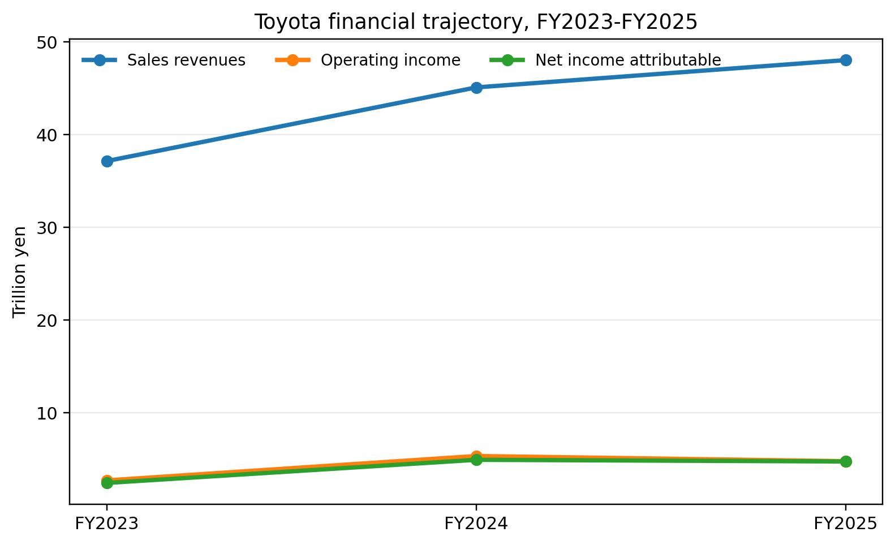
Figure 1. Toyota financial trajectory, FY2023-FY2025
Source: compiled from Toyota Motor Corporation (2023), Toyota Motor Corporation (2024a) and Toyota Motor Corporation (2025a).

1. External environment analysis
A PESTEL analysis reveals that Toyota is in one of the most tactical turbulent industries in the world. The competition in the automotive industry is no longer motivated only by the size of manufacturing, or the reliability of the product. It is becoming more influenced by policy, energy systems, software capability, data and infrastructure and regional industrial policy. The Toyota implications are huge since the company is not only diversified globally but also entrenched in long-cycle manufacturing assets that cannot be reconfigured within the span of a single night.
Table 1. PESTEL summary for Toyota
Factor | Key issue for Toyota | Strategic implication
Political | Trade friction, local content expectations and tariff exposure, especially in North America | Raises pressure for regional manufacturing resilience and supply-chain localisation
Economic | Interest rates, inflation, exchange-rate movements and cyclical auto demand | Affects affordability, margins and financing profitability
Social | Demand for safety, affordability, SUVs, trucks and sustainable mobility varies by region | Supports Toyota's region-centred product logic rather than one global template
Technological | Acceleration in batteries, software, ADAS, chips and data ecosystems | Requires faster learning and collaboration beyond traditional carmaking
Environmental | Decarbonisation targets, lifecycle emissions scrutiny and circularity expectations | Pushes Toyota to prove that its multi-pathway strategy remains consistent with net-zero pathways
Legal | Emission regulation, compliance obligations, product certification and governance scrutiny | Raises cost of missteps and makes quality systems strategically critical
Source: author synthesis based on Reuters (2025a), Reuters (2025b), Reuters (2026a), Toyota Motor Corporation (2025a), Toyota Motor Corporation (2025d) and Toyota Motor Corporation (2025f).
Toyota has a fragmented policy environment as opposed to a global rulebook politically. The US is still of critical significance in terms of income and magnitude, yet tariff policy can be viewed as a direct threat to income. In May 2025, Reuters reported that Toyota expect to decrease the FY2026 operating income by 21%, and U.S. tariffs and a stronger yen are among the key negative contributors (Reuters, 2025a). This is important as a strategic consideration since Toyota conventional advantages, such as effective cross-border manufacturing and global platform advantage, become weak when policy suddenly punishes imports or increases local-content requirements. A company that is established on global optimisation should therefore incur increased expenses to be regionally resilient.
On the economic side, Toyota enjoys the global diversification but this does not exclude the macroeconomic exposure. The exchange of the currencies may drastically transform the reported earnings since Toyota continues to consolidate the results in yen. The consumer financing terms are also important since affordability is the focus of the automotive demand. Increased interest rates increase monthly payment load and may compromise replacement cycles particularly in the mass-market segments. Concurrently, high material and logistics cost undermines margins unless it is compensated by pricing power, reduction of costs and productivity. The FY2025 presentation developed by Toyota shows that value-chain profits, cost reduction, and volume mix play a crucial role in maintaining profitability in the case of a decline in external conditions (Toyota Motor Corporation, 2025b).
Social pressures support the long-term regional focus of Toyota. The needs of consumers vary significantly by market: big pickups and SUVs are still essential in North America, smaller and electrified vehicles are more at the centre of focus in Europe, and affordability and digitalness are key issues in China and emerging Asia. The integrated report of Toyota clearly outlines the region-centred management as the tool that allows aligning products with regional specifics and not imposing a single standardised logic on them (Toyota Motor Corporation, 2025f). This is a social and strategic benefit since it connects the product design with the real experiences of the customers, yet it makes it more difficult to coordinate a portfolio and more complex to develop it.
Software-defined vehicles, batteries, advanced driver assistance, semiconductors and digital services are redefining the industry in terms of technology. Toyota is not a technological laggard, but it is competing in the areas where the learning speed increased and where the specialist companies, including the Chinese competitors, can relocate very fast. In March 2025, Reuters added that Toyota introduced its lowest-priced smart EV in China to reclaim a share and respond to the feature-rich and low-cost offers of local rivals (Reuters, 2025b). That episode underlines a larger fact: Toyota is not competing in the field of reliability and production quality alone anymore. It now has to bring those strengths and speed together in software, user interface, battery ecosystems and local innovation.
Decarbonisation is no longer a peripheral theme of CSR, but a first-order strategic concern, environmentally. Sustainability disclosures by Toyota include clear goals regarding lifecycle greenhouse-gas reduction, carbon neutrality and electrification of vehicles, among others, to a greater degree. By 31 March 2025, the firm had cumulative sales of Toyota and Lexus electrified vehicles of 31.75 million units and its new 2030 and 2035 climate targets put a heavy emphasis on lifecycle emissions, as opposed to tailpipe emissions (Toyota Motor Corporation, 2025d). This helps the multi-pathway strategy of Toyota to be intellectual as there is lifecycle emissions variance in the context of infrastructure. The same strategy, however, is subject to criticism when regulators, investors or activists want a more single battery-electric storey. The strategic problem has thus not only been technological execution but being persuasive.
In law, the automotive companies are vulnerable to safety laws, emissions, testing, standards and labour and governance cheques. In the case of Toyota, trust is strategically associated with compliance since the brand value in the automotive markets is directly related to reliability and safety. The problem of certification in Japan in the past also shows how legal and operational discipline cannot be decoupled and divorced of strategy. A company where reliability is part of the competitive point has less tolerance of compliance failure than a company where novelty or price is the major competitive factor. The same argument can be applied to governance. The issue of investor pressure has been raised in connexion with cross-shareholding and Toyota Industries several times by Reuters, which means that governance now belongs to the Toyota external strategic environment and not an issue of internal board (Reuters, 2024; Reuters, 2026a).
The PESTEL analysis combined identifies five key success factors of Toyota. First, the firm will need to maintain manufacturing strength and minimise tariff and supply-chain risks. Second, it has to create software and battery advantages faster, without abandoning the profitability of hybrids. Third, it will have to retain its regional product logic and reap scale off the global platforms. Fourth, it should also uphold trust by quality, safety and governance enhancement. Fifth, it should prove the validity of its multi-pathway climate strategy through objective gains. These forces are not independent of each other. As an illustration, a quicker EV push should be able to enhance regulatory legitimacy but should undermine short-term returns in case there is execution lag or uneven customer adoption. Balance, as opposed to one-dimensional optimisation is therefore the basis of strategic judgement.
Figure 2 helps to see the balance of Toyota regional sales and also to argue that region-centred management is not an option, but is a strategic necessity.
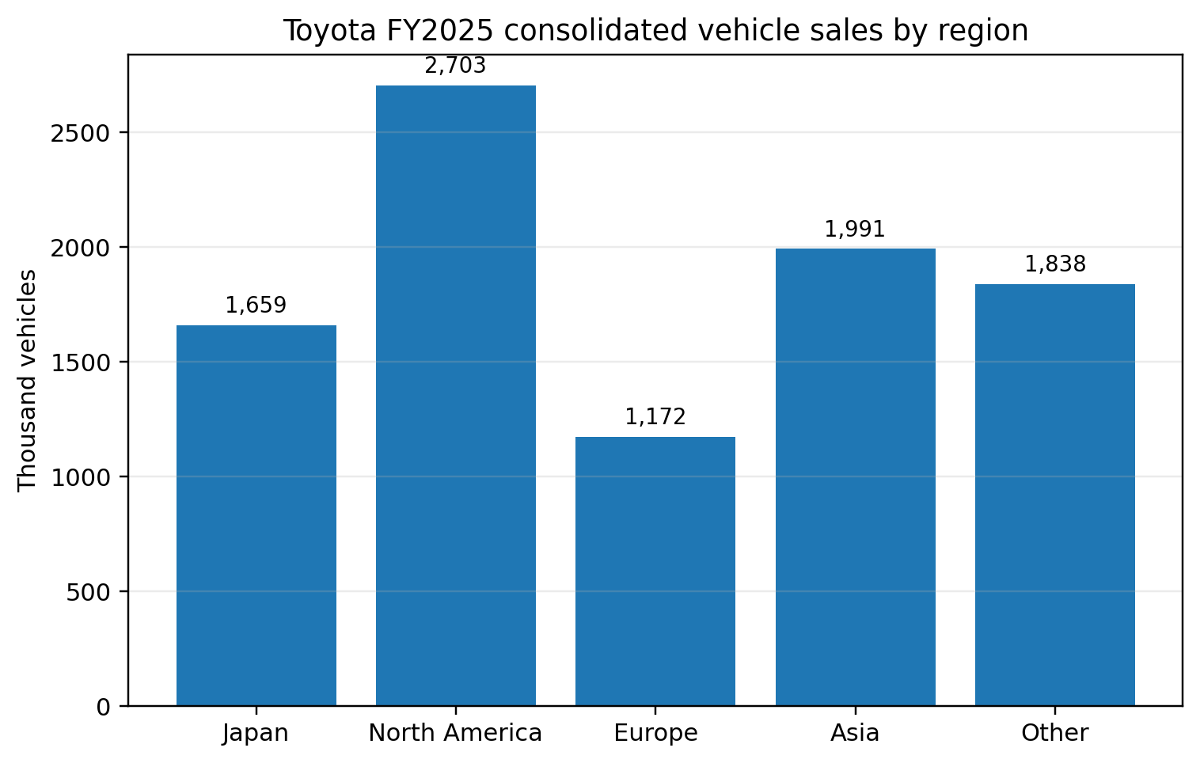
Figure 2. Toyota FY2025 consolidated vehicle sales by region
Source: compiled from Toyota Motor Corporation (2025b).

2. Internal environment analysis
A resource-based and dynamic-capabilities perspective provides the best analysis of Toyota in terms of its internal position. According to Barney (1991), the sustained advantage rests on the resources that are valuable, rare, hard to imitate and well organised. Grant (1991) also emphasises that the strategy must be developed based on what firms can do differently well, whereas Teece, Pisano and Shuen (1997) emphasise that it should be able to integrate, build and reconfigure capabilities in changing conditions. Toyota is a teaching case since the competitive advantage Toyota has historically possessed is not a single asset but a self-strengthening system of capabilities.
The initial and the most evident internal strength is the Toyota Production System along with the extended routines which support the kaizen, quality assurance, standardisation, supplier development and waste reduction. The further the routines are socially embedded and path dependent, the more competitors can emulate the specific lean tools. Leadership beliefs, problem-solving practises, shop-floor discipline and long supplier relationships make them stronger. This renders the operating model of Toyota hard to imitate wholesomely. The second significant strength is brand architecture. In several markets, Toyota is a good position in the mass-market, and Lexus is added to the premium credibility and margin possibilities. The third strength is region-based and product-based management that enables Toyota to integrate global and local adaptation (Toyota Motor Corporation, 2025f).
The fourth strength is financial strength. FY2025 revenues of Toyota were 48.0 trillion yen, and net income attributable were 4.77 trillion yen even though they were lower than the record FY2024 (Toyota Motor Corporation, 2025a). This is important since strategic change in the automotive markets is capital intensive. Cash generation is required by the firms to finance battery platforms, software, partnerships and plant reconfiguration as well as to withstand demand volatility. Toyota profitability is thus a strategic resource per se. The fifth capability is technological optionality. Toyota has not yet given up on hybrids, plug-in hybrids, fuel cells, batteries and software-defined vehicles; instead, it focuses solely on battery electric vehicles. It is still debatable whether that will be better in the end but it does build a portfolio of possibilities in a state of uncertainty.
Nonetheless, weaknesses and tensions should also be found with the help of internal analysis. The best routines of Toyota were developed during a manufacturing period where excellence in mechanical engineering was the order of the day. The present shift needs a faster software cycle, greater digital architecture and another pace of innovation. The company has recognised this by making investments in SDV foundations, AI-enabled safety and partnership, but the danger is that organisational strengths can become stagnant as timeless truth when they are viewed as dynamic systems (Toyota Motor Corporation, 2025f). Likewise, the success of Toyota in hybrids is a strength and a weakness. It offers the cash flow, customer acceptance and lower average emissions, but may also postpone more serious commitment to battery-electric learning in the event that leaders might fall in love with the existing economics.
The following VRIO table identifies which capabilities are most likely to support durable advantage.
Table 2. VRIO assessment of Toyota
Resource / capability | V | R | I | O | Strategic implication
Toyota Production System and supplier-development routines | Yes | Yes | Yes | Yes | Sustained advantage when continuously renewed
Toyota and Lexus brand trust for quality, safety and resale value | Yes | Yes | Moderate | Yes | Strong but must be protected through quality discipline
Region-centred management and local product fit | Yes | Yes | Moderate | Yes | Important source of resilience and share defence
Hybrid powertrain leadership and scale | Yes | Yes | Moderate | Yes | Current advantage, but vulnerable if BEV adoption accelerates faster
Cash generation and balance-sheet capacity | Yes | No | No | Yes | Competitive parity plus transition funding strength
Software-defined vehicle capability | Yes | No | No | Developing | Necessary capability, not yet a clear source of advantage
Source: developed from Barney (1991), Grant (1991), Teece, Pisano and Shuen (1997), and Toyota Motor Corporation (2025f).
The VRIO analysis indicates that Toyota continues to have a sustained competitive edge in production quality and entrenched supplier practises, but brand loyalty and local management is a strong yet less defensible competitive advantage. In comparison, software-defined capability is now more a strategic requirement than a verified differentiator. This difference is important as it is a naive belief that Toyota can count on its former strengths to conquer the new generation. The traditional strengths of the company are still the ones that finance and stabilise the transition and the future benefit will be based on whether the traditional strengths can be re-integrated with accelerated digital learning. It is what dynamic capability is all about. Toyota does not have to give up on its ancient strengths. It should not allow them to inhibit adaptation.
Figure 3 illustrates the structure of the electrified retail sales in FY 2025. It strengthens the existing reliance of Toyota on hybrids and the strategic imbalance between its short-term commercial triumph and its long-term task of electrification.
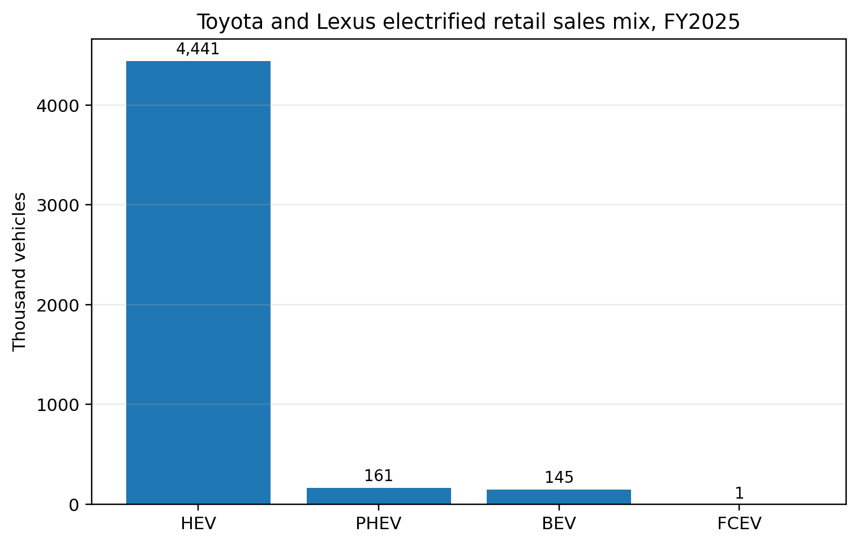
Figure 3. Toyota and Lexus electrified retail sales mix, FY2025
Source: compiled from Toyota Motor Corporation (2025b).

3. CSR and sustainability objectives
The CSR and sustainability agenda of Toyota is strategically important as it directly influences the cost, legitimacy, investor confidence, supplier relationship and market entry. The company bases sustainability on carbon neutrality, circular economy, nature positive outcomes, safety, human rights, quality and value-chain collaboration (Toyota Motor Corporation, 2025d). This is more general than traditional philanthropy and nearer to endemic sustainability, where social and environmental considerations are incorporated into the operating choices.
The most evident sustainability goal is lifecycle decarbonisation. According to the sustainability data book of Toyota, there are new vehicle greenhouse-gas emissions targets and carbon neutrality targets in lifecycle emissions by 2050, with milestones in 2030 and 2035 (Toyota Motor Corporation, 2025d). The new 2030 action plan also targets carbon-neutral plants by 2035 and greater performance in the circular-economy by the company. Notably, Toyota attributes these goals to mass adoption of electrified cars, renewable energy, supply chain optimization, battery and hydrogen value chain, and infrastructure cooperation in the region.
In CSR perspective, Toyota also focuses on human rights, supplier standards, safety and contribution to society. It is important since automotive sustainability cannot be reduced to tailpipe emissions. It entails worker treatment, responsible sourcing, product safety and fair transition effects up the supply chains. Toyota is under pressure in its sustainability agenda on two fronts, however, strategically. On the one hand, the regulators and activists are increasingly insisting on more evident evidence that multi-pathway decarbonisation does not represent merely an alternate method of reaching the same goal. On the inside, the range of goals threatens the diffusion in the event that metrics are not prioritised. The issue is then to join sustainability promises to real business implementation and not just on aspirational statements.
In sum, the CSR agenda of Toyota is plausible as it is functioning and not cosmetic, however, it is strategically disputed. The company should demonstrate that its approach of choice to reducing emissions is commercially viable and fast enough. Sustainability at Toyota, in that regard, is not disassociated with strategy. It is the challenge of whether the operating model of the firm, product logic and investment decisions can continue to be legitimate in a fast-tightening policy and investor world.

4. Balanced scorecard
Kaplan and Norton (1992) argue that strategy should be translated into a coherent performance architecture rather than measured only through financial results. For Toyota, a balanced scorecard should therefore specify not only strategic objectives and KPIs but also concrete targets and delivery initiatives. That fuller architecture is essential because Toyota's transition challenge is practical rather than abstract: management must align profitability, customer trust, operating discipline, capability renewal and decarbonisation through measurable commitments.
Table 3. Proposed balanced scorecard for Toyota
Perspective | Strategic objective | Illustrative KPI | Indicative target | Priority initiatives
Financial | Protect operating resilience while funding electrification and software transition | Operating margin; free cash flow; R&D productivity | Protect margin at or above 10%; maintain positive free cash flow; improve software and battery ROI year on year | Capital-allocation gates; tariff mitigation and localisation; model-mix optimisation; platform sharing
Customer | Strengthen trust, regional product fit and loyalty during the shift to electrified mobility | Repeat purchase rate; quality incidents; electrified mix by region; Net Promoter Score | Improve repeat purchase and NPS annually; reduce quality incidents year on year; grow region-specific electrified mix in core markets | Region-led product planning; faster digital-service updates; quality recovery loops; stronger after-sales experience
Internal process | Increase speed and reliability in product development, software delivery and supply resilience | Development-cycle time; recall rate; supplier disruption days; OTA release frequency | Shorten development-cycle time; reduce recall frequency; increase software-release cadence; cut disruption exposure in key components | Cross-functional SDV programme offices; dual sourcing; battery and semiconductor resilience; process digitisation
Learning and growth | Renew organisational capabilities in software, batteries, data and cross-functional leadership | Critical digital-skill coverage; training hours in software/AI; internal mobility; succession depth | Expand digital-skill coverage annually; raise specialised training completion; increase redeployment into strategic capability areas | Targeted hiring; reskilling academies; technology partnerships; agile leadership development
Sustainability / stakeholder | Reduce lifecycle emissions while improving governance credibility and supplier responsibility | Vehicle CO2 reduction; renewable-energy share in plants; supplier audit coverage; cross-shareholding reduction | Track against published 2030 and 2035 climate milestones; increase renewable-energy use annually; expand supplier-audit coverage; continue disposal of non-essential cross-shareholdings | Plant decarbonisation roadmap; supplier-engagement and audit escalation; circularity pilots; governance and disclosure upgrades
Source: adapted from Kaplan and Norton (1992) and aligned to Toyota Motor Corporation (2025a; 2025d; 2025f); targets are indicative strategic planning targets for evaluation purposes.
The financial viewpoint is also critical since strategies of transition that fail to cover themselves fail in the long run. FY2025 performance indicates good performance in earnings by Toyota, yet Figure 4 indicates that the management perceives a reduced operating-income performance in FY2026 as tariffs, currency and other external pressures would have a negative influence on profitability (Toyota Motor Corporation, 2025b; Reuters, 2025a). A good scorecard must hence be able to differentiate between healthy investment and uncontrolled erosion of earnings.
The customer view cannot be confined to generic measures of satisfaction. In the case of Toyota, the customer value is based on quality, safety, resale confidence, regional relevance, energy cost, charging practicality and digital user experience. A Corolla hybrid in Europe, a pickup in North America and a cheap EV in China address various issues of customers. The scorecard of Toyota should thus be region sensitive in terms of the customer measures as opposed to global averages that level the strategic reality.
Internal process measures are essential since Toyota has an edge that lies on disciplined implementation. The previous firm was known to be good in terms of process reliability, yet the shift towards SDVs and electrified portfolios demands more speed and software capability. The scorecard must thus be tracking the quality of launch, stability of the software release, supplier stability, compliance and defects trend. These pointers assist the management to know whether they are becoming faster innovators by compromising the same routines that made Toyota powerful.
The measures of learning and growth are supposed to be centred on the renewal of capabilities, rather than on generic HR activity. Toyota requires engineers, information experts, battery know-how, cross-functional cooperation and outsourcing that reduces the learning process. The company must also have leaders who can make trade-offs specific to the region as opposed to optimising based on headquarters assumptions. Since the future strength of Toyota lies in recombination of manufacturing excellence and digital competence, learning measures must monitor that integration specifically.
Lastly, Toyota must have a sustainability overlay that is not handled lightly just like cost and quality. The scorecard should not be placed next to Lifecycle emissions, plant decarbonisation, supplier standards and circularity. That is significant strategically as climate legitimacy has become a factor on the market access, regulatory exposure and investor confidence. A balanced scorecard of Toyota must then be a tool of translation between strategy and execution to make sure that the profit engine of today does not overrun the legitimacy and capability needs of tomorrow.
Figure 4 supports the financial perspective of the scorecard by showing the expected near-term profit pressure even after a strong FY2025.
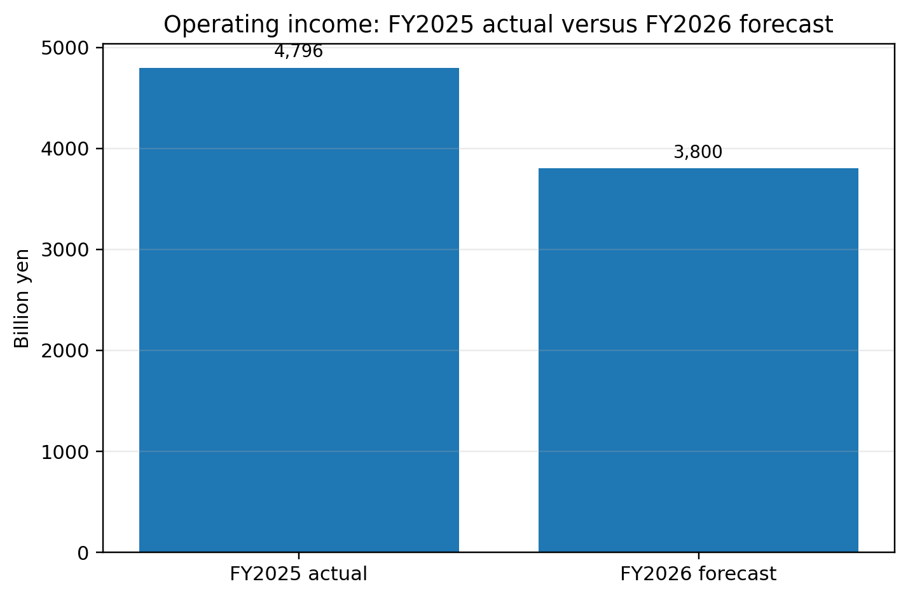
Figure 4. Operating income, FY2025 actual versus FY2026 forecast
Source: compiled from Toyota Motor Corporation (2025b) and Reuters (2025a).

5. Strategic choices and implementation
Multi-pathway mobility strategy is the most dominant strategic decision adopted by Toyota. Toyota is still building hybrids, plug-in hybrids, battery electric vehicles, fuel cell vehicles, hydrogen-related technologies and lower-carbon fuels instead of investing all its resources in battery electric vehicles. This option aligns with the fact that the company holds that infrastructure, customer affordability, regulation and energy systems are too varied to have a single technological pathway that can take the lead in all of the markets simultaneously (Toyota Motor Corporation, 2025f). At the business-level, Toyota is thus seeking differentiated value creation by reliability, scope of choice, local fit and lifecycle pragmatism as opposed to a single symbolic technology risk.
On the corporate level, Toyota is expanding beyond the manufacturing of vehicles into software, intelligent mobility, data and ecosystem alliances. This is reflected in Woven City, SDV initiatives, battery value chains, charging partnerships and regional joint ventures all of which represent this wider direction (Toyota Motor Corporation, 2025f; Toyota Motor Corporation, 2026a). Is Toyota to diversify or not? The corporate-strategy question is not how far or how fast, but whether it can at all lose its coherence in its diversification. The framework by Ansoff (1957) comes in handy. A lot of the present agenda of Toyota lies in-between product development and the surrounding diversification. It is spreading products, propulsion systems and mobility services into new areas and making use of existing engineering, manufacturing and brand resources.
The important issue is implementation. An operationally weak strategy can be intellectually beautiful. The implementation burden on Toyota is very high since it is striving to retain its present profitability, keep quality, appease regulators, localise products, improve its software capability, scale BEVs where necessary, deepen hybrids elsewhere, and keep suppliers in line with it. That demands than capital spending. It demands organisational alignment, prioritisation and signals of clear leadership. Toyota has announced the executive changes will happen in April 2026, which implies that the company tries to focus their management more and make decisions faster under the increasing external pressure (Toyota Motor Corporation, 2026a).
Toyota has a number of strengths as far as change-management is concerned. It possesses financial capability, a culture of good processes, a long track record of operating in the region and having a culture of systematic problem solving. Nevertheless, the organisational breadth may cause decline in change when local optimisation and consensus routine reduce and postpone strategic repositioning. The fact that Toyota does not have resources is not the major implementation risk. It is that the company can spread those resources over too many avenues without acquiring knowledge quickly in the areas that software and battery competition are most vigorous. It does not mean that the multi-pathway strategy should be discarded. It is to establish where the company is required to have optionality and where it is required to have a concentrated commitment.

6. Strategic evaluation and recommendations
Toyota's current strategy is stronger than many critics acknowledge, but weaker than its advocates sometimes assume. A concise SWOT-informed evaluation is presented in Table 4.
Table 4. Strategic evaluation summary
Dimension | Evaluation
Strengths | Deep production capability, trusted brands, hybrid leadership, strong profitability, region-centred management and supplier relationships
Weaknesses | Slower perceived momentum in pure EVs and software, complexity of multi-pathway execution, governance criticism
Opportunities | Affordable EV localisation in China and emerging markets, software monetisation, charging and battery partnerships, mobility ecosystem growth
Threats | Tariffs, Chinese price competition, regulatory tightening, digital disruption, reputational damage from quality or governance failures
Source: author synthesis based on Ansoff (1957), Porter (1985), Reuters (2024), Reuters (2025a), Reuters (2025b), Reuters (2026a) and Toyota Motor Corporation (2025f).
The strengths aspect of the assessment is evident. Toyota remains with one of the most powerful scale-quality- earnings power- manufacturing savvy and regional dispersion in the automobile industry. Much of this, according to Porter (1985), would be a system of mutually reinforcing activities, rather than an isolated capability. The profitability of Toyota in FY2025 although it fell short of that of FY2024 demonstrates that the present system is still commercially viable (Toyota Motor Corporation, 2025a).
The side of weaknesses is also significant. The approach used by Toyota may appear unclear to capital market since the company expresses flexibility even when its competitor’s express commitment. Flexibility can make sense in uncertain situations. Nonetheless, flexibility may be interpreted as indecisiveness in the situation when competitors are seen as going faster in BEVs, software, and digital services. Also, the questions of cross-shareholding and the criticism of the Toyota Industries deal have complicated the governance narrative of Toyota, undermining the moral authority of the larger stakeholder narrative (Reuters, 2024; Reuters, 2026a).
The opportunity factor plays an important role. Toyota is in a good position to respond to markets in which hybrids and affordable, energy and energy-system limited electrification are appealing. It can also do better in China with local products, quicker software implementation and more precise price-feature positioning, which is reflected in the introduction of cheaper smart EV models in 2025 (Reuters, 2025b). The ability to merge the reliability of its manufacturing with improved digital implementation would make the transition path of Toyota more defensible than a slow legacy model or a narrow high-burn EV model.
The danger aspect is escalating. Tariffs threaten earnings. Both price and pace of innovation are at risk by Chinese competitors. The threat on gradualist electrification is regulatory pressure. And digital disruption is a threat to the firms whose fundamental routines were developed in a previous technological age. These threats do not mean that the current strategy of Toyota is incorrect. They suggest that the error margin under which it can execute is decreasing.
This analysis leads to three recommendations. To start with, Toyota needs to maintain the multi-pathway strategy at the global level but reduce the operationally-based strategic focus, meaning, specifying several regions and product spaces, in which BEV and software leadership needs to be realised within a short period of time. One of those spaces should be China since it is a very competitive environment as well as the most learning-intense. This proposal is more concrete than an imprecise demand to become more invested in EVs. It appreciates that Toyota must be selectively strategically focused within a wide strategic framework.
Second, Toyota ought to restructure its implementation dashboard in such a way that the speed of software, quality of digital life and emission, costs and production efficiency are visible at the same levels. This would make the balanced scorecard logic operational and minimise the threat of legacy excellence crowding out transition metrics. As long as managers continue to be rewarded based on traditional manufacturing results, the strategy implementation will be biassed towards the old formula of success.
Third, Toyota needs to enhance its governance credibility by expediting the elimination of non-essential cross-shareholdings, enhancing transparency of capital allocation and connecting executive narrative more directly to transition milestones. Governance is not cosmetic. Credibility is important to a company that claims its path towards sustainability and mobility is more viable than others. The governance would be better hence enhancing investor confidence and strategic legitimacy.
In general, the strategic position of Toyota can be assessed as being strong but in transition. It is well-placed to continue to be victorious next century, and it does not have the indulgence of believing that next-generation excellence will just replicate into software-defined, low-carbon movement. Its optimal course will be to evolve in a disciplined manner: secure the driver of present-day competitiveness, speed up this learning where the future is being determined, and demonstrate with the metrics that multi-pathway agility is a strategic strength not a reason to wait.

Section 2: Reflective account using Gibbs' reflective cycle

Description
I took this report as a strategic assessment issue instead of a mere company profile. Initially, Toyota was attractive due to the abundance of data, the presence of a clear global scale and a high degree of relevance to the concepts of the strategy in the module. Nonetheless, after starting to collect the evidence, I understood that Toyota was also among those companies that are more difficult to analyse properly due to its controversial strategy. Others view Toyota as a disciplined and realistic with multi-pathway approach, others view it as battery electric vehicles as being cautious and late. This made my work not only to gather information but to make contradictory signals read in an organised manner. I structured the work on the following brief: organisational overview, external and internal analysis, CSR, balanced scorecard, strategic choices, evaluation and recommendations. I applied the academic theory to provide the report with the analytical discipline and the current company and news sources to make it be based on the real events.

Feelings
I was confident at the time of the start as Toyota is such a famous company. I thought that its strengths would be not difficult to explain and the report would write itself. The assumption was soon found to be false. The amount of information was big, and not everything could assist in responding to the brief. I was also a little tense after witnessing the degree of polarisation that had been achieved in the discussion of the electrification strategy of Toyota. In case I tilted too much on the praise side the report would be descriptive and unsympathetic. By going too far on the side of criticism, it would not take into account the commercial power and rationality of the regional strategy of Toyota. The process of carrying out the research made me more conscious of the fact that good academic writing does not imply taking the most vocal stand. It is a question of taking evidence into consideration and determining where the strengths of a firm are a risk.

Evaluation
A number of elements of the procedure functioned. To begin with, the selection of Toyota provided me with access to the powerful official resources, such as the financial outcomes, the integrated report, the company profile and the sustainability data book. That was what made it possible to relate strategy theory to existing evidence instead of generic commentary. Second, the report was better organised through the use of frameworks. PESTEL served to isolate outside pressures, VRIO served to differentiate between long-lasting capabilities and short-lived benefits and the balanced scorecard served to turn strategic problems into execution measures. Third, the visual aspects, in particular, the financial, regional and electrification charts, enhanced my skills in explaining patterns in a clear and concise manner, rather than hiding them in very long paragraphs.

Analysis
The greatest lesson of the task was that frameworks can only be helpful upon critical application. Initially I was tempted to consider PESTEL, VRIO and SWOT as a checklist tool. After I started writing, I realised that I had to connect them to make the quality of the report. As an illustration, the hybrid leadership of Toyota appears as a VRIO strength within the company, yet its strategic value is different when external control and competition of EV in China are taken into consideration. Similarly, the balanced scorecard gained significance when I applied it to a problem of implementation, that is the risk that the Toyota tradition of exceptional excellence in the area of cost and quality could obscure the numbers required in digital transition and decarbonisation. This made me realise that strategic analysis is a relational one. A capability cannot be evaluated out of context of the environment it is used in.

Analysis continued
The other significant lesson was about the nature of competitive advantage when there was uncertainty. My preconceived notions prior to completing the assignment were to consider strong strategy as one bold and clear choice. Toyota had to make me view that a portfolio strategy can be more rational than a one-bet strategy under specific circumstances. The multi-pathway approach seemed at first to me to be wavering in its steps due to the large number of media discourses that give battery-electric focus as the standard of seriousness. Nevertheless, when I took the issue of infrastructure differences into consideration, affordability, patterns of hybrid adoption and lifecycle emissions, the argument offered by Toyota appeared more acceptable. Simultaneously, I realised the risk of excessive flexibility as well. One form of risk can be neutralised, and another form enhanced by a company, e.g., slower learning in software or BEVs. This conflict made the report more analytically challenging and, in my opinion, more realistic.

Conclusion
Generally, I believe that the final report has more strength, as I transitioned to judgement out of description. The process enhanced my perception of strategy as being trade-offs and not formulaic. I also got to know that good suggestions cannot merely repeat the fashionable concepts like invest more in EVs or become more sustainable. They must also react to the logic of the company in question. In the case of Toyota, it implied suggesting selective focus in an extended multi-pathway framework, greater execution measures, and enhanced credibility in governance. To enhance the report further, I would further elaborate on China and software ecosystems since they seem to be the key points of future competitiveness of Toyota.

Action plan
My approach to future strategic-management tasks will be to start with a source map earlier and differentiate between theory sources, company disclosures and current external evidence. This would minimise chances of gathering excessive information without a clear purpose of analysis. I will also pin each framework against a simple question what decision or judgement does this framework assist me in achieving? That would maintain the style of writing more critical and less descriptive. Lastly, I would like to enhance my trust in the assessment of competing strategies. Toyota taught me that strategy work can be unfinished evidence, opposing storeys and unclear prospects. Instead of my taking that as a problem, I ought to take it as the ordinary state of managerial analysis. The writer need not and should not minimise or erase uncertainty, but he/she must be capable of clear reasoning within it.

References
Ansoff, H.I. (1957) ‘Strategies for diversification’, Harvard Business Review, 35(5), pp. 113–124.
Barney, J. (1991) ‘Firm resources and sustained competitive advantage’, Journal of Management, 17(1), pp. 99–120. Available at: https://doi.org/10.1177/014920639101700108 (Accessed: 10 March 2026).
Gibbs, G. (1988) Learning by Doing: A Guide to Teaching and Learning Methods. Oxford: Further Education Unit, Oxford Polytechnic.
Grant, R.M. (1991) ‘The resource-based theory of competitive advantage: implications for strategy formulation’, California Management Review, 33(3), pp. 114–135. Available at: https://doi.org/10.2307/41166664 (Accessed: 10 March 2026).
Johnson, G., Scholes, K. and Whittington, R. (2020) Exploring Strategy. 12th edn. Harlow: Pearson.
Kaplan, R.S. and Norton, D.P. (1992) ‘The balanced scorecard: measures that drive performance’, Harvard Business Review, 70(1), pp. 71–79.
Porter, M.E. (1985) Competitive Advantage: Creating and Sustaining Superior Performance. New York: Free Press.
Prahalad, C.K. and Hamel, G. (1990) ‘The core competence of the corporation’, Harvard Business Review, 68(3), pp. 79–91.
Reuters (2024a) ‘Toyota sold $2 bln worth of cross-held listed shares in FY2023/24, filing shows’, 25 June. Available at: https://www.reuters.com/business/autos-transportation/toyota-sold-2-bln-worth-cross-held-listed-shares-fy202324-filing-shows-2024-06-25/ (Accessed: 10 March 2026).
Reuters (2025a) ‘Toyota sees 21% full-year profit decline as tariffs take a bite’, 8 May. Available at: https://www.reuters.com/business/autos-transportation/toyota-sees-21-full-year-profit-decline-fiscal-2025-2025-05-08/ (Accessed: 10 March 2026).
Reuters (2025b) ‘Toyota launches its cheapest smart EV in China, aims to up market share’, 7 March. Available at: https://www.reuters.com/business/autos-transportation/toyota-launches-its-cheapest-smart-ev-china-aims-up-market-share-2025-03-07/ (Accessed: 10 March 2026).
Reuters (2026a) ‘Toyota’s buyout deal is a bigger win for Elliott than for governance’, 3 March. Available at: https://www.reuters.com/sustainability/sustainable-finance-reporting/toyotas-buyout-deal-is-bigger-win-elliott-than-governance-2026-03-03/ (Accessed: 10 March 2026).
Teece, D.J., Pisano, G. and Shuen, A. (1997) ‘Dynamic capabilities and strategic management’, Strategic Management Journal, 18(7), pp. 509–533. Available at: https://doi.org/10.1002/(SICI)1097-0266(199708)18:7%3C509::AID-SMJ882%3E3.0.CO;2-Z (Accessed: 10 March 2026).
Toyota Motor Corporation (2023) Financial summary FY2023. Available at: https://global.toyota/pages/global_toyota/ir/financial-results/2023_4q_summary_en.pdf (Accessed: 10 March 2026).
Toyota Motor Corporation (2024a) Financial summary FY2024. Available at: https://global.toyota/pages/global_toyota/ir/financial-results/2024_4q_summary_en.pdf (Accessed: 10 March 2026).
Toyota Motor Corporation (2025a) Financial summary FY2025. Available at: https://global.toyota/pages/global_toyota/ir/financial-results/2025_4q_summary_en.pdf (Accessed: 10 March 2026).
Toyota Motor Corporation (2025b) FY2025 financial results presentation. Available at: https://global.toyota/pages/global_toyota/ir/financial-results/2025_4q_presentation_en.pdf (Accessed: 10 March 2026).
Toyota Motor Corporation (2025c) Financial highlights and financial performance. Available at: https://global.toyota/en/ir/finance/ (Accessed: 10 March 2026).
Toyota Motor Corporation (2025d) Sustainability Data Book 2025. Available at: https://global.toyota/pages/global_toyota/sustainability/report/sdb/sdb25_en.pdf (Accessed: 10 March 2026).
Toyota Motor Corporation (2025e) Overview. Available at: https://global.toyota/en/company/profile/overview/index.html (Accessed: 10 March 2026).
Toyota Motor Corporation (2025f) Integrated Report 2024. Available at: https://global.toyota/pages/global_toyota/ir/library/annual/2024_001_integrated_en.pdf (Accessed: 10 March 2026).
Toyota Motor Corporation (2026a) TMC announces changes to executive structure. Available at: https://global.toyota/en/newsroom/corporate/43951723.html (Accessed: 10 March 2026).

