MODULE CODE/ COD Y MODIWL: ACCC504 WEB DEVELOPMENT

Cloud computing

Aleksandar Andonov
Student number: 1813107



TABLE OF CONTENTS

1.INTRODUCTION…………………………………………

2.RESEARCHING SECTION……………………………..
2.1 PHP……………………………………………………………………...
2.2 HTML…………………………………………………………………….
2.3 CSS……………………………………………………………………...
2.4 SQL……………………………………………………………………...
2.5 FRAMEWORK………………………………………………………….
- ADVANTAGES…………………………………………………..
- DISADVANTAGE………………………………………………...

3.INTRODUCTION SECTION…………………………….

4.TESTING SECTION……………………………………..

5.EVALUATION…………………………………………….

6.CONCLUTION…………………………………………….

REFERENCES………………………………………………………………

1.Introduction

This project will explore how the web works in relation to web development using HTML, PHP, CSS and MYSQL. The field of web developing is an engineering software that deals with building web pages. Web pages or mobile apps are code bases that are downloaded and run in a web browser, if a user navigates to the address of the website. It varies from other software that typically gets downloaded once and runs on your device or phone as a separate programme.

2.Research section

2.1 PHP
There are many technologies and programming languages ​​that have been developed that offer better and more advanced options in one aspect or another, however PHP is still one of the most popular programming languages. Since the PHP is so common and well used it has a few advantages to its own programming language.
One of its advantages is that it is accessible and easy to learn even for beginners. The syntax is easy to comprehend and will allow them to understand the program language and therefore write the desired code. It is also an open source project, which means that it is free and is developed and maintained by a large community of developers.
In order to develop more complex, dynamic and more user-friendly web applications, PHP is one of the best programming languages. PHP supports some of the most popular databases such as MySQL, ODBC, SQLite and many more. PHP is also supported by any platform which allows it to run on different operating systems. (Josh Lockhart, 2018), (Katzarov, Предимства на PHP, 2020)

2.2 HTML
HTML is another programming language for creating a webpage. Webpages are usually seen in a web browser and they can include writing, links, pictures, and even sound and video.
HTML helps us define the basic structure of a web page. It is also helpful for editing paragraphs, titles and other essential factors of a web page. When someone clicks on a link in a page or enters a new URL in the address field, the browser sends a request for a document from the Web server where the page is uploaded, using the Hypertext Transport Protocol (HTTP). The server then sends the document back to the user, displayed on the display by the browser. Everything that is on this document - text, photos, audio or video files - they are all arranged using an HTML structure. HTML is used to label and identify each of these content types, so they can be viewed correctly by the web browser.
The architecture of Web pages is formatted with CSS. They can be used to define text styles, table sizes and other aspects of Web pages that could only be previously defined in the HTML of a page. (Rouse, 2020) (contributors, 2019) (W3Schools.bg, 2018) (Katzarov, Какво е HTML и как работи той?, 2018)

2.3 CSS
CSS (Cascading Style Sheets) is a language for describing the appearance and styles of principles in an HTML document. CSS along with HTML and JavaScript are one of the main technologies used in web development.
When creating an HTML page, its content is marked with HTML code, and the presentation of this content, i.e. how it will be displayed in the browser, is established with CSS code.
In various cases, it is better to produce an element of an HTML page using CSS than by using well-known HTML tags. The biggest benefit is that CSS is associated with the control of a large set of HTML documents, as the appearance of the pages is done by varying a single file - CSS file, without having to modify the HTML code in each of the HTML pages. (Katzarov, Какво е HTML и как работи той?, 2018) (contributors, 2019)

2.4 SQL
In these present times almost all business work with data and they manage this data using database. This data can be stored using a database system. SQL is the appropriate and most practical programming language that enables programmers to work with the data. SQL stands for Language Structured Query. Essentially, in order to manage all the data, they contain, it is a language that allows communication with databases.
Although an application can be programmed in a language such as Python, PHP it does not configure databases to understand these.
SQL is the key language allowing the data to be managed and edited on your database servers. SQL is crucial as it views, updates, inserts, modifies and alters data. With SQL we can create tables, change information, select information we are interested in, for example if we want to see which users registered last week or which users have a certain badge.
The standard SQL commands such as "Select", "Insert", "Update", "Delete", "Create", and "Drop" can be used to complete almost everything that one needs to do with a database. (Bradford, 2020) (Milin Gokhale, 2009) (Lucky, 2018)

2.5Framework
In general, in programming, “Framework” software transmits basic functionalities depending on the type of application we want to build. Frameworks is a software built by other web developers in order to help you build applications so consequently they are more efficient and versatile. It requires additional tasks, including coding, designing, and testing. HTML is a programming language for creating a webpage. Webpages are usually seen in a web-browsers and they can include writing, links, pictures, and even sound and video. HTML is used to label and identify each of these content types, so they can be viewed correctly by the web browser.
- Advantages of using a software framework:

- It assists in developing better programming practices and using design patterns in programs.
- Using the framework provided the code is more secure.
- May prevent duplicate and redundant code.
- Helps to build code reliably, with less bugs.
- Makes the work on sophisticated technologies easier.
- One may build a software platform for them or contribute to open-source frames. Hence, the performance is continually improving.
- Several pieces of code and functionalities are preconstructed and pre-tested. This makes testing and debugging software much simpler for programmers and can be achieved also by developers who do not own the code.
- The time taken to develop an application is considerably reduced
- Disadvantage of using the framework;

One disadvantage of using framework is that it puts frames around the specific program and consequently you are unable to leave those frames in order to expand and advance the particular code, leading to a more simplistic and uncomplicated code. (Milin Gokhale, 2009) (Singh, 2020) (Katzarov, Какво е "Framework"?, 2020) (Lucky, 2018) (Milin Gokhale, 2009)

3.Introduction section

As a beginner, making a website was a big challenge and there were many difficulties which I faced while making it, however I managed to create the desired website.
The website deals with the enrolling of a student and the different modules which the student requires in order to receive a grade. The website consists of a main page which includes a menu which gives information about the student, course, modules, student registration (we need to load the php file- color.php in localhost). When we click on log in, we need to provide a username and password. If the username and password are not correct, we have to go back to the login section again. If we try to log in without the it will display “please fill in this field”(Image1,Image2 and following pictures). When you click on the individual menu(Image3 and following pictures) it transfers you to a following page regarding the selected menu. For example, when you press the student menu it takes you to the student form (Image 4 and following pictures), where the student can sign up and give their details such as first and last name.
The next menu is the module page (Image 5 and following pictures), which gives information about the name, number and tutor of the specific module.
The following page is about the course (Image 6 and following pictures) the student can take, as for now the only course available is cloud computing.
The last menu is a student registration form (Image 7 and following pictures) where the student can view the subject of their choice and the grade they received for that module.
Another option from the student form is when a new student wants to enrol and enter their details their data is automatically saved onto the phpMyAdmin database (Image 8, Image 9 and following pictures).
The search box displayed on the main page of the website only shows information about the different modules.

4.Testing section
Image 1

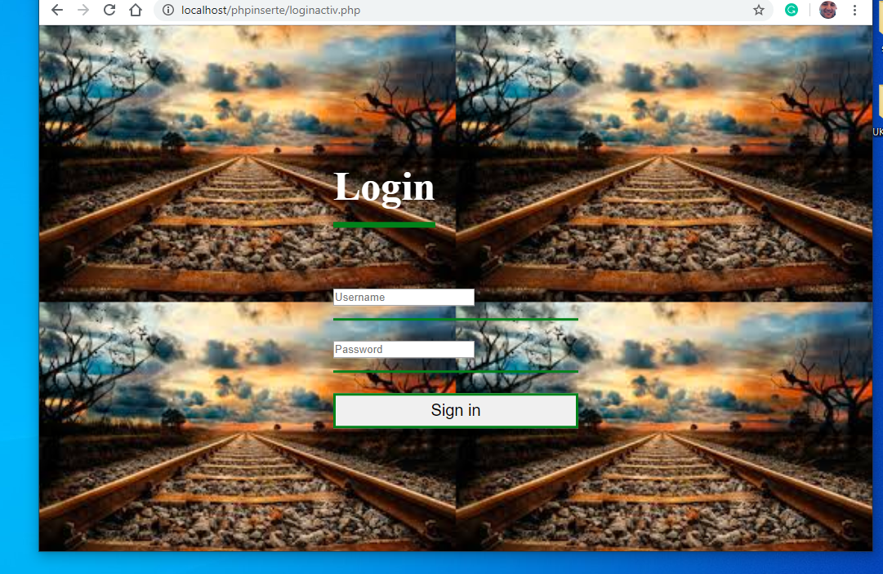

Image 2

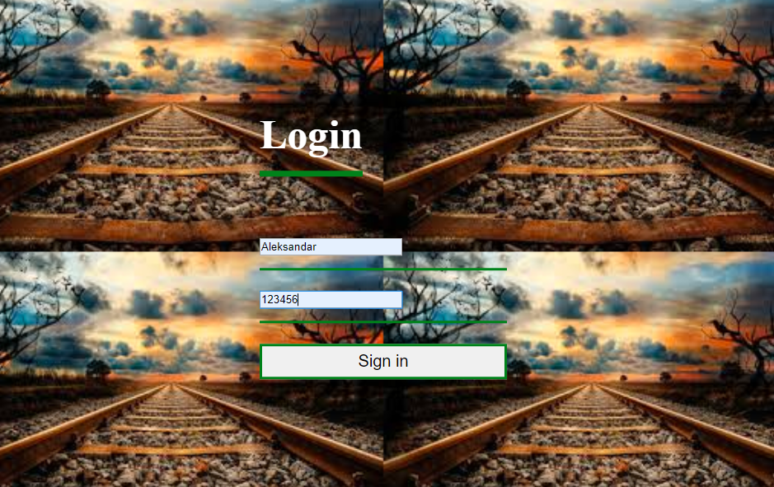
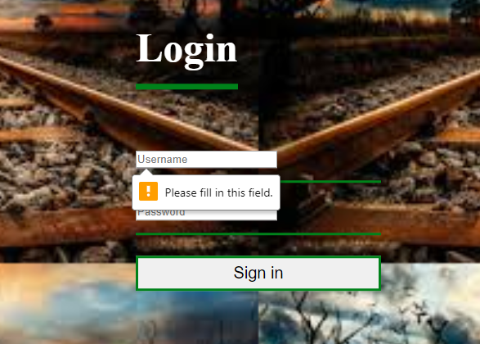

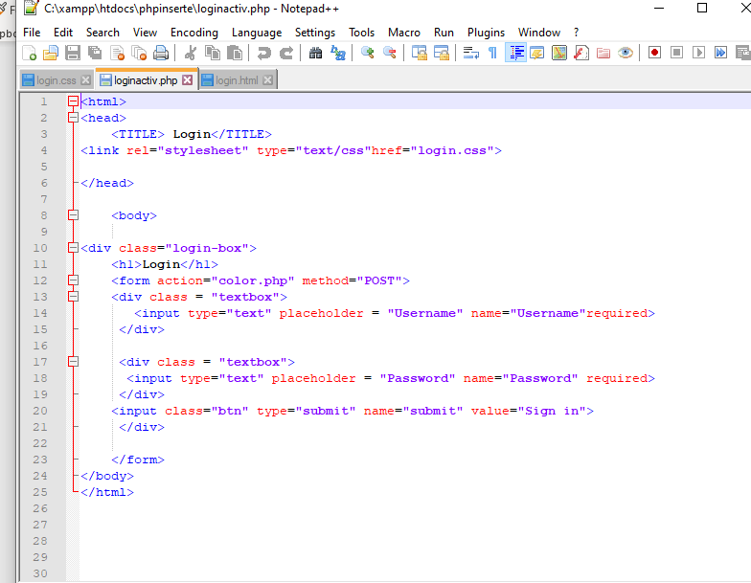

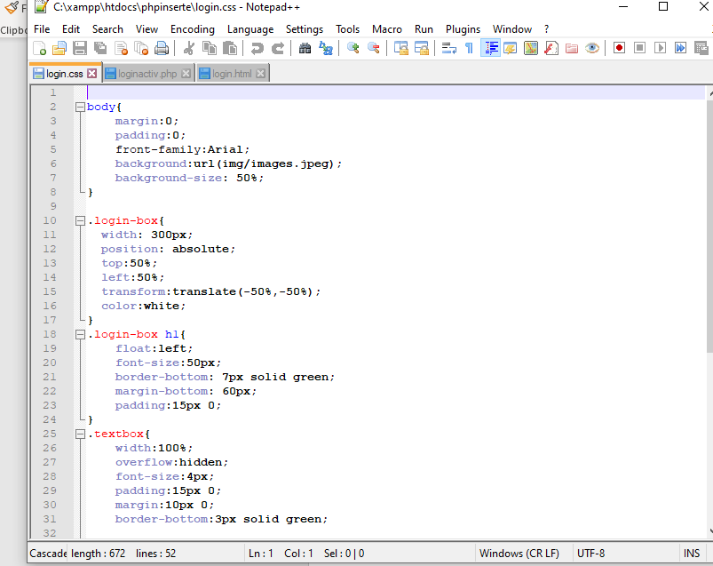

Image 3

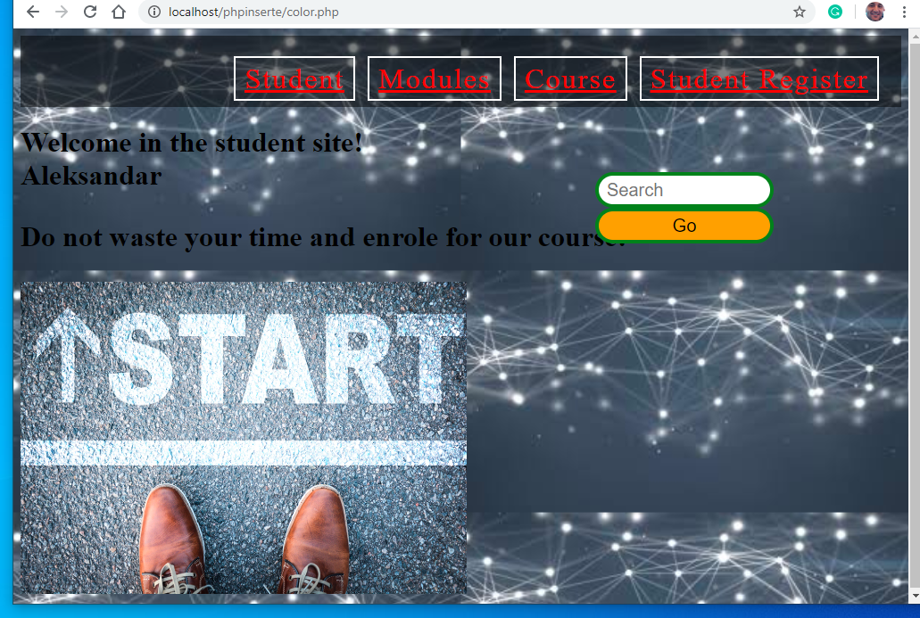

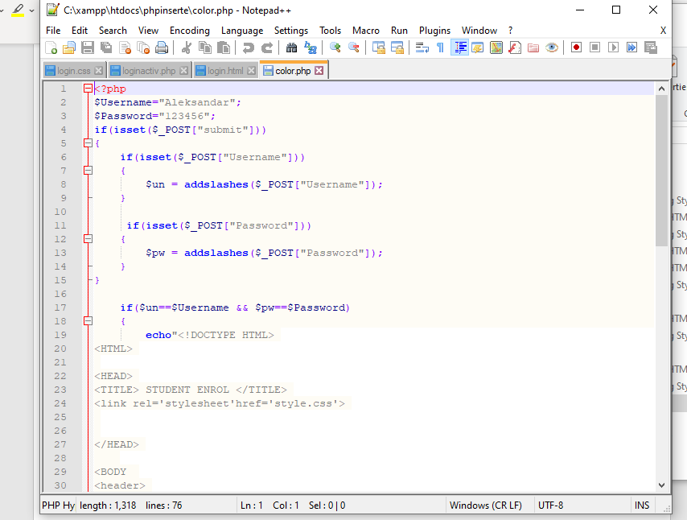
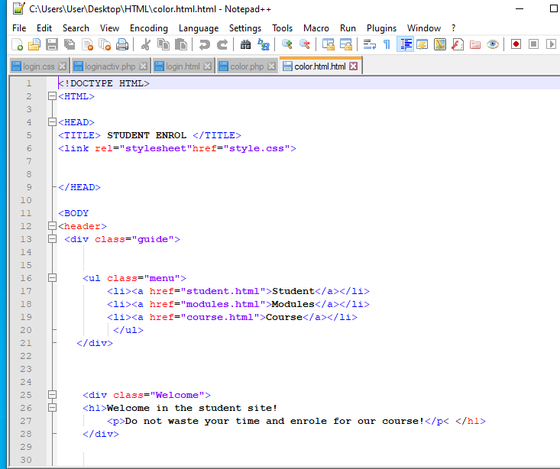

Image 4

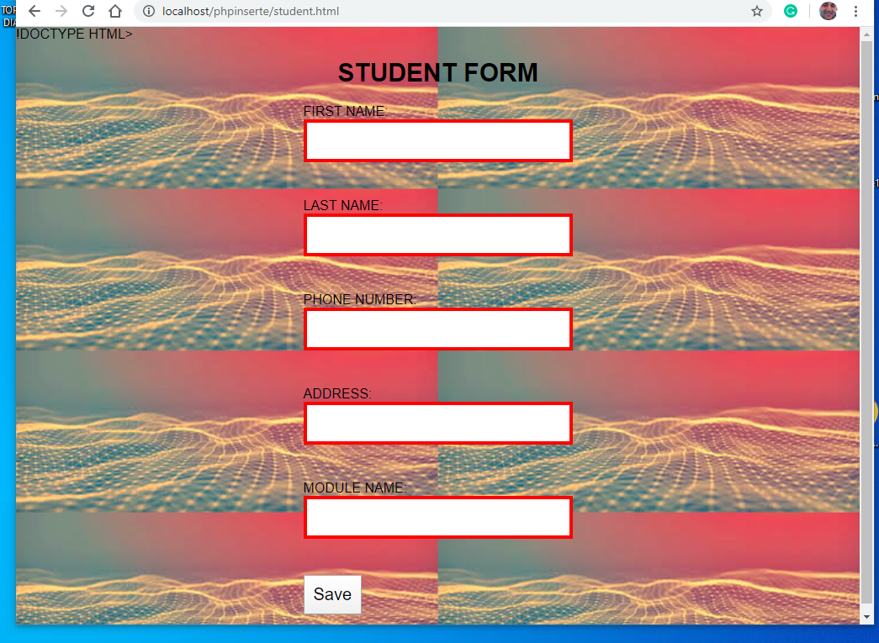

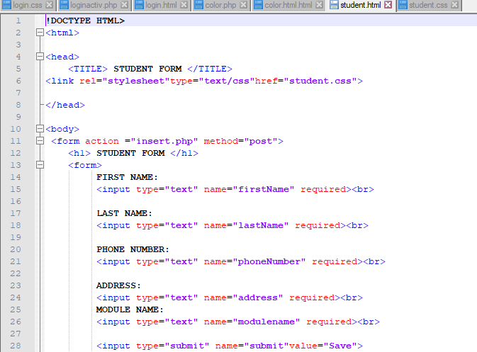

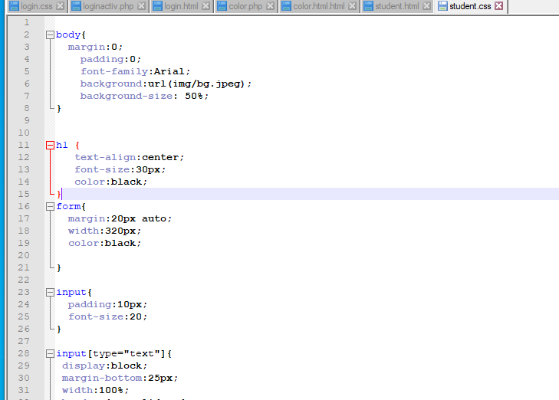

Image 5

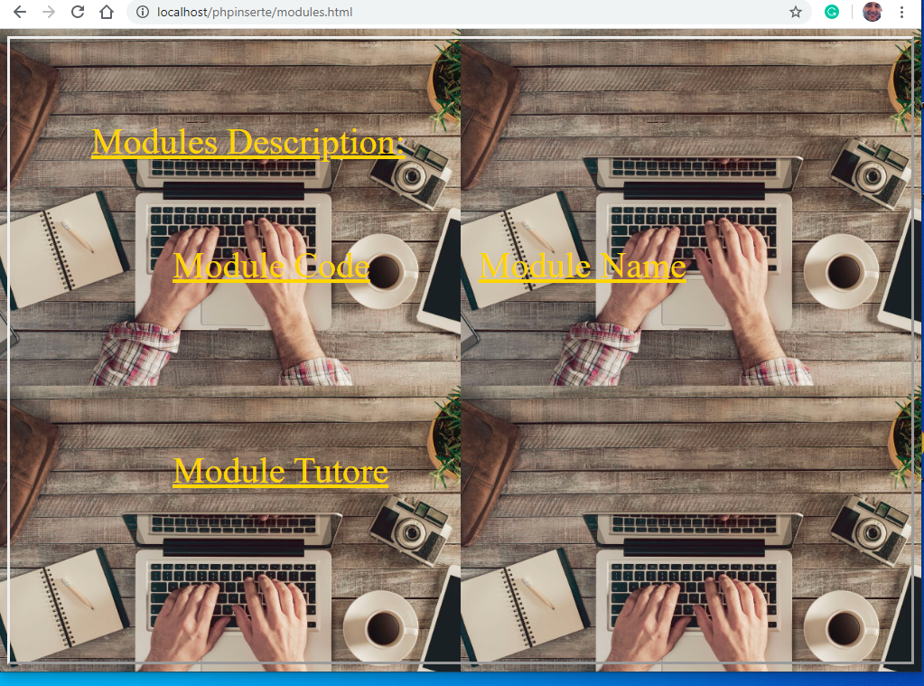
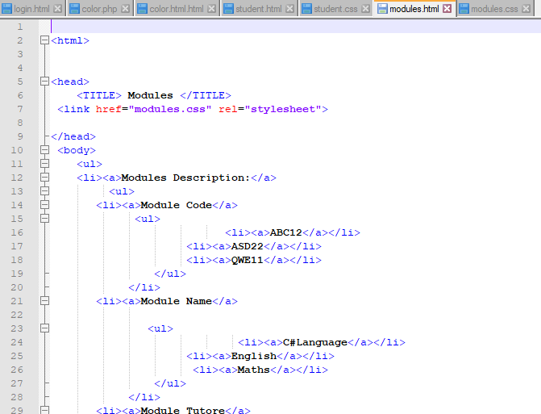

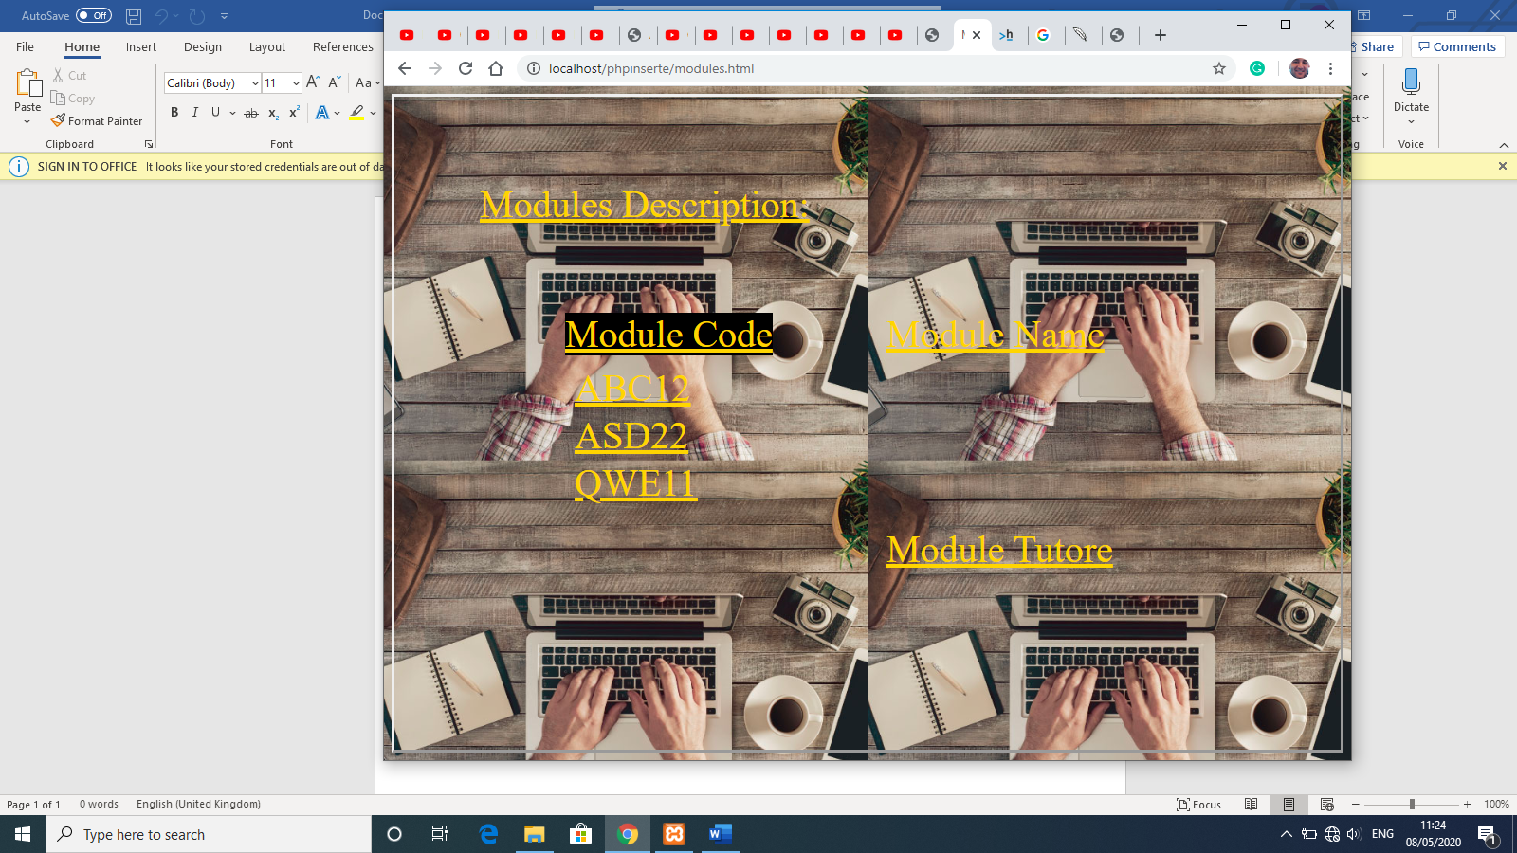

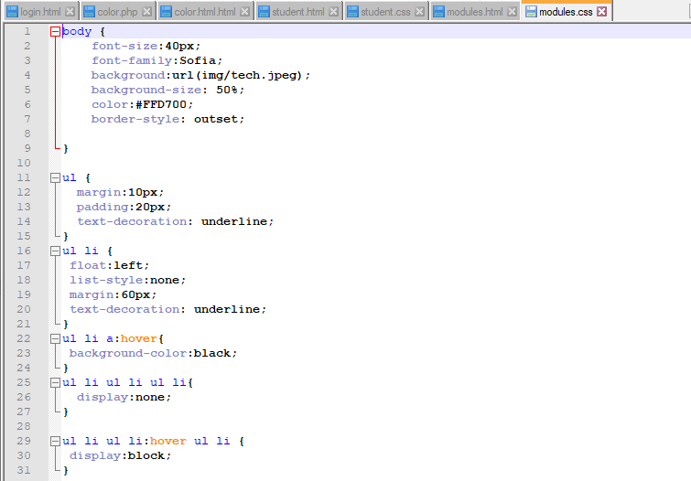
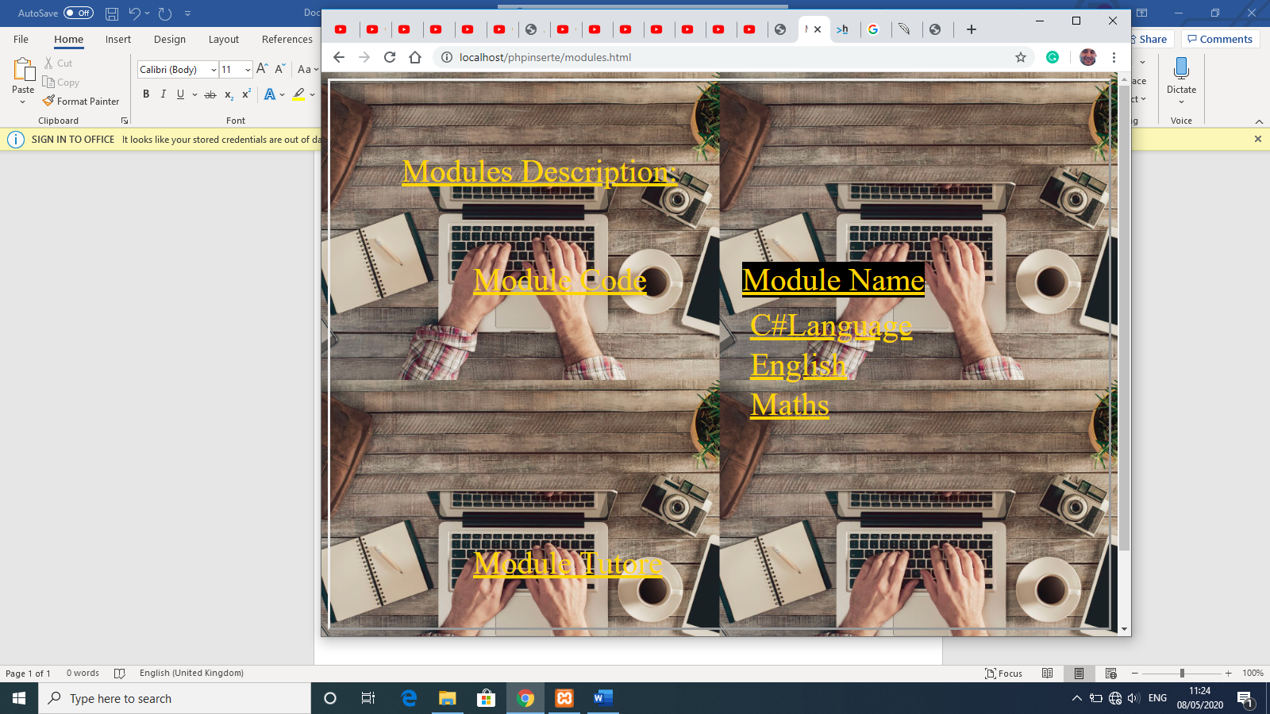

Image 6

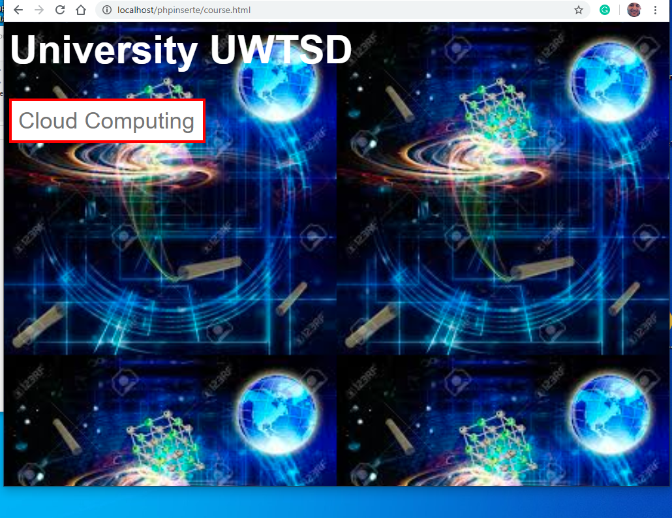

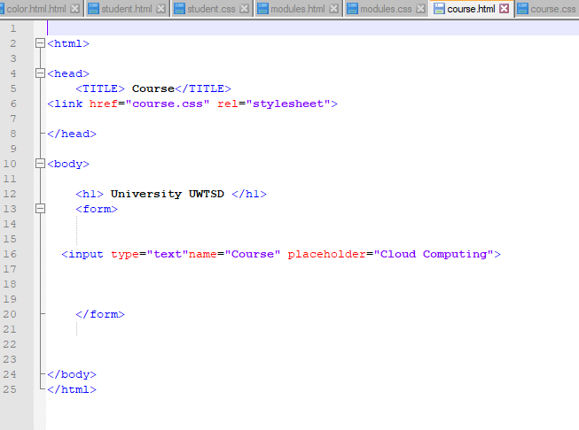

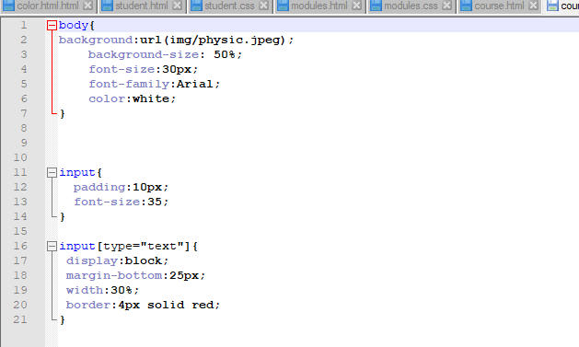

Image 7

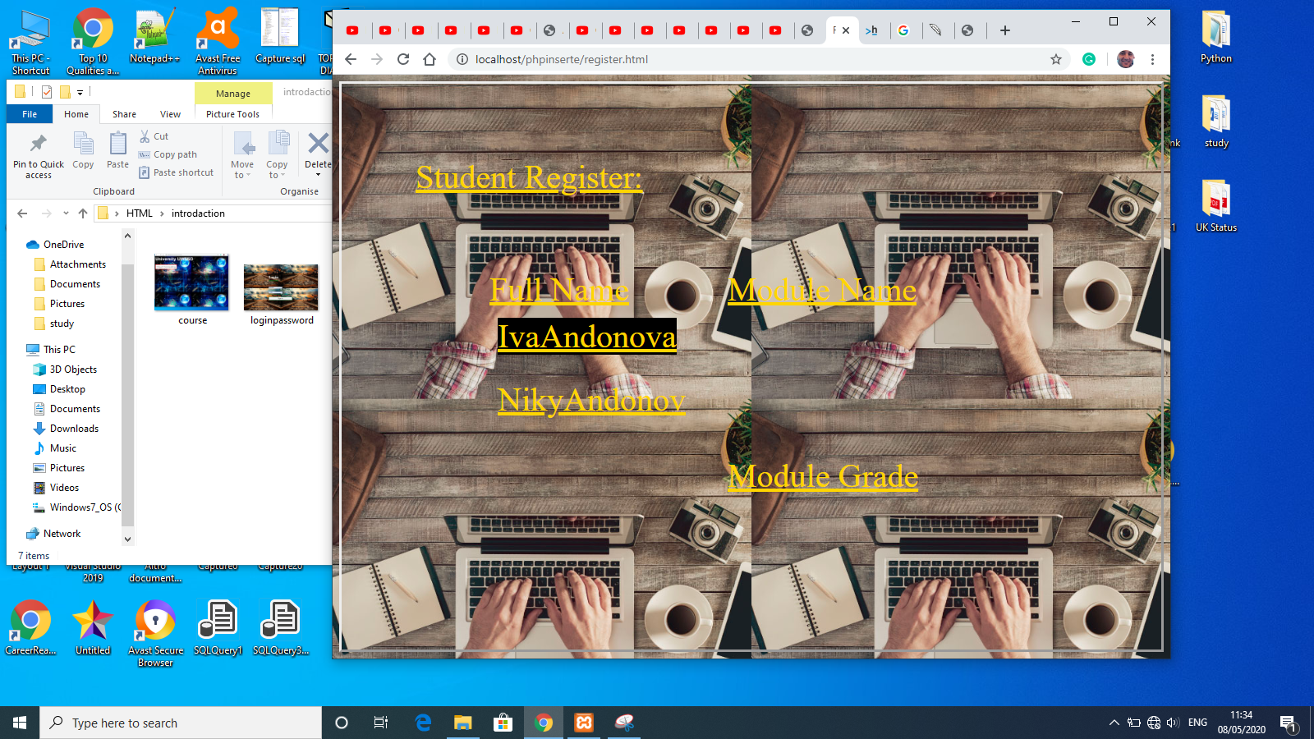

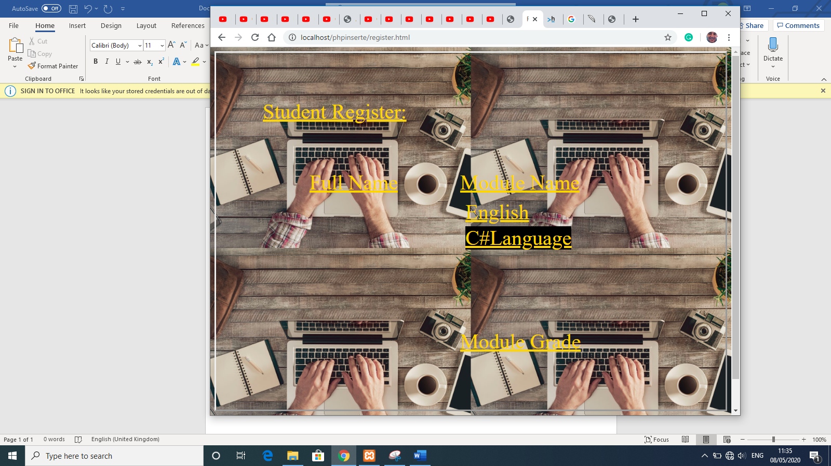

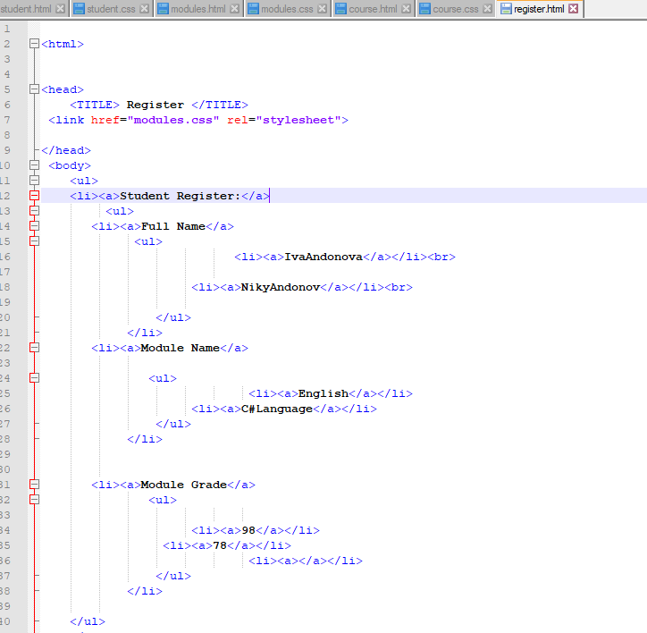

Image 8

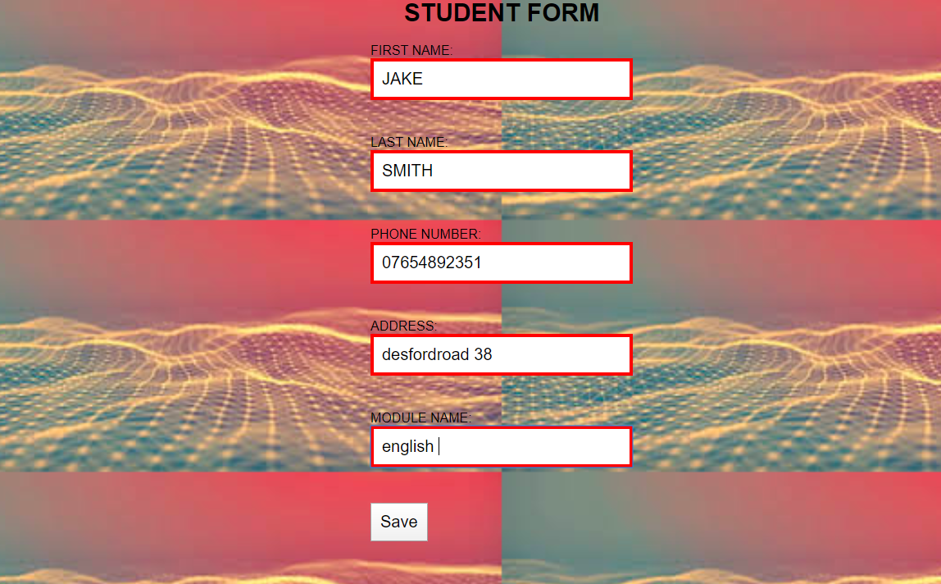

Image 9

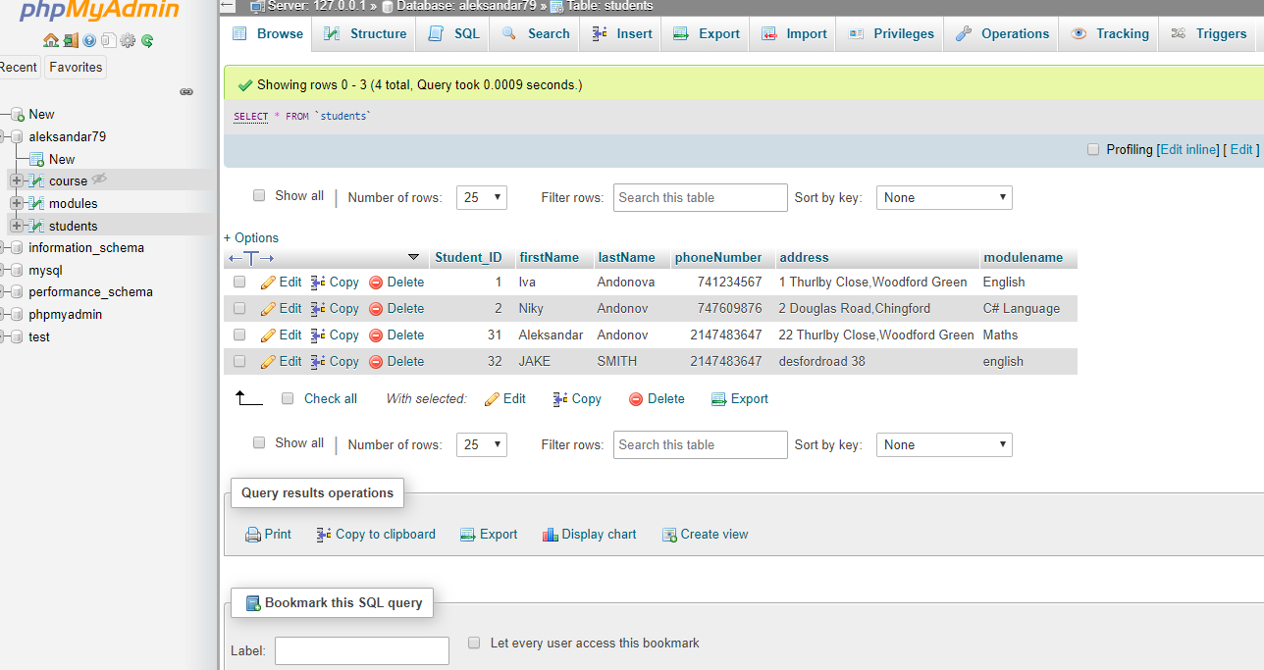

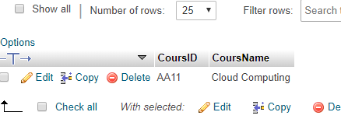

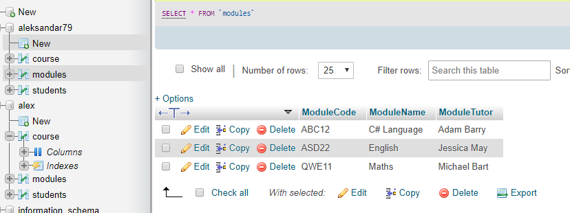

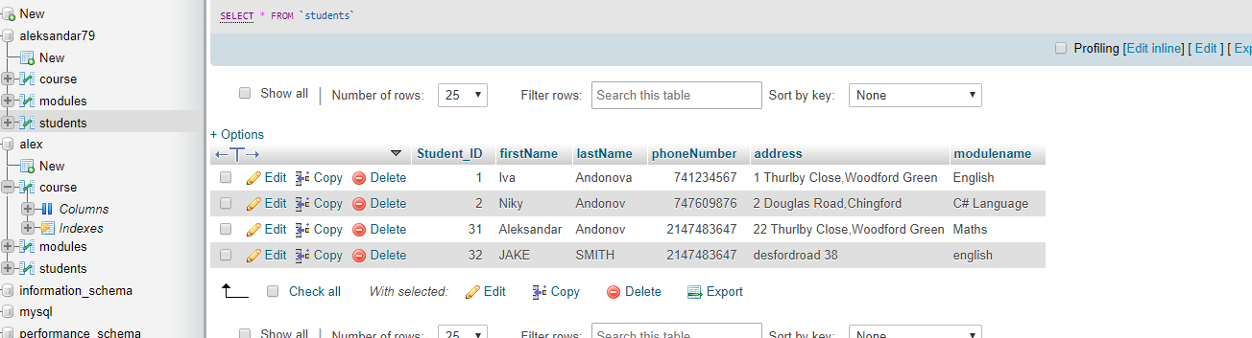

5.Evaluation

As a beginner and a primary student in the web developing field, I realised that web developing is difficult and perplexing. There are a lot of tasks I will need to do and take part in, in order to become a confident web developer. I will also ned to learn the programming languages in depth and understand them comfortably. My current project only consists of basic and more simpler tasks due to the fundamental knowledge I have gained from studying this course.
If I had to deploy my website on the real-world application multiple changes would have to be made. For instance, improving the design, creating an admin folder where only the admin would have access to the database and include more options for the student data such as email address and date of birth as well as nationality. The modules could also be improved by including the learning hours of the specific module. Another thing that could be improved is the searching information, as for every new student willing to enrol would be allowed to add the necessary details about the university, learning hours, the modules they would like to study and the resources the university offers.

6.Conclusion

This report provides a critical review of the difficulties of web developing and describes the key aspects of building a website using different programming languages. This report also highlights that websites are not an easy software and require a lot of practice and knowledge in order to make a sophisticated and practical website which functions correctly. It also focuses on other challenges that come up such as performing website evaluation, conducting market research and choosing the right business model for the website proposal. I have also explored the different function of my website and explained how the enrolling student can use the website, providing clear evidence that the website works and can be used. I have also stated that as a beginner I have done as much as I can and have described the improvements I would make for future references when making new websites using the programming languages.
Overall web development can be difficult at times however it is extremely interesting and fascinating. (Lucky, 2018)

References
/www.youtube.com. (n.d.). Retrieved from /www.youtube.com: https://www.youtube.com/watch?v=0BoZc5oUioA
Bradford, L. (2020, March 11). SQL Introduction for beginners. Retrieved from learntocodewith.me: https://learntocodewith.me/posts/sql-guide/#what-is-sql
contributors, M. (2019, 03 23). Основи на HTML. Retrieved from developer.mozilla.org: https://developer.mozilla.org/bg/docs/Learn/%D0%94%D0%B0_%D0%B7%D0%B0%D0%BF%D0%BE%D1%87%D0%BD%D0%B5%D0%BC_%D1%81_%D0%9C%D1%80%D0%B5%D0%B6%D0%B0%D1%82%D0%B0/%D0%9E%D1%81%D0%BD%D0%BE%D0%B2%D0%B8_%D0%BD%D0%B0_HTML
Josh Lockhart, P. S. (2018, 02 23). PHP The RightWay. Retrieved from www.phptherightway.com.: http://bg.phptherightway.com/
Katzarov, G. (2018, 01 09). Какво е HTML и как работи той? Retrieved from https://softuni.bg/: https://softuni.bg/blog/what-is-html5-and-how-it-works
Katzarov, G. (2020, 01 28). Какво е "Framework"? Retrieved from https://softuni.bg: https://softuni.bg/blog/what-is-framework
Katzarov, G. (2020, 05 05). Предимства на PHP. Retrieved from softuni.bg: https://softuni.bg/blog/three-benefits-from-learning-php
Lucky, M. N. (2018, 05). Internship report on Website application design and development. Retrieved from http://dspace.library.daffodilvarsity.edu.bd:8080/: http://dspace.library.daffodilvarsity.edu.bd:8080/bitstream/handle/20.500.11948/3254/131-15-2188.pdf?sequence=1&isAllowed=y
Milin Gokhale, A. C. (2009, 04 10). Web Development on Web. Retrieved from slideshare.net: https://www.slideshare.net/milindhg/web-development-on-web-project-report
Rouse, M. (2020, 02). HTML(Hypertext Markup Language). Retrieved from www.theserverside.com: https://www.theserverside.com/definition/HTML-Hypertext-Markup-Language
Singh, V. (2020, April 10). What is Frameworks. Retrieved from hackr.io: https://hackr.io/blog/what-is-frameworks
W3Schools.bg. (2018). Важност на HTML. Retrieved from html.w3schools.bg: https://html.w3schools.bg/%D0%B2%D0%B0%D0%B6%D0%BD%D0%BE%D1%81%D1%82%D1%82%D0%B0-%D0%BD%D0%B0-html-%D0%B7%D0%B0-%D1%83%D0%B5%D0%B1-%D0%B4%D0%B8%D0%B7%D0%B0%D0%B9%D0%BD%D0%B0/
www.youtube.com. (n.d.). Retrieved from www.youtube.com: https://www.youtube.com/watch?v=O0Ky0tKvsJ8
www.youtube.com. (n.d.). Retrieved from www.youtube.com: https://www.youtube.com/watch?v=PU2UEv_T8G8
www.youtube.com. (n.d.). Retrieved from www.youtube.com: https://www.youtube.com/watch?v=OHjkg_rifTw&t=147s
www.youtube.com. (n.d.). Retrieved from www.youtube.com: https://www.youtube.com/watch?v=MzxxWPYYCFQ
www.youtube.com. (n.d.). Retrieved from www.youtube.com: https://www.youtube.com/watch?v=nIOYbElTNao&t=778s
www.youtube.com. (n.d.). Retrieved from www.youtube.com: https://www.youtube.com/watch?v=rMR8tFZx67Q

