

EXAMINATION SOLUTIONS
(to accompany the examination paper sent to the external examiner
but NOT to be seen by students)

Programme: | HND/MComp/BSc (Hons) Computer Networks | Level: | 5
Module: | Routing and Switching Concepts (ACCA5002)
Author: | Dr Kapilan Radhakrishnan | Sem: | May 2018

Q 1 | Question | Marks
a  b  c | 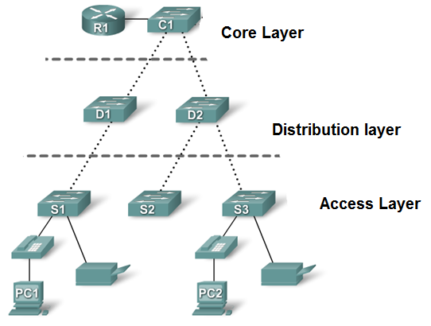  Core layer:  The core layer of the hierarchical design is the high-speed backbone of the internetwork. The core layer is critical for interconnectivity between distribution layer devices, so it is important for the core to be highly available and redundant. The core area can also connect to Internet resources. The core aggregates the traffic from all the distribution layer devices, so it must be capable of forwarding large amounts of data quickly.  Distribution layer:  The distribution layer aggregates the data received from the access layer switches before it is transmitted to the core layer for routing to its final destination. The distribution layer controls the flow of network traffic using policies and delineates broadcast domains by performing routing functions between virtual LANs (VLANs) defined at the access layer.  Access layer:  The access layer interfaces with end devices, such as PCs, printers, and IP phones, to provide access to the rest of the network. The main purpose of the access layer is to provide a means of connecting devices to the network and controlling which devices are allowed to communicate on the network.  Inbound ACL: An inbound ACL filters packets coming into a specific interface and before they are routed to the outbound interface.  Outbound ACL: An outbound ACL filters packets after being routed, regardless of the inbound interface.  Store-and-forward  - The entire frame is received before any forwarding takes place.  - The destination and/or the source addresses are read and filters are applied before the frame is forwarded.  - Latency occurs while the frame is being received; the latency is greater with larger frames because the entire frame takes longer to read. Error detection is high because of the time available to the switch to check for errors while waiting for the entire frame to be received.  Cut-through  - The switch reads the destination address before receiving the entire frame.  - The frame is then forwarded before the entire frame arrives.  - This mode decreases the latency of the transmission and has poor LAN Switching error detection.  - Fast-forward and fragment-free are two forms of cut-through switching. | 3  4  4  4  2  2  3  3

Q 2 | Question | Marks
a  b  c  d | Inside global: The address of the inside host as seen from the outside  Inside local: The address of the inside host as seen from the inside  Outside local: The address of the outside host as seen from the inside  Outside global: The address of the outside host as seen from the outside  Process Switching​  Process switching is the slowest form of routing because the processor must route and rewrite using software.​  Fast Switching​  Is a faster method by which the first packet in a flow is routed and rewritten by a route processor using software, and each subsequent packet is then handled by hardware. ​  Cisco Express Forwarding (CEF)​  The CEF method uses hardware forwarding tables for most common traffic flows, with only a few exceptions. If you use CEF, the route processor spends its cycles mostly on other tasks.​  ​  Static routing has three primary uses:​  - Providing ease of routing table maintenance in smaller networks.​  - Routing to and from stub networks. A stub network is a network accessed by a single route, and the router has no other neighbors.​  - Using a single default route to represent a path to any network that does not have a more specific match with another route in the routing table.  A floating static route will be added to the configuration.  Floating static routes have an administrative distance greater than the administrative distance of another static route or dynamic routes.  Uses: If the preferred route is lost the floating static route can take over. | 2  2  2  2  2  2  2  2  2  2  1  2  2

Q 3 | Question | Marks
a  b  c  d | Client sends DHCP discover broadcast message  DHCP Server responds with a DHCPOFFER unicast to the client  Client accept the offer and send DHCPREQUSET signal to server requesting IP address details.  Server accept the request and acknowledge with DHCPACK to provide ip address, subnet mask and all relevant details  The automatic medium-dependent interface crossover (auto-MDIX) feature eliminates the requirement for use of certain type of cables when connecting devices.  When auto-MDIX is enabled, the interface automatically detects and appropriately configures the connection.  A port security violation has put a switch in error disabled state. A port in error disabled is effectively shutdown.  A no shutdown interface configuration mode command must be issued to re-enable the port.  Extended ACLs - Locate extended ACLs as close as possible to the source of the traffic to be filtered. ​  Standard ACLs - Because standard ACLs do not specify destination addresses, place them as close to the destination as possible.  Guidelines:  Base the ACL on the security policy of the organisation  Prepare a description of what you want your ACLs to do.  Use a text editor to create, edit and save ACLs  Test your ACLs on a development network before implementing them on a production network. | 1.5  1.5  1.5  1.5  2  2  2  2  2  2  7

Q 4 | Question | Marks
a i  ii  iii  iv | Scalability  Redundancy  Performance  Security  Manageability  Maintainability  Data VLAN:  A data VLAN is a VLAN that is configured to carry only user-generated traffic. A VLAN could carry voice-based traffic or traffic used to manage the switch, but this traffic would not be part of a data VLAN. It is common practice to separate voice and management traffic from data traffic.  Management VLAN:  A management VLAN is any VLAN you configure to access the management capabilities of a switch. VLAN 1 would serve as the management VLAN if you did not proactively define a unique VLAN to serve as the management VLAN. You assign the management VLAN an IP address and subnet mask. A switch can be managed via HTTP, Telnet, SSH, or SNMP  Default VLAN:  All switch ports become a member of the default VLAN after the initial boot up of the switch. Having all the switch ports participate in the default VLAN makes them all part of the same broadcast domain. This allows any device connected to any switch port to communicate with other devices on other switch ports. The default VLAN for Cisco switches is VLAN 1. VLAN 1 has all the features of any VLAN, except that you cannot rename it and you can not delete it. By default, Layer 2 control traffic, such as CDP and spanning tree protocol traffic, are associated with VLAN 1.  ‘Router-on-a-Stick’ Inter-VLAN routing  "Router-on-a-stick" is a type of router configuration in which a single physical interface routes traffic between multiple VLANs on a network.  The router interface is configured to operate as a trunk link and is connected to a switch port configured in trunk mode.  The router performs the inter-VLAN routing by accepting VLAN tagged traffic on the trunk interface coming from the adjacent switch and internally routing between the VLANs using subinterfaces.  The router then forwards the routed traffic-VLAN tagged for the destination VLAN-out the same physical interface  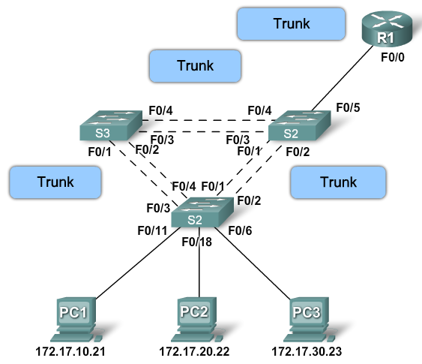  A VLAN trunk is a point-to-point link that carries more than one VLAN.​  A VLAN trunk is usually established between switches so same-VLAN devices can communicate, even if physically connected to different switches.​  A VLAN trunk is not associated to any VLANs; neither is the trunk ports used to establish the trunk link.​  Cisco IOS supports IEEE802.1q, a popular VLAN trunk protocol.​ | 1 mark each any four  3  3  3  2  4  2  2  2  1

