Sean Hazelby

Ground Investigation Report

Level 4

Lecturer: Alan Nantell
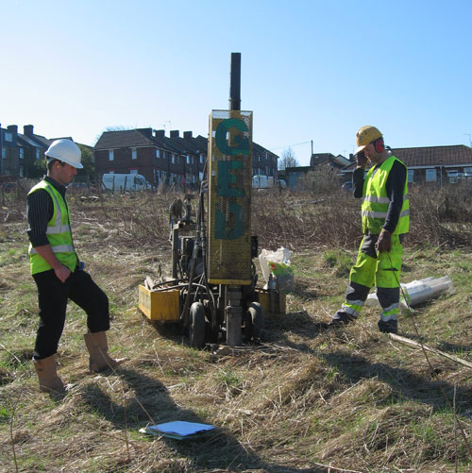

(GEO, 2010)

Contents
Introduction 3
History of Site 3
1. The Docks 3
2. Site soil 4
3. Coal Industry 5
4. Copper Industry 5
5. Docks during the war 6
6. Weather 8
7. Mumbles railway 8
Geology 9
Foundation type 9
2. Before piling construction 10
Conclusion 10
Reference list 11

Introduction
Swansea Council have partnered with Marriot hotels and have decided to construct a new ice cream parlour and restaurant with a manager’s apartment on Swansea foreshore. It is to be positioned on the car park of the Marriott and county hall and is to be a two-story building. In order to determine the foundation spec, we must research the archival material and history of the site and area in order to determine its future.
As is seen in the Arial views above, the site is located next to the south dock which is known now as the mariner. This means that it is on the shoreline of Swansea beach. The site is also near Swansea docks which is loaded with historic industrial activity. The access to site is very convenient as it is adjacent to Oystermouth road although deliveries may cause traffic in busy times of the day and year. There are plenty of services such as water supply and other services like coffee shops and places for nutritional needs while in the construction process.

History of Site
The Swansea docks have been one of the most chaotic docks in the world from the 18th to the 20th century. A large focus on the exports of Coal, copper and tinplate and the addition of being major port during WW2 meant that thousands of jobs were available for locals and migrants. This means that there were a high concentration of people once working on the docks creating the possibility of waste and pollution. Swansea was once known as one of the biggest contributors in these industries until the slow demise of the industry’s in the 20th century. These industries are not considered to be under the ‘clean’ band of creating energy especially coal which would cause environmental problems such as emissions and waste which may be influential on our site. Another effect of this is possible soil contamination which will mean that our site may have some issues regarding soil.
The Weather in Swansea has been wet and cold over the years along with sandy soil and anthropogenic ground which again, will make it hard to build upon.

The Docks
The docks were a massive asset to the UK for years on end in the context of exports. The docks have also seen a large quantity of industrial activity since 18th century. This would explain why the docks has been made up of anthropogenic ground and backfill. The grounds are made up of waste from human and industrial activity making the ground unstable in terms of soil. The grounds would be made up of ash, bricks, mud, soil, sand, water and any waste that would have been around at the time. This is also true for our site which is located right next to the south dock which was used for commercial shipping and was famous for its fish market along with the export of coal.
(Lewis, Swansea & Port Talbot docks history website, 1999 - present)

Site soil
To determine soil type, we use boreholes. A borehole is where we drill into the ground in order to determine the layers of soil beneath the surface. There is a borehole log located on site which gives us a great insight to the ground condition and soil type which may give us an idea of historical significance and future ideas for the foundation.

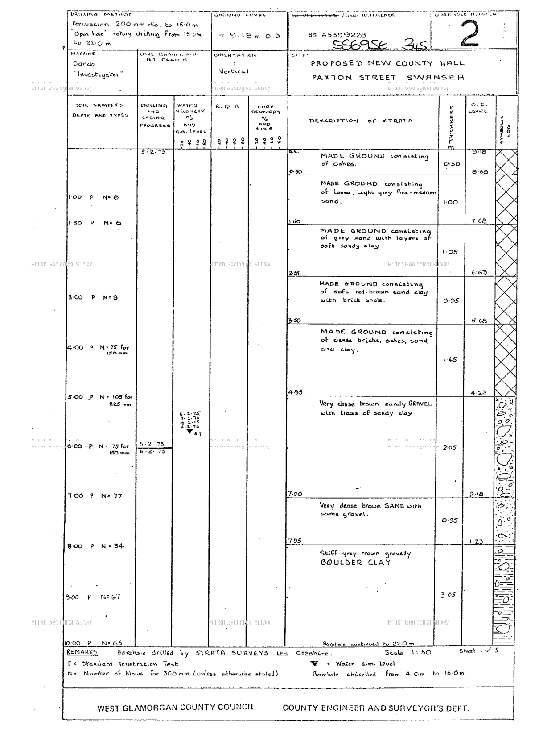
(BGS, BGS, 2020)
As is seen in the bore hole log; the site consists prominently of made ground which is a type of ground that has been backfilled from industrial activity over the years. There is made ground consisting of ashes, brick shale, sand and sandy clay for 7.95 meters until it reaches boulder clay. The ashes have come from industrial activity over the years and possibly the brick shale making it man made. The sand and clay however, are natural soils not made by human activity but have been mixed with the made ground making it manmade. This will still make the site a site of anthropogenic ground consisting of made ground from manmade activity. There are a few risks with this, the shale will be weak due to how it will split into thin pieces so easily when weight will be applied. The boulder clay should act as a good foundation to build upon since clay is so fine grained. Clay can hold water well but must be careful to nearby trees because trees will absorb water and make the clay contract and detract making the foundation unstable. Unfortunately, there are trees and bushes present on site which will drink the water making the clay soil unsuitable for the site. This will be very dangerous and could cause a collapse over time. But luckily the foundation will be deeper than the roots as the boulder clay starts at 7.95m. As a result of this; trees should not be an issue for the clay.
We can also tell the ground condition by the type of borehole test that has been carried out by professionals. In this instance we can see by the borehole log that type is in fact an ‘open hole’ method. The open hole method is used where soil is known to be stiffer and self-supporting. Softer clays will start collapsing when drilling which may be an issue. They are also used where previous mine workings are known to have been in the past. This may indicate some previous historical industrial activity.
In another study, it shows the fact that the soil is sandy; thus proving the evidence of the borehole log.
“The Swansea series consists of very poorly drained organic soils. They formed in 40 to 130 centimetres of highly decomposed organic material over sandy mineral. These soils are in depressions or on flat level areas on uplands and outwash plains” (survey, 2014) (National co-cooperative Soil Survey USA). This conveys the fact that Swansea is located on anthropogenic ground from the backwash of waste from manmade industrial activities. We also know that the site is located on Swansea foreshore which will naturally be sandy. This means drainage will be good but may mean that the soil will be unstable due to the permeability which sand has.

Coal Industry
Coal was a massive export in South Wales with Swansea being one of the main contributors at the time of its peak. The industrial revolution spiralled the growth in coal mining and is still the main use to this day to produce energy. By the time of 1913, Swansea Docks exported 5.5 million tons of coal, coke and patent fuels. At this time there was a total of 32 coal hoists powered by hydraulic pressure spread across the 4 Swansea docks. This conveys it was considered as a vital industry for the docks and the economy of Swansea (Lewis, Swansea & Port Talbot docks hitory, 1999 - Present). Coal contaminates soil therefor there is a danger that our site will be contaminated. This will tie into the fact that the docks are made up of anthropogenic ground. Coal would have been shipped through our site due to the South dock. This means that our site may be contaminated from previous industrial activity. There is proof in the bore hole log of industrial activity on our site.

Copper Industry
Landore was a major export for Copper and at during the 18th and 19th century. the Swansea area was responsible for 17/18 (94%) of the Copper works in Great Britain by mid-19th century making Swansea docks a vital shipping export for Great Britain (Lewis, Swansea & Port Talbot docks history website, 1999 - present). Swansea was even known as ‘Copperopolis’ at these times and has been recognized as one of the earliest industrial city areas of Wales. Copper was a valuable resource in the 18th century due to how easy is was to work with. This is what made it different to metals like iron as it could easily be formed into industrial vessels. As a result of this, it made copper a popular resource and skyrocketed the demand of it. Linking this to our site; the docks would have been exporting the copper across the world. This may result in the contamination of our site.
(Bowen, 2012)

Docks during the war
Swansea was a major contributor for exports and imports of materials and vital supplies for Great Britain during the war. This meant that Swansea was at high risk of ‘the blitz’ where a series of German Luftwaffe planes would drop explosives onto vital cities. This happened throughout the UK during WW2. On the night 19th February 1941 at 7:30pm, German Luftwaffe planes bombed Swansea city centre and parts of the docks in the hope to cripple supplies moving through the docks. It was thought that the Germans missed the docks and hit the city centre on accident. It continued for 3 nights and was known as the ‘3-night blitz’ to locals. A total of 230 people lost their lives and a further 409 were injured. It is Swansea’s worst disaster of the last century. (Bryon, 2012)

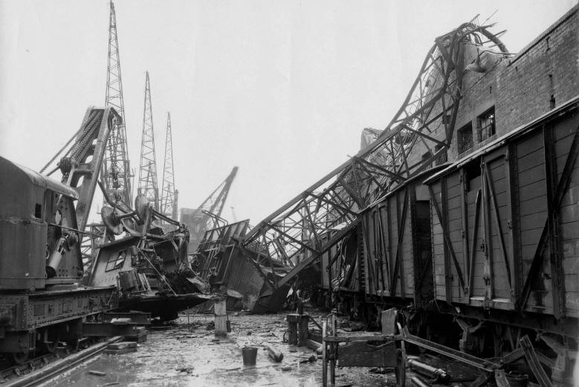
Damage to D wharf Shed, Swansea Docks Photograph taken by Anon, 20th Feb 1941
(Anon, Air Raid damage at the Docks, 1941)

As a result of these bombings there is also a massive threat of unexploded bombs in the area of Swansea. As we all know, Swansea was bombed in WW2 therefore there is a danger that old German bombs that haven’t exploded are lurking beneath the ground from the 3-night air raids. In a BBC article it states “Most of the high explosive WW2 ordnance is buried very deep and it is often discovered by construction workers” (Team, 2018). This is a very serious hazard and could cause multiple fatal incidents. This is a danger on our site and should be treated as a severe hazard. We do not want to set off any bombs therefor the site must be reviewed substantially before action is going to be made. The article also states;
“The German WW2 bombing campaign tended to focus on strategic locations.
This meant that major UK cities or areas with important features, such as railway junctions or ports, were key targets” (Team, 2018). This explains why Swansea was in danger due to how important the docks were during the second world war and over the course of history to the world. Our site is positioned very close to the South dock which could mean that our site could have undetected bombs underground. As seen on the table below; it clearly shows that Swansea has had several high explosive bombs dropped upon them meaning there is a serious risk of live explosives to this day. This also heightens the risk of contaminated soil.
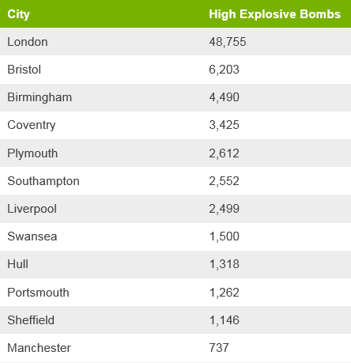
(Team, 2018)

As is shown above; Swansea is going to be in danger of finding explosives underground which means our site is in danger of having underground explosives present. A full ground investigation will have to take place in order to assure the publics safety.

Weather
Swansea is known to have a historically wet weather throughout the year making Swansea a wet city. “The mean annual temperature is about 9 degrees Celsius and the mean annual precipitation is about 1143 millimetres.” (survey, 2014) As the Author states in this quote, Swansea is a wet and cold environment on average throughout the year. This will affect ground moisture on site Which will affect foundations and so on. If the site is wet, it would mean that foundations will have to be deeper. Unfortunately, wet weather will be inevitable to the area and will have to take precautions.
There is also a risk of extreme weather when talking about Swansea foreshore. The risk of flooding is very likely an would be catastrophic to the building. The site is right on the coast which would mean it would experience the floods first-hand. There are no flooding barriers or any protection measures against floods in that area which means it is at high risk. I would recommend flooding barriers before building.
Another thing to consider for this coastal area is the tide Swansea has the second highest tidal range in the world “the second highest tidal range in the world. The sea will advance and retreat twice daily with an average height of 8.5m” (council, 2019). With a tide that varies so much daily, it may cause problems for a job that is directly on the seafront of Swansea.

Mumbles railway
Mumbles railway or Oystermouth railway, was the first passenger tram railway in the world at the time. However, before this, the railway was used to ship materials from Mumbles to Swansea. Materials such as Coal and Limestone were shipped across the railway. This proves that Limestone was in the area. Limestone is very prone to erosion from water. And by looking at the rainfall of Swansea we can see that this is an issue that Swansea has. By today, the railway no longer exists but is now known as Oystermouth road which is adjacent to our site and would be the best way of access to the site. The railway closed in the 60’s.
(Anon, A stroll along the prom - Swansea bay, 2012)
Unfortunately, a railway can be very harmful in terms of ground and soil conditions. If rail ties are old which in this instance they are; then an element called creosote will ooze out of them. Creosote will leach soil making it wet and soggy like a sponge. Leaching soil kills plants, insects and small animals. This element pollutes the environments and will contaminate the soil and contaminate the water table. This is harmful to health after long periods of exposure. The metal of the tracks would also contaminate the soil since the tracks would have been on the ground for years on end.
Coal ash or any fossil fuels combustion products can also contaminate soil. Coal was shipped through the railway originally using steam train which also ran on coal fuel therefor there is risk that the soil has been degraded or contaminated. Petrol also contaminates soil along with spillages or leaks from oils, gasoline, cleaning solvents and so on.
(conservancy, n.d.)

Geology
The Geology of the area is made up of mudstone, siltstone and sandstone. The site is located on the South wales coal fields. The sedimentary bedrock was formed approximately 310 – 318 million years ago which was in the carboniferous period. The site was previously swamps and estuaries all those years ago (Brittish Geological Society, 2020).
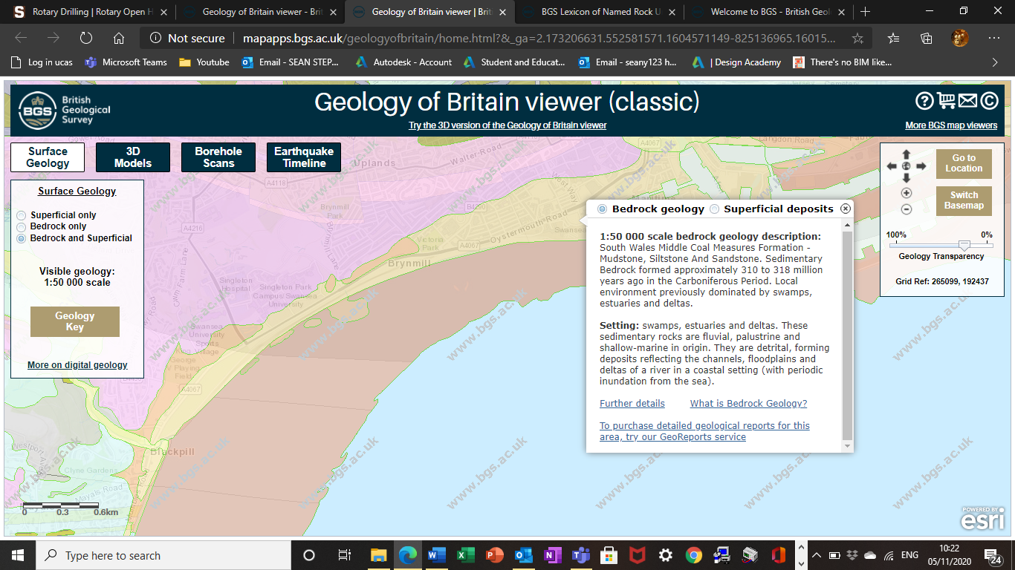
(BGS, 2020)
What needs to be known is how the geology will affect our site. Sandstone is made up of sand particles which are “1/16 millimetre to 2 millimetres in diameter” (King, 2020). This means there is plenty of room for water to travel through over time. This is called permeability. The problem with this is erosion. Sandstone will erode over time with acidic water coming from rainfall and water sinking down to the rocks. This may make sinkholes a problem as has been seen in the Gower recently. The other problem is when water freezes underground. Water expands in size when frozen which may cause the rocks under ground to move. This will accelerate the erosion process. Mudstone is a rock which is quite soft but can be hard and brittle. It is generally made up of clay and silt-sized particles making it a fine-grained sedimentary rock. Acidic water will erode mudstone making sinkholes a danger just like sandstone (Anon, Mudstone, 2020).Siltstone is another fine-grained sedimentary rock. It is hard and durable and is made up of clay materials with grain size of 0.004 – 0.06 mm (Anon, Siltstone, 2020).

Foundation type
The foundations will have to be deep after looking at the borehole log and all the other factors incorporated. We do not want our foundation to be on made ground. The bearing capacity on the surface is not adequate to support the stress loads imposed by the structure. Because of this, the load needs to be transferred to the deeper layers that have a higher bearing capacity. The made ground finishes at 4.95m but the best load bearer would be the boulder clay which starts at 7.95m deep. The boulder clay is a stable and strong layer of rock. This will be considered a deep foundation. This will mean that it will be a piled reinforced concrete foundation. Concrete is great for compression but is not so good at friction. The purpose of this type of foundation is to bypass the made ground down to the boulder clay so that we have solid ground to build upon. We generally use piled foundations on sites where there is loose gravels, sand or manmade ground which applies for our site. I think a bored piling method would be the most suitable due to nearby buildings. We do not want to interfere with other buildings foundations by vibration from drilling as this is putting lives at risk and will also be very costly if any damage was to be done.
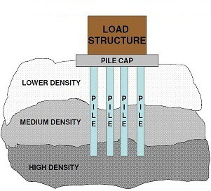
Heavy load structure that is too heavy for soil at shallow depths

Piled strips of reinforced concrete and steel for strength and stability

High bearing capacity soil/rock which can withstand the stress of the load above

(Namita, 2016)
- Our lower density soil would be our made ground.
- Our medium density soil would be the sand and sandy clay soil layers.
- Our high-density soil would be the boulder clay in which we will pile upon.

Before piling construction
Before you use the piling method for a foundation the following is required
- “Geotechnical site investigation report (to below the pile toe)
- Foundation drawings and pile layouts (with pile reference numbers and loadings)
- Calculations to show how the load on each pile was calculated
- Pile design calculation (for vertical, horizontal and heave forces) and a copy of the pile set design” (LABC, 2020).

All the above needs to be submitted to building control and then farther approved until any work can be carried out which proves the importance of thorough ground investigation.

Conclusion
The conclusion to the site is that it has a vast range of previous industrial activity making the ground contaminated. The site is located on anthropogenic ground as shown in the borehole log. There is danger of floods and bad weather in Swansea essentially on the sea front. For these reasons a pilled foundation will be the choice of foundation for this site due to the best bearing layer of ground being 7.95m down. The site is easily accessible with good services in the surrounding area.

Reference list
Citation | URL | Access date
(Anon, A stroll along the prom - Swansea bay, 2012) | https://www.geolsoc.org.uk/Education-and-Careers/Resources/Field-Work-Resources/Gower-Field-Guide/The-structure-of-Gower-five-guided-tours/A-stroll-along-the-prom--Swansea-Bay | 15/19/20
(Anon, Mudstone, 2020) | https://geologyscience.com/rocks/siltstone/ | 18/10/20
(Anon, Siltstone, 2020) | ttps://geologyscience.com  /rocks/siltstone/ | 22/10/20
(BGS, BGS, 2020) | http://scans.bgs.ac.uk/sobi_  scans/boreholes/370246/images/10677923.html | 19/10/20
(BGS, Geoligy of britain viewer, 2020) | http://mapapps.bgs.ac.uk/geologyofbritain  /home.html?&_ga=2.75484178.1824216543.1605049816-825136965.1601557682 | 29/10/20
(Brittish Geological Society, 2020) | http://mapapps.bgs.ac.uk/geologyofbritain  /home.html?&_ga=2.173206631.552581571.1604571149-825136965.1601557682 | 29/10/20
(Bryon, 2012) | https://www.youtube.com/watch?v=yMTmlsKARzQ&t=4s | 10/10/20
(King, 2020) | https://geology.com/rocks/sandstone.shtml | 29/10/20
(Lewis, Swansea & Port Talbot docks hitory, 1999 - Present) | http://swanseadocks.co.uk/docksnewsite/coalshipping.html
(Lewis, Swansea & Port Talbot docks history website, 1999 - present) | http://www.swanseadocks.co.uk/docksnewsite/history.html | 11/10/20
(Team, 2018) | https://www.bbc.co.uk/news/uk-4306124 | 5/11/20
(conservancy, n.d.) | https://www.railstotrails.org/build-trails/trail-building-toolbox/acquisition/environmental-contaminants/#:~:text=If%20the%20railroad%20ties  %20are%20old%2C%20creosote%20may,be%20disposed%  20of%20immediately%20as%20municipal%20solid%20waste.
(council, 2019) | https://www.swansea.gov.uk/tidetimes | 6/11/20
(survey, 2014) | https://soilseries.sc.egov.usda.gov/OSD_Docs/S/SWANSEA.  html#:~:text=The%20Swansea%20series%20consists%20of%  20very%20poorly%20drained,flat%20level%20areas%20on%  20uplands%20and%20outwash%20plains.
(Bowen, 2012) | https://www.walesonline.co.uk/news/wales-news/welsh-history-month-lower-swansea-2032065 | 7/11/20
(Namita, 2016) | https://civildigital.com/pile-foundation-classification-of-pile-foundations-pile-installation-methods/ | 13/11/20
(GEO, 2010) | http://www.geoenvironmentalengineering.com/ground_  investigation_report.php | 6/11/20
(Anon, Air Raid damage at the Docks, 1941) | http://www.swanseadocks.co.uk/docksnewsite/wardamage.html | 15/11//20
(LABC, 2020) | https://www.labc.co.uk/news/six-documents-you-need-piling | 16/11/20

