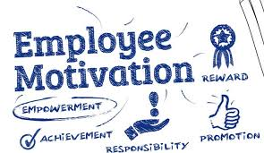

Academic and Employability Skills (BMSW4001_BIRM)

Student name: Martin Naydenov – 2126006

Assignment title: What is the most effective way to motivate staff?

Lecturer name: Doreen

TABLE OF CONTENT:
Introduction……………………………………………………………………………………………… 3
Ways to motivate staff:
- Motivation…………………………………………………………………………………………4
- Communication…………………………………………………………………………………..5
- Team building…………………………………………………………………………………….6

Personal conclusion………………………………………………………………………………………7
Bibliography……………………………………………………………………………………………….8

Introduction
During the course Academic and Employability Skills (BMSW4001_BIRM) one of my assignments is to write a report - What is the most effective way to motivate staff?
The topic of staff motivation is vast and comprehensive. In this academic report, I will try to introduce to you some effective ways for staff motivation, what motivation is, some basic theories about the needs of human beings, and some bad motivation facts. There are a lot of materials for staff motivation books, journals, internet videos, etc.

Motivation
Motivation is the driving force pushing us to purposeful actions. This includes purposeful direction and the direct connection between actions and the results we get. You will rarely meet a person who is completely satisfied with his work. All this is because often people hold positions not by calling. But the manager can make the work process comfortable for everyone, and the staff performs their duties with pleasure. Successful managers know that it is very important for their employees to be stimulated and encouraged in every way to be motivated. The labor productivity, the quality of the work performed, the company's development prospects, etc. depend on it. Motivation is a state that can be of varying duration. In many cases, this depends on the results we achieve, which are, in turn, quite subjective. This means that for each of us a given result would have a different meaning, value, and weight.
According to (Cebollero, 2014) motivation is of two types:
- Internal - internal motivation is achieved when we have the desire and drive to achieve something specific, which will bring us internal satisfaction and pleasure.

- Extrinsic - extrinsic motivation is a state in which we are motivated (prompted, desired) to achieve a certain goal by external satisfaction - money, grades, objects (material rewards).

Motivation arises initially through our thoughts, feelings, and emotions. This is the first process of motivation. The next one is related to our actions. They are of course generated by the already listed internal processes. In English, the words "emotion" and "motion" have the same root. In this line of thought, we can conclude that emotion prompts action. Just as a positive emotion leads to positive actions, so does a negative one to negative ones. Of course, this is also quite subjective. The truth is that it is good for a person to have control over his emotions and manage to direct them in the right direction. To be motivated, we need to reach a certain emotional state. If we reach this state, the desire to perform a certain action or achieve a certain goal arises in us. Motivation is a set of power and energy that steer our behavior in a certain direction for a given period.

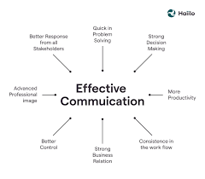
Communication:
“Great communication is not about delivering messages brilliantly – it’s about making yourself listened to” (Murray, 2021)
Good communication is accomplished to resolve conflicts in a work environment. Effective communication is crucial in our lives and is the basis for achieving organizational goals. Furthermore, a good level of communication directly impacts the quality of relationships and the occurrence of conflict. Therefore, effective communication is essential. Communication between members of staff helps to develop the working process and the speed. Hiding of communications brings only problems at work between managers and staff. Sometimes small little problems with communication escalate into huge. People are demotivated to work, and the companies lose their productivity.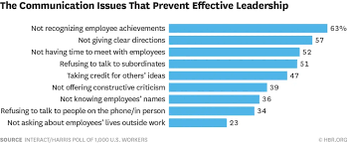 (Solomon, 2015)
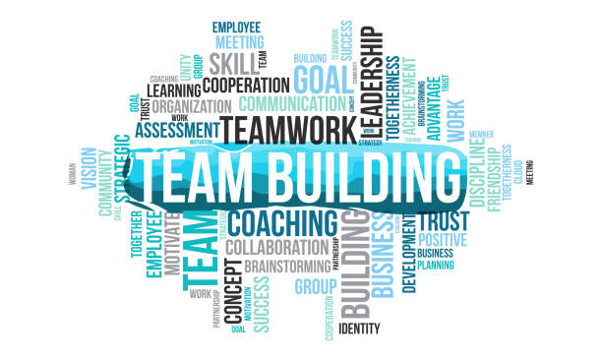

Team Building
Organizing team building is one of the most suitable and effective company events for uniting the team. It helps to break the ice if there are new employees and to achieve better communication and motivation in the team. Without proper planning and consideration of the details, this event will become just a chore. Employees will be most receptive to this activity if it is during work hours and does not take away from their weekend or family time. Role-playing is a very important thing for employees to bond. It is not recommended to serve alcohol during team building.
A key point of team building is that everyone is calm, feels equal, and does not feel the tension.

Personal Conclusion
All good leaders understand and know that the motivational process is based on satisfying the needs of the individual or group. As a basis for identifying these needs, Maslow's pyramid comes to the rescue (Chery, 2022). In it, he divides the needs of the individual into several basic levels, such as primary, psychological, and the need for personality realization. At the base, he places the need for food, water, warmth, rest, etc. On the next level are security, and safety. We call these needs primary. Then follow the secondary needs such as belonging, love, and above them the need for prestige, recognition, respect, and professional realization. At the top of the last category, we can place needs such as the pursuit of personal development, achieving spirituality and satisfaction from achievements, and the enjoyment of achieving the individual's full potential. When creating a motivational plan, each manager must keep in mind the basic needs of his employees, so that by setting the incentives, bonuses, and goals in front of each employee, he can judge whether achieved and received, will satisfy any of the needs that the individual has now. 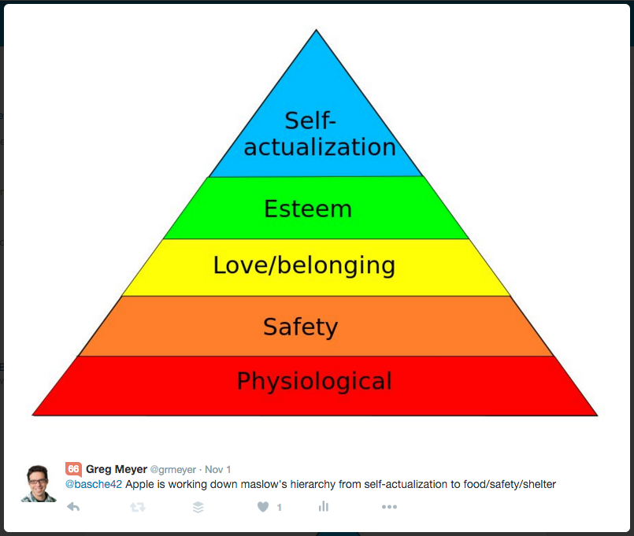

Bibliography
Cebollero, C., 2014. https://www.ems1.com. [Online]
Available at: https://www.ems1.com/ems-management/articles/2-types-of-motivation-explained-6HNgKoJGBA3YYAR9/
[Accessed 15 July 2022].
Chery, K., 2022. https://www.verywellmind.com. [Online]
Available at: https://www.verywellmind.com/what-is-maslows-hierarchy-of-needs-4136760
[Accessed 15 July 2022].
Murray, K., 2021. https://www.managers.org.uk. [Online]
Available at: https://www.managers.org.uk/knowledge-and-insights/article/eight-ways-bad-managers-kill-conversations-and-motivation/
[Accessed 15 July 2022].
Solomon, L., 2015. https://hbr.org. [Online]
Available at: https://hbr.org/2015/06/the-top-complaints-from-employees-about-their-leaders
[Accessed 15 July 2022].

