

Image [11]
Assignment 2
Name: Zaeem
Student No.: 1902036
Course: Applied Computing (Web Development)
Module: Object Oriented Programming and Algorithms
Date: 04/05/2021

Table Of Contents
Content Page Number
1. Part A – Question 1 3
1.1. Arrays 3
1.2. Arrays – Advantages 3
1.3. Arrays – Disadvantages 4
1.4. Linked Lists 5
1.5. Linked Lists – Advantages 5
1.6. Linked Lists – Disadvantages 6
2. Part A – Question 2 7
2.1. The Performance Of The Data Structure 7
3. Part A – Question 3 8
3.1. Binary Search Tree 8
3.2. Balanced Binary Tree 9
4. Part B – Question 1 10
4.1. Dijkstra’s Algorithm 10
4.2. Scenario 1 11
4.3. Scenario 2 11
4.4. Scenario 3 12
4.5. Best Choice 12
5. Part B – Question 2 15
6. Part C 17
6.1. How The Minimax Algorithm Works? 17
7. References 18

1. Part A – Question 1
1.1. Arrays
An array would be a data framework that contains a set of variables, each of them are defined by an array index or key. A structured set of entities of the same type of data with a specific identifier name is also known as an array as well. [1]
Array types can be compared with many other types of data which represent analyses of values, like lists and strings, based on the language. Array data structures are often used to create array types, but other methods including hash tables, linked lists, and search trees are also used. [1]
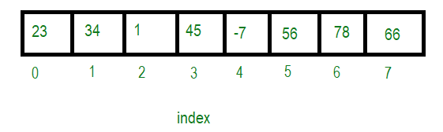
Below will be an example of an array.

Image [2]

1.2. Arrays - Advantages
- Using the index number to access an entity in an array is really simple. [2]

- The search method is simple to apply to an array. [2]

- Matrices are portrayed using a 2D array. [2]

- If a user needs to store several variables of the same kind for some purpose, the Array can be used effectively. [2]

1.3. Arrays - Disadvantages
- The array's size is stable - Since the array is permanent, its size is always the same. It does not have the ability to maximize or minimize the amount of memory assigned to it. [2]

- Array is diverse - The array is diverse, which means it could only hold one kind of value. For instance, an array of sort "int" could only hold integer objects and cannot contain objects of other kinds such as double, float, or char. [2]

- An array would be a set of consecutive memory blocks that holds data in a single location. [2]

- Insertion and deletion in an array are difficult because to add or remove somewhere in the array, the user must navigate the array and then move the existing objects according to the activity. This process is more expensive. [2]

1.4. Linked Lists
A linked list would be a dynamic data structure in which each object, referred to as a node, is created up of two things, data and a connection to another node. A linked list would be a set of nodes joined by a pointer from one node to another. The first node in the sequence is considered a head, and its value is NULL if the set is empty. [3]
A user should consider of a conga line as an actual example of a linked list. A conga line is a type of dance where only people are lining up behind the other with their hands on the shoulders of the individual in the front. Each dancer would be a piece of data, and their hands act as pointers or links towards the next object. [3]
Below will be an example of a linked list.


Image [3]

1.5. Linked Lists - Advantages
- A linked list would be a dynamic data structure that can increase and decrease in size at runtime by assigning and deleting memory. As a result, without any need to specify the linked list's actual size. [4]

- There would be no memory loss in the linked list because the size of the linked list increases or decreases at load time, so there is no memory loss and have no need to pre-allocate memory. [4]

- Implementation - A linked list is also used to apply linear data structures such as stacks and queues. [4]

- Operation of Insertion and Deletion - The linked list makes it far simpler to add and delete items. Once an object is added or removed, it is only necessary to change the address for the next pointer. [4]

1.6. Linked Lists - Disadvantages
- Memory use - A linked list needs additional memory than an array. Since a pointer is needed to maintain the address of another object in a linked list, it needs additional memory. [4]

- As opposed to an array, moving a linked list takes much longer. In a linked list, unlike an array by index, direct connection to an object is not accessible. To get to a node at point n, for example, the user must go through all of the nodes before this one. [4]

- Reverse traversing is indeed not available in a separately linked list, but it is available in a multiple linked list since each node includes a pointer towards the previous connected nodes. This requires additional memory for the back pointer, resulting in memory loss. [4]

- Because of the dynamic memory allocation in a linked list, random access is therefore not achievable. [4]

Arrays maintain objects within compatible memory positions, resulting in simply measured identifiers for the objects held, allowing for quicker access to objects at unique indexes. Linked lists have a reduced static storage layout and objects are rarely kept in consecutive places, requiring the use of specific tags to relate towards the next object. This differs in data storage method determines which data structure is best for a specific case. [5]
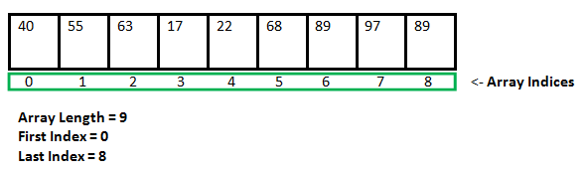

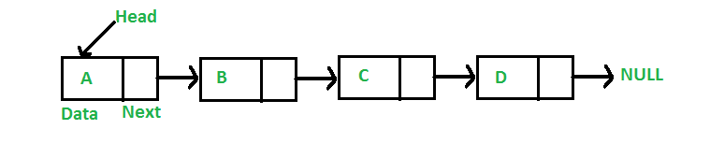
Image Of Linked List [5]
Image Of Array [5]
2. Part A – Question 2
2.1. The Performance Of The Data Structure
Below would be an array of a linked list from the assignment brief which shows a data structure of people names starting with the first letter. For this linked list in a data structure, the performance would not be too bad as the user will be able use random access. For example, if the user wants to look for names beginning with H, the user can go straight to H which will be quicker to access instead of going to A-Z just like the arrays which will take much longer.
In this linked list in a data structure, the user can add new names or delete names with no problems while in arrays, the user will only have limited number of names they can add. Also, linked lists can use additional memory to add more names without any loss while arrays cannot have additional memory when adding new names.
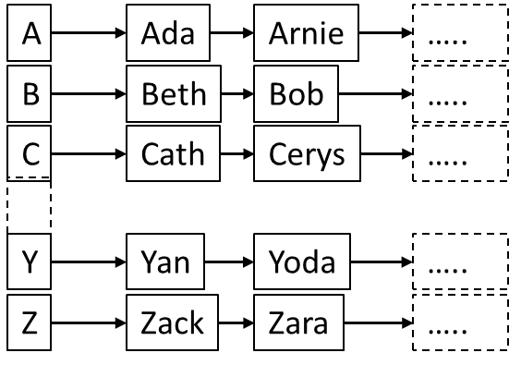

3. Part A – Question 3
3.1. Binary Search Tree
A Binary Search Tree would be a rooted tree in which the elements are arranged in a certain sequence. The element of the left subtree includes numbers which are smaller than the root, and the element of the right subtree includes numbers which are bigger than the root if the sequence is increasing (low to high). This principle applies to every element in the tree, the elements in its left subtree will have small numbers, while the elements in its right subtree will have bigger numbers. [6]
For this task, the values will be 34, 6, 7, 18, 45, 12, 3, 26. The number 34 will be starting value, the number 6 is smaller than 34 as it will go on the left hand side of 34, the number 7 is smaller than 34 but it is bigger than 6 so it will go on the right hand side of 6, the number 18 is smaller than 34 but it is bigger than 6 and 7 as it will go on the right hand side of 7. The number 45 is bigger than 34 so it will go on the right hand side of 34, the number 12 will be smaller than 34 but bigger than 6 and 7 but then again, smaller than 18 so it will go on the left hand side of 18, the next number will be 3 and it is smaller than 34 and 6 as this will go on the left hand side of 6 and the last number will be 26, this number is smaller than 34 but bigger than 6, 7 and 18 as this will go on the right hand side of 18.
The binary tree below shows that it unbalanced due to different number values being placed in specific order.
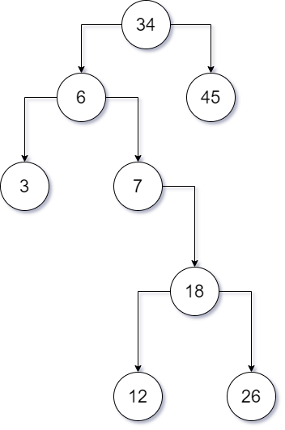

Below will be a Binary Tree from an online generator to show that the user diagram is correct and shows no errors.
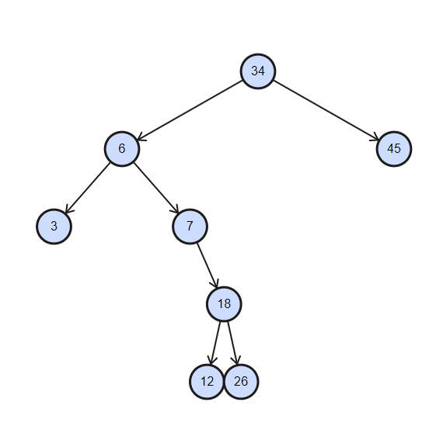

3.2. Balanced Binary Tree
A balanced binary tree, also known as a height-balanced binary tree would be a binary tree whereby the height of each node's left and right subtree differs by no over than one. The requirements for a balanced binary tree are as shown below: [7]
- There will be no than one variation between both the left and right subtrees with any node. [7]

- The subtree on the left is balanced. [7]

- The subtree on the right is balanced. [7]

Below will be an example of a balanced binary tree and how it is configured.
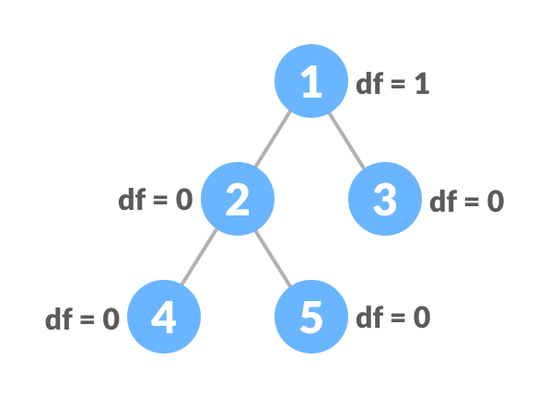

Image [7]
4. Part B – Question 1
4.1. Dijkstra’s Algorithm
The user could use Dijkstra's Algorithm to find the shortest route across nodes in the diagram. The user will build a shortest-route tree by finding the shortest route from one node to another node throughout the diagram. The shortest route between both the present location and the endpoint is found using this algorithm in GPS systems. It has a wide range of programs in business, especially in environments which include network modelling. [8]
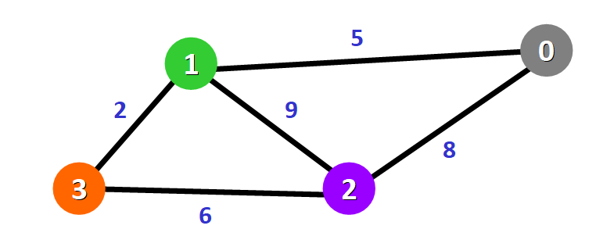
Below will be an example of a Dijkstra’s Algorithm.

Image [8]

For this task, the user will need to get a Camera from a Stamp, Book, Toy Boat, Ships Bells and a Scooter in the cheapest and quickest route using this algorithm as many scenarios can be used.
Trade | Item | Estimated Cost | Acceptable Trades
A | Stamp | 0 | None: you own it
B | Book | 3 | Stamp
C | Toy Boat | 8 | Stamp
D | Ships Bell | 4 | Book
D | Ships Bell | 7 | Toy Boat
E | Scooter | 3 | Ships Bell
E | Scooter | 10 | Toy Boat
F | Camera | 2 | Scooter

Below will be the table showing the items and its cost price from the brief.

4.2. Scenario 1
Route | Cost Price
A to B | £3.00
B to D | £4.00
D to E | £3.00
E to F | £2.00

Total Cost = 3 + 4 + 3 + 2 = £12.00
The first route to get to the Camera will cost £12.00

4.3. Scenario 2
Route | Cost Price
A to C | £8.00
C to D | £7.00
D to E | £3.00
E to F | £2.00

Total Cost = 8 + 7 + 3 + 2 = £20.00
The second route to get to the Camera will cost £20.00
4.4. Scenario 3
Route | Cost Price
A to C | £8.00
C to E | £10.00
E to F | £2.00

Total Cost = 8 + 10 + 2 = £20.00
The third route to get to the Camera will cost £20.00

4.5. Best Choice
Out of the many scenarios for this task, the best choice will be Scenario 1 because it is the cheapest route as the user will save £8.00 compared to both scenarios. The quickest route will be Scenario 3 but it is still the most expensive route as well. This algorithm will estimate best possible route for the user by using it values that it has provided.
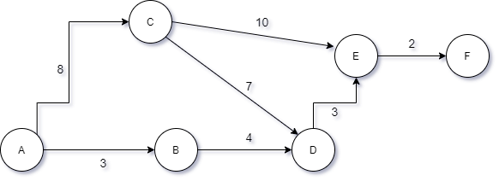
Below will be a diagram to show the Dijkstra’s Algorithm for this specific task.

Below will be a step by step guide of the Dijkstra’s Algorithm for this specific scenario.
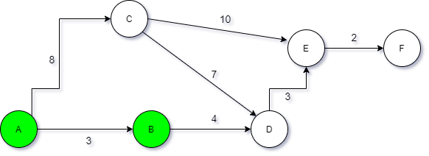
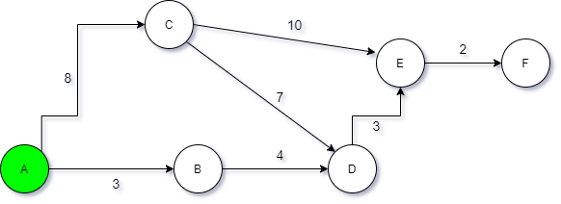

Open: B, C Open: D
Closed: A Closed: A, B

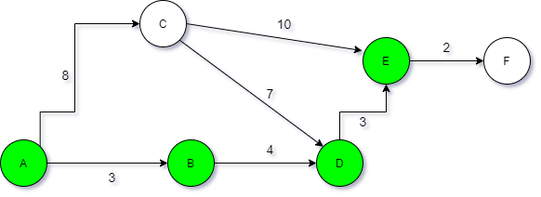
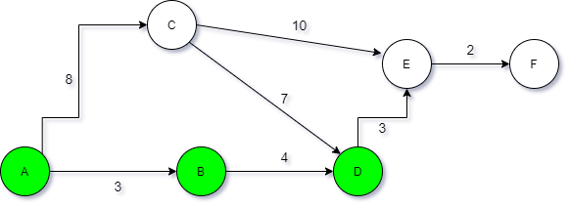

Open: E Open: F
Closed: A, B, D Closed: A, B, D, E

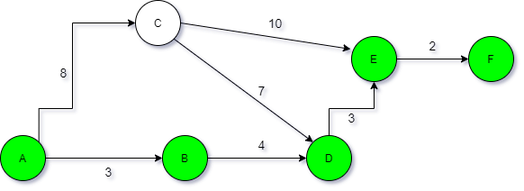

Open:
Closed: A, B, D, E, F

Below will be a Dijkstra’s Algorithm diagram from an online generator to show that the user diagram is correct and shows no errors.
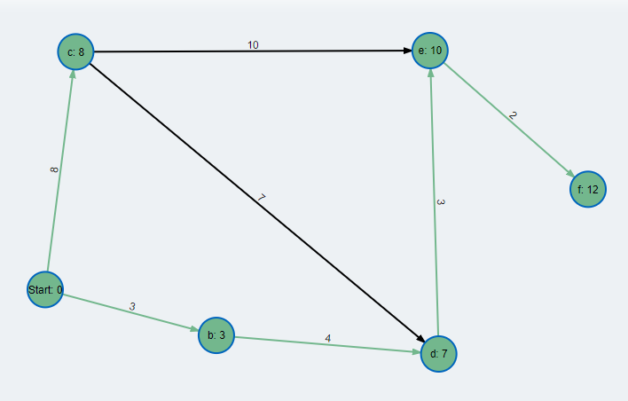

5. Part B – Question 2
The Dijkstra’s Algorithm would operate using O (EV²) time as this shows that E means the number of edges and V means the number of vertices. This algorithm could be improved by using the formula O (E LOG V) time performance.
For this task, the user will need to found out what does O equal to using both formulas O (EV²) and O (E LOG V) with the number of vertices arranging from 1 to 12 and the number of edges arranging from 0 to 11.
Using the formula O (EV²):
E | V | O (EV2)
1 | 0 | 0
2 | 1 | 2
3 | 2 | 12
4 | 3 | 36
5 | 4 | 80
6 | 5 | 150
7 | 6 | 252
8 | 7 | 392
9 | 8 | 576
10 | 9 | 810
11 | 10 | 1100
12 | 11 | 1452

Using the formula O (E LOG V):
E | V | O (E LOG V)
1 | 0 | 1
2 | 1 | 0
3 | 2 | 0.903
4 | 3 | 1.908
5 | 4 | 3.01
6 | 5 | 4.193
7 | 6 | 5.447
8 | 7 | 6.76
9 | 8 | 8.127
10 | 9 | 9.542
11 | 10 | 11
12 | 11 | 12.496
After the user has used both of the time formulas to find out what O is equal to, they will need to create a graph to show the performance difference between these two formulas.

The image above shows a line graph showing the performance difference between number of vertices and edges after using both formulas. The graph shows that when the user uses the formula O (E V²), the number of vertices will increase more value comparing when the user has used the formula O (E LOG V).

6. Part C
6.1. How The Minimax Algorithm Works?
Minimax would be a backtracking algorithm used within decision-making and game theory to identify the best choice for a user, considering that their enemy is also playing efficiently. It's common in two-player turn-based games like Tic-Tac-Toe, Backgammon, Chess and many others. [9]
Maximiser and minimiser are the two users of Minimax. The maximiser aims for the greatest possible result, whereas the minimiser aims for the least potential result. Every platform condition does have an economic value attached to it. If the maximiser does have the advantage in a specific state, the platform's result would appear to be accurate. There would have to be certain lower value if the minimiser does have the advantage in that platform condition. The platform values are determined by a collection of algorithms that are different to each game. [9]
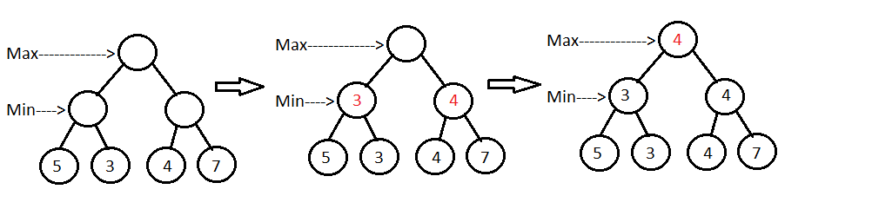
Below will be an example of a Minimax Algorithm game tree.

Image [10]

Beginning with the root node, Maximiser selects the step with the highest score. Due to the fact that only leaves have performance ratings, the algorithm must algorithmically hit leaf nodes. The minimiser is usually choosing a path from the leaf nodes throughout the game tree, so the nodes with the lowest scores, node 3 and 4, would be chosen. It continues to choose the best nodes in the same method until it finds the root node. [10]
One of the most common algorithms for computer board games would be the Minimax algorithm. It's used a lot in turn-based games. Since users have full knowledge about the game, this can be a good option. [10]

7. References

References

[1] | Kenneth Leroy Busbee and Dave Braunschweig, "Arrays and Lists," N/A N/A N/A. [Online]. Available: https://press.rebus.community/programmingfundamentals/chapter/arrays-and-lists/. [Accessed 4 May 2021].
[2] | "Advantages and Disadvantages of Array in C," 29 October 2020. [Online]. Available: https://www.geeksforgeeks.org/advantages-and-disadvantages-of-array-in-c/. [Accessed 7 May 2021].
[3] | O. Stephen, "Linked Lists in C Programming: Definition & Example," 8 December 2020. [Online]. Available: https://study.com/academy/lesson/linked-lists-in-c-programming-definition-example.html. [Accessed 7 May 2021].
[4] | pulkitagarwal03pulkit, "Advantages and Disadvantages of Linked List," 28 December 2020. [Online]. Available: https://www.geeksforgeeks.org/advantages-and-disadvantages-of-linked-list/. [Accessed 7 May 2021].
[5] | GeeksforGeeks, " Linked List vs Array," 13 April 2021. [Online]. Available: https://www.geeksforgeeks.org/linked-list-vs-array/. [Accessed 10 May 2021].
[6] | N/A, "Binary search tree," N/A N/A N/A. [Online]. Available: https://isaaccomputerscience.org/concepts/dsa_search_bst. [Accessed 10 May 2021].
[7] | N/A, "Balanced Binary Tree," N/A N/A N/A. [Online]. Available: https://www.programiz.com/dsa/balanced-binary-tree. [Accessed 14 May 2021].
[8] | E. C. Navone, "Dijkstra's Shortest Path Algorithm - A Detailed and Visual Introduction," 28 September 2020. [Online]. Available: https://www.freecodecamp.org/news/dijkstras-shortest-path-algorithm-visual-introduction/. [Accessed 14 May 2021].
[9] | GeeksforGeeks, "Minimax Algorithm in Game Theory | Set 1 (Introduction)," 31 March 2021. [Online]. Available: https://www.geeksforgeeks.org/minimax-algorithm-in-game-theory-set-1-introduction/. [Accessed 24 May 2021].
[10] | baeldung, "Introduction to Minimax Algorithm with a Java Implementation," 3 October 2020. [Online]. Available: https://www.baeldung.com/java-minimax-algorithm. [Accessed 24 May 2021].
[11] | N/A, "Algorithms: Design and Analysis, Part 1," N/A N/A N/A. [Online]. Available: https://online.stanford.edu/courses/soe-ycsalgorithms1-algorithms-design-and-analysis-part-1. [Accessed 4 May 2021].

