Database Design

The Book Store

Course: Information Engineering Assignment

Author: Jessica Williams
Date: 03/05/2019
Student Number: 1809781

TABLE OF CONTENTS
1 Introduction 3
2 Initial Design 4
2.1 Table creation 4
2.2 Relationships between the tables 7
2.3 Tables populated with suitable data 9
2.4 Appropriate menus created 10
2.5 Appropriate forms created 11
2.6 Appropriate reports created 16
2.7 Query produced from a single table 17
3 Implementation of Querying and the use of SQL 19
3.1 Creating relationships using SQL 19
3.2 Add records to tables using SQL 20
3.3 Producing a Report from a query 21
3.4 Main Menu and form navigation 22
4 Use of additional MS-Access functionality 23
4.1 Produce calculation in a report 23
4.2 Produce Master and Embedded forms 23
4.3 Producing reports and forms from a macro query 24
4.4 Menu display 26
5 User Documentation 28
6 References 29

Introduction
The purpose of this report is to document the use of a database created in MS Access for a Book Store. The report will document the initial design stages, the implementation and functionality of the database. The report will conclude with a user guide. Screenshots have been used throughout to reference the database. Six main tables have been created to store various information. Queries and macros have been utilised to enhance the functionality of the database.

A number of observations have been made throughout the development of the Book Store database:
- Employees of the Book store are referred to as users.
- The user should have the ability to delete and update Customer information.
- Newsletter are sent out via post.
- The user requires purchase invoices to be generated.

Initial Design

Table creation
After review of the user requirements and the observations made the following tables have been created for the Book Store database:

- Customer
- Staff
- Supplier
- Purchase
- Book
- Details

The following details will be included with the tables. The field names are identified with the data type and additional information for the table. To create the tables SQL queries were run and other tables were created in the design view of MS Access.

- Customer Table:

Field Name | Data Type | Additional Information
Customer_id | Text - 4 | Primary Key
Forename | Text - 25
Surname | Text - 25
Address1 | Text - 25
Address2 | Text - 25
Address3 | Text - 25
Postcode | Text - 25
Tel_no | Text - 25

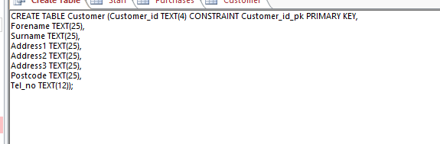

Upon reflection a Newsletter sign up field was added to the Customer table.

- Staff Table:

Field Name | Data Type | Additional Information
Staff_id | Text - 4 | Primary Key
Forename | Text - 25
Surname | Text - 25
Role | Text - 25

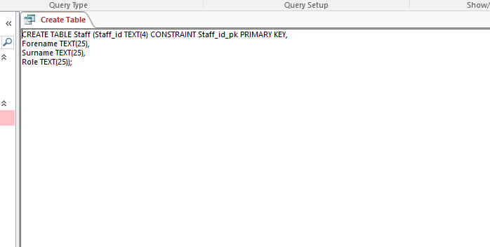

- Supplier Table:
Field Name | Data Type | Additional Information
Supplier_id | Text - 4 | Primary Key
Company_name | Text - 25
Forename | Text - 25
Surname | Text - 25
Tel_no | Text - 12
Email_address | Text - 25

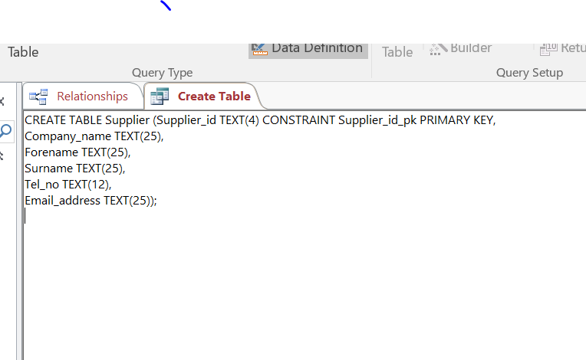

- Purchase Table:
Field Name | Data Type | Additional Information
Purchase_id | Text - 4 | Primary Key
Customer_id | Text - 4 | Foreign Key
Staff_id | Text - 4 | Foreign Key
Mail_order | Text - 25
Method_of_payment | Text - 25
Promotion | Text - 25

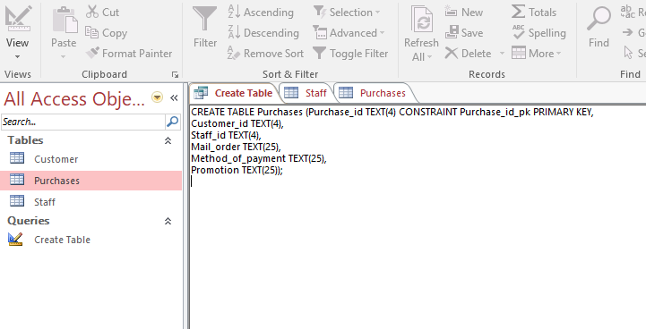

- Book Table:
Field Name | Data Type | Additional Information
Book_id | Text - 4 | Primary Key
First_edition | Text - 25
Title | Text- 25
Author | Text- 25
Date | Date/Time- Short Date
Retail_value | Currency
Supplier_price | Currency
Supplier_id | Text- 4

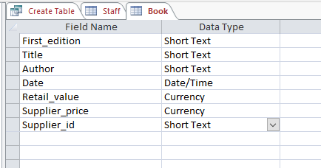
- Details Table:
Field Name | Data Type | Additional Information
Purchase_id | Text - 4 | Primary Key & Foreign key
Book_id | Text - 4 | Primary Key & Foreign key
Quantity_purchased | Number

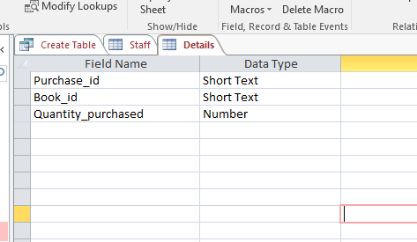

Relationships between the tables

The above tables will have the following relationships:

- One customer will make many purchases.
- One purchase will contain many details.
- One book will contain many details.
- One supplier will supply many books.
- One staff will be linked with many purchases.

To document the database tables and relationships an Entity Relationship Diagram has been created on Visio.

Tables populated with suitable data
In the planning stages of the database the data was analysed and used from Excel in order to populate the database. Data normalisation was considered to meet the rules of the third normal form [1].

An example of the data utilised is below:
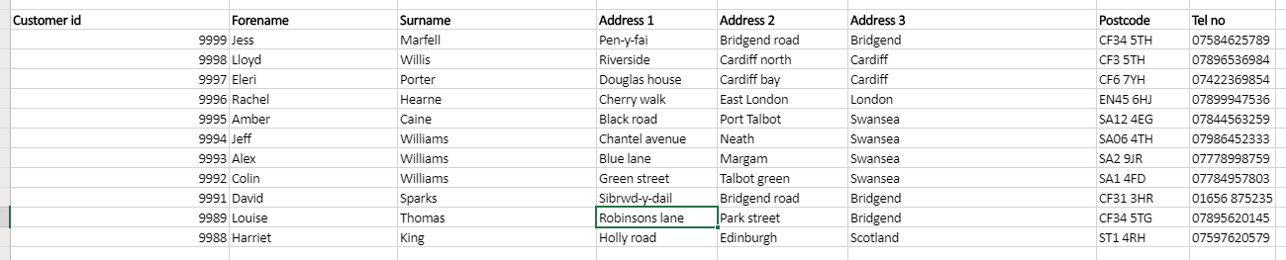

Inserting the data was done through updating the tables and columns individually and through the use of SQL queries.

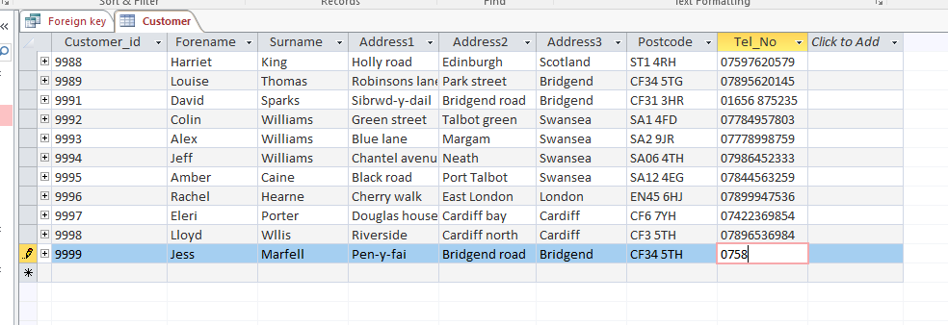

Additional information was added to the tables where required through the use of an insert into query in SQL. In the below example an additional staff member was added to the Staff table.

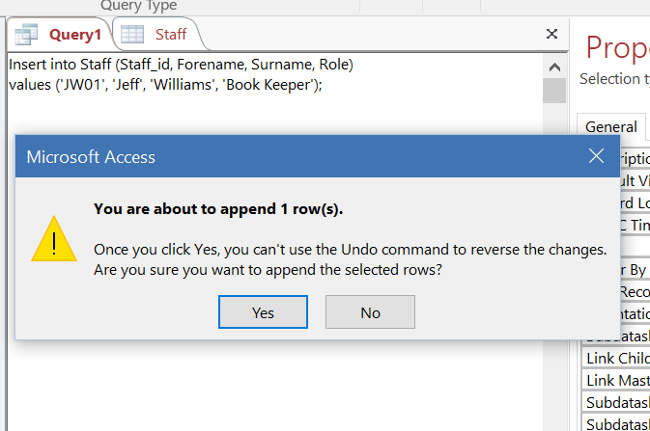

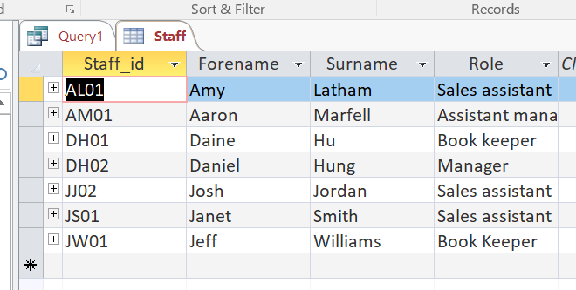

Some of the fields were tested for data quality.

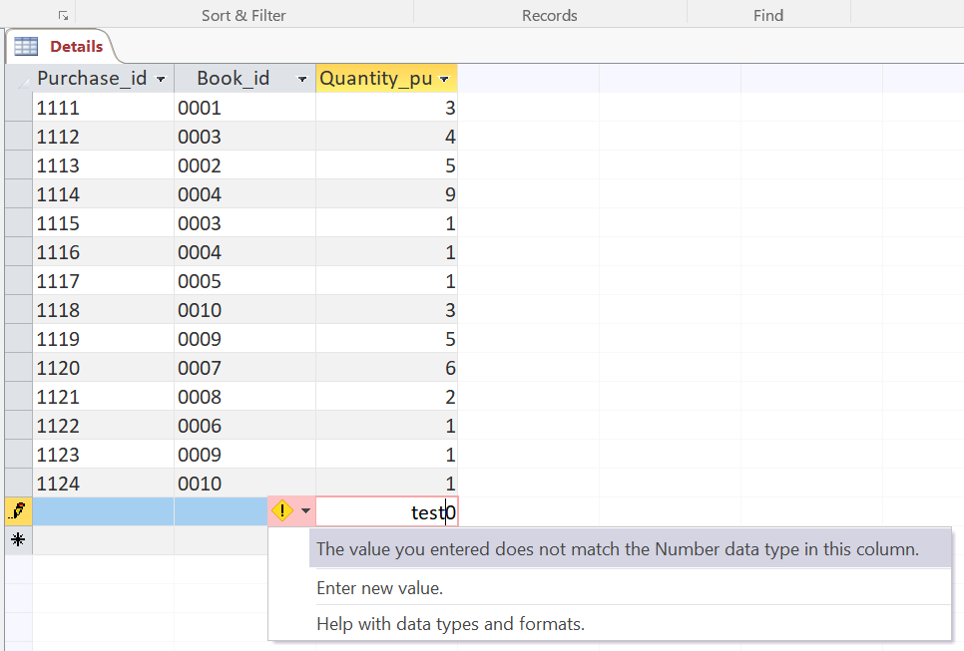

Once the user has hit the maximum count they are unable to insert more characters.

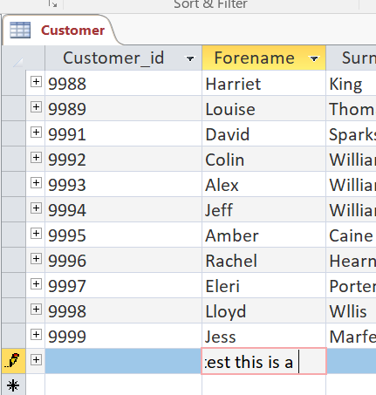

Appropriate menus created
The Main Menu tab has been created as the default form when the database is opened. It is the central hub for all of the appropriate forms.

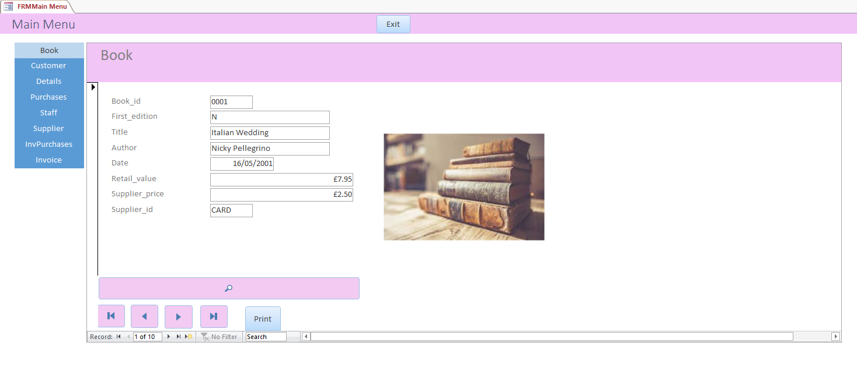

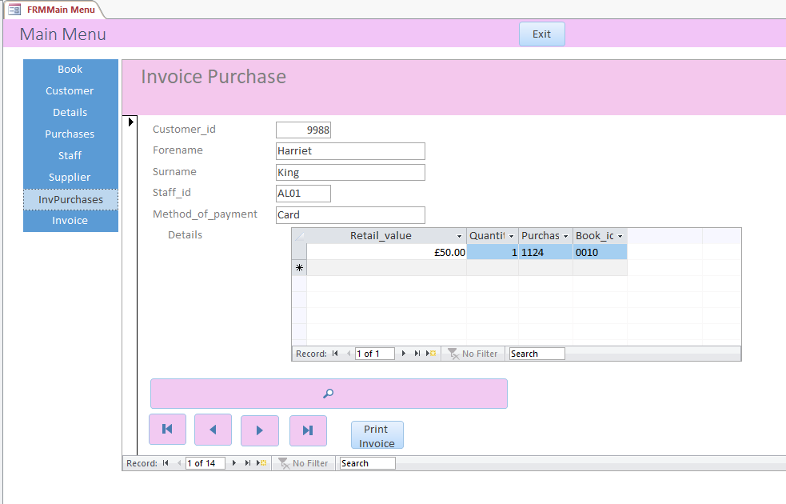

Appropriate forms created
The following forms have been created for usability.

Book:
The Book form has been created for the user to identify the required information regarding a specific book. They are able to navigate through the data and search for a specific book. The form also includes a print function. An image has been displayed on the form for cosmetic purposes [2].
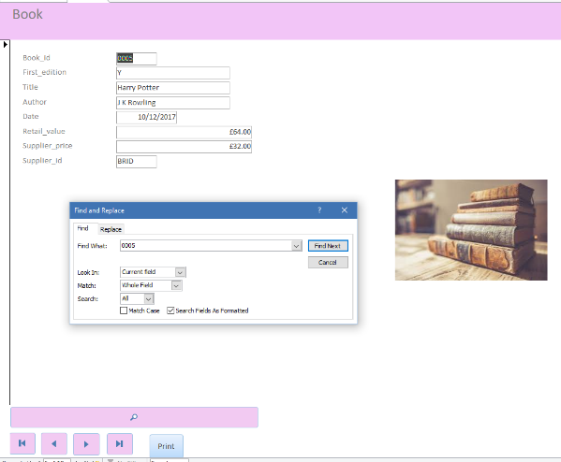

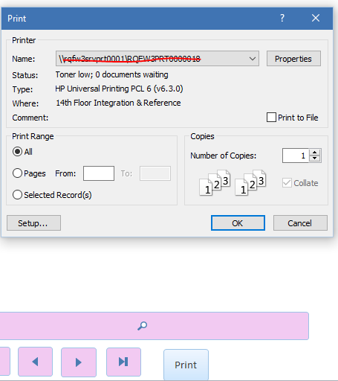

Customer:

The Customer form has been created for the user to identify customer information. They can navigate through the data and search for a specific customer. The form also includes a print, delete and save record function. The Customer form is also linked to the Customer report when selected.

Top half of form:
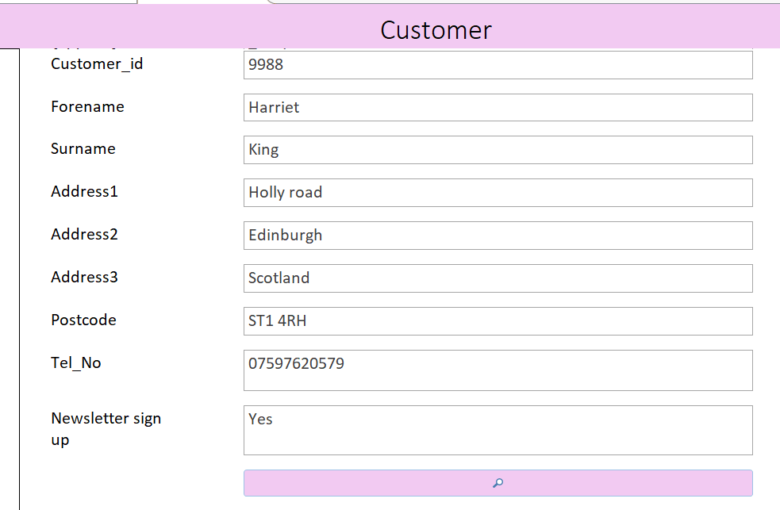

Bottom half of form:

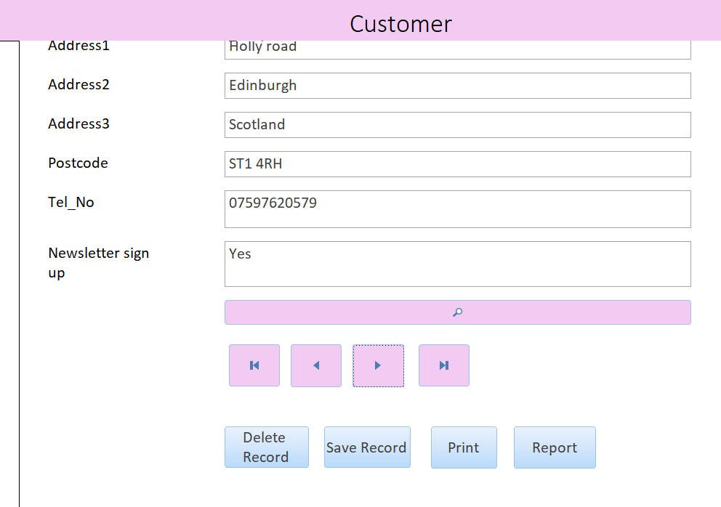
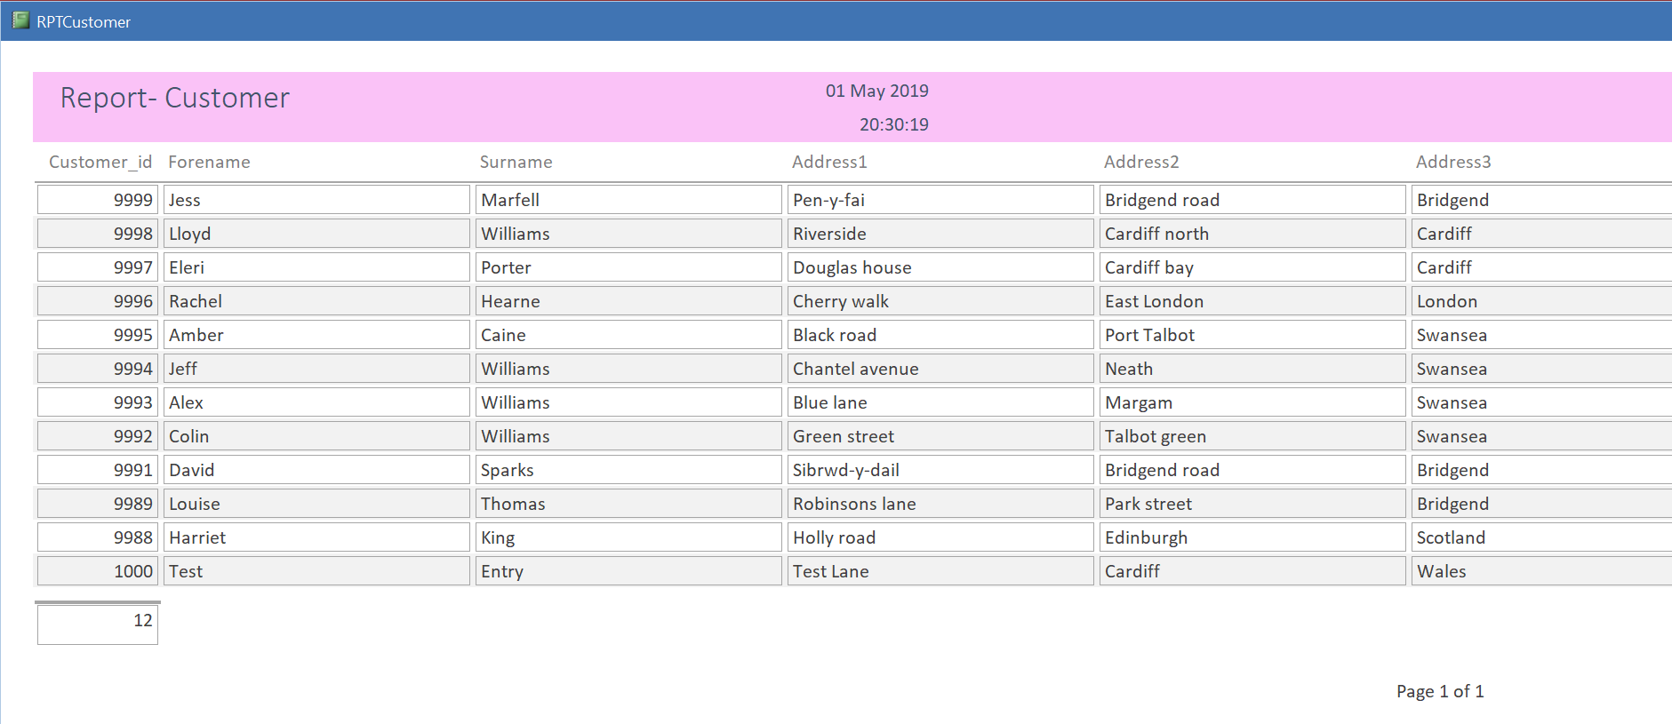

Details:

The Details form has been created for the user to access purchase and book details. They can navigate through the data and search for specific details. The form also includes a print function and a short cut to the Book and Purchase forms.

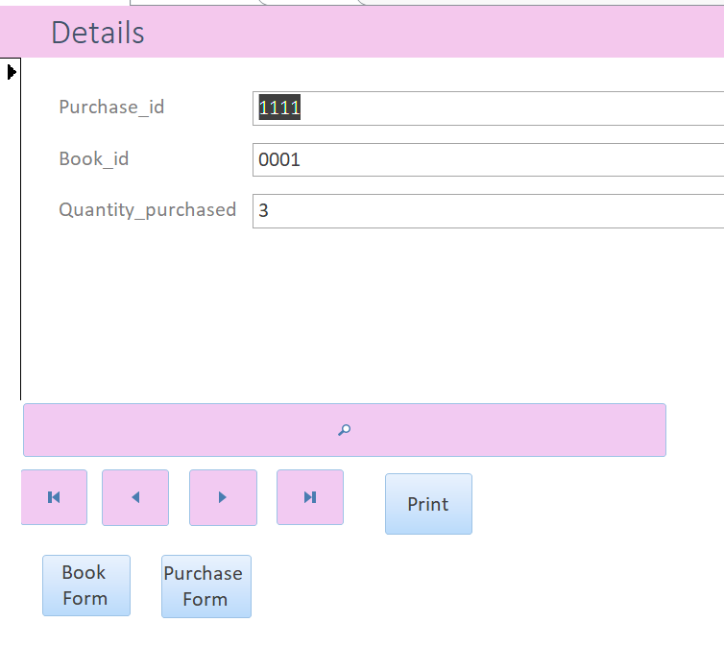
Purchases:

The Purchase form has been created for the user to access purchase details. They can navigate through the data and search for specific details. The form is also available through the details form.

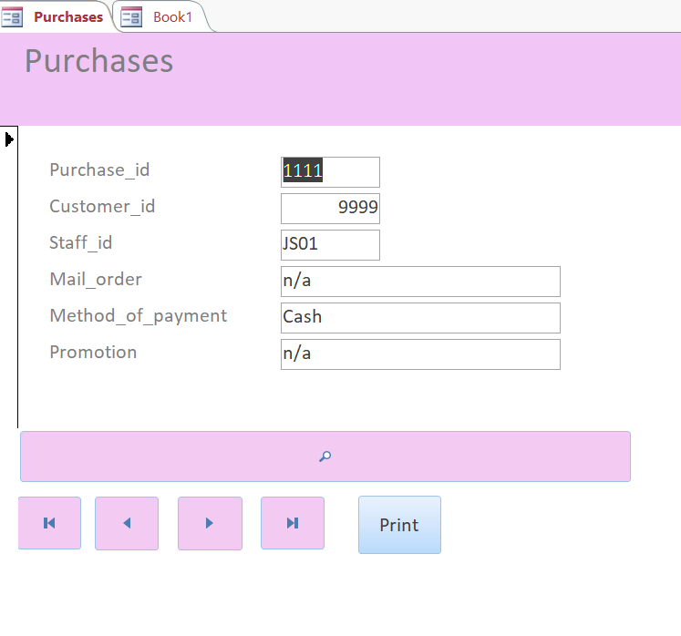

Staff:

The Staff form has been created for the user to access staff details. They are able to navigate through the data and search for specific details. The user is able to print this form.

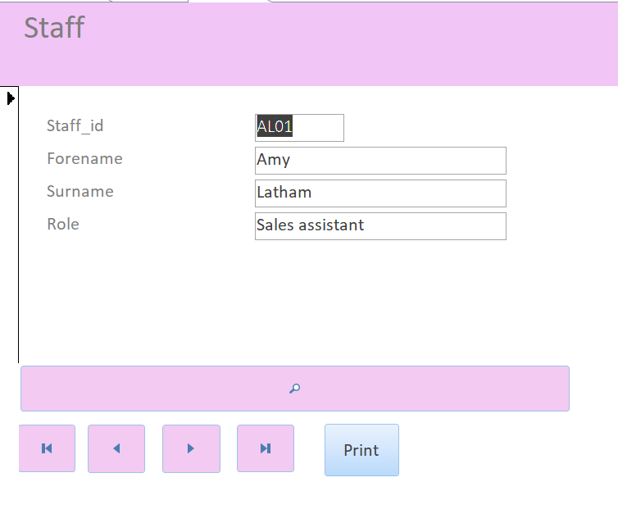

Supplier:

The Supplier form has been created for the user to access supplier details. They can navigate through the data and search for specific details. The user is able to print this form.
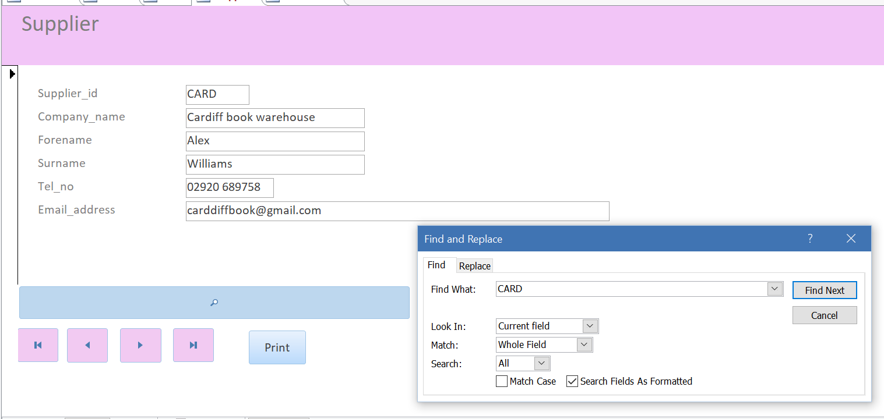

InvPurchases:

The InvPurchases form has been created for the user to access specific purchase details. They are able to navigate through the data and search for specific details. The user is able to print this form. Within the form is a sub form for the details which are connected to the specific purchase.

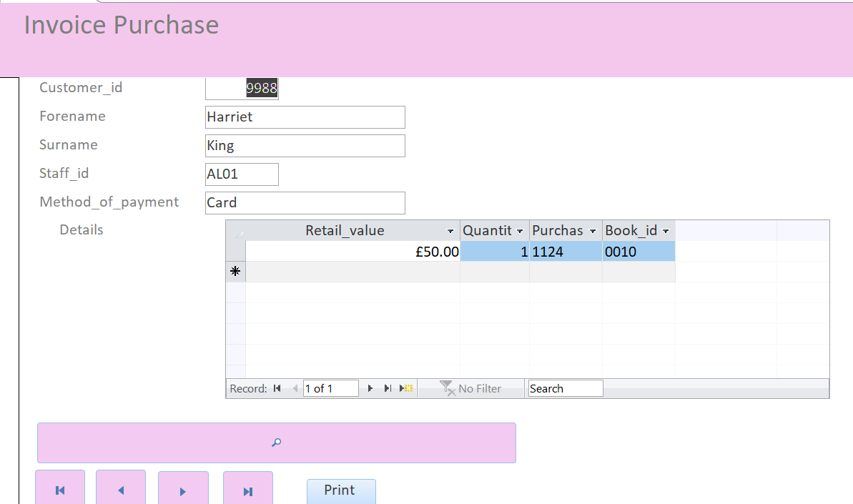

Invoice:

The Invoice form contains a macro for the user to search for a specific record and retrieve a report for the customer to identify the invoice associated to the customer ID.

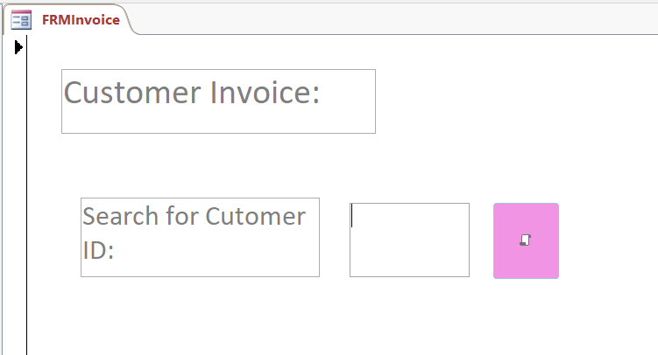

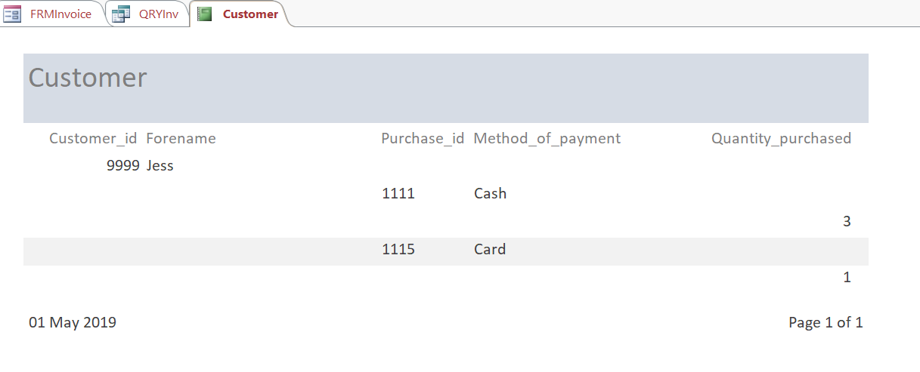

Appropriate reports created
Reports have been created for the user to view the required information.

A Customer report is generated from the invoice form where the user can search for specific details on a customer. Depending on the search criteria the report will generate.

Another report has been created through a query to display all first addition books.

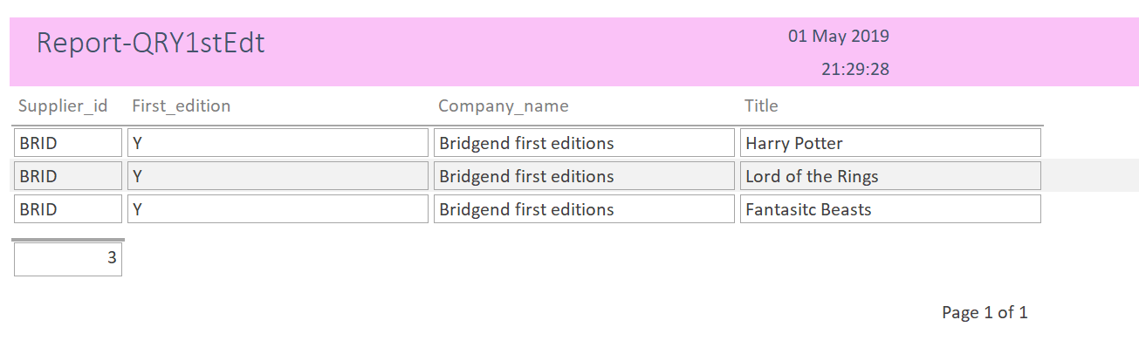
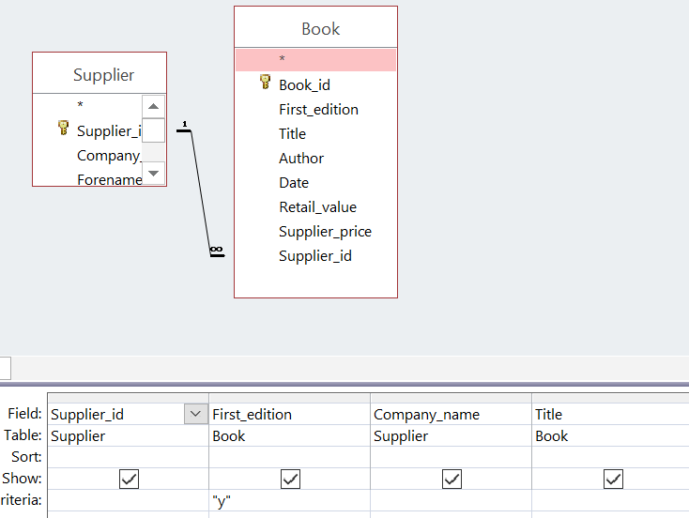

Using an SQL query customer, details and purchase information have been displayed in one single report.

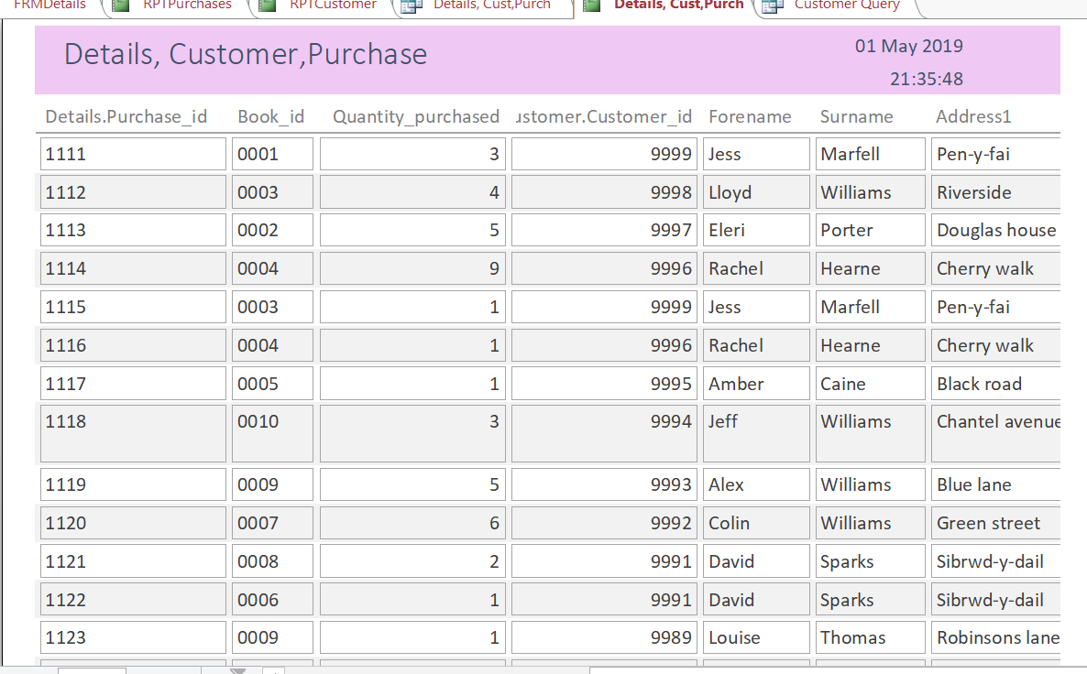

Query produced from a single table
A number of queries have been created to extract certain information from specific tables. An example of one is the QRYBook. The Book table has been used to query itself to only show specific titles and the date of the book. To filter the results the date has been sorted into descending order.

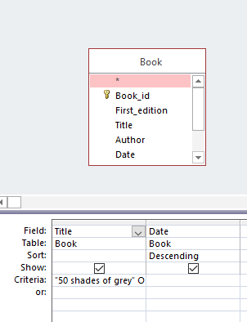

The outcome of the query was:

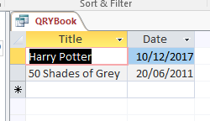

The Query was then made into a basic report for the user to view.

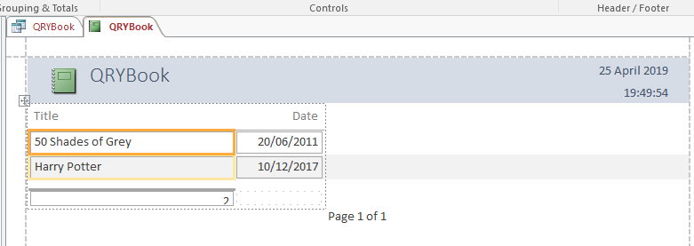

A more complex example of a queries is identified in section 4.4.

Implementation of Querying and the use of SQL

Creating relationships using SQL

As mentioned in section 3.1 some tables were created through using an SQL query. The CREATE command was used as well as the field name, relationship and format of data.

The below query has been executed to create the relationship between the Purchase and Customer table. It links the Customer_id which has been set to the Primary key in the Customer table to the foreign key for the Customer_id within the Purchases table.

ALTER TABLE Purchases
ADD CONSTRAINT FK_Cusomer_id
FOREIGN KEY (Customer_id) REFERENCES Customer(Customer_id);

Another example of creating relationships between two tables is within the relationship tab. Relationships can be set through editing relationships. The Supplier table is linked to the Book table through the Supplier_id field.

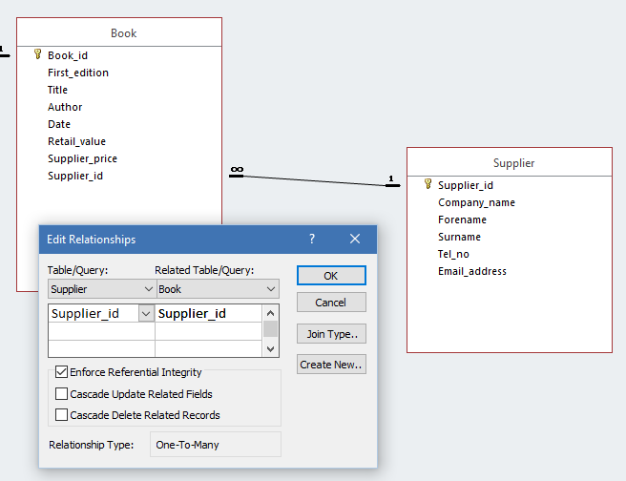

The relationships are as follow in MS Access:

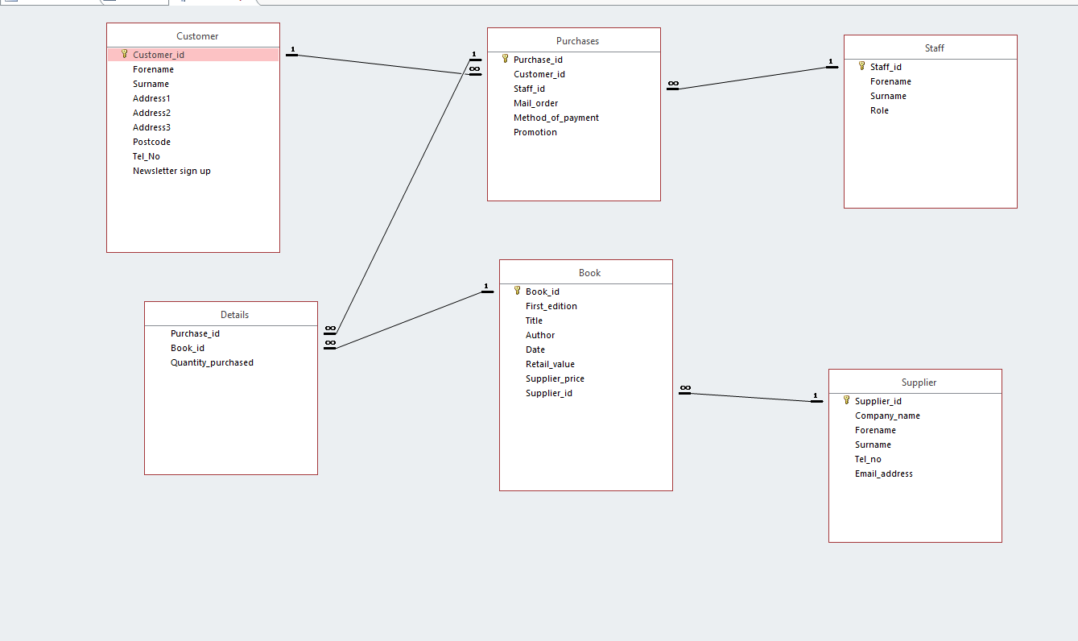

Add records to tables using SQL

As mentioned in section 2.3 records were added through the use of an SQL query.

As well as adding records a delete query has also been utilised.

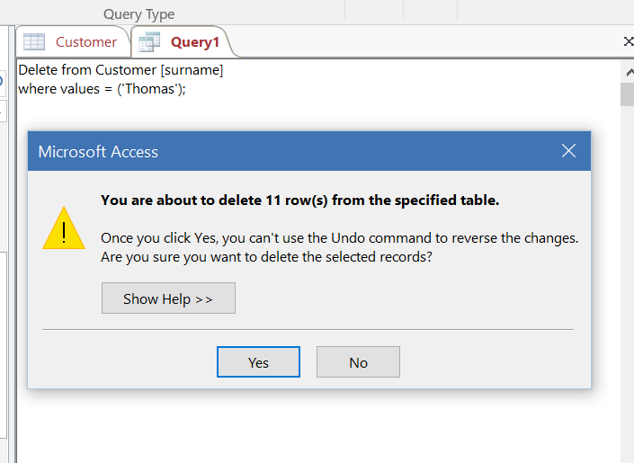

The user is able to save and delete customer records on the Customer form through the use of two macros. The Save function can also be used as an update to an existing record.



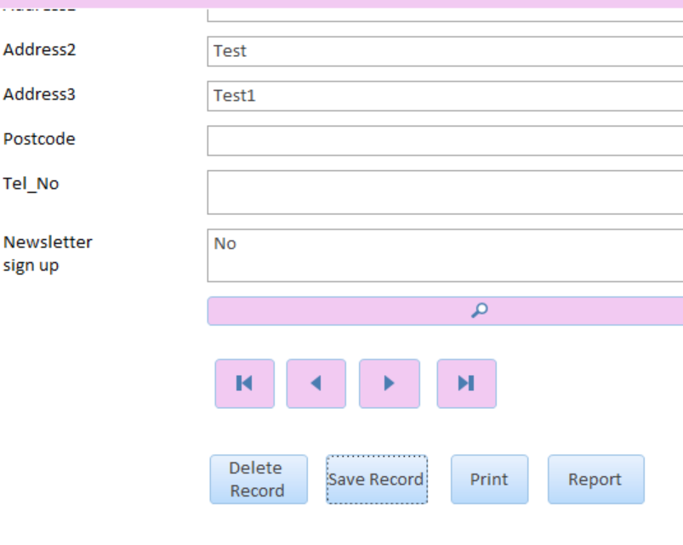


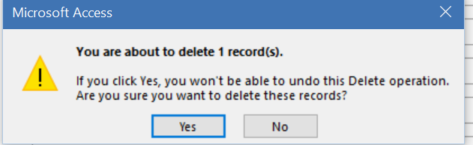

Producing a Report from a query

As previously mentioned in section 2.7 queries have been used to create reports. QRY1stEdt has been created to retrieve information from the Supplier and Book tables and display the Supplier_id, First_edition, Company_name and Title of the book in one report. The purpose of this query was to display all first edition books and what supplier they were from.

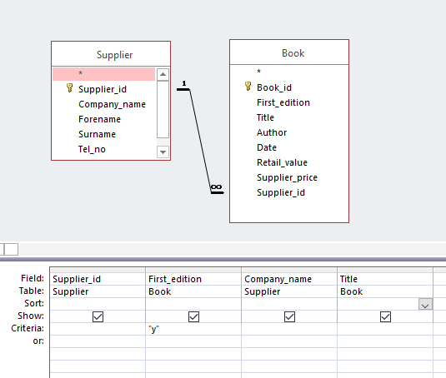

The report for the user is displayed as:

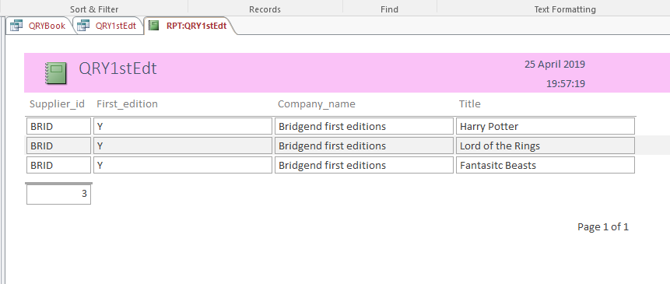

Main Menu and form navigation
The Main menu has been designed for the user to easily navigate to the relevant forms within the database. The Main Menu is the central point and the forms are designed to interact and incorporates functions such as print, view reports and update data. For a full user guide please see section 5.

Use of additional MS-Access functionality

Produce calculation in a report
To display the amount of Purchase_ids the following calculation has been created within the Purchase report: =Count([Purchase_id]). Alternative calculations have been created for reports such as Customer. The calculation is =Count(*).

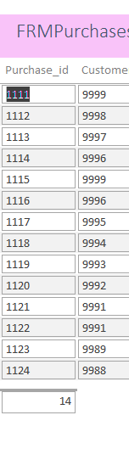

Produce Master and Embedded forms
A master form has been designed as the user’s main menu. This allows the user to navigate to multiple forms. The Main Menu is the default form opened when the database is opened. The master form is linked to the Book, Supplier, Purchase, Staff, Customer, Details, InvPurchase and Invoice forms. Within the Details form two embedding forms have been created. A macro link to Purchases and Books. Upon selection the user will be redirected to the designated forms.

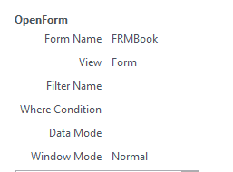

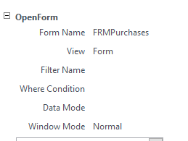

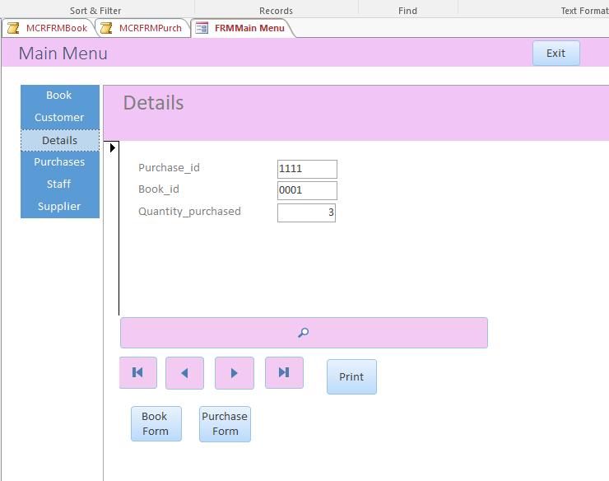

Producing reports and forms from a macro query

Within the Main Menu all forms are displayed for selection. If the Book form is selected and if the user clicks on the Supplier_id text box they will be re-directed to the Supplier form. Once selected the Supplier form will open in another tab for the user to search through the records. The macro used for this functionality was MCRSup_id.

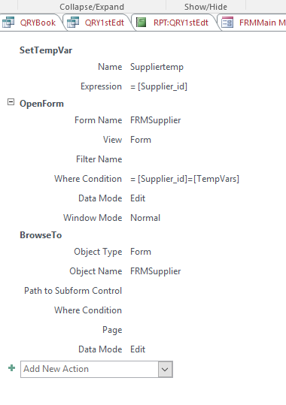

Book form:

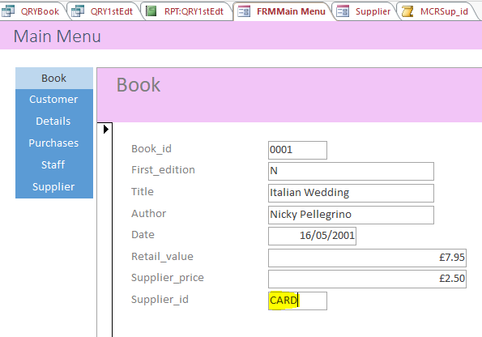

Generates Supplier form in an additional tab.

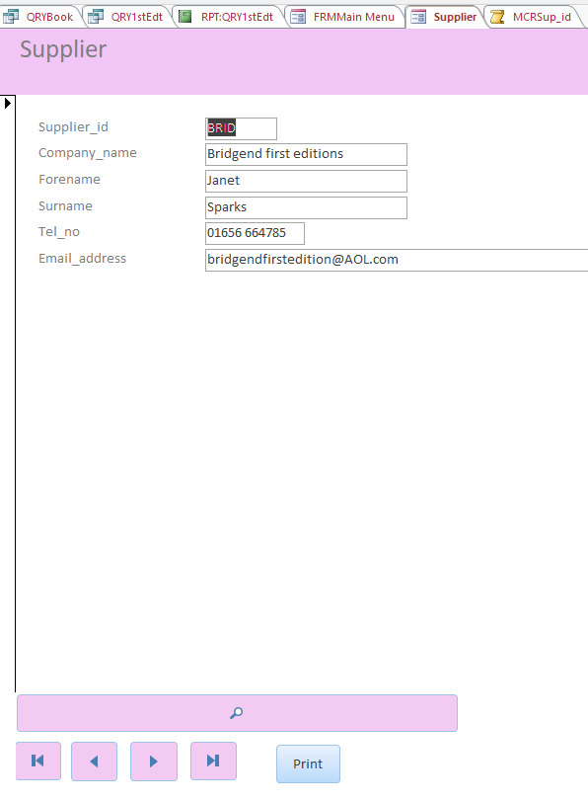

MCRRPTCust was created to allow the user to populate the Customer report upon selection. A report button has been added to the Customer table and once selected an additional window will open and display the Customer report configured on RPTCustomer. The Marco used is displayed below.

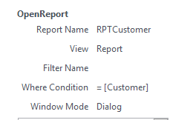

Customer form:

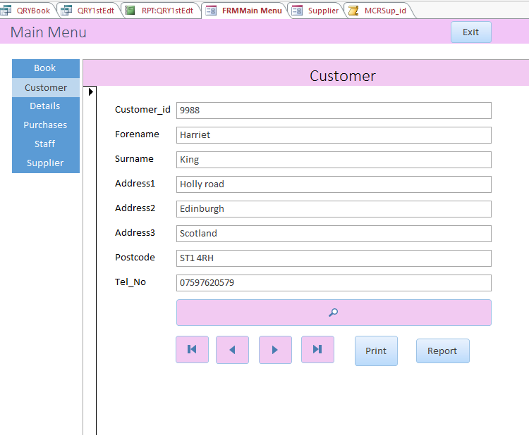

Customer report generated when report button is clicked.

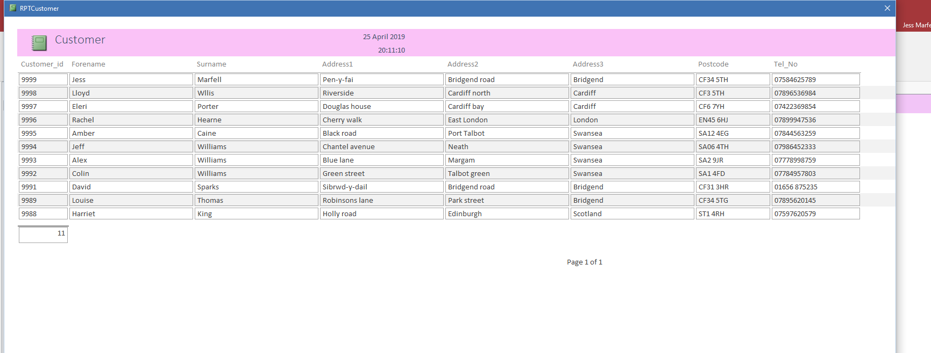

Menu display
To enhance the usability of the system the Main Menu form has been configured to open immediately after the database does. To allow the form to open automatically, setting were changed on the access options. Please see below screenshot.

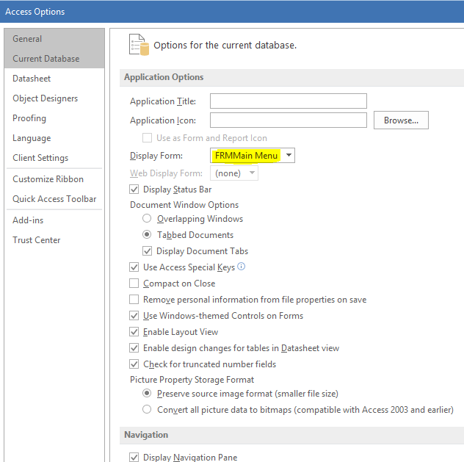

This allows the Main Menu to open immediately.

User Documentation

For the purpose of a brief user guide the follow points are of importance:

- A bookstore database has been created with six tables containing various information on customers, books, purchases and staff.
- The tables connect through primary and foreign keys.
- The Main Menu form is displayed as the user opens the database.
- The user can navigate to the other forms from the Main Menu.
- The user can search for specific details on forms.
- The Customer form has a save and delete function to ensure the user is able to amend the customer details to keep the database up to date.
- A customer invoice can be populated and an Invoice report can be generated when a customer ID has been searched for.
- Multiple reports have been generated for different queries on specific information.

References

[1] | M. Chapple, “Database Normalization Basics,” LifeWire, 04 January 2019. [Online]. Available: https://www.lifewire.com/database-normalization-basics-1019735. [Accessed 01 May 2019].
[2] | “Book Old Vintage,” [Online]. Available: https://www.google.com/search?q=book&rlz=1C1GCEV_enGB841GB841&tbm=isch&source=lnt&tbs=sur:fc&sa=X&ved=0ahUKEwjj8M-M8vrhAhVJyxoKHd9uDigQpwUIIQ&biw=1263&bih=591&dpr=1#imgrc=zkG__pq1h9tt0M:. [Accessed 01 May 2019].

