Museums, Heritage and Representation (HPHE5008, HPHE6008)

A report on: Material ‘tangible heritage’ and non-material ‘intangible heritage’, as mode of cultural heritage, specifically in Tenby as an example of aspects of how Welsh life is represented and how it could develop in the future?
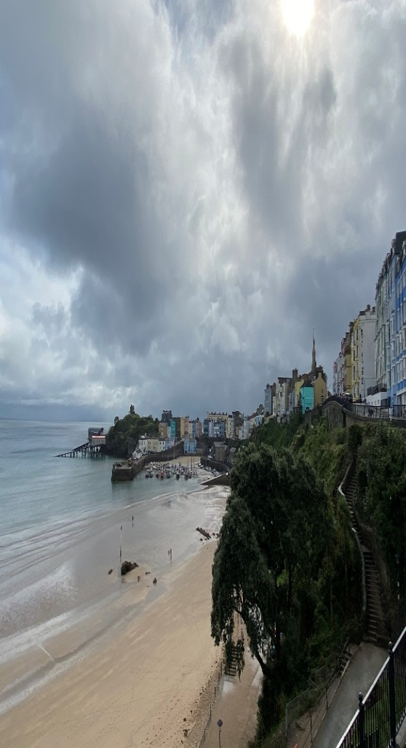
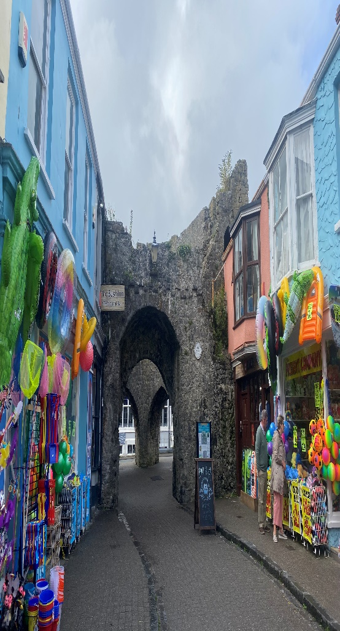
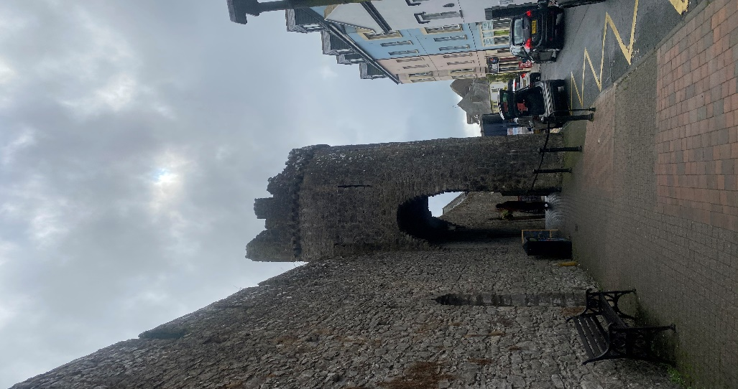
(Williams, 2021)

Jasmine Williams
Student number: 1900461
(25/09/2021) Tenby/Lampeter
Word Count: 2,000 (1850)
Module code: HPHE6008
Contents:
- Introduction
- Tangible and Intangible heritage
- Tourism
- Conclusion
- Bibliography

Introduction:
The term ‘cultural heritage’ is defined by UNESCO as thing that ‘encompasses several main categories of heritage’ (UNESCO, 2021). Those being that of Tangible cultural heritage which encompasses that of moveable and immovable articles such as paintings, monuments, and cities. In comparison to its counterpart Intangible cultural heritage which enraptures that of oral tradition, performing arts and ritual aspects of a culture. This advocates the concept that heritage is more than the collection and categorisation of objects or memorialising of places but rather it is also the inherited traditions and expressionism of our lineage. While both of which are important to the maintaining of cultural diversity in an era of globalisation - beneficial source in the promotion of mutual respect and understanding across ethnic groups, and the drawing away from secular standardised ethnocentric education and towards the transmission of multicultural knowledge.
This report will discuss the concepts of Material ‘tangible heritage’ and non-material ‘intangible heritage’, as modes of cultural heritage, specifically using Tenby, Wales as a case study and example of how Welsh life is represented in postmodern society and how it could be developed in the future. It will go into detail about how the history and heritage of Tenby has affected the overall look, trade, and demographic of the town. Tenby is a harbour town located in Pembrokeshire, capitalised as a medieval walled town and Victorian seaside resort Tenby has settled as a popular tourist destination in Wales. Despite being settled in the early 9th century, the Norman invasion of south Wales in following the battle of Hastings in 1066 was the promoter of Tenby as a major port and trading epicentre till it was later dubbed ‘little England beyond Wales’ (Britianexpress, 2021). Following the Llewelyn ap Gruffydd ransacking in 1260, William de Valence Earl of Pembroke began to impose town walls and adding wide ditches.
Tenby railway station opened 30 July 1863, with the extended line to Pembroke Dock opening on 8 August 1864. In 1866, the line was connected to Whitland railway station then in 1867, work began on the construction of the Palmerston Fort, St Catherine's Island (Tenby Town, 2021).
The economy survives on tourism, supported by its fishing industry. ‘As of April 2017, there are 372 listed buildings and other structures in and around Tenby.’ (Around Tenby, 2021).
Tenby is now recognisably one of the best-preserved medieval towns in Britain, ‘the west gate’ becoming a popular attraction for historians, students, and tourists alike. Other notable Tenby attractions include the 15th-century Tudor Merchant’s House, St Mary’s Church a 13th- century parish and Caldey Island an offshore monastery, home of a medieval abbey where ‘The Cistercian monks of Caldey continue a tradition which began there in Celtic times.’ (https://caldeyislandwales.com/).

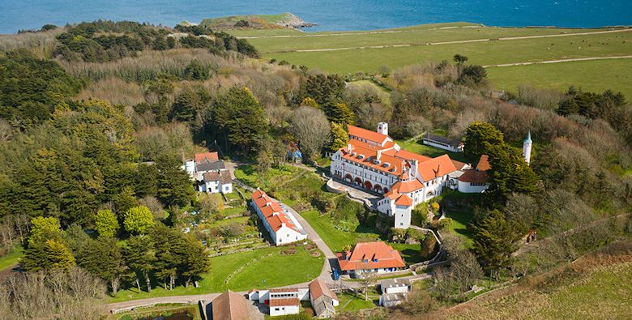

(Caldey Abbey, 2013)

Tangible and Intangible Heritage:
Vecco argues ‘the term “heritage” was characterised by expansion and semantic transfer’ (Vecco,2021) this has however led to generalisation in how the word is frequently utilized for example being used as a connective term for a monument and cultural property. Sites of heritage rarely conform to the same semantic field as other forms of heritage for example paintings.
The wall in Tenby is a prime example of how the conservation of the cultural significant sites, is typically due to its aesthetic, historic, scientific, or social value. The Five Arches Gate has been utilised as a tourist attraction, this is depicted by the structure itself, now home to restaurants and ‘the old market hall’ a collection of shops and pubs for public leisure. This use of tangible heritage sites and materials as areas of modern development allows the history and heritage of Tenby to coexist with its new modern persona as a tourist resort, appealing to holiday makers, students, tourists, and historians alike.
This approach to tangible, and intangible heritage suggests that there is a recognition that certain values, such as capitalising on the historical landmarks as tourist sites for economic value as well as examples of Welsh heritage and lifestyle. Tenby contributed the European year of tourism with The Walled Towns Friendship Circle (WTFC) was founded in 1990 (Bruce, 1994) with support from the European Commission and the Wales Tourist Board. Thus, suggesting a transition between port and resort, between past and future. There are narratives, both of change and continuity, examples of the history and growth of Welsh life in Tenby.

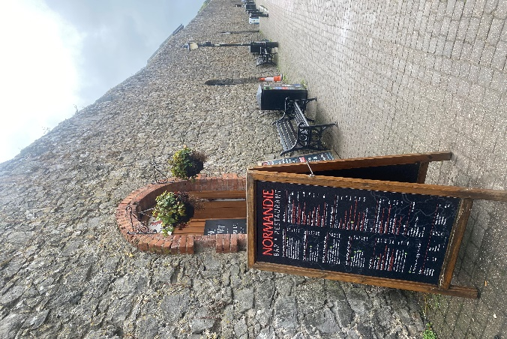
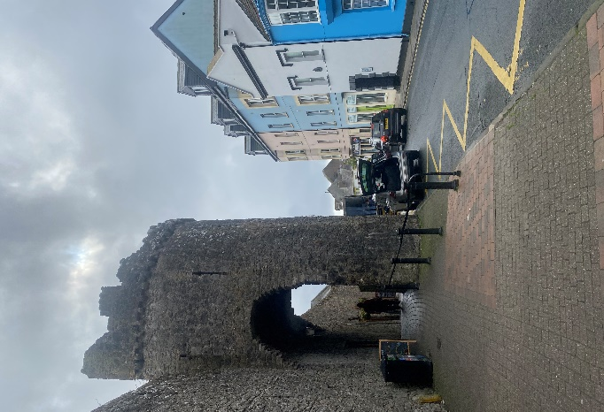
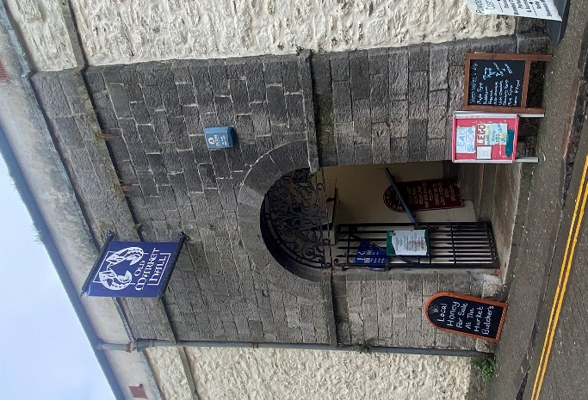
(Williams, 2021)

The heritage of Tenby, its reputation and resemblance as ‘Dinbych-y-pysgod, lit.’ meaning 'fortlet of the fish', transcends past the typical Welsh fishing town it once was, with increased travel and multicultural diversity many changes have been made to adhere to its increased exposure to none native Welsh people; an example of this being the street signs like many Welsh towns, Tenby has translated all their street signs into English this is arguably due to increased tourism from England but also because many residents themselves no longer use the Welsh language commonly, this links to intangible heritage also in reference to the debate on whether the use of the Welsh language is dying out with the new generation.
There are four schools in Tenby, three primary schools and one secondary school: Ysgol Hafan-y-Mor Primary School, St. Teilo's RC School and Ysgol Greenhill Secondary. Many Ysgol Hafan y Môr pupils go on to Ysgol y Preseli, the Welsh-medium secondary school in Crymych. Previous schools in the area were Tenby V.C. Infants School which was an English medium school with a Welsh unit. However, Tenby V.C. Infant school was demolished in 2016 and turned into a field for Ysgol Greenhill Secondary. This alone suggests the concern surrounding the intangible heritage and use of the Welsh language isn’t a formidable opponent to the representation of Welsh life, children are still being taught the language, if it isn’t used its down to the people rather than a lack of representation.

Tourism:
Historically Tenby has a rich heritage in the trading and travel syndicates, which arguably still transpires today still a functional fishing port, Tenby has modernised and now caters to the globalised definition on trade and travel – tourism. As with any cultural development there is areas of polarisation within Tenby, the Welsh natives who believe in the purism of Tenby’s heritage without English interference and those who embrace the financial and diversity enhancements that come with increased tourism. For example, many Tenby merchants have moved away from traditional fishmongers to restaurateurs who still capitalise on the local resources such as fish advertised as ‘fresh from Tenby.’
Tourism is considered a foundation sector in the Wales Economy. The PEMBROKESHIRE DESTINATION MANAGEMENT 2020-2025 Economic Plan depicts ‘Prosperity for All’ in terms of delivering ‘prosperity and jobs, promoting well-being, building communities, presenting Welsh culture, history and language and supporting environmental sustainability.’ (PEMBROKESHIRE COAST NATIONAL PARK AUTHORITY, 2018). These are following on from the 2013 - 2020 terms where a 10% growth in visiting statistics and tourism employment growth from 88,300 to 97,130 and tourism contribution from 4.4% to 4.8%. This along with Statistics for the visiting numbers produced by the Welsh Government and Visit Wales for 2011, indicate that visitor numbers to Southwest Wales were between 3.4 and 3.8 million in 2011 show a growth trend for tourism in Pembrokeshire, with ‘each year, around two and a half million people’ (Harries, 2021) visiting Tenby alone.

Conclusion:
The concept of heritage has been characterised by thematic extension as examples of traditional, chronological, and geographical aspects of a culture thus the concepts of intangible and tangible heritage are arguably giving agency to objects rather than the history. The term heritage within an era of globalisation omits the development places such as Tenby have gone through; having English road signs doesn’t translate to a neglect or heritage but rather the growth through which Tenby has evolved. Representing the undeniable English roots within its heritage, whilst catering to the tourist culture that the people of Tenby capitalise on to survive – the new aspects of Welsh life.
This is arguably an example of how cultural heritage has changed: while initially the historic and artistic values of a site were the main parameters for examples of tangible and intangible, however now other additional values such as population growth, tourism and the economy have joined the cultural values, of identity, livelihood. The capacity of an object, language, or place to interact with memory, educating the people who visit Tenby and South Wales of their heritage. From a normative approach, the recognition of cultural heritage depends on its capacity to arouse the values that the society in question consider important as heritage and therefore, in the case of Tenby the dissolving for the Welsh language in both tangible and intangible aspects of Welsh heritage is an example of this shift in cultural heritage. Suggesting heritage is no longer defined based on its material aspect. These developments have also increased the recognition of intangible cultural heritage, as it acknowledges of the importance of immateriality and orality.
Overall, these in a sense of a bigger picture developments within Tenby’s approach to heritage can be interpreted as examples of how globally steps towards overcoming the Eurocentric perspective of heritage, by adapting to accepting cultural diversity as a source of enrichment for the whole of mankind are being taken.

Bibliography:
- 2013. Caldey Abbey. [image] Available at: <http://www.caldey-island.com/> [Accessed 7 October 2021].
- Around Tenby. 2021. Around Tenby. [online] Available at: <https://www.aroundtenby.co.uk/> [Accessed 7 October 2021].
- Borsay, P., 2011. Chapter 6. From Port to Resort: Tenby and Narratives of Transition, 1760-1914. Resorts and Ports, pp.86-112.
- Bruce, D., 1994. Tourism in Walled towns. Tourism Management, 15(3), pp.228-230.
- Express, B., 2021. Tenby, Pembrokeshire | History, Beautiful Photos, & Visiting Information. [online] Britain Express. Available at: <https://www.britainexpress.com/wales/pembrokeshire/az/tenby.htm> [Accessed 7 October 2021].
- Harries, R., 2021. The jewel of Wales’ tourism industry that no-one has visited for months. [online] WalesOnline. Available at: <https://www.walesonline.co.uk/news/wales-news/jewel-wales-tourism-industry-no-18407228> [Accessed 8 October 2021].
- Ich.unesco.org. 2021. UNESCO - Browse the Lists of Intangible Cultural Heritage and the Register of good safeguarding practices. [online] Available at: <https://ich.unesco.org/en/lists> [Accessed 5 October 2021].
- morris, s., 2020. Tenby residents feel mixed emotions about tourists' return. [online] The Guardian. Available at: <https://www.theguardian.com/uk-news/2020/jul/03/tenby-wales-residents-feel-mixed-emotions-about-arrival-of-tourist-hoards-coronavirus> [Accessed 7 October 2021].
- PEMBROKESHIRE COAST NATIONAL PARK AUTHORITY, 2018. Replacement Local Development Plan (2015-2031). [online] Pembrokeshire, p.22. Available at: <https://www.pembrokeshirecoast.wales/wp-content/uploads/2019/12/Deposit-Appendix-E-Baseline.pdf> [Accessed 7 October 2021].
- Pembrokeshire County Council, 2020. Pembrokeshire Destination Management Plan: 2020-2025. [online] Pembrokeshire: Pembrokeshire Tourism, pp.1-22. Available at: <https://www.visitpembrokeshire.com/wp-content/uploads/Pembrokeshire-Destination-Management-Plan-2020-2025-English.pdf> [Accessed 7 October 2021].
- Tenby Town Council. 2021. Tenby Town. [online] Available at: <https://tenbytowncouncil.co.uk/> [Accessed 6 October 2021].
- Tenbymuseum.org.uk. 2021. Tenby Museum & Art Gallery. [online] Available at: <http://www.tenbymuseum.org.uk/> [Accessed 10 October 2021].
- Vecco, M., 2021. A definition of cultural heritage: From the tangible to the intangible, Journal of Cultural Heritage. 11(3), pp.321-324.
- Williams, J (2021). Tenby.

