Management and Organisational Behaviour
BMIH5004

Assignment 2
REPORT

Shabana Begum
2223853@student.uwtsd.ac.uk

Table of Contents
Executive Summary 3
Introduction 5
Organisational Structure, Culture, and Goals 6
Recent Change Initiatives 9
Strategic Direction 12
Recommendations 15
Conclusion 16
References List: 17

Acknowledgments of AI usage:
I acknowledge the use of consensus, ChatGPT to search for types of organizational structures. I confirm that I have not presented any AI generated text as my own work. I confirm I have copies of my drafts, notes, and other resources I used before, and after the use of AI tools which I may be asked to provide in evidence.

HYATT HOTEL


Executive Summary
Founded in 1957, Hyatt Hotels Corporation has grown to become one of the globally recognised leaders in the hospitality industry, largely because of its philosophy of personalised service and innovative management practices (Organimi, 2022). Boasting a portfolio of luxury, business, and lifestyle hotels worldwide, Hyatt operates on the philosophy of providing memorable guest experiences while fostering a supportive internal culture (Hyatt, 2024). This report presents an in-depth analysis of Hyatt's organisational structure, cultural pillars, goals, recent strategic steps, and future direction, aligning with current market trends and corporate objectives. This analysis examines how Hyatt's strategies aim to increase operational efficiency and responsiveness to market dynamics, securing a strong position within the highly competitive hospitality industry (Hotelier Magazine, 2024).
Hyatt has recently redesigned its organisational structure, particularly in the Americas, where a regional management approach was adopted to improve responsiveness and decentralise decision-making (Business Wire, 2024). This structural change aims to decentralise authority, enabling regional leaders to align operations with local market needs and preferences (Organimi, 2022). Hyatt’s transition to a more localised management model influences service delivery and customer satisfaction across diverse regions. Moreover, the structure includes strong reporting channels to ensure open governance and accountability, essential for maintaining stakeholder trust and achieving long-term success (Hyatt Investors, 2024).
The company's “World of Care” initiative epitomises Hyatt’s cultural commitment to employee well-being, inclusivity, and community involvement, core to Hyatt’s brand identity (Hyatt, 2024). This culture of care, focused on support for both employees and local communities, fosters a positive work environment that builds employee loyalty and enhances customer satisfaction (Scribd, 2024). Hyatt's approach aligns with modern hospitality industry trends that emphasise corporate social responsibility (CSR) and ethical business practices, setting the company apart from competitors who may prioritise profit over purpose (Cram, 2024).
Recent initiatives reflect Hyatt's proactive stance on change management and adaptation within hospitality. For instance, restructuring within the Americas underscores Hyatt's commitment to refining its operational focus in a highly competitive market (Hotel Business, 2024). This restructuring improves efficiency and promotes employee engagement by streamlining responsibilities and defining leadership roles (Business Wire, 2024). Hyatt’s investment in digital transformation is also evident in its enhanced digital booking systems, which improve guest experiences and operational efficiency, establishing Hyatt as a tech-forward brand in hospitality (PMC, 2024).
Strategically, Hyatt maintains a growth-oriented approach through acquisitions and partnerships, expanding its global reach and customer base (Organimi, 2022). Analysing Hyatt's competitive strategy through Porter’s Five Forces highlights a focus on differentiation and customer retention, particularly through exclusive loyalty programs and sustainability initiatives appealing to socially conscious consumers (Hotelier Magazine, 2024). Hyatt’s emphasis on environmental and social governance (ESG) aligns with broader industry trends and resonates with a growing demographic of eco-aware travelers and stakeholders (Hyatt, 2024).
In summary, this report will further explore Hyatt’s organisational structure, cultural framework, change initiatives, and strategic direction, providing insights into how Hyatt’s model supports its competitive advantage. By analysing these aspects, we aim to identify strengths, potential areas for improvement, and actionable recommendations to bolster Hyatt's market position in a dynamic hospitality landscape.

Introduction
Overview
Hyatt Hotels Corporation, established in 1957, has created its brand as a large international player in hospitality. The company boasts an eclectic portfolio in over 60 countries worldwide that includes luxury, business, and lifestyle brands (Organimi, 2022). It is highly appreciated for its guest-oriented philosophy of service; through innovation, the company strives to constantly improve customer experiences, whether targeted at corporate or leisure markets. Hyatt has built its reputation on its pledge for memorable stays, with an emphasis on customer service and satisfaction that has become a defining element of the brand (Hyatt, 2024a). From high-end luxury hotels to practical business accommodations, Hyatt's properties are designed to cater to a wide range of traveler needs, making it a versatile and competitive option in a rapidly evolving industry.
Aim of Report
This report is conducted with the purpose of presenting an in-depth analysis of Hyatt's organisational structure, cultural priorities, corporate and regional objectives, recent strategic moves, and overall strategic direction. By examining these essential elements, the report assesses Hyatt's adaptability to market trends and its strategic focus in the global hospitality landscape. Through this analysis, the report also provides actionable recommendations to further strengthen Hyatt’s market position, enhancing its resilience in a dynamic industry environment (TheOrg, 2024).

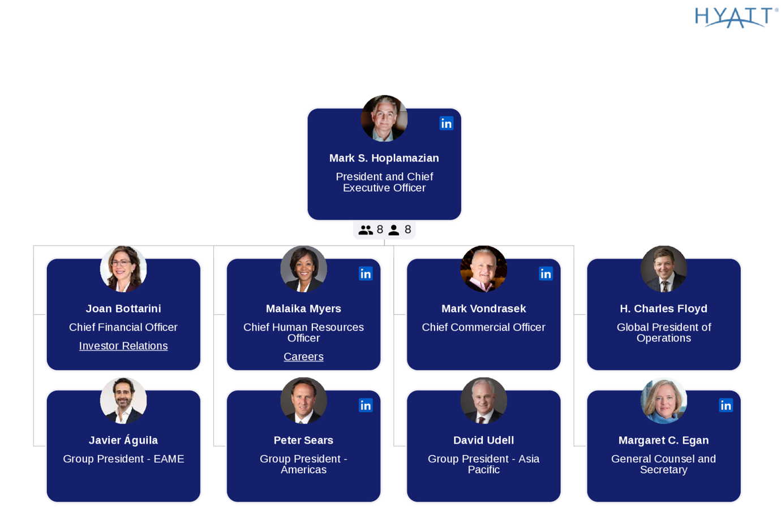

Organisational Structure, Culture, and Goals
Structure
Hyatt's corporate structure is defined by a centralised leadership approach combined with decentralised operations across regional markets. Recently, Hyatt implemented a major restructuring within its Americas division, providing local leaders with more decision-making autonomy. This shift enables regional managers to respond more quickly to local demands—a key factor in an industry where customer expectations vary significantly across regions (Business Wire, 2024). This structure aligns with Mintzberg’s Configurations theory, which suggests that decentralised models are advantageous in complex and dynamic environments, as they enhance responsiveness and operational flexibility (Organimi, 2022).
The decentralised framework also increases transparency within Hyatt, allowing regional managers to adjust strategies while remaining true to the company’s brand identity. With well-defined reporting structures, this approach promotes accountability and supports effective governance across all organisational tiers (Hyatt Investors, 2024). Furthermore, Hyatt’s regional model supports scalability, a crucial aspect for a global hospitality brand serving diverse markets. By balancing corporate oversight with local autonomy, Hyatt upholds consistent brand standards globally, while adapting to the distinct needs of each market (Hotel Business, 2024). This structure reinforces Hyatt’s customer-centred mission, bolstering its strategic resilience—a critical factor in maintaining a competitive edge within the hospitality industry.
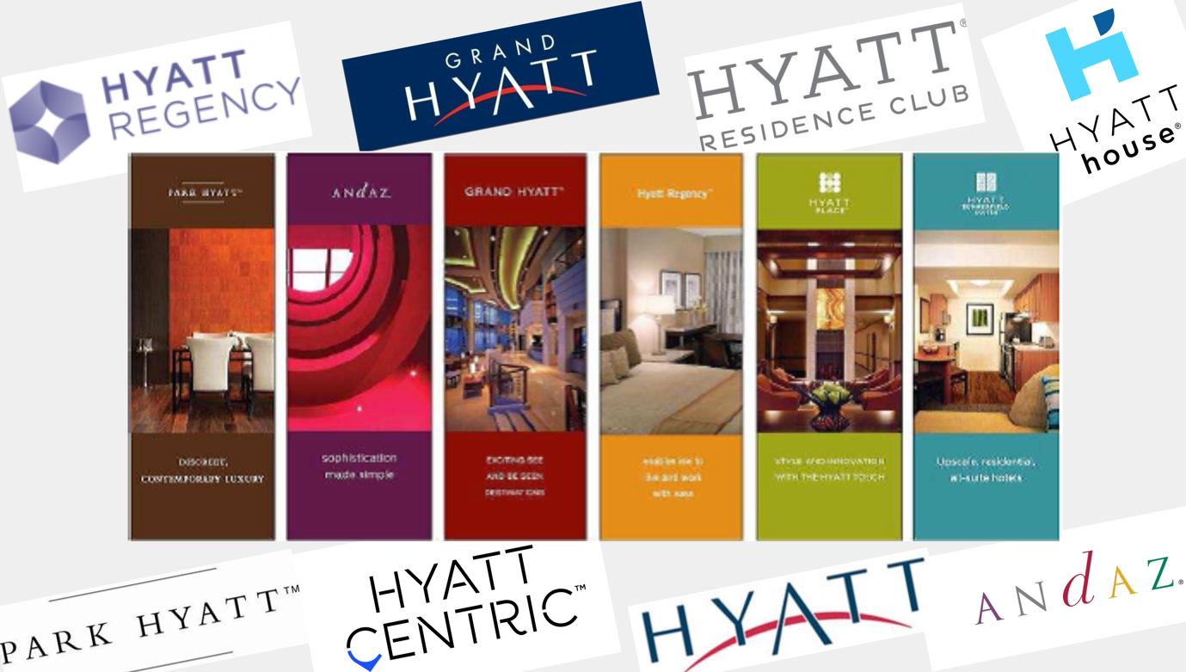
Culture
Hyatt’s “World of Care” initiative embodies the company’s commitment to creating an inclusive and supportive work environment. This program emphasises values like diversity, community involvement, and employee well-being, resonating with Hyatt’s workforce and enhancing employee satisfaction (Hyatt, 2024a). Studies in the hospitality sector indicate that companies with cultures centred on corporate social responsibility (CSR) enjoy higher employee loyalty, lower turnover, and increased guest satisfaction (Scribd, 2024). For Hyatt, this culture forms a core part of its business strategy, directly linking internal well-being with elevated service quality.
The initiative also aligns with broader industry trends that prioritise CSR—a crucial factor for today’s consumers, who increasingly value ethical, inclusive, and socially responsible brands (PMC, 2024). By embedding care and responsibility within its cultural framework, Hyatt effectively differentiates itself from competitors, attracting socially conscious customers and fostering client loyalty. This strategic cultural focus not only appeals to like-minded consumers but also strengthens Hyatt’s appeal as an employer, aiding in the recruitment and retention of top talent (Cram, 2024). Ultimately, “World of Care” provides Hyatt with both a cultural and strategic edge, reinforcing its brand identity as a value-driven organisation that prioritises the well-being of its employees and the communities it serves (TheOrg, 2024).
Goals
Hyatt’s strategic objectives at the corporate level focus on expanding market share by tapping into high-potential luxury and lifestyle segments, aiming to strengthen its competitive advantage. This focus is demonstrated by Hyatt’s recent acquisition of wellness-oriented brands, aligning with the growing demand for wellness-related tourism. This acquisition not only appeals to health-conscious travelers but also strengthens Hyatt’s presence in a rapidly expanding segment within the industry (Organimi, 2022). Each Hyatt property aligns its specific objectives with the broader corporate vision, supporting regional variation and flexibility while preserving Hyatt’s core brand values across all locations (Prezi, 2024).
This alignment between corporate and regional goals enhances Hyatt's adaptability, enabling it to meet diverse customer preferences by tailoring experiences to specific markets. For example, the World of Hyatt loyalty program incorporates region-specific benefits, which contribute to customer retention and build local loyalty (RocketReach, 2024). By balancing a unified corporate strategy with regional customisation, Hyatt maintains its brand integrity on a global scale while offering tailored experiences, solidifying its reputation as a responsive, customer-centred global hospitality leader (Hyatt, 2024a). This flexible approach is essential to sustaining Hyatt’s competitive advantage, enabling the brand to adapt to evolving industry trends and the expectations of a diverse client base.
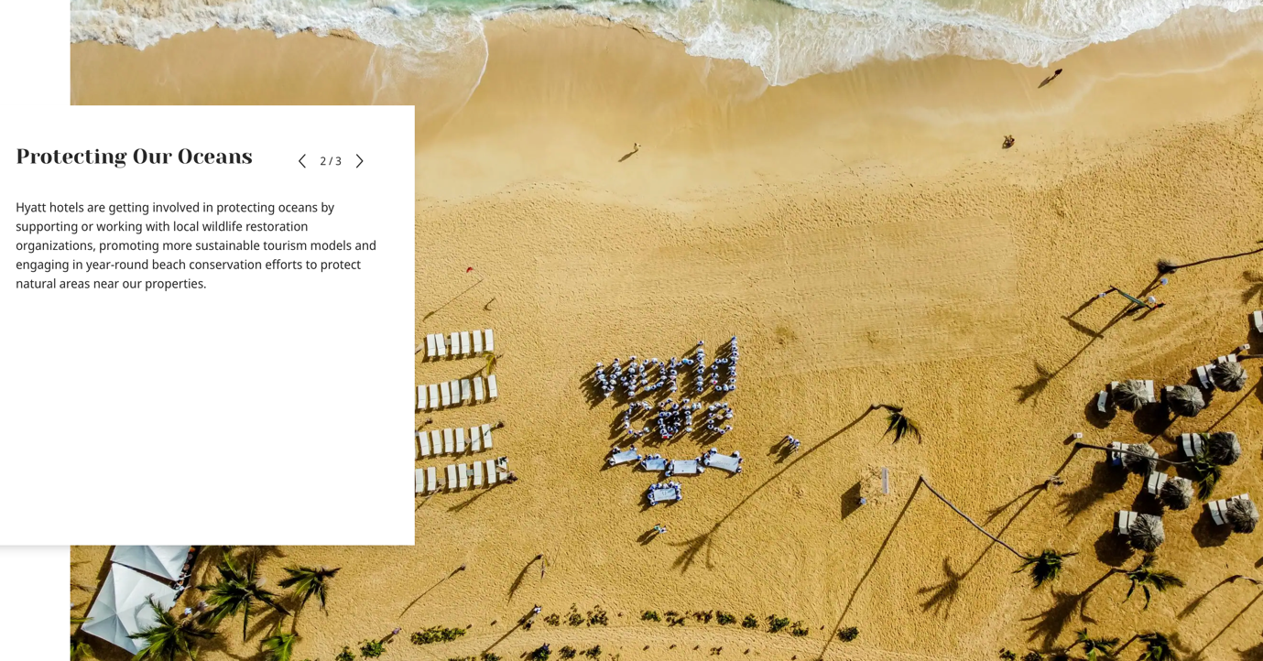

Recent Change Initiatives
Hyatt's recent restructuring within the Americas marks a substantial shift in its organisational strategy to enhance operational efficiency and service quality. This decentralisation grants regional managers increased authority to make decisions based on local needs, a critical factor in hospitality, where customer expectations can vary widely across regions (Business Wire, 2024). By empowering regional leaders, Hyatt better aligns its operations with local market demands, which is essential in an industry where the ability to cater to cultural and regional preferences often determines customer satisfaction (TheOrg, 2024). This restructuring reflects Kotter’s Change Management Model, emphasising the importance of employee engagement and empowerment during organisational transitions. By involving employees in these changes, Hyatt minimises resistance, fosters a supportive environment, and cultivates a culture of flexibility and responsiveness (PMC, 2024).
In addition to structural changes, Hyatt has prioritised digital transformation to remain competitive and meet changing customer expectations. Major investments in digital platforms have modernised Hyatt’s booking and customer interaction systems, simplified the reservation process and enhanced personalised service (Hyatt, 2024a). With these enhancements, Hyatt is better positioned to offer customised services, from room preferences to time-saving digital check-ins. Research suggests that integrating technology throughout the customer journey can significantly boost satisfaction and loyalty, as today’s tech-savvy travelers increasingly expect seamless digital interactions (RocketReach, 2024; Organimi, 2022).
Digital advancements in hospitality, particularly in booking and customer engagement, are now crucial for maintaining competitive advantage. By embracing these trends, Hyatt strengthens its brand image as an innovative company focused on guest convenience and experience. These initiatives also align Hyatt with industry trends, where digital innovation is linked to enhanced service efficiency and guest retention (Hotelier Magazine, 2024). This transformation supports Hyatt’s operational goals, as streamlined digital processes lead to more efficient resource use and improved service delivery.
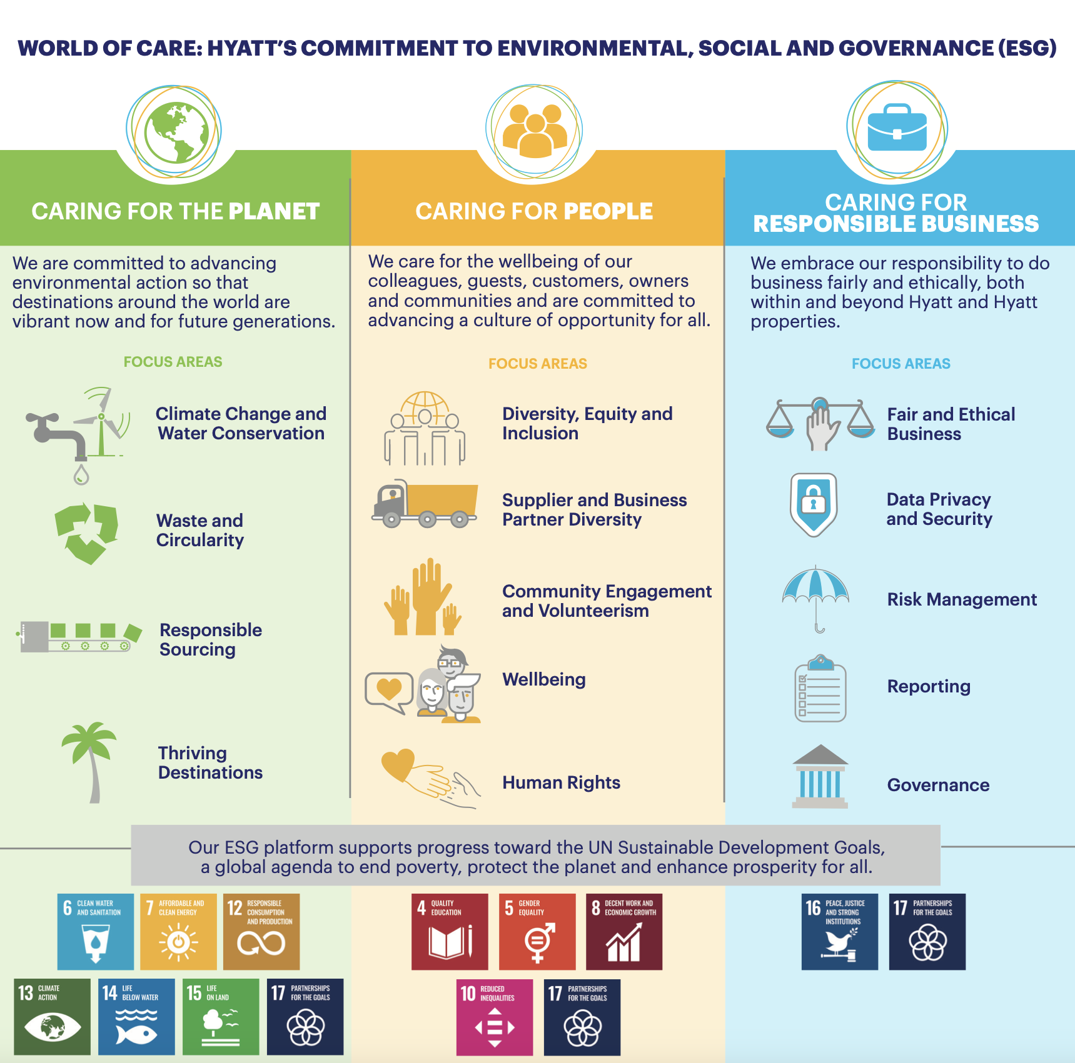
Alongside digital and organisational modifications, Hyatt's commitment to Environmental and Social Governance (ESG) has boosted its brand image, particularly among environmentally sensitive customers. Hyatt's ESG policies include trash minimisation, sustainable sourcing, and energy-efficient building designs, which appeal to the growing number of environmentally conscious travellers (PMC, 2024). Hyatt's eco-friendly activities reflect a proactive commitment to sustainability, coinciding with worldwide CSR trends (TheOrg, 2024). This commitment strengthens Hyatt's appeal to environmentally concerned travellers while also positioning the company as an ethically responsible brand, which is especially relevant in today's market when CSR policies affect consumer choices.
These strategies help Hyatt better address shifting market expectations. Hyatt increases visitor happiness and brand loyalty by combining structural flexibility, technology progress, and sustainable practices. This multidimensional approach guarantees that Hyatt not only responds to market trends, but also increases its competitive position, resulting in a brand image that appeals to modern travellers and socially responsible stakeholders (Hyatt Investors, 2024). As Hyatt continues to innovate and connect with industry trends, it is well-positioned to face future challenges and maintain its status as a hospitality leader.
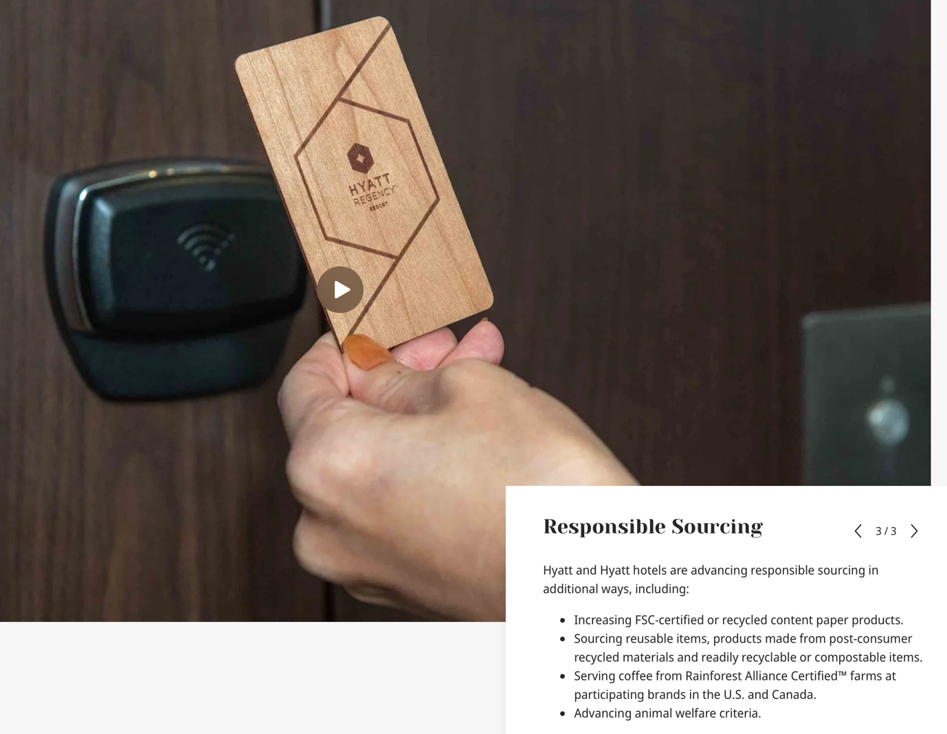

Strategic Direction
Hyatt's strategy orientation is based on its dedication to growth, client loyalty, and sustainability. The purchase of wellness businesses is a major component of Hyatt's growth strategy, as it diversifies its portfolio and broadens its appeal to health-conscious travellers who value wellbeing. By merging these companies, Hyatt enters the wellness tourism market, which has seen significant development as more travellers choose health-focused accommodations. Porter's Five Forces model emphasises the strategic importance of diversification, as expanding brand offerings can lower competition pressures and broaden customer attractiveness (Cram, 2024). Hyatt's acquisitions result in a comprehensive brand portfolio that connects with a varied market, boosting its competitive position.
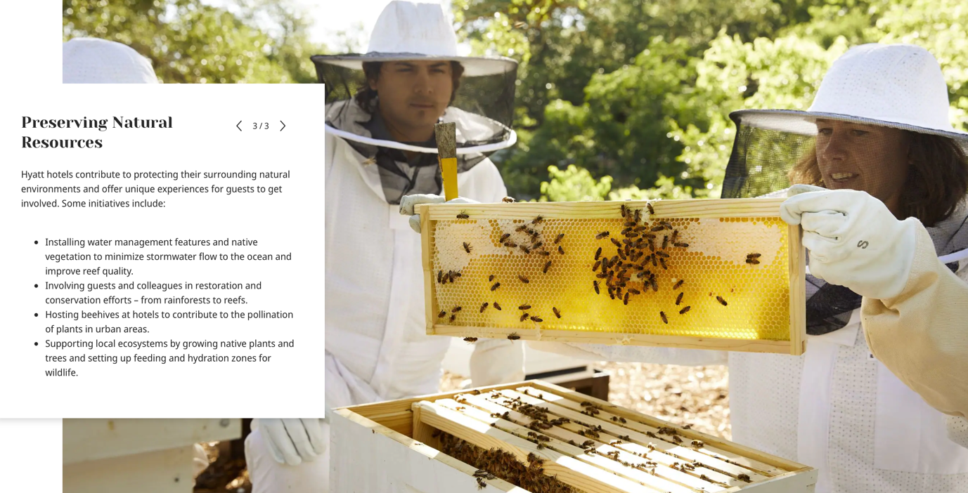
Customer loyalty is a further important aspect of Hyatt's strategic strategy, as seen by the World of Hyatt loyalty program. This program is deliberately designed to foster long-term relationships with customers by providing personalised rewards and perks that stimulate return visits (Hyatt, 2024a). This loyalty program, which aligns with Relationship Marketing philosophy and emphasises the significance of developing long-term customer ties, distinguishes Hyatt in the hospitality business, where demand for loyal clients is serious (Prezi, 2024). Loyalty initiatives such as the World of Hyatt not only improve guest retention but also increase each customer's lifetime value by instilling a deep emotional connection with the company.
Furthermore, Hyatt's focus on Environmental and Social Governance (ESG) indicates its dedication to sustainability, which is becoming increasingly crucial to modern consumers. Hyatt's ESG initiatives include eco-friendly architectural designs, waste reduction methods, and sustainable material procurement, all of which appeal to the expanding demographic of environmentally concerned travellers (PMC, 2024). By aligning its operations with sustainability trends, Hyatt improves its reputation among guests and stakeholders that respect environmental responsibility, bolstering its competitive advantage as an ethical brand. According to research, organisations that prioritise ESG not only boost consumer loyalty but also attract socially responsible investors, which strengthens Hyatt's market position (Hyatt, 2024b).
Hyatt's commitment to progress, loyalty, and sustainability distinguishes it in the challenging hospitality industry. Hyatt creates a brand identity that resonates with modern travellers by continuously growing its brand portfolio, establishing customer relationships through loyalty programs, and implementing sustainable practices. This integrated approach allows Hyatt to respond to changing consumer tastes while strengthening its reputation as a creative and socially responsible hospitality leader.
Finally, Hyatt's strategy orientation is consistent with contemporary industry trends, which prioritise personalisation, wellness, and environmental responsibility. By diversifying its portfolio and committing to customer-centric initiatives, Hyatt guarantees that its brand remains relevant and appealing to a wide spectrum of travellers. The mix of growth-oriented acquisitions, loyalty-focused programs, and sustainable practices enables Hyatt to maintain its competitive advantage, resulting in a unified and resilient strategy that is well-suited to the needs of the modern hospitality market.
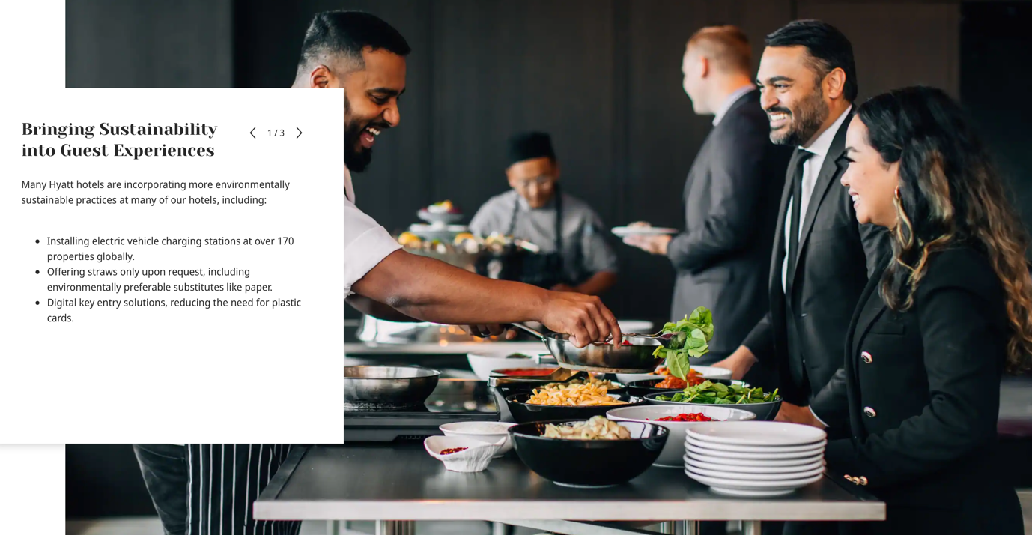

Recommendations
Enhanced Digital Integration
To fulfil the growing demand for seamless, technologically enhanced experiences, Hyatt should prioritise strengthening its digital capabilities. Integrating AI-powered customer assistance with mobile check-ins will simplify operations and increase customer satisfaction by providing convenience and personalisation (Cram, 2024). According to research, hotels that employ advanced digital solutions experience higher efficiency and visitor loyalty because these tools allow staff to focus more on personalised encounters (Hotelier Magazine, 2024). Enhanced digital integration would not only bring Hyatt in line with contemporary hospitality trends but would also cement the brand's reputation as forward-thinking.
Strengthening Employee Development Programs
Investing in courses on leadership development for district managers can help Hyatt's teams respond rapidly to market changes while maintaining service consistency. Focused training in areas such as flexibility and customer-centric service delivery would help managers address specific regional demands while upholding Hyatt's commitment of high-quality service (Organimi, 2022). Improved leadership development would result in a competent workforce that shares the company's values, ultimately increasing employee happiness and retention (RocketReach, 2024).

Expanding Sustainable Practices
To demonstrate its dedication to sustainability, Hyatt might implement more aggressive eco-friendly efforts, such as renewable energy and zero-waste programs. ESG studies demonstrate that hotels that prioritise sustainable practices have higher brand loyalty, particularly among eco-conscious travellers (PMC, 2024). By prioritising good environmental standards, Hyatt can position itself as a socially responsible choice in the hospitality business, appealing to both customers and stakeholders (TheOrg, 2024).
Localising Marketing Strategies
With a decentralised structure, Hyatt may magnify localised marketing techniques that align with regional norms and tastes. Tailoring ads to local cultures can boost customer loyalty and relevance in a wide range of markets, especially in emerging economies where cultural alignment has a big impact on brand perception (Hyatt, 2024b). Localised marketing might provide Hyatt a competitive advantage by strengthening its agility and increasing brand loyalty across geographies.

Conclusion
This research provides a comprehensive examination of Hyatt's organisational structure, culture, goals, recent efforts, and strategic orientation, emphasising the variables that lead to the company's market performance. Hyatt engages with industry trends that value adaptability, corporate responsibility, and client-centred service by creating a decentralised approach, cultivating a caring culture, and focussing on customer loyalty. Hyatt's proactive commitment to fulfilling shifting market demands, as evidenced by initiatives such as the World of Hyatt reward program and recent wellness acquisitions, positions the company favourably in the competitive hospitality industry.
The proposals, including as digital integration, increased employee training, increasing sustainable practices, and localised marketing, all contribute to Hyatt's strategic goals. Implementing these activities can strengthen Hyatt's competitive position by matching its operations more closely with customer expectations and current trends. These best-practice ideas would help Hyatt increase its resilience and adaptability in a constantly shifting market environment.
Hyatt's unique ability to mix global brand consistency with regional responsiveness has made it a trusted brand in a wide range of regions throughout the world. Its emphasis on employee well-being, community involvement, and environmental stewardship appeals to both employees and customers, fostering brand loyalty and enhancing business reputation. Finally, Hyatt's commitment to innovation, sustainability, and customer loyalty distinguishes it as a forward-thinking hospitality industry leader, ready to satisfy the changing requirements of both travellers and stakeholders. This agility ensures Hyatt's continued success and relevance in a dynamic global market.

References List:
Business Wire, 2024. Hyatt Announces New Americas Organisational Structure and Senior Leadership Appointments. [online] Available at: https://www.businesswire.com/news/home/20240219984830/en/Hyatt-Announces-New-Americas-Organisational-Structure-and-Senior-Leadership-Appointments .
Cram, 2024. Hyatt Hotel Management Structure. [online] Available at: https://www.cram.com/essay/Hyatt-Hotel-Management-Structure/FJYKHL89PU .
Hotel Business, 2024. Hyatt reveals new Americas organisational structure. [online] Available at: https://hotelbusiness.com/hyatt-reveals-new-americas-organisational-structure/ .
Hotelier Magazine, 2024. Hyatt reveals new Americas organisation structure and appointments. [online] Available at: https://www.hoteliermagasine.com/hyatt-reveals-new-americas-organization-structure-and-appointments/ .
Hyatt, 2024a. World of Care: Culture. [online] Available at: https://about.hyatt.com/en/world-of-care/caring-for-people/culture.html .
Hyatt, 2024b. Environmental and Social Governance. [online] Available at: https://about.hyatt.com/en/world-of-care/environmental-sustainability.html.
Hyatt, 2024c. Hyatt Announces Expansion of Wellness Offerings. [online] Available at: https://newsroom.hyatt.com/2024-wellness-expansion.
Hyatt Investors, 2024. Executive Management. [online] Available at: https://investors.hyatt.com/governance/executive-management/default.aspx .
Organimi, 2022. Hyatt Hotels Corporation Organisational Structure. [online] Available at: https://www.organimi.com/organisational-structures/hyatt-hotels/ .
PMC, 2024. Sustainable Practices in Hospitality. [online] Available at: https://pmc.ncbi.nlm.nih.gov/articles/PMC9242457/ .
Prezi, 2024. Hyatt Hotels: Strategy and Organisational Structure. [online] Available at: https://prezi.com/gc3esg8fm9rw/hyatt-hotels-organization-structure/ .
RocketReach, 2024. Hyatt Hotels Corporation Management. [online] Available at: https://rocketreach.co/hyatt-hotels-corporation-management_b5c54562f42e0e03 .
Scribd, 2024. Hyatt Assignment. [online] Available at: https://www.scribd.com/document/576048709/Hyatt-Assignment.
TheOrg, 2024. Hyatt Hotels Corporation. [online] Available at: https://theorg.com/org/hyatt .
World Travel & Tourism Council, 2023. Global Trends in Wellness Tourism. [online] Available at: https://wttc.org/research/trends/wellness-tourism.
Smith Travel Research, 2024. 2024 Hospitality Industry Trends. [online] Available at: https://str.com/research/hospitality-2024.
Forbes, 2023. Hyatt’s Growth Strategy in Luxury and Wellness Sectors. [online] Available at: https://www.forbes.com/sites/hyatt-growth-strategy/.
Harvard Business Review, 2023. The Importance of CSR in Hospitality. [online] Available at: https://hbr.org/importance-of-csr-in-hospitality .
Hospitality Net, 2024. Digital Transformation in Hospitality: Hyatt's Journey. [online] Available at: https://www.hospitalitynet.org/news/digital-transformation-hyatt.
J.D. Power, 2023. Customer Satisfaction in the Hospitality Industry. [online] Available at: https://www.jdpower.com/hospitality-customer-satisfaction.

