UNIVERSITY OF WALES
TRINITY SAINT DAVID
BA BUSINESS MANAGEMENT

Name : George Eduard Vodislav

Student ID : 1917506
Module Title : MANAGEMENT ACCOUNTING
Assignment Title: MANAGEMENT ACCOUNTING – ASSESSMENT 1
Module Lecturer’s Name : Widin Bongasu Sha’Ven

Table of Contents
Introduction 3
Discussion 3
Cost Types and Structure 3
Impact of Fixed and Variable Cost 4
Cost management strategy in Covid-19 7
Conclusion 9
Reference List 10
Appendix 11
Appendix 1: Cost Management Process 11

Introduction
Hotel industry in the global market has attained financial downfall due to the lockdown situation established in Covid-19 pandemic. In this scenario, cost management has become a prior activity for the manager of Harriot Hotel as a fragment of this industry. Hence, effective cost cutting strategy will be designed further based on evidence of revenue and expenses attained by this hotel. NI (Net Income) theory ad agency theory of problem-solving is being demonstrated to align with the cost management design for this hotel to sustain in this pandemic situation.
Thesis statement of this study is that a reactionary cost management system is effective for processing rational cut expenditure system by improving efficiency and increasing business value.

Discussion

Cost Types and Structure
Net Income (NI) Theory
Total Debt | 48,000
Total Equity | 12,000
Capital Structure | 25.00%
Table 1: NI theory
(Source: MS Excel)
Cost cutting management in Harriot Hotel will be processed based on the service cost structure acknowledging this pandemic situation. As defined by Zhao (2018), theory of NI indicates optimum range of equity is essential for generating high profit in a crisis situation. In this situation it is observable that the debt range of this hotel can be depreciated by 25% range based on its low equity value. On the contrary, reduction of expenses based on customer cost structure would have been profitable for this company to depreciate financial expenditure based on fixed costs. As indicated by Tsionas (2020), reduction of fixed cost in hotel industry results in the downfall of performance level in a market. Application of service cost reduction will be managed through business value driven strategy of “value optimisation”. Thus, it can be determined that following this theory Harriot Hotel will be able to gain high performance level in this pandemic situation.
John D. Brockville established this hotel in 1941 that has been growing steadily in Africa, Asia, Europe and Americas. In the views of Rueda-López et al. (2021), application of cost reduction in “product-line cost structure” in pandemic situation is effective for coursing “short-term reductions, programmatic cost optimisation through ongoing value optimisation. However, Harriot Hotel requires prioritize and plan business outcomes in global market by maintaining or rather improving its business value. In this situation, incorporation of cost reduction method in service cost structure of this hotel will be profitable for the manager to sustain efficiency in the global market. As assessed by Filimonau et al. (2020), renegotiating “cut expenditure” method in product cost structure of hotel industry generates feasible performance range enhancement. Nevertheless, this approach generates high operational expenses that are unpredictable for a manager. Therefore, it can be highlighted that cost reduction in service cost structure of Harriot Hotel will be financially profitable addressing this pandemic situation.

Impact of Fixed and Variable Cost
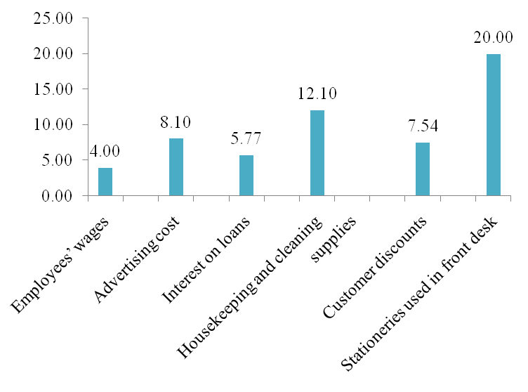
Figure 1: Risk-Reduction ROI
(Source: MS Excel)
In the previous discussion, it has been indicated that rationalised cost cutting method will be implied for Hotel Harriot to gain maximum profit in this pandemic situation. As defined by Anguera-Torrell et al. (2020), rationalised system of cutting cost implies deduction procedure for fixed and variable cost of an organisation based on hotel industry. Fixed cost involves “interest expenses, taxes, property, insurance, salaries, ad rental lease payments” of this hotel. On the contrary, variable costs of this hotel include “utility costs, raw materials’ cost, cost of direct labour, and sales commission”. As indicated by Japutra and Situmorang (2021), acknowledging “structured spend optimisation” method is quintessential for a manager in hotel industry to gain effective business outcomes. In this situation, pandemic outbreak has deteriorated customer base level for Harriot Hotel that needs to be compromised through the implication of effective cost reduction method. Thus, it can be determined that effective Risk-reduction ROI (Return on Investment) method will be feasible for attaining reduction in expenses.
Item (£m) | Value | As a percentage of revenue | Reduction in Risk | Cost of Control | Risk-Reduction ROI
Revenue | 60,000
Employees’ wages | 15,000 | 25% | 15000 | 1.00 | 4.00
Advertising cost | 7,000 | 12% | 7200 | 0.97 | 8.10
Interest on loans | 10,000 | 17% | 10200 | 0.98 | 5.77
Housekeeping and cleaning | 5,000 | 8.30% | 4980 | 1.00 | 12.10
supplies
Customer discounts | 8,000 | 13.30% | 7980 | 1.00 | 7.54
Stationeries used in front desk | 3,000 | 5% | 3000 | 1.00 | 20.00
and restaurants
Table 2: Risk-Reduction
(Source: MS Excel)
Anticipated outcomes of risk-reduction ROI has been displayed above to be 5.77% for interest on loans and 12.10% for Housekeeping and cleaning supplies. In the views of Yu et al. (2021), deduction in service cost structure can be determined as an effective step for hotel industry to gain high profit through service-based expense reduction. Implication of cost reduction method in these two services of Harriot Hotel will allow the manager to avoid discrepancies with employees regarding their wages. This process will be beneficial for this hotel to avoid job-role termination process for gaining profit in this pandemic situation that has been implied by maximum fragments of hospitality industry. However, decreasing these service costs will affect customer perception towards this hotel. As assessed by Hao et al. (2020), influencing the buying behaviour of customer is possible for hotel industry through the provision of “high quality services” in the global market. Nonetheless, in this situation, Hotel Harriot will be managing its customer service enhancement process after the termination of lockdown period through innovation. Therefore, it can be highlighted that effective measures for cost cutting in service cost structure of this hotel will be decreasing its variable costs and avoid elimination of any other costs.

Cost management strategy in Covid-19
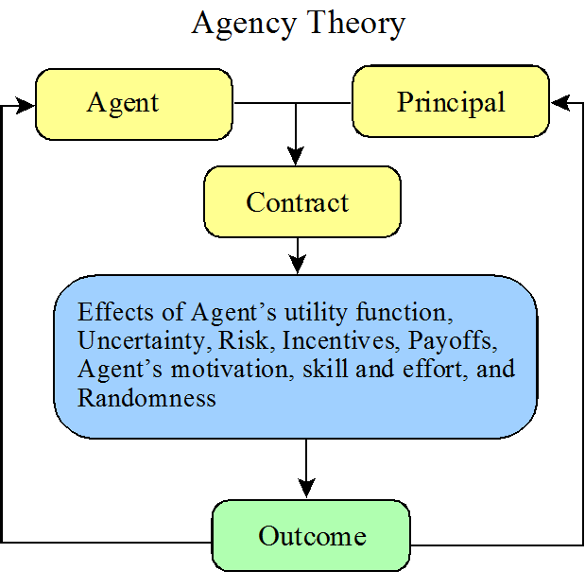
Figure 2: Agency Theory
(Source: Self-created)
Practically cost management strategy applied by Harriot Hotel will be based on depreciation of its variable costs as demonstrated previously by its newly appointed manager. As defined by Parker et al. (2018), agency theory determines an organisation to employ an agent of cost reduction by developing contracts regarding principal based on maintaining brand image for gaining valid outcomes. Manager of this hotel has been appointed as the agent to reduce expenses through strategic cost deduction process. This operation has been defined earlier to be utilising a rationalised process for avoiding the reduction of payoffs and incentives of employees. On the contrary, this theory emphasises on the management of cost through the involvement of expense reduction in these elements. Avoiding these criteria will be elevating risk in long-term operations of this hotel in the global market. As indicated by Rueda-López et al. (2021), in this pandemic situation uncertainty of economic policies is a significant risk for hotel industry to experience critical downfall of financial context. Thus, it can be determined that cost reduction in service based cost structure has a possibility of reducing profit income for Hotel Harriot to question its sustainability in the international market.
Rational Cost Cutting | Before NI | After NI
Employees’ wages | 15,000 | 11,250
Advertising cost | 7,000 | 5,250
Interest on loans | 10,000 | 7,500
Housekeeping and cleaning | 5,000 | 3,750
supplies
Customer discounts | 8,000 | 6,000
Stationeries used in front desk | 3,000 | 2,250
and restaurants
Efficiency Ratio | 133.33%
Table 3: Rational Cost Cutting Output
(Source: MS Excel)
It is observable in the above table that high efficiency range can be obtained through the incorporation of product line cost structure. In the views of Filimonau et al. (2020), depreciation of variable and fixed cost range of hotel industry becomes possible through the application of cost reduction in product line structure. Hence, depreciation in all the factors of Hotel Harriot has been conducted above to gain an efficiency range of 133.33% in the global market. However, cost reduction strategy has been maintained to be rationalised as discussed earlier [Refer to Appendix 1]. This process will be highly profitable for this hotel to sustain in the market after pandemic situation. Maintaining suitable employee motivation range as the value of this hotel will be possible through the reduction of employee wages by nominal range as denoted above. As assessed by Anguera-Torrell et al. (2020), through the provision of sufficient wages to workers retailing sustainable employee motivation level becomes possible for a manager in hotel industry after pandemic. In this scenario, the manager of Hotel Harriot will be able to channel motivation without any constriction due to avoidance of job termination process. Therefore, it can be highlighted that this cost management process based o product line structure will be feasible for Harriot Hotel for maintaining its business value in this pandemic situation.

Conclusion
Cost management through rationalised strategy has been determined for Hotel Harriot to gain maximum profit in 2021 for pandemic outbreak. Reduction of cost in service structure of this hotel had been determined to be feasible based on NI theory of capital structure. However, this strategy did not generate optimum benefits for this hotel to sustain in the long-run. In this scenario, agency theory determined an effective solution to imply cost reduction in product line structure due to low risk rate. Implication of rationalised cost reduction method has been generating substantial efficiency ratio for this hotel to sustain with high employee performance for maintaining business value.
Therefore, thesis statement of this study stating that a reactionary cost management system is effective for processing rational cut expenditure system by improving efficiency and increasing business value has been met.

Reference List
Anguera-Torrell, O., Aznar-Alarcón, J.P. and Vives-Perez, J., 2020. COVID-19: hotel industry response to the pandemic evolution and to the public sector economic measures. Tourism Recreation Research, pp.1-10.
Filimonau, V., Derqui, B. and Matute, J., 2020. The COVID-19 pandemic and organisational commitment of senior hotel managers. International Journal of Hospitality Management, 91, p.102659.
Hao, F., Xiao, Q. and Chon, K., 2020. COVID-19 and China’s hotel industry: Impacts, a disaster management framework, and post-pandemic agenda. International journal of hospitality management, 90, p.102636.
Japutra, A. and Situmorang, R., 2021. The repercussions and challenges of COVID-19 in the hotel industry: Potential strategies from a case study of Indonesia. International Journal of Hospitality Management, p.102890.
Parker, D.W., Dressel, U., Chevers, D. and Zeppetella, L., 2018. Agency theory perspective: International development project. International Journal of Productivity and Performance Management (pp. 55-67). Springer: Dordrecht.
Rueda-López, R., López-Felipe, T., Navajas-Romero, V. and Menor-Campos, A., 2021. Lessons from the First Wave of COVID-19. What Security Measures Do Women and Men Require from the Hotel Industry to Protect against the Pandemic?. International Journal of Environmental Research and Public Health, 18(5), p.2232.
Tsionas, M.G., 2020. COVID-19 and gradual adjustment in the tourism, hospitality, and related industries. Tourism Economics, p.1354816620933039.
Yu, J., Seo, J. and Hyun, S.S., 2021. Perceived hygiene attributes in the hotel industry: customer retention amid the COVID-19 crisis. International Journal of Hospitality Management, 93, p.102768.
Zhao, L., 2018. Literature review of capital structure theory and influencing factors. Modern Economy, 9(10), p.1644.

Appendix

Appendix 1: Cost Management Process
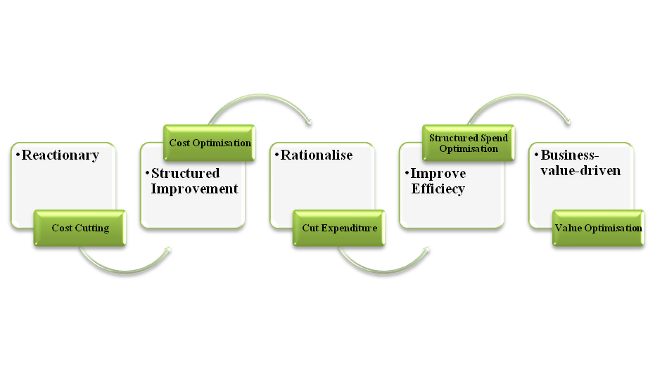
(Source: Self-created)

