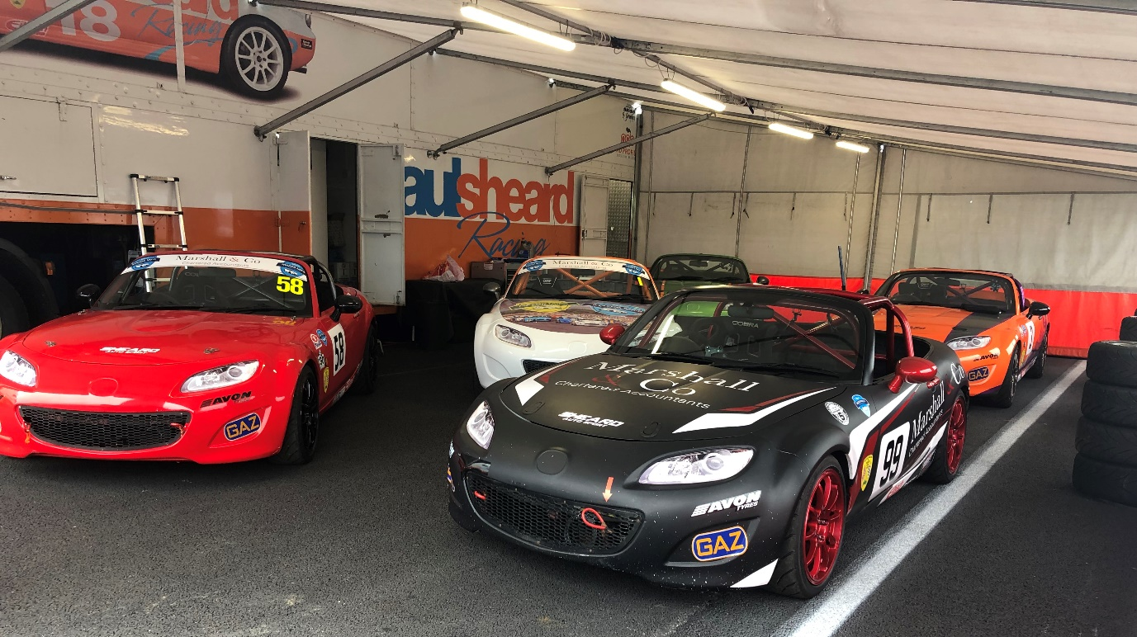
Figure 1- Mazda Mk3 MX-5 race car which the report focuses around. (Marshall, 2019)

Seminar
M6X02206

Toby Marshall (1702695)

Contents
Abstract 1
Introduction 1
Bump Steer 2
Independent Multi-Link Suspension 2
Method 4
Bumpsteer 4
Measuring for Computer Aided Engineering 5
Validation of CAE 5
Track Testing for Validation 6
Conclusion 6

Figure 1 The skeleton view of the Mercedes linkage in perspective requirements the corresponding front and side view and plan to be fully understood. (Bastow, et al., 2204) 3
Figure 2-Bump/steer gauge, As upright rises/falls (using jack under suspension after removal of spring/damper unit) plate will indicate on dial gauge whether to in/out is occurring and magnitude of change in series of steps from maximum bump to maximum droop (Staniforth, 2006) 5

Abstract
Circuit race cars desire to travel as fast as possible round a race circuit. To achieve this a race car must optimize its suspension geometry. If errors are present in the suspension geometry, then a race car will not be able to travel as fast round the race circuit and have tenancies to be difficult to control through cornering. A measurement can be taken from a race cars suspension to evaluate whether errors are present. Bumpsteer can be developed aided by using computer software, the computer software can produce solutions to improve steering errors. These solutions can be used to improve the race car’s suspension geometry, this ultimately allows the race car to travel faster round a race circuit.
Steering and suspension system has to be designed and optimized properly to achieve good performance handling characteristics. Flaws in design will result in steering errors such as bumpsteer and roll steer (Kulkarni, et al., 2016). Through experiments, measurements and CAE analysis a regression model of toe angle displacement during wheel travel is obtained (Suh, et al., 2000). Track test will be used to evaluate and review if changes made to the suspension geometry have made a positive impact on the vehicle’s handling performance (Santos, 2014).

Introduction
The focus of the paper is to understand how multi-link system induces bumpsteer, and the optimization of suspension geometry to reduce bumpsteer. Suspension geometry has a substantial role in the stability and control of a vehicle (Upadhyay, et al., 2008). Handling performance relies on the configuration of the vehicle kinematic characteristics; toe angle, camber and caster (Suh, et al., 2000). The paper will look mainly into toe angle and its relationship with bumpsteer relative to the vehicle handling and stability.
In particular a Mazda Mk3 MX-5 rear suspension has been chosen to subject of investigation and optimization. Mk3 MX-5’s is a popular vehicle for circuit racing with various national race championship including United kingdom based Supercup (BRSCC, 2019), and American series (Spec MX-5 Challenge, 2019). The popular use of the vehicle for track use means for an importance of optimizing the handling of the vehicle in particular the rear suspension geometry. The rear suspension geometry can benefit from optimization for the benefit of performance handling and control of the vehicle (Upadhyay, et al., 2008). Evidence of the Mk3 MX-5 requiring optimization of the rear suspension particularly bumpsteer has been expressed by Glenn Long of Long Road Racing.
The paper will look at how bumpsteer can be measured statically to gain an understanding of the suspension geometry, a CAE (computer aided engineering) package will allow for deeper analyses of the suspension geometry. CAE is essential for dynamically investigation the integration and development of a suspension layout with the need for producing multiple prototypes (Bastow, et al., 2204). Wingeo3 will be utilized in the process of optimizing the suspension design to reduce bumpsteer (Sharma, et al., 2015). Other CAE packages available include ADAMS, SolidWorks and DADS these can be used to optimize the suspension geometry. These packages may be used as supporting models, however Wingeo will produce the main model due to its main application specializing in motorsport suspension geometry. (Upadhyay, et al., 2008) (Suh, et al., 2000) (Bastow, et al., 2204) (Mohan, et al., 2008)

Bump Steer
Bumpsteer is a relative measurement, not an absolute or liner measurement. Rodger Sharpio explains ‘we are not interested in how much there is but interested in making it go away (Smith, 1984). This supports the fact that the main focus of bumpsteer is reducing it as much as possible through suspension geometry optimization. The measurement of bumpsteer is key when completing an investigation of suspension geometry, as the measurement allows for a comparison and evaluation of improvements. This allows the percentage change of parameters and their influence on vehicle behavior to be evaluated throughout the investigation, also highlighting most desirable solution when multiple solutions are used to gain a similar result of suspension geometry and bumpsteer. All these parameters can be used with the measurement of bumpsteer to evaluate its reduction through suspension geometry optimization. (Upadhyay, et al., 2008)
Bumpsteer is a steering error caused by the ride of the vehicle and the movement of the suspension through its travel. As the wheels move through bump and rebound, the wheels with out driver input creating toe in or toe out (Upadhyay, et al., 2008) (Kulkarni, et al., 2016). Toe angles are normally viewed from above, it is determined as a measurement of the movement of a wheel from the centerline of a vehicle across a single axle. Toe-in occurs when the wheel points inwards to the centerline of the vehicle, similarly toe-out occurs when the wheel points outwards away from the centerline of the vehicle (Mavrigian, 2000). Keeping wheel alignment constant through a vehicle motion is key for providing better handling performances particularly during high-speed cornering (Suh, et al., 2000) (Kulkarni, et al., 2016). The movement of the wheel through bump and rebound is when bumpsteer occurs, this is a result of the toe arm or toe controlling suspension link changing its angle. The angle change of the toe arm will either extend or reduce the distance from the chassis to the hub relative to the suspension arms, this creates the variation of toe through bump and rebound (Upadhyay, et al., 2008). A toe arms angle change can be optimized to reduce bumpsteer, this is achieved by optimizing its position to be perpendicular to the chassis with a matching movement of liner motion with the suspension arm between the hub and chassis. (Biswal, et al., 2017)

Independent Multi-Link Suspension
Multi-Link rear suspension has been used on production cars since 1980’s with Mercedes Benz being one of the first companies to implement it. Multi-link allows for ‘total flexibility of static geometry and geometry changes with vertical travel, longitudinal compliance without adverse effects on wheel geometry changes’ (Bastow, et al., 2204) these advantages demonstrate why manufactures have chosen the design on many of their production car. The particular example for this investigation is the Mazda Mk3 MX-5.
The multi-link system comprises of 5 links mounted to the chassis or sub-frame at one side, with the other end of the link mounting to the hub. The multi-link design forms tow triangles when viewed from above with the addition of a stabilizer/ toe arm which forms the fifth link. Flexibility in the ball joints and bushes allow for some fore and aft movement. The compression of the front arm with the tension of the rear link induces a toe-in wheel action which is not desirable as this is a form of bumpsteer. However, with the mounting points of links this toe-in can be reduced by a opposite effect, if the placement of the apices of the triangles are placed outwards from the middle of the contact patch it will produce a toe-out wheel motion.
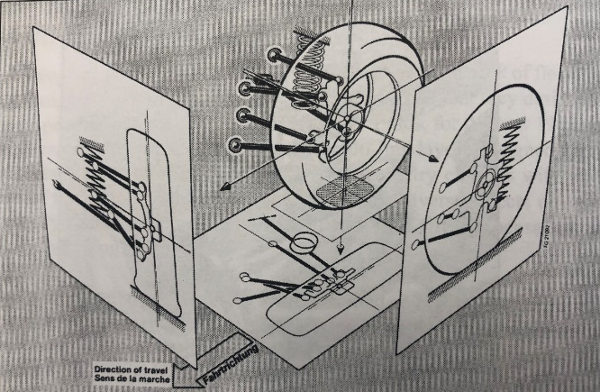
Figure 2 The skeleton view of the Mercedes linkage in perspective requirements the corresponding front and side view and plan to be fully understood. (Bastow, et al., 2204)
Consideration of the apex points of the links at the chassis, hub and link length can be evaluated so the tow tendencies cancel each other out to achieve a suspension geometry with minimal steering deflection through the wheels travel. This is aided by the fifth link; however fore and aft compliance must still be obtained to eliminate/minimize steering deflection which includes bumpsteer. (Bastow, et al., 2204)
Multi-link is a popular application with race cars as there is no swing arm effect, therefore the wheels will lean with the vehicle roll. This allows the wheel to move independently with no external influence on camber change through compression, this means constant camber is present through the wheel travel which can be set to optimize the tire contact patch with the track surface when corning. (Bastow, et al., 2204)
‘Incorrect relative lengths of the instantaneous radii of suspension and steering linages, incorrect relative heights of the ends of the tow effective radii’ are described in (Bastow, et al., 2204) as the cause of steering geometry errors, bump and rebound. A Mk3 MX-5 race car has an altered suspension geometry from factory including toe, camber and ride height. These changes mean the ‘cancel out tendencies’ of multi-link are altered creating a variation in the steering deflection. This variation will allow bumpsteer to become more prominent, the aim being addressed in this investigation is how bumpsteer can be reduced, this is why the optimization of the suspension geometry for a Mk3 MX-5 is key for improving the vehicle’s handling performances in particular high-speed cornering (Suh, et al., 2000) (Bastow, et al., 2204).

Method

Bumpsteer
For investigating optimization of multi-link suspension by reducing bumpsteer many processes must be followed to gain data and validation during the investigation. Measuring bumpsteer; the vehicle will be placed on a measuring flatbed to allow for accurate measurements avoiding inconsistences of data caused by measurements made on an uneven floor. A plate is attached to the wheel or the wheel is removed and a plate and bolted to the hub. The vehicle should be raised 60-80mm above its ride height so bump and rebound can be measured through the suspensions full travel. The vehicle will be set up to its race set up of toe and camber before any measures are taken. The spring/shock absorber must be removed this allows the wheel to move in its full travel freely. A stand should be placed with a DTI (dial test indicator) gauge which is placed against the plate and zeroed, this experiment set up in shown in figure 3 shown below. Using a jack, the wheel should be moved through its travel in equal increments, at each increment the measurement of the DTI should be recorded (Smith, 1984) (Staniforth, 2006). Once the measurement has been recorded a graph will be plotted showing wheel travel against toe movement, this creates a bumpsteer graph. The graph can then be used to evaluate improvements and show certain area where research should be focused because of the prominent presents of bumpsteer. (Mohan, et al., 2008)
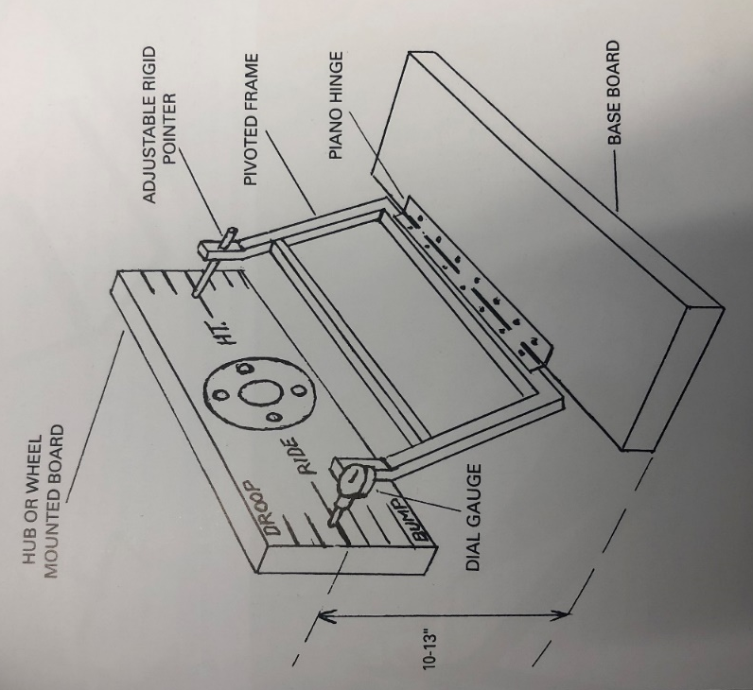
Figure 3-Bump/steer gauge, As upright rises/falls (using jack under suspension after removal of spring/damper unit) plate will indicate on dial gauge whether to in/out is occurring and magnitude of change in series of steps from maximum bump to maximum droop (Staniforth, 2006)

Measuring for Computer Aided Engineering
Measuring for computer models to evaluate suspension geometry will be conducted using certain parameters to improve validation. The XYZ points of the hub and suspension points will be measured from the centerline of the vehicle. The points will be measured using a measuring flatbed and calibrated measuring equipment; rulers, measuring squares, height gauge and measuring calipers. These points will then be recorded so a computer model of the suspension geometry can be created using Wingeo predominantly (Sharma, et al., 2015). CAE will be used to investigate the bumpsteer measured, CAE allows for fast and easily changes to the suspension geometry to draw improvements and conclusions (Bastow, et al., 2204). CAE is fathered other track teasing for development as track testing is highly subjective and expensive method of research and testing. (Oral, et al., 2004)

Validation of CAE
Once proposed improvements have been conclude using CAE a prototype/improvement will be implemented to the vehicle suspension geometry. Once an improvement/change has been made, a bumpsteer graph will be generated using the same process used when measuring bumpsteer at the start of the investigation. The new bumpsteer graph will be used as a comparison against the first graph produced in the investigation to evaluate the change/improvement of bumpsteer.

Track Testing for Validation
Once a conclusion of optimizing the suspension geometry has been draw using the measuring flatbed and CAE. Track testing will further validate the changes of geometry. A Mk3 Mx-5 race will be used at a racetrack for testing. The race car will be driven by the same driver and have the set up throughout testing. A test plan will be implemented for the testing this will consist of a baseline data collected. Baseline data will be collected from the driver and base set up of the car. Once data is collected for the baseline then changes to the geometry will be made and data collected from the laps. It is imperative for the car to record data from its baseline set up throughout the day of testing between changes. This allows for an evaluation of the data against track changing condition through out the day of testing. This allows for irregularities in track conditions not to affect the data obtained (Santos, 2014). A data logger will be used throughout all testing to record vehicle behavior and lap times. Driver feedback will be recorded through out testing to cross reference against data to gain a better understanding of how a change has altered the vehicle’s handling. Testing will gain results to directly address one of the projects aims ‘Investigate how the reduction/control of bumpsteer effects a race car’s handling and lap times.

Conclusion
The report has been used to discuss to a reasonable depth the process needed to explore and address the project aims. The report has talked about how multi-link suspension can induce bumpsteer when geometry characteristics are altered and how design and layout of multi-link changes its relationship with bumpsteer. In the report the method of how bumpsteer can be altered/controlled and measured has been discussed. This has explored physical static testing and how CAE can be used to optimize the presence of bumpsteer. The report has discussed how live track testing can be used to evaluate changes generated by CAE, and how track testing can validate changes in perspective to improving a race car’s handling and lap times.
‘Bumpsteer effect is changed with toe variation. The effect increased with greater toe variation’ (Kulkarni, et al., 2016). This has been the main focus of the report with main subject discussing how bumpsteer has a negative effect on the vehicles handling performance. The methods proposed in the report show a good approach to analyze multi-link suspension for optimizing degree of bumpsteer.

References
Bastow, D., Howard, G. & Whitehead, J. P., 2204. Car Suspension and Handling. 4th ed. Warrendale: SAE International.
Biswal, S. et al., 2017. Design of Steering System for a Small Forumal Type Vehicle using Tire Data and Slip Angles, s.l.: MATEC.
BRSCC, 2019. Brscc Mazda MX-5 Supercup. [Online]
Available at: mx5supercup.co.uk
[Accessed 8 11 2019].
Kulkarni, U., Gowda, M. M. H. & Venna, H. K., 2016. Effect of Tie Rod Length Variation on Bump Steer, s.l.: SAE International.
Mavrigian, M., 2000. Wheel Alignment Basics. Automotive Body Reapir News, 39(2), p. 40.
Mohan, G., Rouelle, C. & Hugon, E., 2008. A New Method to Evaluate Bump Steer and Steering Influence on Kinematic Roll and itch Axes for All Independent Suspension Types, Concord, North Carolina: SAE International .
Oral, H. A., Wen, Y. & Kemp, K., 2004. Measuring Active Chassis System Performance in an HIL Environment, Detroit, Michigan: SAE International.
Santos, R. d. O., 2014. How To Plan A Practice Session To Win Races. [Online]
Available at: racingcardynamics.com/plan-a-practice-session/
[Accessed 10 11 2019].
Sharma, Y. et al., 2015. Design and Development of Single Seat, Four Wheeled All-Terrain Vehicle for Baja Collegiate Design Series, s.l.: SAE International.
Smith, C., 1984. Engineer to Win: Understanding Race Car Dynamics. Osceola: Motorbooks International.
Spec MX-5 Challenge, 2019. Spec MX-5. [Online]
Available at: specmx-5.com
[Accessed 8 11 2019].
Staniforth, A., 2006. Competition Car Suspension. 4th ed. Sparkford, Yeovil: Haynes Publishing.
Suh, K.-H., Lee, Y.-K. & Yoon, H.-S., 2000. Optimization of Front Bump Steer Using Design of Experiments, Troy, Michigan: SAE International.
Upadhyay, V. A., Gopalakrishna, K. & Kshirsagar, A. R., 2008. A Simple, Cost Effective, Method of Evaluating Bump Steer and Brake Steer, and Achieving Correlation with ADAMS Analysis, Detroit, Michigan: SAE International.

