BMHP5014 Changemakers

Creativity and Value Creation

Component 2

Academic Poster
&
Written Pitch Guidance

Student ID: 2409581
Student Name: Andreea Talmaciu

Table of Contents
1. Academic Poster 3
2. Written Pitch: 9
3. References 13

Academic Poster
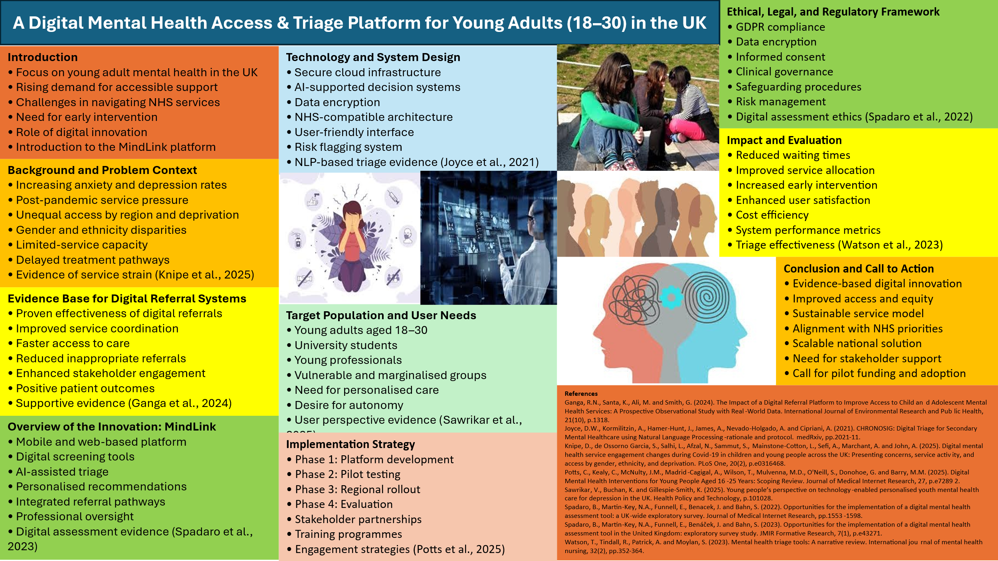
Introduction
- Focus on young adult mental health in the UK
- Rising demand for accessible support
- Challenges in navigating NHS services
- Need for early intervention
- Role of digital innovation
- Introduction to the MindLink platform
Background and Problem Context
- Increasing anxiety and depression rates
- Post-pandemic service pressure
- Unequal access by region and deprivation
- Gender and ethnicity disparities
- Limited-service capacity
- Delayed treatment pathways
- Evidence of service strain (Knipe et al., 2025)
Evidence Base for Digital Referral Systems
- Proven effectiveness of digital referrals
- Improved service coordination
- Faster access to care
- Reduced inappropriate referrals
- Enhanced stakeholder engagement
- Positive patient outcomes
- Supportive evidence (Ganga et al., 2024)
Overview of the Innovation: MindLink
- Mobile and web-based platform
- Digital screening tools
- AI-assisted triage
- Personalised recommendations
- Integrated referral pathways
- Professional oversight
- Digital assessment evidence (Spadaro et al., 2023)
Technology and System Design
- Secure cloud infrastructure
- AI-supported decision systems
- Data encryption
- NHS-compatible architecture
- User-friendly interface
- Risk flagging system
- NLP-based triage evidence (Joyce et al., 2021)
Target Population and User Needs
- Young adults aged 18–30
- University students
- Young professionals
- Vulnerable and marginalised groups
- Need for personalised care
- Desire for autonomy
- User perspective evidence (Sawrikar et al., 2025)
Implementation Strategy
- Phase 1: Platform development
- Phase 2: Pilot testing
- Phase 3: Regional rollout
- Phase 4: Evaluation
- Stakeholder partnerships
- Training programmes
- Engagement strategies (Potts et al., 2025)
Ethical, Legal, and Regulatory Framework
- GDPR compliance
- Data encryption
- Informed consent
- Clinical governance
- Safeguarding procedures
- Risk management
- Digital assessment ethics (Spadaro et al., 2022)
Impact and Evaluation
- Reduced waiting times
- Improved service allocation
- Increased early intervention
- Enhanced user satisfaction
- Cost efficiency
- System performance metrics
- Triage effectiveness (Watson et al., 2023)
Conclusion and Call to Action
- Evidence-based digital innovation
- Improved access and equity
- Sustainable service model
- Alignment with NHS priorities
- Scalable national solution
- Need for stakeholder support
- Call for pilot funding and adoption

Written Pitch:
I would suggest creating and introducing MindLink, a digital mental health access and triage service aimed at enhancing the provision of services to young adults aged 18 to 30 in the United Kingdom. The last few years have been marked by the worsening of mental health issues among the youth due to the pressures of studying, financial instability, social exclusion, and the long-term impacts of the COVID-19 pandemic. There is evidence that the patterns of service engagement have evolved enormously, where the demand continues to be high, and the disparities in access persist (Knipe et al., 2025). The increasing awareness does not mean that many young adults are not languishing in long queues, on unclear referral paths and with minimal guidance to seek help. MindLink aims to overcome these problems by providing a user-centred, evidence-based and secure digital solution.
As a result, the general practitioners and the conventional referral systems are currently seen as a major component of access to specialist mental health services. Although this model guarantees clinical control, there are delays, fragmented care, and wrong referrals that are common in this model. Digital referral systems have also been reported to enhance coordination and efficiency in mental health services (Ganga et al., 2024; Santa et al., 2024). Nevertheless, most of the existing systems are not personalised; they also fail to assist the young people who seek to find their way through services alone.
MindLink is implemented as a mobile and web-based solution which incorporates a validated digital assessment with an intelligent triage system. The users create secure accounts, give informed consent, and fill in structured screening instruments that evaluate the state of emotional wellbeing, functional capacity, and risk factors. It is evidenced by the fact that digital assessment tools are applicable in the context of UK mental health services under the condition of adequate governance systems (Spadaro et al., 2022; Spadaro et al., 2023). MindLink expands on this fact by integrating automated analysis and human supervision in order to be reliable and secure.
It operates on artificial intelligence-supported decision-support systems and analyses the user feedback and suggests suitable care sets. These referral routes are self-help wellbeing services, online cognitive behavioural therapy, NHS Improving Access to Psychological Therapy services, crisis referral, and community-based services. Joyce et al. (2021) report on the possibilities of natural language processing and digital triage systems that can improve the accuracy of referral and service distribution. In the same manner, Watson et al. (2023) state that structured triage instruments enhance efficiency and lower the usage of irrelevant services.
Besides assessment and referral functions, MindLink also offers educational content, peer support forums that are moderated, and progress-tracking features. Digital mental health interventions are most optimally achieved when promotion of engagement, personalisation, and long-term participation is encouraged (Potts et al., 2025). Young people can appreciate systems that mirror their personal needs and preferences (Sawrikar et al., 2025). Hence, MindLink will use a user-centred approach to design, where the service users are consulted in the development and testing of the platform.
MindLink is expected to have an enormous effect. First, it will shorten the waiting time since it will refer people to the relevant services at an early stage. Second, it will reduce congestion in primary care as it will reduce unnecessary consultations. Third, it will enhance equity by enhancing the access of people in rural and socioeconomically disadvantaged communities. Spadaro et al. (2022) and Spadaro et al. (2023) prove that digital assessment tools have the potential to decrease geographical and structural barriers to care. MindLink facilitates the inclusive and responsive service delivery by offering a centralised point of access.
The implementation will be done in phases over a duration of twelve months. The initial phase will be dedicated to the platform design and development based on the cooperation of software developers with clinicians and youngsters. The second stage will be pilot testing in some of the chosen universities and community health environments. The step will enable usability testing, risk analysis and system refinement. The third stage will entail local implementation with the assistance of specific communication plans and training programmes. The last step will involve a thorough assessment by applying quantitative and qualitative measures. According to Potts et al. (2025), implementation and continuous assessment of the digital intervention should be structured, and these are the keys to its success.
The main stakeholders will be the NHS trusts, institutions of higher learning, mental health charities, technology providers and regulatory bodies. Interoperability, governance, and sustainability will be enabled through strategic partnerships. It will request funding through public health innovation grants, research councils, and digital health investors. There is some indication that institutions will show greater acceptance of and scale to stakeholder-driven platforms (Ganga et al., 2024; Santa et al., 2024). The continuous interaction with stakeholders will ensure that it aligns with clinical interests and service user expectations.
The design and functioning of MindLink revolve around regulatory compliance. The platform will comply with the requirements of the GDPR, NHS Digital standards, and clinical safety frameworks. Any personal information will be encrypted and anonymised to be used in the research and stored on secure servers. The process of transparent consent and protection protocols will be integrated into the user journey. Spadaro et al. (2022) point to the necessity to deal with ethical and legal issues in digital mental health innovation. MindLink addresses these issues by having strong governance frameworks and frequent auditing.
Value-wise, MindLink is an inexpensive investment in preventive and early intervention services. Digital delivery saves money on infrastructure and employees and increases coverage. The platform saves the healthcare system long-term money by avoiding the process of escalating to specialist and inpatient care. Watson et al. (2023) claim that efficient triage systems enhance the allocation of resources and efficiency of operations. MindLink uses this evidence to provide quantifiable clinical and financial gains.
However, a number of obstacles should be overcome. Digital exclusion is still a problem for people who have little or no access to technology or do not possess much digital literacy. The concern of data privacy might decrease the user trust, and not every professional will be ready to accept the technological change (Ziebart et al., 2023). The mitigation of these challenges will be done by training them on digital skills, having open communication, and involving stakeholders. Cultural adaptation will be supported using continuous professional development and organisational learning. As Potts et al. (2025) emphasise, sustainable digital innovation needs to be transformed not only technically but also socially.
The mixed-methods research will be used to evaluate it. Quantitative measures will be the accuracy of referral, Waiting time, utilisation of service and improvement in symptoms. Qualitative interviews and surveys will be conducted into the user experiences, professional perceptions and ethical considerations. Knipe et al. (2025) prove the usefulness of such methods in knowing the patterns of service engagement. Results will be used to conduct ongoing improvement and policy formulation.
In conclusion, MindLink offers an innovative, evidence-based, and ethically responsible response to major access challenges in youth mental health care. By integrating digital assessments, intelligent triage, and user-centred design, the platform strengthens early intervention, improves equity, and enhances system efficiency. Support from healthcare leaders and policymakers is essential for successful implementation and national scaling.

References
Ganga, R.N., Santa, K., Ali, M. and Smith, G. (2024). The Impact of a Digital Referral Platform to Improve Access to Child and Adolescent Mental Health Services: A Prospective Observational Study with Real-World Data. International Journal of Environmental Research and Public Health, 21(10), p.1318.
Joyce, D.W., Kormilitzin, A., Hamer-Hunt, J., James, A., Nevado-Holgado, A. and Cipriani, A. (2021). CHRONOSIG: Digital Triage for Secondary Mental Healthcare using Natural Language Processing-rationale and protocol. medRxiv, pp.2021-11.
Knipe, D., de Ossorno Garcia, S., Salhi, L., Afzal, N., Sammut, S., Mainstone-Cotton, L., Sefi, A., Marchant, A. and John, A. (2025). Digital mental health service engagement changes during Covid-19 in children and young people across the UK: Presenting concerns, service activity, and access by gender, ethnicity, and deprivation. PLoS One, 20(2), p.e0316468.
Potts, C., Kealy, C., McNulty, J.M., Madrid-Cagigal, A., Wilson, T., Mulvenna, M.D., O'Neill, S., Donohoe, G. and Barry, M.M. (2025). Digital Mental Health Interventions for Young People Aged 16-25 Years: Scoping Review. Journal of Medical Internet Research, 27, p.e72892.
Santa, K., Dixon, C., Ganga, R.N., Trainor, G., Smith, G., Furfie, V. and Brown, H. (2024). Facilitating access to mental health services: a stakeholder-driven improvement of the children and young people (CYP) as one referral platform. International Journal of Environmental Research and Public Health, 21(6), p.784.
Sawrikar, V., Buchan, K. and Gillespie-Smith, K. (2025). Young people’s perspective on technology-enabled personalised youth mental health care for depression in the UK. Health Policy and Technology, p.101028.
Spadaro, B., Martin-Key, N.A., Funnell, E., Benacek, J. and Bahn, S. (2022). Opportunities for the implementation of a digital mental health assessment tool: a UK-wide exploratory survey. Journal of Medical Internet Research, pp.1553-1598.
Spadaro, B., Martin-Key, N.A., Funnell, E., Benáček, J. and Bahn, S. (2023). Opportunities for the implementation of a digital mental health assessment tool in the United Kingdom: exploratory survey study. JMIR Formative Research, 7(1), p.e43271.
Watson, T., Tindall, R., Patrick, A. and Moylan, S. (2023). Mental health triage tools: A narrative review. International journal of mental health nursing, 32(2), pp.352-364.
Ziebart, C., Kfrerer, M.L., Stanley, M. and Austin, L.C., (2023). A Digital-First Health Care Approach to managing pandemics: scoping review of pandemic self-triage tools. Journal of Medical Internet Research, 25, p.e40983.

