Analysis on the Global Challenges of Manufacturing Enterprises
-----a Case Study of Gree Electric
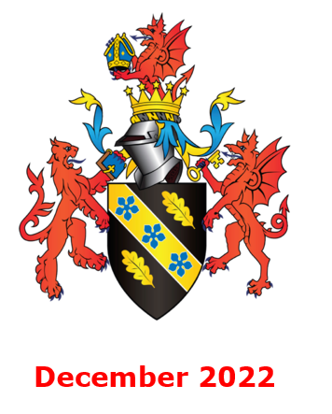
Module name：Global Business Challenges BMMB7006
Name：Nanfei Yan
student number：2203497

Table of contents
Executive summary 1
1.Introduction 1
2.strategic analysis 3
2.1 PESTEL model analysis 3
2.2 Porter's Five Forces 14
3.Conclusions 17
4. Recommendations 18
References 19
Figures
Figure 1 GDP and PCDI from 2017 to 2021 6
Figure 2 China ResidentialCommercial Housing SalesArea from 2018 to 2021 7
Figure 3 Global home appliance market retail sales from 2014 to 2021(billion dollars) 8
Figure 4 The number and growth of china's total population from 2015 to 2020 11
Figure 5 The number of patent applications and authorizations in the global smart home appliance industry 12
Figure 6 The number of patent applications and publications in China's smart home appliance industry 13
Tables
Table 1 Statistics of household appliance exports by continent in 2021 7

Executive summary
Gree Electric Appliances is a home appliance manufacturer mainly engaged in the research and development, production, sales and service of air conditioners, as well as the largest professional electrical appliance enterprise in China.Based on the analysis of the internal and external environment of Gree's development strategy adjustment under the background of the new retail reform, this paper uses PESTel, Porter's Five Forces model and other analytical tools to analyze and discuss the macro environment and industry competition environment of Gree Electric Appliances, and draws a conclusion that Gree Electric appliances has a good market prospect. And provide strategic suggestions for the future development of Gree Electric Appliances.

1.Introduction
Gree Electric Appliances is a home appliance manufacturer mainly engaged in the research and development, production, sales and service of air conditioners. It is also the largest professional electrical appliance enterprise in China.Gree Electric Appliances has always adhered to product quality as the center, providing customers with high-quality air conditioners and services as the goal, and attaches great importance to scientific and technological innovation, increasing the efforts of scientific and technological research and development, and becoming a national demonstration enterprise of technological innovation.The five stages of Gree's development are as follows:
(1) Start-up stage
The first three years of the establishment of Gree Electric Appliances is the start-up stage, in which the key task of Gree is to grasp the products. At this time, Gree is only a small factory with backward production technology and low annual production capacity.In order to seek development, Chairman Zhu Hongjiang has always led all the staff, constantly carry forward the spirit of breaking through difficulties and hard innovation, overcome one challenge after another, develop a series of new products to meet the needs of consumers, and lay a good foundation for Gree to become a "world famous brand".
(2) Development stage
After completing the basic goal in the early stage of entrepreneurship, Gree will focus on quality as the key task in the new stage.During this period, Gree implemented the "high-quality strategy".Over the past few years, Gree Electric Appliances has always strictly controlled the quality, which not only improved the quality of products to a new height, but also won the recognition of the majority of consumers and gained new competitive advantages.
(3) Expansion stage
During this period, Dong Mingzhu created a brand new marketing strategy, "regional sales company", in order to grasp the market, scale and cost, which greatly promoted the expansion of the enterprise's sales market.During this period, the company also actively explored overseas markets, expanded the production scale of Gree Electric Appliances, and strengthened cost control to improve product profit margins.Since then, the production and sales volume, sales revenue and market share of Gree Electric appliances have been steadily exceeding those of the same industry, standing out in the fierce competition.
(4) Internationalization stage
During this period, the company took "striving for the first place in the world" as its development goal.Continuously increase research and development efforts, adhere to the "self-development, independent innovation, free brand" development ideas, set up research and development team, the establishment of research and development system.At the same time, we also continue to innovate in management, introduce advanced management mode, and promote the development of enterprises to internationalization.
(5) The stage of creating a global famous brand
Although Gree Electric Appliances became the "single champion" of household air conditioners in the world in 2005, it still has shortcomings in scientific research ability and management mechanism compared with some well-known foreign home appliance enterprises.Therefore, Gree Electric Appliances put forward the strategy of "creating high-quality enterprises, manufacturing high-quality products and creating high-quality brands" to forge ahead towards the vision of "world famous brands".

2.Environmental analysis

2.1 PESTEL model analysis
2.1.1 Political
(1) Domestic policies drive domestic demand for home appliances
In 2021, the report on the work of the Government pointed out that it is necessary to steadily increase the consumption of large quantities such as automobiles and home appliances, and focus on "naming" the consumption of home appliances to expand the domestic demand of home appliances;In 2022, the government work report said that local governments should be encouraged to carry out green and smart home appliances to the countryside and exchange old appliances for new ones, so as to maintain a supportive attitude towards the home appliance industry.Among them, Jiangxi, Guangxi, Shaanxi, Liaoning, Inner Mongolia, Yunnan and other places have made it clear that they will promote the deployment of smart home appliances to the countryside, and Chongqing, Zhejiang and other places will carry out green and smart home appliances to the countryside and trade in old and new ones.At present, many home appliances in the last round of home appliances to the countryside have exceeded the safe service life of the products, and the government has encouraged the initiative of home appliances to the countryside for several consecutive years.
On April 13, 2022, the executive meeting of The State Council deployed policies and measures to promote consumption, again mentioning the encouragement of bulk consumption of automobiles and home appliances.Since March, various regions have launched measures to promote consumption. For example, Zhengzhou issued 30 million yuan of green home appliance consumption vouchers to consumers in the whole city, Wuhan fully launched the 2022 green consumption season, and the Beijing Municipal Bureau of Commerce issued more than 300 million yuan of green energy-saving consumption vouchers to consumers in Beijing from April to September 2022.The implementation of local green consumption activities is expected to further promote the consumption promotion of household appliances for new ones and green household appliances.
(2) Real estate policies will promote the development of home appliance industry in 2022
From September 2021, the real estate policy is expected to pick up. The quarterly regular meeting of the central bank in September proposed to "maintain the healthy development of the real estate market and safeguard the legitimate rights and interests of housing consumers". In October 2021, high-level officials made intensive noises to promote the healthy development of the real estate market.The 2022 Government Work Report pointed out that stable growth should be given greater priority, and the real estate industry is a pillar industry of the national economy, with a large scale, long chain and wide involvement, which has an important systemic impact on economic and financial stability and risk prevention.
On March 16, the Financial Stability and Development Committee of The State Council held a special meeting. The meeting talked about monetary policy, real estate and other aspects, and proposed to actively introduce policies favorable to the market, while prudently introducing contractionary policies.After the meeting, many central departments followed up their comments to promote the healthy and stable development of the real estate market.
(3) Changes in the international situation will lead to a decline in the growth rate of export
The World Bank predicts that global economic growth will slow down to 4.1% in 2022, down 1.4 percentage points from 2021, while the slowdown in the pace of economic recovery will affect the growth of trade volume.According to the China Home Appliances Association, although the supply chain of China's home appliance industry has obvious advantages and strong resilience, it is expected that it will be difficult for China's exports to maintain high growth in 2022, and the growth rate of home appliance exports is likely to slow down, considering the factors such as high global inflation expectations, tight global energy supply caused by the geopolitical conflict between Russia and Ukraine, slowing down the growth rate of global economic recovery, and continuous tension between China and the US.
(4) The entry into force of RCEP brings new opportunities for home appliance exports.
The Regional Comprehensive Economic Partnership (RCEP), also known as the RCEP, came into force on January 1, 2022.As of April 18, 12 of the 15 RCEP-member countries have entered into force.According to customs statistics, in the first quarter of 2022, China's imports and exports to the remaining 14 RCEP members reached 2.86 trillion yuan, up 6.9 percent year on year, accounting for 30.4 percent of China's total foreign trade;Among them, exports reached 1.38 trillion yuan, up 11.1 percent year on year.Imports and exports between China and ASEAN reached 1.35 trillion yuan in the first quarter of 2022, up 8.4 percent year on year, and ASEAN regained its position as China's largest trading partner after the RCEP took effect, the General Administration of Customs said.As one of China's important export products, the export end of the industry will enjoy the dividend of RCEP, and the growth rate of home appliance export is expected to be boosted to some extent.With the transformation of the global economic environment, Gree Electric Appliances' export faces both challenges and opportunities.
2.1.2 Economic:
(1)domestic economy
①GDP and PCDI continued to grow
It can be seen from Figure 1 that China's economy has developed rapidly in recent years, and the per capita disposable income of the people has been on a steady upward trend from 2017 to 2021.In 2020, China's GDP exceeded 100 trillion yuan for the first time, reaching 101.6 trillion yuan, an increase of 2.51 trillion yuan compared with 2019, with a year-on-year growth of 2.54%.In 2021, China's GDP reached 114 trillion yuan, with a per capita GDP of 47,412 yuan.With the growth of national income, people's consumption power is also increasing, which is conducive to regional upgrading of consumption.In 2020, China released the 14th Five-Year Plan, which mentioned the need to improve people's quality of life in an all-round way, especially in rural areas.This means that rural areas will become a huge consumer market for home appliances in the future

Figure 1 GDP and PCDI from 2017 to 2021
② China's home appliance market recovered growth in 2021
In 2020, due to the impact of the epidemic, the sales of the overall home appliance market was weak in the first quarter, and the operation gradually recovered in the second quarter. The annual market size declined.In 2021, in the face of complex and volatile domestic and international environment, China's economy continued to develop towards high quality on the basis of maintaining overall stability.In terms of the home appliance industry, the whole industry has entered a new development stage of stock replacement, the overall sales and demand tend to be stable, and the average price of products has benefited from the structural upgrading and steadily increased.
According to the China Electronics and Information Industry Development Research Institute, China's home appliance market fully recovered in 2021, with the market retail sales of 881.1 billion yuan, up 5.7% year on year, recovering to about 98% of the market size in 2019.According to China Electronics and Information Industry Development Research Institute, the rise of China's home appliance market in 2021 is mainly due to the rapid expansion of the scale of the sinking market and the vigorous development of the high-end market.
③Commercial housing sales drive the demand for home appliances
As can be seen from Figure 2, from 2018 to 2021, the sales area of China's commercial housing continued to grow. In 2021, the sales area reached 1,794 square kilometers, with a growth rate of 1.9%.Although the growth rate is not as fast as before the epidemic, as the main driving factor for the development of the home appliance industry, the continuous expansion of the sales area of residential commercial housing makes the home appliance industry have a greater demand.

Figure 2 China ResidentialCommercial Housing SalesArea from 2018 to 2021
(2) International market
①The overseas market is broad
The global market size of household appliances has reached 640 billion US dollars, with steady growth since 2014.According to Statista, the global retail sales of home appliances have reached 640 billion US dollars in 2021, including 380 billion US dollars for consumer appliances and 260 billion US dollars for small appliances.In terms of growth rate, the global retail sales of home appliances grew at a compound rate of 3.3% from 2014 to 2021, with a compound growth rate of 2.9% for consumer appliances and 4.0% for small appliances.
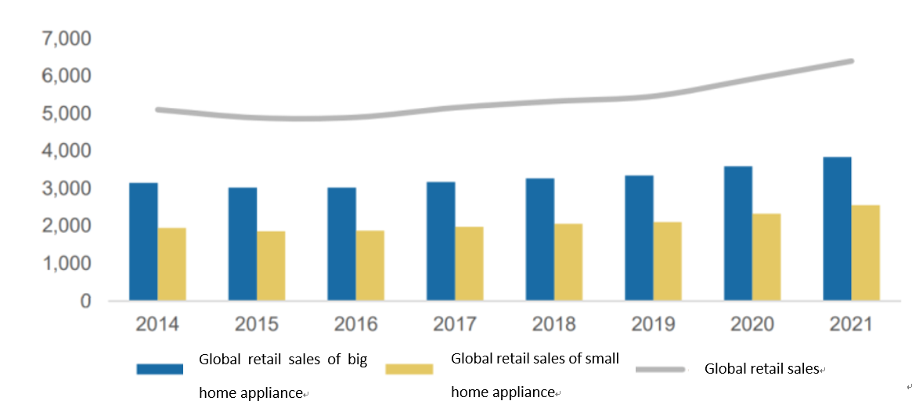
Figure 3 Global home appliance market retail sales from 2014 to 2021(billion dollars)
②The export scale of home appliance market has exceeded 100 billion dollars
Since 2021, the vaccination rate of major economies has continued to increase, the impact of COVID-19 has significantly weakened, and there has been a global economic recovery and a decline in unemployment. The driving role of home economy and online economy is still obvious, and the global home appliance sales market has recovered significantly.According to statistics from GfK, a consultancy, global retail sales of home appliances maintained steady growth from January to December 2021, up 14.8% from the same period last year, and small home appliances increased 11.1% from the same period last year.However, inflation in Europe, the United States and other countries accelerated, logistics and raw material costs remained high, and affected by repeated epidemics and the early release of some demand, as well as a high base in the second half of 2020, the year-on-year growth slowed down in many regions of the world in the second half of 2021.
In the complex environment, China's home appliance industry fully relied on the stability of its own supply chain, overcame difficulties such as trade protection and rising logistics and material costs, and actively explored the market. The export scale and growth rate both reached a new high in nearly a decade.According to the statistics of the China Chamber of Commerce for Import and Export of Mechanical and Electrical Products (hereinafter referred to as the "Chamber of Commerce for Mechanical and Electrical Products"), the annual cumulative export of China's home appliance products in 2021 reached US $118.45 billion, up 26.4% compared with the export scale in 2020 and 48.4% compared with 2019, with both the export scale and growth rate hitting a new high in nearly a decade.
③The rapid growth of home appliance export market has leveled off
As shown in Table 1, in 2021, China's export to European and American markets will continue to maintain high growth, with the growth rate ranking among the top in all statistical regions. The five-year average growth rate of export to Europe is 10.6%, and that to the United States is 9.6%, but the growth rate has become stable.In 2021, China's export value to Europe and North America was 33.29 billion US dollars and 29.19 billion US dollars respectively, up 36.2% and 21.3% respectively.Combined exports to Europe and North America accounted for more than 50 percent of China's total exports of home appliances. China's overall exports to the Asian market reached $40.21 billion, up 21.3 percent from the same period last year.Among them, the export of home appliances to India increased by 19.2% compared with the same period last year, showing a continued recovery trend, but the export scale fell out of the top ten markets, ranking 16th.Previously, India was once the sixth largest market for China's home appliance exports. In 2018, the Indian government imposed tariffs on refrigerators, air conditioners, washing machines and household appliances, and successively launched compulsory BIS certification, banning the import of air conditioning refrigerants and other technical barriers, resulting in a continuous decline in China's exports to India.
Saudi Arabia is the only declining market among China's major home appliance export markets in 2021, with export volume falling by 8%, and its position as the largest market in the Middle East was replaced by the United Arab Emirates.As a result, overall exports to the Arab League countries increased by 5.6%, a smaller increase among the regions.Exports to Latin America and Africa rebounded rapidly.From 2015 to 2020, the CAGR of China's exports to Latin America and Africa was 2.1% and 3.9%, respectively.In 2021, China's export to Latin America reached 8.71 billion US dollars, up 45.7%;And exports to Africa reached $4.1 billion, up 21 percent.
Table 1 Statistics of household appliance exports by continent in 2021
Statistic Scope | Exports(RMB million) | Growth（%）
All Asia | 40207 | 21.34
All Europe | 33291 | 36.24
All North America | 29190 | 21.27
All Latin America | 8705 | 45.70
All Oceania | 2918 | 15.63
All Africa | 4102 | 21.00
10 ASEAN countries | 10864 | 28.20
RCEP10+4(Without China) | 26723 | 23.77
28 EU countries | 28758 | 36.14
Arab League of 22 countries | 7060 | 5.55
2.1.3 Sociocultural
(1) Population environment
China has a large population, but its distribution is seriously uneven. There is a wide gap between the levels of economic development and residents' income in different regions.China has a population of nearly 1.4 billion, of which nearly 60% are distributed in rural areas. It can be said that the rural market is the potential of China's home appliance consumption.In 2020, China's population was 1,412.12 million, an increase of 0.14 percent over 2019.With the increase of population, the update of home appliance industry is also gradually increasing, which drives the development of smart home appliance industry.

Figure 4 The number and growth of china's total population from 2015 to 2020
(2) Social and cultural environment
With the growth of home appliance consumption, durable consumer goods are developing towards the high-end direction, and the penetration rate is steadily increasing.The proportion of urban population continues to rise, and the overall demand for home appliances and the overall consumption power continue to improve.Home appliances are closely related to upstream industries such as electronics, steel and machinery manufacturing.This change has given a strong boost to the electronics, steel and other industries, and has effectively driven the output growth of these upstream industries.It has promoted economic development.In today's era, home appliance industry has become an indispensable part of people's life and a very important life tool.
2.1.4 Technological
(1) Overview of patent applications in the global smart home appliance industry
From 2012 to 2019, the number of patent applicants and patent applications in the global smart home appliance industry showed an increasing trend.Although the number of patent applicants and patent applications in the global smart home appliance industry decreased in 2020, the number of these two indicators is still large.On the whole, the global smart home appliance technology is in the growth stage.From 2010 to 2019, the number of patent applications in the global smart home appliance industry showed an increasing trend year by year. In 2021, the number of patent applications in the global smart home appliance industry decreased.In terms of patent authorization, the number of patents authorized in the global smart home appliance industry increased year by year from 2010 to 2017, and began to show a downward trend in 2018. In 2020, the number of patents authorized in the global cloud computing industry was 40.25 million, accounting for 33.61% of the total.In 2021, the number of patent applications and patent authorization in the global smart home appliance industry was 5232 and 960 respectively, accounting for 18.35% of the total.
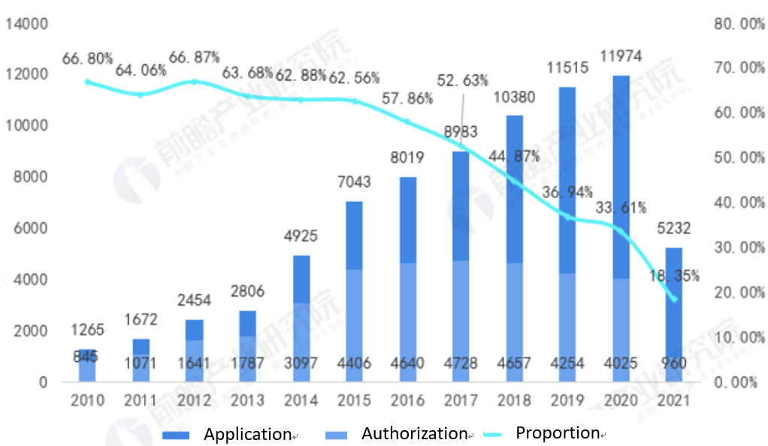
Figure 5 The number of patent applications and authorizations in the global smart home appliance industry
(2) Domestic situation
In recent years, China's home appliance industry has been booming, with rapid growth in the number and quality of patents, and the number of patent applications ranking first in the world. According to statistics, the number of patent applications for home appliances in China reached a stage peak in 2018. By 2020, the number of patent disclosures for home appliances in China was 5289, and the number of patent applications was 2921.In 2021, the number of patent applications in China's smart home appliance industry was 511, down 30.4% year on year;The number of patents published in the smart home appliance industry was 1,016, up 58.5% year on year.
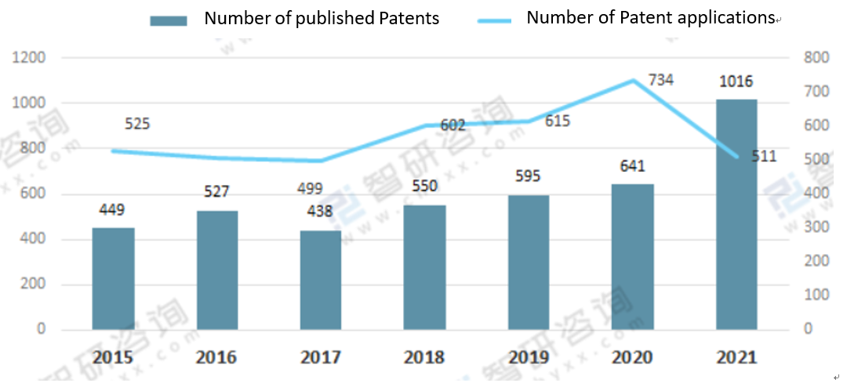
Figure 6 The number of patent applications and publications in China's smart home appliance industry
2.1.5 Environmental
As the public attaches great importance to energy conservation and environmental protection, the awareness of energy conservation and environmental protection is gradually popularizing.Air conditioning enterprises to meet the trend of consumption concept, environmental protection products will account for an increasing proportion of sales.According to a new market research report released by BSRIA, the main drivers of global cooling demand are economic development, population growth, urbanization and rising temperatures in Bangladesh, Brazil, Ghana, India, Indonesia, Kenya and Vietnam.The European market is also seeing significant growth, with consumers preferring energy-efficient products and frequency conversion products that use greener technology.
2.1.6 Legal
①The improvement of legislation is conducive to the development of home appliance industry
Laws can regulate property rights, patents and stimulate innovation.Perfect laws can reduce or even eliminate government rent-seeking activities (corruption), thus creating a relatively pure development environment for the development of the home appliance industry
(2) Trade legislation is conducive to protecting the development of domestic home appliance industry
By stating the legality of tariff collection in the legislation, the government can create certain barriers and restrictions for the international market of household appliances to enter the Chinese market through tariff collection, so as to protect the development of the domestic household appliance industry

2.2 Porter's Five Forces
2.2.1 Bargaining Power of Suppliers
The main raw materials used in the manufacture of home appliance products include metal materials such as copper, steel, aluminum and non-metal materials such as plastic, which account for a large proportion of the cost. According to China Industrial Information, a set of cost statistics of home appliance industry is released, air conditioning.
In the cost of raw materials, steel and copper materials account for a large proportion, about 25% and 20% respectively, plastic cost accounts for about 10%, aluminum cost is about 5%, and other materials about 40%.
Affected by the rising prices of bulk commodities, the prices of steel and copper have been rising in the past two years, and the bargaining power of upstream suppliers has been enhanced.Especially for precision copper pipe, one of the core components of air conditioning, the main suppliers of the whole air conditioning industry are mainly Jinlong Copper pipe, Hailiang Stock, Jingyi Stock, Auboter and a few major suppliers. The suppliers are relatively concentrated and the supply scale of a single customer is large. Among them, Hailiang Stock and Jingyi stock are listed companies, and Jinlong Copper pipe is a leader in the precision copper pipe industry. All of them have strong bargaining power
2.2.2 Bargaining Power of Buyers
On the one hand, due to the intensified industrial competition pattern, air conditioning price wars occur from time to time, and new forces of air conditioning continue to emerge. Especially in recent years, with the explosive development of ecommerce, the overall logistics and storage costs have been diluted, and the rapid development of the Internet has narrowed the space of information asymmetry that dealers rely on. The rapid change of information flow and logistics makes consumers have more and more say in product pricing.
On the other hand, as the proportion of hardcover houses required by the real estate market policy increases year by year and the replacement demand for the localization of central air conditioning in infrastructure projects increases, the proportion of B-end air conditioning demand of real estate enterprises and infrastructure project companies continues To increase. The sales of air conditioning have gradually shifted from mainly relying on the C-end retail mode in the past To paying equal attention To the C-end retail mode and the B-end engineering mode. The bargaining power of B-end customers is much stronger than that of C-end retail customers.
2.2.3 Threat of New Entrants
Although the air conditioning market has been firmly occupied by the leading enterprises such as Grae, Mimei and Haier, on May 13, 2021, Xiaomi's Mijia new air conditioning products won the "double first" in terms of single product browsing and transaction on the first day of the first sale of Jingdong home appliances, and more than 4,000 units were directly sold out. Driving Xiaomi air conditioner sales across the board increased by 15 times on a monthly basis. Reflecting that in today's Internet era, in the era of diversified, personalized, customized and trendy consumer demand, more and more niche markets and long-tail markets are attracting the attention of potential entrants.
The long tail market was first proposed by Chris Anderson (2004). People usually focus on the concentrated market in the head, while those fragrances and seemingly no common needs of products constitute a very long tail market.In today's demand-oriented new economic era, the "disintermediation" function of the Internet can enable manufacturers to realize point-to-point interaction with customers, accurately grasp and divide the consumption pain points of different customers, identify the needs of long-tail customers, and continue to develop new markets."Disintermediation" is considered as a counterattack to "channel is king", which enables manufacturers to skip all the intermediate links and realize direct interaction with both customers.In the past, air conditioners needed to build a national physical sales network, and it was difficult for others to enter the air conditioners or electrical appliances industry. However, with the rise of online sales, the threat of potential entrants in the market has become much larger.
2.2.4 Substitutes
There are some differences in the substitutes for different types of home appliances, but most of the substitutes for home appliances are still other home appliances.For example, the substitute of color TV may be a computer, or it may be other color TV with better performance.The function of air conditioning is divided into two aspects: refrigeration and heating.In terms of refrigeration, the alternative to air conditioning in hot summer is the electric fan. On the one hand, its power consumption is much lower than that of air conditioning, and the cooling effect is also considerable;On the other hand, it has low installation cost and is more convenient to use.In terms of heating, air conditioning is used for heating in southern China, but with the emergence of products such as electric blankets, electric fans and hand warppers, the sales of air conditioning have been affected.In northern China, residents are more inclined to use floor heating for heating, and the demand for air conditioning is not very large.Therefore, there are not many substitutes for home appliances, but we should prevent the substitution of the same or related products.
2.2.5 Rivalry
(1) The impact of the industry's stage of development
At present, the household appliance industry has developed to the mature stage.Consumer demand for home appliance products is gradually slowing down, and the household appliance industry is oversupplied.According to the data released by the Ministry of Industry and Information Technology, from 2015 to 2011, the production and sales rate of home appliance industry failed to reach 100% year after year.Among them: in July 2018, the production and sales rate of home appliance industry was only 94.5%, the lowest in recent years.Home appliance enterprises often reduce the price of goods by means of price war and providing value-added services, thus accelerating the competition between enterprises.
(2) The influence of brand concentration
At present, domestic home appliance enterprises show a high degree of brand concentration.In the white home appliance industry, there has been a "three pillars" situation of Mimei, Gree and Haier.In the black appliance industry, Skyworth, Hisic, TCL three leading enterprises coexist.In the small home appliance industry, Jiuyang, Supor and Midea are the top domestic brands.According to the data released by the China Industry Information Network, the product market share of the dominant enterprises in household appliances is rising year by year, and the market share of the top 10 enterprises in the refrigerator industry is more than 90%.

3.Conclusions
Based on the analysis of the internal and external environment of Gree's development strategy adjustment under the background of the new retail reform, this paper uses PESTel, Porter's Five Forces model and other analytical tools to analyze and discuss the macro environment and industry competition environment of Gree Electric Appliances, and draws the following conclusions:
(1) The domestic policy situation is good, whether it is real estate policy or consumption policy, it is conducive to the growth of domestic demand for home appliances.Changes in the international economic situation have a complex impact on home appliance exports.
(2) With the change of economic globalization and macro environment at home and abroad and the diversification of home appliance products, the competition in the home appliance industry is becoming increasingly fierce.Gree should continue to promote the process of product diversification and internationalization.

4. Recommendations
(1) Increase investment in research and development and constantly develop new products
First of all, Gree Electric Appliances should increase R&D investment, make full use of the existing scientific research personnel and scientific research platform, expand the scientific research team, and actively strengthen the cooperation with universities and research institutes, strengthen basic research, focus on improving the performance of household air conditioners, central air conditioners and other major products, maintain product differentiation and brand advantage, at the same time, to At the same time, it should increase the research and development of intelligent and healthy home appliances, strengthen the combination and application of 5G technology and other new generation information technology with home appliances, and lead the new trend of home appliance development.Secondly, Gree Electric Appliances should continuously develop new products and expand new profit growth points for a long time. Smart home appliances such as clothes dryers and healthy home appliances are the future development trend, and the development of such products will further enhance the competitiveness of Gree electric appliances products.
(2) Continue to adhere to the differentiation and diversification of development strategy
First, we should rely on the existing domestic and foreign market resources, fully investigate the preferences and biases of consumers in different regions, countries and regions for products, rely on the global research and development system, regularly formulate research and development plans, actively sign agreements with domestic and foreign research institutions such as Tsinghua University, Chinese Academy of Sciences, MIT and UC Berkeley, and constantly innovate technology brands. To seize the mainstream product market.Second, it is necessary to comprehensively analyze the profits of household air conditioners, central air conditioners, washing machines, refrigerators, kitchen and bathroom appliances, life appliances, robots, intelligent logistics and other businesses. While adhering to the diversification strategy, it is appropriate to withdraw or give up low-profit and high-loss businesses and invest limited funds in high-profit businesses.
(3) Explore new overseas markets
Gree Electric Appliances should take advantage of its brand advantages to explore new overseas markets, actively layout the "Belt and Road" market, Southeast Asian market and European market, establish overseas marketing network, expand business scope, further open the market, and increase export sales.

References
[1]Morrison, J. (2020) The Global Business Environment Towards Sustainability, Red Globe Press
[2]Johnson, G., Whittington, R., Regner, P., Scholes, K and Angwin, D. (2020) Exploring Strategy: Text & Cases, 12th edition, Pearson
[3]Griffin, R. and Putstay, M. (2015) International Business, Global edition, Pearson
[4]Forbes China,(2022).Opportunities Beyond Your Horizon.[online]Availablle at: https://www.forbeschina.com/[Accessed 13 Dec. 2022]
[5]GREE.com, (2022). GREE’S Official Website. [online] Available at: https://global.gree.com/ [Accessed 13 Dec. 2022]
[6]Midea Group.(2016-2021).Midea Group Co., Ltd.Annual Report.Guangdong:Midea Group Co., Ltd.
[7]Gree Electric Appliances.(2016-2021).Gree Electric Appliances,INC.of Zhuhai Annual Report. Guangdong:Gree Electric Appliances,INC.of Zhuhai.
[8]stats.gov,(2022).National Bureau of Statistics of China.[online]Available at:http://www.stats.gov.cn/english/PressRelease/202201/t20220118_1826502.html/[Accessed 13 Dec. 2022]
[9]Sloman, J. and Jones, E. (2020): Essential Economics for Business, 6/E, Pearson, London.
[10]Tang Ruihuan. (2022). Gree Electric SWOT Analysis and Development Suggestions. Cooperative Economy and Technology (05), 140-141
[11]Zhou Qiongfang. (2020). Research on corporate financial management strategies under the new crown pneumonia epidemic. Financial Management Research (04), 40-45.
[12]The people's Republic of China National Bureau of Statistics. (2021).Chinese statistical yearbook. Beijing: China Statistics Press.
[13] Statista, “Leading mobile apps worldwide in 2021, by downloads”, Jul 15, 2022, at https://www.statista.com/statistics/1285960/top-downloaded-mobile-apps-worldwide/
[14]Qingxia H.(2019).Optimization Analysis of Enterprise Capital Structure.Accountant(02),33-34.
[15]Tang Ruihuan. (2022). Gree Electric SWOT Analysis and Development Suggestions. Cooperative Economy and Technology (05), 140-141
[16]Lu Tianyu. (2021). SWOT analysis of manufacturing brands in the Pearl River Delta. Science and Technology Entrepreneurship Monthly (03), 49-53.
[17]Li Yuanzhen. (2022). Capital management analysis based on the perspective of working capital—taking Gree Electric as an example. Time-honored brand marketing (05), 18-20
[18]Zhiyan China,(2022).Intelligence Research Group.[online]Availablle at:http://www.zhiyan.org/plus/list.php?tid=6/[Accessed 13 Dec. 2022]
[19]He, Y. L. (2019). Based on the corporate financial strategy of capital expansion and its foreign investment research. Enterprise reform and management, 16, 75-77.
[20]Lan,W. (2020).Financial analysis and development suggestions for listed companies-Taking Gree Electric as an example. Fortune Times, 3(03),pp.144-145.
[21]Qi Zhian. (2021). Analysis of the current situation of Gree Electric Appliances and development suggestions. China Business Review (23), 33-37.
[22]Yuan Feng. (2020). What profound impact will the new crown epidemic have on China's manufacturing industry. Enterprise Observer (03), 52-53.
[23]Zhou Qiongfang. (2020). Research on corporate financial management strategies under the new crown pneumonia epidemic. Financial Management Research (04), 40-45.
[24]Qin, Z. H. (2009). Analysis of the core competitiveness of domestic air-conditioning enterprises-taking Gree Electric Appliance as an example. Guangdong: Sun Yat-sen University.
[25]Wen Lin, Wang Hui & Xue Jing.(2012). Comparative Analysis of Working Capital Management Performance of Marketing Channels——Taking Qingdao Haier, Gree Electric Appliances and Midea Electric Appliances as Examples. Accounting Communications (35), 115-116.

Data resource：chinese statistical yearbook from 2017 to 2022
Data resource：Real estate development investment and sales nationwide from 2019 to 2022
Data resource：Statista
Data resource：China Chamber of Commerce for Import and Export of Machinery and Electronic Products
Data resource：Intelligence Research Group
Data resource：Statista
Data resource：Intelligence Research Group

