

University of Wales : Trinity Saint David
London Campus

BA Business Management
LCBB4005 The Global Business Environment

Environmental Analysis of an industry - Assessment 1

Submitted by Nikola Ivanov Module lecturer: Nadeem Mirza
Student number: 1914806

Table of Contents
Introduction 3
Major forces shaping the car industry 3
PESTLE analysis 4
Political factors 4
Economic factors 5
Social factors 6
Technological factors 7
Environmental factors 8
Legal factors 8
Implications to the companies’ value chain 9
Opportunities and challenges that these forces present for the car manufacturers 9
Strengths 9
Weaknesses 10
Opportunities 10
Threats 10
Conclusion 11
References 12

Introduction
A business organization needs to be well aware of the environment or surroundings within which it operates. The factors of the external business environment not only influence the decisions made within the organization, but also its performance both in the short and in the long run (David and David, n.d.). Any mismatch between the internal and external factors of the business environment can lead to serious consequences, and may even cause the business to close down its operations in that particular location. For this same reason, large corporations such as Walmart and Uber have failed to position themselves in countries like China, Russia and South Africa (Fossdyke, 2020). This report explores the major forces shaping the business environment of the automobiles industry. Discussions have also been made on the opportunities and threats within the external business environments that the car manufacturers need to consider as they aim for competitive market positioning in different countries. Evidences have been taken from the cases of different car companies.

Major forces shaping the car industry
The car industry right now is far different compared to what it used to be even like five to ten years ago (Kirkland, 2020). There have been many obvious changes such as the demands and regulations for environmentally friendly car models, changes to the fuel consumption aspects, replacing the interiors with leather alternatives etc (Jay and McCarter, 2020). Thus, the demand for sustainability has been one of the major factors contributing to a lot of contemporary changes in the automotive sector. Then there have been changes influenced by the market competition, supply chain disruptions, opportunities in the emerging markets, economic recessions, government regulations etc (Kirkland, 2020). Technological shifts in the car industry have also been quite substantial with the development of various tech advanced car models including the auto-driving cars, IoT enabled cars, AI enabled cars etc. Companies such as Ford, Nissan, General Motors, Volkswagen and others have been leading the way in terms of environmentally friendly innovations, whereas, companies like Apple, Google and Tesla have been disrupting the sector with dynamic and never seen before technologies (IEA, 2020). The following PESTLE analysis should provide a fair understanding of how the factors of the external business environment have been bringing changes to the automobiles sector worldwide.

PESTLE analysis

Political factors
The political factors do have significant influence on the car manufacturing companies. The car manufacturers gather resources and source their operations across different countries to gain from the economies of scale benefits (Kirkland, 2020). However, companies can only do so, if there are positive political ties between the home country and the country where the potential suppliers are located in. Many of the UK based automobile manufacturers currently have a significant portion of their operations conducted in China and India because of the obvious benefits they receive in terms of labour and resource supply as well as the availability of land for plant facilities (Rogers, 2020). On the other hand, the recent political move with the BREXIT has concerned a lot of automobile companies based in the UK because a large part of their market is across Europe, and the BREXIT would potentially lead to higher taxes and tariffs paid by the companies when exporting the cars in those countries (Polymermedics, 2020). Market analysts suggest that BREXIT will cost the UK based car manufacturers with a loss of competitive advantage. An increased cost of importing the materials from EU countries should also be taken into account since 60% of the materials for the UK manufactured cars are brought from the EU countries. According to SMMT (2020), “EU tariffs on cars could add an annual £2.7 billion to imports and £1.8 billion to exports”.
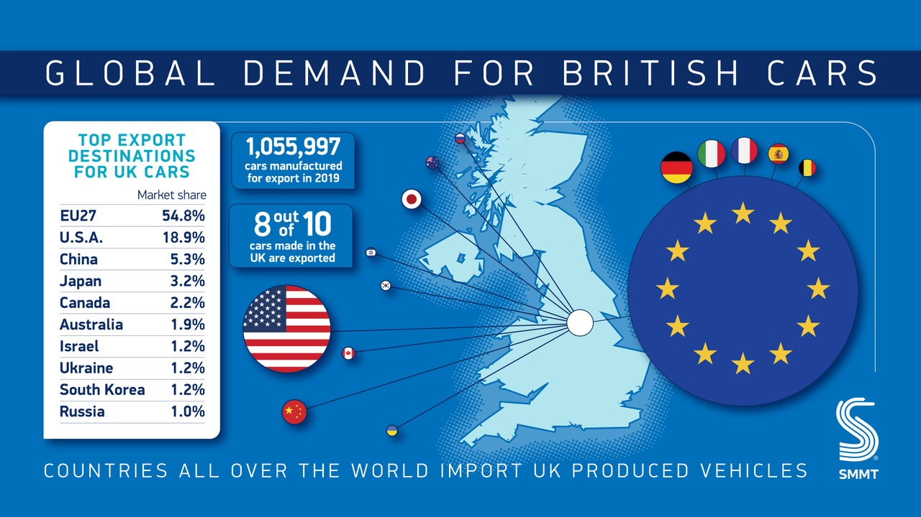
Figure: Impact of Brexit on car industry (SMMT, 2020)

Economic factors
The uncertainties and changes in the global economy in the last five years have brought significant changes to the car industry as well (Rogers, 2020). The major economic changes that underwent in the last several years include the slow growth of the developed economies, and China’s emergence as the fastest growing market in the global economy (Nauhria, Kulkarni and Pandey, 2017). The number of car sales over the years is a good reflection of it.
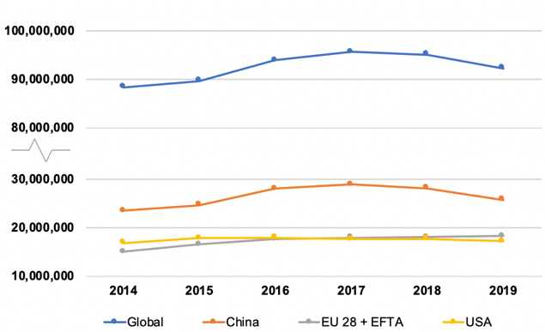
Figure: Changes in the annual sales of cars worldwide (Rogers, 2020)
The USA and the EU countries including the UK have experienced lower sales growth of cars over the years, whereas in China, more cars have been sold during this timeline (Scott, 2020). Other emerging markets have also experience greater sales of cars which led to many automotive companies shifting their focus on those countries instead. India, Brazil, Thailand, Saudi Arabia, and Egypt- these emerging markets have presented great opportunities for the car companies. These are the effects of the increased GNI and accelerating GDP in the emerging markets including China, whereas, the US and the EU economies haven’t experienced any significant boost lately (SMMT, 2020).

Social factors
The demand for sustainability and ethical business models have been some of the leading factors bringing changes to the industry (Thompson, Scott and Martin, 2017). The environmental costs of the cars with traditional engines are well-established. As the global leaders and the people across the world realize the constant damages done to the environment, people are now more aware of the carbon footprints their cars generate. Because of this, there has been a massive increase in the sales of environmentally friendly vehicles (Vošta and Kocourek, 2017). It is projected that by 2040, more than half of the automobiles will have environmentally friendly features. In 2019, over 2.5 million electric cars have been sold, surpassing the sales figures in 2018. Currently, the sales of electric vehicles are around 40% per year (SMMT, 2020).
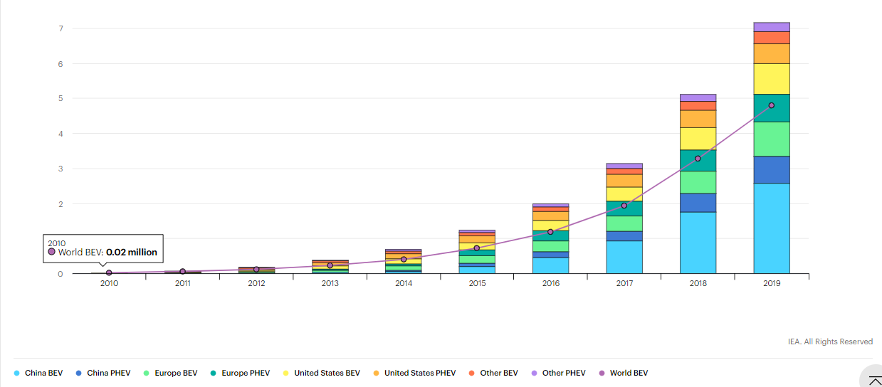
Figure: Increase in the sales of EVs due to the demands for sustainability (SMMT, 2020)
The trend is only going to get bigger as year passes. Not only that, some of the large automotive brands have also been replacing the use of leather for interior design with non-leather alternatives because of the mistreatment of animals in the leather industries (SMMT, 2020). It is obvious that sustainability and socially responsible branding are the biggest trends in the car sector right now.

Technological factors
The automobile industry is also introducing some disruptive technologies recently. Tesla’s self-driving cars, Google and Apple’s AI integrated automobiles- these are clearly the future trends in the automobile sector (Scott, 2020). Technological developments are making cars more energy efficient, more accident resistant, safer, more secured, more robust, and command driven. Autonomous Emergency Braking (AEB) technology is becoming more mainstream. It is one of the many autonomous features that can change the way people drive cars in the future. The only challenge there is in making these innovations more mainstream is the fact that they are still quite expensive, and not all companies have the skills to develop these (Rothaermel, n.d.). However, the technological shifts are certainly taking place at a fast rate compared to ever before.
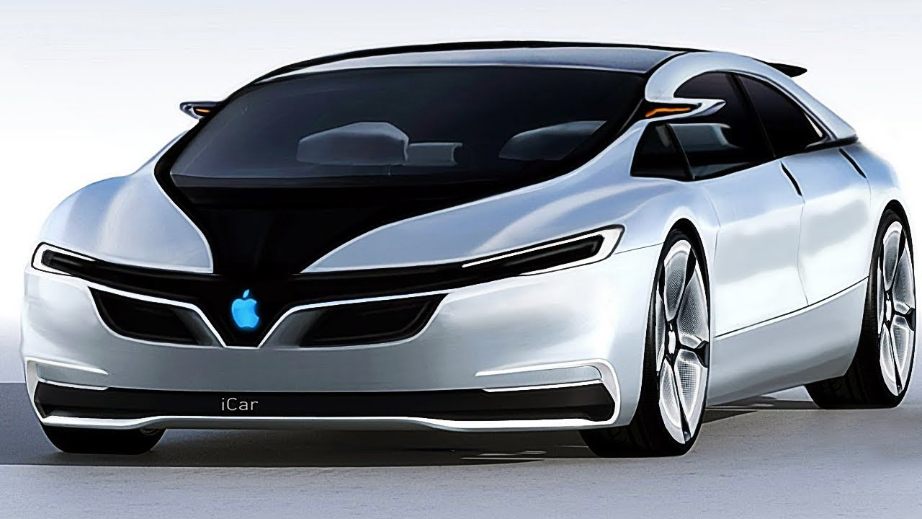
Figure: Apple Inc. has announced to release an energy efficient, IoT enabled and AI integrated Apple car in 2021 (Rogers, 2020)

Environmental factors
The social and environmental factors in the automobile industry have the same implications because the demands for sustainability in the modern society is translated into more eco-friendly and ethically manufactured cars (Rogers, 2020). The automobile manufacturers also have to comply with various international regulations that require them to manufacture environmentally friendly vehicles.

Legal factors
The legislations influence the car manufacturers differently in different countries. Since most of the large companies in this sector operate in an international scale, therefore, they have to comply with the laws in different countries and adjust to any legal changes taking place (Polymermedics, 2020). For instance, the legislative changes in the UK after Brexit will have significant impact on the local car industry. In some of the emerging markets such as Bangladesh, car manufacturers face market entry challenges due to the higher taxations (Nauhria, Kulkarni and Pandey, 2017).

Implications to the companies’ value chain
Due to the recent changes in the market and the overall business environments, companies are forced to respond with relevant changes to their firm infrastructure, technology development, procurement and HR so that their core business operations can be optimized to the current market demands, and their marketing activities can be made more customer oriented (Polymermedics, 2020).
For instance, in the USA alone, the car manufacturers invest over $19 billion each year on technology development and R&D. General Motors, a US based car manufacturer, had invested over $6.8 billion in 2019 in its R&D. The largest car manufacturer in the UK, Fords, had invested over $7.4 billion in its R&D last year (Kirkland, 2020). In 2019, around $26.2 billion has reportedly been spend on training and development of the workforce as well. Thus, the companies are more invested nowadays to improve their value chain components (Jay and McCarter, 2020).

Opportunities and challenges that these forces present for the car manufacturers
Given the current shifts in the industry and the ongoing developments, there are many opportunities that car manufacturers nowadays can capitalize on. However, given the uncertain political and economic landscapes, they also face significant threats in their global operations. To understand the opportunities and challenges that these factors present for the car manufacturers, the strengths and weaknesses of this sector first need to be acknowledged.

Strengths
Most of the car manufacturers such as Fords, Toyota, Nissan, Volkswagen, BMW, etc. - they are well established brands with clear target markets (Jay and McCarter, 2020). The industry itself is a capital intensive sector. Therefore, the companies find themselves in a challenges but also well-sustained position. Brand power has been one of the core strengths in this sector (Kirkland, 2020). The larger brands are more capable of penetrating the market.
In the recent years, innovation capabilities and resources have become the competitive strengths for many car manufacturers. Companies with greater innovation capabilities are able to market products that the customers expect and the products that meet the sustainability criteria (Jay and McCarter, 2020).

Weaknesses
The common weakness in this industry is the fact that innovation and unique designs cost more. Thus, more innovative cars are tagged with higher prices in the market, which fail to attract a larger consumer base. Also, the brand loyalty aspect often affect the smaller car manufacturers and limit their potentials for international market expansion (Kirkland, 2020).

Opportunities
The industry can easily be penetrated with dynamic innovation (Jay and McCarter, 2020). This has been one of the reasons why electric cars and AI integrated cars have seen a massive sales growth in the last several years. If a company can introduce innovation that meet the sustainability criteria and the consumer expectations, it becomes easy for the brand to capture a significant portion of the market share (Kirkland, 2020).
The industry is also growing at a fast pace. Therefore, investments in this sector are more likely to generate greater returns quickly. The increasing demands in the emerging markets have opened new doors for the global car manufacturers as well (Jay and McCarter, 2020).
As the digital technologies become more advanced and more accessible as well as less expensive, the car manufacturing industry finds new ways to innovate the automobiles. Market analysts suggest that the sector will see more disruptive innovations in the years to come (Fossdyke, 2020). Thus, it is an industry with high prospects.
The global economic recessions have also increased the manufacturing and sales of low cost cars across many of the parts of the world (David and David, n.d.). Therefore, companies do not necessarily have to solely focus on technologies and dynamic innovations.

Threats
The automobile industry is also a very challenging one. The brands that can introduce models with the right innovation and with the right architectures are the ones that ultimately make the largest amount of profits (McGee, Thomas and Wilson, 2006). Even the consumers of the low cost cars expect decent looking cars. The problems with this is that consumer preferences matter from person to person, which makes it quite difficult to introduce any particular model that will be generally acceptable (Rothaermel, n.d.).
The sector currently faces significant threats due to the pandemic lockdowns, which have put the business operations of many companies in a standstill position. Car manufacturers have been losing millions in profit during this pandemic (Scott, 2020). Right now, the major challenge for the companies would be to recover from this state.

Conclusion
The report has been presented with a detail discussion on the prospects, challenges, and the analysis of the internal and external business environments. It is evident that the car manufacturing industry worldwide is currently in a difficult position, but the opportunities are more than substantial as well. The sector will likely to see more disruptions in the years to come.

References
David, F. and David, F., n.d. Strategic Management.
Fossdyke, J., 2020. Demand For Eco-Friendly Cars Surges As Diesel's Decline Continues. [online] Motor1.com. Available at: <https://uk.motor1.com/news/304013/new-car-registrations-jan-2019/> [Accessed 23 December 2020].
IEA, 2020. Global EV Outlook 2020 – Analysis - IEA. [online] IEA. Available at: <https://www.iea.org/reports/global-ev-outlook-2020> [Accessed 23 December 2020].
Jay, A. and McCarter, E., 2020. Economic Conditions That Impact Auto Markets | Liberty Advisor Group. [online] Liberty Advisor Group. Available at: <https://libertyadvisorgroup.com/insight/economic-conditions-in-the-automotive-industry/> [Accessed 23 December 2020].
Jeyarathmm, M., 2008. Strategic Management. New Delhi: Himalaya Pub. House.
Kirkland, G., 2020. How New Technologies Have Changed The Automotive Industry » Oponeo.Co.Uk. [online] Oponeo.co.uk. Available at: <https://www.oponeo.co.uk/blog/how-new-technologies-have-changed-the-automotive-industry#:~:text=The%20biggest%20change%20that%20has,Autonomous%20Emergency%20Braking%20(AEB).> [Accessed 23 December 2020].
McGee, J., Thomas, H. and Wilson, D., 2006. Strategic Management. [Limerick]: McGraw-Hill.
Nauhria, Y., Kulkarni, M. and Pandey, S., 2017. Development of Strategic Value Chain Framework for Indian Car Manufacturing Industry. Global Journal of Flexible Systems Management, 19(S1), pp.21-40.
Polymermedics, 2020. How Brexit Will Affect The Automotive Industry. [online] Polymermedics. Available at: <https://polymermedics.com/blog/guide/how-brexit-will-affect-the-automotive-industry/> [Accessed 23 December 2020].
Rogers, K., 2020. Manufacturers To Spend $26.2 Billion On ‘Upskilling’ In 2020 To Attract And Keep Workers. [online] CNBC. Available at: <https://www.cnbc.com/2020/01/17/manufacturers-to-spend-26point2-billion-on-upskilling-workers-in-2020.html> [Accessed 23 December 2020].
Rothaermel, F., n.d. Strategic Management.
Scott, M., 2020. Electric Models To Dominate Car Sales By 2040, Wiping Out 13M Barrels A Day Of Oil Demand. [online] Forbes. Available at: <https://www.forbes.com/sites/mikescott/2019/06/10/electric-models-to-dominate-car-sales-by-2040-wiping-out-13m-barrels-a-day-of-oil-demand/?sh=4a8481d9342e> [Accessed 23 December 2020].
SMMT, 2020. Brexit And The UK Automotive Industry. [online] SMMT. Available at: <https://www.smmt.co.uk/industry-topics/europe-and-international-trade/> [Accessed 23 December 2020].
Thompson, J., Scott, J. and Martin, F., 2017. Strategic Management. Andover: Cengage.
Vošta, M. and Kocourek, A., 2017. Competitiveness of the European Automobile Industry in the Global Context. Politics in Central Europe, 13(1), pp.69-86.

