Student Name: Katie Rees
Student Number: 1903413
Date: 03/05/2022

geographical information systems

Contents
Task 1 1
Task 2 15
References 22

Task 1
Geographical Information Systems (GIS) are used to manage, analyse and map all types of data, combining location data with other type of data such as socio-demographic and census data. GIS helps to describe what things are like in a particular area, allowing us to make comparisons and decisions. [1] Geocoding can be used to turn a description of a location into a location on a map, in turn allowing us to demonstrate our data against specific locations on a map. [3]
To analyse the uptake of covid-19 vaccine, the middle super output area (MSOA) data for the whole of Wales has been downloaded using UK Data Services and Infuse Data [2], as shown in the screenshot below: -

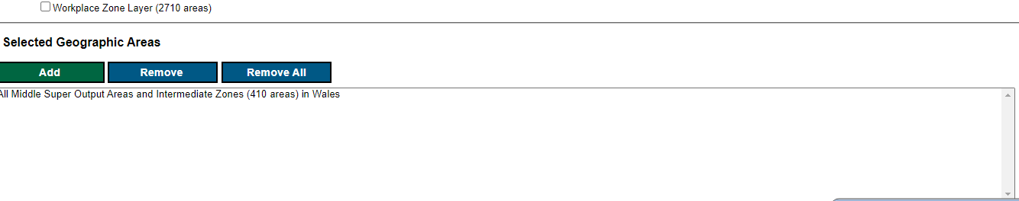
Fig. 1 Downloading MSOA data for Wales
Once downloaded, this information can be loaded into ‘MapInfo’ as demonstrated below: -
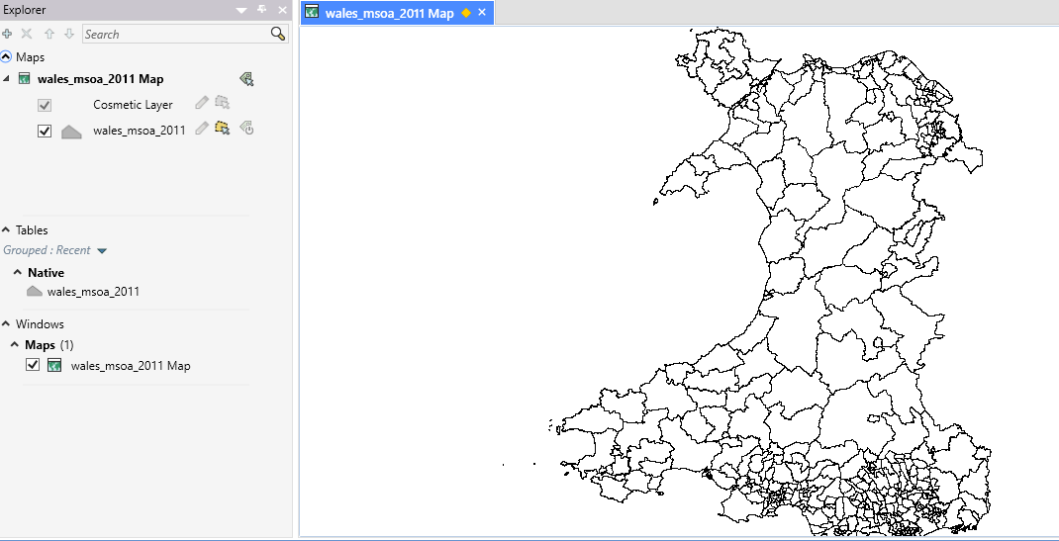
Fig 2. Wales Middle Super Output Area
The MSOA data can allow us to analyse the Covid-19 cases across the whole of Wales using the information from the ‘Rapid Covid-19 Surveillance Data’ spreadsheet provided. [3]
Data was extracted for rolling 7 days, rolling 21 days and all cases of Covid-19 incidence into three separate spreadsheets, and geocoded on MSOA code/GEO_CODE fields.
Once geocoded, a theme on the map has been created, which makes it easier to analyse the data. Thematic maps focus on a specific theme, such as Townsend Index or, as shown below, the number of Covid-19 cases. Thematic maps can be useful when trying to compare data in different locations and identifying any trends in data. [4]
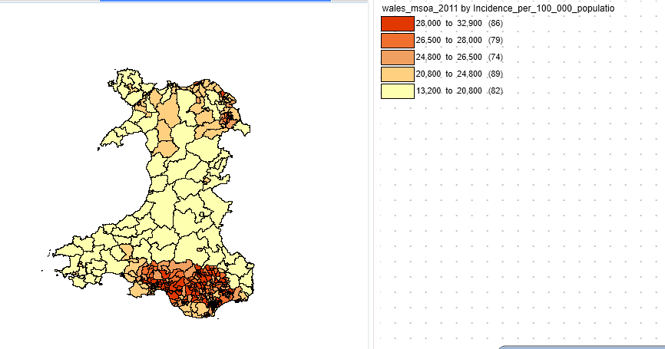
Fig 3. Covid-19 cases per 100,000 across Wales

Next, unitary census data has been collected via UK Data Service (Boundary Data Selector) [5] which will allow us to compare the Covid-19 Vaccine Uptake, as provided by the ‘Uptake of COVID-19 vaccination spreadsheet. [5]
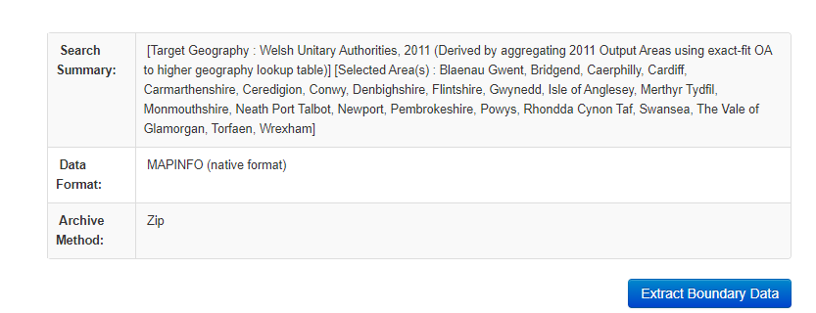
Fig 4. Downloading Welsh Unitary Authorities
Once downloaded, the unitary data can be loaded into MapInfo as shown below: -

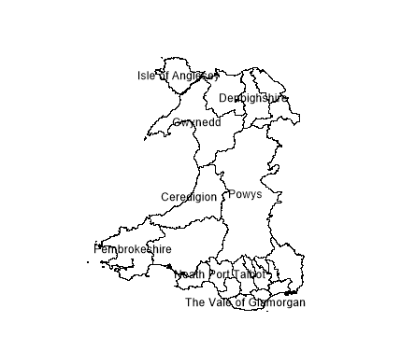
Fig 5. Welsh Unitary Authorities map
As you can see above, by downloading the unitary data, we still have a map of Wales, however the localities are at a higher level. These local authorities are used to group the Covid-19 vaccination uptake data.
As we are using Health Care data, Primary Care data has also been downloaded using UK Data Service (Boundary Data Selector) [5] which will allow us to compare information on a Health Board basis. This information will be useful to compare the covid-19 cumulative deaths across the whole of Wales.
To do this, the cumulative deaths held on the ‘Rapid Covid-19 Surveillance data’ [7] have been exacted into it a new excel file and the W code identified in the Primary Care data file has been added in as an extra column. This code has been included to allow us to Geocode the data against the local health board map.
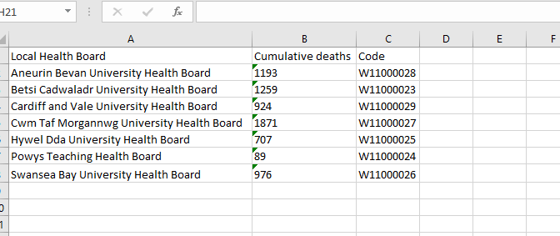Fig 6. Cumulative Deaths per LHB
Below outlines us geocoding the covid_19_deaths_by_LHB excel file against the primary care boundary data.
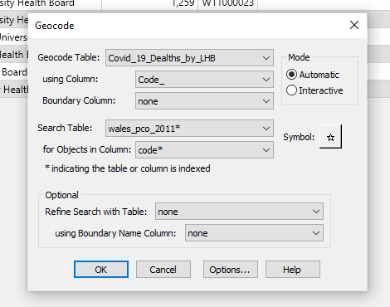
Fig 7. Geocoding covid-19 deaths data to primary care boundary data
To be able to compare the data easily, a thematic map has been created and joined on the primary care data table with cumulative deaths to observe the data through Wales:-
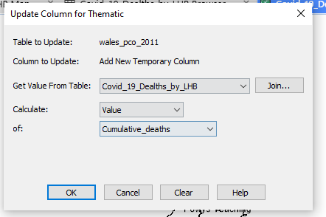
Fig. 8 Display cumulative deaths by primary care boundaries
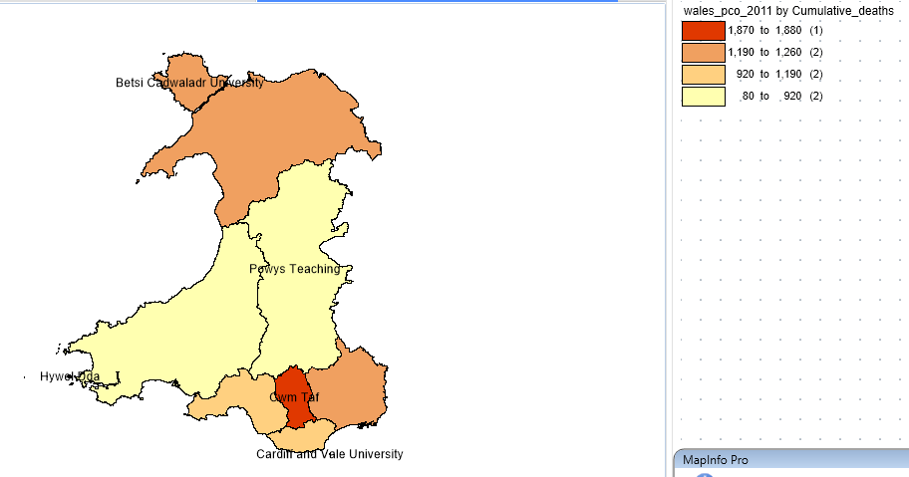
Fig. 9 Cumulative deaths by Primary Care Boundary
As we can see above, the highest cumulative deaths have been recorded in Cwm Taf area. However, as we’re using cumulative death figures, it would be useful to compare this data against the population for each area.
Below shows uploading the population data for Wales to MapInfo. This data has been downloaded from UK Data Services (Infuse Data) [2].
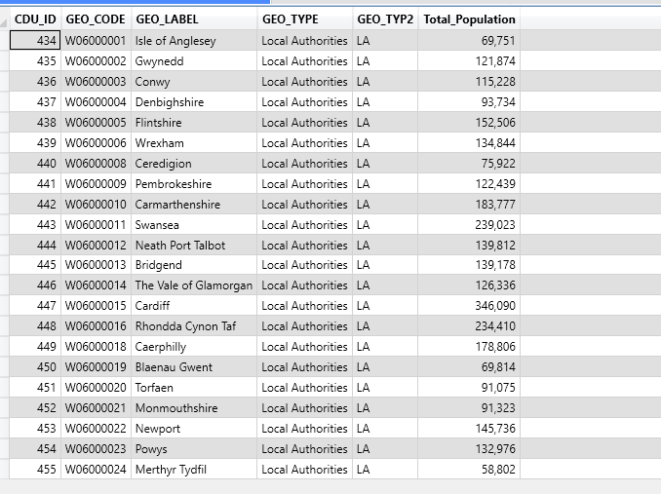
Fig. 10 Population database for Local Authorities across Wales
To display the information to allow us to compare Covid-19 cumulative deaths against population, it will need to be created into a thematic map, as shown below: -
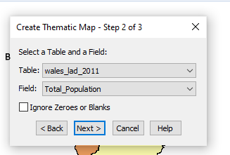
Fig. 11 Creating thematic map to display population in local authorities
Below is the total population against local authorities: -
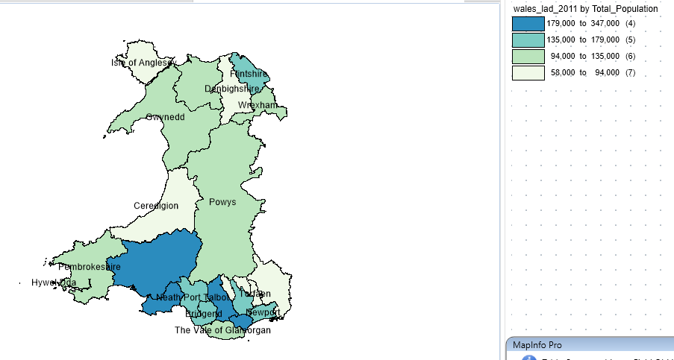
Fig. 12 Total population in Local Authorities
When comparing Covid-19 cumulative deaths against total population, we can see that in Cwm Taf, where the cumulative deaths were at its highest, it is in fact highly populated in comparison to the rest of Wales. However, we can see that Swansea and Cardiff are also highly populated, even more so than some areas in Cwm Taf (ie. Bridgend) yet their cumulative deaths are lower than the Cwm Taf. Most interesting are the population figures in Carmarthen against the cumulative deaths. Even though the population is high in Carmarthen, the cumulative Covid-19 death figures are some of the lowest across Wales. Whilst this is interesting, Carmarthen is a much larger area than the area of Cwm Taf and therefore density may have been a more suitable measure.
Next, the covid-19 vaccine uptake information has been uploaded into MapInfo from the Covid-19 Vaccination Data Download spreadsheet [3]: -
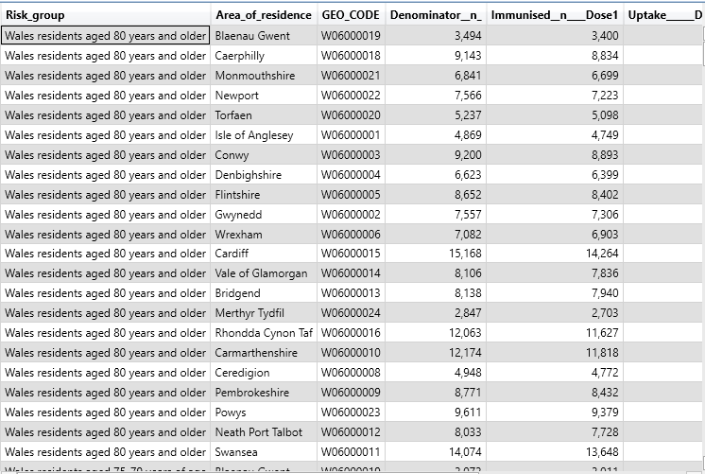
Fig. 13 database storing covid-19 vaccine uptake
This data includes the percentage of the population who have received their 1st dose, 2nd dose and booster dose of the Covid-19 vaccination, split by risk group and local authority. This can be used against our local authority map to compare the uptake of the Covid-19 vaccination uptake across Wales. Mostly, it will be interesting to compare the Cwm Taf area against the Covid-19 Uptake to see if there is any correlation between Covid-19 Vaccine uptake and Covid-19 cumulative deaths.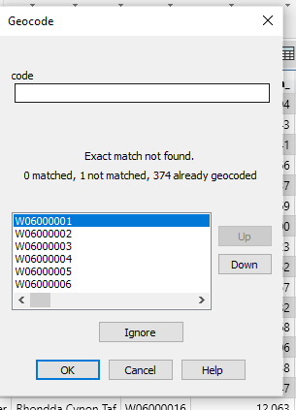
Fig 14. Geocoding covid-19 uptake data
Whilst geocoding this data, one code could not match and therefore an interactive had to take place.
To display the data, a thematic map was created to display the uptake of the first, second and booster Covid-19 doses.
At first, number of doses administered was considered however, to get a better picture of the actual uptake, it was decided that the percentage uptake would be a much better measure.
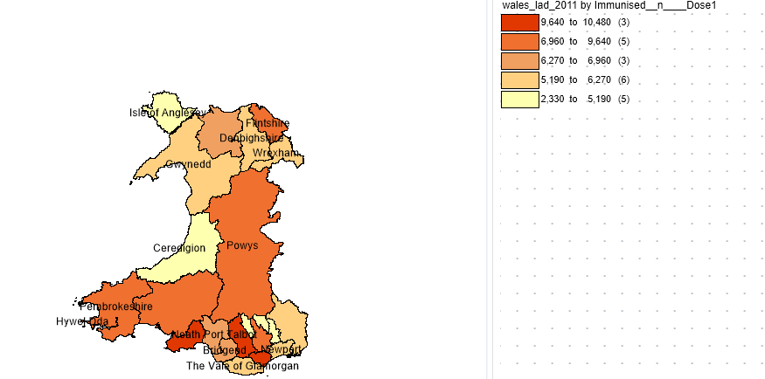
Fig 15. Number of 1st doses administered

Below shows the percentage uptake of the first dose: -
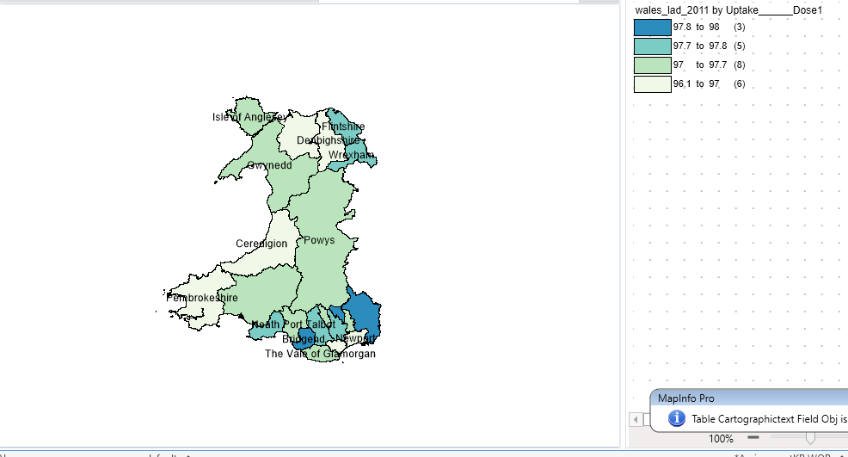
Fig. 16 Percentage of 1st doses received
As we can see above, there is the highest uptake for first dose in the South East of Wales.
Below shows the uptake of the second dose: -
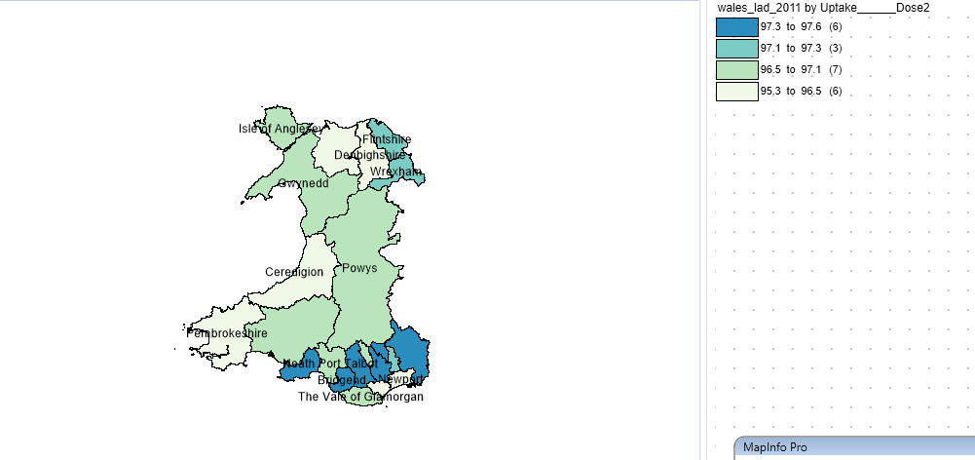
Fig. 17 Percentage of 2nd dose uptake
And finally, the booster dose: -
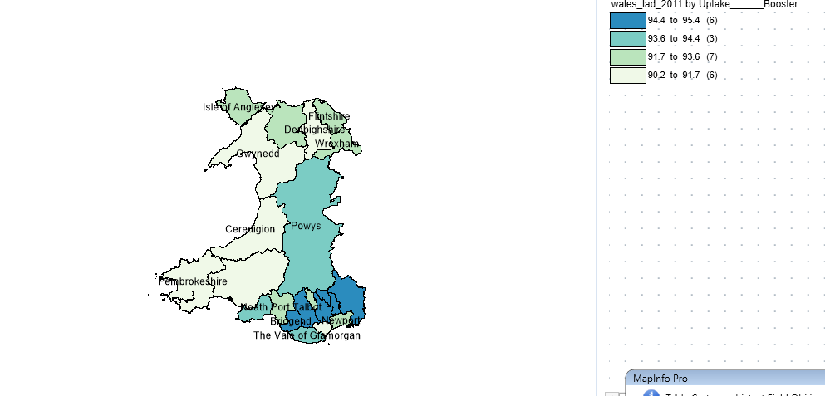
Fig. 18 Percentage of Booster dose uptake
In the thematic maps above, comparing the uptake for 1st, 2^{nd,} and booster doses, we can see the highest uptake of the covid-19 vaccine for all doses is in the Southeast region of Wales. There could be numerous reasons for this, such as access to transport and availability of vaccination centres.
To investigate further, the below maps show the locations of current mass vaccination centres across Wales. To identify this data, the postcode for vaccine sites were extracted from a Welsh Government website [8]. A postcode converter site was then used to identify the longitude and latitude locations of each Mass Vaccination Centre across Wales. [9]
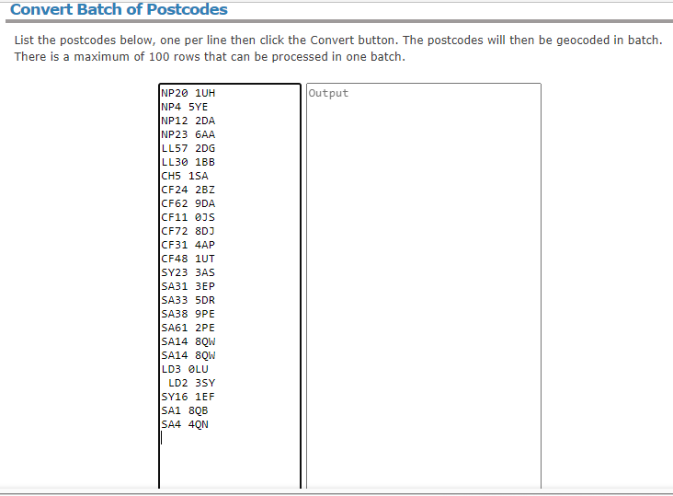
Fig. 19 Postcode converter
Once converted, the latitude and longitude figures, along with the postcode and name of vaccination centre were combined in an excel spreadsheet. This spreadsheet was then uploaded onto MapInfo.
Once the excel spreadsheet is loaded into MapInfo, points need to be created. To do this, the ‘Create Points’ tool is used against the longitude and latitude included in the excel spreadsheet.
The points created can then be included in the map, as shown below: -
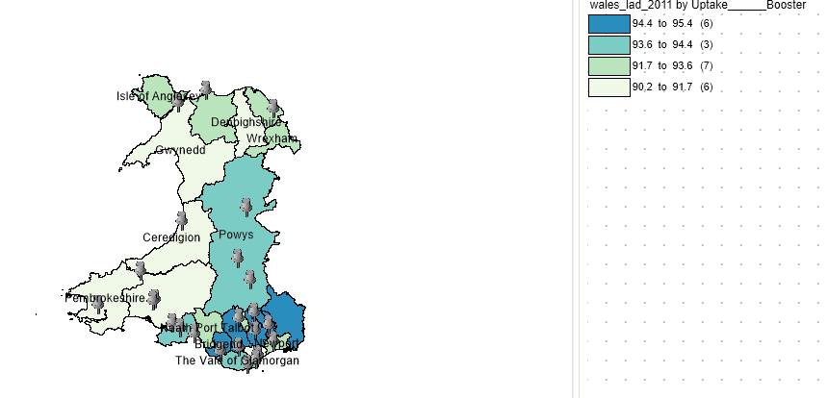
Fig. 20 Mass Vaccination Centres across Wales and Percentage Uptake of the Booster Covid-19 Vaccine
In the above map, the grey pin highlights the points at which the mass vaccination centres are located. As we can see, there seems to be a lot more vaccination centres in Southeast Wales in comparison to North, Mid and West Wales. This corresponds with the high uptake in this area and suggests that it could be advantageous to offer more vaccination centres in more rural areas of Wales to encourage a higher uptake of the COVID-19 vaccine.
Transport links could also be another factor as to why Covid-19 uptake is at its highest in Southeast Wales. The screenshot below includes transport links across Wales. This topographic ordnance survey data was captured using Digimap [10]. Once the strategi data had been downloaded, specific transport links were selected to be included on the current maps. This included railways, a-roads, b-roads, and motorways.
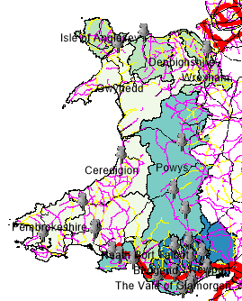
Fig 21. Map of Wales with Transport Link
Above shows the uptake of the covid-19 booster vaccine, along with the vaccination centre locations and transport links. What stands out immediately is the red motorway running through the Southeast of Wales. Not only is a motorway available but a lot of the vaccination centres are along the corridor of the motorway and therefore easily accessible for residents. When compared to the rest of Wales, transport links such as motorways are not available at all. Taking the local authority of Gwynedd for example, it has one of the lowest vaccination rates and it could be considered that this is because the vaccination centre is located towards the north of Gwynedd and very few transportation links are available, especially those located in the South of Gwynedd.
Finally, the covid-19 cumulative testing figures and cumulative cases were also uploaded to MapInfo to compare testing against cases in the localities. The below map shows the number of cases of covid-19 per 100,000: -
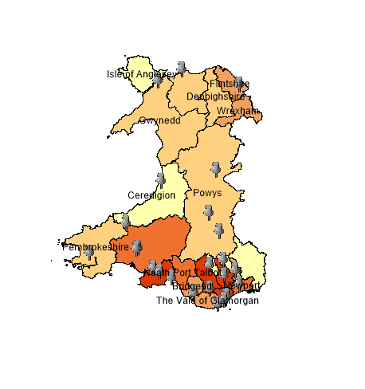
Fig. 22 cumulative Covid-19 cases across Wales and Vaccination Locations
As we can see, the above map shows us that there are more cases of Covid-19 per 100,000 in Southeast Wales in comparison to the rest of Wales. However the below map also shows that there is also much more testing in Southeast Wales: -
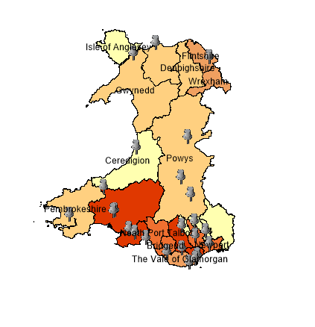
Fig. 23 Cumulative testing figures across Wales
There is very little difference between cumulative cases and cumulative testing figures and therefore whilst it can be concluded there are more cases in Bridgend, it does need to be considered that when there is more testing carried out, more identified cases would be a natural biproduct. It could be that less people required tests in the rest of Wales as they never had Covid-19 but it could also mean that citizens had less access to testing centres. As with the covid-19 vaccine uptake, we saw that transport links were much better in Southeast Wales and this should also be considered when comparing the testing and covid-19 cases figures.
To conclude, it’s apparent that the Southeast of Wales has the highest uptake of the Covid-19 vaccination, and it could be considered that this is due to the availability of not only transport links but multiple vaccination centres also. To encourage vaccine uptake in areas such as West, Mid and North Wales, it would be encouraged to locate more vaccination centres which would in turn make the Covid-19 booster vaccine more accessible. Alternative measures could be set in place such as offering more vaccines at GP locations where an area is more rural.

Task 2
The case study above highlights areas throughout the whole of Wales where the Covid-19 vaccination uptake may need promotion and improvement. Areas such as Gwynedd in North Wales have a low Covid-19 vaccination uptake in contrast to somewhere like Bridgend in South Wales. In this report, GIS will be used to analyse the Covid-19 data against sociodemographic data to find further trends and patterns within our data.
GIS is a system that connects data to a map allowing us to understand patterns and relationships in data. [1]
Sociodemographic data allows mapping in GIS and holds data about humans, their activities and even the room that’s required to carry out those activities. Socio demographic data is used extensively by Governments to make important decisions that include their country. Examples of socio demographic data would be births, income, age distribution, education levels, depravation and even access to car/van availability. This data can be incorporated into GIS which can then be used to demonstrate where this data sits at a location level. [11] For example, it can identify where there may be high levels of deprivation or where there is a high level of education. This data can then be compared with itself or against other datasets to conclude an argument, along with the use of thematic and spatial maps.
GIS can be useful for socio-economic data as users are able to upload data in serval different formats. It allows you to use census data, topology data, health care data, such as the one used in this report, and data created by the user. These datasets can be used on their own, or they can form a combination of layers within a GIS map which can help you form an opinion and make decisions. GIS allows you to display data across a country, and narrow that data down to perform further, more extensive analysis, for example on a specific county, as has been done in this report. One major advantage is that it allows you to upload your own data from an excel spreadsheet, that can be cleansed before importing, and easily transform that data into a visual representation of a map of your choice. GIS allows you to show your socio demographic data in a visual way that makes it easy to create a decision. The data can be displayed in different ways, using multiple colours and symbols. [12] As GIS can offer quick data collections, more time can be spent analysing the dataset to reach better, more informed decisions rather than wasting time collecting the data. [13]
Whilst GIS is useful for displaying socio-economic data, it is absolutely vital that the data being used is accurate. The underlying map data must be accurate for any data to display in the correct location. It is therefore imperative that the underlying map references are correct before displaying your data. It’s also important to ensure that if this data is provided by a third party, such as the boundary data selector on UK Data Service, that the source is reliable. It is also important that the dataset sets uploaded have accurate data so that geocoding is correct. If the geocode was incorrect, then you would see incorrect data displayed which could impact a major decision. [12] Another downfall of GIS systems is that they are not always user friendly. MapInfo for example, isn’t always self-explanatory and therefore it’s important to invest time into learning the system before creating thematic and spatial maps to ensure that MapInfo is being used to the best of its ability. GIS also depends on data being readily available, and that data being accurate. [13] For example, the Covid-19 spreadsheet provided suggests that some Covid-19 vaccination data may still be on paper and that the data relies on Health Board staff to input accurate data onto the Welsh Immunisation System (WIS). Due to this, it could be considered that the data may be skewed in some locations. For example, some Health Boards may have different local processes and may take longer to upload their data onto WIS or some may be better at uploading accurate data. Taking Betsi Cadwaldr Health Board as an example, they have the largest area in Wales to cover, yet there are only three vaccination centres. As they have so many people to vaccinate, it could be the case that results aren’t uploaded to WIS in such a timely manner as Powys for example, who have a much smaller population to manage. Another example is that Covid-19 cases were much higher in Southeast Wales in comparison to the rest of Wales however it was soon identified that there was a lot more testing also. Whilst it may be that more people were ill in Southeast Wales, requiring a test, it should also be considered that there are less transport links in the rest of Wales and therefore it may be more difficult for citizens to access testing facilities.

Thematic and spatial maps are very important in representing data in a powerful visual. They are used to demonstrate spatial patterns of one or multiple datasets, for example, as used in task 1, Covid-19 vaccine uptake and population data. They are important tools within GIS and it allows you to make a decisions by providing easy visuals. [12] They have been used throughout this report to highlight common trends in the data provided and to make conclusions.
The case study in task 1 found some interesting patterns and trends. We found Covid-19 deaths correlate with the population density in an area. Densely populated areas had a higher number of cumulative deaths however, the data used for cumulative deaths was not a percentage, and instead a cumulative figure therefore the results found would be expected and could be considered unreliable. Comparing the population density against the percentage of covid-19 deaths in an area could have given us a more accurate reflection. It was also noted that the uptake of the Covid-19 booster was much better in Southeast Wales compared to the rest of Wales. This could be due to numerous reasons however GIS allowed us to confirm that Southeast Wales has much better transport links which alludes to citizens being able to access Covid-19 vaccination centres easier. GIS also noted that South Wales had more vaccination centres in a much smaller area and therefore it could be considered that there are more available appointments, and it would take a lot less time to get to a Covid-19 appointment than in the North of Wales for example. This could be a huge factor into why the uptake in Southeast Wales is so high in comparison to the rest of Wales. Citizens may be able to get to their vaccination centres within minutes whereas in North Wales especially, it could be hours. Using the case study above, we will focus on one area within Wales, and provide further analysis on the Covid-19 data against socio economic data within that area.
The below map displays the covid-19 total cases per 100,000 population in the mid super output level of Bridgend only: -
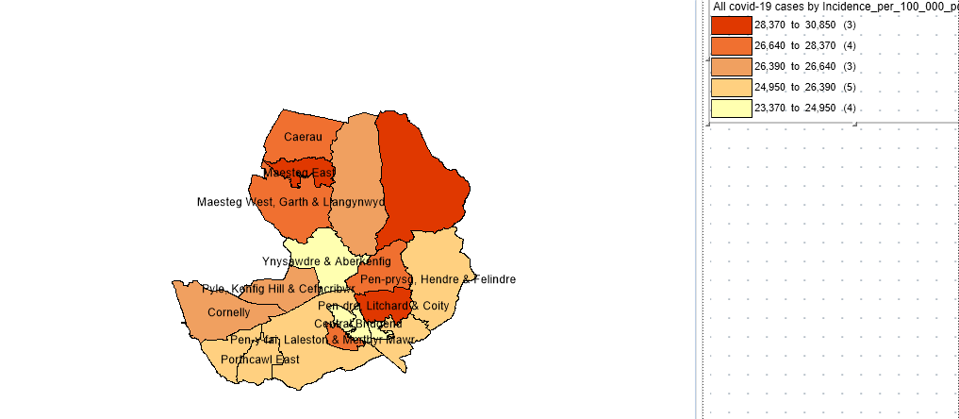
Fig. 24 Total Covid-19 cases per 100,000 in Bridgend
We can see that in Bridgend the cases tend to be higher in North Bridgend however there are some localities that do not fit that argument, such as Litchard.
If we were to compare this to the townsend index of Bridgend we can see in the below map that the north of Bridgend is more deprived. Again, there are areas that go against this trend, such as Bridgend Town and Cornelly however as a majority, the south of Bridgend has a lower townsend index than North Bridgend, suggesting that it is less deprived.
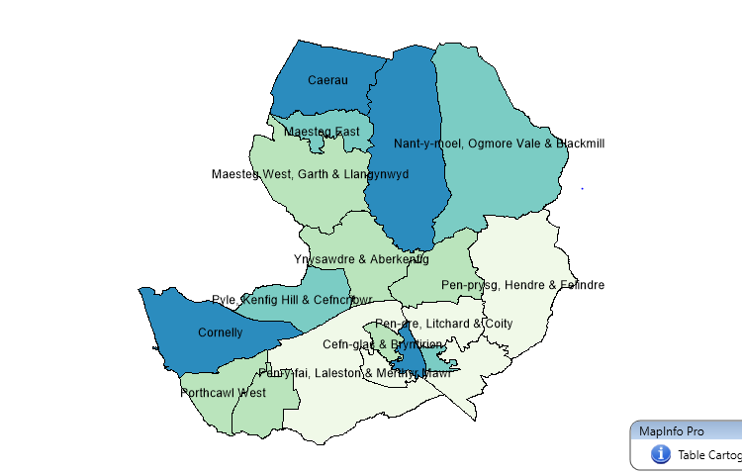
Fig. 25 Townsend Index in Bridgend
If comparing this against covid-19 cases, we can see that there does seem to be a trend against the townsend index. Where there is a higher townsend index ie. higher deprivation, the covid-19 cases are generally higher. This does not ring true however within Litchard & Coity where there is a low townsend index but a high reporting of cases. This could be down to a more testing or a higher population.
The map below compares the density of the middle super output areas of Bridgend: -
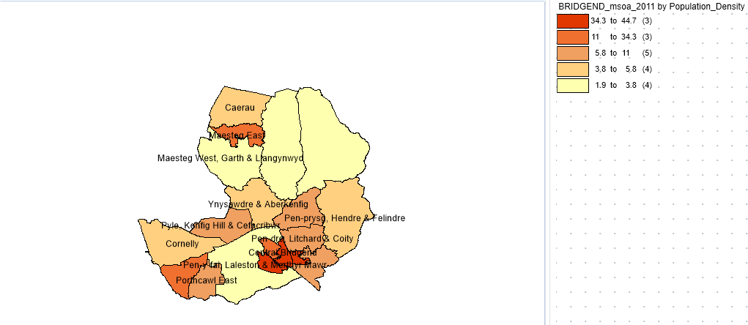
Fig 26. Density in Bridgend
We can see that whilst Litchard and Coity have a high Covid-19 case, they have a low townsend index and they’re not highly populated either. Bridgend town on the other hand, which is a high deprivation area and highly dense, has a low Covid-19 case rate. Referencing the location of mass vaccination centres, we can see below that the centre in Bridgend is in the town centre: -
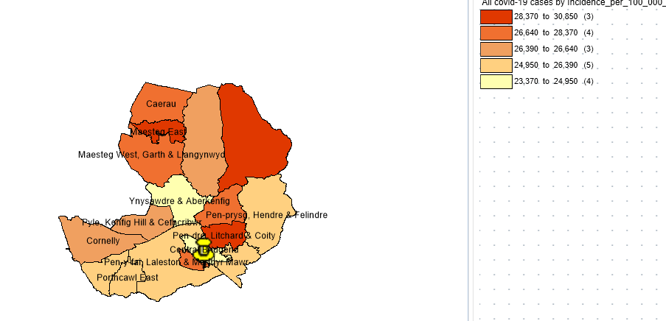
Fig. 27 Covid-19 cases per 100,000 in Bridgend
This could suggest why the covid-19 cases are lower in Bridgend town.
Next, we can analyse health data within Bridgend against the covid-19 data. The below map shows the percentage of the population who have very good health within Bridgend: -
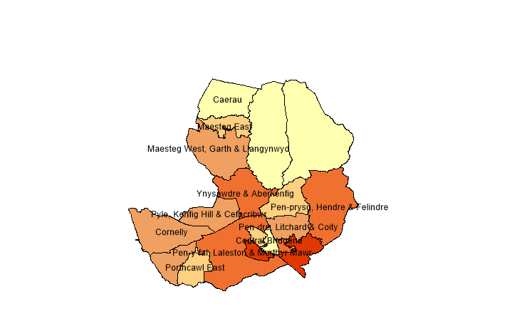
Fig 28. Very Good Health in Bridgend
We can see that generally, very good health and Covid-19 cases see a compelling trend of the better the general health in a location, the lower the covid-19 cases. Taking Nant-y-moel, Ogmore Vale & Blackmill into consideration, we can see from the above map that this area does not have a high percentage of bad health and they also have one of the highest rates of covid-19 cases. If we were also to look at the percentage of very bad health, we would expect to see a high percentage in this area, which is proven by the map below: -
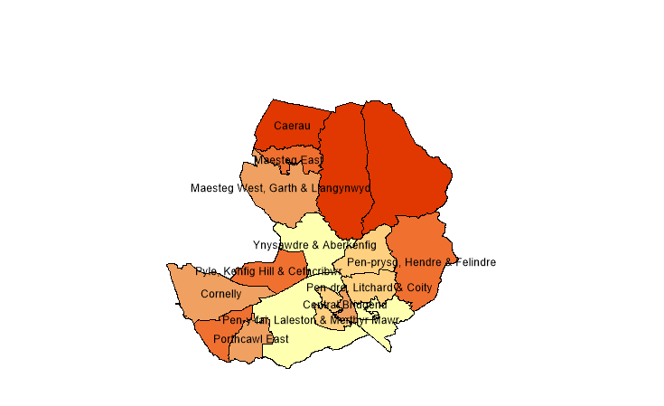
Fig. 29 Very Bad Health
We can see that where there is better health in the South of Bridgend, the covid-19 cases are lower and vice versa. Again, however Bridgend Town goes against this trend. Whilst it has high deprivation and a generally low rate of very good health, the covid-19 cases are low. Again, this could be down to the location of the main vaccination centre in Bridgend. It could also be down to the great transport links that are also located in Bridgend Town such as the railway line and the motorway close-by.

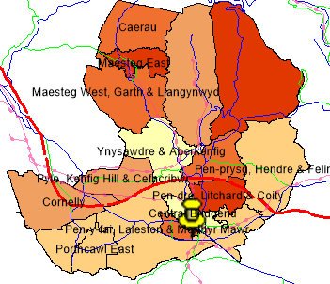
Fig. 30 Transport Links in Bridgend
The map above compares the cumulative cases per 100,000 against the transport links within Bridgend. With the motorway and railway line, it becomes apparent that there is better transport links within the South/Mid Bridgend. Ogmore Vale for example has no railway transport and with a high deprivation level also, it suggests that people may struggle to access their local mass vaccination site. Observing the map above makes it apparent that Bridgend would benefit from a vaccination centre located in North of Bridgend also. This would give people in the North a better chance of being able to attend their appointments easily. For example, those who may not have access to a car or family/friends who could take them to their appointment would struggle to travel to the centre of Bridgend, which is reflected in the number of Covid-19 cases recorded in that area.

To conclude, GIS along with the use of thematic and spatial maps has allowed us to analyse the Covid-19 vaccine uptake and Covid-19 cases across Wales, alongside other socio-demographic and topology data. GIS made it apparent that those place where transport links where of more avail had higher rates of Vaccination. It also suggested that within Bridgend, the areas with low health were generally more at risk of Covid-19 cases however the area of Bridgend town did skew that observation.

References

[1] | “What is GIS?,” ESRI, [Online]. Available: https://www.esri.com/en-us/what-is-gis/overview#:~:text=A%20geographic%20information%20system%20(GIS,what%20things%20are%20like%20there).. [Accessed 1 May 2022].
[2] | “Whats is Geocoding?,” [Online]. Available: https://learn.g2.com/geocoding. [Accessed 1 May 2022].
[3] | [Online]. Available: https://infuse.ukdataservice.ac.uk/. [Accessed May 2022].
[4] | P. H. Wales, Rapid Covid-19 Surveillance Data.
[5] | “What is a Thematic Map? 6 Types of Thematic Maps,” 19 October 2020. [Online]. Available: https://www.maptive.com/thematic-map-examples/. [Accessed 1 May 2022].
[6] | “Boundary Data Selector,” UK Data Service, [Online]. Available: https://borders.ukdataservice.ac.uk/bds.html. [Accessed 1 May 2022].
[7] | Welsh Immunisation System, 2022.
[8] | “Get your Covid-19 Vaccination,” Welsh Government, [Online]. Available: https://gov.wales/get-your-covid-19-vaccination. [Accessed 1 May 2022].
[9] | “Convert UK Postcode to Latitude/Longitude,” Free Map Tools, [Online]. Available: https://www.freemaptools.com. [Accessed 1 May 2022].
[10] | Ordnance Survery, Digimap, 2022.
[11] | “GIS and Socio-Economic Data,” GIS University, [Online]. Available: https://gis-university.com/gis-and-socio-economic-data/. [Accessed 2 May 2022].
[12] | “Thematic Maps (GIS and Spacial Analysis),” what-when-how, [Online]. Available: http://what-when-how.com/gis-and-spatial-analysis-for-the-social-sciences/thematic-maps-gis-and-spatial-analysis-part-1/. [Accessed 2 May 2022].
[13] | H. Soffar, “GIS Data (Geographic Information Systems) uses, advantages and disadvantages,” 6 February 2017. [Online]. Available: https://www.online-sciences.com/technology/gis-data-geographic-information-systems-uses-advantages-and-disadvantages/. [Accessed 2 May 2022].
[14] | S. S. Ayca, “Thematic Mapping With CARTO,” 4 September 2019. [Online]. Available: https://www.gislounge.com/thematic-mapping-with-carto/#:~:text=Thematic%20maps%20are%20referred%20to,%2C%20maximum%20daily%20temperature%2C%20etc.. [Accessed 2 May 2022].

