

Data Handling and Business Intelligence

LCBB5000

Assessment 2

Student’s Name: Ralitsa Yordanova
Student’s Id: 2023562
Lecturer’s Name: Dr. Anupam Mazumdar
Table of Contents
Introduction 3
MS Excel 4
If function 4
PIVOT TABLES 5
Visual representation 6
Section 2 7
Count if function 7
Mean function 8
Median function 10
Visual representations 11
K-Mean clustering 12
Data mining methods 23
Text mining methods 24
Advantages and disadvantages of Excel and SPSS 24
Conclusion 26
References 27

List of figures
Figure 1 Graphical presentation of pivot table 7
Figure 2Graphical presentation of pivot table 8
Figure 3Graphical presentation of students data 12
Figure 4 Graphical presentation of students' data 13

Introduction
Spreadsheets are used to organize, store, and track data sets in Microsoft Excel, which is an analysis and visualization application programme. This application software can process numerous data sets at the same time. Advanced functions allow users to answer a variety of statistical problems more quickly. The report will cover multiple functions of excel including if, count and average. The report will deliver a better understating of the data with the use of visual representations. The K-mean clustering function of SPSS will also cover by the report. The advantages and disadvantages of excel and SPSS software will also be discussed in the report.

MS Excel
Microsoft excel is an analysis and visualization application software, for organising, storing and tracking the data sets spreadsheets are used. This application software has the ability to handle multiple data sets at a single time. With the help of advanced functions, users can solve various statistical problems at quicker rates. For the given data set MS Excel is used for functions including:

If function
The IF function of MS excel is considered the most demandable function of Excel. With the help of IF functions users can make logical comparisons among the values. For the given data the function has been used for making the logical compression between the crime rates.
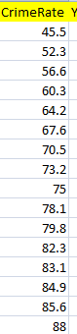
The above figure has shown the crime rates to make the logical compression between the values of crime rates the IF function has applied to the data set
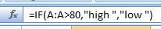
the use of the IF function has made logical compression in terms of “HIGH” “LOW” if the value of the crime rate is below 80 the function has shown the result in terms of low but if the value of the result is above then 80 the function has shown the result in term of high.
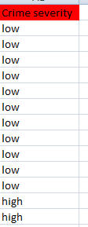

PIVOT TABLES
In excel Pivot tables are considered the interactive way to summarize a huge amount of data sets at a quicker rate. Pivot tables are specially designed for analyzing a wide amount of data sets in user-friendly ways.
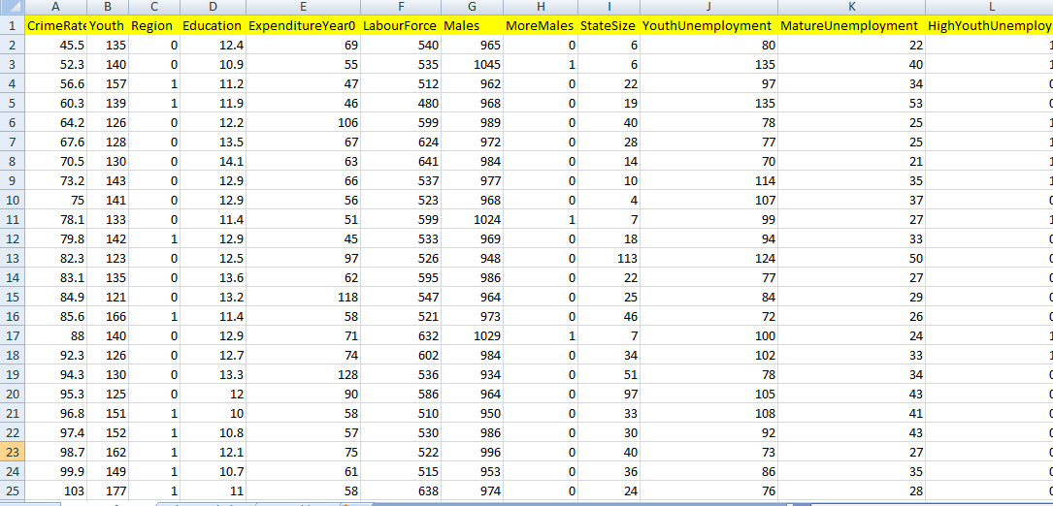
The above figure shows the data of different categories with the help of pivot tables the entire data set can be solved in a linear and easy way
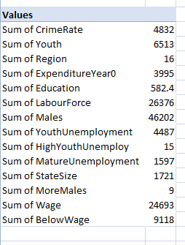

Visual representation

Figure 1 Graphical presentation of pivot table

Figure 2Graphical presentation of pivot table

Section 2

Count if function
It is considered the statistical function of excel, the use of this function is to count the cells of specific criteria. For the given set of data, the function is used to count the number of students who like vanilla flavor.
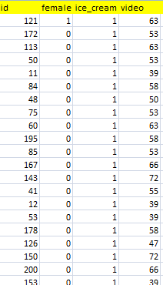
The above figure shows the data of multiple students who like different flavours including vanilla with the help of the count if function the number of students who like vanilla flavour will be calculated
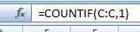
The function counts the cells according to the requirements and provides desired results.
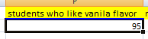

Mean function
This function is considered the most used function in excel, the function provides an arithmetic average of the given set of numbers. For the given data set the mean function is used to define the average of participants who like the chocolate and strawberry flavour.
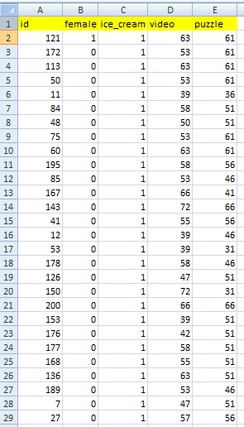
The data set includes multiple entries including the male and female students who like different types of flavours. To find the mean of participants who like chocolate and strawberry flavour the average function has been applied to the data set
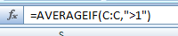
The average function adds the values and divides the sum of numbers by the numbers of data values
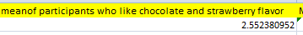

Median function
In statistics median provide the middle value of the given data, this function is categorized under the functions of excel statics. For the given data set median function is used to determine the number of participants who likes chocolate and strawberry flavor.
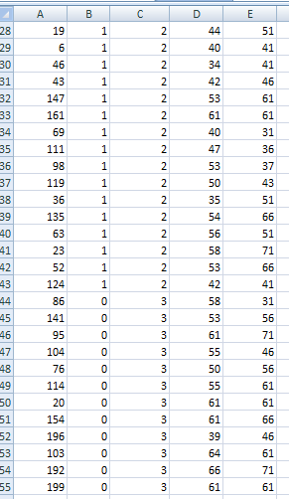
The data set has provided the data of particular students who like chocolate and strawberry flavour. the formula of median has been applied to the c Colum to determine the number

The formula of median classifies the middle number of students from chocolate and strawberry flavour
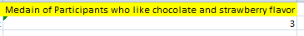

Visual representations
Data visualization is considered the graphical representation of the data. With the help of visual representations, users can get a quick understating of information of data.

Figure 3Graphical presentation of students data

Figure 4 Graphical presentation of students' data
The above graphs deliver the multiple attributes of data which define the number of male and female students, students who like vanilla flavour, as well as the graphs, also provide the mean and median of the students who like strawberry and chocolate flavour.

K-Mean clustering
Initial Cluster Centers
 | Cluster
 | 1 | 2 | 3 | 4
female | 0 | 1 | 1 | 0
ice_cream | 2 | 1 | 3 | 1

Iteration Historyª
Iteration | Change in Cluster Centers
Iteration | 1 | 2 | 3 | 4
1 | .568 | .000 | .000 | .000
2 | .000 | .000 | .000 | .000

a. Convergence achieved due to no or small change in cluster centers. The maximum absolute coordinate change for any center is .000. The current iteration is 2. The minimum distance between initial centers is 1.000.

Cluster Membership
Case Number | Cluster | Distance
1 | 1 | .568
2 | 2 | .000
3 | 1 | .748
4 | 1 | .748
5 | 4 | .000
6 | 4 | .000
7 | 4 | .000
8 | 4 | .000
9 | 4 | .000
10 | 4 | .000
11 | 4 | .000
12 | 4 | .000
13 | 1 | .748
14 | 1 | .748
15 | 1 | .568
16 | 1 | .568
17 | 1 | .748
18 | 4 | .000
19 | 1 | .748
20 | 4 | .000
21 | 4 | .000
22 | 4 | .000
23 | 4 | .000
24 | 1 | .748
25 | 4 | .000
26 | 4 | .000
27 | 1 | .748
28 | 4 | .000
29 | 1 | .748
30 | 1 | .568
31 | 4 | .000
32 | 1 | .748
33 | 1 | .748
34 | 4 | .000
35 | 1 | .748
36 | 1 | .748
37 | 4 | .000
38 | 1 | .748
39 | 1 | .568
40 | 4 | .000
41 | 4 | .000
42 | 4 | .000
43 | 4 | .000
44 | 1 | .568
45 | 1 | .748
46 | 1 | .568
47 | 1 | .748
48 | 4 | .000
49 | 4 | .000
50 | 4 | .000
51 | 4 | .000
52 | 1 | .748
53 | 4 | .000
54 | 4 | .000
55 | 4 | .000
56 | 1 | .748
57 | 1 | .568
58 | 4 | .000
59 | 4 | .000
60 | 4 | .000
61 | 4 | .000
62 | 1 | .748
63 | 1 | .568
64 | 4 | .000
65 | 1 | .748
66 | 4 | .000
67 | 4 | .000
68 | 1 | .568
69 | 1 | .568
70 | 4 | .000
71 | 4 | .000
72 | 1 | .748
73 | 4 | .000
74 | 4 | .000
75 | 4 | .000
76 | 1 | .568
77 | 1 | .748
78 | 1 | .748
79 | 4 | .000
80 | 1 | .748
81 | 1 | .748
82 | 1 | .568
83 | 4 | .000
84 | 1 | .568
85 | 4 | .000
86 | 1 | .748
87 | 1 | .748
88 | 1 | .748
89 | 4 | .000
90 | 1 | .748
91 | 4 | .000
92 | 1 | .568
93 | 3 | .000
94 | 1 | .693
95 | 1 | .693
96 | 1 | .693
97 | 2 | .000
98 | 3 | .000
99 | 1 | .693
100 | 3 | .000
101 | 3 | .000
102 | 3 | .000
103 | 1 | .693
104 | 3 | .000
105 | 2 | .000
106 | 2 | .000
107 | 3 | .000
108 | 1 | .693
109 | 1 | .693
110 | 3 | .000
111 | 2 | .000
112 | 1 | .693
113 | 3 | .000
114 | 1 | .693
115 | 3 | .000
116 | 2 | .000
117 | 3 | .000
118 | 3 | .000
119 | 1 | .693
120 | 1 | .693
121 | 1 | .693
122 | 2 | .000
123 | 2 | .000
124 | 2 | .000
125 | 1 | .693
126 | 3 | .000
127 | 2 | .000
128 | 2 | .000
129 | 3 | .000
130 | 1 | .693
131 | 2 | .000
132 | 1 | .693
133 | 2 | .000
134 | 2 | .000
135 | 1 | .693
136 | 3 | .000
137 | 2 | .000
138 | 2 | .000
139 | 2 | .000
140 | 2 | .000
141 | 1 | .693
142 | 3 | .000
143 | 2 | .000
144 | 2 | .000
145 | 2 | .000
146 | 3 | .000
147 | 2 | .000
148 | 2 | .000
149 | 1 | .693
150 | 1 | .693
151 | 1 | .693
152 | 3 | .000
153 | 2 | .000
154 | 2 | .000
155 | 2 | .000
156 | 2 | .000
157 | 2 | .000
158 | 2 | .000
159 | 2 | .000
160 | 3 | .000
161 | 1 | .693
162 | 2 | .000
163 | 3 | .000
164 | 1 | .693
165 | 2 | .000
166 | 1 | .693
167 | 2 | .000
168 | 1 | .693
169 | 2 | .000
170 | 1 | .693
171 | 1 | .693
172 | 2 | .000
173 | 3 | .000
174 | 3 | .000
175 | 1 | .693
176 | 1 | .693
177 | 2 | .000
178 | 2 | .000
179 | 3 | .000
180 | 1 | .693
181 | 2 | .000
182 | 2 | .000
183 | 3 | .000
184 | 2 | .000
185 | 3 | .000
186 | 1 | .693
187 | 2 | .000
188 | 2 | .000
189 | 3 | .000
190 | 1 | .693
191 | 1 | .693
192 | 3 | .000
193 | 2 | .000
194 | 3 | .000
195 | 2 | .000
196 | 2 | .000
197 | 2 | .000
198 | 2 | .000
199 | 2 | .000
200 | 3 | .000

Final Cluster Centers
 | Cluster
 | 1 | 2 | 3 | 4
female | 0 | 1 | 1 | 0
ice_cream | 2 | 1 | 3 | 1

Distances between Final Cluster Centers
Cluster | 1 | 2 | 3 | 4
1 |  | 1.498 | .847 | 1.444
2 | 1.498 |  | 2.000 | 1.000
3 | .847 | 2.000 |  | 2.236
4 | 1.444 | 1.000 | 2.236

ANOVA
 | Cluster |  | Error |  | F | Sig.
 | Mean Square | df | Mean Square | df | F | Sig.
female | 10.356 | 3 | .095 | 196 | 109.564 | .000
ice_cream | 42.740 | 3 | .092 | 196 | 467.101 | .000

The F tests should be used only for descriptive purposes because the clusters have been chosen to maximize the differences among cases in different clusters. The observed significance levels are not corrected for this and thus cannot be interpreted as tests of the hypothesis that the cluster means are equal.

Number of Cases in each Cluster
Cluster | 1 | 76.000
Cluster | 2 | 48.000
Cluster | 3 | 29.000
Cluster | 4 | 47.000
Valid |  | 200.000
Missing |  | .000

Data mining methods
Classification: In this data mining process, attributes are utilized to record the data under distinct categories. Client information may be kept more regularly and businesses can gain a better understanding of customer needs with the assistance of categories classification.
Clustering: with this process of data mining, related data sets are categorized and businesses are given the most basic form of data.
Regression analysis is a strategy for creating a plan and strategy, as well as identifying specific variables. The relation between the sets can be established using regression analysis.
Telecom companies, for example, can utilize data mining to plan their campaigns marketing and keep their clients from switching to another vendor.

Text mining methods
Information extraction is the most frequent text mining technique used by corporations, and it is based on the communication of material. Meaningful data is gathered from a number of datasets using this technique.
Categorization, or Natural Language Processing (NLP), is the act of gathering textual content and analyzing and evaluating them to determine the appropriate indexes or subjects for each text.
Text mining, for example, is utilized in customer support to deliver quick responses to clients; the whole response procedure is focused on computerized patterns.

Advantages and disadvantages of Excel and SPSS
Advantages of Excel | Disadvantages of Excel
Excel spreadsheets are used for data gathering and organization, allowing the full data established to be managed in a well-defined manner and providing instant understanding to users.  Numerous user access: This is considered Excel's best feature; multiple users can access the same file at the same time.  Excel, for example, is often used in organisations for entering data and processing, and it is a critical tool for both tasks. | user bias: in data analysis and interpretation, the decision-making method can be eliminated.  Lack of security: Another downside of spreadsheets is the potential for data corruption and incompetence.

Advantages of SPSS | Disadvantages of SPSS
SPSS is advanced statistical software that offers users a number of advantages in terms of data handling.  SPSS has a number of advanced statistical tests, which distinguishes it from its competitors.  The outcome is relatively simple to interpret.  It has the ability to display data tables at a faster rate.  SPSS, for example, is widely utilized by a variety of organizations for the examination of complex data sets. | The cost of purchasing is excessive for students.  Users must be trained in order to take advantage of its features.  The graph's feature is not as straightforward as Excel's.

Conclusion
In Excel Spreadsheets, which is an analytical and presentation application programme, spread worksheets are being used to arrange, save, and record data sets. This application programme can handle a large number of data sets at once. Advanced features allow users to easily solve a range of statistical problems. The report has covered multiple functions of excel including if, count and pivot tables. The report has delivered a better understating of the data with the use of visual representations of excel. The K-mean clustering function of SPSS has also been covered in the report. The advantages and disadvantages of excel and SPSS software has also been described in the report.

References
Purwanto, A., Asbari, M., & Santoso, T. I. (2021). Education Management Research Data Analysis: Comparison of Results between Lisrel, Tetrad, GSCA, Amos, SmartPLS, WarpPLS, and SPSS For Small Samples. Nidhomul Haq: Jurnal Manajemen Pendidikan Islam.
Gola, J., Britz, D., Staudt, T., Winter, M., Schneider, A. S., Ludovici, M., & Mücklich, F. (2018). Advanced microstructure classification by data mining methods. Computational Materials Science, 148, 324-335.
Han, J. and Kamber, M. (2006). Data mining : concepts and techniques. 2nd ed. Amsterdam: Elsevier, pp.384, 401.
Salloum, S. A., Al-Emran, M., Monem, A. A., & Shaalan, K. (2018). Using text mining techniques for extracting information from research articles. In Intelligent natural language processing: Trends and Applications (pp. 373-397). Springer, Cham.
Tandel, S. S., Jamadar, A., & Dudugu, S. (2019, March). A survey on text mining techniques. In 2019 5th International Conference on Advanced Computing & Communication Systems (ICACCS) (pp. 1022-1026). IEEE.

